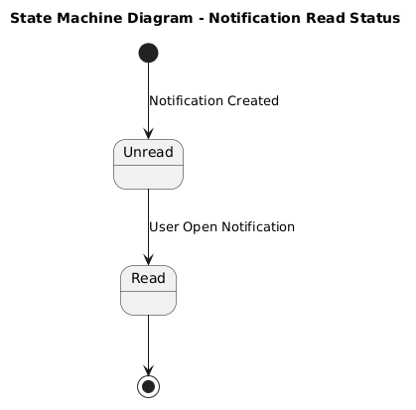

NGUỒN: SƠ ĐỒ STATE MACHINE DIAGRAM - READ NOTIFICATION [PORTFOLIO]

Code
@startuml

title State Machine Diagram - Notification Read Status

[*] --> Unread : Notification Created

state Unread
state Read

Unread --> Read : User Open Notification

Read --> [*]

@enduml

