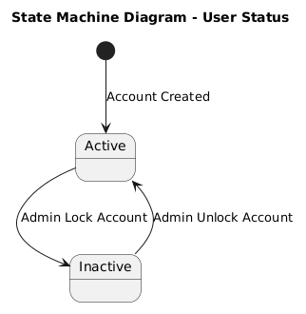

NGUỒN: SƠ ĐỒ STATE MACHINE DIAGRAM - USER ACCOUNT [PORTFOLIO]

Code
@startuml

title State Machine Diagram - User Status

[*] --> Active : Account Created

state Active
state Inactive

Active --> Inactive : Admin Lock Account

Inactive --> Active : Admin Unlock Account

@enduml

