Chay ff co profile, dat ten profoile, chon link folder luu( cai nay quan trong de copy paste acc sang VPS khac ma ko can dang nhap. Qua VPS jkhac thi copy nguen cai foler acc do, roi luc tao profile ben VPS mới thì click folder chọn folder chứa acc dó là chạy dc, ko cần login)

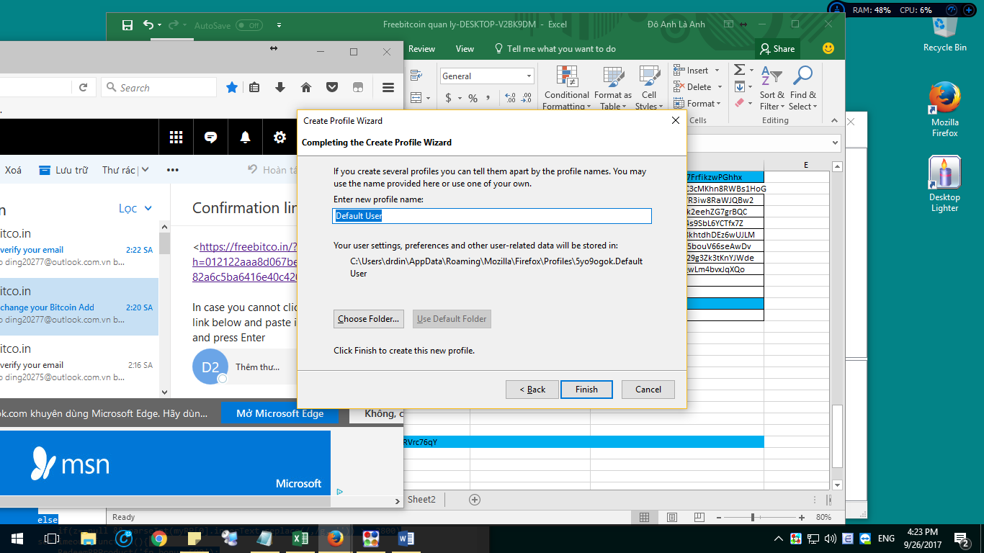

Vao trang bt

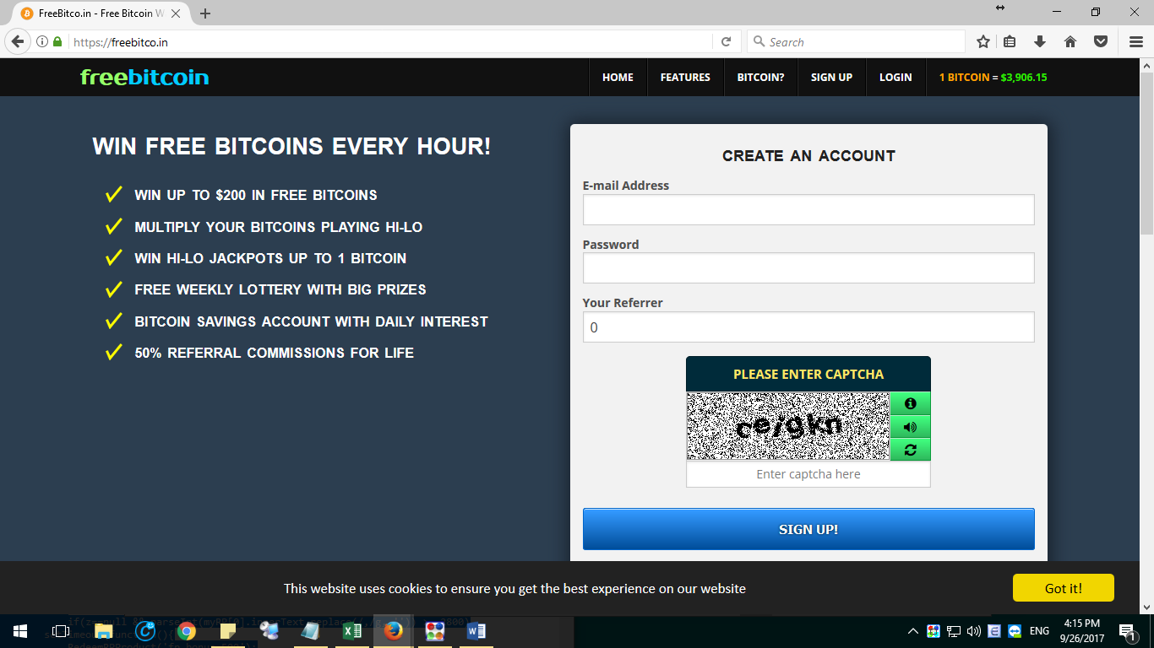

Loin tk dinh dky ( ko nhap login)

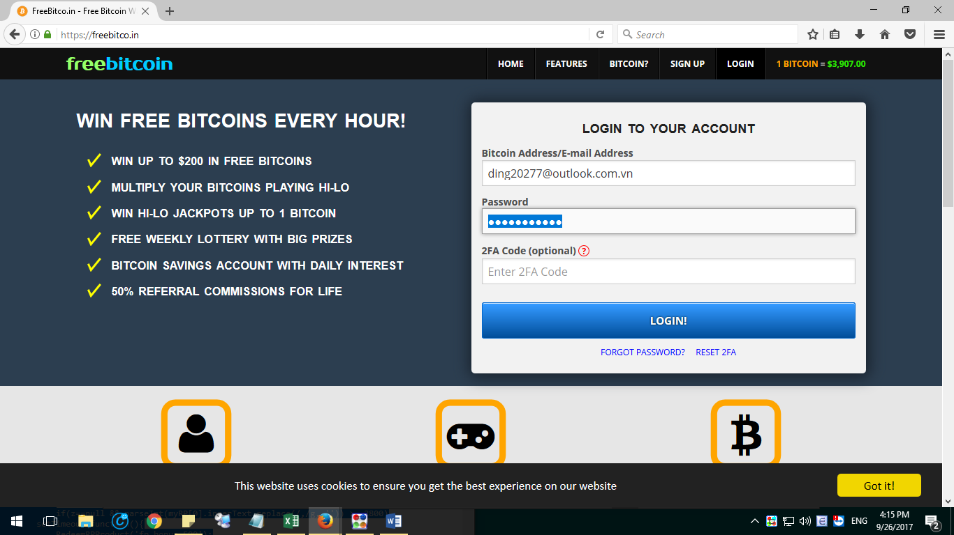

Mo fake IP va chon 1 cai ket noi dc

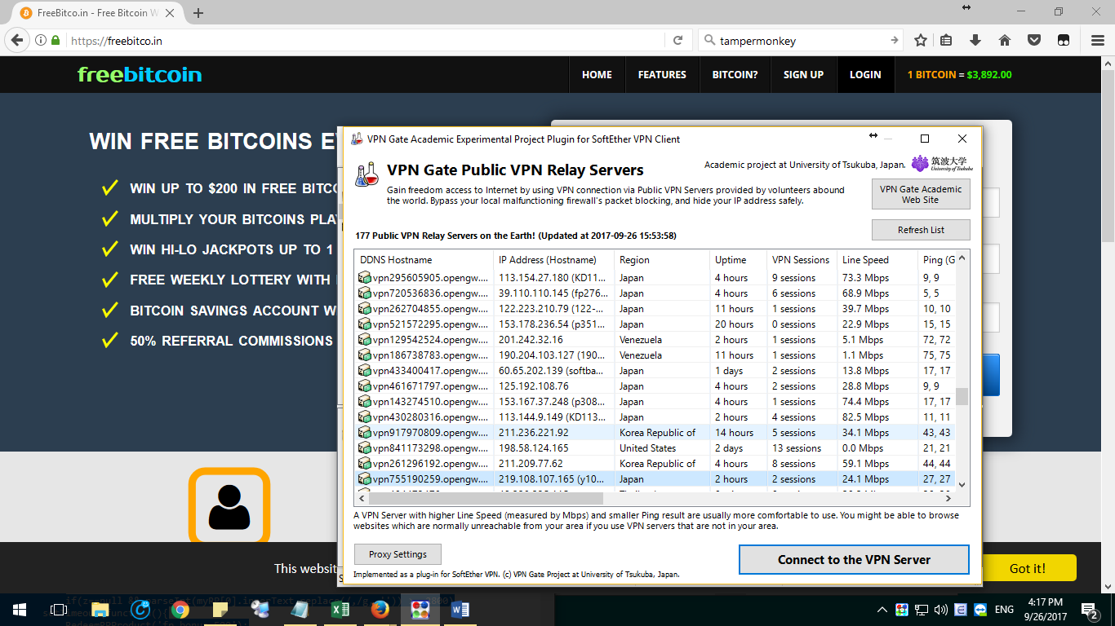

Mo tab an danh. Nhap dia chi freebitco.in hay dia chi ref

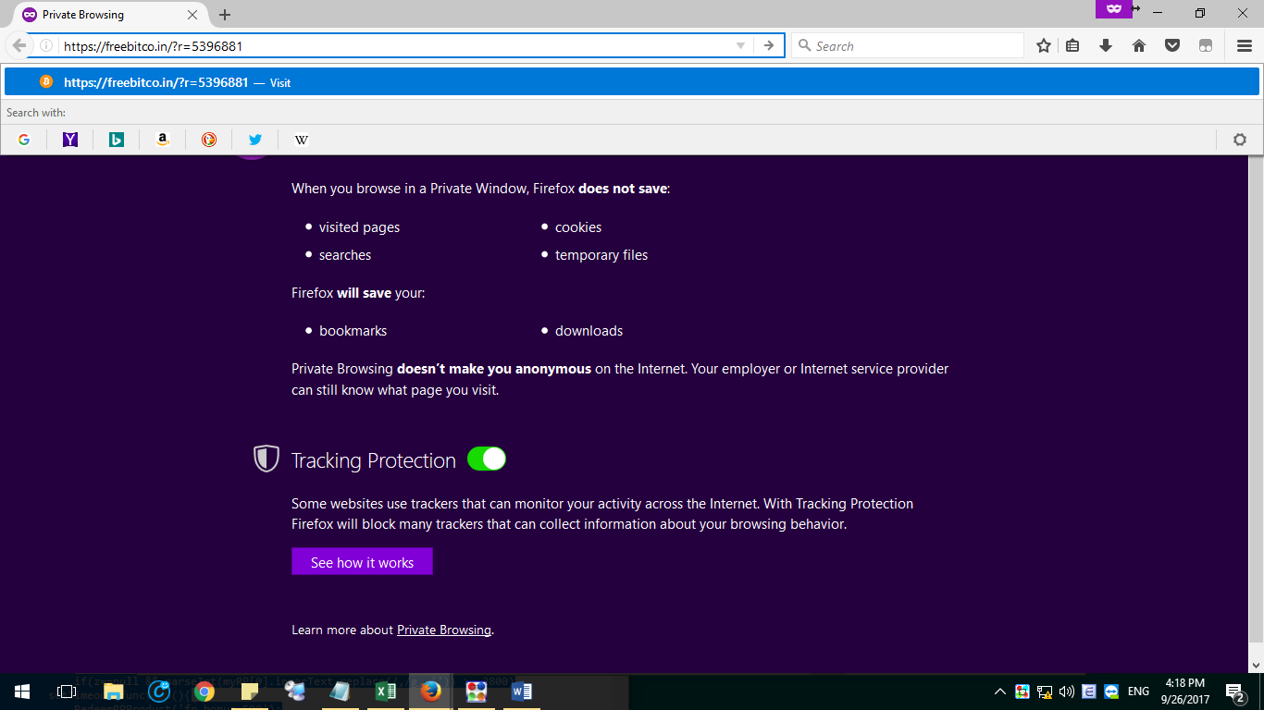

Dky acc hoi nay danh

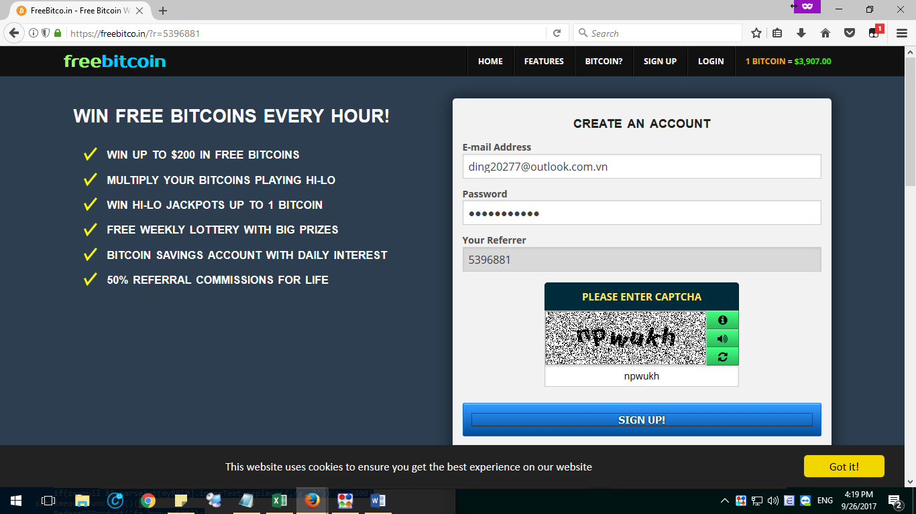

Doi dia chi vi withrall ve acc chinh

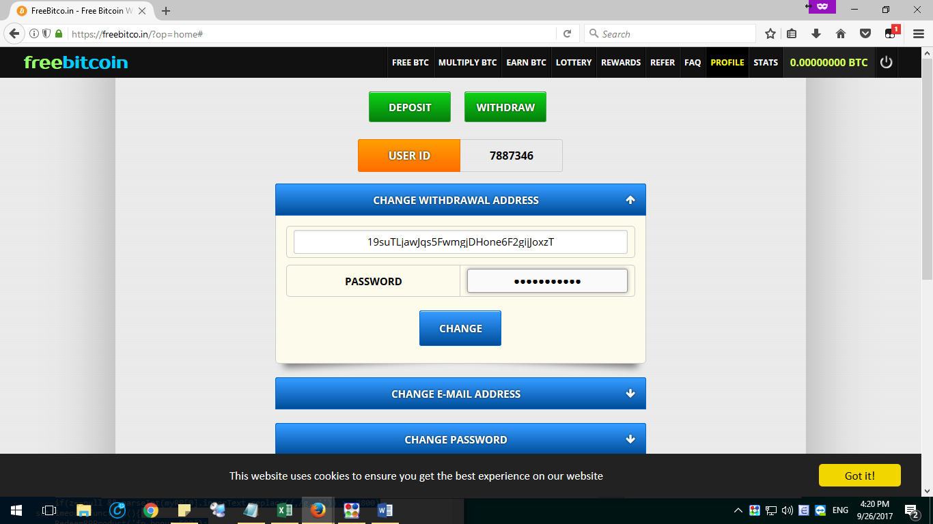

Ra quay so dau tien

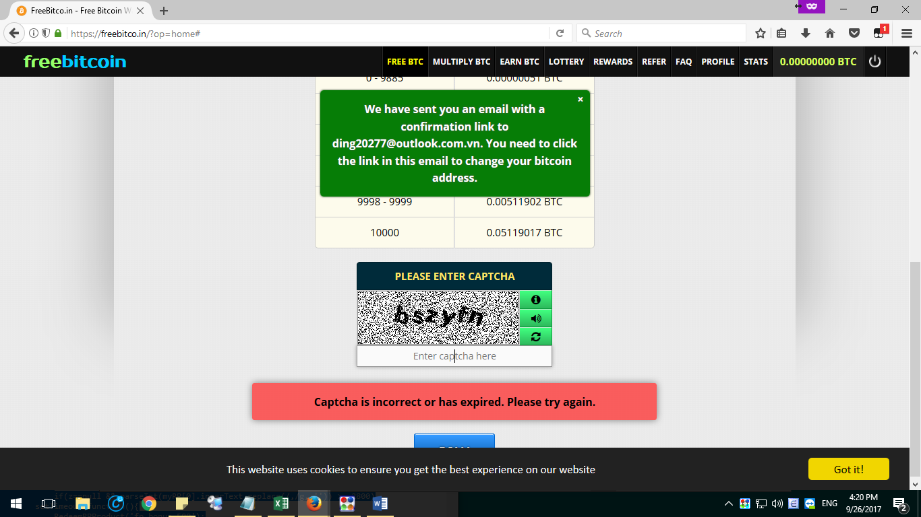

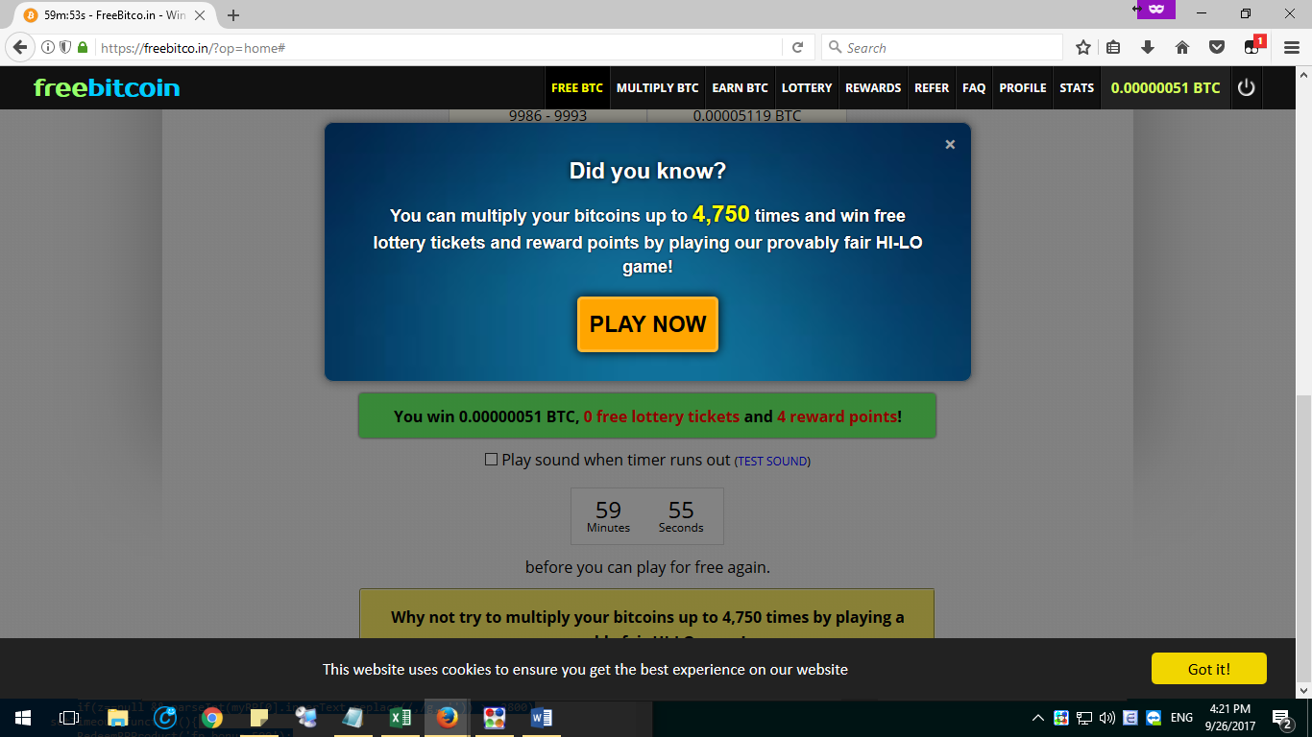

Tat tab an danh

Vao mail xac nhanj 2 cai: 1 cai email 1 cai doi dia chi vi

Quay lai trang ban dau nhap login

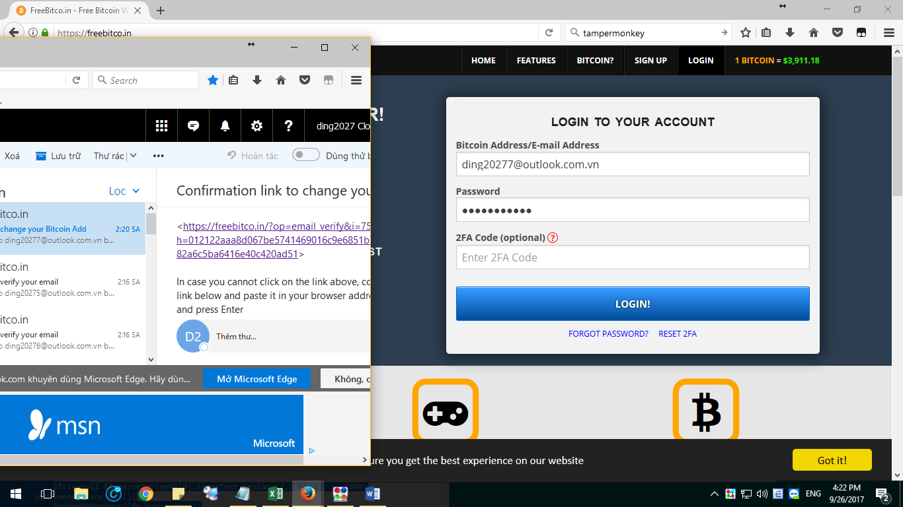

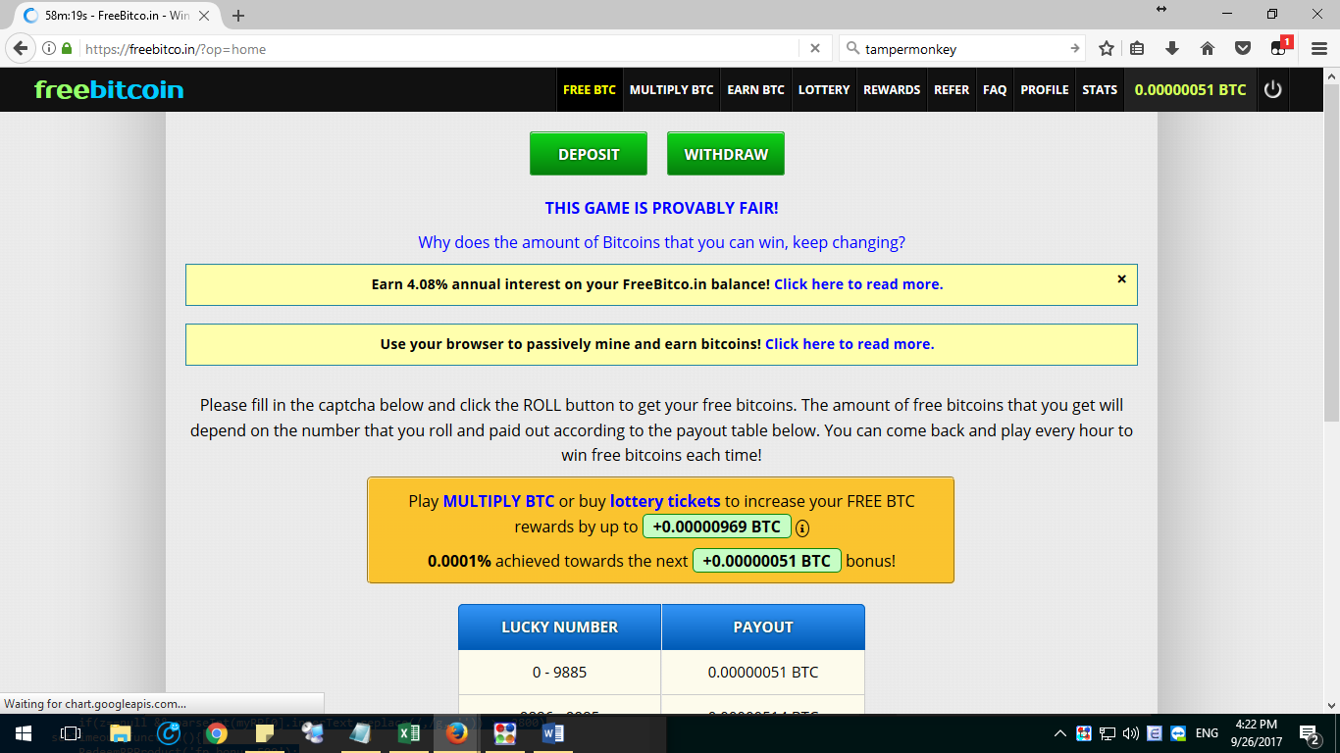

Xong, gio cai tampermonkey, imacros. . Gio tao acc khac bat dau tu dau