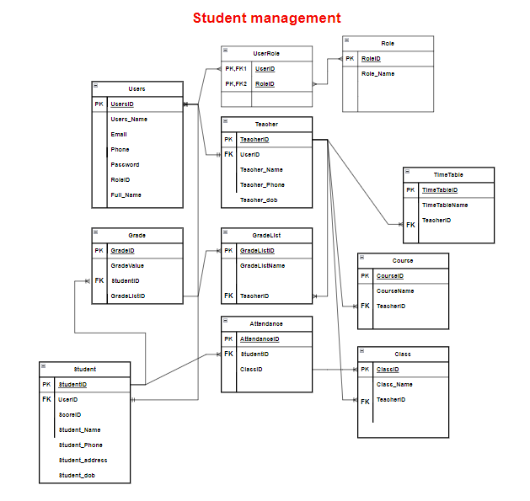

1. **Teacher** table and **Class** table:
   * One teacher can have many classes.
   * The relationship is one-to-many, where one **Teacher** record can be associated with many **Class** records.
2. **Teacher** table and **GradeList** table:
   * One teacher can have many grade lists.
   * The relationship is one-to-many, where one **Teacher** record can be associated with many **GradeList** records.
3. **Teacher** table and **Course** table:
   * One teacher can have many courses.
   * The relationship is one-to-many, where one **Teacher** record can be associated with many **Course** records.
4. **Teacher** table and **Timetable** table:
   * One teacher can have many timetables.
   * The relationship is one-to-many, where one **Teacher** record can be associated with many **Timetable** records.
5. **Student** table and **Enrollment** table:
   * One student can be enrolled in many classes.
   * The relationship is one-to-many, where one **Student** record can be associated with many **Enrollment** records.
6. **Class** table and **Enrollment** table:
   * One class can have many students enrolled in it.
   * The relationship is many-to-one, where many **Enrollment** records can be associated with one **Class** record.
7. **GradeList** table and **Grade** table:

* One grade list can have many grades.
* The relationship is many-to-one, where many **Grade** records can be associated with one **GradeList** record.

1. **Student** table and **Grade** table:

* One student can have many grades.
* The relationship is one-to-many, where one **Student** record can be associated with many **Grade** records.

