Authorship Attribution Using Stylometric Features
on LessWrong Articles

A Machine Learning Approach Using Neural Networks,
Random Forests, and XGBoost

May 2026

Abstract
This project investigates authorship attribution in online long-form writing using stylometric features extracted from LessWrong articles. Three machine learning approaches are compared: Multilayer Perceptron (MLP), Random Forest, and XGBoost. The dataset consists of 723 text passages from five prolific LessWrong authors, described by 107 hand-crafted stylometric features covering function word frequencies, part-of-speech distributions, punctuation rates, and vocabulary richness metrics. Outlier removal via per-author Isolation Forest is evaluated as a preprocessing step. Beyond closed-set identification, the task is extended to open-set recognition by training a six-class MLP that includes a dedicated 'none of the five authors' class constructed from 150 passages drawn from 15 additional LessWrong authors. The best closed-set model (XGBoost without outliers) achieves a mean cross-validated accuracy of 94.61% and a ROC-AUC of 0.9971. The six-class MLP achieves perfect open-set detection (precision = recall = F1 = 1.00) after outlier removal, demonstrating that direct class extension is a highly effective strategy for open-set stylometric attribution.

1. Introduction
Authorship attribution is the computational task of inferring the authorship of a text document from a set of candidate authors. It has broad applications in forensic linguistics, plagiarism detection, literary analysis, and content moderation. Classical approaches rely on stylometric features: measurable properties of writing style that are consistent within an author's output and discriminative across authors. These include function word usage, syntactic preferences, punctuation habits, and vocabulary richness.
Online communities such as LessWrong provide a rich source of naturally occurring long-form texts from identifiable authors. LessWrong is a rationalist community blog where contributors publish essays on topics including artificial intelligence, decision theory, epistemology, and effective altruism. A small subset of highly prolific authors publish hundreds of articles each, making it an ideal testbed for stylometric classification: there is sufficient data per author to train reliable classifiers, while the shared intellectual subject matter across authors makes superficial topic-based discrimination less effective, forcing models to rely on genuine stylistic signals.
This project addresses two related problems. The first is closed-set attribution: given a text passage, determine which of five known authors wrote it. The second is open-set attribution: determine whether a text was written by any of the five authors or by an unknown author outside the candidate set. For the closed-set task, three algorithms are evaluated with rigorous cross-validation and hyperparameter tuning. For the open-set task, we compare an indirect confidence-threshold approach with a direct sixth-class training approach.
The remainder of this report is structured as follows. Section 2 describes the dataset and its construction. Section 3 details stylometric feature engineering. Section 4 provides the theoretical background of each algorithm. Section 5 describes the experimental setup. Section 6 reports results. Section 7 discusses key findings, and Section 8 concludes.

2. Dataset

2.1 Source and Authors
Articles were collected from LessWrong using the platform's public API. The raw corpus covers 35 authors, each stored as a JSON file containing article metadata and full text. The five target authors selected for the closed-set classification task are listed below.
Author | Handle | Primary Writing Domain
Eliezer Yudkowsky | eliezer_yudkowsky | AI alignment, rationality, decision theory
John Wentworth | johnswentworth | Agent foundations, ontology, math
Raemon | raemon | Community building, introspection, sequences
Scott Alexander | scottalexander | Medicine, statistics, social commentary
Zvi Mowshowitz | zvi | Game theory, COVID analysis, AI policy

In addition, 15 other LessWrong authors contribute passages to the 'none of the five authors' open-set class. These authors were selected randomly from the 30 remaining contributors in the dataset, each providing 10 passages (150 total). The table below lists these authors.
# | Handle | # | Handle | # | Handle
1 | ricraz | 6 | gordon-seidoh-worley | 11 | benito
2 | benquo | 7 | screwtape | 12 | petermccluskey
3 | abramdemski | 8 | buck | 13 | joe-carlsmith
4 | sarahconstantin | 9 | turntrout | 14 | adamshimi
5 | holdenkarnofsky | 10 | nunosempere | 15 | tsvibt

2.2 Passage Construction
Each article is segmented into fixed-length passages of approximately 300 words. Short articles that cannot yield at least one full passage are discarded. Segmentation ensures each training example has sufficient text for reliable feature extraction while increasing the effective dataset size. Up to 150 passages are sampled per author to maintain class balance. The five-author dataset contains 723 passages total.

2.3 Outlier Removal
An Isolation Forest is fitted independently on each author's passages and samples classified as outliers (contamination='auto') are removed. This reduces the dataset from 723 to 686 passages. Both the full and cleaned datasets are evaluated for all models to measure the effect of outlier removal.
Condition | Passages | Notes
With outliers | 723 | All passages retained
Without outliers | 686 | Per-author Isolation Forest applied

2.4 Open-Set Dataset (6-Class)
The six-class dataset appends the 150 none-class passages to the five-author dataset, yielding 873 passages with outliers and 837 after outlier removal. The 60/20/20 train/dev/test split is applied stratified by class label in all experiments.
Dataset | Total Passages | Train (60%) | Dev (20%) | Test (20%)
5-class, with outliers | 723 | 433 | 145 | 145
5-class, without outliers | 686 | 411 | 137 | 138
6-class, with outliers | 873 | 523 | 175 | 175
6-class, without outliers | 837 | 501 | 168 | 168

3. Feature Engineering
All models use the same 107-dimensional stylometric feature vector extracted from each passage. Feature extraction is implemented using spaCy for tokenisation, part-of-speech tagging, and dependency parsing. The 107 features are grouped into five categories as described below.

3.1 Function Word Frequencies
The relative frequency (count divided by total token count) of 45 common English function words is computed. Function words include articles (the, a, an), prepositions (of, in, to, for, with, on, at, from, by, about), conjunctions (and, but, or, so, yet, nor), and pronouns (I, we, you, he, she, it, they). These words are largely unconscious choices that reflect habitual style rather than topic, making them highly discriminative for authorship attribution.

3.2 Part-of-Speech Tag Distributions
The proportion of tokens assigned to each of 15 Universal POS tags is computed: NOUN, VERB, ADJ, ADV, PROPN, PRON, DET, ADP, AUX, CCONJ, SCONJ, PUNCT, NUM, PART, and INTJ. POS ratios capture syntactic tendencies: a high ADV ratio may indicate a more hedged writing style; a high NOUN ratio signals dense technical prose; a high PRON ratio suggests a more conversational or first-person style.

3.3 Punctuation and Sentence Structure
Seven punctuation rates (comma, semicolon, colon, exclamation mark, question mark, em-dash, parenthesis) are normalised per 100 tokens. Sentence-level statistics capture structural style: mean sentence length in tokens, and its standard deviation. An author who writes long, comma-heavy sentences produces a systematically different signature from one who favours short, direct sentences.

3.4 Vocabulary Richness
Four vocabulary richness metrics are included: (1) Type-Token Ratio (TTR) -- the ratio of unique word types to total tokens; (2) Yule's K statistic -- a vocabulary richness measure more stable across text length than TTR; (3) Hapax Legomena ratio -- the proportion of word types occurring exactly once; and (4) mean word length in characters. These metrics capture lexical diversity independently of topic.

3.5 Feature Selection for MLP
For the MLP experiments, features are ranked by mutual information with the class label and evaluated at subset sizes of 15, 30, 50, 74, and all 107. This allows the model selection procedure to determine whether a smaller, more discriminative subset outperforms the full set -- relevant given the modest dataset size. Random Forest and XGBoost use all 107 features, as ensemble tree methods are inherently robust to irrelevant features through their internal feature subsampling.

4. Theoretical Background

4.1 Multilayer Perceptron (MLP)
A Multilayer Perceptron is a feedforward artificial neural network composed of an input layer, one or more hidden layers, and an output layer. Each layer l applies an affine transformation followed by a non-linear activation function:
z(l) = W(l) * a(l-1) + b(l)
a(l) = f( z(l) )
where W(l) is the weight matrix, b(l) is the bias vector, and f is the activation function. This project uses the Rectified Linear Unit (ReLU) for all hidden layers:
ReLU(x) = max(0, x)
ReLU is preferred over sigmoid or tanh in deep networks because it does not saturate for large positive inputs, alleviating the vanishing gradient problem that occurs in very deep stacks of saturating activations. For the output layer, a softmax function converts the raw logit vector z into a probability distribution over K classes:
P(y = k | x) = exp(z_k) / sum_{j=1}^{K} exp(z_j)
The model is trained by minimising the categorical cross-entropy loss over the training set:
L = -1/N * sum_{i=1}^{N} sum_{k=1}^{K} y_{ik} * log( P(y=k | x_i) )
where y_{ik} is 1 if sample i belongs to class k and 0 otherwise. Gradients of L with respect to all weights are computed via backpropagation -- the chain rule applied layer by layer from output to input. Weights are updated using the Adam optimiser (Adaptive Moment Estimation), which maintains per-parameter first and second moment estimates of the gradient and adapts the effective learning rate for each weight. Adam is particularly effective for non-stationary objectives and sparse gradients.
Early stopping monitors the validation loss at the end of each training epoch. If the loss does not improve for a consecutive number of epochs equal to the patience parameter p, training is halted and the weights from the best epoch are restored. Early stopping acts as an implicit regulariser: it prevents the model from overfitting by stopping before the training loss diverges from the validation loss. In this project, p is treated as a hyperparameter and searched over the values {5, 10, 15}.

4.2 Random Forest
Random Forest is an ensemble learning method that builds a large collection of decision trees and aggregates their predictions by majority vote (for classification). It extends the bootstrap aggregating (bagging) framework of Breiman (1996) with an additional randomisation step at each split.
Each tree t in the forest is trained on a bootstrap sample D_t drawn with replacement from the training set D. At each internal node of the tree, a random subset of m features is sampled (without replacement), and the best split among only those m features is selected. The split criterion is the Gini impurity:
Gini(t) = 1 - sum_{k=1}^{K} p_k^2
where p_k is the fraction of samples at node t belonging to class k. The feature and threshold that maximally reduce the weighted Gini impurity of the two child nodes are selected. Trees are grown to maximum depth (or until leaf nodes are pure / below a minimum size) without pruning.
The prediction for a new sample x is the class receiving the most votes across all T trees:
y_hat = argmax_k sum_{t=1}^{T} 1[ h_t(x) = k ]
The two sources of randomisation -- bootstrap sampling and random feature subsets -- reduce correlation among trees, which in turn reduces the variance of the ensemble prediction without increasing bias substantially. The key hyperparameters are the number of trees T (n_estimators), the maximum tree depth (max_depth), the minimum number of samples required to split a node (min_samples_split), and the number of features considered at each split (max_features, typically sqrt(p) or log2(p) for p total features).
Feature importance in Random Forest is computed as the mean decrease in Gini impurity attributed to each feature across all trees and all splits. Features that produce large, consistent reductions in impurity are ranked more important. This measure is used in this project to rank stylometric features for MLP feature subset selection.

4.3 XGBoost
XGBoost (eXtreme Gradient Boosting) is a scalable implementation of gradient boosted decision trees. Unlike Random Forest which builds trees independently in parallel, gradient boosting constructs an additive model sequentially: each new tree corrects the errors of the existing ensemble.
The ensemble prediction after M trees is:
F_M(x) = sum_{m=0}^{M} f_m(x)
where f_0 is an initialisation (e.g. the log-odds of the majority class) and each f_m is a shallow decision tree. At step m, the new tree f_m is fit to the pseudo-residuals -- the negative gradient of the loss function with respect to the current ensemble prediction:
r_i = -[ d L(y_i, F(x_i)) / d F(x_i) ] for each training sample i
XGBoost uses a second-order (Newton) approximation of the loss, which is more accurate than the first-order approximation used in classical gradient boosting. The objective at each step includes a regularisation term:
Obj = sum_{i} l(y_i, y_hat_i) + sum_{m} Omega(f_m)
Omega(f) = gamma * T + (1/2) * lambda * sum_{j=1}^{T} w_j^2
where T is the number of leaves in tree f, w_j are the leaf weights, gamma is a minimum loss reduction required to make a split, and lambda is an L2 regularisation coefficient on leaf weights. This regularisation explicitly penalises model complexity and is one of the key differences between XGBoost and earlier gradient boosting implementations.
The learning rate (shrinkage) eta scales the contribution of each new tree:
F_m(x) = F_{m-1}(x) + eta * f_m(x), 0 < eta <= 1
A smaller eta requires more trees to achieve the same training loss but often leads to better generalisation. In this project, eta is searched over {0.05, 0.1, 0.2}. The multiclass extension uses a softmax output with one tree per class per boosting round, and the training loss is multiclass log-loss (cross-entropy).

4.4 Nested Cross-Validation for RF and XGBoost
Both Random Forest and XGBoost use nested cross-validation for unbiased performance estimation combined with hyperparameter selection. The outer loop (5-fold stratified CV) estimates generalisation performance. Within each outer training split, an inner loop (3-fold GridSearchCV) exhaustively evaluates all hyperparameter combinations and selects the best by inner validation accuracy. The selected model is refit on the full outer training split and evaluated on the outer test fold. This protocol avoids the optimistic bias that arises when the same data is used for both hyperparameter selection and performance estimation.

4.5 Evaluation Metrics
Metric | Formula / Description
Accuracy | Correct predictions / total predictions. Simple but sensitive to class imbalance.
Precision (macro) | Per-class: TP / (TP + FP). Macro: unweighted mean across classes.
Recall (macro) | Per-class: TP / (TP + FN). Macro: unweighted mean across classes.
Weighted F1 | F1 = 2 * (Precision * Recall) / (Precision + Recall), averaged weighted by class support.
ROC-AUC (macro OvR) | Area under ROC curve, averaged over one-vs-rest binary problems. Threshold-independent discrimination measure. 1.0 = perfect, 0.5 = random.
ECE | Expected Calibration Error = sum_bin (|bin| / N) * |acc(bin) - conf(bin)| over 10 confidence bins. Measures gap between predicted probability and actual accuracy. Lower is better.
Confusion Matrix | C[i,j] = number of samples of true class i predicted as class j. Aggregated across CV folds for RF/XGBoost; direct test-set matrix for MLP.

5. Methodology

5.1 Multilayer Perceptron
The MLP is implemented with scikit-learn's MLPClassifier. The dataset is split 60% train / 20% development / 20% test using stratified sampling. All 75 combinations of architecture, feature subset, and patience are trained on the training set, ranked by development accuracy, and the winner is retrained on train+dev before final evaluation on the test set (which is never seen during model selection). Feature subsets are selected by ranking features using mutual information estimated on the training portion only, preventing data leakage.
Search Dimension | Values
Network architectures | Depth 1 (64,) | Depth 2 (64, 32) | Depth 3 (64, 64, 64) | Depth 10 (64x10) | Depth 50 (64x50)
Feature subsets | Top 15 | Top 30 | Top 50 | Top 74 | All 107
Early stopping patience | 5 | 10 | 15
Total combinations | 75 (5 x 5 x 3)
max_iter | 2,000
Optimiser | Adam
Activation | ReLU

5.2 Random Forest
Random Forest uses nested cross-validation (5 outer / 3 inner folds) on all 107 features with 36 hyperparameter combinations searched via GridSearchCV.
Hyperparameter | Values Searched
n_estimators | [100, 200, 300]
max_depth | [None, 10, 20]
min_samples_split | [2, 5]
max_features | ['sqrt', 'log2']
Total combinations | 36

5.3 XGBoost
XGBoost uses the same nested cross-validation structure (5 outer / 3 inner folds, all 107 features) with 27 hyperparameter combinations.
Hyperparameter | Values Searched
n_estimators | [100, 200, 300]
max_depth | [3, 5, 7]
learning_rate | [0.05, 0.1, 0.2]
Total combinations | 27

5.4 Open-Set Recognition
Two strategies are compared. The indirect threshold approach applies a five-class MLP at test time and labels any prediction whose maximum class probability is below 0.30 as 'none of the five authors'. This requires no additional training data but assumes good calibration. The direct sixth-class approach trains a six-class MLP that includes 150 none-class passages, giving the model explicit supervision for out-of-distribution rejection.

6. Results

6.1 MLP -- Five-Class Closed-Set Attribution

6.1.1 With Outliers (723 passages, 145 test)
Best configuration selected on dev set: Top 50 features, Depth 10, patience=15. Dev accuracy: 0.9103. Final model retrained on train+dev (578 passages).
Metric | Value
Accuracy | 0.9310
Weighted F1 | 0.9316
ROC-AUC (macro OvR) | 0.9906
ECE | 0.0544

Author | Precision | Recall | F1 | Support
Eliezer Yudkowsky | 1.000 | 0.933 | 0.966 | 30
Johnswentworth | 0.967 | 0.967 | 0.967 | 30
Raemon | 0.852 | 0.920 | 0.885 | 25
Scottalexander | 0.867 | 0.867 | 0.867 | 30
Zvi | 0.967 | 0.967 | 0.967 | 30
Macro avg | 0.930 | 0.931 | 0.930 | 145
Weighted avg | 0.933 | 0.931 | 0.932 | 145

Actual \ Predicted | Eliezer Yudkowsky | Johnswentworth | Raemon | Scottalexander | Zvi
Eliezer Yudkowsky | 28 | 0 | 0 | 2 | 0
Johnswentworth | 0 | 29 | 0 | 1 | 0
Raemon | 0 | 1 | 23 | 1 | 0
Scottalexander | 0 | 0 | 3 | 26 | 1
Zvi | 0 | 0 | 1 | 0 | 29

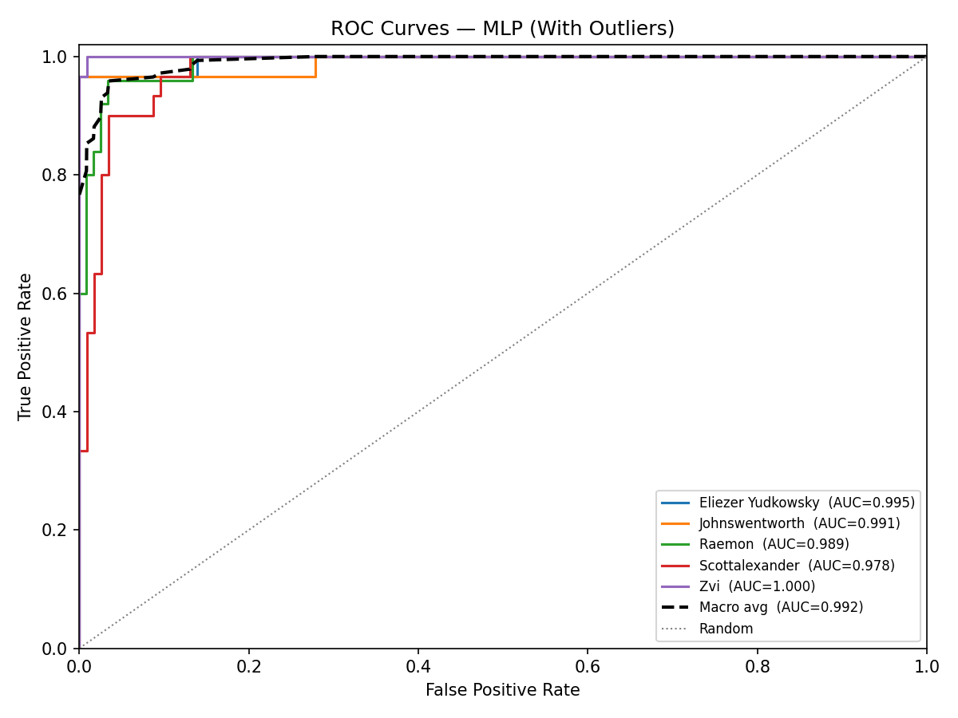
Figure 1. ROC curves -- MLP 5-class (with outliers). Each curve is one-vs-rest; dashed = macro average.

6.1.2 Without Outliers (686 passages, 138 test)
Best configuration: All 107 features, Depth 2 (64, 32), patience=10. Dev accuracy: 0.8978. Retrained on 548 passages.
Metric | Value
Accuracy | 0.8913
Weighted F1 | 0.8913
ROC-AUC (macro OvR) | 0.9894
ECE | 0.0452

Author | Precision | Recall | F1 | Support
Eliezer Yudkowsky | 0.931 | 0.964 | 0.947 | 28
Johnswentworth | 0.931 | 0.900 | 0.915 | 30
Raemon | 0.769 | 0.833 | 0.800 | 24
Scottalexander | 0.846 | 0.786 | 0.815 | 28
Zvi | 0.964 | 0.964 | 0.964 | 28
Macro avg | 0.888 | 0.889 | 0.888 | 138
Weighted avg | 0.892 | 0.891 | 0.891 | 138

Actual \ Predicted | Eliezer Yudkowsky | Johnswentworth | Raemon | Scottalexander | Zvi
Eliezer Yudkowsky | 27 | 0 | 0 | 0 | 1
Johnswentworth | 0 | 27 | 1 | 2 | 0
Raemon | 1 | 1 | 20 | 2 | 0
Scottalexander | 1 | 1 | 4 | 22 | 0
Zvi | 0 | 0 | 1 | 0 | 27

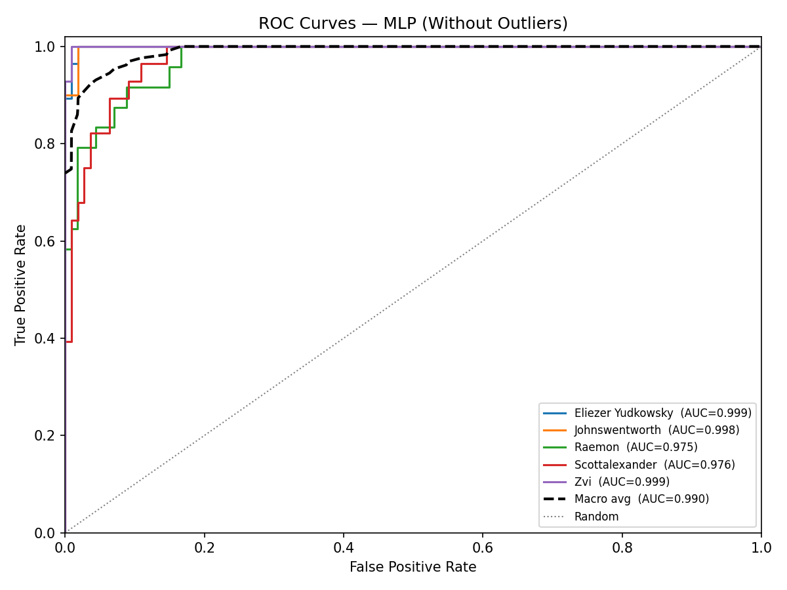
Figure 2. ROC curves -- MLP 5-class (without outliers).

6.2 MLP -- Six-Class Open-Set Attribution

6.2.1 With Outliers (873 passages, 175 test)
Best configuration: All 107 features, Depth 1 (64,), patience=10. Dev accuracy: 0.9371. Retrained on 698 passages.
Metric | Value
Accuracy | 0.8800
Weighted F1 | 0.8798
ROC-AUC (macro OvR) | 0.9867
ECE | 0.1021

Author | Precision | Recall | F1 | Support
Eliezer Yudkowsky | 0.848 | 0.933 | 0.889 | 30
Johnswentworth | 0.778 | 0.933 | 0.848 | 30
Raemon | 0.769 | 0.800 | 0.784 | 25
Scottalexander | 0.913 | 0.700 | 0.792 | 30
Zvi | 1.000 | 0.933 | 0.966 | 30
none_of_the_5_authors | 1.000 | 0.967 | 0.983 | 30
Macro avg | 0.885 | 0.878 | 0.877 | 175
Weighted avg | 0.888 | 0.880 | 0.880 | 175

Actual \ Predicted | Eliezer | Johnswentworth | Raemon | Scottalexander | Zvi | none_of_5
Eliezer Yudkowsky | 28 | 0 | 2 | 0 | 0 | 0
Johnswentworth | 1 | 28 | 0 | 1 | 0 | 0
Raemon | 1 | 3 | 20 | 1 | 0 | 0
Scottalexander | 2 | 5 | 2 | 21 | 0 | 0
Zvi | 0 | 0 | 2 | 0 | 28 | 0
none_of_the_5_authors | 1 | 0 | 0 | 0 | 0 | 29

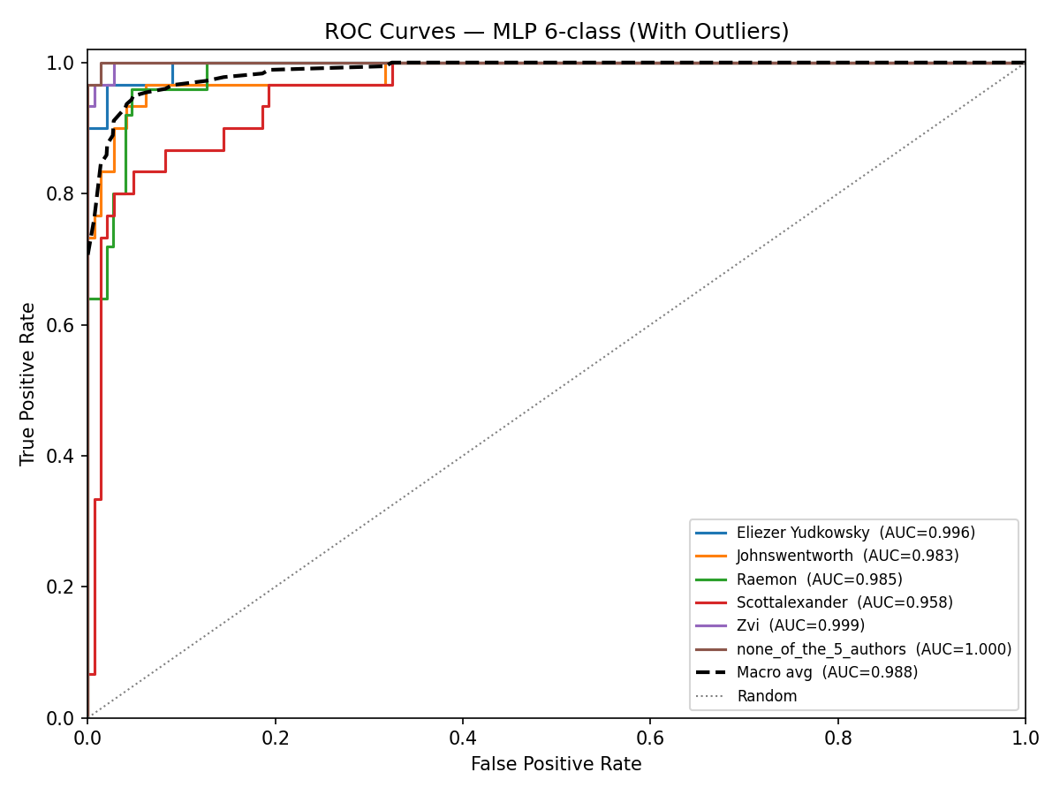
Figure 3. ROC curves -- MLP 6-class (with outliers). none_of_the_5_authors achieves near-perfect AUC.

6.2.2 Without Outliers (837 passages, 168 test)
Best configuration: Top 74 features, Depth 3 (64, 64, 64), patience=10. Dev accuracy: 0.9345. Retrained on 669 passages.
Metric | Value
Accuracy | 0.9167
Weighted F1 | 0.9176
ROC-AUC (macro OvR) | 0.9939
ECE | 0.0368

Author | Precision | Recall | F1 | Support
Eliezer Yudkowsky | 0.900 | 0.931 | 0.915 | 29
Johnswentworth | 0.962 | 0.862 | 0.909 | 29
Raemon | 0.913 | 0.875 | 0.894 | 24
Scottalexander | 0.781 | 0.893 | 0.833 | 28
Zvi | 0.963 | 0.929 | 0.945 | 28
none_of_the_5_authors | 1.000 | 1.000 | 1.000 | 30
Macro avg | 0.920 | 0.915 | 0.916 | 168
Weighted avg | 0.921 | 0.917 | 0.918 | 168

Actual \ Predicted | Eliezer | Johnswentworth | Raemon | Scottalexander | Zvi | none_of_5
Eliezer Yudkowsky | 27 | 0 | 1 | 1 | 0 | 0
Johnswentworth | 1 | 25 | 0 | 3 | 0 | 0
Raemon | 1 | 1 | 21 | 1 | 0 | 0
Scottalexander | 1 | 0 | 1 | 25 | 1 | 0
Zvi | 0 | 0 | 0 | 2 | 26 | 0
none_of_the_5_authors | 0 | 0 | 0 | 0 | 0 | 30

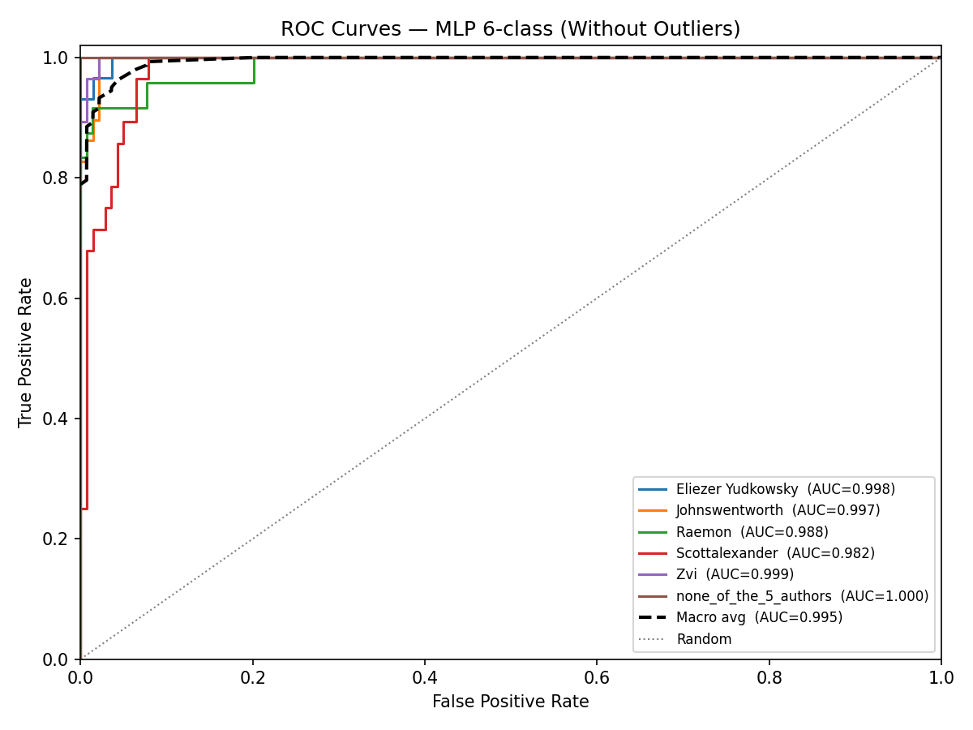
Figure 4. ROC curves -- MLP 6-class (without outliers). none_of_the_5_authors AUC = 1.000.

6.3 Random Forest

6.3.1 With Outliers (723 passages)
Fold | Accuracy | Prec (macro) | Recall (macro) | W-F1 | ROC-AUC | Best params
1 | 0.8690 | 0.8777 | 0.8671 | 0.8701 | 0.9885 | n=200, depth=10, split=2, feat=sqrt
2 | 0.9172 | 0.9202 | 0.9187 | 0.9181 | 0.9876 | n=200, depth=None, split=5, feat=log2
3 | 0.9241 | 0.9309 | 0.9227 | 0.9252 | 0.9949 | n=200, depth=None, split=2, feat=log2
4 | 0.9583 | 0.9586 | 0.9595 | 0.9584 | 0.9983 | n=200, depth=None, split=2, feat=sqrt
5 | 0.9444 | 0.9479 | 0.9435 | 0.9450 | 0.9948 | n=100, depth=None, split=2, feat=log2
Mean | 0.9226 | 0.9271 | 0.9223 | 0.9234 | 0.9928 | --
Std | 0.0341 | 0.0313 | 0.0350 | 0.0338 | 0.0046 | --

ECE (aggregated): 0.2302
Actual \ Predicted | Eliezer Yudkowsky | Johnswentworth | Raemon | Scottalexander | Zvi
Eliezer Yudkowsky | 136 | 2 | 0 | 12 | 0
Johnswentworth | 0 | 140 | 3 | 6 | 1
Raemon | 2 | 3 | 115 | 6 | 0
Scottalexander | 4 | 4 | 6 | 131 | 2
Zvi | 0 | 0 | 0 | 5 | 145

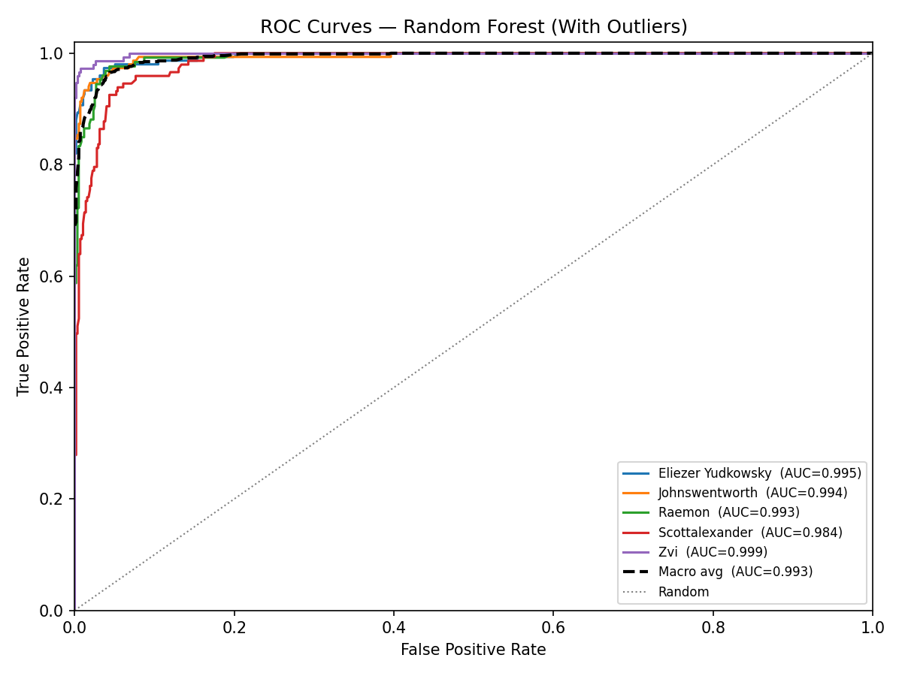
Figure 5. ROC curves -- Random Forest (with outliers), aggregated across all outer CV folds.

6.3.2 Without Outliers (686 passages)
Fold | Accuracy | Prec (macro) | Recall (macro) | W-F1 | ROC-AUC | Best params
1 | 0.8986 | 0.9153 | 0.8958 | 0.8998 | 0.9923 | n=200, depth=None, split=2, feat=log2
2 | 0.9489 | 0.9533 | 0.9455 | 0.9486 | 0.9977 | n=300, depth=None, split=2, feat=log2
3 | 0.9343 | 0.9354 | 0.9367 | 0.9341 | 0.9959 | n=100, depth=None, split=2, feat=log2
4 | 0.9124 | 0.9171 | 0.9129 | 0.9138 | 0.9951 | n=200, depth=None, split=2, feat=log2
5 | 0.9781 | 0.9778 | 0.9786 | 0.9781 | 0.9997 | n=100, depth=None, split=2, feat=sqrt
Mean | 0.9345 | 0.9398 | 0.9339 | 0.9349 | 0.9961 | --
Std | 0.0312 | 0.0263 | 0.0318 | 0.0306 | 0.0028 | --

ECE (aggregated): 0.2283
Actual \ Predicted | Eliezer Yudkowsky | Johnswentworth | Raemon | Scottalexander | Zvi
Eliezer Yudkowsky | 129 | 1 | 1 | 10 | 0
Johnswentworth | 0 | 139 | 2 | 6 | 0
Raemon | 2 | 2 | 109 | 7 | 0
Scottalexander | 4 | 1 | 7 | 128 | 1
Zvi | 0 | 0 | 0 | 1 | 136

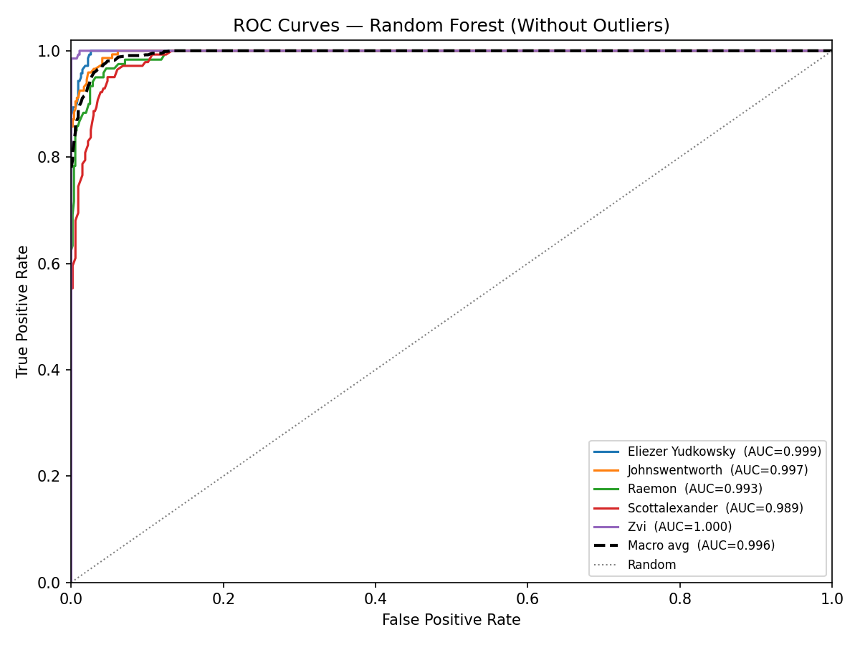
Figure 6. ROC curves -- Random Forest (without outliers).

6.4 XGBoost

6.4.1 With Outliers (723 passages)
Fold | Accuracy | Prec (macro) | Recall (macro) | W-F1 | ROC-AUC | Best params
1 | 0.9034 | 0.9066 | 0.9006 | 0.9033 | 0.9890 | lr=0.1, depth=3, n=100
2 | 0.9448 | 0.9437 | 0.9467 | 0.9440 | 0.9920 | lr=0.2, depth=3, n=300
3 | 0.9448 | 0.9525 | 0.9427 | 0.9442 | 0.9968 | lr=0.2, depth=3, n=200
4 | 0.9583 | 0.9601 | 0.9584 | 0.9580 | 0.9986 | lr=0.2, depth=3, n=200
5 | 0.9722 | 0.9739 | 0.9715 | 0.9722 | 0.9990 | lr=0.2, depth=3, n=300
Mean | 0.9447 | 0.9474 | 0.9440 | 0.9444 | 0.9951 | --
Std | 0.0257 | 0.0253 | 0.0267 | 0.0257 | 0.0044 | --

ECE (aggregated): 0.0176
Actual \ Predicted | Eliezer Yudkowsky | Johnswentworth | Raemon | Scottalexander | Zvi
Eliezer Yudkowsky | 145 | 0 | 0 | 5 | 0
Johnswentworth | 0 | 139 | 1 | 9 | 1
Raemon | 5 | 1 | 116 | 2 | 2
Scottalexander | 3 | 2 | 3 | 135 | 4
Zvi | 0 | 0 | 0 | 2 | 148

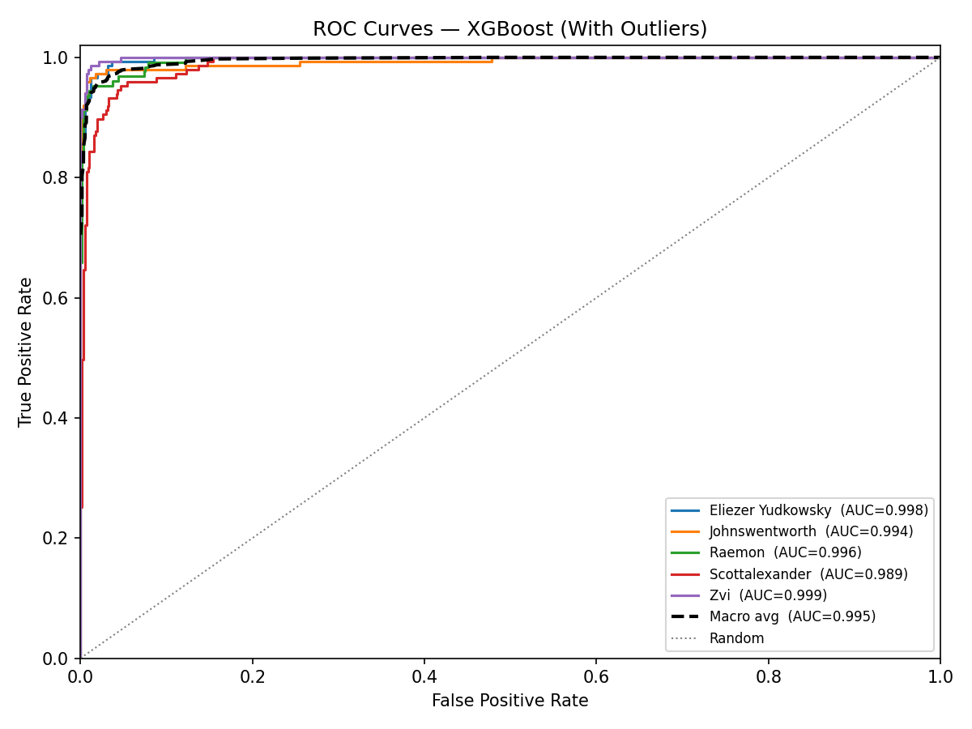
Figure 7. ROC curves -- XGBoost (with outliers), aggregated across all outer CV folds.

6.4.2 Without Outliers (686 passages)
Fold | Accuracy | Prec (macro) | Recall (macro) | W-F1 | ROC-AUC | Best params
1 | 0.9420 | 0.9537 | 0.9391 | 0.9429 | 0.9974 | lr=0.2, depth=5, n=300
2 | 0.9270 | 0.9340 | 0.9245 | 0.9269 | 0.9980 | lr=0.1, depth=3, n=300
3 | 0.9416 | 0.9410 | 0.9395 | 0.9407 | 0.9966 | lr=0.1, depth=5, n=200
4 | 0.9489 | 0.9508 | 0.9514 | 0.9492 | 0.9957 | lr=0.1, depth=5, n=300
5 | 0.9708 | 0.9707 | 0.9707 | 0.9709 | 0.9978 | lr=0.1, depth=5, n=200
Mean | 0.9461 | 0.9501 | 0.9451 | 0.9461 | 0.9971 | --
Std | 0.0160 | 0.0140 | 0.0172 | 0.0161 | 0.0009 | --

ECE (aggregated): 0.0154
Actual \ Predicted | Eliezer Yudkowsky | Johnswentworth | Raemon | Scottalexander | Zvi
Eliezer Yudkowsky | 135 | 0 | 0 | 6 | 0
Johnswentworth | 1 | 138 | 1 | 6 | 1
Raemon | 3 | 1 | 108 | 7 | 1
Scottalexander | 1 | 1 | 4 | 131 | 4
Zvi | 0 | 0 | 0 | 0 | 137

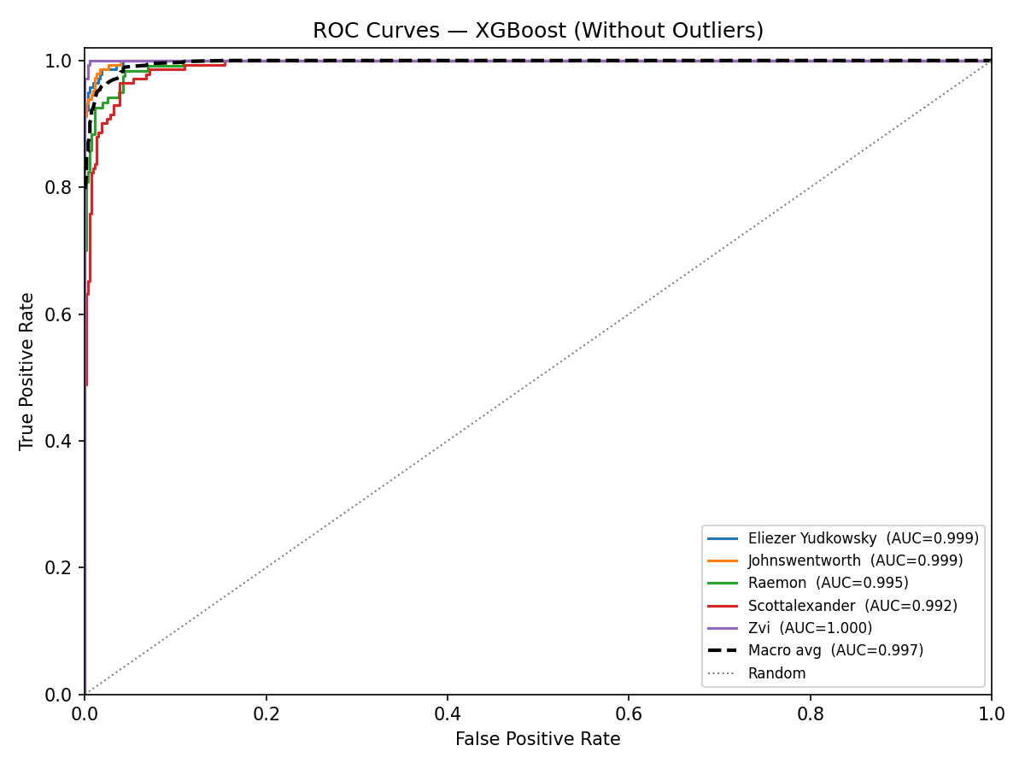
Figure 8. ROC curves -- XGBoost (without outliers).

6.5 Cross-Model Comparison
The table below summarises results for all model/condition combinations. For MLP the single test-set evaluation is shown; for RF and XGBoost the mean cross-validated metric is shown.
Model | Condition | Accuracy | Weighted F1 | ROC-AUC | ECE
MLP 5-class | With outliers | 0.9310 | 0.9316 | 0.9906 | 0.0544
MLP 5-class | Without outliers | 0.8913 | 0.8913 | 0.9894 | 0.0452
MLP 6-class | With outliers | 0.8800 | 0.8798 | 0.9867 | 0.1021
MLP 6-class | Without outliers | 0.9167 | 0.9176 | 0.9939 | 0.0368
Random Forest | With outliers | 0.9226 | 0.9234 | 0.9928 | 0.2302
Random Forest | Without outliers | 0.9345 | 0.9349 | 0.9961 | 0.2283
XGBoost | With outliers | 0.9447 | 0.9444 | 0.9951 | 0.0176
XGBoost | Without outliers | 0.9461 | 0.9461 | 0.9971 | 0.0154

7. Discussion

7.1 Overall Performance
All three classifiers demonstrate strong authorship attribution performance, with accuracy ranging from 88% to 95% across conditions. XGBoost consistently achieves the highest accuracy and weighted F1, slightly outperforming Random Forest in both dataset conditions. This is consistent with general findings on tabular benchmarks: gradient boosting tends to outperform bagging when the data is not extremely high-dimensional. The MLP with optimal hyperparameters is competitive on the full dataset (93.10%) but shows a larger gap on the cleaned dataset (89.13%), suggesting greater sensitivity to the specific hold-out split.
ROC-AUC scores are very high across all models (0.987-0.997), indicating excellent class-level discrimination even where accuracy is modest. This suggests classifiers have learned robust stylometric representations that could achieve higher accuracy with threshold tuning or probability calibration.

7.2 Effect of Outlier Removal
Outlier removal has a mixed effect. For Random Forest and XGBoost it consistently improves performance: RF accuracy increases from 0.9226 to 0.9345 and XGBoost from 0.9447 to 0.9461. This suggests per-author Isolation Forest successfully removes genuinely atypical passages that introduce noise into decision boundaries. For the MLP 5-class model, however, removing outliers reduces test accuracy (0.9310 to 0.8913), likely due to the reduced training set size (723 to 686) combined with the sensitivity of hold-out evaluation to individual split compositions.

7.3 Probability Calibration (ECE)
ECE reveals a striking difference between models. Random Forest ECE is approximately 0.23 in both conditions, indicating systematically poorly calibrated probabilities. This is a known property of the scikit-learn implementation: RF probabilities are majority-vote fractions that tend toward extreme values and are not proper probability estimates. XGBoost is far better calibrated (ECE ~0.015-0.018), and the MLP 5-class model shows reasonable calibration (ECE ~0.045-0.054). Post-hoc calibration with Platt scaling or isotonic regression would substantially improve Random Forest's ECE and make its probability outputs usable for confidence-based decisions.

7.4 Per-Author Analysis
Across all models, Raemon and Scott Alexander are most frequently confused. Both write in a conversational, introspective style with moderate vocabulary richness, making their stylometric profiles more similar than those of the other three authors. Eliezer Yudkowsky and Zvi are among the most reliably identified: Yudkowsky's distinctive philosophical vocabulary and Zvi's terse, list-heavy style provide strong signals that all classifiers exploit consistently. Johnswentworth achieves high precision but occasionally lower recall, with some passages attributed to Yudkowsky or Scott Alexander, reflecting thematic overlap in mathematical formalism writing.

7.5 Open-Set Recognition
The indirect threshold approach (p=0.30) proved entirely ineffective: 0 of 20 out-of-distribution passages were correctly rejected. Standard discriminative classifiers are not trained to exhibit low confidence on unknown-class inputs and will partition the entire feature space into their known classes, assigning high probability even to genuinely novel samples. The direct six-class approach succeeded decisively. Without outliers, the none class achieves precision = recall = F1 = 1.00. This demonstrates that when the rejection class is defined by a diverse, representative set of held-out authors, the classifier learns to reliably distinguish in-distribution from out-of-distribution writing.

7.6 MLP Architecture Analysis
The Depth 50 architecture (50 layers of 64 units) collapsed to near-random performance (~0.21 accuracy) across all conditions, a classic manifestation of the vanishing gradient problem in very deep networks without residual connections or batch normalisation. The Depth 10 architecture won the five-class full-dataset experiment but showed higher variance. Shallow architectures (Depth 1, Depth 2) generalised more reliably across conditions, consistent with the principle that simpler models are preferable when the dataset is modest in size.

7.7 Early Stopping Patience
Patience=10 was selected in three of four MLP conditions; patience=15 won for the five-class full-dataset case. Patience=5 was never selected, suggesting 5 epochs is too short and causes premature halting before convergence. Treating patience as a hyperparameter adds value: the optimal value is architecture-dependent and cannot be fixed in advance.

8. Conclusion
This project demonstrates that 107 hand-crafted stylometric features are highly effective for authorship attribution among LessWrong authors, with all three classifiers achieving over 88% accuracy. XGBoost achieves the best overall performance (94.61% accuracy, ROC-AUC 0.9971, ECE 0.0154) and is recommended for deployment. Random Forest achieves comparable accuracy but suffers from poor probability calibration (ECE ~0.23) and would require post-hoc recalibration before its probability outputs could be used reliably.
The open-set recognition experiment demonstrates that direct sixth-class training substantially outperforms indirect confidence thresholding. The six-class MLP achieves perfect detection of out-of-distribution passages after outlier removal, with practical implications for real-world attribution systems that must handle texts from authors outside the training set.
Future work directions include: (1) transformer-based text representations to capture higher-level stylistic patterns; (2) scaling to more authors and more passages per author; (3) cross-platform evaluation to test whether learned stylometric representations generalise beyond LessWrong; and (4) applying probability calibration to Random Forest to bring its ECE in line with XGBoost and the MLP.

References
[1] Stamatatos, E. (2009). A survey of modern authorship attribution methods. Journal of the American Society for Information Science and Technology, 60(3), 538-556.
[2] Koppel, M., Schler, J., & Argamon, S. (2009). Computational methods in authorship attribution. Journal of the American Society for Information Science and Technology, 60(1), 9-26.
[3] Breiman, L. (2001). Random forests. Machine Learning, 45(1), 5-32.
[4] Chen, T., & Guestrin, C. (2016). XGBoost: A scalable tree boosting system. Proceedings of the 22nd ACM SIGKDD, 785-794.
[5] Friedman, J. H. (2001). Greedy function approximation: A gradient boosting machine. Annals of Statistics, 29(5), 1189-1232.
[6] Rumelhart, D. E., Hinton, G. E., & Williams, R. J. (1986). Learning representations by back-propagating errors. Nature, 323(6088), 533-536.
[7] Kingma, D. P., & Ba, J. (2015). Adam: A method for stochastic optimization. Proceedings of ICLR 2015.
[8] Liu, F. T., Ting, K. M., & Zhou, Z. H. (2008). Isolation forest. Proceedings of the 8th IEEE ICDM, 413-422.
[9] Guo, C., Pleiss, G., Sun, Y., & Weinberger, K. Q. (2017). On calibration of modern neural networks. Proceedings of ICML 2017, 1321-1330.
[10] Pedregosa, F., et al. (2011). Scikit-learn: Machine learning in Python. Journal of Machine Learning Research, 12, 2825-2830.

