NGUYỄN KHÁNH TOÀN 235626

ALL the codes

UPDATE THE DIAGRAMS

2. Working with overloading

2.1

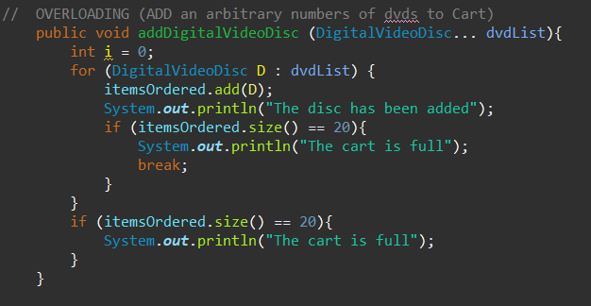

- I prefer the second one as I don’t need to make a new array for the dvdList

2.2

3. Passing parameter

**Questions:**

* After the call of **swap(jungleDVD, cinderellaDVD)** why does the title of these two objects still remain?
* After the call of **changeTitle(jungleDVD, cinderellaDVD.getTitle())** why is the title of the JungleDVD changed?

- BECAUSE JAVA IS A PASS BY VALUE PROGRAMMING, THEN WE DON’T CHANGE IT BY OBJECT = OBJECT

-JAVA IS A PASS BY VALUE PROGRAMMING LANGUAGE.

4. Use debug run

5. Classifier Member and Instance Member

6. Open the Cart Class

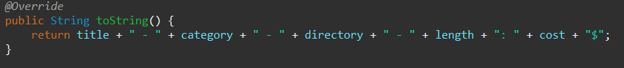

* + toString() returns String

7. Implement the Store Class

9. String concatenation

