|  |  |
| --- | --- |
| https://www.lifewire.com/thmb/pfs_437nEv6AUUQgzWSq5X6G4_U=/1732x1732/filters:fill(auto,1)/turn-off-location-services-5a3430ca7bb2830037a7a681.jpg  **eventme proposal** | **Abstract**  An event-sharing application that allows user to find, create, and like any events that located nearby or based on specific locations  **GROUP MEMBERS**  Nguyen Minh Toan – ID: 300282895  Truong Thanh Thao – ID: 300284134 |

# Description

EventMe is an Android application using Google Map API service to locate user’s current location and recommend any nearby events around them. It enables people discover new, popular local events that matches their interests. Users can view details information about a particular event, like any events they are interested. In addition, EventMe allows users to create and manage their own events.

# Functionalities

Main functionalities of EventMe application includes:

1. User authentication activity: login/logout, registration
2. Events list activity:
   1. Users can view a list of popular events nearby
   2. Users can search for events with specific locations
3. Event detail activity:
   1. Detail information of an event (time, location, description, numbers of people like the event, event’s owner)
   2. Users are able to like/dislike the event
4. Create event activity: user can create their own events
5. User profile activity:
   1. User’s information: name, password, phone, address, email
   2. Events that they interested
   3. Events that they created

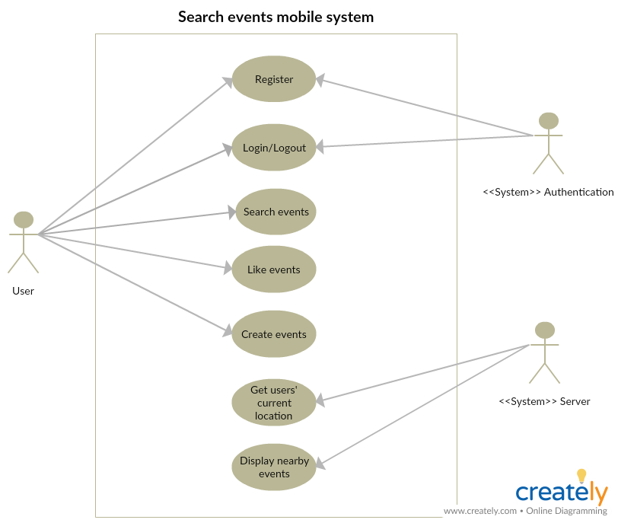

# Design Interface

## Register & Login Screen:

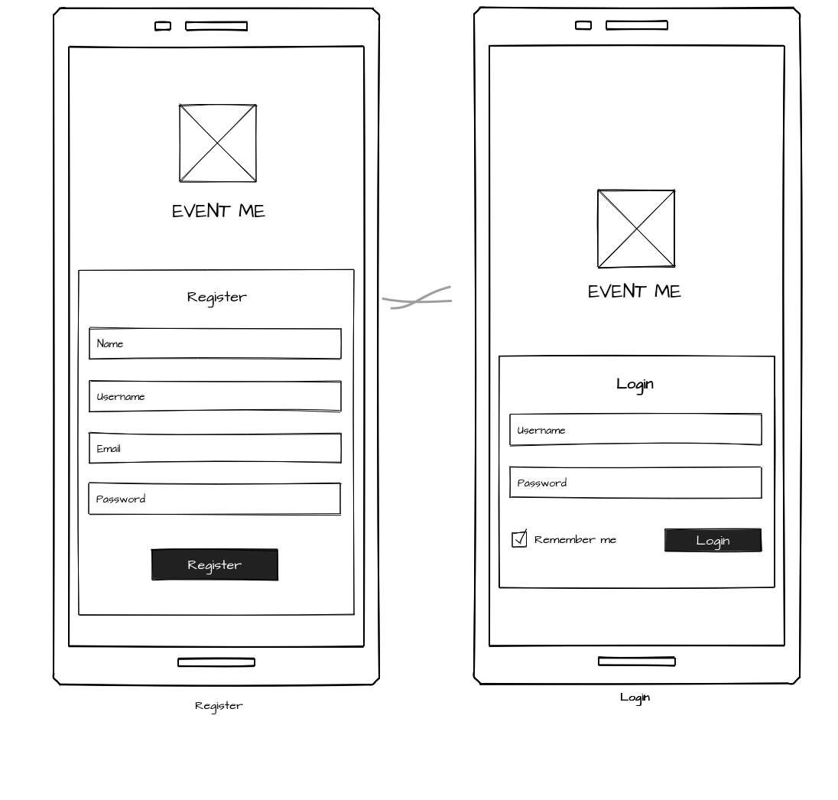

## Home Screen : display list of nearby events Details of an event Screen:

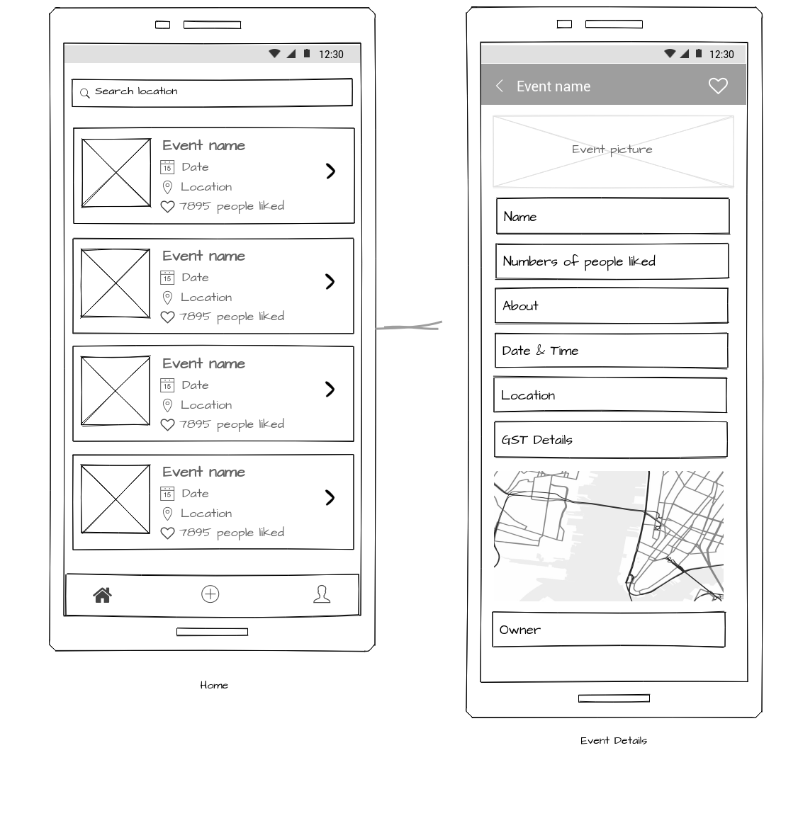

## User’s profile Screen: Create Event Screen: users create events

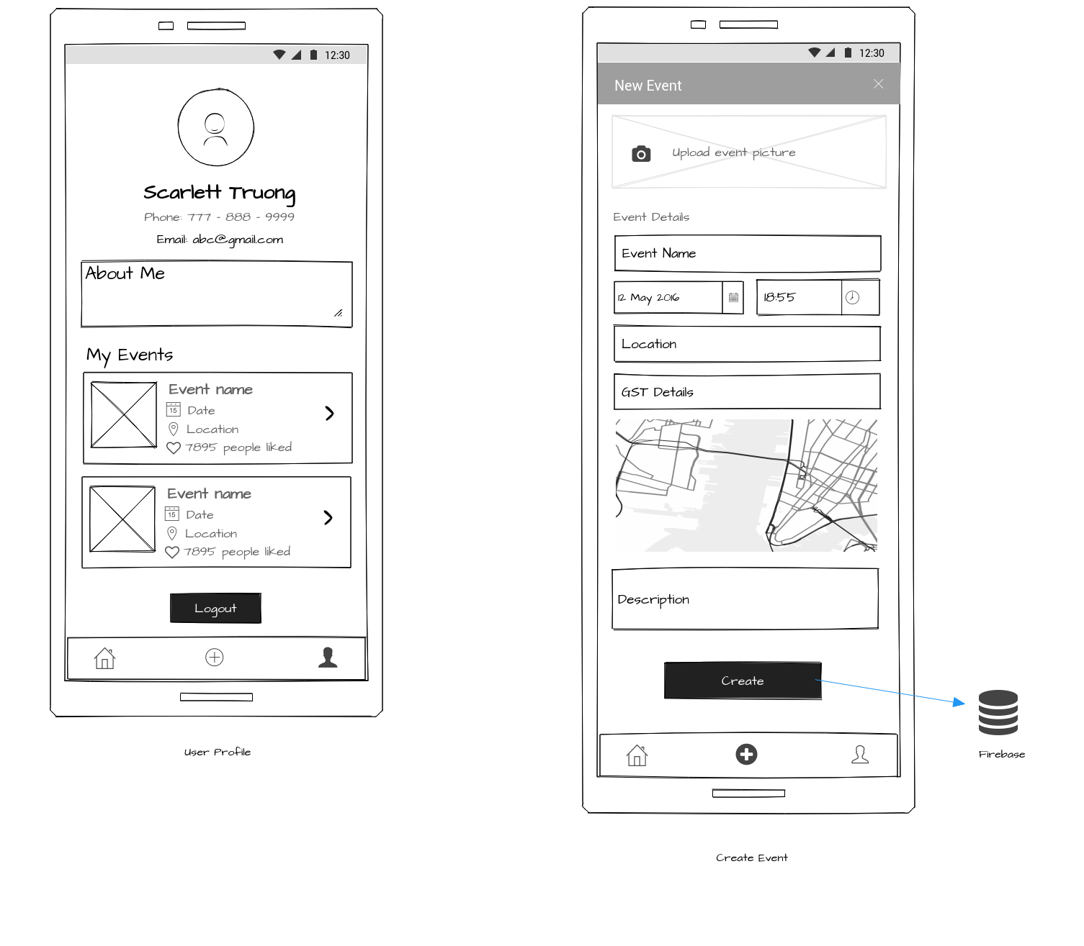

# System architecture

* Client: Android
* Database: Firebase
* Authentication System: Firebase
* Other services: Google Map

# Timeframe

|  |  |
| --- | --- |
| Phase | Week |
| Authentication activity | 1 |
| Design database | 2 |
| Events list activity | 3 |
| Event details activity | 4-6 |
| Event create activity | 7 |
| User profile activity | 8 |

CSIS 4175 – mobile 2

project log

members: nguyen minh toan | truong thanh thao

| Task | Hours | PIC | Due Date | Status |
| --- | --- | --- | --- | --- |
| Write proposal | 7 | Thao | Sep 23 | Done |
| Create android project, initialize structure and firebase | 2 | Toan | Sep 23 | Done |
| Create login activity | 3 | Toan | Sep 23 | Done |
| Create registration activity | 5 | Toan | Sep 23 | Done |
| Design UI for login & registration activity | 3 | Thao | Sep 24 | In process |
| User profile activity |  |  |  |  |
| User profile edit |  |  |  |  |
| List Events / search events |  |  |  |  |
| Event detail activity |  |  |  |  |
| Create event activity |  |  |  |  |
|  |  |  |  |  |