

**Software Architecture and Design**

**Software Design Document**

**BirdCageShop**

**Sales Management System For Business Premises and Bird Cage Production**

| **Group F23NJS02** | | | | | | | |
| --- | --- | --- | --- | --- | --- | --- | --- |
| **Group members** | | | Nguyễn Văn Toàn-SE150463  Lương Huỳnh Ngọc Hảo-SE150758  Ôn Thị Thu Hạnh-HE153752  Lê Phạm Đông Anh-SE140384  Võ Thùy Trang-SE160179  Houang Gia Thành-SE161051 | | | | |
|
|
|
| **Supervisor** | | | **Nguyễn Ngọc Lâm** | | | | |
|
| **Project code** | | | **BirdCS** | | | | |

Table of Contents

**I. Record of Changes** **3**

**II. Software Requirements Specification** **3**

1. Overall Description 3

1.1. Business Rules 3

2. User Requirements 5

2.1. System Actors 5

2.2. Use Case Diagram 5

2.2.1. Guest 6

2.2.2. Customer 7

2.2.3. Staff and Manage 8

2.2.4. Admin 9

2.3. Use Case List 9

2.4. Use Case Specification 12

2.4.1. Sign up 12

2.4.2. Login 14

2.4.3. View all product 16

2.4.4. View product detail 17

2.4.5. Search product 19

2.4.6. Add to cart 20

2.4.7. Delete product from cart 23

2.4.8. View profile 24

2.4.9. Update profile 26

2.4.10. Create new order 27

2.4.11. Cancel order 28

2.4.12. View order status 30

2.4.13. View order history 32

2.4.14. Create new product 33

2.4.15. Update product 35

2.4.16. Delete product 37

2.4.17. Approve sale 38

2.4.18. Approve customer’s order 39

2.4.19. Cancel customer’s order 41

2.4.20. View order 42

2.4.21. View order detail 43

2.4.22. View dashboard 45

2.4.23. Create new account 46

2.4.24. Change account status 48

2.4.25. Delete account 49

2.4.26. Search account 51

**III. Software Design Document** **52**

1. System Design 52

1.1. System Architecture 52

1.2. Package Diagram 52

2. Database Design 54

2.1. Class Diagram 54

2.2. Class Specification 55

3. System Detailed Design 61

3.1. Guest Register Feature 61

3.2. Login Feature 63

3.3. Staff Manage Product Feature 65

3.4. Staff Manage Order Feature 69

3.5. Staff Manage Custom Order Feature 71

3.6. User Create Order Feature 73

3.7. User Manage Order Feature 76

3.8. User Create Custom Order Feature 77

3.9. User Manage Custom Order Feature 79

3.10. Admin Manage Account Feature 80

# **Record of Changes**

# **Software Requirements Specification**

## **Overall Description**

### **Business Rules**

| ID | Rule Definition |
| --- | --- |
| BR-01 | Id will be generated by the system |
| BR-02 | Id is not changed when updated |
| BR-03 | Phone must be unique |
| BR-04 | Registered accounts must authenticate via email. |
| BR-05 | Email must be in standard email format |
| BR-06 | Phone number length must be 10 characters |
| BR-07 | If you forgot your password, you must authenticate via email and create a new password. |
| BR-08 | User can update their own profile, including their avatar, full name, phone number, gender |
| BR-09 | User can only update their profile |
| BR-10 | User can only change their password |
| BR-11 | Admin and Staff must log in before using the system |
| BR-12 | Admin and staff can buy the product |
| BR-13 | Admin and Staff have to login by admin and staff accounts. |
| BR-14 | Staff must provide a valid email to admin to create a staff account |
| BR-15 | Status default of new account is active |
| BR-16 | All account has two statuses: active and inactive |
| BR-17 | All account can view and update their profile |
| BR-18 | Admin creates an account for an Staff |
| BR-19 | Admin can updates the account status of Staff and Customer |
| BR-21 | Only staff updates order status |
| BR-22 | Staff can create product |
| BR-23 | Staff can update product |
| BR-24 | Order is created by Customer must be approved by the Staff |
| BR-25 | The Order has five status: Pending, Processing, Transporting, Return, Done and Cancel |
| BR-26 | To buy a product, the Customer must be logged in to the system |
| BR-27 | Customers can only buy as many items as they have available |
| BR-28 | Customers can only cancel orders when the order has not been approved |
| BR-29 | Custom orders are non-refundable |
| BR-30 | When the service is used, it cannot be deactivated |
| BR-31 | Staff can delete product |
| BR-32 | Only Manager can view dashboard |
| BR-33 | Only Admin can delete staff and customer account |
| BR-34 | Admin can only delete inactive account |
| BR-LG-01 | The login email need has 6 - 30 characters long |
| BR-LG-02 | The login password need has 6 - 10 characters long |
| BR-LG-03 | Username need has 5 - 100 characters long |
| BR-LG-04 | Username must be unique |
| BR-CP-01 | Product value need to be an integer bigger than 1000 |
| BR-CP-02 | Quantity must be a integer number that bigger than 0 |
| BR-CA-01 | The email create user must be valid |
| BR-CA-02 | The password create user must be have 6 -10 character |
| BR-CA-03 | User need role |
| BR-CA-05 | User need to be selected status |

## **User Requirements**

### **System Actors**

| **No** | **Actor** | **Description** |
| --- | --- | --- |
| 1 | Guest | Users who have not logged in the web application |
| 2 | Customer | Users who have logged in the web application |
| 3 | Staff | User who have managed product and order of user |
| 4 | Manager | User who have managed spending and revenue issues |
| 5 | Admin | User who have managed account of system |

### **Use Case Diagram**

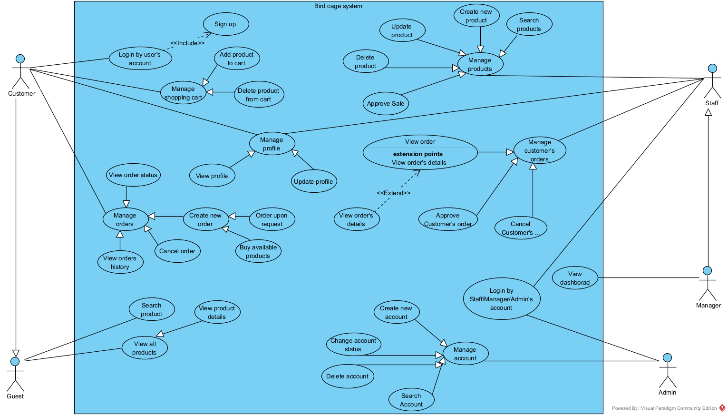

#### **Guest**

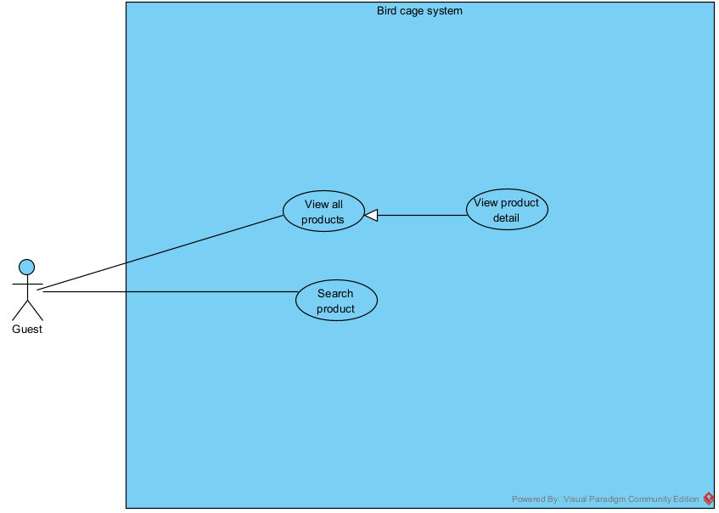

#### **Customer**

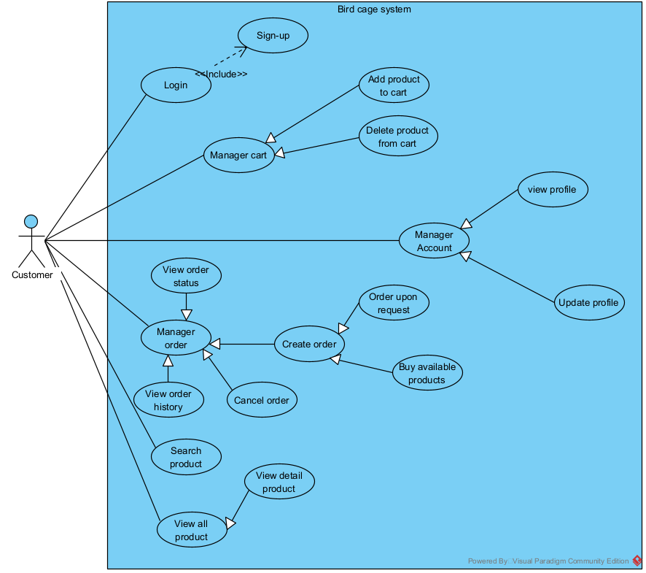

#### **Staff and Manage**

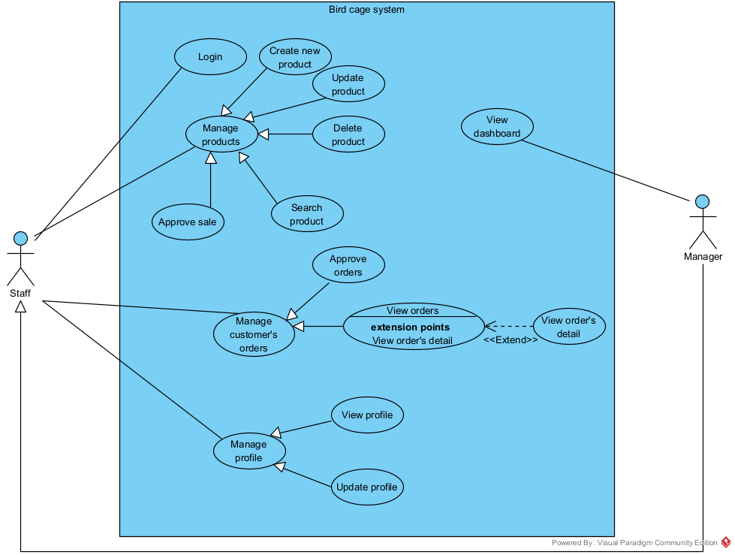

#### **Admin**

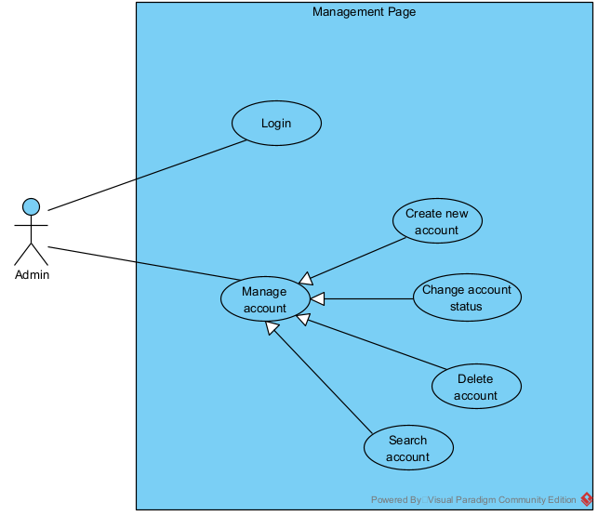

### 

### **Use Case List**

| **No.** | **Use Case** | **Primary Actors** | **Description** |
| --- | --- | --- | --- |
| UC-01 | Sign up | Guest | This feature helps users create an  account to log in to the web |
| UC-02 | Login | Customer | Unauthenticated User login to shop to  verify role, and give them access to more features in the system |
| UC-03 | View all product | Customer | This feature helps user view all product in  home page |
| UC-04 | View product detail | Customer | This feature helps user view detail of product |
| UC-05 | Search product | Customer | This feature helps user search product |
| UC-06 | Add to cart | Customer | This feature helps user add product to cart |
| UC-07 | Delete product from cart | Customer | This feature helps user delete product  From cart |
| UC-08 | View profile | Customer | This feature helps user view their profile |
| UC-09 | Update profile | Customer | This feature helps user update their profile |
| UC-10 | Create new order | Customer | This feature helps user create order |
| UC-11 | Cancel order | Customer | This feature helps user cancel order |
| UC-12 | View order history | Customer | This feature helps user view history of  order |
| UC-13 | View order status | Customer | This feature helps user view status of order |
| UC-14 | Create new product | Staff | This feature helps staff create new  product |
| UC-15 | Update product | Staff | This feature helps staff update product |
| UC-16 | Delete product | Staff | This feature helps staff delete product |
| UC-17 | Approve sale | Staff | This feature helps staff approve sale of  product |
| UC-18 | Approve customer’s order | Staff | This feature helps staff approve  customer’s product |
| UC-19 | Cancel customer’s order | Staff | This feature helps staff cancel customer’s product |
| UC-20 | View order | Staff | This feature helps staff view all order of customer |
| UC-21 | View order detail | Staff | This feature helps staff view detail order of customer |
| UC-22 | View dashboard | Manager | This feature helps manager view page  about economy |
| UC-23 | Create new account | Admin | This feature helps admin create new  account with role staff/manager for staff  and manager |
| UC-24 | Change account status | Admin | This feature helps the admin change the status of the account when staff/manager quit |
| UC-25 | Delete account | Admin | This feature helps admin delete account |
| UC-26 | Search account | Admin | This feature helps admin search account  to do something |

### Use Case Specification

#### **Sign up**

| **Use Case Specification** | | | | |
| --- | --- | --- | --- | --- |
| **Use Case No.:** | UC-01 | | | |
| **Use Case Name:** | Sign up | | | |
| **Created By:** | ThanhHG | | **Date Created:** | Sep 17, 2023 |
| **Primary Actor:** | Guest | | **Secondary Actors:** | N/A |
| **Trigger:** | Guests want to be able to order and pay for products in the shopping cart. | | | |
| **Description:** | Guests want to visit the sales website to order and pay for the products they like. | | | |
| **Preconditions:** | **PRE-1:**User is not already registered.  **PRE-2:**Mobile phone verification | | | |
| **Post–condition:** | **POST-1:**The guest's information will be saved to the data server.  **POST-2:**The system will output a successful or unsuccessful account creation message**.**  **POST-3:**The system will return to the login page. | | | |
| **Normal Flow:** | **Step** | **Actor Action** | | **System Response** |
| 1 | The guest will click on the registration signature in the homepage**.** | | The system will take guests to the registration page. (E1) |
| 2 | Guests will enter all required information in the registration form. (E2) | |  |
| 3 | Guest clicks the "Đăng ký" button. | | The system will issue an "Đăng ký thành công" notification and return it to the login page. (E3, E4) |
| **Alternative Flows:** | N/A | | | |
| **Exceptions:** | **No** | **Cause** | | **System Response** |
| E1 | The system does not take guests to the registration page. | | The system is still on the home page. |
| E2 | The guest fills in the wrong format. | | System informs “Bạn đã nhập sai định dạng. Vui lòng thử lại!” |
|  | E3 | The system does not respond to notifications. | | The system returns to the login page. |
|  | E4 | The system does not return to the login page. | | The system will issue an "Đăng ký thành công" notification. |
| **Priority:** | High | | | |
| **Frequency of Use:** | Usually | | | |
| **Business Rules:** | BR-LG-01, BR-LG-02, BR-LG-03, BR-LG-04, BR-03, BR-04, BR-05, BR-06 | | | |
| **Other Information:** | N/A | | | |
| **Assumptions:** | N/A | | | |

#### **Login**

| **Use Case Specification** | | | | |
| --- | --- | --- | --- | --- |
| **Use Case No.:** | UC-02 | | | |
| **Use Case Name:** | Log in | | | |
| **Created By:** | ThanhHG | | **Date Created:** | Sep 17, 2023 |
| **Primary Actor:** | Customer | | **Secondary Actors:** | Admin, Manager, Staff |
| **Trigger:** | Guests want to be able to order and pay for products in the shopping cart. | | | |
| **Description:** | Guests want to visit the sales website to order and pay for the products they like. | | | |
| **Preconditions:** | **PRE-1:**User is already registered. | | | |
| **Post–condition:** | **POST-1:**Customers can place an order or pay for an order.  **POST-2:**The system records user login history. | | | |
| **Normal Flow:** | **Step** | **Actor Action** | | **System Response** |
| 1 | The customer will click on the login signature in the homepage. | | The system will take guests to the login page. (E1) |
| 2 | Customer will enter “tên đăng nhập” and “mật khẩu” fields in the login form. (E2) | |  |
| 3 | Guest clicks the "Đăng nhập" button. | | The system returns it to the home page. (E3) |
| **Alternative Flows:** | N/A | | | |
| **Exceptions:** | **No** | **Cause** | | **System Response** |
| E1 | The system does not take customers to the login page. | | The system is still on the home page. |
| E2 | The customer fills in the wrong “tên đăng nhập” and “mật khẩu”. | | System informs “tên đăng nhập hoặc mật khẩu không đúng. Vui lòng thử lại!” |
| E3 | The system does not return to the home page. | | The system is still on the login page. |
| **Priority:** | High | | | |
| **Frequency of Use:** | Usually | | | |
| **Business Rules:** | BR-LG-01, BR-LG-02, BR-LG-03, BR-11, BR-13 | | | |
| **Other Information:** | N/A | | | |
| **Assumptions:** | N/A | | | |

#### **View all product**

| **Use Case Specification** | | | | |
| --- | --- | --- | --- | --- |
| **Use Case No.:** | UC-03 | | | |
| **Use Case Name:** | View all product | | | |
| **Created By:** | ThanhHG | | **Date Created:** | Sep 17, 2023 |
| **Primary Actor:** | Customer | | **Secondary Actors:** | Manager, Staff, Guest |
| **Trigger:** | When a user wants to see all products on the website. | | | |
| **Description:** | The website will show all products currently in the store's inventory. | | | |
| **Preconditions:** | **PRE-1:**The website must be posted to the server.  **PRE-2:**The website must be able to link to product data in the warehouse. | | | |
| **Post–condition:** | **POST-1:**The system shows all products. | | | |
| **Normal Flow:** | **Step** | **Actor Action** | | **System Response** |
| 1 | The user will click on the “trang chủ” in the homepage. (A1) | | The system will take the user to the page which shows all products. (E1,E2) |
| **Alternative Flows:** | **Step** | **Actor Action** | | **System Response** |
| A1 | The user will click on the logo in the homepage. | | The system will take the user to the page which shows all products. (E1,E2) |
| **Exceptions:** | **No** | **Cause** | | **System Response** |
| E1 | The system does not take users to the login page. | | The system is still on the home page. |
| E2 | The system does not show any product. | | The system show message “Lỗi kết nối hệ thống”. |
| **Priority:** | High | | | |
| **Frequency of Use:** | Usually | | | |
| **Business Rules:** | N/A | | | |
| **Other Information:** | N/A | | | |
| **Assumptions:** | N/A | | | |

#### **View product detail**

| **Use Case Specification** | | | | |
| --- | --- | --- | --- | --- |
| **Use Case No.:** | UC-04 | | | |
| **Use Case Name:** | View product detail | | | |
| **Created By:** | ThanhHG | | **Date Created:** | Sep 17, 2023 |
| **Primary Actor:** | Customer | | **Secondary Actors:** | Manager, Staff, Guest |
| **Trigger:** | When a user wants to see details of products on the website. | | | |
| **Description:** | The website will show details of products currently in the store's inventory. | | | |
| **Preconditions:** | **PRE-1:**User is already on the page which shows all products.  **PRE-2:**The website must be able to link to product data in the warehouse.  **PRE-3:**Users must be on a page which shows all products. | | | |
| **Post–condition:** | **POST-1:**The system shows details of each product. | | | |
| **Normal Flow:** | **Step** | **Actor Action** | | **System Response** |
| 1 | The user will click on the “chi tiết” in this product. (A1) | | The system will take the user to show details of the product. (E1) |
| **Alternative Flows:** | **Step** | **Actor Action** | | **System Response** |
| A1 | The user will click on the picture in this product. | | The system will take the user to show details of the product. (E1) |
| **Exceptions:** | **No** | **Cause** | | **System Response** |
| E1 | The system does not show detailed products. | | The system show message “Mất kết nối máy chủ”. |
| **Priority:** | High | | | |
| **Frequency of Use:** | Usually | | | |
| **Business Rules:** | N/A | | | |
| **Other Information:** | N/A | | | |
| **Assumptions:** | N/A | | | |

#### **Search product**

| **Use Case Specification** | | | | |
| --- | --- | --- | --- | --- |
| **Use Case No.:** | UC-05 | | | |
| **Use Case Name:** | Search product | | | |
| **Created By:** | ThanhHG | | **Date Created:** | Sep 17, 2023 |
| **Primary Actor:** | Customer | | **Secondary Actors:** | Manager, Staff, Guest |
| **Trigger:** | Users want to find the right product. | | | |
| **Description:** | Users can search for requests that suit their needs. | | | |
| **Preconditions:** | **PRE-1:**The website must be posted to the server**.** | | | |
| **Post–condition:** | **POST-1:**Find the right products according to your requirements. | | | |
| **Normal Flow:** | **Step** | **Actor Action** | | **System Response** |
| 1 | Users will enter the product name they want to search for and click on the "magnifying glass" icon. | | The system will display items whose names match the key word. (E1) |
| **Alternative Flows:** | N/A | | | |
| **Exceptions:** | **No** | **Cause** | | **System Response** |
| E1 | The system does not display items whose names match the key word. | | The system show message “Không tìm thấy sản phẩm”. |
| **Priority:** | Medium | | | |
| **Frequency of Use:** | Usually | | | |
| **Business Rules:** | N/A | | | |
| **Other Information:** | N/A | | | |
| **Assumptions:** | N/A | | | |

#### **Add to cart**

| **Use Case Specification** | | | | |
| --- | --- | --- | --- | --- |
| **Use Case No.:** | UC-06 | | | |
| **Use Case Name:** | Add to cart | | | |
| **Created By:** | ThanhHG | | **Date Created:** | Sep 17, 2023 |
| **Primary Actor:** | Customer | | **Secondary Actors:** | N/A |
| **Trigger:** | User wants to add a product to the cart, which the user wants to buy. | | | |
| **Description:** | After finding the desired item, the user adds it to the cart to purchase. | | | |
| **Preconditions:** | **PRE-1:**User is already logged.  **PRE-2:**The product must be in stock.  **PRE-3:**Users must be on a page which shows all products. | | | |
| **Post–condition:** | **POST-1:**The product will be added to the cart. | | | |
| **Normal Flow:** | **Step** | **Actor Action** | | **System Response** |
| 1 | User clicks on the "Thêm giỏ hàng" button below the section of each product in page which show all products. (A1) | | The system will display the message "Đã thêm vào giỏ hàng". (E1,E2) |
| 2 |  | | The system will update the number on the cart icon. (E3) |
| **Alternative Flows:** | **Step** | **Actor Action** | | **System Response** |
| A1 | User clicks on the "Thêm giỏ hàng" button below the section of product in page which show detail product. | | The system will display the message "Đã thêm vào giỏ hàng". |
| **Exceptions:** | **No** | **Cause** | | **System Response** |
| E1 | Product does not exist | | The system show message “Sản phẩm không tồn tại”. |
| E2 | Product is no longer available. | | The system show message “Sản phẩm không đủ”. |
| E3 | Do not update the number of products in the cart. | | The system does not update the number on the cart icon. |
| **Priority:** | High | | | |
| **Frequency of Use:** | Usually, | | | |
| **Business Rules:** | N/A | | | |
| **Other Information:** | N/A | | | |
| **Assumptions:** | N/A | | | |

#### **Delete product from cart**

| **Use Case Specification** | | | | |
| --- | --- | --- | --- | --- |
| **Use Case No.:** | UC-07 | | | |
| **Use Case Name:** | Delete product from cart | | | |
| **Created By:** | ThanhHG | | **Date Created:** | Sep 17, 2023 |
| **Primary Actor:** | Customer | | **Secondary Actors:** | N/A |
| **Trigger:** | User wants to delete products from the cart. | | | |
| **Description:** | Users delete products after they change their mind. | | | |
| **Preconditions:** | **PRE-1:**User is already logged.  **PRE-2:**The cart must have products.  **PRE-3:**User must be in the cart page. | | | |
| **Post–condition:** | **POST-1:**The product will be deleted from cart. | | | |
| **Normal Flow:** | **Step** | **Actor Action** | | **System Response** |
| 1 | User clicks on the cart icon in the page which shows all products. | | The system takes the user to the shopping cart page. |
| 2 | User clicks on the trash icon on that product. | | The system will display the popup "bạn có muốn xóa khỏi giỏ hàng". |
| 3 | User clicks “Có”. (E1) | | The system will display the message " Đã xóa khỏi giỏ hàng ". |
| **Alternative Flows:** | N/A | | | |
| **Exceptions:** | **No** | **Cause** | | **System Response** |
| E1 | User click “Không”. | | The system takes the user to the shopping cart page. |
| **Priority:** | High | | | |
| **Frequency of Use:** | Usually | | | |
| **Business Rules:** | N/A | | | |
| **Other Information:** | N/A | | | |
| **Assumptions:** | N/A | | | |

#### **View profile**

| **Use Case Specification** | | | | |
| --- | --- | --- | --- | --- |
| **Use Case No.:** | UC-08 | | | |
| **Use Case Name:** | View Profile | | | |
| **Created By:** | ThanhHG | | **Date Created:** | Sep 17, 2023 |
| **Primary Actor:** | Customer | | **Secondary Actors:** | Admin, Manager, Staff |
| **Trigger:** | User wants to see personal information. | | | |
| **Description:** | Users see all information in their profile. | | | |
| **Preconditions:** | **PRE-1:**User is already logged. | | | |
| **Post–condition:** | **POST-1:**The user will see all information about the user. | | | |
| **Normal Flow:** | **Step** | **Actor Action** | | **System Response** |
| 1 | User clicks on the avatar icon in navigation. | | The system will drop down the service list. |
| 2 | The user will click "Thông tin cá nhân" in that list. | | The system will take the user to the user's profile page. (E1) |
| **Alternative Flows:** | N/A | | | |
| **Exceptions:** | **No** | **Cause** | | **System Response** |
| E1 | Could not get data about user information | | The system show message “Lỗi kết nối hệ thống”. |
| **Priority:** | High | | | |
| **Frequency of Use:** | Usually | | | |
| **Business Rules:** | N/A | | | |
| **Other Information:** | N/A | | | |
| **Assumptions:** | N/A | | | |

#### **Update profile**

| **Use Case Specification** | | | | |
| --- | --- | --- | --- | --- |
| **Use Case No.:** | UC-09 | | | |
| **Use Case Name:** | Update Profile | | | |
| **Created By:** | ThanhHG | | **Date Created:** | Sep 17, 2023 |
| **Primary Actor:** | Customer | | **Secondary Actors:** | Admin, Manager, Staff |
| **Trigger:** | User wants to update personal information. | | | |
| **Description:** | Users can update information in their profile. | | | |
| **Preconditions:** | **PRE-1:**User is already logged.  **PRE-2:**User must be in profile page. | | | |
| **Post–condition:** | **POST-1:**User information will be updated. | | | |
| **Normal Flow:** | **Step** | **Actor Action** | | **System Response** |
| 1 | The user fills in the fields that allow changes in personal information. | |  |
| 2 | The user clicks "Cập nhật" in that form. (E1) | | The system show message “Đã được cập nhật”. |
| **Alternative Flows:** | **N/A** | | | |
| **Exceptions:** | **No** | **Cause** | | **System Response** |
| E1 | Can not click “Cập nhật” | | The system show message “Sai định dạng của thông tin”. |
| **Priority:** | High | | | |
| **Frequency of Use:** | Usually | | | |
| **Business Rules:** | BR-08, BR-09, BR-10 | | | |
| **Other Information:** | N/A | | | |
| **Assumptions:** | N/A | | | |

#### **Create new order**

| **Use Case Specification** | | | | |
| --- | --- | --- | --- | --- |
| **Use Case No.:** | UC-10 | | | |
| **Use Case Name:** | Create new order | | | |
| **Created By:** | ThanhHG | | **Date Created:** | Sep 17, 2023 |
| **Primary Actor:** | Customer | | **Secondary Actors:** | N/A |
| **Trigger:** | Create a request for the manufacturer to create the user's own product. | | | |
| **Description:** | Users will create a request for the store to create a product according to their wishes. | | | |
| **Preconditions:** | **PRE-1:**User is already logged. | | | |
| **Post–condition:** | **POST-1:**An order is sent to the store for the product. | | | |
| **Normal Flow:** | **Step** | **Actor Action** | | **System Response** |
| 1 | The user fills in the fields that allow changes in personal information. | |  |
| 2 | The user clicks "Cập nhật" in that form. (E1) | | The system show message “Đã được cập nhật”. |
| **Alternative Flows:** | N/A | | | |
| **Exceptions:** | **No** | **Cause** | | **System Response** |
| E1 | Can not click “Cập nhật” | | The system show message “Sai định dạng của thông tin”. |
| **Priority:** | High | | | |
| **Frequency of Use:** | Usually | | | |
| **Business Rules:** | BR-25, BR-26, BR-27 | | | |
| **Other Information:** | N/A | | | |
| **Assumptions:** | N/A | | | |

#### **Cancel order**

| **Use Case Specification** | | | | |
| --- | --- | --- | --- | --- |
| **Use Case No.:** | UC-11 | | | |
| **Use Case Name:** | Cancel order | | | |
| **Created By:** | ThanhHG | | **Date Created:** | Sep 17, 2023 |
| **Primary Actor:** | Customer | | **Secondary Actors:** | N/A |
| **Trigger:** | The user wants to cancel the order they placed. | | | |
| **Description:** | User wants to cancel the order they placed because their design needs changed. | | | |
| **Preconditions:** | **PRE-1:**User is already logged.  **PRE-2:**Must have an order.  **PRE-3:**Order must be in pending “Chờ duyệt” status. | | | |
| **Post–condition:** | **POST-1:**The order status will be changed to "Đã hủy". | | | |
| **Normal Flow:** | **Step** | **Actor Action** | | **System Response** |
| 1 | User clicks on the avatar icon in navigation. | | The system will drop down the service list. |
| 2 | The user will click "Lịch sử" in that list. | | The system will take the user to the user's history page. (E1) |
| 3 | The user will select the "Đơn đặt hàng" tab | | The system will display a table of orders. (E1) |
| 4 | The user clicks the "Hủy" button | | The system will display a popup "Bạn có muốn xóa đơn đặt hàng này không?" |
| 5 | The user clicks “Có” (E2) | | The system show message “Đơn hàng đã được hủy”. |
| 6 |  | | The system will reload, and the order status will also be updated |
| **Alternative Flows:** | N/A | | | |
| **Exceptions:** | **No** | **Cause** | | **System Response** |
| E1 | No data displayed | | The system show message “Không tìm thấy dữ liệu”. |
| E2 | The user clicks “Không” | | The system will reload. |
| **Priority:** | High | | | |
| **Frequency of Use:** | Usually | | | |
| **Business Rules:** | BR-28, BR-29 | | | |
| **Other Information:** | N/A | | | |
| **Assumptions:** | N/A | | | |

#### **View order status**

| **Use Case Specification** | | | | |
| --- | --- | --- | --- | --- |
| **Use Case No.:** | UC-12 | | | |
| **Use Case Name:** | View order status | | | |
| **Created By:** | ThanhHG | | **Date Created:** | Sep 17, 2023 |
| **Primary Actor:** | Customer | | **Secondary Actors:** | N/A |
| **Trigger:** | The user wants to see the order status. | | | |
| **Description:** | User wants to check the order status they placed. | | | |
| **Preconditions:** | **PRE-1:**User is already logged.  **PRE-2:**Must have an order. | | | |
| **Post–condition:** | **POST-1:**The order status of each order will be shown. | | | |
| **Normal Flow:** | **Step** | **Actor Action** | | **System Response** |
| 1 | User clicks on the avatar icon in navigation. | | The system will drop down the service list. |
| 2 | The user will click "Lịch sử" in that list. | | The system will take the user to the user's history page. (E1) |
| 3 | The user will select the "tất cả" tab | | The system will display a table of orders. (E1) |
| **Alternative Flows:** | N/A | | | |
| **Exceptions:** | **No** | **Cause** | | **System Response** |
| E1 | No data displayed | | The system show message “Không tìm thấy dữ liệu”. |
| **Priority:** | High | | | |
| **Frequency of Use:** | Usually | | | |
| **Business Rules:** | BR-25 | | | |
| **Other Information:** | N/A | | | |
| **Assumptions:** | N/A | | | |

#### **View order history**

| **Use Case Specification** | | | | |
| --- | --- | --- | --- | --- |
| **Use Case No.:** | UC-13 | | | |
| **Use Case Name:** | View order history | | | |
| **Created By:** | ThanhHG | | **Date Created:** | Sep 17, 2023 |
| **Primary Actor:** | Customer | | **Secondary Actors:** | N/A |
| **Trigger:** | The user wants to see the order’s history. | | | |
| **Description:** | User wants to check the order history they placed. | | | |
| **Preconditions:** | **PRE-1:**User is already logged.  **PRE-2:**Must have an order. | | | |
| **Post–condition:** | **POST-1:**The order’s history of each order will be shown. | | | |
| **Normal Flow:** | **Step** | **Actor Action** | | **System Response** |
| 1 | User clicks on the avatar icon in navigation. | | The system will drop down the service list. |
| 2 | The user will click "Lịch sử" in that list. | | The system will take the user to the user's history page. (E1) |
| 3 | The user will select the "Đơn đặt hàng" tab | | The system will display a table of orders. (E1) |
| **Alternative Flows:** | N/A | | | |
| **Exceptions:** | **No** | **Cause** | | **System Response** |
| E1 | No data displayed | | The system show message “Không tìm thấy dữ liệu”. |
| **Priority:** | High | | | |
| **Frequency of Use:** | Usually | | | |
| **Business Rules:** | N/A | | | |
| **Other Information:** | N/A | | | |
| **Assumptions:** | N/A | | | |

#### **Create new product**

| **Use Case Specification** | | | | | |
| --- | --- | --- | --- | --- | --- |
| **Use Case No.:** | UC-14 | | | | |
| **Use Case Name:** | Create new product | | | | |
| **Created By:** | Trang | | **Date Created:** | September 16. 2023 | |
| **Primary Actor:** | Staff | | **Secondary Actors:** | Manager | |
| **Trigger:** | The staff wants to add a new product. | | | | |
| **Description:** | This feature allows the staff to add a new product into the system. | | | | |
| **Preconditions:** | **PRE1:**The staff has logged in.  **PRE2:**The product hasn't been created yet | | | | |
| **Post–condition:** | **POST1:** System winforms “Thêm sản phẩm mới thành công”  **POST2:** system informs “Thêm sản phẩm mới không thành công” | | | | |
| **Normal Flow:** | **Step** | **Actor Action** | | | **System Response** |
| 1 | The staff accesses the Product Management then chooses the “ Thêm sản phẩm mới” button. | | | system redirects to the “Add Product” screen. |
| 2 | The staff fills in the product's information and clicks on the “Lưu” button. | | | system informs “Thêm sản phẩm mới thành công” |
| **Alternative Flows:** | N/A | | | | |
| **Exceptions:** | **No** | **Cause** | | | **System Response** |
| 1 | The staff clicks on the “Hủy” button. | | | system returns to Product Management screen |
| 2 | The staff doesn’t fill anything and submits. | | | system informs “Vui lòng nhập thông tin sản phẩm!” |
| **Priority:** | High | | | | |
| **Frequency of Use:** | Usually | | | | |
| **Business Rules:** | BR-22, BR-23, BR-CP-01, BR-CP-02 | | | | |
| **Other Information:** | N/A | | | | |
| **Assumptions:** | N/A | | | | |

#### **Update product**

| **Use Case Specification** | | | | | |
| --- | --- | --- | --- | --- | --- |
| **Use Case No.:** | UC-15 | | | | |
| **Use Case Name:** | Update product | | | | |
| **Created By:** | Trang | | **Date Created:** | September 16. 2023 | |
| **Primary Actor:** | Staff | | **Secondary Actors:** | Manager | |
| **Trigger:** | The staff wants to update the product. | | | | |
| **Description:** | This feature allows the staff to edit the product’s detailed information. | | | | |
| **Preconditions:** | **PRE1:**The staff has logged in.  **PRE2:**The product has been created yet | | | | |
| **Post–condition:** | **POST1:** System informs “Cập nhật sản phẩm thành công”  **POST2:** system informs “Cập nhật sản phẩm không thành công” | | | | |
| **Normal Flow:** | **Step** | **Actor Action** | | | **System Response** |
| 1 | The staff accesses the Product Management then chooses the “ Cập nhật sản phẩm ” button. | | | system redirects to the Update Product screen. |
| 2 | The staff changes the product's information and clicks on the “Lưu” button. | | | system informs “Cập nhật sản phẩm thành công” |
| **Alternative Flows:** | N/A | | | | |
| **Exceptions:** | **No** | **Cause** | | | **System Response** |
| 1 | The staff clicks on the “Hủy” button. | | | system returns to “Product Management” screen |
| **Priority:** | Medium | | | | |
| **Frequency of Use:** | Sometime | | | | |
| **Business Rules:** | BR-21 | | | | |
| **Other Information:** | N/A | | | | |
| **Assumptions:** | N/A | | | | |

#### **Delete product**

| **Use Case Specification** | | | | | |
| --- | --- | --- | --- | --- | --- |
| **Use Case No.:** | UC-16 | | | | |
| **Use Case Name:** | Delete product | | | | |
| **Created By:** | Trang | | **Date Created:** | September 16. 2023 | |
| **Primary Actor:** | Staff | | **Secondary Actors:** | Manager | |
| **Trigger:** | The staff wants to delete the product. | | | | |
| **Description:** | This feature allows the staff to remove the product from the system. | | | | |
| **Preconditions:** | **PRE1:**The staff has logged in.  **PRE2:**The product has been created yet | | | | |
| **Post–condition:** | **POST1:** System informs “Sản phẩm đã xóa thành công”  **POST2:** System informs “Xóa sản phẩm không thành công” | | | | |
| **Normal Flow:** | **Step** | **Actor Action** | | | **System Response** |
| 1 | The staff accesses the Product Management then chooses the “Xóa sản phẩm” button. | | | system informs “Bạn có chắc chắn muốn xóa sản phẩm này”. |
| 2 | The staff clicks on the “Có” button. | | | system informs “Sản phẩm đã xóa thành công” |
| **Alternative Flows:** | N/A | | | | |
| **Exceptions:** | **No** | **Cause** | | | **System Response** |
| 1 | The staff clicks on the “Không” button. | | | system returns to “Product Management” screen |
| **Priority:** | Medium | | | | |
| **Frequency of Use:** | Sometime | | | | |
| **Business Rules:** | BR-31 | | | | |
| **Other Information:** | N/A | | | | |
| **Assumptions:** | N/A | | | | |

#### **Approve sale**

| **Use Case Specification** | | | | | |
| --- | --- | --- | --- | --- | --- |
| **Use Case No.:** | UC-17 | | | | |
| **Use Case Name:** | Approve sale | | | | |
| **Created By:** | Trang | | **Date Created:** | September 16. 2023 | |
| **Primary Actor:** | Staff | | **Secondary Actors:** | Manager | |
| **Trigger:** | The staff wants to sell off the product. | | | | |
| **Description:** | This feature allows staff to discount the products. | | | | |
| **Preconditions:** | **PRE1:**The staff has logged in.  **PRE2:**The product has been created yet | | | | |
| **Post–condition:** | **POST1:** system informs “Giảm giá đơn hàng thành công”  **POST2:** system informs “Giảm giá đơn hàng chưa thành công” | | | | |
| **Normal Flow:** | **Step** | **Actor Action** | | | **System Response** |
| 1 | The staff accesses the Product Management and clicks on “Giảm giá” button | | | system redirects to Approve Sale screen. |
| 2 | The staff fills in the product's sale information and clicks on the “Lưu” button. | | | system informs “Giảm giá đơn hàng thành công” |
| **Alternative Flows:** | N/A | | | | |
|
|
| **Exceptions:** | N/A | | | | |
|
| **Priority:** | High | | | | |
| **Frequency of Use:** | Usually | | | | |
| **Business Rules:** | N/A | | | | |
| **Other Information:** | N/A | | | | |
| **Assumptions:** | N/A | | | | |

#### **Approve customer’s order**

| **Use Case Specification** | | | | | |
| --- | --- | --- | --- | --- | --- |
| **Use Case No.:** | UC-18 | | | | |
| **Use Case Name:** | Approve customer's order | | | | |
| **Created By:** | Trang | | **Date Created:** | September 16. 2023 | |
| **Primary Actor:** | Staff | | **Secondary Actors:** | Manager | |
| **Trigger:** | The staff wants to accept an order. | | | | |
| **Description:** | This feature allows staff to approve customer orders | | | | |
| **Preconditions:** | **PRE1:**The staff has logged in.  **PRE2:**The order has been created yet | | | | |
| **Post–condition:** | **POST1:** System informs “Phê duyệt đơn hàng thành công”  **POST2:** System informs “Phê duyệt đơn hàng chưa thành công” | | | | |
| **Normal Flow:** | **Step** | **Actor Action** | | | **System Response** |
| 1 | The staff accesses the Order Management and clicks on tab “Chờ duyệt” | | | system redirects to Approve Order Management screen. |
| 2 | The staff clicks on the “Duyệt” button. | | | system informs “Phê duyệt đơn hàng thành công” and the customer’s order redirects to “Đang xử lý ” tab. |
| **Alternative Flows:** | N/A | | | | |
|
|
| **Exceptions:** | N/A | | | | |
|
| **Priority:** | High | | | | |
| **Frequency of Use:** | Usually | | | | |
| **Business Rules:** | BR-24 | | | | |
| **Other Information:** | N/A | | | | |
| **Assumptions:** | N/A | | | | |

#### **Cancel customer’s order**

| **Use Case Specification** | | | | | |
| --- | --- | --- | --- | --- | --- |
| **Use Case No.:** | UC-19 | | | | |
| **Use Case Name:** | Cancel Customer's order | | | | |
| **Created By:** | Staff | | **Secondary Actors:** | Manager | |
| **Primary Actor:** | The staff wants to cancel an order. | | | | |
| **Trigger:** | This feature allows staff to cancel customer orders | | | | |
| **Description:** | **PRE1:**The staff has logged in.  **PRE2:**The order has been created yet | | | | |
| **Preconditions:** | **POST1:** System informs “Từ chối đơn hàng thành công”.  **POST2:** System informs “Từ chối đơn hàng chưa thành công”. | | | | |
| **Post–condition:** | **Step** | **Actor Action** | | | **System Response** |
| **Normal Flow:** | 1 | The staff accesses the Approve Order Management then chooses the “Từ chối” button. | | | system informs “Nhập lý do từ chối” |
| 2 | The staff fills in the reason and clicks on the “Lưu'' button. | | | system informs “Từ chối đơn hàng thành công”. |
| **Alternative Flows:** | N/A | | | | |
| **Exceptions:** | N/A | | | | |
|
| **Priority:** | High | | | | |
| **Frequency of Use:** | Usually | | | | |
| **Business Rules:** | BR-28 | | | | |
| **Other Information:** | N/A | | | | |
| **Assumptions:** | N/A | | | | |

#### **View order**

| **Use Case Specification** | | | | | |
| --- | --- | --- | --- | --- | --- |
| **Use Case No.:** | UC-20 | | | | |
| **Use Case Name:** | View order | | | | |
| **Created By:** | Trang | | **Date Created:** | September 16. 2023 | |
| **Primary Actor:** | Staff | | **Secondary Actors:** | Manager | |
| **Trigger:** | The staff wants to view all orders. | | | | |
| **Description:** | This feature allows staff to view all customer orders | | | | |
| **Preconditions:** | **PRE1:**The staff has logged in.  **PRE2:**The order has been created yet | | | | |
| **Post–condition:** | **POST1:** System displays all available orders. | | | | |
| **Normal Flow:** | **Step** | **Actor Action** | | | **System Response** |
| 1 | The staff accesses the Order Management then chooses the “Tất cả” button. | | | The system displays all available orders. |
| **Alternative Flows:** | N/A | | | | |
| **Exceptions:** | N/A | | | | |
| **Priority:** | High | | | | |
| **Frequency of Use:** | Usually | | | | |
| **Business Rules:** | N/A | | | | |
| **Other Information:** | N/A | | | | |
| **Assumptions:** | N/A | | | | |

#### **View order detail**

| **Use Case Specification** | | | | | |
| --- | --- | --- | --- | --- | --- |
| **Use Case No.:** | UC-21 | | | | |
| **Use Case Name:** | View order’s details | | | | |
| **Created By:** | Trang | | **Date Created:** | September 16. 2023 | |
| **Primary Actor:** | Staff | | **Secondary Actors:** | Manager | |
| **Trigger:** | The staff wants to view the order's detailed information. | | | | |
| **Description:** | This feature allows staff to view customer’s orders detail information | | | | |
| **Preconditions:** | **PRE1:**The staff has logged in.  **PRE2:**The order has been created yet | | | | |
| **Post–condition:** | **POST1:** System displays customer’s order detail information. | | | | |
| **Normal Flow:** | **Step** | **Actor Action** | | | **System Response** |
| 1 | The staff accesses the Order Management then chooses the “Tất cả” button. | | | The system displays all available orders. |
| 2 | The staff clicks on the “Xem chi tiết” button. | | | System displays customer’s order detail information. |
| **Alternative Flows:** | N/A | | | | |
| **Exceptions:** | N/A | | | | |
|
| **Priority:** | High | | | | |
| **Frequency of Use:** | Usually | | | | |
| **Business Rules:** | N/A | | | | |
| **Other Information:** | N/A | | | | |
| **Assumptions:** | N/A | | | | |

#### **View dashboard**

| **Use Case Specification** | | | | | |
| --- | --- | --- | --- | --- | --- |
| **Use Case No.:** | UC-22 | | | | |
| **Use Case Name:** | View dashboard | | | | |
| **Created By:** | Trang | | **Date Created:** | September 16. 2023 | |
| **Primary Actor:** | Manager | | **Secondary Actors:** | N/A | |
| **Trigger:** | The manager wants to view the dashboard. | | | | |
| **Description:** | This feature allows the manager to view the dashboard. | | | | |
| **Preconditions:** | **PRE1:**The manager has logged in. | | | | |
| **Post–condition:** | **POST1:** System displays dashboard. | | | | |
| **Normal Flow:** | **Step** | **Actor Action** | | | **System Response** |
| 1 | The manager accesses the Dashboard | | | System displays a dashboard. |
| **Alternative Flows:** | N/A | | | | |
| **Exceptions:** | N/A | | | | |
|
| **Priority:** | High | | | | |
| **Frequency of Use:** | Usually | | | | |
| **Business Rules:** | BR-32 | | | | |
| **Other Information:** | N/A | | | | |
| **Assumptions:** | N/A | | | | |

#### **Create new account**

| **Use Case Specification** | | | | | |
| --- | --- | --- | --- | --- | --- |
| **Use Case No.:** | UC-23 | | | | |
| **Use Case Name:** | Create new account | | | | |
| **Created By:** | Trang | | **Date Created:** | September 16. 2023 | |
| **Primary Actor:** | Admin | | **Secondary Actors:** | N/A | |
| **Trigger:** | The admin wants to create a new account. | | | | |
| **Description:** | This feature allows the admin to create a new account for staff/manager. | | | | |
| **Preconditions:** | **PRE1:**The admin has logged in.  **PRE1:**The account hasn't been created yet. | | | | |
| **Post–condition:** | **POST1:** The account has been added successfully.  **POST2:** system inform “Tạo tài khoản không thành công”. | | | | |
| **Normal Flow:** | **Step** | **Actor Action** | | | **System Response** |
| 1 | The admin accesses the Account Management then chooses the “ Thêm tài khoản” button. | | | system redirects to Add Account screen. |
| 2 | The admin fills in the account's information and clicks on the “Lưu” button. | | | system inform “Thêm tài khoản mới thành công” |
| **Alternative Flows:** | N/A | | | | |
| **Exceptions:** | **No** | **Cause** | | | **System Response** |
| 1 | The admin clicks on the “Hủy” button. | | | system return to Account Management screen |
| 2 | The admin fills information in the wrong format. | | | The system gives a warning to enter the correct value. |
| 3 | The admin doesn’t fill anything and submit. | | | The system issues a warning to enter required fields. |
| **Priority:** | High | | | | |
| **Frequency of Use:** | Usually | | | | |
| **Business Rules:** | BR-CA-01, BR-CA-02, BR-CA-03, BR-CA-05, BR-15,BR-16, BR-18 | | | | |
| **Other Information:** | N/A | | | | |
| **Assumptions:** | N/A | | | | |

#### **Change account status**

| **Use Case Specification** | | | | | |
| --- | --- | --- | --- | --- | --- |
| **Use Case No.:** | UC-24 | | | | |
| **Use Case Name:** | Change account’s status | | | | |
| **Created By:** | Trang | | **Date Created:** | September 16. 2023 | |
| **Primary Actor:** | Admin | | **Secondary Actors:** | N/A | |
| **Trigger:** | The admin wants to change the account status. | | | | |
| **Description:** | This feature allows the admin to change the account's status. | | | | |
| **Preconditions:** | **PRE1:**The admin has logged in and the account still exists. | | | | |
| **Post–condition:** | **POST1:** The account status has been changed successfully. | | | | |
| **Normal Flow:** | **Step** | **Actor Action** | | | **System Response** |
| 1 | The admin accesses the Account Management then clicks on the change account’s status button. | | | system automatically changes the account status. |
| **Alternative Flows:** | N/A | | | | |
| **Exceptions:** | N/A | | | | |
|
| **Priority:** | Low | | | | |
| **Frequency of Use:** | Sometime | | | | |
| **Business Rules:** | BR-19 | | | | |
| **Other Information:** | N/A | | | | |
| **Assumptions:** | N/A | | | | |

#### **Delete account**

| **Use Case Specification** | | | | | |
| --- | --- | --- | --- | --- | --- |
| **Use Case No.:** | UC-25 | | | | |
| **Use Case Name:** | Delete account | | | | |
| **Created By:** | Trang | | **Date Created:** | September 16. 2023 | |
| **Primary Actor:** | Admin | | **Secondary Actors:** | N/A | |
| **Trigger:** | The admin wants to delete an account. | | | | |
| **Description:** | This feature allows the admin to remove the account from the system. | | | | |
| **Preconditions:** | **PRE1:**The admin has logged in.  **PRE2:**The account has been created yet | | | | |
| **Post–condition:** | **POST1:** System informs “Tài khoản đã xóa thành công”  **POST2:** system informs “Xóa tài khoản không thành công” | | | | |
| **Normal Flow:** | **Step** | **Actor Action** | | | **System Response** |
| 1 | The admin accesses the Account Management then chooses the “Xóa tài khoản” button. | | | system informs “Bạn có chắc chắn muốn xóa tài khoản này”. |
| 2 | The admin clicks on the “Có” button. | | | System informs “Tài khoản đã xóa thành công” |
| **Alternative Flows:** | N/A | | | | |
| **Exceptions:** | **No** | **Cause** | | | **System Response** |
| 1 | The admin clicks on the “Không” button. | | | system returns to “Account Management” screen |
| 2 |  | | |  |
| **Priority:** | Low | | | | |
| **Frequency of Use:** | Sometime | | | | |
| **Business Rules:** | BR-33, BR-34 | | | | |
| **Other Information:** | N/A | | | | |
| **Assumptions:** | N/A | | | | |

#### **Search account**

| **Use Case Specification** | | | | | |
| --- | --- | --- | --- | --- | --- |
| **Use Case No.:** | UC-26 | | | | |
| **Use Case Name:** | Search account | | | | |
| **Created By:** | Trang | | **Date Created:** | September 16. 2023 | |
| **Primary Actor:** | Admin | | **Secondary Actors:** | N/A | |
| **Trigger:** | The admin wants to search the account. | | | | |
| **Description:** | This feature allows the admin to search the account from the systerm | | | | |
| **Preconditions:** | **PRE1:**The admin has logged in.  **PRE2:**The account has been created yet | | | | |
| **Post–condition:** | **POST1:** The system displays the search results. | | | | |
| **Normal Flow:** | **Step** | **Actor Action** | | | **System Response** |
| 1 | The admin accesses the Account Management then enter information in the search box | | | The system displays the search results. |
| **Alternative Flows:** | N/A | | | | |
| **Exceptions:** | N/A | | | | |
|
| **Priority:** | High | | | | |
| **Frequency of Use:** | Usually | | | | |
| **Business Rules:** | N/A | | | | |
| **Other Information:** | N/A | | | | |
| **Assumptions:** | N/A | | | | |

# **Software Design Document**

## **System Design**

### **System Architecture**

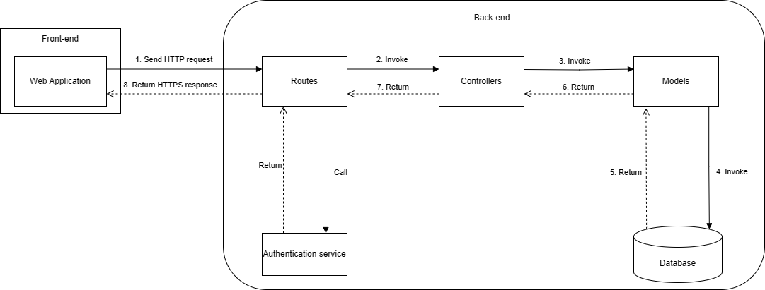

### **Package Diagram**

* + 1. **Package Diagram**

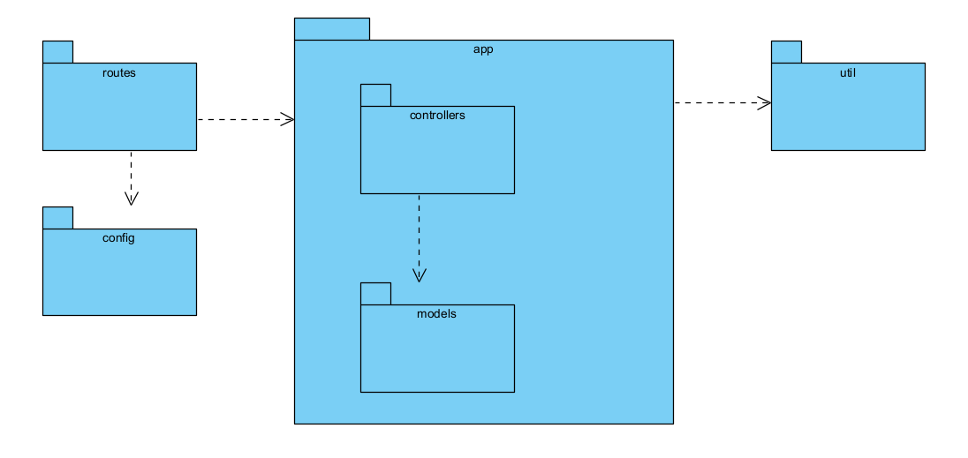

Package Diagram

* + 1. **Package Diagram Description**

| **No.** | **Package** | **Description** |
| --- | --- | --- |
| 1 | routes | This package contains the paths and methods of the function |
| 2 | config | This package contains authorization and authentication files and database connections |
| 3 | app | This package contains logical processing files and filed files contain  fields to receive data from the database |
| 4 | controllers | This package contains logical processing files called from the routes package |
| 5 | models | This package contains files that store fields of 1  object taken from the database |
| 6 | util | This Package contains multiObject and Object converters; And  handle functions as required |

Package Diagram Description

## **Database Design**

### **Class Diagram**

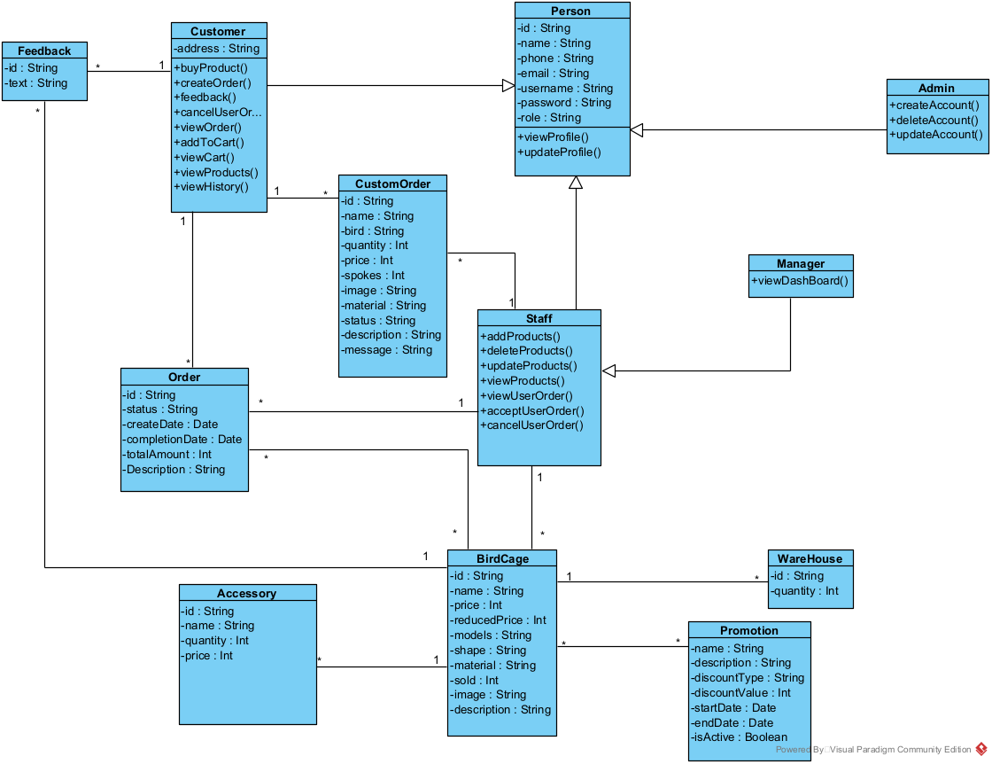

### **Class Specification**

* + 1. **Person class**

| **No** | **Attribute** | **Data Type** | **Visibility** | **Description** |
| --- | --- | --- | --- | --- |
| 1 | id | String | Private | Unique define of user |
| 2 | name | String | Private | Name of user |
| 3 | phone | String | Private | Phone number of user |
| 4 | email | String | Private | Email of user |
| 5 | username | String | Private | Username for login |
| 6 | password | String | Private | Password for login |
| 7 | role | String | Private | Define role of user |

Person Class Attribute

| **No** | **Method** | **Return Type** | **Accessibility** | **Description** |
| --- | --- | --- | --- | --- |
| 1 | viewProfile**()** | JSON | Public | View profile of user |
| 2 | updateProfile() | JSON | Public | Update profile of user |

Person Class Method

* + 1. **Customer class**

| **No** | **Attribute** | **Data Type** | **Visibility** | **Description** |
| --- | --- | --- | --- | --- |
| 1 | address | String | Private | Address of user and shipping |

Customer Class Attribute

| **No** | **Method** | **Return Type** | **Accessibility** | **Description** |
| --- | --- | --- | --- | --- |
| 1 | buyProduct() | JSON | Public | Buy product of user |
| 2 | createOrder() | JSON | Public | Create order |
| 3 | feedback() | JSON | Public | Feedback product |
| 4 | cancelUserOrder() | JSON | Public | Cancel order |
| 5 | viewOrder() | JSON | Public | View all order of user |
| 6 | addToCart() | JSON | Public | Add product to cart |
| 7 | viewCart() | JSON | Public | View all product on cart |
| 8 | viewProducts() | JSON | Public | View all product |
| 9 | viewHistory() | JSON | Public | History order of user |

Customer Class Method

* + 1. **Admin class**

| **No** | **Method** | **Return Type** | **Accessibility** | **Description** |
| --- | --- | --- | --- | --- |
| 1 | createAccount() | JSON | Public | Create account for staff |
| 2 | updateAccount() | JSON | Public | Update account for staff |
| 3 | deleteAccount() | JSON | Public | Delete account for staff |

Admin Class Method

* + 1. **Staff class**

| **No** | **Method** | **Return Type** | **Accessibility** | **Description** |
| --- | --- | --- | --- | --- |
| 1 | addProduct() | JSON | Public | Create account for staff |
| 2 | updateProduct() | JSON | Public | Update account for staff |
| 3 | deleteAccount() | JSON | Public | Delete account for staff |
| 4 | viewProduct() | JSON | Public | View product in home |
| 5 | viewUserOrder() | JSON | Public | View order of user |
| 6 | acceptUserOrder() | JSON | Public | Accept order |
| 7 | cancelUserOrder() | JSON | Public | Cancel order |

Staff Class Method

* + 1. **Manager class**

| **No** | **Method** | **Return Type** | **Accessibility** | **Description** |
| --- | --- | --- | --- | --- |
| 1 | viewDashboard() | JSON | Public | Dashboard about economy |

Manager Class Method

* + 1. **BirdCage class**

| **No** | **Attribute** | **Data Type** | **Visibility** | **Description** |
| --- | --- | --- | --- | --- |
| 1 | id | String | Private | Unique define of product |
| 2 | name | String | Private | Name of product |
| 3 | price | Int | Private | Price of product |
| 4 | reducedPrice | Int | Private | Price after apply discount |
| 5 | models | String | Private | Model of product |
| 6 | shape | String | Private | Shape for product |
| 7 | material | String | Private | Material build product |
| 8 | sold | Int | Private | Products sold |
| 9 | image | String | Private | Image of product |
| 10 | description | String | Private | More about the product |

Person Class Attribute

* + 1. **Promotion class**

| **No** | **Attribute** | **Data Type** | **Visibility** | **Description** |
| --- | --- | --- | --- | --- |
| 1 | name | String | Private | Name of promotion |
| 2 | description | String | Private | Description of promotion |
| 3 | discountType | String | Private | Type of discount |
| 4 | discountValue | Int | Private | Value of discount |
| 5 | startDate | Date | Private | Date start discount |
| 6 | endDate | Date | Private | Date end discount |
| 7 | isActive | Boolean | Private | Status of discount |

Promotion Class Attribute

* + 1. **WareHouse class**

| **No** | **Attribute** | **Data Type** | **Visibility** | **Description** |
| --- | --- | --- | --- | --- |
| 1 | id | String | Private | Unique define of warehouse |
| 2 | quantity | Int | Private | Residual quantity of product |

Warehouse Class Attribute

* + 1. **Accessory class**

| **No** | **Attribute** | **Data Type** | **Visibility** | **Description** |
| --- | --- | --- | --- | --- |
| 1 | id | String | Private | Unique define of accessory |
| 2 | name | String | Private | Name of accessory |
| 3 | quantity | Int | Private | Residual quantity of accessory |
| 4 | price | Int | Private | Price of accessory |

Accessory Class Attribute

* + 1. **Order class**

| **No** | **Attribute** | **Data Type** | **Visibility** | **Description** |
| --- | --- | --- | --- | --- |
| 1 | id | String | Private | Unique define of order |
| 2 | status | String | Private | Status of order |
| 3 | createDate | Date | Private | Date create order by user |
| 4 | comDate | Date | Private | Date completion the order |
| 5 | totalAmount | Int | Private | Cost of order |
| 6 | description | String | Private | Description of order |

Order Class Attribute

* + 1. **CustomOrder class**

| **No** | **Attribute** | **Data Type** | **Visibility** | **Description** |
| --- | --- | --- | --- | --- |
| 1 | id | String | Private | Unique define of custom order |
| 2 | name | String | Private | Name of custom order |
| 3 | bird | String | Private | Bird for bird cage |
| 4 | quantity | Int | Private | Number of product to custom |
| 5 | price | Int | Private | Cost of order |
| 6 | spokes | Int | Private | Number of spokes of cage |
| 7 | image | String | Private | Illustrations image |
| 8 | material | String | Private | Material of cage |
| 9 | status | String | Private | Status of order |
| 10 | description | String | Private | More about the product |
| 11 | message | String | Private | Message from customer |

Custom Order Class Attribute

* + 1. **Feedback class**

| **No** | **Attribute** | **Data Type** | **Visibility** | **Description** |
| --- | --- | --- | --- | --- |
| 1 | id | String | Private | Unique define of feedback |
| 2 | text | String | Private | Customer feedback |

Feedback Class Attribute

## **System Detailed Design**

### **Guest Register Feature**

* + 1. **Guest Register Activity Diagram**

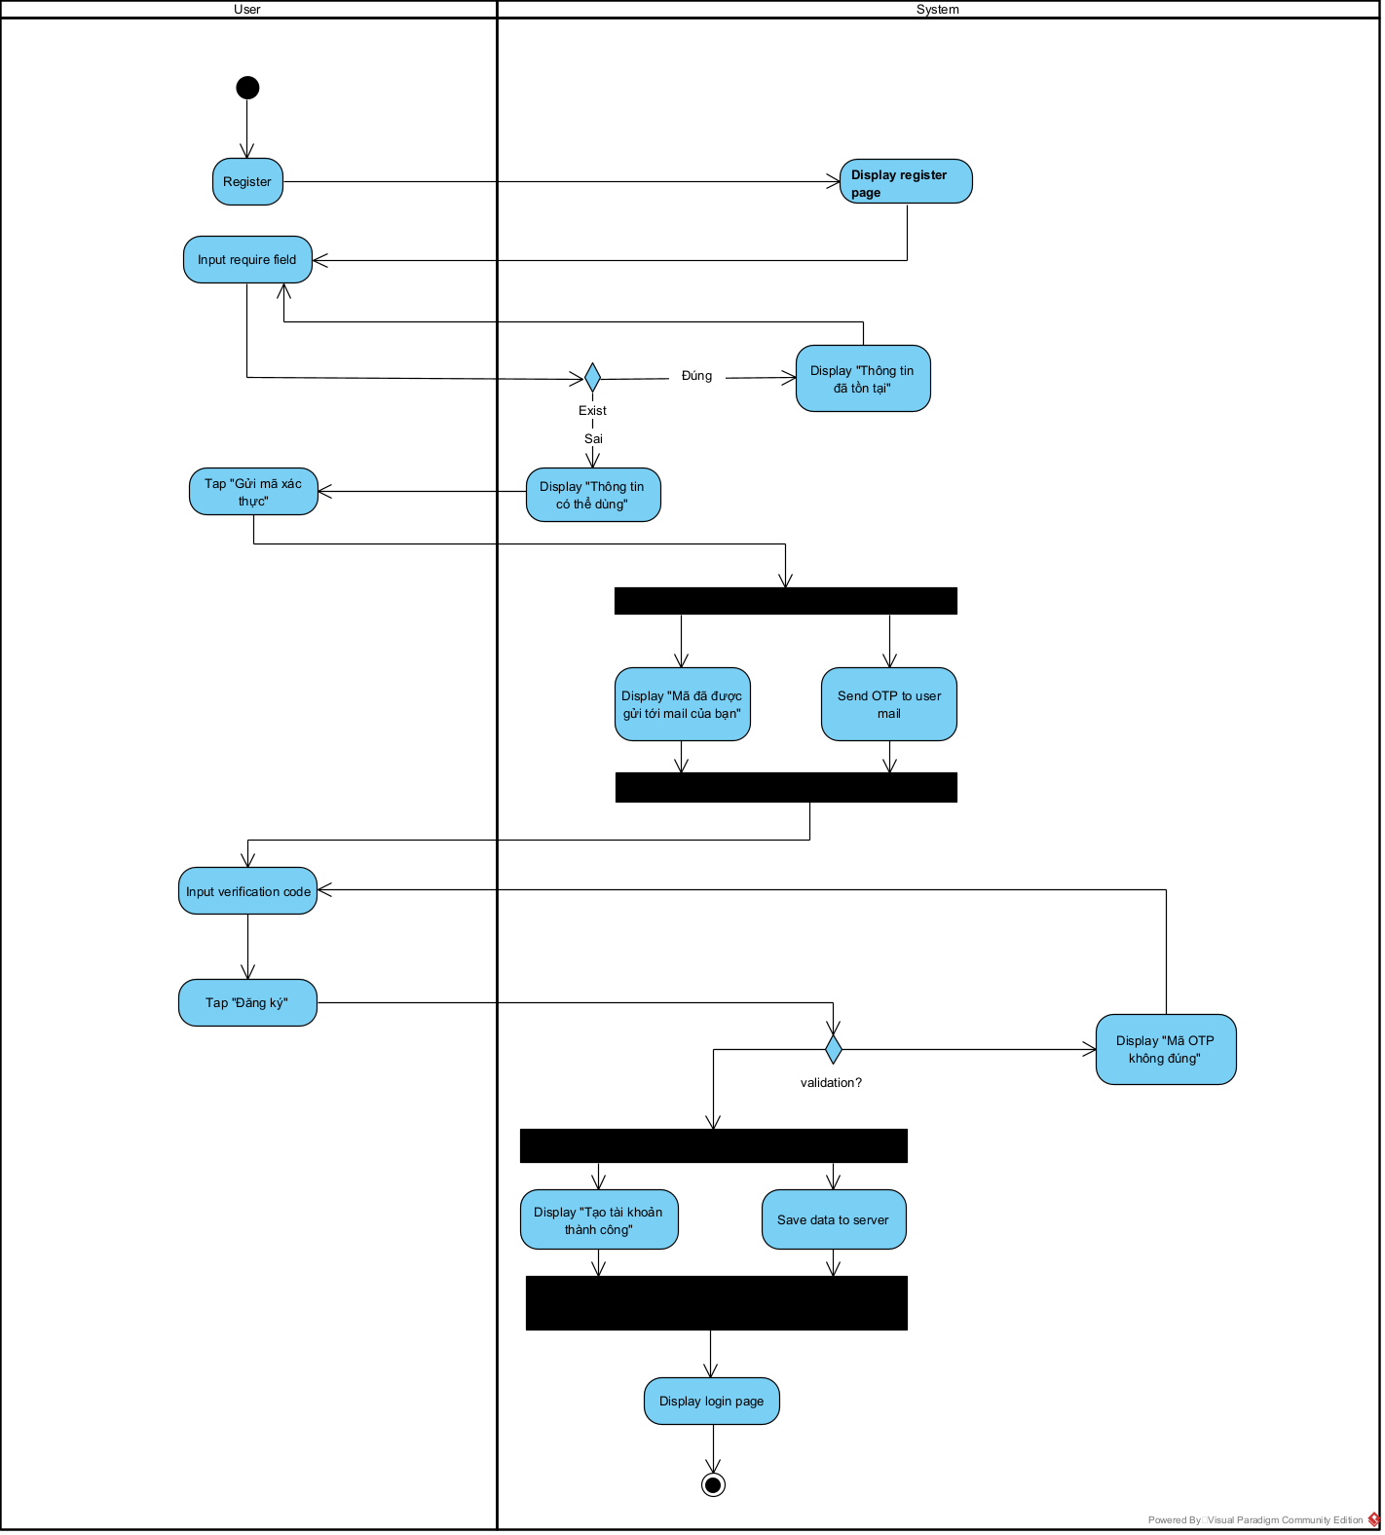

* + 1. **Guest Register Sequence Diagram**

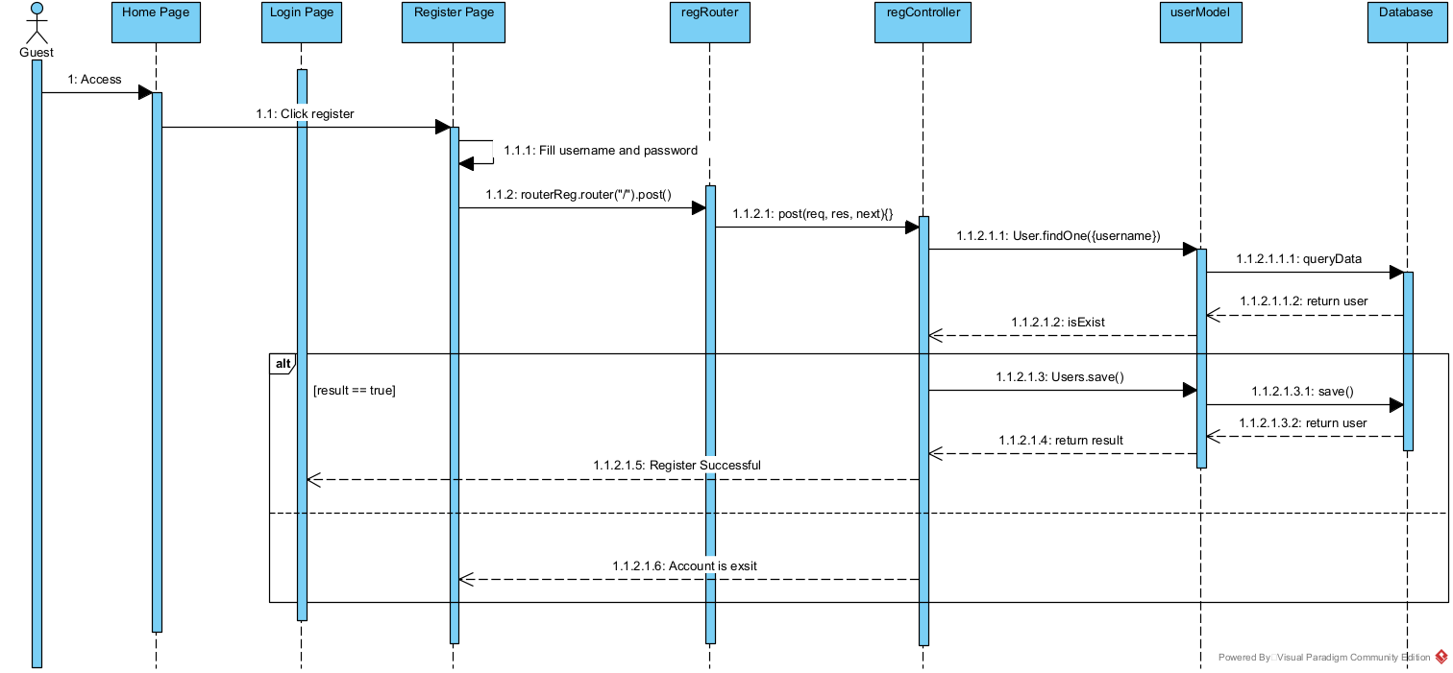

### **Login Feature**

* + 1. **Login Activity Diagram**

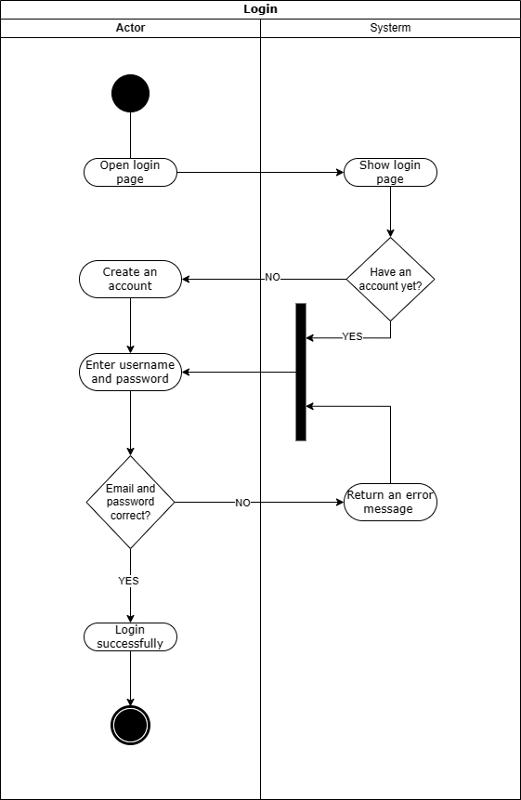

* + 1. **Login Sequence Diagram**

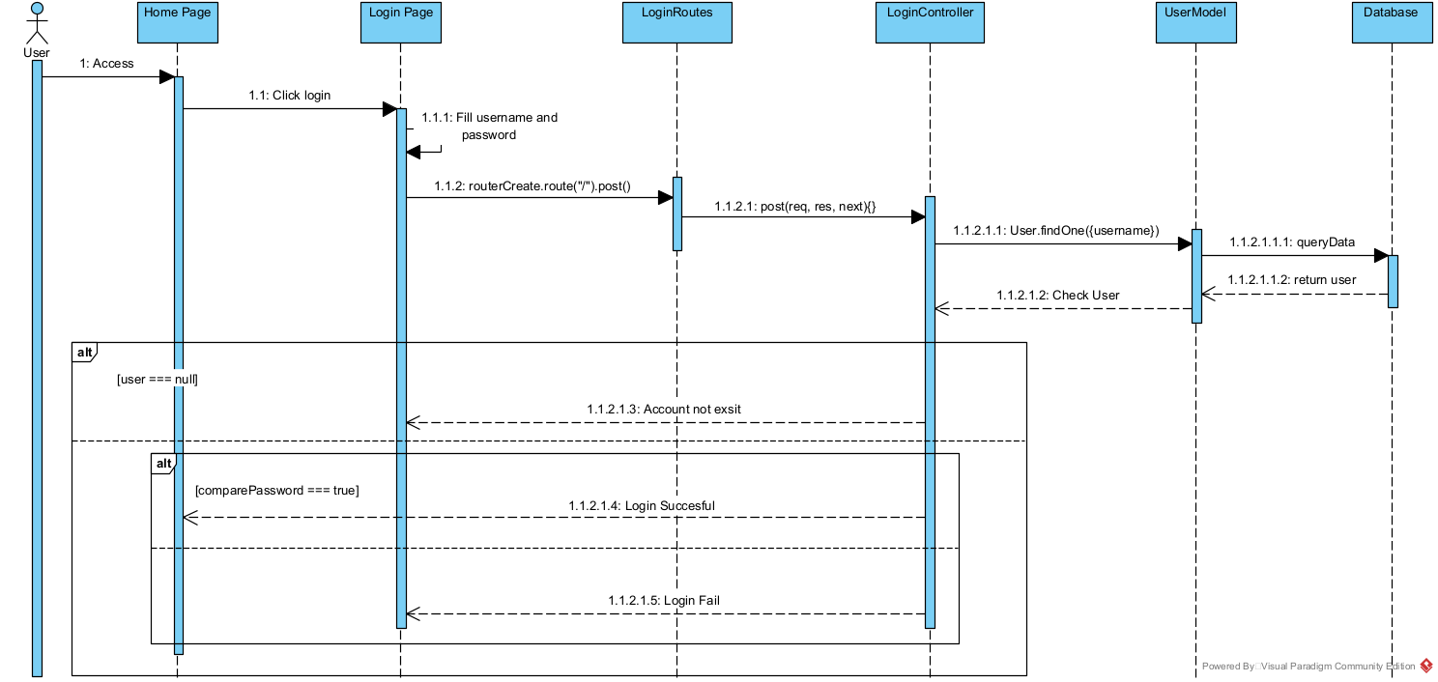

### **Staff Manage Product Feature**

* + 1. **Staff Manage Product Activity Diagram**
       1. **Staff Create Product Activity Diagram**

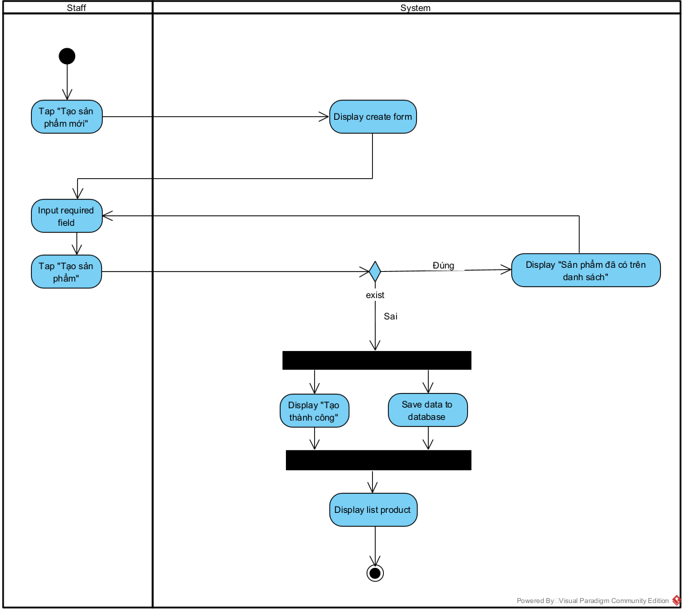

* + - 1. **Staff Update Product Activity Diagram**

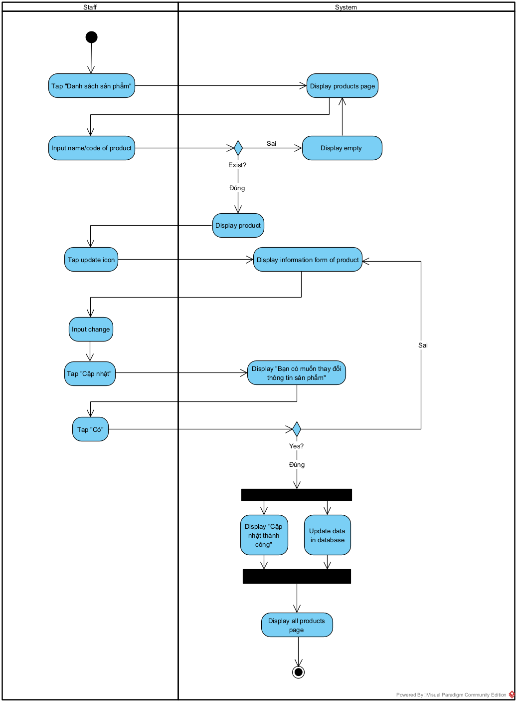

* + - 1. **Staff Delete Product Activity Diagram**

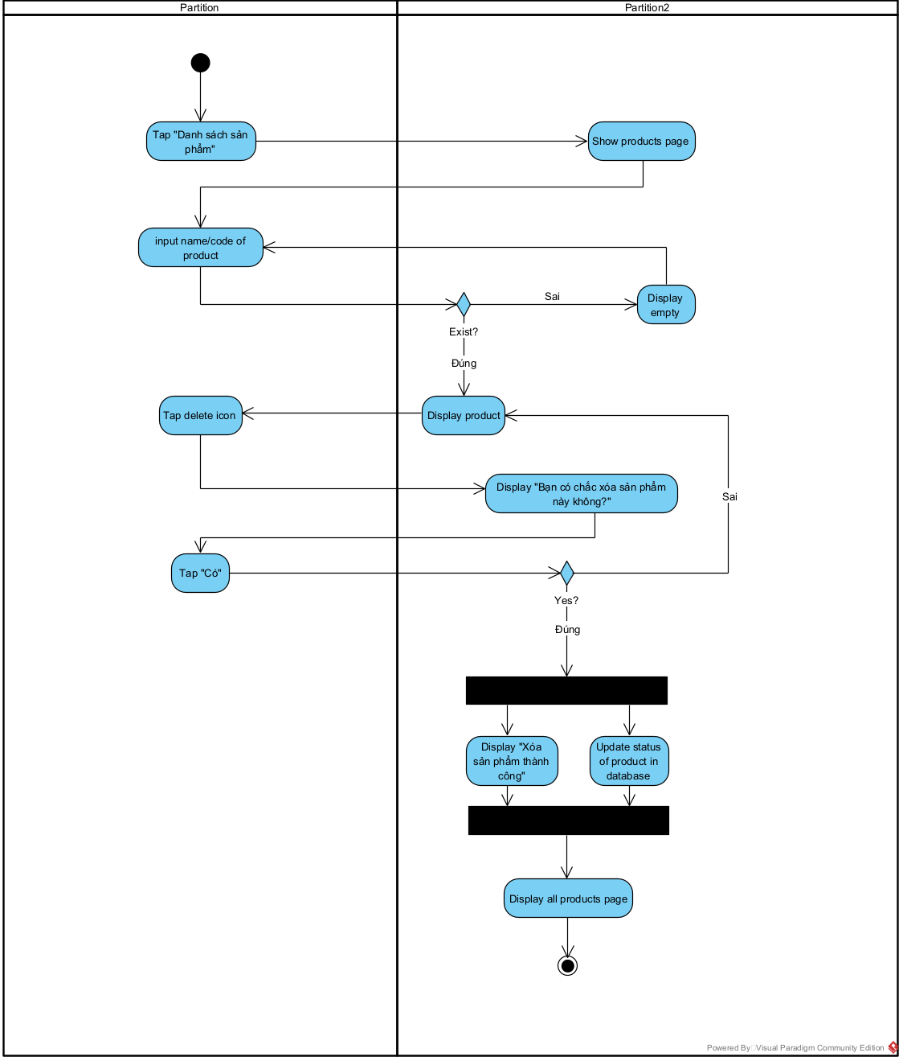

* + 1. **Staff Manage Product Sequence Diagram**
       1. **Staff Create Product Sequence Diagram**

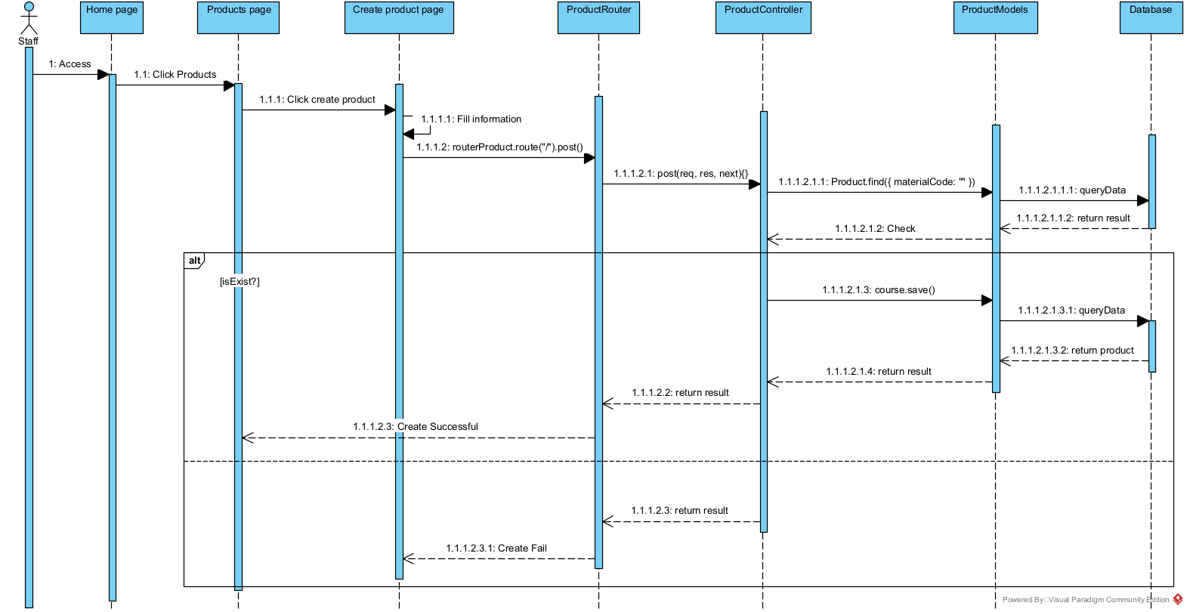

* + - 1. **Staff Update Product Sequence Diagram**

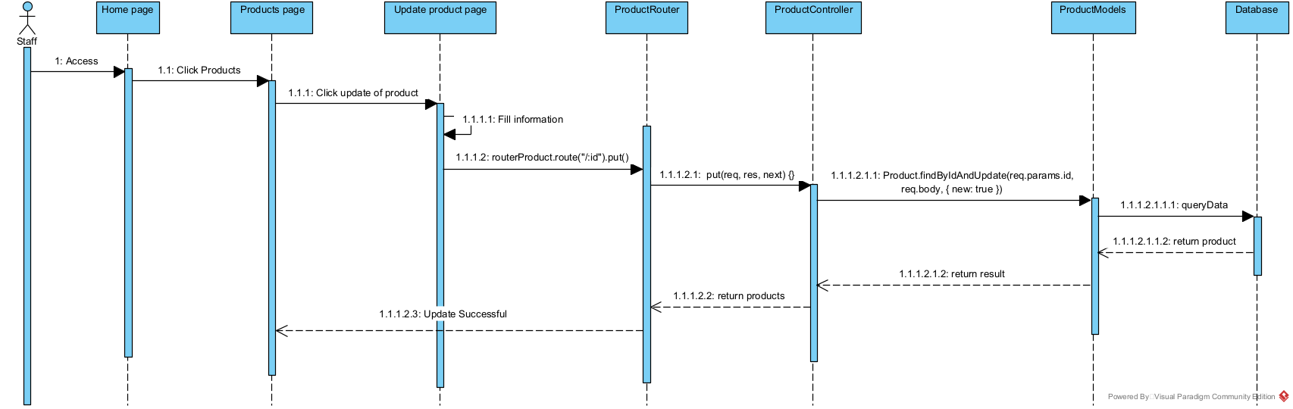

* + - 1. **Staff Delete Product Sequence Diagram**

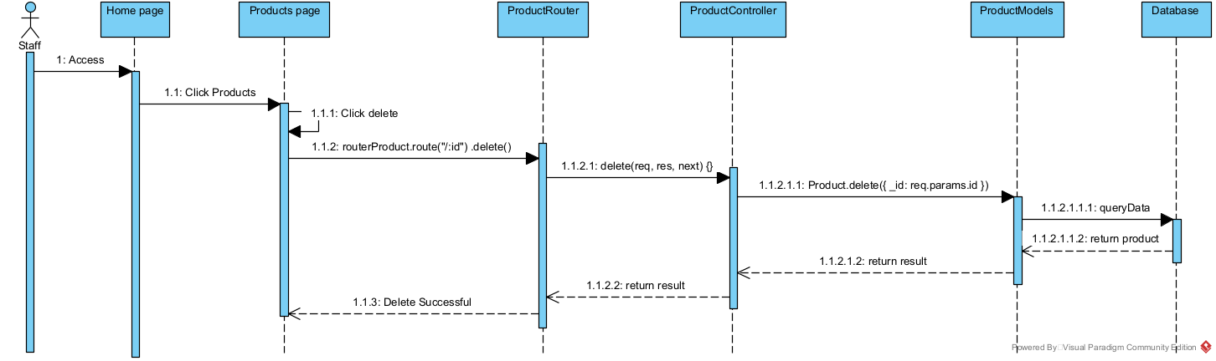

### **Staff Manage Order Feature**

* + 1. **Staff Manage Order Activity Diagram**
       1. **Staff Change Status of Order Activity Diagram**

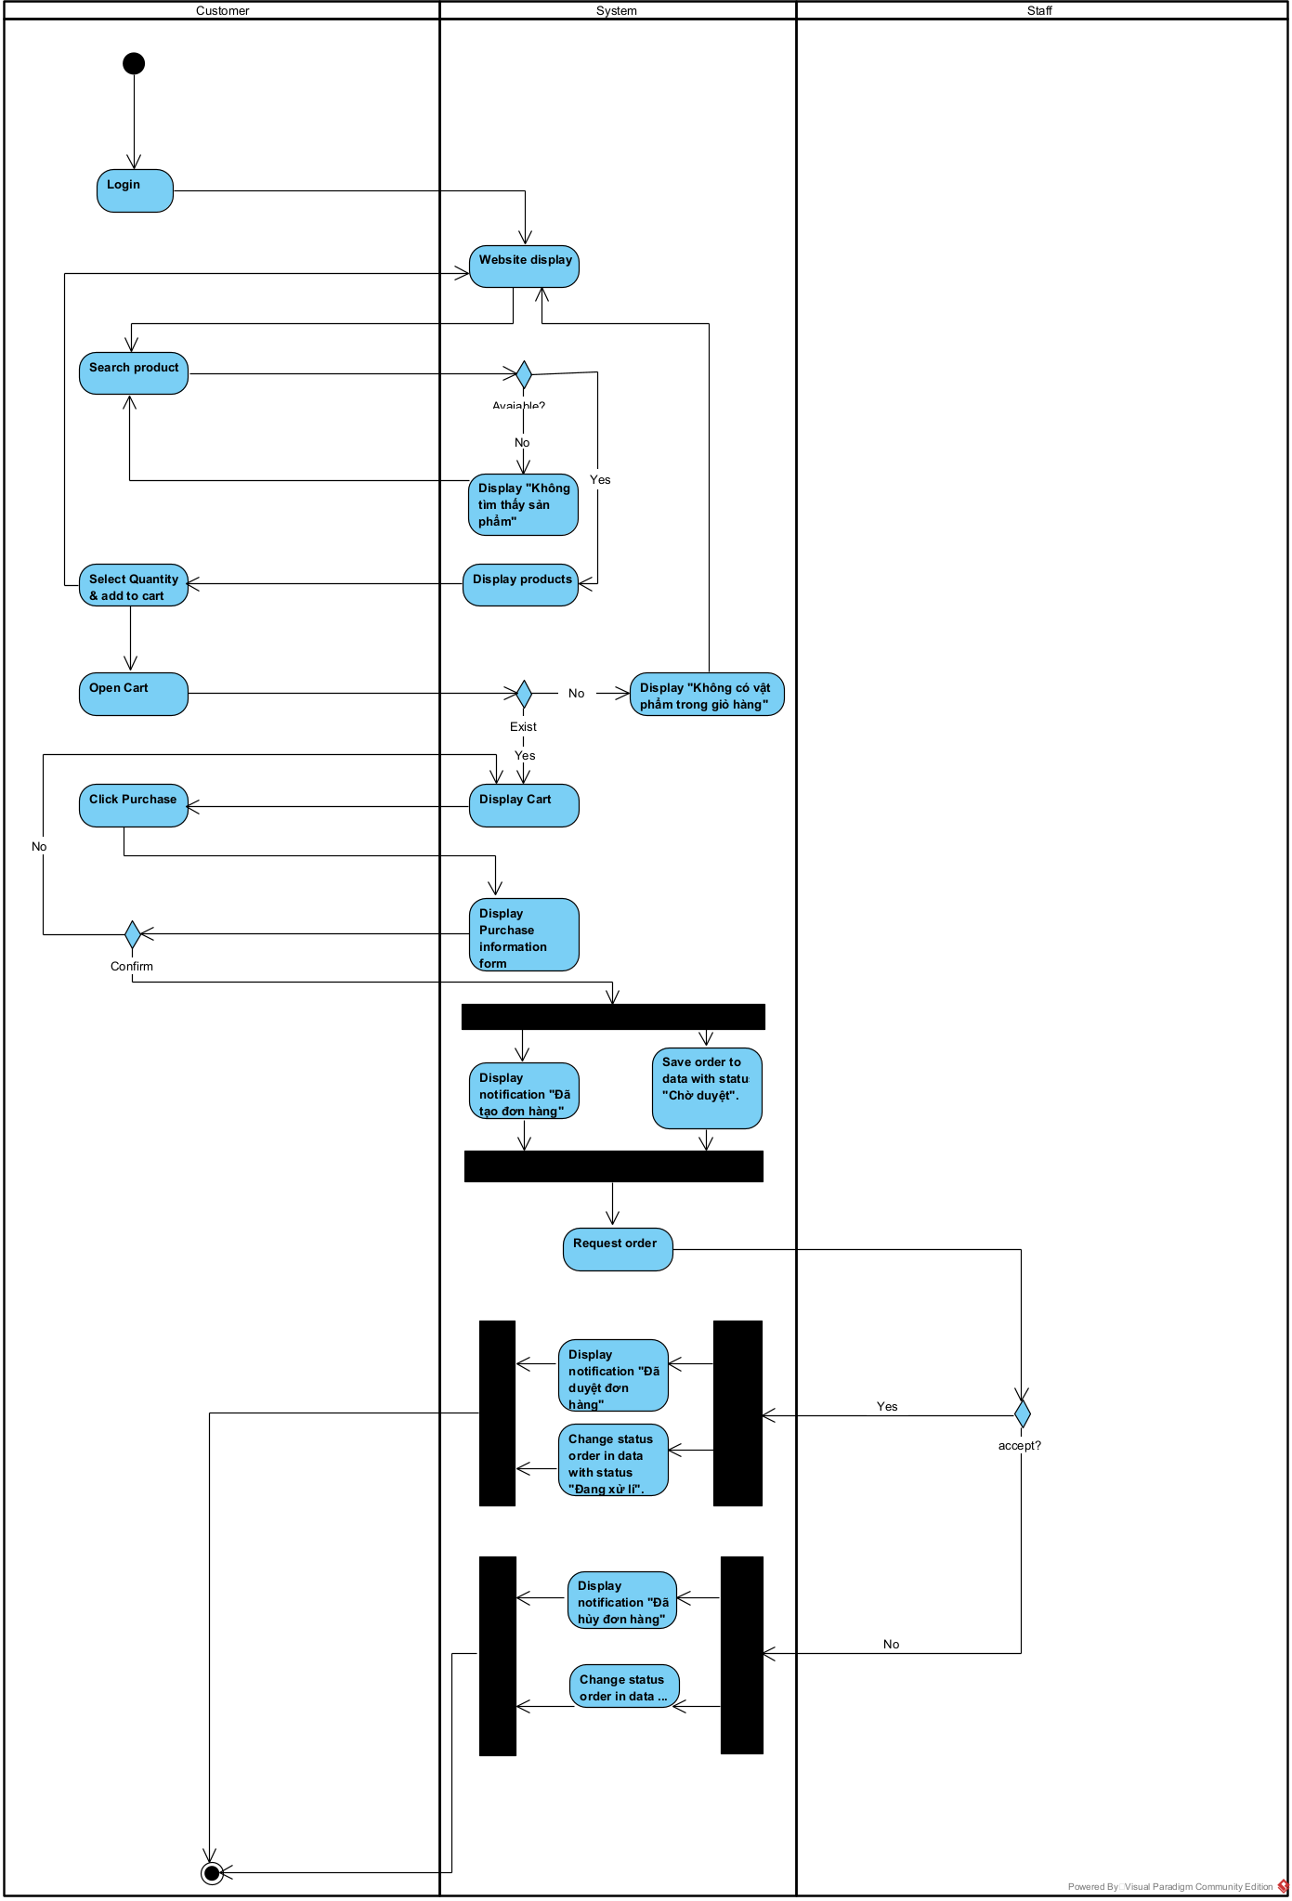

* + 1. **Staff Manage Order State Machine Diagram**
       1. **Staff Change Status of Order State Machine Diagram**

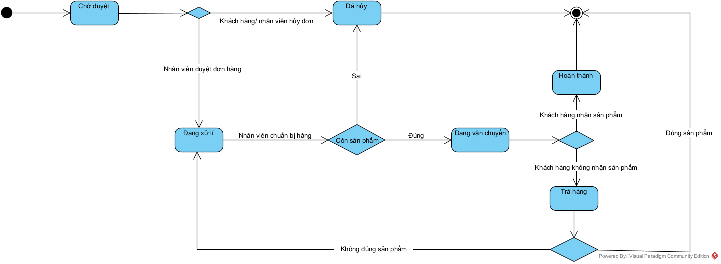

### **Staff Manage Custom Order Feature**

* + 1. **Staff Manage Custom Order Activity Diagram**
       1. **Staff Change Status of Custom Order Activity Diagram**

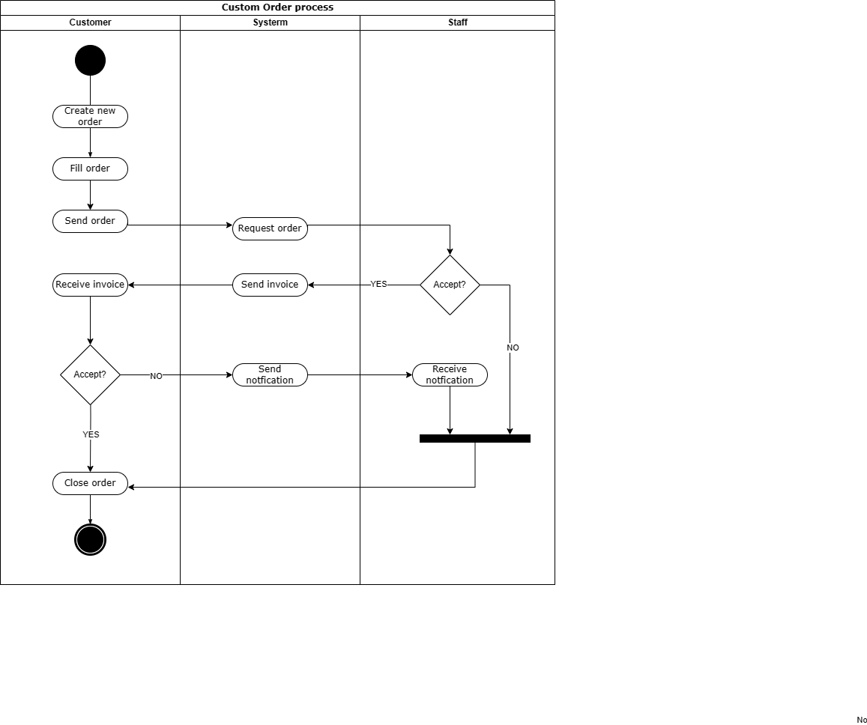

* + 1. **Staff Manage Custom Order State Machine Diagram**
       1. **Staff Change Status of Custom Order State Machine Diagram**

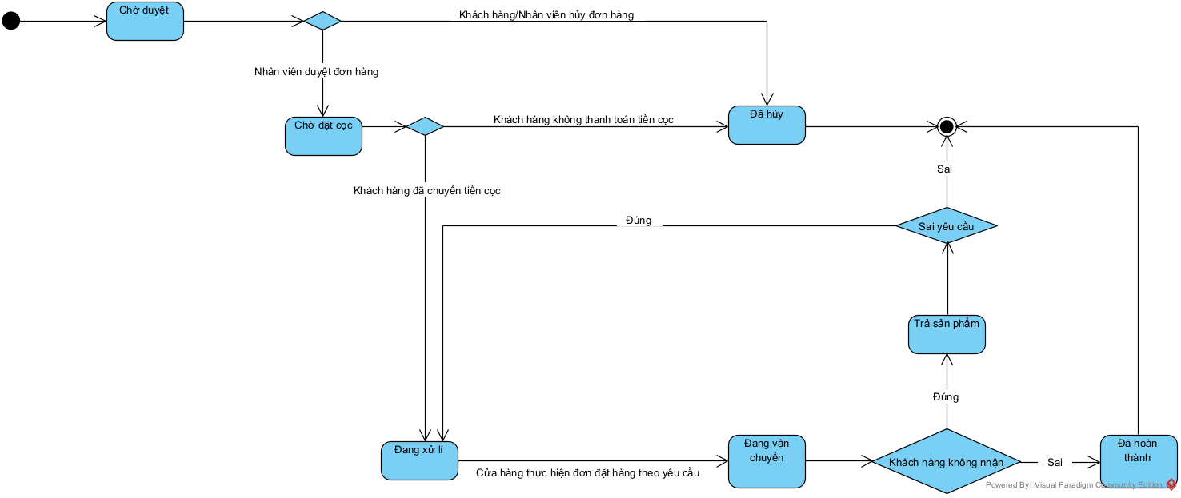

### **User Create Order Feature**

* + 1. **User Create Order Activity Diagram**



* + 1. **User Create Order Sequence Diagram**
       1. **User View All Product Sequence Diagram**

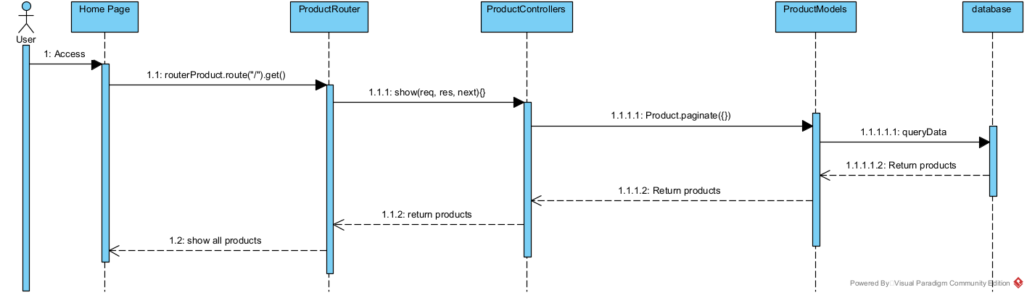

* + - 1. **User Search Product Sequence Diagram**

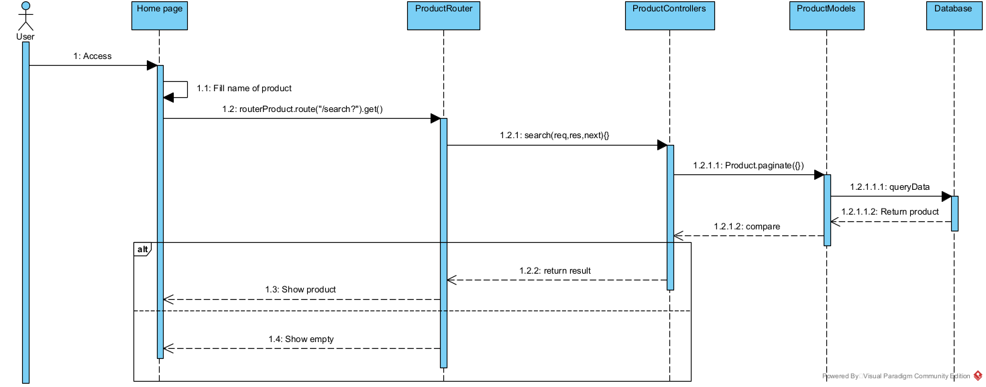

* + - 1. **User View Detail Product Sequence Diagram**

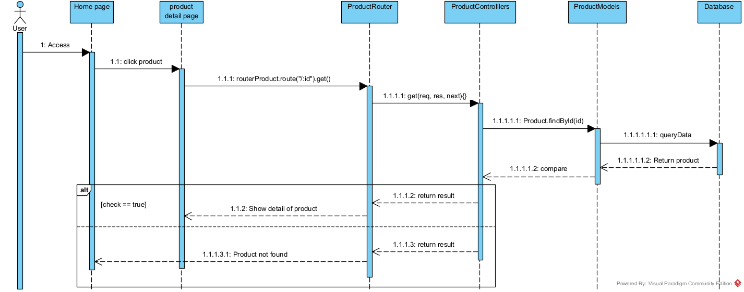

### **User Manage Order Feature**

* + 1. **User Manage Order Sequence Diagram**
       1. **User View All Order Sequence Diagram**

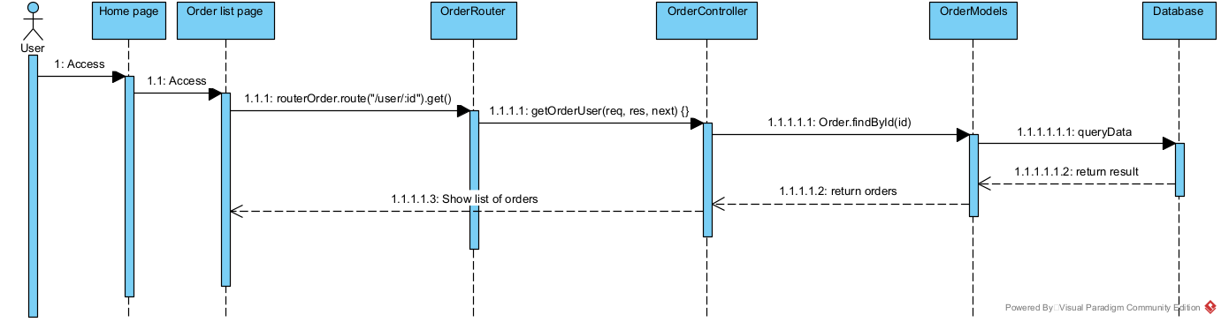

* + - 1. **User View Detail Order Sequence Diagram**

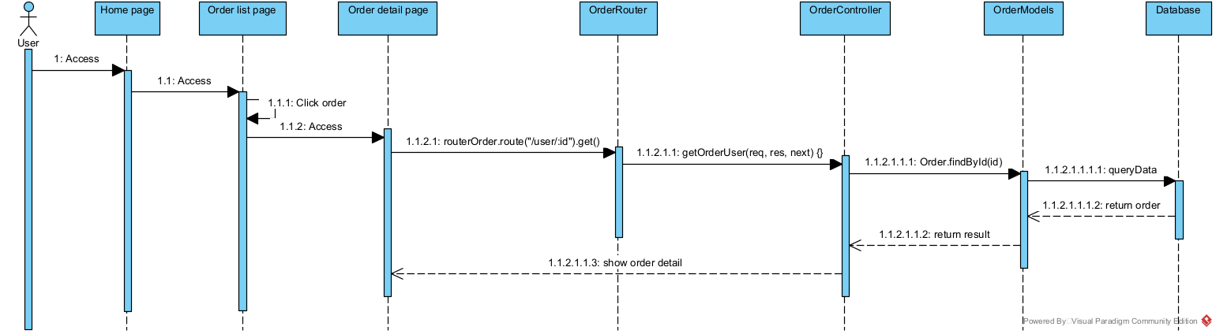

### **User Create Custom Order Feature**

* + 1. **User Create Custom order Activity Diagram**



* + 1. **User Create Custom Order Sequence Diagram**

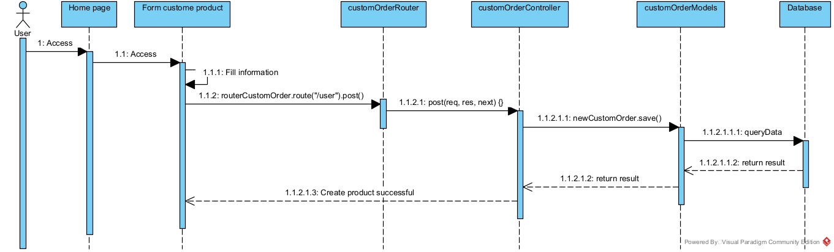

### **User Manage Custom Order Feature**

* + 1. **User Manage Custom Order Sequence Diagram**
       1. **User View All Custom Order Sequence Diagram**

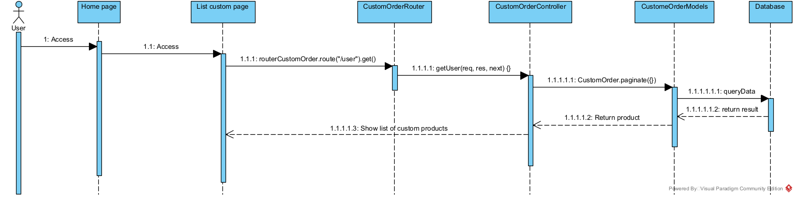

* + - 1. **User View Detail Custom Order Sequence Diagram**

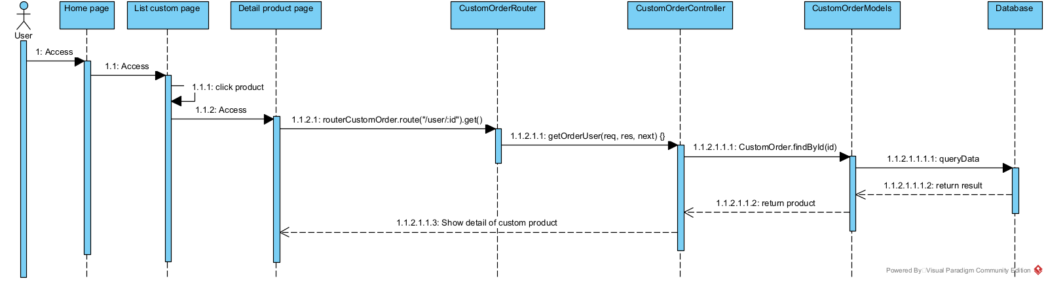

### **Admin Manage Account Feature**

* + 1. **Admin Manage Account Sequence Diagram**
       1. **Admin Create Account Sequence Diagram**

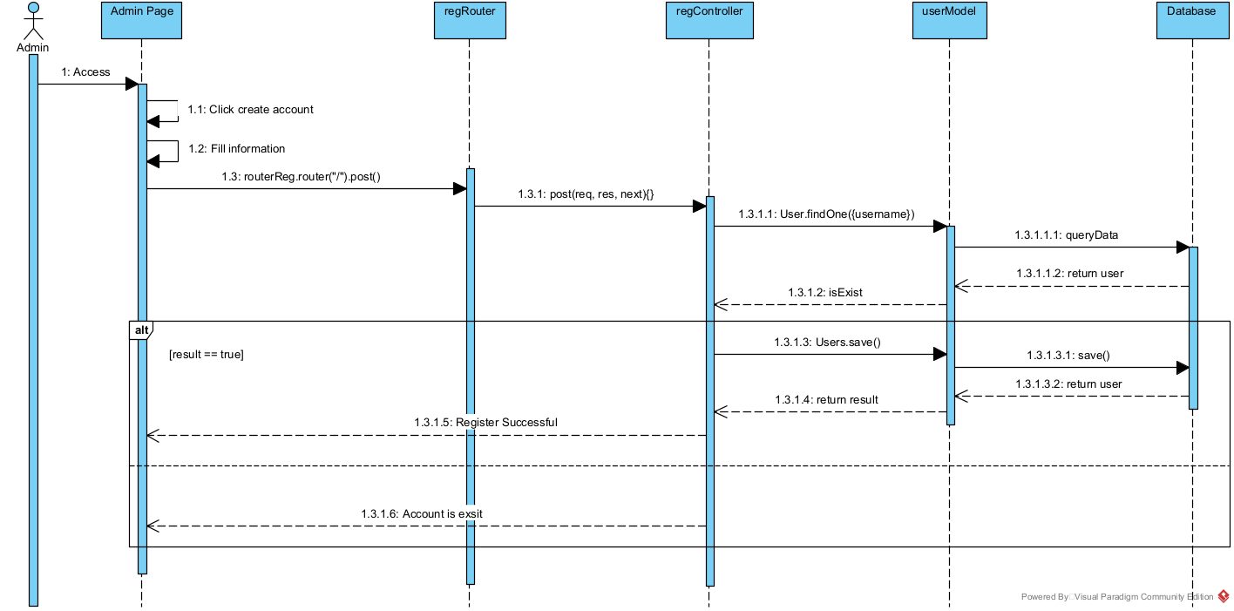

* + - 1. **Admin Update Account Sequence Diagram**

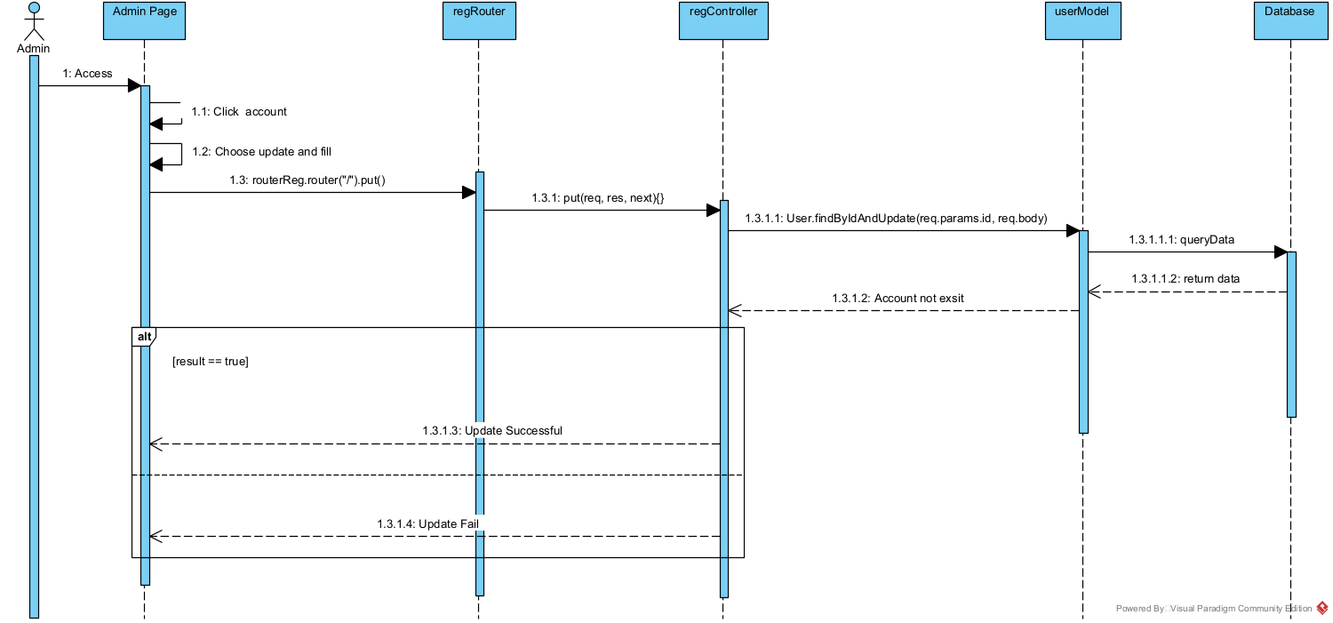

* + - 1. **Admin Delete Account Sequence Diagram**

