[Port-mapped I/O](https://en.wikipedia.org/wiki/Memory-mapped_I/O) also requires the use of special I/O instructions. Typically one or more ports are assigned to the device, each with a special purpose. The port numbers are in a separate address space from that used by normal instructions.

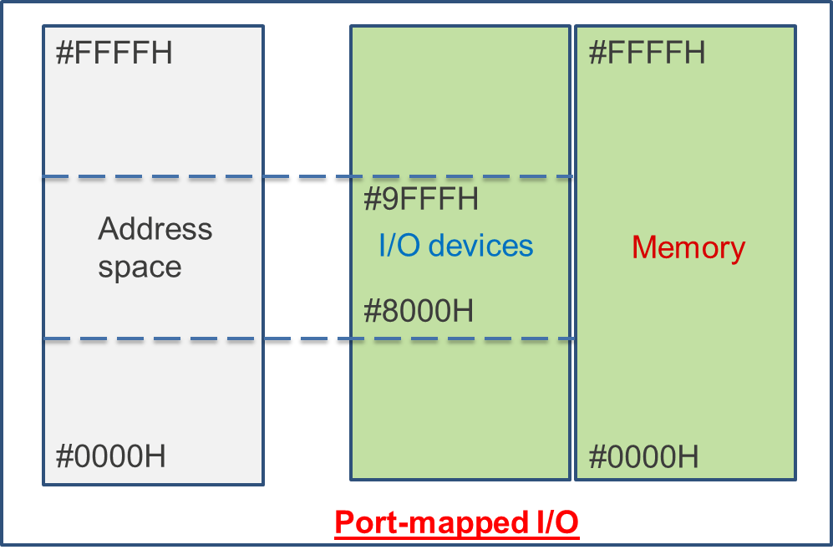

[Memory-mapped I/O](https://en.wikipedia.org/wiki/Memory-mapped_I/O), an alternative to port I/O; a communication between CPU and peripheral device using the same instructions, and same bus, as between CPU and memory

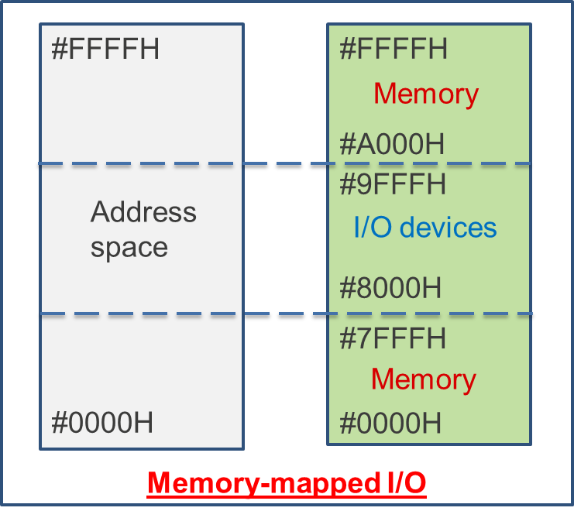

Difference between PMIO and MMIO:

MMIO:

* Device and memory share an address space
* I/O looks just like memory read/write
* No special commands for I/O
* Large selection of memory access commands available.

PMIO:

* Separate address spaces
* Need I/O or memory select lines
* Special commands for I/O
* Limit set

Relationship between Linux Kernel, Hardware, Applications:

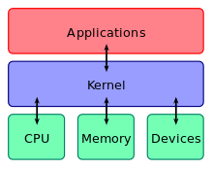

A kernel connects the application software to hardware of computer.