

**KOI VETERINARY SERVICE CENTER**

**Software Requirement Document**

– HoChiMinh, November 2024 –

**Table of Contents**

Record of Changes 5

Definition and Acronyms 6

I. Introduction 7

1. Product Background 7

2. Existing Systems 7

2.1 CaFishVet.com 7

3. Business Opportunity 7

4. Software Product Vision 8

5. Major Features 8

6. Limitations and Exclusions 9

II. Overall Description 9

1. Product Overview 9

2. Business Process 10

III. User Requirements 11

1. Actors 11

2. Use Cases 12

2.1 Diagram 12

2.2 Descriptions 12

3. Business Rules 28

IV. Functional Requirements 29

1. System Functional Overview 29

1.1 Screen Flow 29

1.2 Screen Descriptions 31

1.3 Screen Authorization 32

1.4 Non-Screen Functions 34

2. Data Requirements 35

2.1 Logical Data Model 35

2.2 Data Dictionary 35

2.3 Reports 38

2.4 State transition diagram 42

3. Home Page (FR-01) 43

3.1 Home Screen 43

4. Login (FR-02) 44

4.1 User Login Screen 44

5. Register (FR-03) 44

5.1 User Registration Screen 44

6. Forget Password (FR-04) 45

6.1 Password Recovery Screen 45

7. User Profile (FR-05) 45

7.1 Manage Profile Screen 45

8. Feedback (FR-06) 46

8.1 Review Submission Screen 46

9. Booking (FR-07) 46

9.1 Appointment Scheduling Screen 46

10. FAQ (FR-08) 47

10.1 FAQ Section 47

11. All Doctors (FR-09) 47

11.1 Veterinarian Listing Screen 47

12. Veterinarian’s Schedule (FR-10) 48

12.1 Availability View Screen 48

13. About Us (FR-11) 48

13.1 Company Information Screen 48

14. Confirm (FR-12) 49

14.1 Booking Confirmation Screen 49

15. Manage Booking (FR-13) 49

15.1 Booking Management Screen 49

16. VNPay (FR-14) 49

16.1 Payment Gateway Integration Screen 49

17. Manage Booking (Admin) (FR-15) 50

17.1 Admin Booking Management Screen 50

18. Manage Feedback (FR-16) 50

18.1 Feedback Management Screen 50

19. Assign Schedule (FR-17) 51

19.1 Schedule Assign Screen 51

20. Add Schedule (FR-18) 51

20.1 Schedule Creation Screen 51

21. Manage User (FR-19) 52

21.1 User Management Screen 52

22. Dashboard (FR-20) 52

22.1 Performance Overview Screen 52

23. Schedule (Veterinarian) (FR-21) 53

23.1 View Schedule Screen 53

24. Booking List (FR-22) 53

24.1 Appointment Management Screen 53

V. Non-Functional Requirements 54

1. External Interface Requirements 54

1.1 User Interfaces 54

1.2 Software Interfaces 54

1.3 Hardware Interfaces 54

1.4 Communications Interfaces 55

2. Quality Attributes 55

2.1 Usability 55

2.2 Performance 56

2.3 Security 56

2.4 Safety 56

2.5 Availability 56

2.6 Reliability 56

2.8 [Others as relevant] 56

# Record of Changes

|  |  |  |  |
| --- | --- | --- | --- |
| **Date** | **A* M, D** | **In charge** | **Change Description** |
|  |  |  |  |
|  |  |  |  |
|  |  |  |  |
|  |  |  |  |
|  |  |  |  |
|  |  |  |  |
|  |  |  |  |
|  |  |  |  |
|  |  |  |  |
|  |  |  |  |
|  |  |  |  |
|  |  |  |  |
|  |  |  |  |

*A - Added M - Modified D - Deleted

# Definition and Acronyms

|  |  |
| --- | --- |
| **Acronym** | **Definition** |
| BA | Business Analysis |
| BR | Business Rule |
| ERD | Entity Relationship Diagram |
| GUI | Graphical User Interface |
| PM | Project Manager |
| SDD | Software Design Description |
| SPMP | Software Project Management Plan |
| SRS | Software Requirement Specification |
| UAT | User Acceptance Test |
| UC | Use Case |
| API | Application Program Interface |

# I. Introduction

## 1. Product Background

The Koi Fish Veterinary Appointment Management Software is developed to provide a scheduling management platform for a veterinary centre specialising in Koi fish health issues. Currently, with the increasing popularity of Koi fish keeping, the care and maintenance of high-quality Koi fish habitats are receiving growing attention. Many Koi fish owners face difficulties in scheduling appointments with veterinarians. Therefore, this system is designed to address these problems, making it more convenient for customers to care for the health of their Koi fish.

## 2. Existing Systems

Some existing systems that can serve as references or integrate features:

### 2.1 [CaFishVet.com](http://cafishvet.com)

Brief Description: CaFishVet is a website specialising in Koi fish healthcare services, offering at-home consultation and treatment for Koi fish. The system is particularly focused on veterinary services for Koi fish, including health checkups, water quality advice, and fish disease treatments.

System Actors: Koi Fish Owners, Koi Fish Veterinarians.

Features:

* Provide health checkups and consultations for Koi fish.
* Schedule appointments for veterinarians to visit customers' homes to inspect ponds and offer improvement suggestions.
* Provide fish disease treatment at home or at the Koi fish centre.
* Offer expert information and articles on caring for and preventing diseases in Koi fish.

Pros:

* Highly specialised in Koi fish healthcare, with an experienced veterinary team.
* Support for on-site services, including home visits for checkups and treatments.

Cons:

* The appointment system is simple, relying on direct contact, not fully automated.
* More focused on information rather than a customer-interactive platform.
* Not having an extensive doctor selection system for customers.

## 3. Business Opportunity

With the growing number of Koi fish owners and the increasing demand for specialised Koi fish care, the market for Koi fish health care and treatment is expanding. Currently, most veterinary management systems are not specialised in Koi fish or do not provide sufficient features for booking consultation and treatment services. This new system will not only solve the problems that current customers face but also help the Koi fish veterinary centre expand its service scope and improve management efficiency.

## 4. Software Product Vision

For customers looking to book consultation and treatment services, the Koi Fish Veterinary Service Management Software is an online system that allows customers to schedule consultation and treatment services at home or at the centre, track the execution process, and evaluate service quality. Unlike the current manual appointment procedures, this system will make it easier for customers to follow appointments, ensuring that services are carried out according to their requirements.

## 5. Major Features

**5.1. Client-Side Web Application:**

* FE-1.1: Display introductory information about the veterinary centre, including general information, services, news, and contact details.
* FE-1.2: Display all services’ information.
* FE-1.3: Display detailed information about the service centre.
* FE-1.4: Display information about veterinarians.
* FE-1.5: Display schedule based on veterinarian’s availability.
* Display customer’s profile information and booking history.
* FE-1.6: Allow customers to book consultations with veterinarians for remote or in-person services.
* FE-1.7: Offer an appointment booking system for Koi pond health evaluation at the customer's location.
* FE-1.8: Allow customers to book fish disease treatment services, either at their home or at the veterinary centre.
* FE-1.9: Display the customer's booking information, including consultation history.
* FE-1.10: Provide a feedback system for customers to rate the services and veterinarians after the consultation or treatment.

**5.2. Admin Web Application:**

* FE-2.1: Provide options to manage appointment slots and the working schedules of the veterinarians.
* FE-2.2: Assign veterinarians to consultations based on customer requests or by staff.
* FE-2.3: Manage customer profiles, including contact information, and appointment history.
* FE-2.4: Display schedule based on veterinarians’ availability.
* FE-2.5: Provide options to manage services’ price.
* FE-2.6: Display customer feedback and service ratings to improve service quality.
* FE-2.7: Provide access to a dashboard for viewing customer data, booking trends, service usage, and feedback.
* FE-2.8: Generate detailed reports on centre performance.

## 6. Limitations and Exclusions

* LI-1: The service only supports scheduling consultations and treatments for Koi fish, without recording specific fish disease information.
* LI-2: There is currently no subscription service system for customers.
* LI-3: Cannot handle large-scale orders.
* LI-4: Tracking the status and progress of booked services.
* LI-5: Changing the schedule of the veterinarian after they have been assigned.
* LI-6: Manage and update general information about the veterinary centre and services.
* LI-7: Does not support notification.
* LI-8: Manage notifications to customers, such as appointment confirmations and reminders.
* LI-9: Does not support gaining permission to accounts.
* LI-10: Does not support cancelling appointments.

# II. Overall Description

## 1. Product Overview

The Koi Fish Veterinary Appointment Management System is designed to provide an easy-to-use platform for booking and managing veterinary consultations, with a specific focus on Koi fish health services. Given the rising popularity of keeping Koi fish, proper health management and maintenance of these ponds is becoming an increasing concern for owners. The system is aimed at assisting Koi fish owners in booking health consultations for their fish, whether remotely or in-person, to ensure the highest quality care

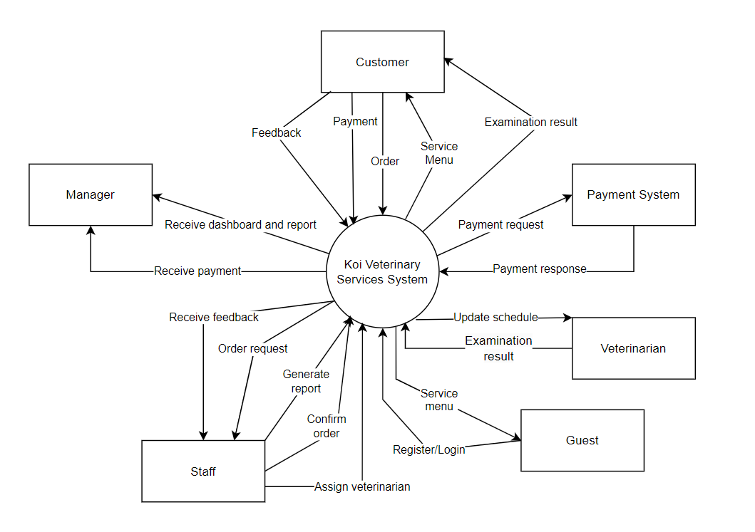

## 2. Business Process

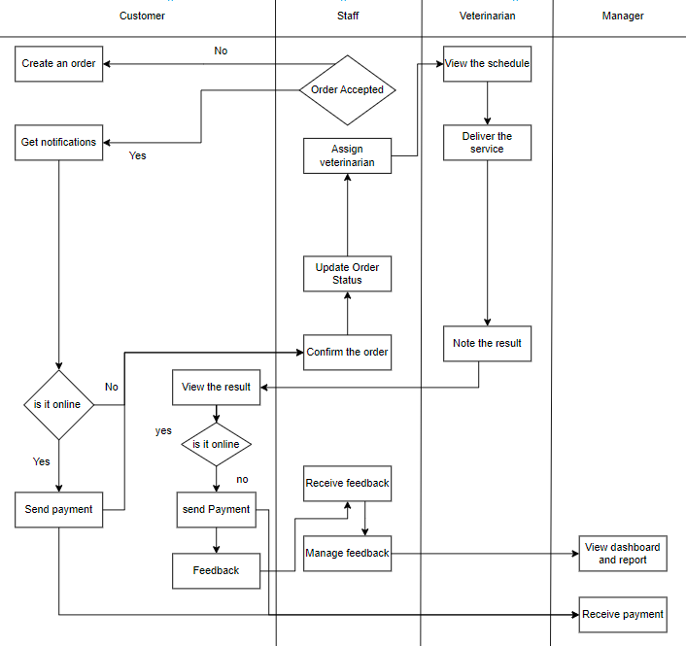

|  |  |  |
| --- | --- | --- |
| **#** | **Process Step** | **Description** |
| 1 | Create an order | Fill in information to create a new order/appointment . |
| 2 | Order accepted | If the customer does not confirm the appointment, cancel the appointment registration. And if the customer confirms the appointment, continue to the next step. |
| 3 | Get invoice | Get the invoice information of the system and show it to the customer |
| 4 | Send payment | The customer proceeds to pay the down payment to continue with the appointment. |
| 5 | Receive payment | The manager will receive the payment from the customer. |
| 6 | Update order status | Update the order status in the system and forward the order to staff. |
| 7 | Confirm the order | Staff receive the information of the order and confirm the order if the order information is correct and feasible or not. |
| 8 | Assign veterinarian | Staff assign the veterinarian if the customer did not choose the veterinarian first. |
| 9 | View the schedule | The order information reflects into the specific veterinarian’s schedule and that veterinarian is only able to view his/her own schedule. |
| 10 | Deliver the service | The veterinarian delivers the service based on his/her schedule. |
| 11 | Note the result | The veterinarian notes the result of his/her examination and the advice the customer should follow |
| 12 | View the result | The customer sees the result of the particular appointment they’ve ordered after that appointment is done. |
| 13 | Feedback | The customer writes the feedback of a particular appointment they’ve ordered. |
| 14 | Receive feedback | The staff receives the feedback from the customer and manages it depending on circumstances. |
| 15 | View dashboard and report | The manager will receive the report of the revenue, overall feedback of the customer, what services did the customer book the most and which veterinarian did the customer choose the most. |

# III. User Requirements

## 1. Actors

|  |  |  |
| --- | --- | --- |
| **#** | **Actor** | **Description** |
| 1 | Guest | Unregistered users who visit the system to browse general information about the Koi Veterinary Service Center. Guests can view the homepage, read about services, news, FAQs, and contact details but cannot book any services without registering. |
| 2 | Customer | Registered users who have the ability to book services such as consultations, treatments, and on-site evaluations. They can also provide feedback and ratings after receiving services and can view their booking history |
| 3 | Staff | Administrative employees responsible for handling customer inquiries, managing service bookings, and assigning veterinarians to tasks. Staff ensure that customers' appointments are correctly scheduled and that the necessary resources are available. |
| 4 | Veterinarian | Professionals responsible for providing the actual veterinary services, including consultations, treatments, and on-site evaluations. Veterinarians update service records, provide medical advice, prescribe medication, and document outcomes after service. |
| 5 | Manager | Oversees the entire system, including staff and veterinarians. The manager ensures smooth operation, manages service pricing, monitors feedback and ratings, and generates reports for performance and service analytics. |

## 2. Use Cases

### 2.1 Diagram

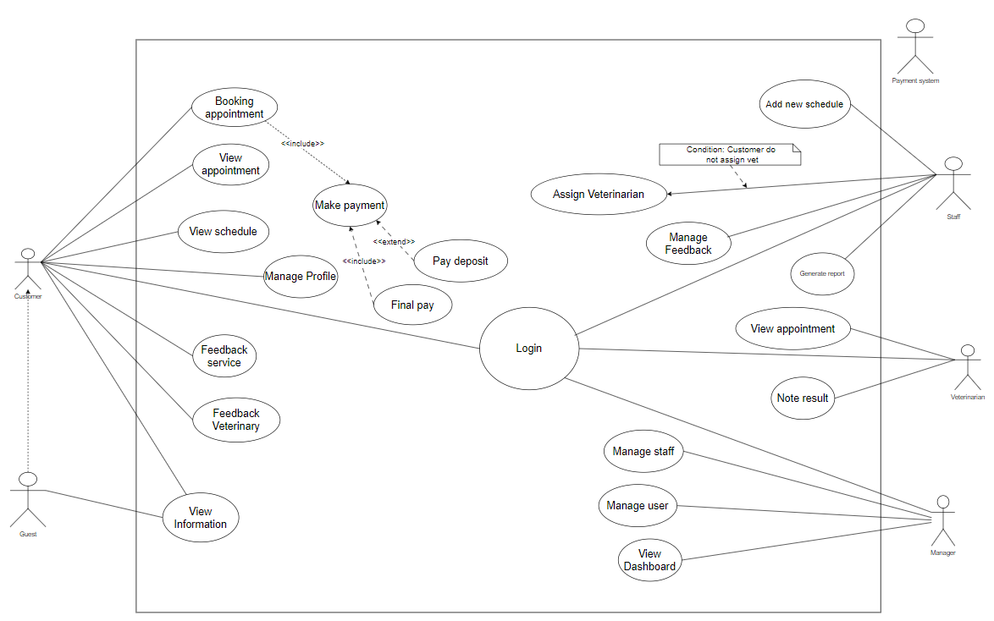

### 2.2 Descriptions

|  |  |  |  |
| --- | --- | --- | --- |
| **ID** | **Use Case** | **Actors** | **Use Case Description** |
| UC-01 | Booking Appointment | Customer | Customer selects a service (consultation, evaluation, treatment), books an appointment, pays a deposit, and receives the service. Staff manages the appointment and assigns the veterinarian​ |
| UC-02 | View Information | Customer, Guest | Customers can view general information about services, veterinarians, FAQ, and terms of service. |
| UC-03 | View Appointment | Customer | Customers can view details of their booked and past appointments, including status, assigned veterinarian, and results |
| UC-04 | View Schedule | Customer | Customers can view available slots and schedules of veterinarians to select a suitable time for appointments |
| UC-05 | Feedback Service | Customer | After receiving a service, customers can provide feedback on their overall experience to help improve service quality. |
| UC-06 | Feedback Veterinarian | Customer | Customers can rate and leave specific feedback for the veterinarian who performed the service. |
| UC-07 | Make Payment | Customer | Customers can pay for services booked through the system using various payment methods (credit card, bank transfer, etc.). |
| UC-08 | Manage Profile | Customer | Customers can update their personal information, such as contact details and preferences, to keep their profile up-to-date. |
| UC-09 | Pay Deposit | Customer | Customers pay a deposit to secure the booking. The deposit is deducted from the final payment. |
| UC-10 | Final Pay | Customer | After completing the service, customers make the final payment based on the service fee minus the deposit already paid. |
| UC-11 | Assign veterinarian | Staff | Staff assign veterinarian to do the booking. |
| UC-12 | Manage Feedback | Staff | Staff reviews and manages customer feedback, addressing complaints or highlighting positive reviews for internal recognition. |
| UC-13 | Generate Report | Staff | Staff can generate reports based on service usage, payment records, and customer feedback for management analysis. |
| UC-14 | Note Result | Veterinarian | Veterinarians document the results of consultations, treatments, and other services provided to the customer. |
| UC-15 | View Appointment | Veterinarian | Veterinarians can view their scheduled appointments, including customer details and service type. |
| UC-16 | Manage User | Manager, Staff | Managers have the ability to manage customer accounts, including handling issues, updating information, and resolving disputes. |
| UC-17 | View Dashboard | Manager | Managers can view a comprehensive dashboard that displays key metrics such as revenue, appointment statistics, and service trends. |
| UC-18 | Add new schedule | Staff | Staff can create new schedule |

|  |  |  |  |
| --- | --- | --- | --- |
| ID and Name: | **UC-01 Booking Appointment** | | |
| Created By: | Group4 | Date Created: |  |
| Primary Actor: | Customer | Secondary Actors: |  |
| Description: | Customer selects a service (consultation, evaluation, treatment), books an appointment, pays a deposit, and receives the service. Staff manages the appointment and assigns the veterinarian | | |
| Trigger: | The customer decides to book a veterinary service for their Koi fish through the system. | | |
| Preconditions: | PRE-1: The customer must be logged into the system.  PRE-2: The selected service must be available.  PRE-3: The veterinarian must have availability during the requested time. | | |
| Postconditions: | POST-1: The customer’s appointment is confirmed and stored in the system.  POST-2: The payment is processed and marked as received.  POST-3: The assigned veterinarian is notified of the scheduled service and the customer is notified of the appointment details. | | |
| Normal Flow: | 1. Customer selects a service   * The customer navigates to the "Services" section and selects a desired service.   2. Customer chooses appointment time   * The system displays available appointment slots based on veterinarian availability. * The customer selects a preferred date and time.   3. Customer reviews and confirms details   * The system shows a summary of the service details, including the selected veterinarian (if applicable), service date, time, and pricing. * The customer reviews and confirms the appointment details.   4. Customer makes a payment   * The system prompts the customer to pay a deposit (or full payment) to secure the appointment. * The customer completes the payment using an integrated payment gateway. * The system processes the payment and updates the order status to "Confirmed."   5**.** Veterinarian assigned (if needed)   * If the customer hasn’t chosen a specific veterinarian, Staff assigns one based on availability. * The assigned veterinarian’s schedule is updated with the new appointment.   6. Confirmation sent   * The system sends a confirmation notification to the customer via email containing appointment details. * The veterinarian is also notified of the upcoming appointment. | | |
| Alternative Flows: | AF-1: Customer cancels before payment   * If the customer changes their mind before confirming the payment, they can cancel the booking without penalty.   AF-2: Payment failure   * If the payment fails, the system notifies the customer to retry the payment or cancel the booking. * If the payment is not completed within 2 hours, the appointment is automatically cancelled, and the customer is notified. | | |
| Exceptions: | E-1: Appointment cancellation due to veterinarian unavailability   * In case the assigned veterinarian becomes unavailable (due to emergency, etc.), the system sends a notification to the customer offering alternative slots or another veterinarian.   E-2: No veterinarian available   * Customer can not order if no veterinarians are available at the chosen time | | |
| Priority: | High | | |
| Frequency of Use: | The use case is expected to be executed frequently by Koi fish owners, especially during peak service seasons or during promotional periods. | | |
| Business Rules: | **BR-01, BR-02, BR-03, BR-04** | | |
| Other Information: | * Veterinarians will receive their updated schedules in real-time and can view any new assignments through their profile page​ * Customers should be able to modify or cancel the appointment up to 2 hours before the scheduled time. | | |
| Assumptions: | * Assume that veterinarian schedules are efficiently managed and updated in real-time. * Assume that the payment system uses robust security measures for transactions. | | |

|  |  |  |  |
| --- | --- | --- | --- |
| ID and Name: | **UC-02 View Information** | | |
| Created By: | Group 4 | Date Created: |  |
| Primary Actor: | Customer, Guest | Secondary Actors: |  |
| Description: | Customers can view general information about services, veterinarians, FAQ, and terms of service. | | |
| Trigger: | The customer or guest chooses to view information on the website or application. | | |
| Preconditions: | PRE-1: The information on services, veterinarians, FAQ, and terms of service is preloaded and maintained in the system. | | |
| Postconditions: | POST-1: The customer or guest views the desired information. | | |
| Normal Flow: | 1. The customer or guest accesses the website or application.  2. The customer navigates to the “Information” section.  3. The customer selects the category (services, veterinarians, FAQ, terms of service) they wish to view.  4. The system displays the selected information.  5. The customer reads and interacts with the information as needed. | | |
| Alternative Flows: | None | | |
| Exceptions: | E-1: If there is missing or outdated information, the system may display a notice or direct the customer to contact support. | | |
| Priority: | Medium | | |
| Frequency of Use: | Frequently, as customers and guests will likely refer to this information regularly. | | |
| Business Rules: |  | | |
| Other Information: | None | | |
| Assumptions: | * The customer or guest has basic navigation skills. * The system’s information content is reviewed regularly for accuracy and relevance. | | |

|  |  |  |  |
| --- | --- | --- | --- |
| ID and Name: | **UC-03 View Appointment** | | |
| Created By: | Group4 | Date Created: |  |
| Primary Actor: | Customer | Secondary Actors: |  |
| Description: | Customers can view details of their booked and past appointments, including status, assigned veterinarian, and results | | |
| Trigger: | The customer selects the option to view appointment details on the website or application. | | |
| Preconditions: | PRE-1: The customer must be logged into their account.  PRE-2: Appointments (both upcoming and past) should be recorded and stored in the system. | | |
| Postconditions: | POST-1: The customer can view the relevant details of their selected appointment.  POST-2: The system logs this access for potential review or audit. | | |
| Normal Flow: | 1. The customer logs into their account and navigates to the "Appointments" section.  **2.** The customer selects either “Upcoming Appointments” or “Past Appointments.”  3. The customer chooses a specific appointment to view details.  4. The system displays information for the selected appointment, including:   * Appointment date and time * Status (e.g., confirmed, cancelled, completed) * Assigned veterinarian * Any results or notes related to the appointment   5. The customer reviews the information as needed. | | |
| Alternative Flows: | **AF-1:** If the customer wants to view a different appointment, they can return to the main appointment menu and select another one.  **AF-2:** If the customer encounters unclear information, they may be directed to a help or support option for further assistance. | | |
| Exceptions: | **Exception 1:** If the system is down or inaccessible, an error message is displayed, and the customer cannot view appointment details.  **Exception 2:** If no appointments are available (upcoming or past), the system displays a message informing the customer that no records are available. | | |
| Priority: | High | | |
| Frequency of Use: | Frequently, customers may regularly review appointment details for upcoming visits and past records. | | |
| Business Rules: | **BR-09, BR-10** | | |
| Other Information: | * The system may record and display appointment changes, such as rescheduling or cancellations. * Access to sensitive appointment information is logged for security purposes. | | |
| Assumptions: | * Customers are familiar with navigating the “Appointments” section. | | |

|  |  |  |  |
| --- | --- | --- | --- |
| ID and Name: | **UC-04: View Schedule** | | |
| Created By: | Group4 | Date Created: |  |
| Primary Actor: | Customer | Secondary Actors: |  |
| Description: | Customers can view available slots and schedules of veterinarians to select a suitable time for appointments | | |
| Trigger: | The customer navigates to the scheduling section to check available times. | | |
| Preconditions: | PRE-1: The customer must be logged into the system.  PRE-2: The system has updated schedules and availability for veterinarians. | | |
| Postconditions: | POST-1: The customer successfully views available time slots.  POST-2: The system may store the viewing activity for tracking purposes. | | |
| Normal Flow: | 1. The customer logs into their account and navigates to the “Schedule” or “Book Appointment” section.  2. The system displays a list of veterinarians and their available slots.  3. The customer selects a veterinarian to view their detailed schedule.  4. The system displays the specific time slots available for the chosen veterinarian.  5. The customer reviews the available times to identify a suitable slot. | | |
| Alternative Flows: | AF-1: The customer can switch between different veterinarians to compare schedules and find the most convenient time.  AF-2: If the customer has specific time requirements, they may apply filters to view only relevant available slots. | | |
| Exceptions: | E-1: If the system is down, the customer is unable to view schedules, and an error message is shown.  E-2: If no slots are available for a selected veterinarian, the system displays a message suggesting the customer choose a different veterinarian or check back later. | | |
| Priority: | High | | |
| Frequency of Use: | Regularly, as customers may often need to check availability before booking an appointment. | | |
| Business Rules: | **BR-02, BR-04, BR-08** | | |
| Other Information: | None | | |
| Assumptions: | * The customer understands the booking process and is familiar with navigating the scheduling interface. * Veterinarian schedules are updated frequently to ensure accurate information for customers. | | |

|  |  |  |  |
| --- | --- | --- | --- |
| ID and Name: | **UC-05: Feedback Service** | | |
| Created By: | Group4 | Date Created: |  |
| Primary Actor: | Customer | Secondary Actors: |  |
| Description: | After receiving a service, customers can provide feedback on their overall experience to help improve service quality. | | |
| Trigger: | The customer receives a prompt to provide feedback after their service has been completed, or they access the feedback section on the website or app. | | |
| Preconditions: | PRE-1: The customer must be logged into the system.  PRE-2: The customer has completed a service appointment. | | |
| Postconditions: | POST-1: The customer’s feedback is successfully recorded.  POST-2: The feedback is stored in the system for analysis. | | |
| Normal Flow: | 1. The customer logs into their account and navigates to the “Feedback” section, or clicks a feedback prompt after the service.  2. The system displays a feedback form, including fields or ratings for overall experience, service quality, and other relevant criteria.  3. The customer completes the form by providing ratings, comments, or suggestions.  4. The customer submits the feedback.  5. The system confirms the feedback submission and stores it for future analysis. | | |
| Alternative Flows: | AF-1: If the system is down, the feedback submission is unavailable, and an error message is displayed.  AF-2: If the customer has immediate concerns, they may be redirected to contact customer support directly. | | |
| Exceptions: | E-1: If the system is down, the customer is unable to view schedules, and an error message is shown.  E-2: If the customer attempts to submit multiple feedback entries for the same service, the system may restrict this or flag it for review. | | |
| Priority: | Medium | | |
| Frequency of Use: | Occasionally, as customers will provide feedback only after receiving a service. | | |
| Business Rules: | **BR-05** | | |
| Other Information: | None | | |
| Assumptions: | * Customers are comfortable providing feedback and understand how to navigate the feedback form. * The organization actively reviews and responds to feedback to enhance service quality. | | |

|  |  |  |  |
| --- | --- | --- | --- |
| ID and Name: | **UC-06: Feedback Veterinarian** | | |
| Created By: | Group4 | Date Created: |  |
| Primary Actor: | Customer | Secondary Actors: |  |
| Description: | Customers can rate and leave specific feedback for the veterinarian who performed the service. | | |
| Trigger: | The customer receives a prompt to provide veterinarian-specific feedback after the appointment or accesses the feedback section in their account. | | |
| Preconditions: | PRE-1: The customer has completed a service appointment with a specific veterinarian.  PRE-2: The system has a feature to log and store feedback for individual veterinarians. | | |
| Postconditions: | POST-1: The customer’s feedback for the veterinarian is recorded.  POST-2: The feedback is stored in the system and linked to the respective veterinarian’s profile for analysis. | | |
| Normal Flow: | 1. The customer logs into their account and navigates to the “Feedback” section or clicks on a feedback prompt.  2. The system displays a feedback form specific to the veterinarian who performed the service.  3. The customer provides ratings for the veterinarian on various criteria (e.g., professionalism, communication, expertise) and leaves additional comments if desired.  4. The customer submits the feedback.  5. The system confirms the feedback submission and links it to the veterinarian’s profile. | | |
| Alternative Flows: | AF-1: If the customer wants to leave feedback for more than one veterinarian (in cases of multiple visits), they can access a list of previous veterinarians and provide feedback for each one.  AF-2: If the customer prefers to provide feedback anonymously, they can choose this option before submission. | | |
| Exceptions: | E-1: If the system is down, the customer is unable to submit feedback, and an error message is shown.  E-2: If the customer attempts to submit multiple feedback entries for the same appointment, the system may restrict or flag this for review. | | |
| Priority: | Medium | | |
| Frequency of Use: | Occasionally, following an appointment. | | |
| Business Rules: | **BR-05** | | |
| Other Information: | * The system may prompt customers for feedback after every appointment to encourage participation. | | |
| Assumptions: | * Customers are willing to provide constructive feedback on their experience with the veterinarian. * The organization values and uses this feedback to support veterinarian development and enhance service quality. | | |

|  |  |  |  |
| --- | --- | --- | --- |
| ID and Name: | **UC-07: Make Payment** | | |
| Created By: | Group4 | Date Created: |  |
| Primary Actor: | Customer | Secondary Actors: |  |
| Description: | Customers can pay for services booked through the system using various payment methods (credit card, bank transfer, etc.). | | |
| Trigger: | The customer selects the option to pay for a booked service or is prompted to complete payment after booking or receiving a service. | | |
| Preconditions: | PRE-1: The customer has an outstanding payment for a booked or completed service.  PRE-2: The system is integrated with payment gateways to process transactions securely. | | |
| Postconditions: | POST-1: The payment is successfully processed, and the service status is updated to reflect payment completion.  POST-2: A receipt or confirmation is provided to the customer. | | |
| Normal Flow: | 1. The customer logs into their account and navigates to the “Payments” section or is directed there after booking a service.  2. The system displays the outstanding payment amount and available payment methods (credit card, bank transfer, etc.).  3. The customer selects a payment method.  4. The customer enters the required payment details (e.g., credit card information, bank details).  5. The system processes the payment through the selected gateway.  6. If the payment is successful, the system updates the service status to “Paid” and provides a confirmation message and receipt.  7. The customer reviews the payment confirmation and receipt. | | |
| Alternative Flows: | AF-1: If the customer chooses a different payment method (e.g., bank transfer), the system may redirect to the appropriate banking portal or display instructions.  AF-2: If the customer wants to apply a discount or promotional code, they can enter it before payment to adjust the amount. | | |
| Exceptions: | E-1: If the payment fails due to insufficient funds or incorrect details, the system prompts the customer to re-enter information or choose a different payment method.  E-2: If there is a network or system error during payment, the customer is notified, and the system prompts them to try again later. | | |
| Priority: | High | | |
| Frequency of Use: | Frequently, as customers are required to pay for each service. | | |
| Business Rules: | **BR-01, BR-03, BR-04** | | |
| Other Information: | * The system may support installment payments or split payments, if applicable. * Payment records are stored for financial reporting and customer access. | | |
| Assumptions: | * The customer has access to an accepted payment method. * Payment gateways are functional and able to process transactions securely at the time of payment. | | |

|  |  |  |  |
| --- | --- | --- | --- |
| ID and Name: | **UC-08: Manage Profile** | | |
| Created By: | Group4 | Date Created: |  |
| Primary Actor: | Customer | Secondary Actors: |  |
| Description: | Customers can update their personal information, such as contact details and preferences, to keep their profile up-to-date. | | |
| Trigger: | The customer selects the option to manage or update their profile information in their account. | | |
| Preconditions: | PRE-1: The customer is logged into their account.  PRE-2: The system provides access to editable profile fields. | | |
| Postconditions: | POST-1: The customer’s updated profile information is saved successfully in the system.  POST-2: The system reflects the latest information in the customer’s profile. | | |
| Normal Flow: | 1. The customer logs into their account and navigates to the “Profile” or “Account Settings” section.  2. The system displays the customer’s current profile information, including fields such as contact details, address, and communication preferences.  3. The customer selects the field(s) they wish to update and enters the new information.  4. The customer saves the changes.  5. The system updates the customer’s profile with the new information and confirms the update. | | |
| Alternative Flows: | AF-1: If the customer wants to reset specific preferences to default, they can select a “Reset to Default” option before saving.  AF-2: If the customer is unsure about the changes, they can choose to discard modifications and retain the existing information. | | |
| Exceptions: | E-1: If the system fails to save the updated information due to a network issue, an error message is displayed, and the customer is prompted to try again.  E-2: If the customer enters invalid data (e.g., an incorrect email format), the system displays an error message prompting them to correct the information before saving. | | |
| Priority: | Medium | | |
| Frequency of Use: | Occasionally, as customers update profile information periodically or when changes occur. | | |
| Business Rules: | **None** | | |
| Other Information: | * The system may log changes to profile information for security and audit purposes. * Customers may receive an email or notification confirming any significant profile updates, especially for contact information. | | |
| Assumptions: | * Customers know how to access and manage their profile settings. * The system securely stores profile information and protects customer data according to relevant privacy regulations. | | |

|  |  |  |  |
| --- | --- | --- | --- |
| ID and Name: | **UC-09: Pay Deposit** | | |
| Created By: | Group4 | Date Created: |  |
| Primary Actor: | Customer | Secondary Actors: |  |
| Description: | Customers pay a deposit to secure the booking. The deposit is deducted from the final payment. | | |
| Trigger: | The customer selects the option to pay a deposit when booking a service. | | |
| Preconditions: | PRE-1: The customer has selected a service that requires a deposit.  PRE-2: The system supports partial payments and secure transactions. | | |
| Postconditions: | POST-1: The deposit payment is successfully processed, securing the booking.  POST-2: The deposit amount is recorded in the customer’s booking and applied to the final payment. | | |
| Normal Flow: | 1. The customer logs into their account, selects a service, and proceeds with booking.  2. The system calculates the required deposit amount based on the service.  3. The system displays the deposit amount and available payment options.  4. The customer selects a payment method and enters payment details.  5. The system processes the deposit payment through the chosen payment gateway.  6. If the payment is successful, the system confirms the deposit, secures the booking, and provides a confirmation message.  7. The deposit amount is stored and linked to the customer’s booking record. | | |
| Alternative Flows: | AF-1: If the customer wants to pay the full amount instead of just the deposit, they can select that option before proceeding with payment.  AF-2: If the customer decides to cancel the booking after paying the deposit, the system may apply a cancellation policy that determines whether the deposit is refundable. | | |
| Exceptions: | E-1: If the payment fails due to insufficient funds or incorrect details, the system prompts the customer to re-enter information or select a different payment method.  E-2: If there is a network or system error during payment, the customer is notified, and the system prompts them to try again later. | | |
| Priority: | High | | |
| Frequency of Use: | Regularly, as deposits are often required to secure bookings. | | |
| Business Rules: | **BR-01, BR-03, BR-04** | | |
| Other Information: | * The system may send an email or notification confirming the deposit payment and booking. * The deposit payment details are stored for reference and financial reporting. | | |
| Assumptions: | * The customer has access to a valid payment method for deposit. * The system securely processes and stores deposit information in compliance with financial regulations. | | |

|  |  |  |  |
| --- | --- | --- | --- |
| ID and Name: | **UC-10 Final Pay** | | |
| Created By: | Group4 | Date Created: |  |
| Primary Actor: | Customer | Secondary Actors: |  |
| Description: | After completing the service, customers make the final payment based on the service fee minus the deposit already paid. | | |
| Trigger: | The service is completed, and the final payment is due. | | |
| Preconditions: | PRE-1: The service must be fully completed.  PRE-2: The initial deposit payment must be recorded in the system. | | |
| Postconditions: | POST-1: The final payment is processed and recorded in the system.  POST-2: The customer receives a payment confirmation. | | |
| Normal Flow: | * Customer receives notification for final payment. * Customer reviews the outstanding balance and completes the payment through the system. * The system confirms the payment and updates the transaction as "Paid." | | |
| Alternative Flows: | AF-1: Payment failure — If the payment fails, the system notifies the customer to retry or contact support. | | |
| Exceptions: | E-1: Discrepancy in balance — If there’s a discrepancy between the deposit and total fees, the system flags it for staff review. | | |
| Priority: | High | | |
| Frequency of Use: | Executed for each completed service requiring a final payment. | | |
| Business Rules: | **BR-01, BR-04, BR-11** | | |
| Other Information: | None | | |
| Assumptions: | The initial deposit has already been processed and recorded correctly. | | |

|  |  |  |  |
| --- | --- | --- | --- |
| ID and Name: | **UC-11 Assign Veterinarian** | | |
| Created By: | Group4 | Date Created: |  |
| Primary Actor: | Staff | Secondary Actors: | Veterinarian, Customer |
| Description: | Staff assign veterinarian after verifying availability of the veterinarian. | | |
| Trigger: | A customer completes the booking process for a service. | | |
| Preconditions: | PRE-1: Customer’s payment must be received.  PRE-2: Availability of the veterinarian must be verified. | | |
| Postconditions: | POST-1: The veterinarian’s schedule is updated | | |
| Normal Flow: | * Staff logs into the system and navigates to the assign schedule page. * Staff select the day have booking * Staff select the booking to assign * Staff select the veterinarian that available to be assigned * System updates the veterinarian’ schedule. | | |
| Alternative Flows: | AF-1: Veterinarian unavailable — Staff assigns another veterinarian and informs the customer. | | |
| Exceptions: | E-1: Discrepancy in booking details — Staff contacts customers to clarify. | | |
| Priority: | High | | |
| Frequency of Use: | Performed for each new booking. | | |
| Business Rules: | **BR-01 BR-02 BR-07 BR-11** | | |
| Other Information: | None | | |
| Assumptions: | The system reliably verifies veterinarian availability before confirmation. | | |

|  |  |  |  |
| --- | --- | --- | --- |
| ID and Name: | **UC-12 Manage Feedback** | | |
| Created By: | Group4 | Date Created: |  |
| Primary Actor: | Staff | Secondary Actors: |  |
| Description: | Staff reviews and manages customer feedback, addressing complaints or highlighting positive reviews for internal recognition. | | |
| Trigger: | Customer submits feedback after receiving service. | | |
| Preconditions: | PRE-1: The feedback system is operational. | | |
| Postconditions: | POST-1: Feedback is recorded and marked as addressed (if applicable). | | |
| Normal Flow: | * Staff reviews submitted feedback. * Staff responds to complaints or highlights positive feedback internally. | | |
| Alternative Flows: | AF-1: Negative feedback — Staff initiates follow-up for resolution. | | |
| Exceptions: | E-1: Inappropriate feedback is flagged for review. | | |
| Priority: | Medium | | |
| Frequency of Use: | Weekly or as needed based on feedback volume. | | |
| Business Rules: | **BR-05 BR-06** | | |
| Other Information: | None | | |
| Assumptions: | The system accurately captures and timestamps feedback. | | |

|  |  |  |  |
| --- | --- | --- | --- |
| ID and Name: | **UC-13 Generate Report** | | |
| Created By: | Group4 | Date Created: |  |
| Primary Actor: | Staff | Secondary Actors: |  |
| Description: | Staff can generate reports based on service usage, payment records, and customer feedback for management analysis. | | |
| Trigger: | A request is made for a report on specific service metrics. | | |
| Preconditions: | PRE-1: The reporting system must have access to up-to-date service and payment records. | | |
| Postconditions: | POST-1: A report is generated and saved in the system.  POST-2: Authorised staff can access the report. | | |
| Normal Flow: | * Staff selects the type of report needed (e.g., service usage, payments, feedback). * Staff specifies the report parameters (date range, service type). * System generates the report and makes it available for download or review. | | |
| Alternative Flows: | AF-1: Report customization — Staff may filter data by additional metrics (e.g., location, time). | | |
| Exceptions: | E-1: Data retrieval error — If there is an issue retrieving data, an error message is displayed, and staff is prompted to retry later. | | |
| Priority: | Medium | | |
| Frequency of Use: | Monthly or as needed for management analysis. | | |
| Business Rules: | **BR-09** | | |
| Other Information: | None | | |
| Assumptions: | All data is securely stored and retrievable by the system. | | |

|  |  |  |  |
| --- | --- | --- | --- |
| ID and Name: | **UC-14 Note Result** | | |
| Created By: | Group4 | Date Created: |  |
| Primary Actor: | Veterinarian | Secondary Actors: |  |
| Description: | Veterinarians document the results of consultations, treatments, and other services provided to the customer. | | |
| Trigger: | A service is completed, and the veterinarian must document the outcome. | | |
| Preconditions: | PRE-1: The veterinarian must be assigned to the customer’s appointment. | | |
| Postconditions: | POST-1: Service results are saved and associated with the customer’s profile. | | |
| Normal Flow: | * Veterinarian accesses the completed appointment in the system. * Veterinarian records the service details and notes any observations or results. * System saves the documentation and updates the customer’s profile with the service details. | | |
| Alternative Flows: | AF-1: Additional comments — Veterinarian may add follow-up recommendations if needed. | | |
| Exceptions: | E-1: Data entry error — If there is a saving error, the veterinarian is prompted to retry. | | |
| Priority: | High | | |
| Frequency of Use: | Performed after each customer appointment. | | |
| Business Rules: | **BR-07** | | |
| Other Information: | None | | |
| Assumptions: | The system ensures secure access and storage of medical information. | | |

|  |  |  |  |
| --- | --- | --- | --- |
| ID and Name: | **UC-15 View Appointment** | | |
| Created By: | Group4 | Date Created: |  |
| Primary Actor: | Veterinarian | Secondary Actors: |  |
| Description: | Veterinarians can view their scheduled appointments, including customer details and service type. | | |
| Trigger: | Veterinarian checks their schedule for upcoming appointments. | | |
| Preconditions: | PRE-1: The veterinarian must be logged into the system. | | |
| Postconditions: | POST-1: The veterinarian accesses their appointment details. | | |
| Normal Flow: | * Veterinarian logs into the system and navigates to their schedule. * System displays the veterinarian’s upcoming appointments with customer and service details. | | |
| Alternative Flows: | AF-1: Filter appointments — Veterinarian can filter appointments by date or type of service. | | |
| Exceptions: | E-1: Schedule not loading — If there’s a loading error, the system prompts a retry. | | |
| Priority: | Medium | | |
| Frequency of Use: | Daily, as veterinarians check their schedules. | | |
| Business Rules: | **BR-08** | | |
| Other Information: | None | | |
| Assumptions: | The schedule is always up-to-date with real-time changes. | | |

|  |  |  |  |
| --- | --- | --- | --- |
| ID and Name: | **UC-16 Manage User** | | |
| Created By: | Group4 | Date Created: |  |
| Primary Actor: | Manager, Staff | Secondary Actors: |  |
| Description: | Managers have the ability to manage customer accounts, including handling issues, updating information, and resolving disputes. | | |
| Trigger: | A user requests account assistance, or there is an internal need to update user information. | | |
| Preconditions: | PRE-1: Manager or staff must have the required permissions. | | |
| Postconditions: | POST-1: Customer account is updated as needed. | | |
| Normal Flow: | * Staff or manager accesses customer account management section. * Staff views and edits customer information as needed, ensuring all updates are accurate. * System saves the updated information and notifies the customer if applicable. | | |
| Alternative Flows: | AF-1: Customer account locked — Manager can unlock or reset the account for the customer. | | |
| Exceptions: | E-1: Unauthorized access — Only authorized personnel can access and edit accounts. | | |
| Priority: | High | | |
| Frequency of Use: | On demand, based on customer requests or issues. | | |
| Business Rules: | **BR-03 BR-10** | | |
| Other Information: | None | | |
| Assumptions: | Authorized staff can securely access and edit customer information. | | |

|  |  |  |  |
| --- | --- | --- | --- |
| ID and Name: | **UC-17 View Dashboard** | | |
| Created By: | Group4 | Date Created: |  |
| Primary Actor: | Manager | Secondary Actors: |  |
| Description: | Managers can view a comprehensive dashboard that displays key metrics such as revenue, appointment statistics, and service trends. | | |
| Trigger: | Manager accesses the system to review business metrics. | | |
| Preconditions: | PRE-1: The manager must have the required permissions. | | |
| Postconditions: | POST-1: Key metrics are displayed on the dashboard. | | |
| Normal Flow: | * Manager logs into the system and accesses the dashboard. * System displays various metrics like revenue, appointment stats, and trends. | | |
| Alternative Flows: | AF-1: Custom date range — Manager can set custom date ranges for analysis. | | |
| Exceptions: | E-1: Data retrieval error — If there’s an issue with data retrieval, an error message is displayed. | | |
| Priority: | Medium | | |
| Frequency of Use: | Weekly or monthly, based on reporting needs. | | |
| Business Rules: | **BR-09** | | |
| Other Information: | None | | |
| Assumptions: | Dashboard metrics are accurate and up-to-date for informed decision-making. | | |

|  |  |  |  |
| --- | --- | --- | --- |
| ID and Name: | **UC-18 Add New Schedule** | | |
| Created By: | Group4 | Date Created: |  |
| Primary Actor: | Staff | Secondary Actors: | Veterinarian |
| Description: | Staff adds a new schedule for a veterinarian, specifying available dates and times to accommodate customer appointments. | | |
| Trigger: | Staff initiates the schedule creation process to update the veterinarian's availability. | | |
| Preconditions: | PRE-1: The Staffs must be registered in the system. PRE-2: Existing schedules must not conflict with the new entry. | | |
| Postconditions: | POST-1: The new schedule is saved in the system and displayed in the veterinarian’s schedule. POST-2: Customers can see updated availability for booking. | | |
| Normal Flow: | * Staff logs into the system and navigates to the add new schedule page. * Staff clicks the “Add New Schedule” button. * Staff selects the veterinarian for whom the schedule is being created. * Staff inputs the date, start time, and end time for the schedule. * System validates the input to ensure there are no conflicts with existing schedules. * Staff confirms the new schedule entry. * System saves the schedule and updates the database. * Confirmation message is displayed to the staff. | | |
| Alternative Flows: | AF-1: If the selected time conflicts with an existing schedule, the system prompts the staff to choose a different time or adjust existing entries. | | |
| Exceptions: | E-1: If there is a system error during the process, the staff is notified, and the schedule is not saved. E-2: If data validation fails (e.g., invalid date format), the system prompts staff to correct the information. | | |
| Priority: | High | | |
| Frequency of Use: | As needed for updating veterinarian schedules. | | |
| Business Rules: | **BR-01 BR-02 BR-07 BR-11** | | |
| Other Information: | None | | |
| Assumptions: | The system reliably verifies veterinarian availability before confirmation. | | |

## 3. Business Rules

|  |  |
| --- | --- |
| **ID** | **Rule Definition** |
| BR-01 | Payment is required to confirm the appointment. |
| BR-02 | Appointment slots are assigned on a first-come, first-served basis. |
| BR-03 | Only registered users can book services. |
| BR-04 | The system will hold appointment slots for 30 minutes until payment is received |
| BR-05 | Feedback must be submitted within 7 days of the appointment. |
| BR-06 | Ratings will be averaged and displayed publicly as part of veterinarian profiles and service. |
| BR-07 | Staff must assign veterinarians based on the veterinarian’s area of expertise if required by the service. |
| BR-08 | Veterinarians can only be assigned to one appointment per time slot |
| BR-09 | Appointment history is stored for at least one year. |
| BR-10 | Customers can only view their own appointment history |
| BR-11 | Staff must assign before veterinarian do their own job. |

# IV. Functional Requirements

## 1. System Functional Overview

### 1.1 Screen Flow

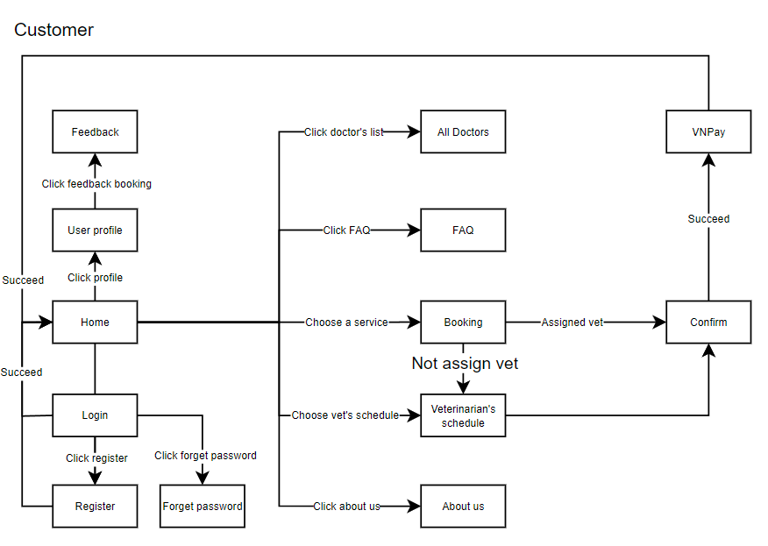

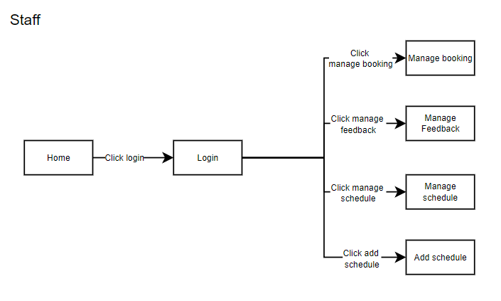

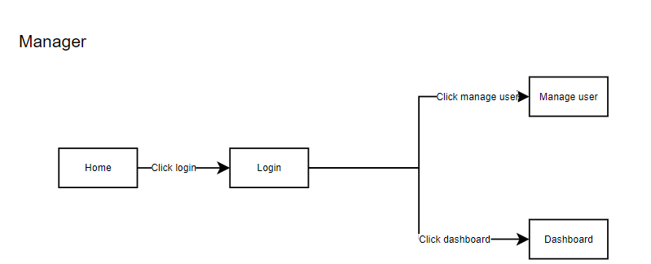

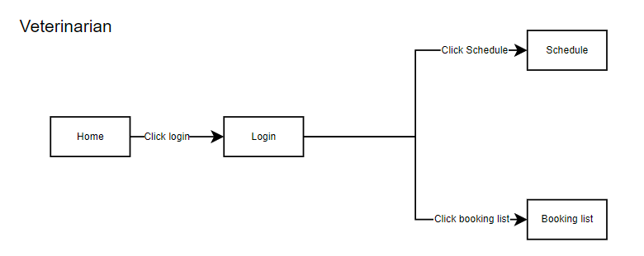

### 1.2 Screen Descriptions

|  |  |  |  |
| --- | --- | --- | --- |
| **#** | **Screen** | **Feature** | **Description** |
| FR-01 | Home | Home page | The main landing page after login, providing navigation options to access all core system features. |
| FR-02 | Login | User authentication | Users access the login page to enter credentials. If credentials are forgotten, users can recover their account using Forget Password. |
| FR-03 | Register | User registration | New users can create an account by filling in their information through the Register page. |
| FR-04 | Forget password | Password recovery | Allows users to reset their password by providing their registered email and following a password recovery process. |
| FR-05 | User profile | Manage user profile | Users can view and edit their personal details, such as email, phone number, and other personal information. |
| FR-06 | Feedback | Review Submission | Provides a section for customers to leave feedback about their experience with services and specific veterinarians. |
| FR-07 | Booking | Appointment Scheduling | Facilitates booking appointments by selecting services, choosing available dates and times, and assigning a veterinarian if needed. |
| FR-08 | FAQ | Appointment Scheduling | Facilitates booking appointments by selecting services, choosing available dates and times, and assigning a veterinarian if needed. |
| FR-09 | All Doctors | Veterinarian Listing | Displays a list of all veterinarians, with detailed profiles including qualifications, available services, and schedules. |
| FR-10 | Veterinarian's Schedule | Availability View | Shows the working schedule of a selected veterinarian, enabling customers to plan appointments according to their availability. |
| FR-11 | About Us | Company Information | Provides information about the veterinary system, its mission, team members, and services offered for Koi fish care. |
| FR-12 | Confirm | Booking Confirmation | A summary screen that confirms booking details before submission and allows users to review and make any necessary changes. |
| FR-13 | Manage booking | Manage existing bookings | Users can view, update, or cancel their upcoming bookings, depending on their current status. |
| FR-14 | VNPay | Payment gateway | The system directs users to the VNPay page for secure online payment processing. |
| FR-15 | Manage Booking | Booking Management | Allows staff to view, update, and manage customer bookings. Staff can confirm, cancel, or modify appointment details as necessary. |
| FR-16 | Manage Feedback | Manage feedback | Enables staff to review and respond to customer feedback and ratings for services and veterinarians, ensuring quality and addressing any concerns raised. |
| FR-17 | Manage Schedule | Schedule Management | Provides tools for staff to view and adjust the working schedules of veterinarians, ensuring availability and avoiding scheduling conflicts. |
| FR-18 | Add Schedule | Schedule Creation | Allows staff to add new schedules for veterinarians, specifying dates, times, and availability, ensuring updated and accurate information for appointments. |
| FR-19 | Manage User | User Management | Provides the manager with the ability to view, edit, activate/deactivate, and manage user accounts, including customers, staff, and veterinarians. |
| FR-20 | Dashboard | Performance Overview | Displays key performance indicators (KPIs), statistics, and reports related to clinic operations, booking trends, customer feedback, and overall system usage. |
| FR-21 | Schedule | View Schedule | Allows the veterinarian to view their upcoming appointments and work schedule, including details of each appointment such as time, date, and client. |
| FR-22 | Booking List | Appointment Management | Enables the veterinarian to view the list of bookings assigned to them, check details about each patient, and update the status or make notes. |

### 

### 

### 1.3 Screen Authorization

|  |  |  |  |  |  |
| --- | --- | --- | --- | --- | --- |
| **Screen** | **Guest** | **Customer** | **Staff** | **Veterinarian** | **Manager** |
| Home | X | X | X | X | X |
| Login | X | X | X | X | X |
| Register | X | - | - | - | - |
| Forget password | X | X | X | X | X |
| User profile | - | X | X | - | X |
| Booking | - | X | X | - | X |
| FAQ | X | X | X | X | X |
| All Doctors | X | X | X | X | X |
| Veterinarian's Schedule | X | X | X | X | X |
| About Us | X | X | X | X | X |
| Confirm | - | X | - | - | - |
| VNPay | - | X | - | - | X |
| Manage Booking | - | - | X | - | X |
| Manage Feedback | - | - | X | - | X |
| Manage Schedule | - | - | X | - | X |
| Add Schedule | - | - | X | - | X |
| Manage User | - | - | - | - | X |
| Dashboard | - | - | - | - | X |
| Schedule | - | - | - | X | X |
| Booking List | - | - | - | X | X |

In which:

**Guest**: Can access only publicly available screens, like Home, Login, Register, and viewing services or veterinarians.

**Customer**: Has access to booking, payment, profile, and feedback features.

**Staff**: Can manage bookings, services, and feedback but doesn't have veterinary scheduling permissions.

**Veterinarian**: Manages their schedule and provides services, with limited access to administrative screens.

**Manager**: Has full administrative control, including dashboards, reports, and feedback management.

### 1.4 Non-Screen Functions

|  |  |  |  |
| --- | --- | --- | --- |
| **#** | **System Function** | **Feature** | **Description** |
|  | VNPay Payment Integration | Payment manage | The system integrates with VNPay for secure online payments. Once a booking is confirmed, users are redirected to VNPay, where they can process payments using their preferred payment method. Upon successful payment, the system updates the booking status to *Paid*. |
|  | Email Notification | Send Email | Upon successful service booking or payment, the system sends an email confirmation to the user. It includes the details of the booking, payment, and veterinarian assigned. |
|  | ReportGeneration | Create Report | Admins have access to a report dashboard that summarises booking histories, payment statuses, and feedback ratings. This allows the admin to monitor the system’s overall performance. |

## 2. Data Requirements

### 2.1 Logical Data Model

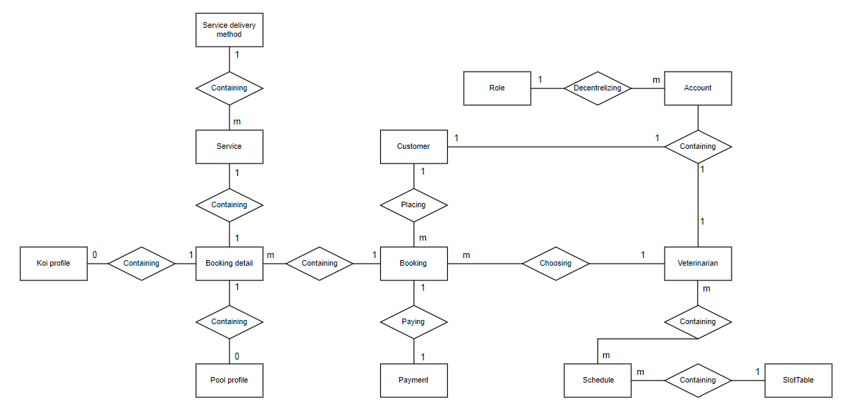

### 2.2 Data Dictionary

|  |  |  |  |  |
| --- | --- | --- | --- | --- |
| **Data Element** | **Description** | **Data Type** | **Length** | **Values or Format** |
| Customer Name | Name of the customer  who is booking the service . | Alphabetic | 50 | Uppercase and lowercase  letters only . |
| Customer Email | Email address of the  customer for account  creation and notifications . | Alphanumeric | 50 | Valid email format ( e.g. ,  user@example.com ) |
| Customer Phone Number | Contact number for the  customer . | Numeric , dashes | 15 | XXX - XXX - XXXX |
| VeterinarianName | Name of the veterinarian  providing the service . | Alphabetic | 50 | Letters only . |
| Booking ID | Unique identifier for each  service booking . | Integer | 10 | Auto - incremented . |
| Booking Date | Date on which the booking  is made . | Date | 10 | MM / DD / YYYY |
| Service Type | Type of veterinary service  selected by the customer . | Alphabetic | 30 | " Vaccination " ,  " Consultation " , " Surgery " ,  etc. |
| Booking Status | Current status of the  service booking . | Alphabetic | 20 | " Pending " , " Confirmed " ,  " Cancelled " , " Completed " |
| Service Cost | Price of the selected  service . | Numeric , dollars  & cents | 7 | DDDD.CC |
| VeterinarianRating | Customer's rating for the  veterinarian after service  completion . | Integer ( 1-5 ) | 1 | 1 to 5 |
| Feedback Comment | Customer's written  feedback on the service  provided . | Alphabetic ,  special chars | 500 | Letters , punctuation marks  allowed . |
| Payment ID | Unique identifier for each  payment transaction . | Integer | 12 | Auto - generated by the  system . |
| Payment Method | Method of payment used  by the customer . | Alphabetic | 16 | " Credit Card " , " Debit Card " ,  " VNPay " |
| Payment Amount | Total amount charged for  the booking , including  service and taxes . | Numeric , dollars  & cents | 10 | DDDD.CC |
| Transaction Number | Unique sequence number  assigned to each payment . | Integer | 12 | Auto - incremented  sequence . |
| Service Feedback ID | Unique ID for feedback  related to each service . | Integer | 10 | Auto - generated . |
| Service Description | Detailed description of the  service provided by the  veterinarian . | Alphabetic | 250 | Textual description . |
| Report Date | The date the report is  generated . | Date | 10 | MM / DD / YYYY |
| Staff Name | Name of the staff member  handling the booking . | Alphabetic | 50 | Letters only . |
| Manager Name | Name of the manager  overseeing the services or  reports . | Alphabetic | 50 | Letters only . |
| Feedback Date | Date when the customer  submitted feedback for the  service . | Date | 10 | MM / DD / YYYY |
| Booking Time | The time of day when the  booking was made . | Time | 5 | HH  format ( 24 - hour ) |
| Booking End Time | The end time of a  scheduled service . | Time | 5 | HH  format ( 24 - hour ) |
| Booking Duration | Total time duration of the  booked service . | Numeric | 5 | Measured in minutes . |
| Service Category | Category under which the  service falls ( e.g. , medical ,  grooming , etc. ) . | Alphabetic | 30 | " Medical " , " Grooming " ,  " Surgery " , etc. |
| Veterinarian Schedule | Scheduled working hours  of the veterinarian . | Time Range | 11 | Start Time - End Time ( HH  - HH  ) |
| Customer Address | Address where the service  is provided if required . | Alphanumeric | 100 | Letters , numbers , hyphens ,  and commas permitted . |

### 

### 

### 

### 2.3 Reports

|  |  |  |
| --- | --- | --- |
| ***#*** | ***Report Name*** | ***Description*** |
| RPT- 01 | Service Booking History | Users can view all past service bookings, including date, service type, veterinarian assigned, and status of the booking, helping them review past transactions. |
| RPT- 02 | Payment Report | This report provides a detailed overview of all payments made via the VNPay gateway, with filtering options for payment dates, amounts, and status (completed, pending). |
| RPT- 03 | Feedback and Ratings Report | Displays user feedback and ratings on services and veterinarians over a selected time period, helping managers assess performance and customer satisfaction. |
| RPT- 04 | Veterinarian Service Report | Shows a summary of services provided by each veterinarian within a specified time frame, including the number of bookings, service type, and feedback. |
| RPT- 05 | Dashboard Summary | Provides an overall system summary for managers, showing key metrics such as total bookings, payment status, number of active users, most popular services, and total revenue over a selected period. |

|  |  |
| --- | --- |
| Report ID | RPT - 01 |
| Report Title | Service Booking History |
| Report Purpose | Provides customers and staff with a list of all previous service bookings , including  booking details such as date , service type , and veterinarian . |
| Priority | Medium |
| Report Users | Customers , Staff |
| Data Sources | Booking database |
| Frequency | Generated on demand by customers or staff . Data is static and displayed on the web  interface . |
| Latency | Report should be generated within 3 seconds after being requested . |
| Visual Layout | Portrait mode |
| Header and  Footer | Header : report title , user's name , and report date range . Footer : page number ( if  printed ) . |
| Report Body | Booking ID , Booking Date , Service Type , Veterinarian , Booking Status |
| Selection Criteria | Date range specified by the user |
| Sort Criteria | Chronological order |
| End - of - Report  Indicator | None |

|  |  |
| --- | --- |
| Report ID | RPT - 02 |
| Report Title | Payment Report |
| Report Purpose | Provides detailed information about payments made via VNPay , including amounts and payment status . |
| Priority | High |
| Report Users | Managers , Staff |
| Data Sources | Payment database ( VNPay ) |
| Frequency | Generated monthly or on - demand for financial auditing purposes . |
| Latency | Must load within 2 seconds after request . |
| Visual Layout | Landscape mode |
| Header and Footer | Header : report title , user name , and payment time period . Footer : page number ( if printed ) . |
| Report Body | Payment ID , Customer Name , Payment Date , Amount Paid , Payment Status ( Completed , Pending ) |
| Selection Criteria | Date range , payment status |
| Sort Criteria | Date of payment |
| End - of - Report Indicator | None |
| Security Restrictions | Only accessible by authorized staff and managers . |

|  |  |
| --- | --- |
| Report ID | RPT - 03 |
| Report Title | Feedback and Ratings Report |
| Report Purpose | Analyzes customer feedback and ratings for services provided within a specified period . |
| Priority | Medium |
| Report Users | Managers |
| Data Sources | Feedback and rating database |
| Frequency | Generated weekly and available on the dashboard . |
| Latency | Must display within 3 seconds after request . |
| Visual Layout | Portrait mode |
| Header and Footer | Header : report title , date range , and feedback trends . Footer : page number ( if printed ) . |
| Report Body | Feedback ID , Service Type , Veterinarian Name , Rating , Comments |
| Selection Criteria | Time range , rating ( low to high ) |
| Sort Criteria | Service type , rating |
| End - of - Report  Indicator | None |
| Security Restrictions | Managers only . |

|  |  |
| --- | --- |
| Report ID | RPT - 04 |
| Report Title | Veterinarian Service Report |
| Report Purpose | Provides a summary of services provided by each veterinarian within a given  timeframe , including bookings and feedback . |
| Priority | Medium |
| Report Users | Managers , Veterinarians |
| Data Sources | Booking and service database |
| Frequency | Generated on - demand or monthly for performance evaluations . |
| Latency | Must display within 3-4 seconds . |
| Visual Layout | Landscape mode |
| Header and Footer | Header : report title , veterinarian's name , and time period . Footer : page number ( if  printed ) . |
| Report Body | Veterinarian Name , Service Type , Number of Bookings , Feedback ( if available ) |
| Selection Criteria | Veterinarian name , time period |
| Sort Criteria | Number of bookings , service type |
| End - of - Report  Indicator | None |
| Security  Restrictions | Veterinarians view only their own report ; Managers can view all reports . |

|  |  |
| --- | --- |
| Report ID | RPT - 05 |
| Report Title | Dashboard Summary |
| Report Purpose | Provides a high - level summary of key metrics like bookings , payments , user statistics ,  and feedback for managers . |
| Priority | High |
| Report Users | Managers |
| Data Sources | Booking , payment , user , and feedback databases |
| Frequency | Displayed in real - time on the manager's dashboard . |
| Latency | Instant ( real - time ) |
| Visual Layout | Dashboard format ( not printable ) |
| Report Body | Total Bookings , Total Payments , Active Users , Top - rated Services , Revenue by service  type |
| Selection Criteria | Automatic real - time data |
| Sort Criteria | Service type , user activity |
| End - of - Report  Indicator | None |
| Security Restrictions | Managers only . |

### 2.4 State transition diagram

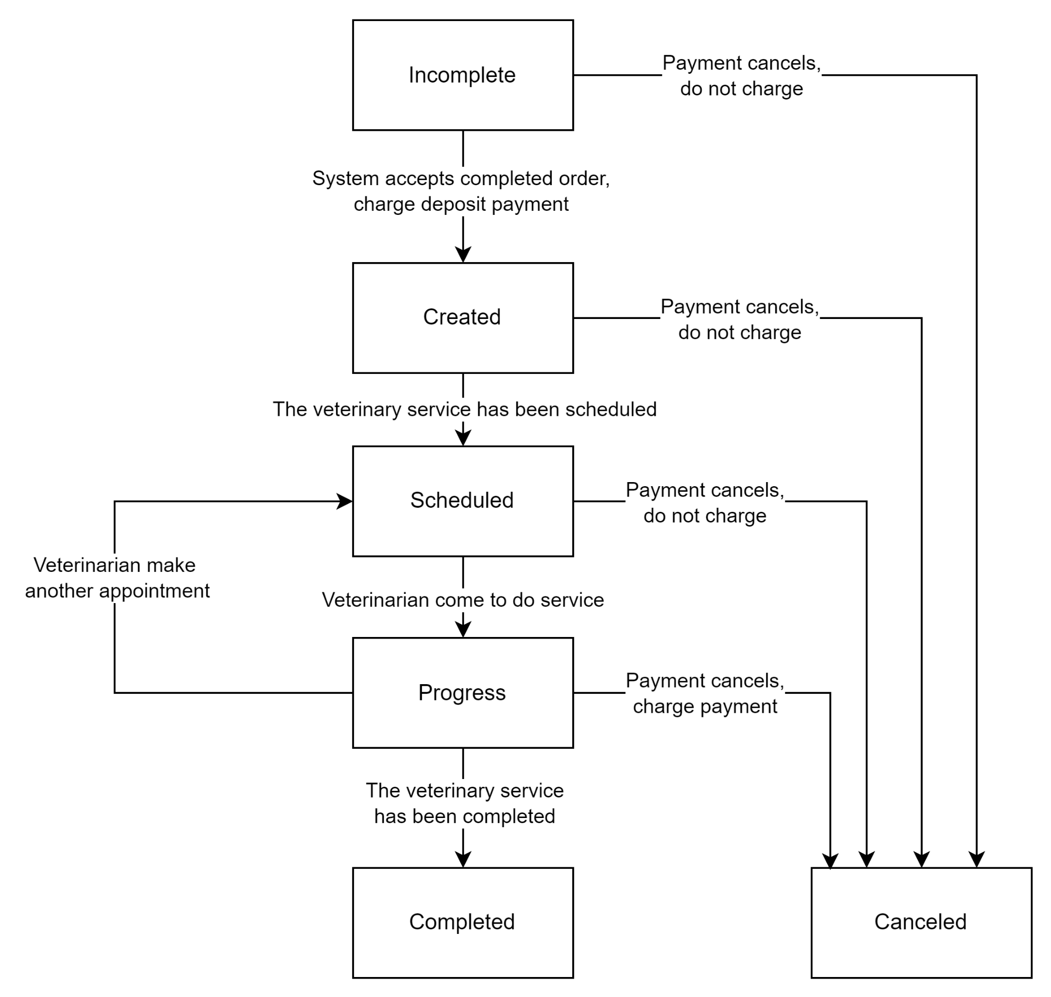

## 3. Home Page (FR-01)

### 3.1 Home Screen

- Function Trigger: Triggered upon successful user login, and accessible via the main navigation menu.

- Function Description:

- Actors/Roles: All user types (Customers, Staff, Manager).

- Purpose: Serves as the main landing page providing access to key system features through navigation options.

- Interface: Displays a welcome message, a quick overview of system stats (e.g., upcoming appointments, feedback), and links to core functions like booking, user profile, and feedback.

- Data Processing: None directly; it pulls static information and system highlights.

- Screen Layout: The screen includes sections for a welcome banner, a navigation panel, and a summary of system highlights.

- Function Details:

- Data: No user data entry is required.

- Validation: No input validation; static display only.

- Business Logic: Displays information relevant to the user role (e.g., different quick actions for staff vs. customer).

- Normal Case: All users see the same Home screen structure with role-based options.

- Abnormal Case: If a user session expires, they are redirected to the login screen.

## 4. Login (FR-02)

### 4.1 User Login Screen

- Function Trigger: Accessed via the main system URL or when a user attempts to access restricted content without logging in.

- Function Description:

- Actors/Roles: All users needing access to the system.

- Purpose: Allows users to securely log into the system.

- Interface: Displays fields for username and password, along with buttons for "Login" and "Forget Password".

- Data Processing: Validates credentials against stored user information in the database.

- Screen Layout: A simple form layout with fields for entering username and password and a link for "Forget Password".

- Function Details:

- Data: Requires input of username and password.

- Validation: Checks username and password; provides error messages for incorrect inputs.

- Business Logic: If correct credentials are provided, the system grants access and redirects to the Home page.

- Normal Case: User inputs correct credentials and is redirected.

- Abnormal Case: Incorrect login details prompt an error message, allowing the user to retry.

### 5. Register (FR-03)

### 5.1 User Registration Screen

- Function Trigger: Accessible through the main navigation menu or link from the Login page.

- Function Description:

+ Actors/Roles: New users wanting to register for system access.

+ Purpose: Enables new users to create an account.

- Interface: Presents fields for entering user information (e.g., email, password, contact number) and a submit button.

- Data Processing: Stores user details in the database after successful validation.

- Screen Layout: Form layout with fields for necessary registration details.

- Function Details:

+ Data: User inputs required for registration.

+ Validation: Ensures fields like email format, password strength, and unique email.

+ Business Logic: On successful submission, the user is registered and redirected to the Login page.

+ Normal Case: Valid data allows successful registration.

+ Abnormal Case: Invalid data prompts validation error messages, blocking submission.

## 6. Forget Password (FR-04)

### 6.1 Password Recovery Screen

- Function Trigger: Accessed via "Forget Password" link on the Login screen.

- Function Description:

+ Actors/Roles: Any user who has forgotten their login credentials.

+ Purpose: Allows users to reset their password by entering their registered email.

+ Interface: Provides a form to enter the registered email and submit.

+ Data Processing: Sends a recovery link to the entered email if it matches a registered account.

- Screen Layout: Single input form for email, with instructions on resetting the password.

- Function Details:

+ Data: Requires user’s registered email.

+ Validation: Checks if the email matches any registered account.

+ Business Logic: Sends a recovery email with a reset link to the provided email.

+ Normal Case: Valid email triggers a password reset email.

+ Abnormal Case: Unregistered email entry prompts an error message.

## 7. User Profile (FR-05)

### 7.1 Manage Profile Screen

- Function Trigger: Accessible via the Home screen or main navigation.

- Function Description:

+ Actors/Roles: Logged-in users wishing to manage their personal information.

+ Purpose: Enables users to view and edit their personal details.

+ Interface: Form with fields like email, phone number, address, etc., allowing updates.

+ Data Processing: Updates user profile information in the system upon saving.

- Screen Layout: Editable form layout with user profile fields.

- Function Details:

+ Data: User inputs for updating personal details.

- Validation: Ensures fields are in the correct format and adhere to data integrity constraints.

- Business Logic: Saves updated data to the system and confirms the update.

- Normal Case: User successfully updates profile.

- Abnormal Case: Invalid input prompts error messages for correction.

## 8. Feedback (FR-06)

### 8.1 Review Submission Screen

- Function Trigger: Accessible from the Home page or main navigation after login.

- Function Description:

+ Actors/Roles: Customers who have used the clinic’s services.

+ Purpose: Allows customers to provide feedback on services or veterinarians.

+ Interface: A form for submitting feedback, with fields for rating (e.g., 1-5 stars), comments, and the veterinarian’s name (if applicable).

+ Data Processing: Stores submitted feedback in the database for review by the staff.

- Screen Layout: Form layout with fields for star rating, feedback text, and optional veterinarian selection.

- Function Details:

+ Data: User-entered feedback details.

+ Validation: Ensures feedback meets minimum character limits and rating selection.

+ Business Logic: Feedback is saved to the system and marked as pending review.

+ Normal Case: User submits valid feedback successfully.

+ Abnormal Case: Incomplete or missing feedback details prompt validation messages.

## 9. Booking (FR-07)

### 9.1 Appointment Scheduling Screen

- Function Trigger: Accessed from the Home page or main navigation.

- Function Description:

+ Actors/Roles: Customers scheduling an appointment.

+ Purpose: Facilitates appointment scheduling by allowing users to choose a service, date, time, and assign a veterinarian.

+ Interface: Form with options to select a service, date picker, time slots, and veterinarian selection (optional).

+ Data Processing: Records the booking details in the system and verifies availability.

- Screen Layout: Interactive form with dropdowns for services, date and time pickers, and a "Book Appointment" button.

- Function Details:

+ Data: Inputs for service, date, time, and optional veterinarian.

+ Validation: Checks for time conflicts and service availability.

+ Business Logic: Confirms booking if slots are open; otherwise, alerts the user.

+ Normal Case: User completes and confirms the booking.

+ Abnormal Case: Overbooked or unavailable slot prompts user to select different options.

## 10. FAQ (FR-08)

### 10.1 FAQ Section

- Function Trigger: Available in the main navigation or accessible from the Home page.

- Function Description:

+ Actors/Roles: All users.

+ Purpose: Provides answers to common questions about appointments, services, and policies.

+ Interface: A list or accordion of frequently asked questions with answers.

+ Data Processing: Static information displayed to users.

- Screen Layout: List or collapsible view showing each question and its answer.

- Function Details:

+ Data: No data entry required.

+ Validation: N/A.

+ Business Logic: Display only; no complex functionality.

+ Normal Case: Users browse through FAQs.

+ Abnormal Case: N/A.

## 11. All Doctors (FR-09)

### 11.1 Veterinarian Listing Screen

- Function Trigger: Accessed via main navigation or Home page.

- Function Description:

+ Actors/Roles: Customers looking for available veterinarians.

+ Purpose: Lists veterinarians with profiles showing qualifications, services, and availability.

+ Interface: Displays cards or list items for each veterinarian, including an option to view more details.

+ Data Processing: Pulls veterinarian information from the database.

- Screen Layout: List or card layout showing veterinarian name, photo, qualifications, and services.

- Function Details:

+ Data: Display of system-stored veterinarian profiles.

+ Validation: N/A.

+ Business Logic: Simple display of profiles; clicking a profile shows more details.

+ Normal Case: Users browse available veterinarians.

+ Abnormal Case: If no veterinarians are available, display a “No veterinarians found” message.

## 12. Veterinarian’s Schedule (FR-10)

### 12.1 Availability View Screen

- Function Trigger: Accessed from the "All Doctors" screen by selecting a specific veterinarian.

- Function Description:

+ Actors/Roles: Customers and staff.

+ Purpose: Shows the selected veterinarian's working schedule.

+ Interface: Calendar or list view showing available dates and times for appointments.

+ Data Processing: Queries the database for the veterinarian’s schedule.

- Screen Layout: Calendar or schedule list showing available time slots.

- Function Details:

+ Data: Display of pre-scheduled availability.

+ Validation: Ensures selected slots do not conflict with existing bookings.

+ Business Logic: Prevents double-booking by locking booked slots.

+ Normal Case: Users view available dates and times.

+ Abnormal Case: No available slots display a “No availability” message.

## 13. About Us (FR-11)

### 13.1 Company Information Screen

- Function Trigger: Accessed via the main navigation or footer.

- Function Description:

+ Actors/Roles: All users.

+ Purpose: Provides background information on the veterinary clinic, mission, and services.

+ Interface: Text and images presenting company details.

+ Data Processing: Static information display.

- Screen Layout: Text and image layout with sections on mission, services, and team.

- Function Details:

+ Data: Static display; no input.

+ Validation: N/A.

+ Business Logic: Simple display.

+ Normal Case: All users view company information.

+ Abnormal Case: N/A.

## 14. Confirm (FR-12)

### 14.1 Booking Confirmation Screen

- Function Trigger: Accessed after selecting appointment details in the Booking screen.

- Function Description:

+ Actors/Roles: Customers finalizing their appointments.

+ Purpose: Provides a summary of booking details for review before final submission.

+ Interface: Displays booking details, with options to confirm or edit the appointment.

+ Data Processing: Final confirmation saves the appointment in the database.

- Screen Layout: Summary screen with “Confirm” and “Edit” buttons.

- Function Details:

+ Data: Confirmation of appointment details.

+ Validation: N/A.

+ Business Logic: Confirms booking details before saving.

+ Normal Case: Users review and confirm appointments.

+ Abnormal Case: User edits booking details if changes are needed.

## 15. Manage Booking (FR-13)

### 15.1 Booking Management Screen

- Function Trigger: Accessed from the main navigation for managing current bookings.

- Function Description:

+ Actors/Roles: Customers.

+ Purpose: Allows customers to view, update, or cancel their bookings.

+ Interface: List of upcoming bookings with options to view, edit, or cancel.

+ Data Processing: Updates or deletes booking records.

- Screen Layout: List view showing each booking with action buttons.

- Function Details:

+ Data: Booking details for each appointment.

+ Validation: Ensures valid updates without conflicts.

+ Business Logic: Modifies or cancels bookings based on user actions.

+ Normal Case: Users manage their appointments.

+ Abnormal Case: Invalid updates prompt correction messages.

## 16. VNPay (FR-14)

### 16.1 Payment Gateway Integration Screen

- Function Trigger: Triggered after a customer confirms their booking and proceeds to pay.

- Function Description:

+ Actors/Roles: Customers making payments for appointments.

+ Purpose: Redirects users to the VNPay portal for secure online payment processing.

+ Interface: Displays a "Proceed to Payment" button that redirects to the VNPay gateway.

+ Data Processing: Collects payment details from VNPay and records transaction success or failure.

- Screen Layout: Simple confirmation screen with a "Proceed to Payment" button.

- Function Details:

+ Data: Booking details and total payment amount.

+ Validation: Confirms transaction status post-payment.

+ Business Logic: Marks booking as “Paid” on successful payment.

+ Normal Case: Users proceed to VNPay and complete payment.

+ Abnormal Case: Payment failure redirects to a retry or support option.

## 17. Manage Booking (Admin) (FR-15)

### 17.1 Admin Booking Management Screen

- Function Trigger: Accessed via staff/admin panel in the navigation.

- Function Description:

+ Actors/Roles: Staff and managers overseeing customer bookings.

+ Purpose: Allows staff to view, update, confirm, or cancel customer bookings.

+ Interface: List view showing all customer bookings, with action buttons for confirming, updating, or cancelling.

+ Data Processing: Updates booking status, modifies details, or removes appointments.

- Screen Layout: Admin dashboard layout with filters and action buttons for each booking.

- Function Details:

+ Data: Displays all bookings with relevant details.

+ Validation: Ensures staff actions don’t conflict with system constraints.

+ Business Logic: Allows modification or cancellation of bookings.

+ Normal Case: Staff manage bookings based on customer needs.

+ Abnormal Case: Attempts to confirm unavailable slots show an error message.

## 18. Manage Feedback (FR-16)

### 18.1 Feedback Management Screen

- Function Trigger: Accessed via staff/admin panel.

- Function Description:

+ Actors/Roles: Staff or managers reviewing customer feedback.

+ Purpose: Enables staff to review and respond to customer feedback, addressing service concerns or highlighting positive reviews.

+ Interface: List view of feedback submissions with options to view details, respond, or flag issues.

+ Data Processing: Records staff responses and feedback statuses.

- Screen Layout: Feedback dashboard with each entry displaying customer name, rating, comments, and response options.

- Function Details:

+ Data: Feedback and responses from customers.

+ Validation: N/A for customer input; staff can flag inappropriate feedback.

+ Business Logic: Tracks feedback responses, displays flags for unresolved items.

+ Normal Case: Staff view and respond to feedback.

+ Abnormal Case: No feedback available displays “No feedback found” message.

## 19. Assign Schedule (FR-17)

### 19.1 Schedule Assign Screen

- Function Trigger: Accessed from the staff panel.

- Function Description:

+ Actors/Roles: Staffs assigns veterinarians’ schedules.

+ Purpose: Allows staff to update and adjust veterinarian availability.

+ Interface: Calendar or schedule form where dates and times can be modified.

+ Data Processing: Stores or updates veterinarian availability in the database.

- Screen Layout: Calendar layout or form view with date and time selection.

- Function Details:

+ Data: Schedule inputs, including available dates, times and booking on the day.

+ Validation: Ensures no overlap with existing bookings.

+ Business Logic: Modifications sync with the booking system to prevent conflicts.

+ Normal Case: Staffs successfully assign schedule as needed.

+ Abnormal Case: Conflicts prompt a rescheduling message.

## 20. Add Schedule (FR-18)

### 20.1 Schedule Creation Screen

- Function Trigger: Accessed via schedule management interface.

- Function Description:

+ Actors/Roles: Staffs creating new schedules.

+ Purpose: Enables staff to add new availability schedule for veterinarians.

+ Interface: Form for adding date, time, and availability details.

+ Data Processing: Adds new schedules to the database and updates veterinarian profiles.

- Screen Layout: Form layout for entering new schedule details.

- Function Details:

+ Data: New schedule details.

+ Validation: Confirms dates don’t conflict with existing bookings.

+ Business Logic: New slots are displayed to customers as open for booking.

+ Normal Case: Schedule added successfully.

+ Abnormal Case: Date conflicts prompt error messages.

## 21. Manage User (FR-19)

### 21.1 User Management Screen

- Function Trigger: Accessed via the admin panel.

- Function Description:

+ Actors/Roles: Managers managing system users.

+ Purpose: Allows managers to view, activate/deactivate, and update user accounts.

+ Interface: List view with action buttons for each user to update or change status.

+ Data Processing: Modifies user account details or status in the system.

- Screen Layout: User management dashboard with filtering and action options.

- Function Details:

+ Data: User profile and status information.

+ Validation: Ensures data integrity.

+ Business Logic: Controls user access levels based on role.

+ Normal Case: Managers successfully manage user accounts.

+ Abnormal Case: Errors prompt corrective actions.

## 22. Dashboard (FR-20)

### 22.1 Performance Overview Screen

- Function Trigger: Accessed via the admin panel.

- Function Description:

+ Actors/Roles: Managers monitoring clinic performance.

+ Purpose: Displays KPIs, reports, and usage statistics.

+ Interface: Charts and tables summarising bookings, feedback, and activity metrics.

+ Data Processing: Aggregates system data for reporting.

- Screen Layout: Dashboard with interactive charts and tables.

- Function Details:

+ Data: System metrics for performance analysis.

+ Validation: N/A.

+ Business Logic: Updates in real-time for accuracy.

+ Normal Case: Managers view reports on clinic performance.

+ Abnormal Case: No data results in “No data available” notice.

## 23. Schedule (Veterinarian) (FR-21)

### 23.1 View Schedule Screen

- Function Trigger: Accessed by veterinarians from their account dashboard.

- Function Description:

+ Actors/Roles: Veterinarians viewing their schedules.

+ Purpose: Allows veterinarians to review their upcoming appointments.

+ Interface: Calendar or list of appointments.

+ Data Processing: Pulls scheduled appointments from the database.

- Screen Layout: Calendar or list format with appointment details.

- Function Details:

+ Data: Scheduled appointments.

+ Validation: N/A.

+ Business Logic: Veterinarians can view but not modify schedules.

+ Normal Case: Veterinarian views schedule.

+ Abnormal Case: N/A.

## 24. Booking List (FR-22)

### 24.1 Appointment Management Screen

- Function Trigger: Accessed from the veterinarian’s dashboard.

- Function Description:

+ Actors/Roles: Veterinarians managing patient appointments.

+ Purpose: Lists all bookings assigned to the veterinarian, with details for each patient.

+ Interface: List view of assigned bookings with notes and status update options.

+ Data Processing: Updates appointment status or adds notes.

- Screen Layout: List view with booking details and action buttons.

- Function Details:

+ Data: Booking details, notes.

+ Validation: Ensures data integrity.

+ Business Logic: Enables veterinarians to update appointment status.

+ Normal Case: Veterinarian manages appointment list.

+ Abnormal Case: Missing data prompts appropriate alerts.

This feature breakdown provides a structured view of each function, ensuring that all actors, business logic, and data processes are fully covered.

# V. Non-Functional Requirements

## 1. External Interface Requirements

### 1.1 User Interfaces

**UI-1**: The Koi Fish Veterinary System (KFVS) screens shall follow the Koi Care User Interface Design Standard, Version 1.0.

**UI-2**: The system shall provide a help link on each displayed webpage to guide users on utilising each feature.

**UI-3**: Each screen will permit complete navigation and operation via keyboard inputs, as well as mouse interactions, to ensure accessibility for various user preferences.

### 1.2 Software Interfaces

**SI-1**: KFVS shall interact with the Koi Health Database System (KHDS) to access health records and history through a secure API.

**SI-1.1**: The KFVS will retrieve data on previous health checkups, treatment histories, and prescriptions through a programmatic interface.

**SI-1.2**: The system will update health records in the KHDS after each vet consultation.

**SI-2:** The KFVS (Koi Fish Veterinary System) will integrate with the VNPAY payment system to facilitate secure and efficient payment processing for services rendered.

**SI-2.1**: The KFVS shall connect with the VNPAY API to initiate payment requests, enabling users to complete transactions via the VNPAY platform.

**SI-2.2**: The KFVS shall receive transaction confirmation messages from VNPAY, updating the user’s payment status in the system automatically.

**SI-2.3**: The system shall handle errors or transaction failures by displaying appropriate error messages to users and providing options to retry or cancel the payment.

**SI-2.4**: The KFVS shall log all transactions with VNPAY for tracking and reconciliation purposes.

**SI-2.5**: Payment data exchanged with VNPAY shall be encrypted to ensure secure transmission of sensitive information, following relevant data protection standards.

### 1.3 Hardware Interfaces

HI-1: ***Server Configuration***

*Application Server*

CPU : Intel Xeon 12 Core 2.5 GHz

Memory Space : 128 GB RAM 3200 MHz

Storage Space : 4 TB

Operating System : MS Windows Server 2019

Software : Microsoft IIS 10.x, .NET Framework 4.8

*Database Server*

CPU : Intel Xeon 16 Core 2.5 GHz

Memory Space : 256 GB RAM 3200 MHz

Storage Space : 6 TB

Operating System : MS Windows Server 2019

Software : Microsoft SQL Server 2019

HI-2: ***Client Configuration***

*PC Device*

CPU : Intel Core i3 or higher

Memory Space : 8 GB RAM 3200MHz

Storage Space : HDD: 500GB, 2.5" SATA x 2, RAID 1

Operating System : Win10/Win11

Operator Display : 18.5-inch widescreen, 16:9 format

1280 x 720 pixel, 1024 x 768 pixel

*Mobility Device*

CPU : Dual-Core 2.2 GHz or higher

Memory Space : 2 GB

Storage Space : 64 GB

Operating System : Android 14.0, IOS 15 or higher

Wifi Standard : 5GHz Wi-fi

Operator Display : 7.0 inches, 16:9 format

1280 x 800 Pixels

HI-3: ***Network***

LAN Network : Speed ≥ 1 Gbps

WAN Network : Speed ≥ 2Mbps/10 Users operate together

### 1.4 Communications Interfaces

The communication interface requirements detail the messaging protocols and security for data exchanges.

**CI-1**: The KFVS shall send email notifications to the koi owner upon confirming appointments, treatment updates, or vaccination schedules.

**CI-2**: The system shall send an email or SMS notification if any diagnostic results require immediate attention

## 2. Quality Attributes

### 2.1 Usability

These requirements aim to ensure that the KFVS provides a user-friendly experience.

**USE-1**: The KFVS shall allow users to view past health records and booking histories with one click.

**USE-2**: 90% of new users shall be able to navigate the appointment scheduling feature without errors on their first attempt.

### 2.2 Performance

**PER-1**: The system shall support up to 100 users with a maximum of 50 concurrent users during peak hours (8:00 A.M. to 10:00 A.M, 14:00 P.M to 16:00 P.M).

**PER-2**: 95% of pages shall load within 3 seconds for users on a 10 Mbps or faster internet connection

### 2.3 Security

**SEC-1**: All personal and medical data transfers within the KFVS shall be encrypted using AES-256 encryption.

**SEC-2**: Users must log in to access all health records and diagnostic data.

**SEC-3**: Only authorised veterinarians and administrators (staff, manager) shall have access to modify health records.

### 2.4 Safety

No content

### 2.5 Availability

**AVL-1**: The KFVS shall be available at least 99% of the time between 7:00 A.M. and 17:00 P.M. local time, excluding scheduled maintenance.

**AVL-2**: Downtime for maintenance shall not exceed 1 hour per month, scheduled during non-peak hours.

### 2.6 Reliability

**REL-1**: No more than 3 data operations out of 1,000 should fail due to software issues.

**REL-2**: The mean time between failures (MTBF) for the KFVS should be at least 60 days.

**2.7 Design Constraints**

**DES-1**: Programming languages: C# and .NET Core.

**DES-2**: Web server: IIS 10.

**DES-3**: Database: SQL Server 2019.

**DES-4**: Design tools: Visual Studio 2019, SQL Server Management Studio, Visual Studio Code.

**DES-5:** Test tools: Postman

**DES-6:** Other: Github, Git

### 2.8 [Others as relevant]

No content