[Currently Shop is supporting 03 forms of payment, including:

1. Pay by banking system
2. VNPAY QR
3. Ship COD

**Step 1:** **You need to click on the link to see the order sent in the mail**

**And click to choose payment method:**

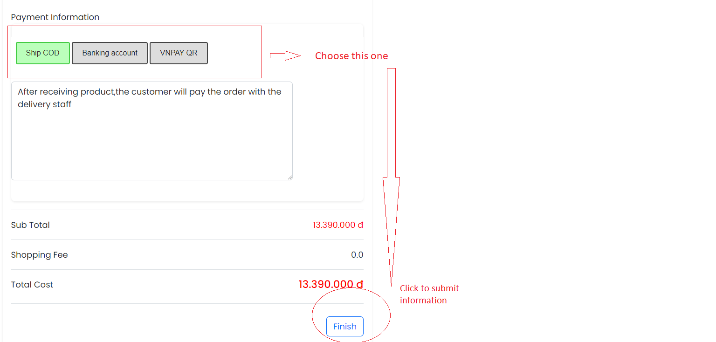

**Step 2:** **You click to ‘Finish’ to submit your payment method**

**And finish your cart**

**Detail Payment guide**

**1.Pay by banking system**

Customers pay in advance for orders through the account number below.

Sales staff will activate the order when receiving the money.

**Bank system:***TPBANK*

**Account holder:***Bui Anh Dung*

**Bank Account number**:*03253556201*

**2. Vn pay**

The system will show you QR CODE

And you login vnpay app in mobile

To scan QR for payment

**3. Ship COD**

After receiving product,the customer will pay the order with the delivery staff

**⚠️Note:**

+If you do not complete order confirmation, the order will be deleted after 1 day by the administrator

+You can cancel your order until the active status is confirmed