**ĐỀ THI TRẮC NGHIỆM**

**Mã đề: 123**

**Kỳ thi: …**

**Môn: ….**

Câu 1: Should I go over the material once again before showing it to the client?

A. It’s about our new product.

B. That’d be a wise thing to do.

C. He is expected to show up soon.

Câu 2: Did you hear about John’s promotion?

A. The sales promotion was successful.

B. Yes, he is being recognized for the great work he did on the project.

C. No, I have not heard anything from him yet.

Câu 3: The bonuses will be paid this month, won’t they?

A. No, I paid the bill last month.

B. Yes, they will.

C. Payday is this Friday.

Câu 4: What is PI number?

A. 1. B. 2. C. 3, 14. D. 4.

Câu 5: Who is going to attend the Mr. McKenzie’s retirement party?

A. Everyone except Jill.

B. He has not arrived yet.

C. Let’s go right now.

Câu 6: Would you like to reserve the larger hall for the event?

A. Yes, I’ve already completed it.

B. It’s bigger than the others.

C. Yes, that would be fine.

I don’t be an answer

Câu 7: What is the correct fomular?

A. B. C. D.

Câu 8: Who is in the picture?

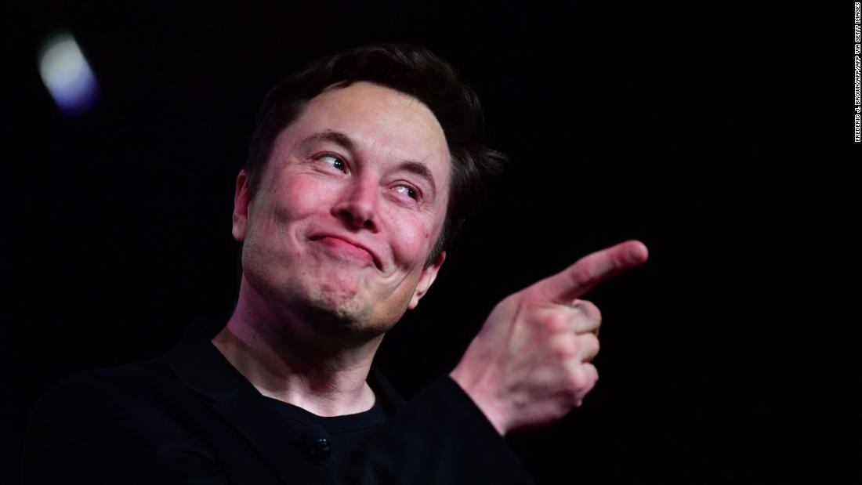

A. Bill Gates.

B. Elon Musk.

C. Jeff Bezos.

D. Larry Ellision.

**- HẾT -**