Đề thi tổng kết
Môn: Tiếng anh căn bản
Thời gian: 60 phút

Câu 1. In case of inclement weather, employees are encouraged to work _____ rather than travel to the office.
A. Carefully
B. Eventually
C. Closely
D. Remotely
Câu 2. ______ two additional designers are hired, current staffers will not need to work overtime to complete projects on time.
A. Already B. Instead C. Whether D. If
Câu 3. During yesterday’s meeting, Ms. Milne offered her _____ to the salse team for their excellent results this quarter.
A. congratulations
B. congratulate
C. congratulating
D. congratulatory
Câu 4. When filling out the order form, please _____ your address clearly to prevent delays.
A. Write B. Send C. Fix D. Direct
Câu 5. Marburg Electro Company is ______ to report a significant increase in profits for the year.
A. Earned B. Expected C. Risen D. Outgrown
Câu 6. The upcoming _____ of Tantino Airport will ease congestion and modernize guest accommodations.
A. performance
B. supplement
C. deadline
D. renovation
Câu 7. Ms. Hu will check the storage closet before she ______ more office supplies.
A. Contains B. Writes C. Copies D. Orders
Câu 8. Due to the ongoing renovations in the lobby, please do not enter the building through the north entrance until you are _____ other wise.
A. Realized B. Achieved C. Notified D. Searched
Câu 9. The Delmar Highway Department _____ an online list of current road closures.
A. maintenance
B. maintains
C. maintaining
D. is maintained
Câu 10.
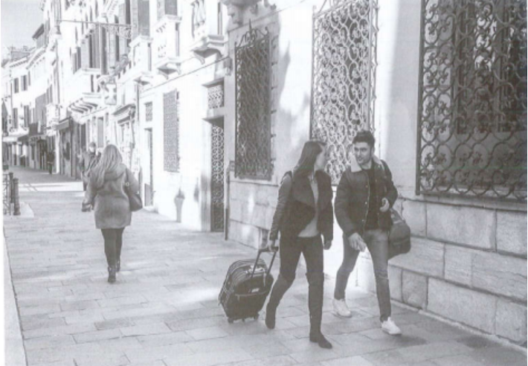
A. They’re taking off their jackets.
B. They’re walking outside.
C. They’re going into a building.
D. They’re packing some luggage.
Câu 11. She has very high _____ for her new job, although she has only been there for a week.
A. expecting
B. expectedly
C. expected
D. expectations
Câu 12. Workers in ther Accounting Department have a _____ to ensure that the company’s funds are not wasted.
A. responsibly
B. responsible
C. responsibility
D. responsibilities
Câu 13.
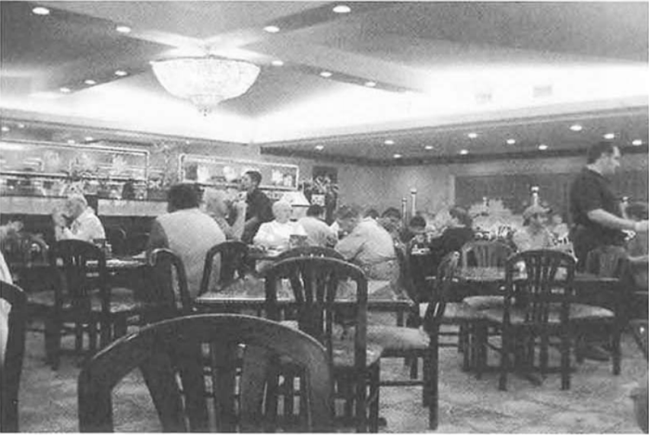
A. Everyone is sitting in their seats.
B. People are watching a band playing jazz.
C. There are some empty seats in the restaurant.
D. People are ordering food from the menu.
Câu 14. During the busy tourist season, you should _____ hetel reservations several weeks ahead of time.
A. make B. making C. made D. makes
Câu 15. The _____ of our factory equipment is vital for the high quality of out manufactured goods.
A. reliable B. reliably C. relied D. reliability
Câu 16. ______ Usually have boiled rice and meat for lunch?
A. Have you
B. Do you
C. Are you
D. Had you
Câu 17. Listen! Someone _____ in the shower!
A. Is sing
B. Singing
C. Sings
D. Is singing
Câu 18. The analyst’s commentary in the progress report was sharply _____ of the leadership team.
A. critic
B. critically
C. critical
D. criticism
Câu 19. My brother _____ (have) never been to Europe until he went there last year.
A. had B. hadn’t C. has D. have
Câu 20. Participating in public-service ______ is just one of many ways companies can improve their company image and bring unity among their employees.
A. Active B. Activities C. Activate D.Activation
Câu 21. Videos of Korean pop music have become very popular _____ adolescents worldwide.
A. Including B. Whereas C. Among D. Within
Câu 22. Save 25 percent on any printer _____ you buy a laptop computer at Diego’s Electronics.
A. whereas
B. sush as
C. seeing that
D. whenever
Câu 23.
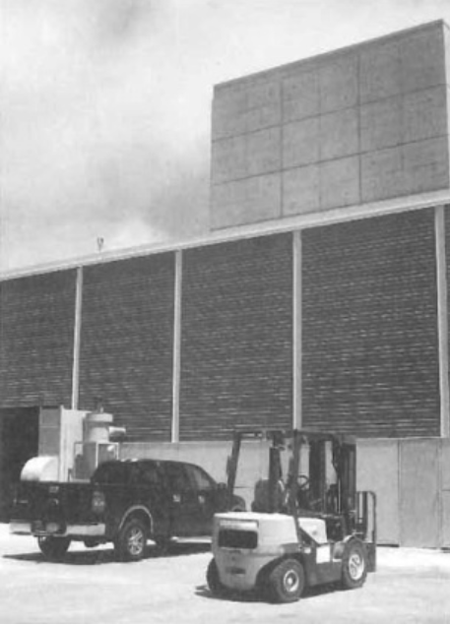
A. Workers are entering a factory.
B. A machine is pouring cement.
C. A truck is being towed.
D. Vehicles are parked side by side.
Câu 24. Because there were so _____ people registered for the Business Writing seminar, it was postponed until September.
A. few B. barely C. less D. hardly
Câu 25. All of the trees on the property were damaged in the storm _____ the one near the rear entrance.
A. Except B. Considering C. Still D. Along
Câu 26.
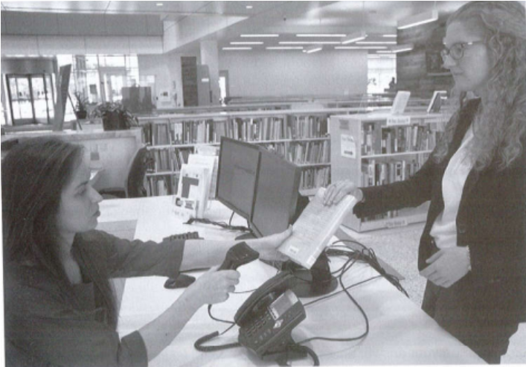
A. One of the women is removing an item from a shelf.
B. The women are across the desk from each other.
C. The women are shaking hands.
D. One of the women is making a phone call.
Câu 27. The event planner determined that Tuesday’s forum will require _____ chairs.
A. Additions B. Additional C. Addition D. Additionally
Câu 28. I was afraid to ask her out because she _____ me before.
A. Had rejected
B. Rejected
C. Was rejecting
D. Has Rejected
Câu 29. After twenty-three years of _____, Jeffrey Bartlett is retiring from his position as chief accounting officer.
A. server
B. serving
C. serves
D. service
Câu 30.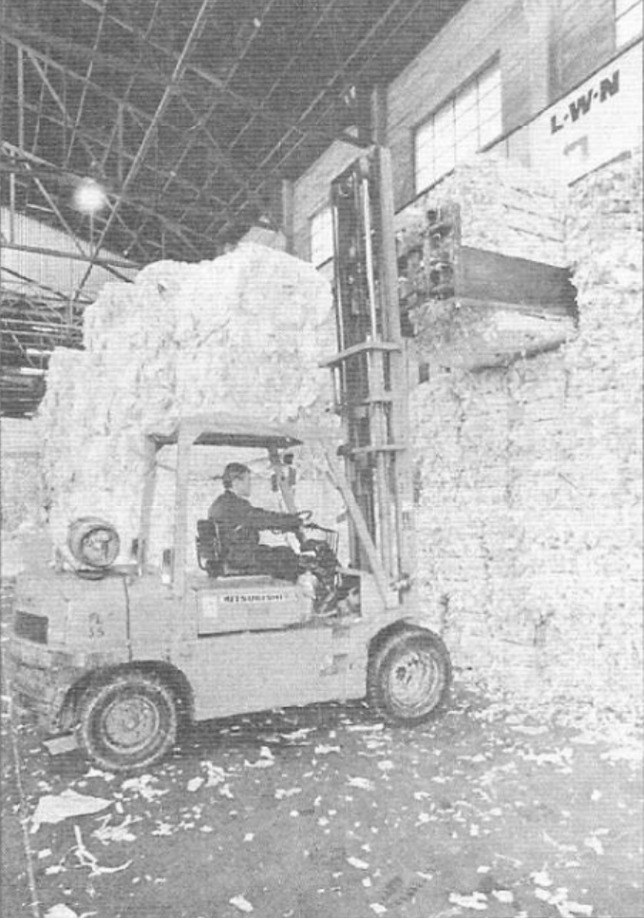
A. He’s operating heavy equipment.
B. He’s shredding paper.
C. He’s using a knife and fork.
D. He’s driving to work.
Câu 31. She ______ lunch when someone rang the doorbell.
A. Prepared
B. Has been preparing
C. Was preparing
D. Has prepared
Câu 32. My father hasn’t smoked cigarettes for a month.
A. It’s a month ago that my father smoked cigarettes.
B. It’s a month that my father hasn’t smoked cigarettes.
C. It’s a month since my father last smoked cigarettes.
D. It’s a cigarette that my father smoked a month ago.
Câu 33. In the event of _____ weather, the employee recognition ceremony will be relocated from the gradents to the conference room.
A. Vigilant B. Susceptible C. Inclement D. Unfounded
Câu 34. _____ films should be made for school.
A. Educational
B. Educated
C. Educate
D. Education
Câu 35. The bench would collapse if they _____ on it.
A. stand B. standing C. stood D. stands
Câu 36. He was finally _____ in his final attempt.
A. successive
B. unsuccessful
C. successful
D. success
Câu 37. Please complete and return this form ______ the enclosed envelope, along with any required documentation, by August 1.
A. At B. To C. On D. In
Câu 38. Marsha sometimes _____ her homeword.
A. Doesn’t do
B. Hasn’t done
C. Has been done
D. Do
Câu 39. Please adjust the volume knob _____ so the sound is not too loud.
A. Slight B. Slighter C. Slightly D. To Slight
Câu 40. If she _____ him, she would be very happy.
A. Would meet
B. Met
C. Should meet
D. Will meet
1. D | 2. D | 3. A | 4. A
5. B | 6. D | 7. D | 8. C
9. B | 10. B | 11. D | 12. C
13. C | 14. A | 15. D | 16. B
17. D | 18. C | 19. A | 20. B
21. C | 22. D | 23. D | 24. A
25. A | 26. B | 27. B | 28. A
29. D | 30. A | 31. C | 32. C
33. C | 34. A | 35. C | 36. C
37. D | 38. A | 39. C | 40. B

