Deep Learning — Final Exam Report
WideResNet-28-4 + SE Attention
Training on CIFAR-10 and CIFAR-100
200 Epochs | SGD + CosineAnnealing | AutoAugment + Cutout

HCMUTE — 2026

1. Model Architecture
The model M2 is a WideResNet-28-4 with Squeeze-and-Excitation (SE) Attention blocks. This architecture uses pre-activation residual blocks with widening factor 4, resulting in a deep and wide network suitable for image classification tasks.

Architecture Details
Component | Description
Network Type | WideResNet (Pre-activation ResNet)
Depth | 28 layers (4 blocks per group x 3 groups)
Widen Factor | 4 (channels: 16 → 64 → 128 → 256)
Attention | SE Block (reduction=16) after each residual block
Pooling | Adaptive Average Pooling → FC layer
Dropout | 0.3 (between conv layers in each block)
Weight Init | Kaiming Normal (Conv), Xavier Normal (FC)
Parameters (CIFAR-10) | 5,893,962
Parameters (CIFAR-100) | 5,917,092

2. Training Configuration
Setting | CIFAR-10 | CIFAR-100
Epochs | 200 | 200
Batch Size | 128 | 128
Optimizer | SGD (Nesterov) | SGD (Nesterov)
Learning Rate | 0.1 | 0.1
Momentum | 0.9 | 0.9
Weight Decay | 5e-4 | 5e-4
Scheduler | CosineAnnealingLR | CosineAnnealingLR
Label Smoothing | 0.1 | 0.1
Cutout Size | 16 | 8
Augmentation | RandomCrop + HFlip + AutoAugment + Cutout | RandomCrop + HFlip + AutoAugment + Cutout

3. Results on CIFAR-10
CIFAR-10 consists of 60,000 32x32 color images in 10 classes (50,000 train / 10,000 test). The model achieved a best test accuracy of 96.36%.

Training Curves
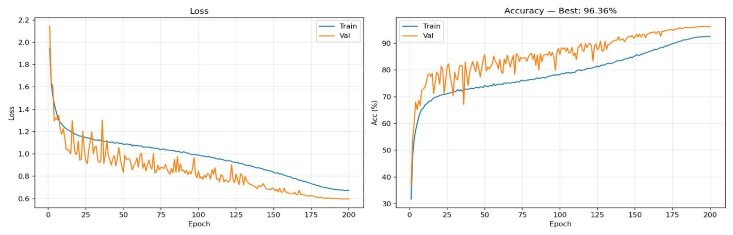
Figure 1: Loss and Accuracy curves for CIFAR-10 (200 epochs)

4. Results on CIFAR-100
CIFAR-100 consists of 60,000 32x32 color images in 100 classes (50,000 train / 10,000 test). The model achieved a best test accuracy of 79.67%.

Training Curves
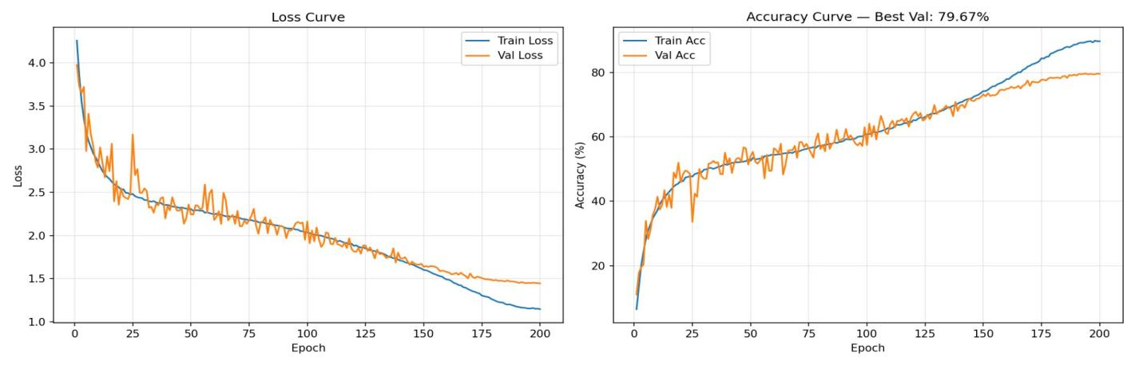
Figure 2: Loss and Accuracy curves for CIFAR-100 (200 epochs)

5. Best Results Summary
Dataset | Best Test Accuracy | Best Epoch
CIFAR-10 | 96.36% | 194
CIFAR-100 | 79.67% | 194
Both models converge well with CosineAnnealingLR scheduler, showing consistent improvement throughout the 200 epochs. The SE attention mechanism helps the model focus on important feature channels, contributing to strong performance on both datasets.
On CIFAR-10, the val accuracy surpasses train accuracy early on due to heavy data augmentation (AutoAugment + Cutout) applied only during training, which is a well-known regularization effect. On CIFAR-100, the gap between train and val accuracy remains small, indicating good generalization with minimal overfitting.

