Deep Learning — Midterm Report
WideResNet-16-2 + SE Attention
Training on Animals-5 Custom Dataset
224x224 and 32x32 | 100 Epochs | SGD + CosineAnnealing
Van Cong Toan — Phan Dinh Trung
HCMUTE — 2026

1. Dataset
The dataset D is a custom subset of Animals-10 from Kaggle, consisting of 5 classes: butterfly, cat, chicken, dog, horse. Images were deduplicated using MD5 hashing before splitting.
Property | Value
Source | Animals-10 (Kaggle) — 5 selected classes
Classes | butterfly, cat, chicken, dog, horse
Train samples | 500 images/class x 5 = 2,500 images
Test samples | 50 images/class x 5 = 250 images
Deduplication | MD5 hash to remove duplicate images

2. Model Architecture
The model M1 is a WideResNet-16-2 with Squeeze-and-Excitation (SE) Attention blocks. WRN-16-2 was chosen instead of WRN-28-4 (used in the final exam) because the dataset is small (2,500 images). A smaller model (0.7M vs 5.9M parameters) reduces overfitting on limited data.

Architecture Details
Component | Description
Network Type | WideResNet (Pre-activation ResNet)
Depth | 16 layers (2 blocks per group x 3 groups)
Widen Factor | 2 (channels: 16 -> 32 -> 64 -> 128)
Attention | SE Block (reduction=16) after each residual block
Pooling | Adaptive Average Pooling -> FC layer
Dropout | 0.3 (between conv layers in each block)
Weight Init | Kaiming Normal (Conv), Xavier Normal (FC)
Total Parameters | 696,881

3. Training Configuration
Setting | 224x224 | 32x32
Epochs | 100 | 100
Batch Size | 32 | 128
Optimizer | SGD (Nesterov) | SGD (Nesterov)
Learning Rate | 0.1 | 0.1
Momentum | 0.9 | 0.9
Weight Decay | 5e-4 | 5e-4
Scheduler | CosineAnnealingLR | CosineAnnealingLR
Label Smoothing | 0.1 | 0.1
Cutout Size | 56 (IMG/4) | 8 (IMG/4)
Augmentation | Resize + RandomCrop + HFlip + ColorJitter + Cutout | Resize + RandomCrop + HFlip + ColorJitter + Cutout
Normalization | ImageNet mean/std | ImageNet mean/std

4. Results on 224x224
The model was trained on images resized to 224x224. With batch size 32 and 100 epochs, the model achieved a best test accuracy of 80.40% at epoch 73.

Training Curves
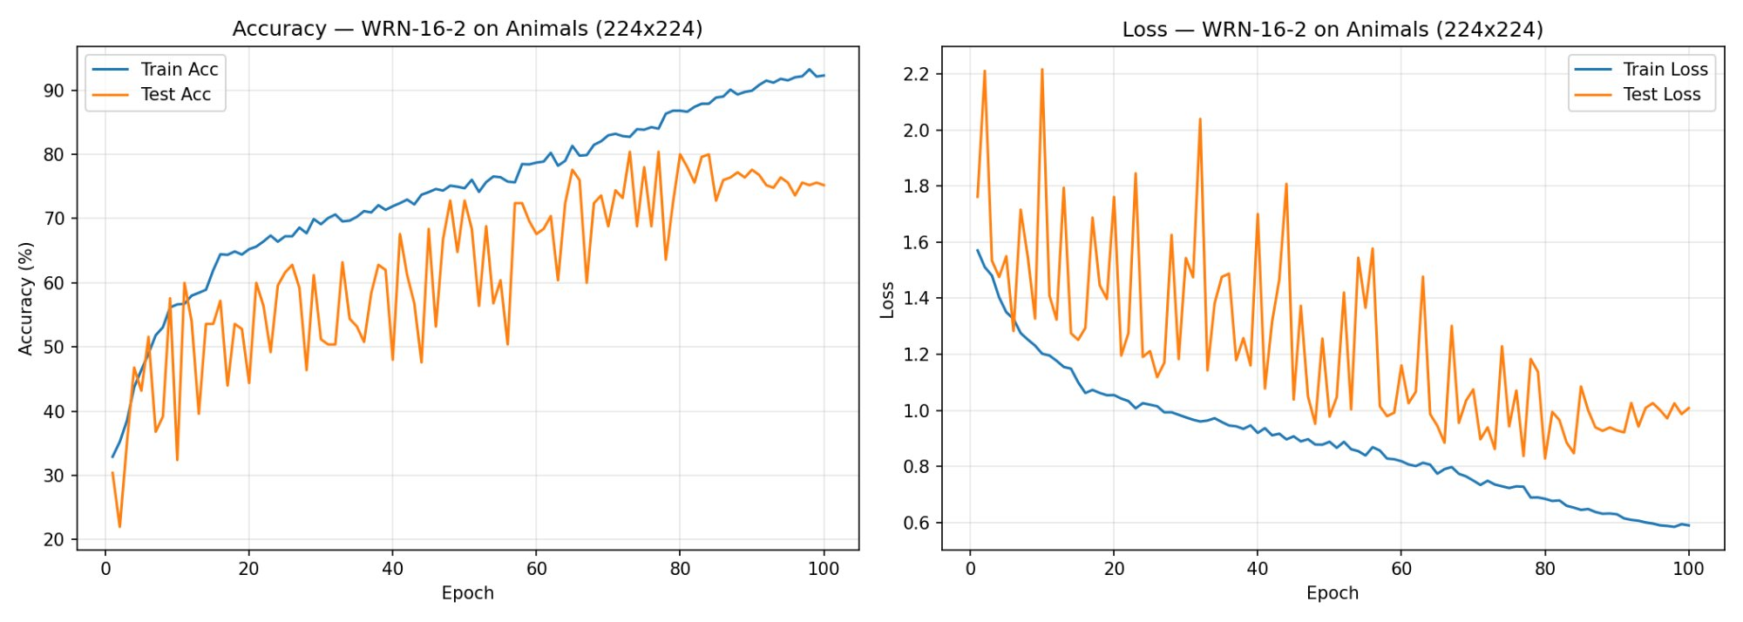
Figure 1: Loss and Accuracy curves for Animals-5 at 224x224 (100 epochs)

5. Results on 32x32
The same model was trained on images resized to 32x32. With batch size 128 and 100 epochs, the model achieved a best test accuracy of 78.80% at epoch 58.

Training Curves
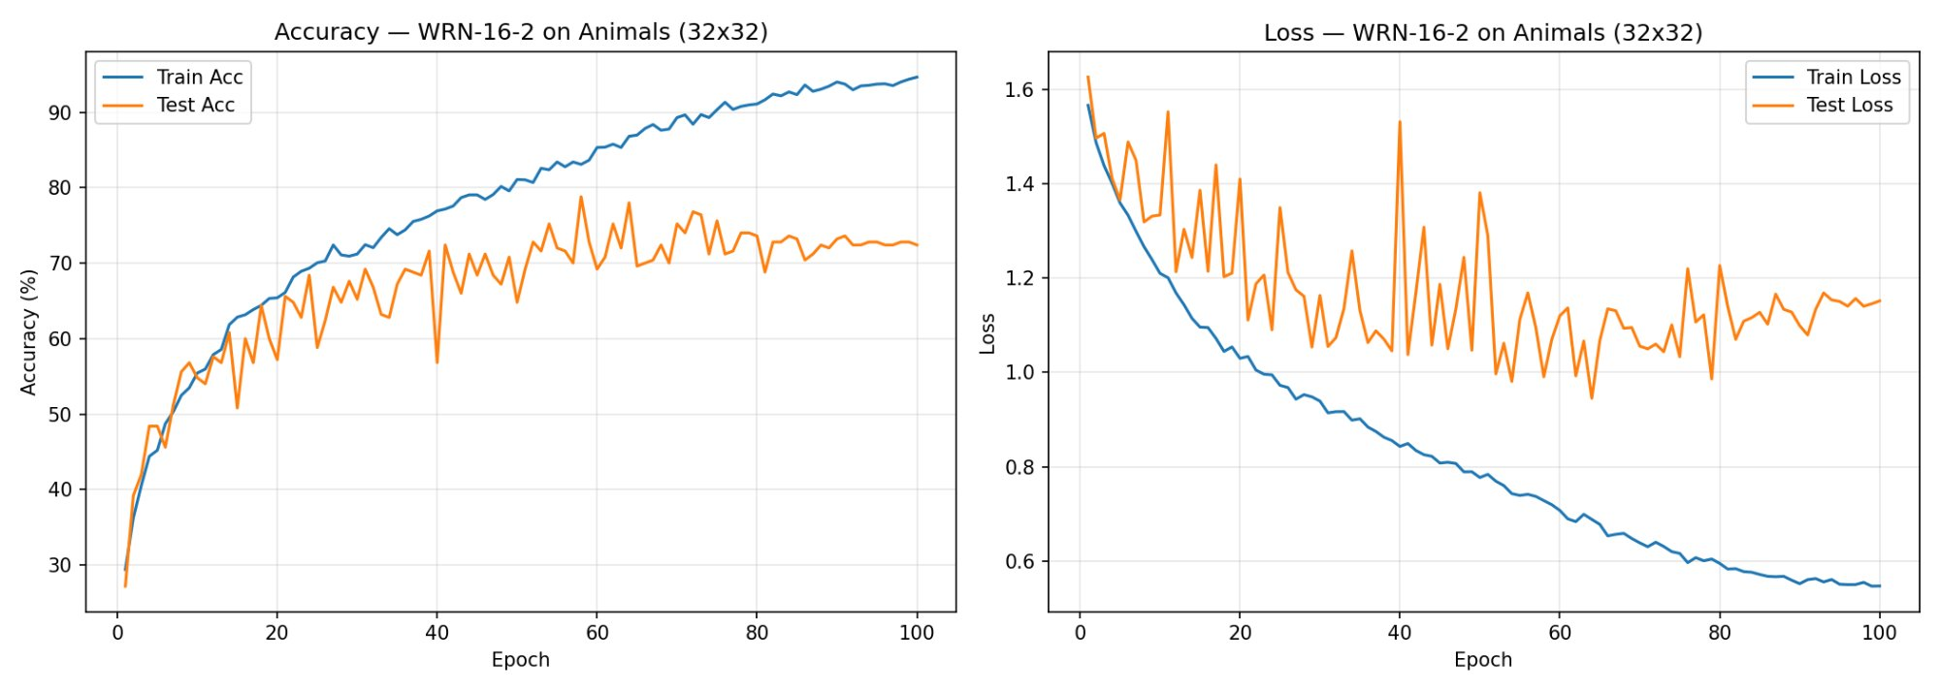
Figure 2: Loss and Accuracy curves for Animals-5 at 32x32 (100 epochs)

6. Best Results Summary
Image Size | Best Test Acc | Train Acc (final) | Gap
224x224 | 80.40% | 92.28% | ~12%
32x32 | 78.80% | 94.64% | ~16%

7. Analysis

224x224 vs 32x32
The 224x224 resolution achieved slightly higher best test accuracy (80.40% vs 78.80%). At 224x224, the model can exploit finer spatial details (textures, shapes) that are lost when downscaling to 32x32. However, 224x224 training is more volatile (val acc fluctuates more) due to the smaller effective batch and stronger augmentation at higher resolution.

Overfitting
Both resolutions show overfitting: train accuracy reaches 92-94% while test accuracy plateaus around 73-80%. This is expected given the small dataset size (2,500 train images) relative to the model capacity (696K parameters). The gap is moderate (12-16%) and acceptable for a dataset of this size.

Model Selection: WRN-16-2 vs WRN-28-4
Initially, WRN-28-4 (5.9M parameters) was tested on the 32x32 dataset. It produced severe overfitting: train accuracy 98% vs test accuracy 73% (gap of 30%). Switching to WRN-16-2 (0.7M parameters) reduced the gap to 16% and improved best test accuracy from 73% to 78.80%. The architecture (WideResNet + SE Attention) remains identical to the final exam model, only differing in depth (16 vs 28) and widen factor (2 vs 4).

