Solver
Excel includes a tool called solver that uses techniques from the operations research to find optimal solutions for all kind of decision problems.

Load the Solver Add-in
To load the solver add-in, execute the following steps.
1. On the File tab, click Options.
2. Under Add-ins, select Solver Add-in and click on the Go button.
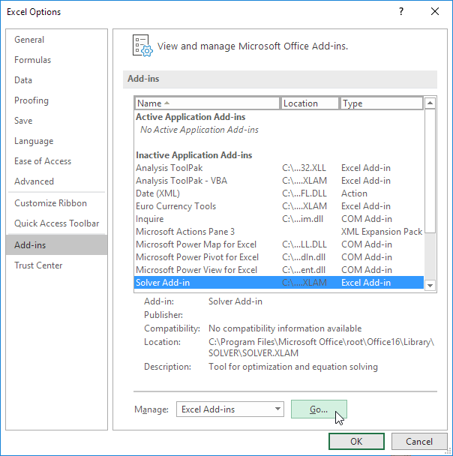
3. Check Solver Add-in and click OK.
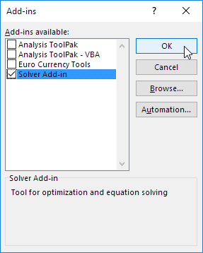
4. You can find the Solver on the Data tab, in the Analyze group.
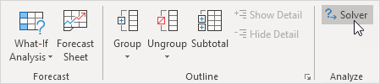

Formulate the Model
The model we are going to solve looks as follows in Excel.
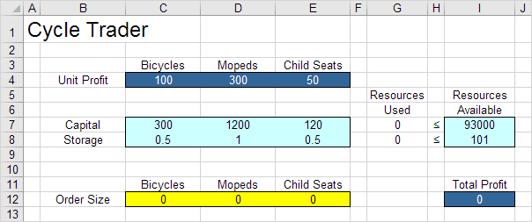
1. To formulate this linear programming model, answer the following three questions.
a. What are the decisions to be made? For this problem, we need Excel to find out how much to order of each product (bicycles, mopeds and child seats).
b. What are the constraints on these decisions? The constrains here are that the amount of capital and storage used by the products cannot exceed the limited amount of capital and storage (resources) available. For example, each bicycle uses 300 units of capital and 0.5 unit of storage.
c. What is the overall measure of performance for these decisions? The overall measure of performance is the total profit of the three products, so the objective is to maximize this quantity.
2. To make the model easier to understand, name the following ranges.
Range Name | Cells
UnitProfit | C4:E4
OrderSize | C12:E12
ResourcesUsed | G7:G8
ResourcesAvailable | I7:I8
TotalProfit | I12

3. Insert the following three SUMPRODUCT functions.
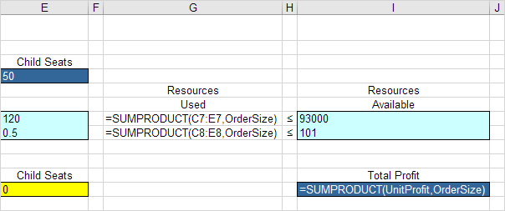
Explanation: The amount of capital used equals the sumproduct of the range C7:E7 and OrderSize. The amount of storage used equals the sumproduct of the range C8:E8 and OrderSize. Total Profit equals the sumproduct of UnitProfit and OrderSize.

Trial and Error
With this formulation, it becomes easy to analyze any trial solution.
For example, if we order 20 bicycles, 40 mopeds and 100 child seats, the total amount of resources used does not exceed the amount of resources available. This solution has a total profit of 19000.
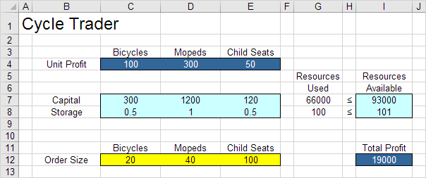
It is not necessary to use trial and error. We shall describe next how the Excel Solver can be used to quickly find the optimal solution.

Solve the Model
To find the optimal solution, execute the following steps.
1. On the Data tab, in the Analyze group, click Solver.

Enter the solver parameters (read on). The result should be consistent with the picture below.
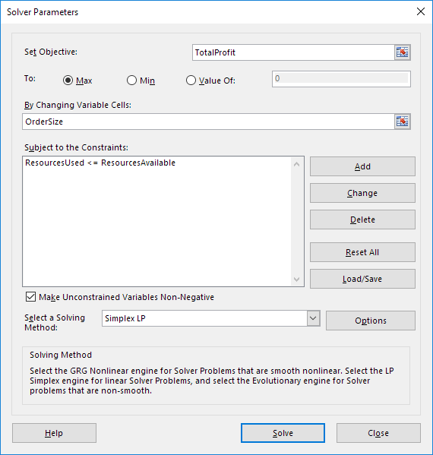
You have the choice of typing the range names or clicking on the cells in the spreadsheet.
2. Enter TotalProfit for the Objective.
3. Click Max.
4. Enter OrderSize for the Changing Variable Cells.
5. Click Add to enter the following constraint.
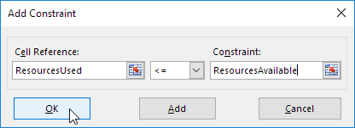
6. Check 'Make Unconstrained Variables Non-Negative' and select 'Simplex LP'.
7. Finally, click Solve.
Result:
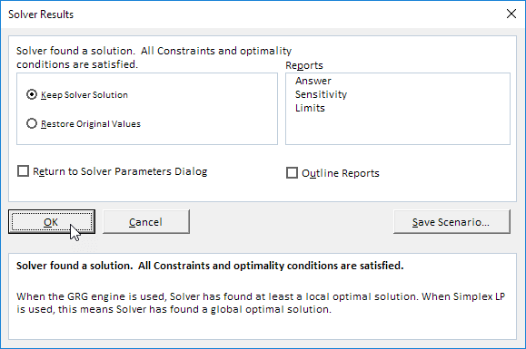
The optimal solution:
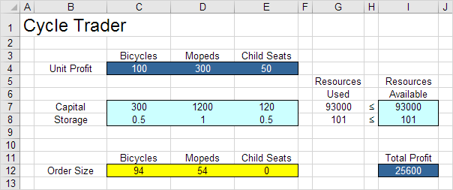
Conclusion: it is optimal to order 94 bicycles and 54 mopeds. This solution gives the maximum profit of 25600. This solution uses all the resources available.

Transportation Problem
Use the solver in Excel to find the number of units to ship from each factory to each customer that minimizes the total cost.

Formulate the Model
The model we are going to solve looks as follows in Excel.
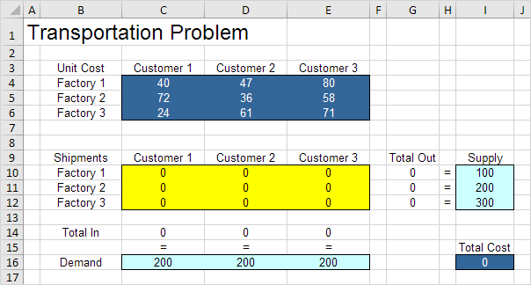
1. To formulate this transportation problem, answer the following three questions.
a. What are the decisions to be made? For this problem, we need Excel to find out how many units to ship from each factory to each customer.
b. What are the constraints on these decisions? Each factory has a fixed supply and each customer has a fixed demand.
c. What is the overall measure of performance for these decisions? The overall measure of performance is the total cost of the shipments, so the objective is to minimize this quantity.
2. To make the model easier to understand, name the following ranges.
Range Name | Cells
UnitCost | C4:E6
Shipments | C10:E12
TotalIn | C14:E14
Demand | C16:E16
TotalOut | G10:G12
Supply | I10:I12
TotalCost | I16

3. Insert the following functions.
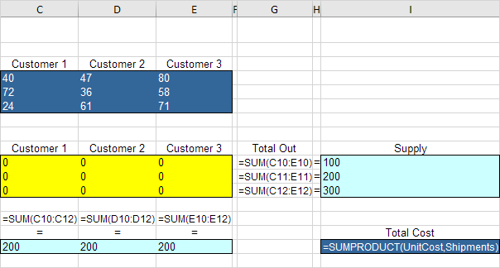
Explanation: The SUM functions calculate the total shipped from each factory (Total Out) to each customer (Total In). Total Cost equals the sumproduct of UnitCost and Shipments.

Trial and Error
With this formulation, it becomes easy to analyze any trial solution.
For example, if we ship 100 units from Factory 1 to Customer 1, 200 units from Factory 2 to Customer 2, 100 units from Factory 3 to Customer 1 and 200 units from Factory 3 to Customer 3, Total Out equals Supply and Total In equals Demand. This solution has a total cost of 27800.
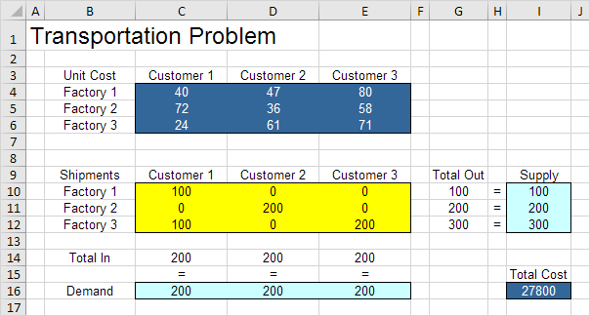
It is not necessary to use trial and error. We shall describe next how the Excel Solver can be used to quickly find the optimal solution.

Solve the Model
To find the optimal solution, execute the following steps.
1. On the Data tab, in the Analyze group, click Solver.
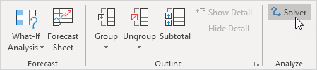
Note: can't find the Solver button? Click here to load the Solver add-in.
Enter the solver parameters (read on). The result should be consistent with the picture below.
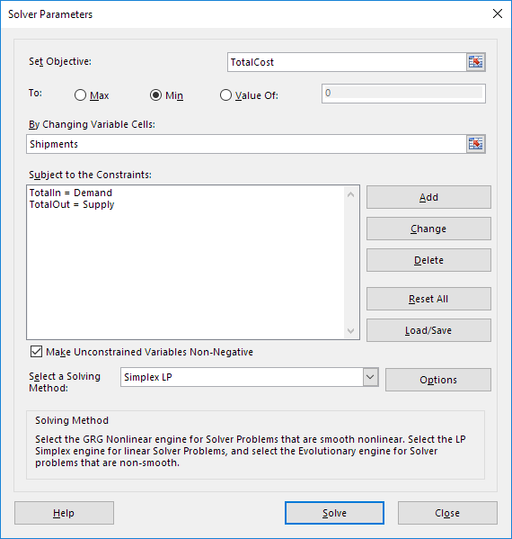
You have the choice of typing the range names or clicking on the cells in the spreadsheet.
2. Enter TotalCost for the Objective.
3. Click Min.
4. Enter Shipments for the Changing Variable Cells.
5. Click Add to enter the following constraint.
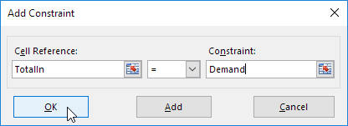
6. Click Add to enter the following constraint.
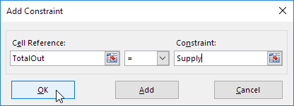
7. Check 'Make Unconstrained Variables Non-Negative' and select 'Simplex LP'.
8. Finally, click Solve.
Result:
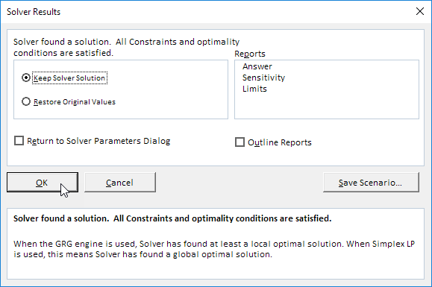
The optimal solution:
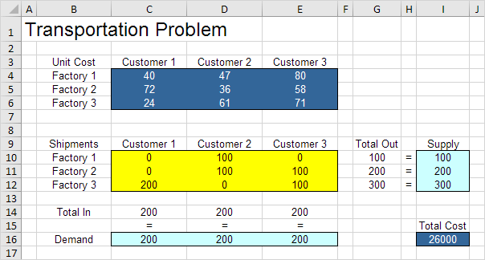
Conclusion: it is optimal to ship 100 units from Factory 1 to Customer 2, 100 units from Factory 2 to Customer 2, 100 units from Factory 2 to Customer 3, 200 units from Factory 3 to Customer 1 and 100 units from Factory 3 to Customer 3. This solution gives the minimum cost of 26000. All constraints are satisfied.

Assignment Problem
Use the solver in Excel to find the assignment of persons to tasks that minimizes the total cost.

Formulate the Model
The model we are going to solve looks as follows in Excel.
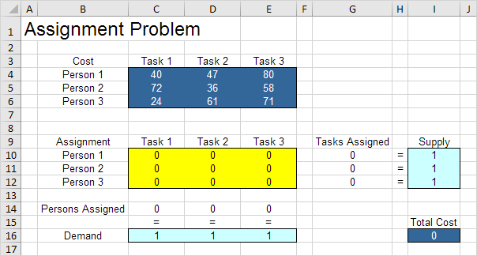
1. To formulate this assignment problem, answer the following three questions.
a. What are the decisions to be made? For this problem, we need Excel to find out which person to assign to which task (Yes=1, No=0). For example, if we assign Person 1 to Task 1, cell C10 equals 1. If not, cell C10 equals 0.
b. What are the constraints on these decisions? Each person can only do one task (Supply=1). Each task only needs one person (Demand=1).
c. What is the overall measure of performance for these decisions? The overall measure of performance is the total cost of the assignment, so the objective is to minimize this quantity.
2. To make the model easier to understand, name the following ranges.
Range Name | Cells
Cost | C4:E6
Assignment | C10:E12
PersonsAssigned | C14:E14
Demand | C16:E16
TasksAssigned | G10:G12
Supply | I10:I12
TotalCost | I16

3. Insert the following functions.
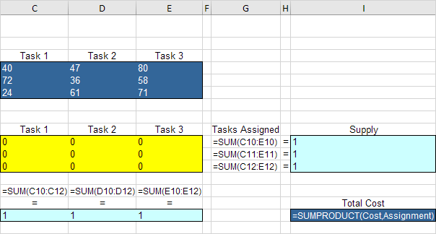
Explanation: The SUM functions calculate the number of tasks assigned to a person and the number of persons assigned to a task. Total Cost equals the sumproduct of Cost and Assignment.

Trial and Error
With this formulation, it becomes easy to analyze any trial solution.
For example, if we assign Person 1 to Task 1, Person 2 to task 2 and Person 3 to Task 3, Tasks Assigned equals Supply and Persons Assigned equals Demand. This solution has a total cost of 147.
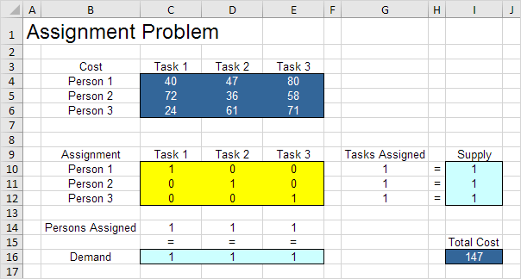
It is not necessary to use trial and error. We shall describe next how the Excel Solver can be used to quickly find the optimal solution.

Solve the Model
To find the optimal solution, execute the following steps.
1. On the Data tab, in the Analyze group, click Solver.
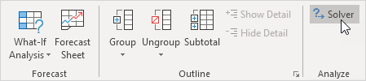
Note: can't find the Solver button? Click here to load the Solver add-in.
Enter the solver parameters (read on). The result should be consistent with the picture below.
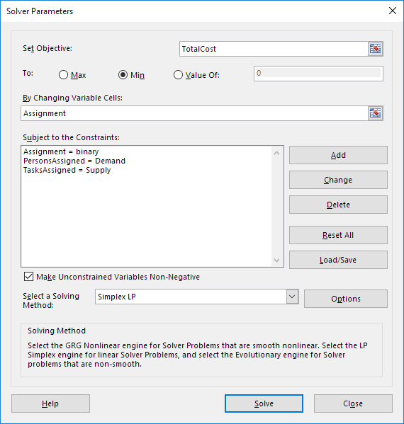
You have the choice of typing the range names or clicking on the cells in the spreadsheet.
2. Enter TotalCost for the Objective.
3. Click Min.
4. Enter Assignment for the Changing Variable Cells.
5. Click Add to enter the following constraint.
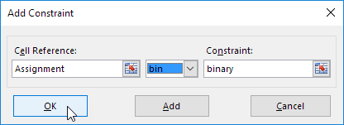
Note: binary variables are either 0 or 1.
6. Click Add to enter the following constraint.
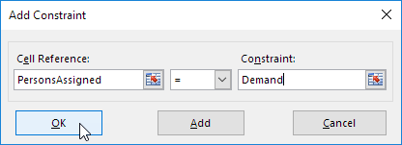
7. Click Add to enter the following constraint.
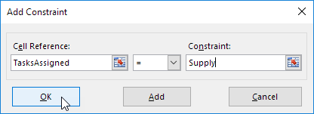
8. Check 'Make Unconstrained Variables Non-Negative' and select 'Simplex LP'.
9. Finally, click Solve.
Result:

The optimal solution:
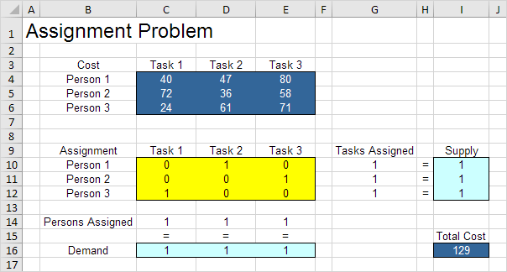
Conclusion: it is optimal to assign Person 1 to task 2, Person 2 to Task 3 and Person 3 to Task 1. This solution gives the minimum cost of 129. All constraints are satisfied.

Shortest Path Problem
Use the solver in Excel to find the shortest path from node S to node T in an undirected network. Points in a network are called nodes (S, A, B, C, D, E and T). Lines in a network are called arcs (SA, SB, SC, AC, etc.).

Formulate the Model
The model we are going to solve looks as follows in Excel.
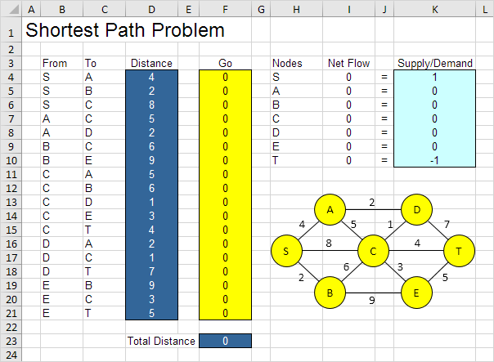
1. To formulate this shortest path problem, answer the following three questions.
a. What are the decisions to be made? For this problem, we need Excel to find out if an arc is on the shortest path or not (Yes=1, No=0). For example, if SB is part of the shortest path, cell F5 equals 1. If not, cell F5 equals 0.
b. What are the constraints on these decisions? The Net Flow (Flow Out - Flow In) of each node should be equal to Supply/Demand. Node S should only have one outgoing arc (Net Flow = 1). Node T should only have one ingoing arc (Net Flow = -1). All other nodes should have one outgoing arc and one ingoing arc if the node is on the shortest path (Net Flow = 0) or no flow (Net Flow = 0).
c. What is the overall measure of performance for these decisions? The overall measure of performance is the total distance of the shortest path, so the objective is to minimize this quantity.
2. To make the model easier to understand, name the following ranges.
Range Name | Cells
From | B4:B21
To | C4:C21
Distance | D4:D21
Go | F4:F21
NetFlow | I4:I10
SupplyDemand | K4:K10
TotalDistance | F23

3. Insert the following functions.
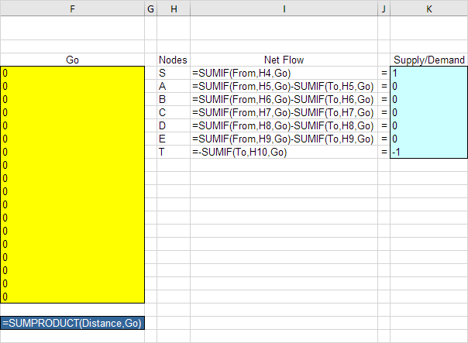
Explanation: The SUMIF functions calculate the Net Flow of each node. For node S, the SUMIF function sums the values in the Go column with an "S" in the From column. As a result, only cell F4, F5 or F6 can be 1 (one outgoing arc). For node T, the SUMIF function sums the values in the Go column with a "T" in the To column. As a result, only cell F15, F18 or F21 can be 1 (one ingoing arc). For all other nodes, Excel looks in the From and To column. Total Distance equals the sumproduct of Distance and Go.

Trial and Error
With this formulation, it becomes easy to analyze any trial solution.
1. For example, the path SBET has a total distance of 16.
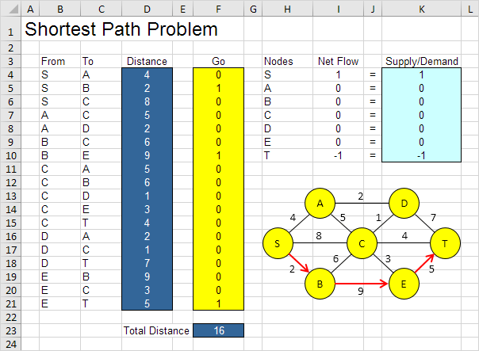
It is not necessary to use trial and error. We shall describe next how the Excel Solver can be used to quickly find the optimal solution.

Solve the Model
To find the optimal solution, execute the following steps.
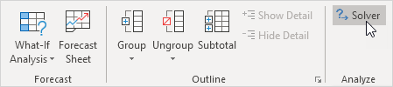
1. On the Data tab, in the Analyze group, click Solver.
Note: can't find the Solver button? Click here to load the Solver add-in.
Enter the solver parameters (read on). The result should be consistent with the picture below.
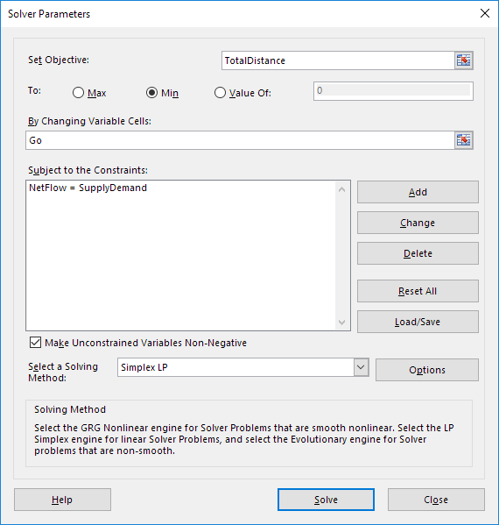

You have the choice of typing the range names or clicking on the cells in the spreadsheet.
2. Enter TotalDistance for the Objective.
3. Click Min.
4. Enter Go for the Changing Variable Cells.
5. Click Add to enter the following constraint.
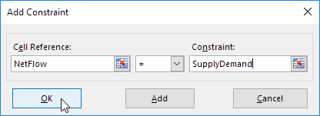
6. Check 'Make Unconstrained Variables Non-Negative' and select 'Simplex LP'.
7. Finally, click Solve.
Result:

The optimal solution:
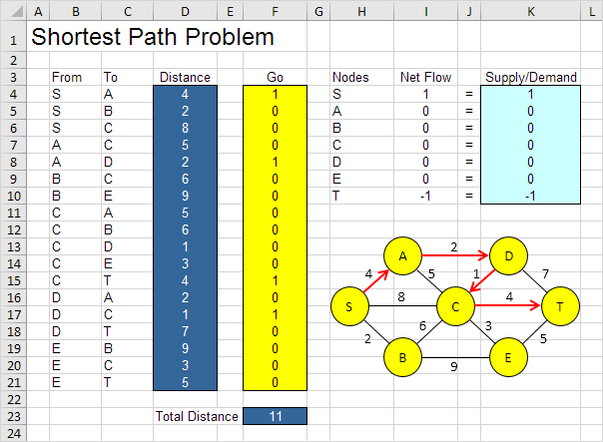
Conclusion: SADCT is the shortest path with a total distance of 11.

