Google Ads API Design Documentation

Company Name:
Toastd

Business Model:
My company operates in the performance and affiliate marketing space. We run and manage our own Google Ads campaigns to generate high-intent traffic for our affiliate network partners (such as Kelkoo, Admedia, and MaxBounty). We only advertise for our own affiliate endeavors and do not manage ads for external clients or third parties.

Tool Access/Use:
Our tool is used exclusively by our internal employees and ad managers. It serves as a centralized reporting and alert dashboard. It allows our team to monitor campaign performance, detect sudden spikes in spend, and view a unified dashboard combining Google Ads cost data with external affiliate revenue data. The tool provides a dashboard interface and automated Telegram notifications for our internal team. It is not externally accessible to clients or the public.

Tool Design:
For the reporting and monitoring aspects of our tool, our backend (Python/FastAPI) runs hourly and daily scheduled workers (via Celery) to proactively pull performance metrics and campaign structures from the Google Ads API into our internal PostgreSQL database.
The UI of our tool (built with React/Next.js) reads from this internal database to display interactive reports. It merges the Google Ads metrics with revenue data from our affiliate networks to calculate true ROAS (Return on Ad Spend) and CPA. Users can view different levels of ad performance across varying time periods and receive alerts if performance drops or spend spikes abruptly.
Below is an architectural process flow of our tool:
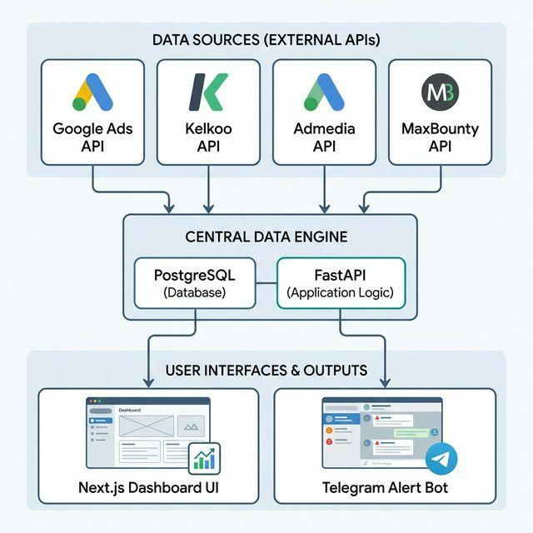

API Services Called:
• CustomerService: To list accessible customers and identify the specific account IDs we need to pull reports for (list_accessible_customers).
• GoogleAdsService: To execute GAQL queries to pull account structure and performance reports. Specifically, pulling from campaign, ad_group, and campaign metrics segmented by segments.date and segments.hour (impressions, clicks, cost_micros, conversions).

Tool Mockups:
Here is a mockup/screenshot of what our company’s API tool looks like:
(Please insert your UI screenshots from your frontend dashboard here prior to submission. Example screenshots should show the main performance overview and the metrics grid.)

