UNIVERSITY OF ABERDEEN SESSION 2013/14

Degree Examination

EG5099 Upstream Oil and Gas Processing

January 2014

PLEASE NOTE THE FOLLOWING

- You must not have in your possession any material other than that expressly permitted in the rules appropriate to this examination. Where this is permitted, such material must not be amended, annotated or modified in any way.

- You must not have in your possession any material that could be determined as giving you an advantage in the examination.

- You must not attempt to communicate with any candidate during the exam, either orally or by passing written material, or by showing material to another candidate, nor must you attempt to view another candidate’s work.

Failure to comply with the above will be regarded as cheating and may lead to disciplinary action as indicated in the Academic Quality Handbook (www.abdn.ac.uk/registry/quality/appendix7x1.pdf) Section 4.14 and 5.

CANDIDATE INSTRUCTIONS

Attempt all 5 questions

ANSWERS

Question 1 – Phase Behaviour and Physical Properties

- The following temperature – pressure plot is the phase envelope for a mixed hydrocarbon fluid. Sketch the same figure on your script and indicate the cricondenbar, cricondentherm, dew point locus, bubble point locus and typical quality lines.
[5 marks]
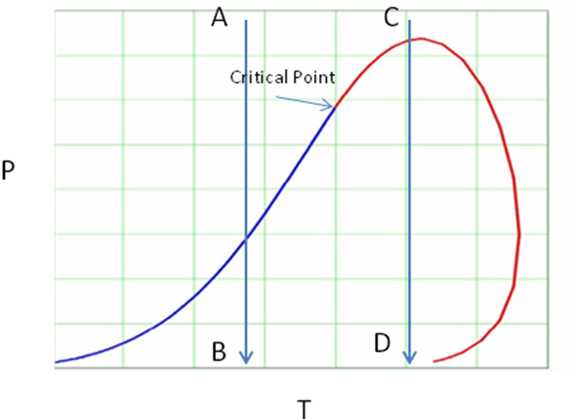

1 mark for each identified.

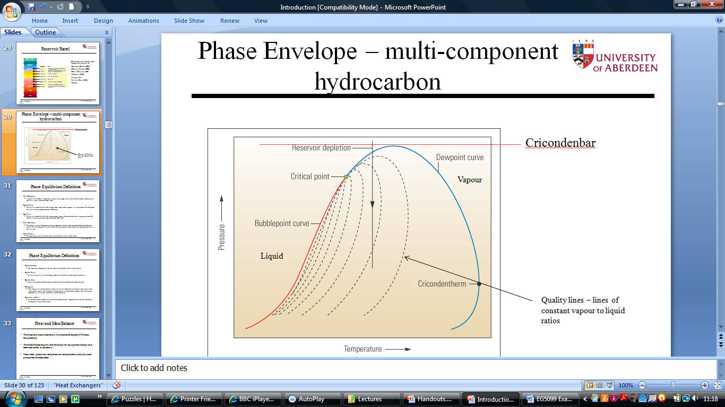

- Discuss the significance of the cricondenbar for gas pipeline operations.

If a gas pipeline is operated above the cricondenbar conditions promoting two-phase flow are prevented. Irrespective of pipeline temperature the gas can not enter the two-phase region. If liquid were to be produced this will reduce the flow area and could also cause troublesome slug flow.
[3 marks]

- Describe the phase changes associated with the paths marked A-B and C-D.

A-B. At point A the system is single phase, as the pressure is reduced the two phase region is encountered. This fluid is behaving as a liquid and at the bubble point locus the first bubbles of gas appear. As the pressure is further reduced the quality lines are crossed producing an increasing ratio of gas to liquid. (2marks)
C-D. At point C the system is single phase, as the pressure is reduced the two phase region is encountered. This fluid is behaving as a gas and at the dew point locus the first droplets of liquid appear. As the pressure is further reduced, the quality lines are crossed producing an increasing ratio liquid to gas. However, there comes a point where further pressure reductions produce the opposite trend where a reduction in pressure results in an increasing gas to liquid ratio. (2marks)

[4 marks]

- An oil, gas separator is operating at 85 DegC and 2.3 bara which produces an oil with a True Vapour Pressure (TVP) of 0.94 bara. Water is introduced, what will happen to the TVP if the separator pressure and temperature remain unchanged. Explain your reasoning.

It is important to maintain a TVP below atmospheric pressure to prevent vapourisation with oil storage tanks. (2 marks)

The TVP will reduce. The introduction of water produces an additional partial pressure of water onto the gas phase. (3 marks)

Since the separator pressure is fixed the partial pressure associated with the gaseous hydrocarbon components will reduce. This effectively ‘boils off’ more light ends resulting in a lowering of the liquid phase (oil) TVP. (3 marks)

[8 marks]

Question 2 – Fluid Flow

- What are the three main components that could contribute to the pressure loss in a flowing system.

Friction, elevation, acceleration (1 mark each)
[3 marks]

- 15,000 barrel/day of oil (density, ρ = 800 kg/m3, viscosity, μ = 0.003 Pa.s ) flows from A to C in a pipe with an inside diameter of 0.1 m. Calculate the pressure loss from A to C given the following information.

System sketch with distances in metres. H is a horizontal section, V is a vertical section.

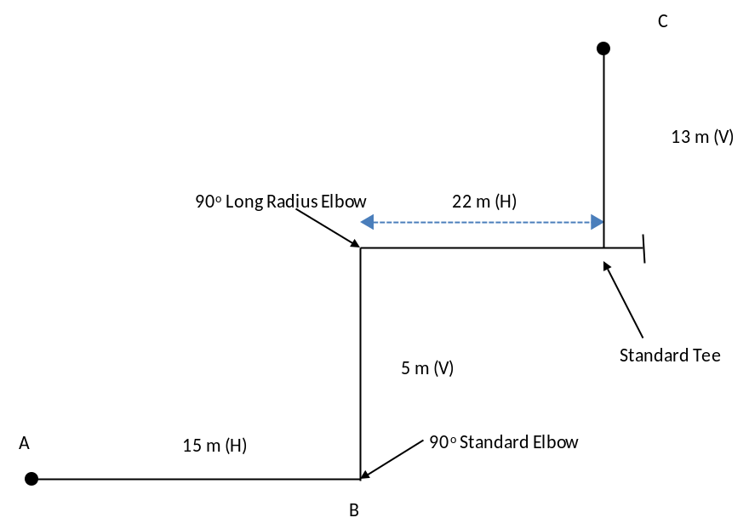

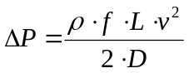Darcy’s equation applies (usual notation)

For turbulent flow the Blasius expression for friction factor applies, f = 0.316/Re^{0.25}

1 barrel = 0.159 m³

Pipe Fitting |  |  | Equivalent Length in Pipe Diameters (L/D)
Fittings | 90º Standard Elbow  45º Standard Elbow  90º Long Radius Elbow |  | 30  16  20
Fittings | 90º Street Elbow  45º Street Elbow  Square Corner Elbow |  | 50  26  57
Fittings | Standard Tee | Flow through run  Flow through branch | 20  60
Fittings | Close Pattern Return Bend |  | 50

Pipe CSA = 3.14 x 0.1^2/4 = 0.00785 m²

Oil volume flow = 15000 x 0.159/(24x3600) = 0.0276 m³/s

Oil Velocity = 0.0276/0.00785 = 3.52 m/s

Reynolds Number = ρ.v.d/μ = 800 x 3.52 x 0.1/0.003 = 93900 – fully turbulent (1 mark)

From Blasius, friction factor f = 0.316 / 93900^0.25 = 0.018 (1 mark)

Calculate equivalent length

Straight pipe = 15 + 5 +22 + 13 = 55m
Fittings
1 90 degree standard elbow L/D = 30, EL = 30 x 0.1 = 3m
1 90 long radius elbow L/D = 20, EL = 20 x 0.1 = 2m
1 flow through branch tee L/D = 60, EL = 60 x 0.1 = 6m

Total equivalent length L = 55 +3+2+6 = 66m (1 mark)

Pressure loss due to friction,
DelP = ρ.f.L.v^2/(2D) = 800 x 0.018 x 66 x 3.52^2/ (2 x 0.1) = 58900 Pa (1 mark)

Prssure loss due to elevation
ρ.g.h
h = 5+13 = 18m
DelP = 800 x 9.81 x 18 = 141200 Pa (1 mark)

Total pressure drop = 58900 + 141200 = 200100 Pa (1 mark)
[6 marks]

- The flow is stopped. Calculate the pressure difference between B and C.
[2 marks]
No friction only elevation, pressure drop = 141200 Pa

- The oil is changed to a fluid with a viscosity of 0.3 pa.s, recalculate the new pressure loss from A to C assuming no other changes are made.

New Reynolds number, RE = 939 – Laminar
Friction factor becomes, 64/RE = 0.0681
Pressure drop due to friction = 800 x 0.0681 x 66 x 3.52^2/(2x0.1) = 222800 Pa
Elevation loss remains the same, so new pressure drop becomes = 222800 + 141200 = 364000 Pa

[2 marks]

- Recalculate the pressure loss for part a) with the orientation of the pipe changed from flowing upwards in the vertical sections to flowing downwards.

Friction remains the same but elevation loss becomes positive
Pressure loss = 58900 – 141000 = - 82100 Pa i.e.a pressure increase
[3 marks]

- Process pipework in an offshore installation has been designed for solid free operation. Whilst in production it is found that sand is being produced. What are the problems associated with sand, and what would you wish to check to ensure the validity of the pipework design.

Sand could cause pipeline blockages and also cause erosion resulting in reduced pipe wall thickness. The reduced wall thickness could lead to a situation where the system was no longer capable of holding the internal pressure resulting in a loss of containment. (2 marks)

Pipework velocities should be established and checked against erosion limits. (2 marks)

[4 marks]

Question 3 – Upstream Systems

- A sea water deaeration column utilising gas stripping in a single packed bed is operating with the following conditions.

Stripping gas is Nitrogen. The oxygen partial pressure contained within the nitrogen at inlet and outlet conditions is 0 and 0.02atm respectively. Seawater counter flows to the Nitrogen. The seawater enters the column with an Oxygen concentration of 8 x 10⁻⁶ mol fraction, the sea water leaves the bottom of the column with a concentration of 0.05 x 10⁻⁶ mol fraction. The column operates at 10 DegC. The height of the packing is 3.5 m.

The information is to be used to design a new column to achieve an Oxygen outlet of 0.04 x 10⁻⁶ mol fraction. The other conditions for the new column are as above, calculate the packing height which would be required in the new column.

Henry’s constant for seawater can be taken as;
T(ºC) | H_{O2}
 | atm/mol fraction
0 | 25,500
5 | 29,100
10 | 32,700
15 | 36,400
20 | 40,100
25 | 43,800
30 | 47,500
35 | 50,700
40 | 53,500
45 | 56,300
50 | 58,800
60 | 62,900
70 | 66,300
80 | 68,700
90 | 69,900
100 | 70,100

The number of transfer units for the packing can be calculated from (usual notation);

NTU = (x₁-x₂)/Δx_{lm} , where Δx_{lm} = ((x –x_{e})₁ – (x –x_{e})₂)/ln((x –x_{e})₁ / (x –x_{e})₂)

1 is column top, 2 is column bottom

x₁ = 8 x 10⁻⁶
x₂ = 0.05 x 10⁻⁶

The equilibrium concentration at column top and bottom can be determined from Henry’s law;

Partial pressure O2, PPO2 = H.x

At column temperature 10 DegC, H = 32700 atm/mol fct

Hence,

x_{e1} = PPO2/H = 0.02/32700 = 6.12 x 10⁻⁷

x_{e2} = PPO2/H = 0

Substituting into the NTU expression;

NTU = (x₁-x₂)/Δx_{lm} , where Δx_{lm} = ((x –x_{e})₁ – (x –x_{e})₂)/ln((x –x_{e})₁ / (x –x_{e})₂)

Δx_{lm} = ((x –x_{e})₁ – (x –x_{e})₂)/ln((x –x_{e})₁ / (x –x_{e})₂)
= (8 x 10⁻⁶- 6.12 x 10⁻⁷ ) - (0.05 x 10⁻⁶- 0 )/ln((8 x 10⁻⁶- 6.12 x 10⁻⁷ )/ (0.05 x 10⁻⁶- 0 ))
= 1.468 x 10⁻⁶

Therefore, NTU = (8 x 10⁻⁶- 0.05 x 10⁻⁶)/ 1.468x 10⁻⁶= 5.41 (2 marks)

Packing height, Z = NTU x HTU

Z = 3.5m

Thus the HTU = 3.5/5.44 = 0.643m (2 marks)

The new packing will have the same HTU (2marks)

Calculate new NTU, with x₂ = 0.04 x 10⁻⁶ mf

NTU(new)

Δx_{lm} = ((x –x_{e})₁ – (x –x_{e})₂)/ln((x –x_{e})₁ / (x –x_{e})₂)
= (8 x 10⁻⁶- 6.12 x 10⁻⁷ ) - (0.04 x 10⁻⁶- 0 )/ln((8 x 10⁻⁶- 6.12 x 10⁻⁷ )/ (0.04 x 10⁻⁶- 0 ))
= 1.408 x 10⁻⁶

Therefore, NTU(new) = (8 x 10⁻⁶- 0.04 x 10⁻⁶)/ 1.408x 10⁻⁶= 5.65

Z(new) = NTU (new) x HTU = 0.643 x 5.65 = 3.63m (2 marks)

[8 marks]

- A horizontal separator is to be sized to treat 40,000 BPD of oil and 25,000 BPD of water. Required residence times have been established as 4 minutes and 2 minutes for the respective oil and water phases. Assume the vessel can be approximated by a cylinder, it is 50% full and the L:D ratio is 4:1. Calculate the vessel volume, length and diameter.

1 barrel = 0.159 m³

Volume flow of oil, Qo = 40000 x 0.159/(24 x 60) = 4.42 m³/min
Volume of oil in vessel,Vo = Qo x Residence time = 4.42 x 4 = 17.66 m³ (1 mark)
Volume flow of water, Qw = 20000 x 0.159/(24 x 60) = 2.21 m³/min
Volume of water in vessel, Vw x Residence time = 2.31 x 2 = 4.42 m³ (1 mark)
Volume of liquid in vessel = Vo + Vw = 22.08 m³
Vessel is 50% full, hence volume of vessel, Vv = 2 x 22.08 = 44.16 m³ (1 mark)
Volume of cylinder = (3.14 D^2/4).L
L= 4D
Thus (3.14 D^2/4).L = (3.14 D^2/4).4D = 44.16
D = 2.41 m
L = 9.64 m (1 mark)

[4 marks]

- The polytropic head of a centrifugal compressor is measured at 120 kJ/kg. If the rotational speed of the compressor is increased by 5% estimate the new polytropic head. Explain your answer.

The head developed by a centrifugal compressor results from the conversion of kinetic to pressure energy. The kinetic energy developed is proportional to v², where v is the impeller tip speed. Hence the head is proportional to v². If the speed is increased by 5% the change in head will be;

1.05^2 x 120 = 132.3kJ/kg

[4 marks]

- Water saturated methane gas enters a tri-ethylene glycol (TEG), counter flow, gas dehydrator absorber operating at 35 DegC and 60 bara. It is required to produce a product gas with a water content of 30 mg/Sm³ from the absorber. Could this be achieved using a 99% wt TEG lean solution. Use the attached water saturation and glycol equilibrium chart to explain your reasoning.

From glycol water equilibrium chart, at 35 DegC the equilibrium water dew point temperature will be minus 14 DegC at 99% TEG. Using the methane water saturation minus 14 degC (2 marks)

This corresponds to an equilibrium methane water content at 60 bara of around 50kg/Msm³ - 50 mg/Sm3. Hence the absorber could not achieve the required product gas water specification. (2 marks)

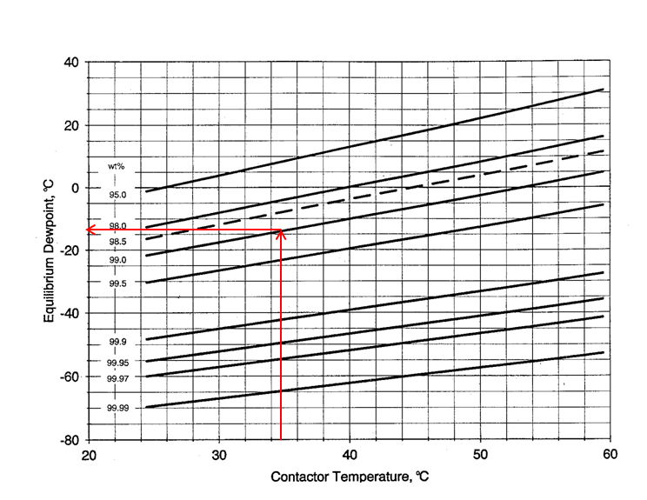
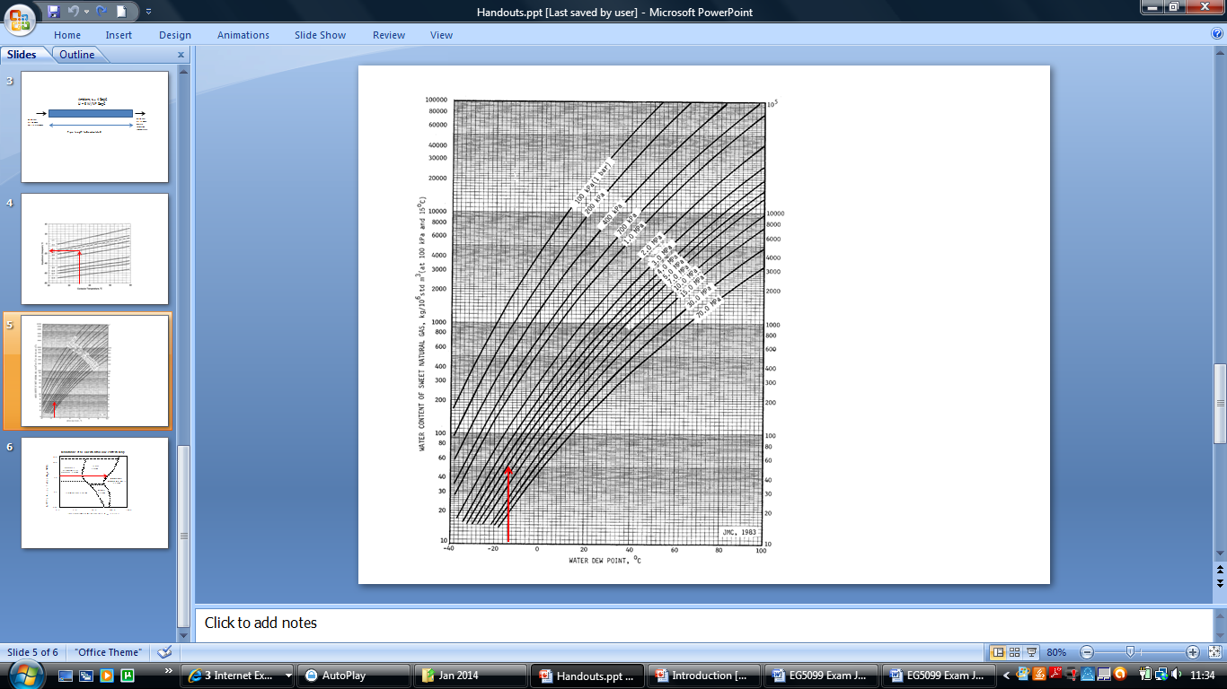
[4 marks]

Question 4 – Process Safety

- Compressible flow through a relief valve is defined as critical or sub-critical flow. Describe both flow conditions and discuss their nature with respect to the pressure drop across the relief valve.

The relief valve provides a restriction to flow and can be compared to an orifice. In critical flow a limiting flowrate is achieved - the flowing velocity through the orifice is at the speed of sound (speed of pressure wave) for the specific compressible fluid (gas). In this instance the flow through the relief is only a function of upstream pressure and not pressure drop across the valve.

In sub-critical flow the velocity is less than the speed of sound. In this instance the velocity through the valve is less than the speed of the sound and the flow through the valve is a related to the pressure drop. (2marks each)
[4 marks]

- A hydrocarbon gas processing vessel is depressured through a blowdown valve to the flare system. Describe the purpose of a blowdown system. If there were a power system failure on a process plant, what would be the fail safe position for a blowdown valve.

Blowdown Systems are important for 2 reasons:-
  - In a fire situation, metal temperatures may reach a level at which stress rupture could occur, even though the pressure does not exceed design pressure (or relief set pressure). Depressurisation can therefore avoid vessel rupture.
  - The hazard severity is a function of hazardous inventory. If the inventory can be reduced following an incident, the severity of the potential consequences can be significantly reduced. (3 marks)
The fail safe position would be open. (1 mark)

[4 marks]

- A gas filled vessel is depressured through a blowdown valve. The initial vessel pressure is Po = 100 bara and the pressure downstream of the blowdown is 2 bara. Assuming that the gas behaves ideally and that the process is isothermal, show that the blowdown time to a given pressure, Pt, can be approximated by;

Ln (Po/ Pt) = C.t

Where,
t = time
C = system constant

State any other assumptions used to develop the above expression.

Assume gas behaves ideally PV = nRT
Vessel volume is fixed and system is isothermal, hence

dP/dt = (RT/V) dn/dt .........................1

dn/dt will also be the mass rate through the blowdown valve. (2marks)

With an inlet and outlet pressure of 100 and 2bara, the flow through the blowdown will be critical. Hence the flow through the blowdown valve will be proportional to P not pressure difference. (2 marks)

Thus dn/dt = K.P

K will be a function of the blowdown valve flow characteristics – coefficient of expansion and effective flow area..

Substitute in 1 gives

dP/dt = (RT/V).KP (2 marks)

Integrate from t=0 to t=t gives

Ln (Po/ Pt) = C.t

Where C is a system constant. (2marks)

[8 marks]

- Comment on the validity of the assumptions used in c) above.

Ideal gas law will not accurately describe gas PVT relationship at the system pressure.

The system will not behave isothermally. As the gas expands within the vessel the temperature will drop, similarly the temperature will drop across the blowdown valve due to Joule-Thomson effect. In addition, the gas will not behave ideally at elevated pressures, significant departures are expected and a more advanced equation of state such as Peng-Robinson would be required.
These assumptions will introduce errors within the expression developed. More advanced methods would be required if an accurate blowdown time is required.

[4 marks]

Question 5 – Flow Assurance

- Oil production from a vertical riser is enhanced by injecting gas at the riser base. A series of test are conducted where the injected gas rate is varied. The oil production trend observed indicates an optimal gas rate which maximises oil production. If gas rates are reduced from the optimal gas rate, oil production drops, similarly if gas rates are increased above the optimal rate, oil production drops. State any assumptions and explain this observation.

Trend observed
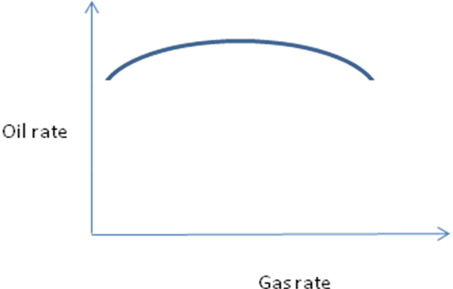

Oil flowrate will be a function of the pressure drop in the riser. For vertical flow there will be two components influencing the pressure drop – friction and elevation. Acceleration will be negligible. (2 marks)

As gas is first introduced, the oil flow rate increases as the gas lowers the density of the fluid in the column. Thus reducing the elevation pressure losses (ρ.g.h). Further increases in oil flow are seen as the gas rate is increased as the density is further reduced. (2 marks)

Although density is reducing which is reducing the elevation losses the frictional component of the pressure loss is increasing due to the increased system velocity. There comes a point where the benefits obtained from density reduction are overcome by friction. At this point further increases in gas rate result in an increased pressure drop and reduced oil rate. Hence the opposite trend is seen wrt oil flowrate. (2 marks)

[6 marks]

- Liquid and gas are flowing in a horizontal pipeline. The liquid rate and pipe diameter are as follows. Using the enclosed Mandhane flow map calculate the gas rate in m³/s where there will be a transition from slug to annular flow.

Pipeline diameter = 0.381 m
Liquid volume flow = 0.0369 m³/s

1 m = 3.281 ft

Pipe CSA, A = 3.14 x 0.381^2/4 = 0.114 m²
Liquid volume flow, V_{l} = 0.0369 m³/s
Liquid superficial velocity, v_{sl} = V_{l}/A = 0.0369/0.114 = 0.324 m/s = 1.06 ft/s (2 marks)

From map find superficial gas velocity at slug to annular transition.

v_{sg} = 80 ft/s approx = 24.4 m/s

Hence gas volume flow = v_{sg} . A = 24.4 x 0.114 = 2.78 m³/s (2 marks)

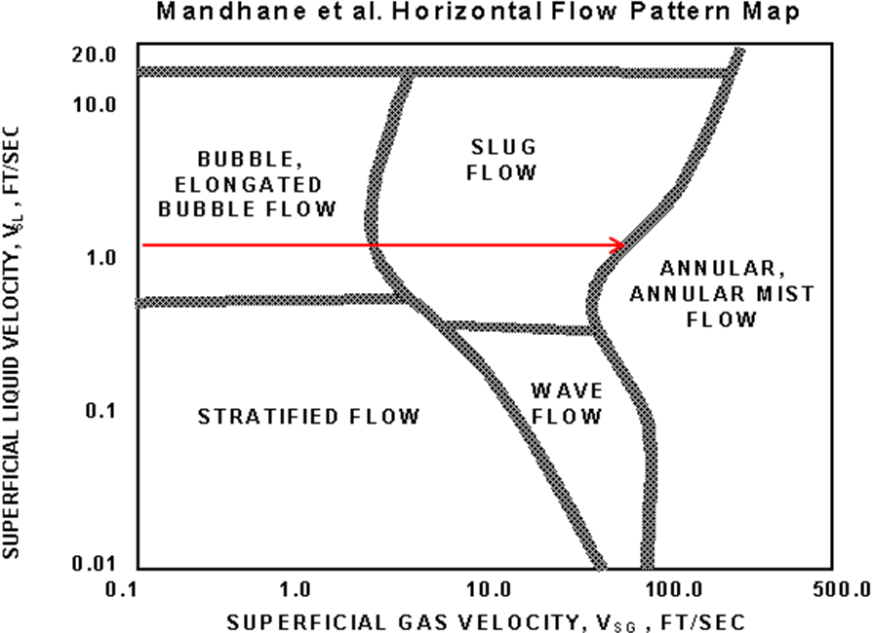
[4 marks]

- What is a hydrate and what are the conditions required for their formation.

A hydrate is an ice like substance where water reacts with small hydrocarbon molecules and water. (1 mark)
Conditions promoting hydrate formation are low temperatures and high pressures. (1mark)

[2 marks]

- A pipeline is flowing with a light hydrocarbon gas and water. Given the following information calculate the distance from the pipeline inlet to the point where hydrates will form. The hydrate formation temperature for the pipeline is 15 DegC.

Pipeline Overall Heat Transfer Coefficient (OHTC), U = 5 W/m²DegC (based on pipe OD)
Pipeline inside diameter, D_{i}= 0.2 m
Pipeline wall thickness, W_{t} = 0.02m
Gas/water mixture specific heat, Cp = 2.8 kJ/kgDegC
Gas/water mixture mass rate, m = 10 kg/s
Ambient temperature, t_{a} = 4 DegC
Pipeline inlet temperature, T₁ = 50 DegC

System sketch
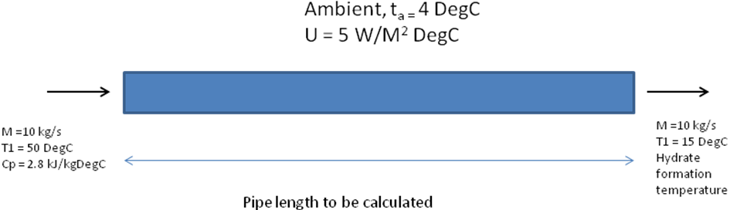

Heat balance, heat gained by surroundings, Hs = heat loss by flowing fluid, Hf

Hs = U.A.ΔT_{lm}

A = pipe outside area = 3.14 x OD x L
OD = 0.2 + 2 x 0.02 = 0.24m
A = 0.754. L m² (2 marks)

ΔT_{lm} = (50 – 4) – (15 - 4)/ln((50-4)/(15-4) = 35/ ln (4.182) = 24.5 Degc (2 marks)

Hf = m.Cp. ΔT = 10 x 2800 x (50 – 15) = 980000 J/s (2 marks)

Equating Hf = Hs and solving for A;

A = Hf/ U.ΔT_{lm} = 980000/(5 x 24.5) = 8000 m²

Thus, L = A/0.754 = 8000/0.754 = 10610m (2marks)

L = the length along the pipe where the temperature will equal the hydrate formation temperature of 15 DegC

[8 marks]

END OF PAPER

Figures and charts

