UNIVERSITY OF ABERDEEN SESSION 2014/15

Degree Examination

EG5099 Upstream Oil and Gas Processing

December 2014

PLEASE NOTE THE FOLLOWING

- You must not have in your possession any material other than that expressly permitted in the rules appropriate to this examination. Where this is permitted, such material must not be amended, annotated or modified in any way.

- You must not have in your possession any material that could be determined as giving you an advantage in the examination.

- You must not attempt to communicate with any candidate during the exam, either orally or by passing written material, or by showing material to another candidate, nor must you attempt to view another candidate’s work.

Failure to comply with the above will be regarded as cheating and may lead to disciplinary action as indicated in the Academic Quality Handbook (www.abdn.ac.uk/registry/quality/appendix7x1.pdf) Section 4.14 and 5.

CANDIDATE INSTRUCTIONS

Attempt all 5 questions

Question 1 – Phase Behaviour and Physical Properties

- Sketch a phase envelope for a multicomponent hydrocarbon mixture including quality lines. Indicate the critical point, dew point and bubble point, cricondentherm and cricondenbar.

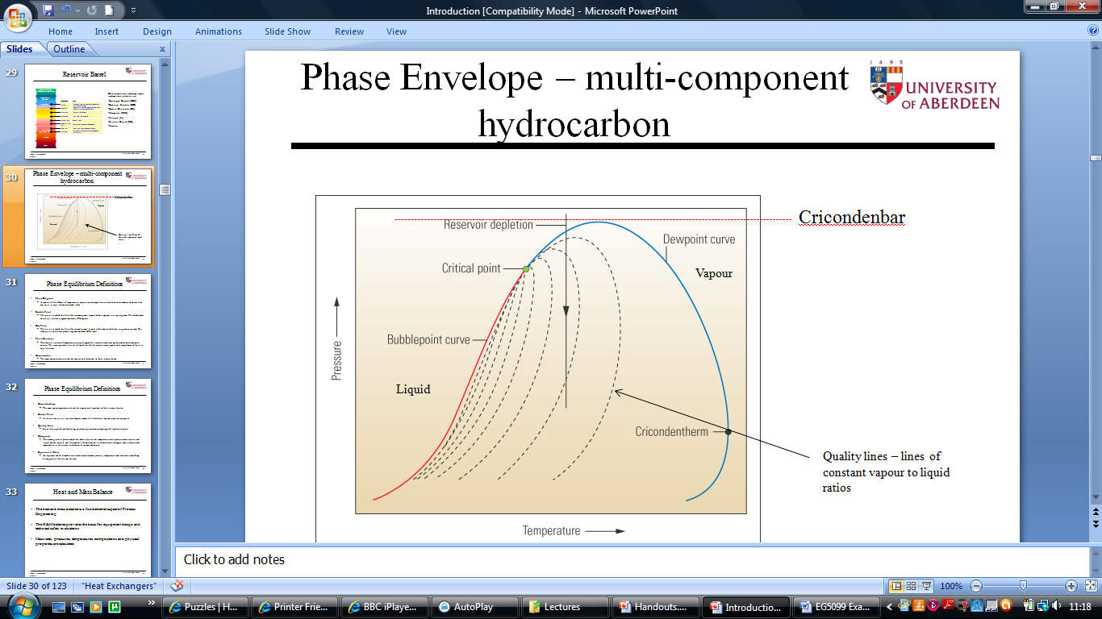

[6 marks]

- A knock out drum following a compressor and aftercooler is operating at a temperature and pressure within the two phase region of the phase envelope but very close to the critical point. Comment on the accuracy of an Equation of State to predict the liquid and gas rates at conditions close to the critical point.

[4 marks]

The accuracy of any EOS will gave cause concern for mass balance predictions close to the critical point. At the critical point the quality lines converge hence a small change in temperature or pressure will significantly affect the liquid to gas ratio.

- The following is a screenshot from a heat and mass balance simulation. The feed stream (1) pressure, temperature and composition are known. V-100 is a flash drum disengaging gas and liquid and the operating pressure is specified. The liquid from the flash drum is pumped for onward transportation (stream 7) and a specified portion is recycled back to V-100. The outlet pressure and efficiency of the pump P-100 is specified. Describe the calculation steps a heat and mass balance simulator would utilise to converge this arrangement to a solution.

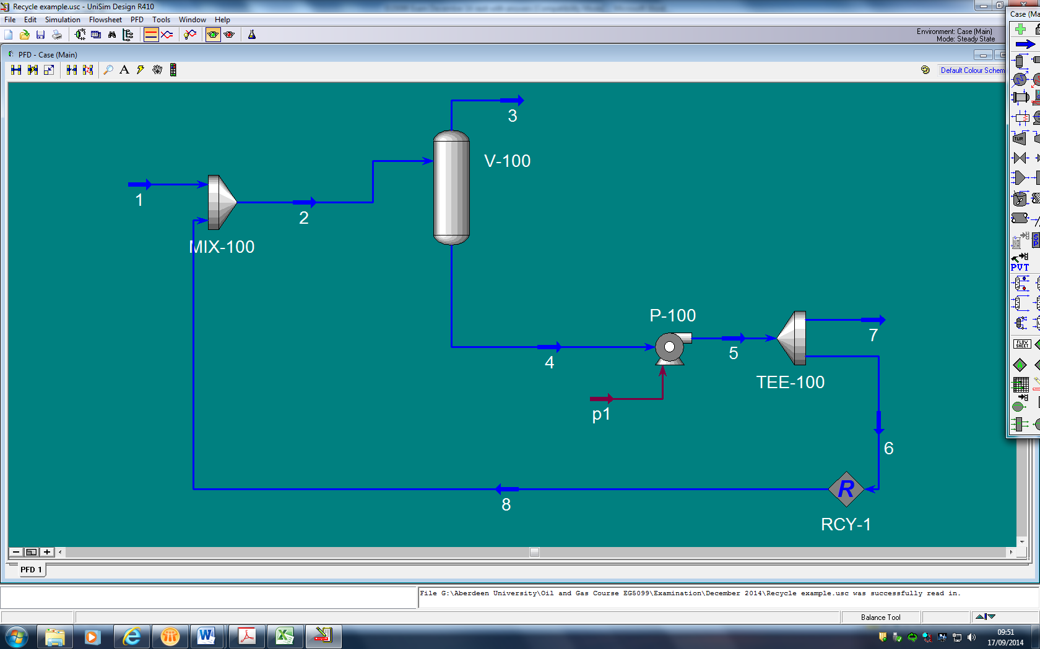

The recycle stream 8 is nested. A guess at the temperature, compostion and mass rate of stream 8 has to be made. This guess is added to known stream 1 to give stream 2 composition and mass rate - the mixer unit will determine the mixed temperature of stream from an enthalpy balance. In V-100 a flash calculation will be undertaken calculating temperature and compositions of 3 and 4. P-100 will calculate the conditions of stream 5 – there will be a small temperature increase due to pump inefficiency. Stream 6 conditions can be calculated and compared with the initial guess of stream 8. If different the calculation will be re-done until successive interations show the same value for stream 8.
[4 marks]

- V-100 is operating at temperature T and pressure P. Indicate on a typical multicomponent hydrocarbon phase envelope for streams 3 and 4 the location of temperature T and pressure P.

Stream 3 will be on the dewpoint locus at T & P. Stream 4 on the bubble point locus at T & P. Example shown is 50 DegC and 1000kPa.

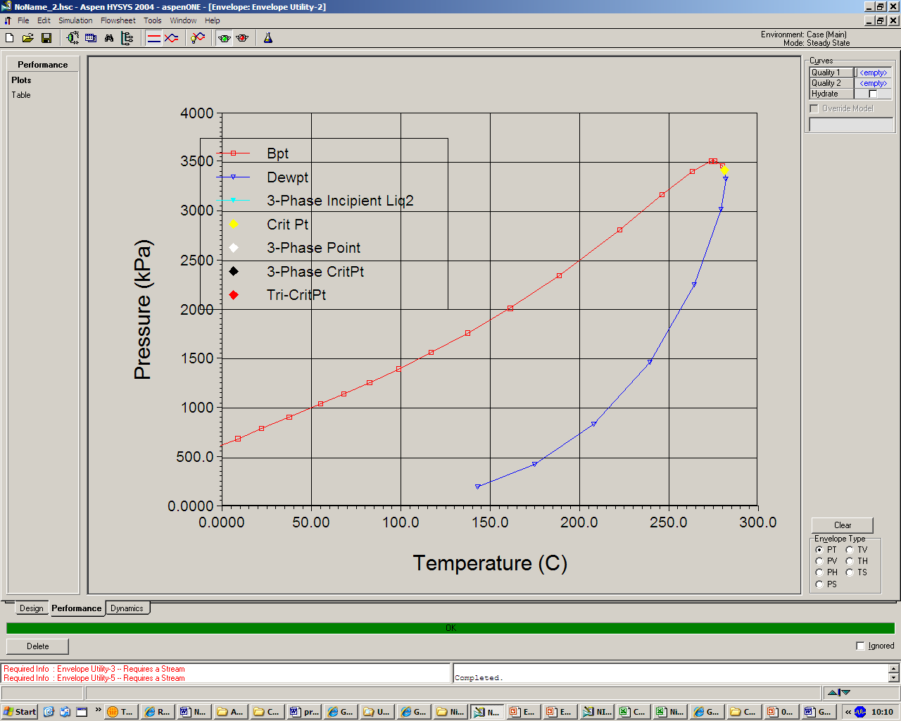
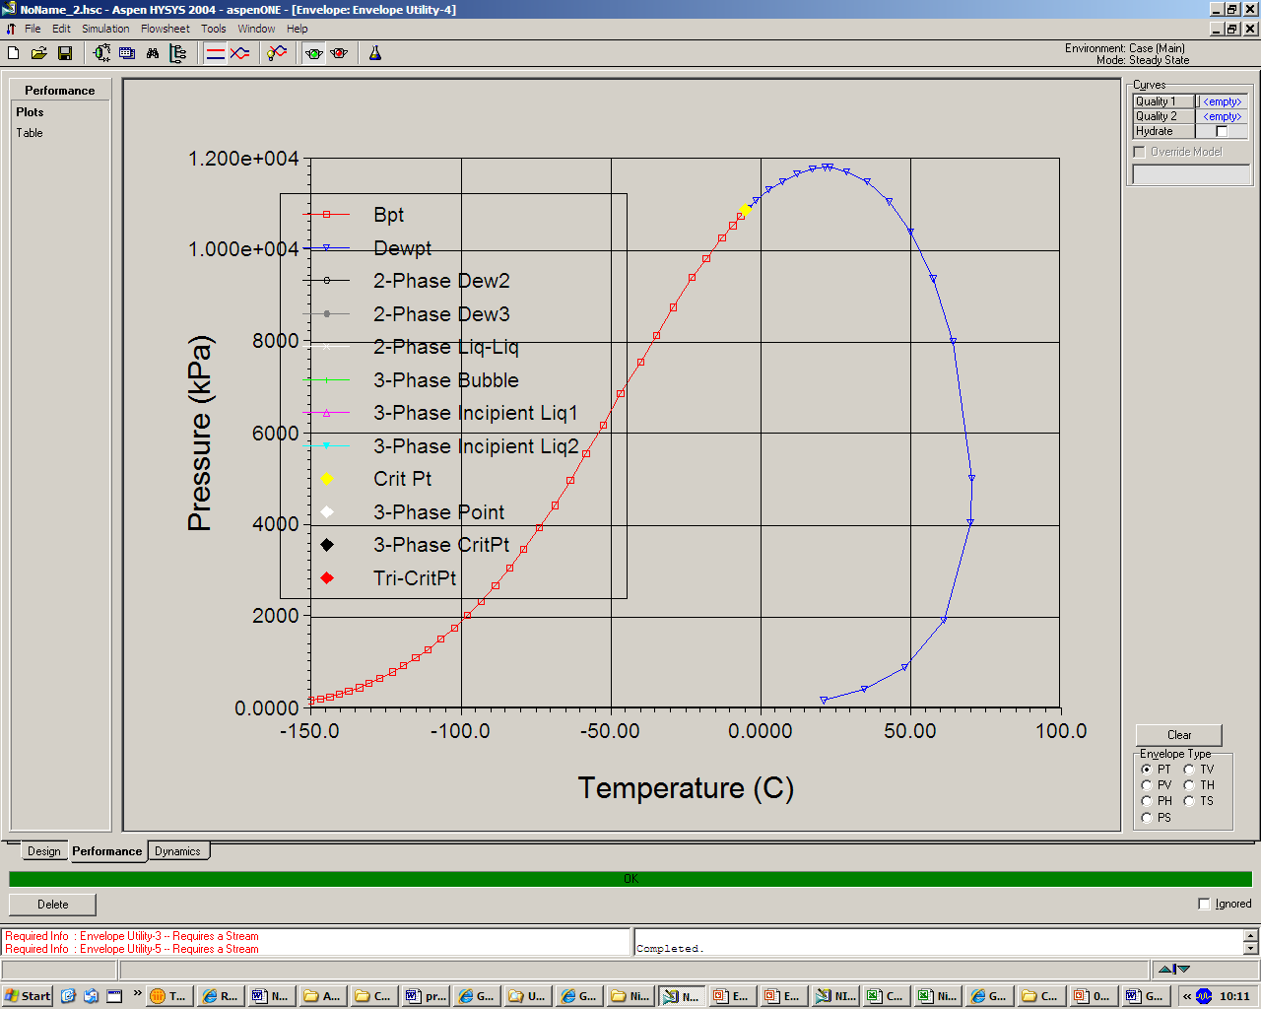

[6 marks]

Question 2 – Fluid Mechanics

- Name the three components of pressure loss.

Friction, acceleration and elevation
[3 marks]

- A very viscous heavy oil is flowing in a horizontal, highly insulated pipeline. The oil is introduced into the pipeline at 30 ºC and the surrounding temperature is 4 ºC. It is found that the oil temperature is increasing. Explain why the oil temperature may be increasing.

The operating condition of the pipeline follows. Utilising this data estimate the increase in oil temperature. Although very viscous, the oil can be assumed to behave as a Newtonian fluid. State any assumptions.

Oil mass rate = 320000 kg/hr
Oil viscosity = 49 Pa.s
Oil density = 1000 kg/m³
Oil specific heat = 1.53 kJ/kg.ºC
Pipe diameter = 250 mm
Pipe length = 100 m

The Darcy equation can be used to predict pressure drop.
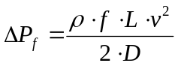

Where;

f Friction factor (-)
L Pipe length (m)
v Fluid velocity (m/s)
D Pipe internal diameter (m)
ΔP_{f} Frictional pressure loss (Pa)
ρ Fluid density (kg/m³)

The very viscous nature of the fluid means a high friction pressure drop per unit length. The pressure energy loss will appear as heat. With a highly insulated system the rate of heat dissipation to the surroundings per unit length is smaller than the frictional heat. Hence the pipeline contents will heat up.

Calculate pipe CSA = 0.049 m2
Calculate oil volume flow = 320000/1000x1/3600 = 0.089m3/s
Oil velocity = 0.089/0.049 = 1.82 m/s
Thus Reynolds No = 1000 x 1.82 x 0.25/49 = 9.3 ie Laminar

Student should know that in Laminar flow, friction factor f = 64/RE = 6.88

Hence Delta P for 100m pipe = 6.88 x 1000 x 100 x 1.82^2/(2 x 0.25) = 4557900pa = 45.6 bar (very high).

Assume no heat loss from pipe (highly insulated) and the energy lost as a frictional pressure drop heats the fluid.

Amount of heat energy = V. ΔP = 0.088 x 4560000 = 401280 m3/s.N/m2 (J/s)
Equate with M.C_{P}.ΔT, Temp increase = 401280/(320000/3600 x 1530) = 2.95 DegC/100m
[10 marks]

- Describe why the introduction of gas into the bottom of an oil well can increase the flow of oil.

For the flowing oil well, pressure is lost by friction and elevation losses. If the pressure loss can be reduced the oil flow will increase. Introducing gas reduces the density of the fluid column hence elevation losses – ρ.g.h – are reduced. Provided the effects of increased friction loss due to the extra gas are less than the benefits achieved by reducing density, then overall the pressure loss will be less from the introduced gas hence increased flow.

[4 marks]

- Briefly explain the phenomena of surge (hammer) and column separation in a liquid pipeline. Further explain why hammer and column separation could be a concern.

Surge is an increase in pressure caused by the change in kinetic energy/momentum of a fluid in motion for example when it is forced to stop suddenly. The magnitude of the pressure increase is system specific, in some circumstances it could result in a pressure above the pipeline design pressure leading to failure.

In column separation a region of low pressure caused by a flow disturbance is generated. The inside to outside pressure forces reverse with external atmospheric pressure possibly causing the pipeline to collapse.

[3 marks]

Question 3 – Upstream Systems

- An oil, gas, water separator is processing fluids from an existing stock of naturally flowing wells. New wells are to be introduced which require downhole pumps. The new wells will also produce oil with a higher density and viscosity than the existing well stock. You are asked to comment on how this might affect the oil in water and water in oil quality from the separator. Describe how this change might affect product quality with your reasons.

Consider Stokes law;
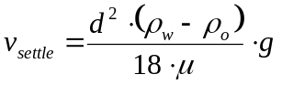
All the changes will have an adverse effect. The pumps will introduce additional shear potentially resulting in smaller droplet sizes. The density difference between water and oil will reduce hence reducing the effects of buoyancy separation. The increased velocity will also hinder the separation of the two phases. Hence the oil in water and water in oil from the separator both increase.
[6 marks]

- A glycol dehydration system is used to remove water from a gas stream. Describe the operating principles and main components of a glycol system. A sketch may help.

Glycol absorbs water as it flows down through a contactor with countercurrent to the gas flow. Mass transferred is enhanced by either a trayed or packed column configuration. Water-rich glycol is removed from the bottom of the contactor, passes through the reflux condenser coil, flashes off most of the soluble gas in a flash tank, and flows through the rich-lean heat exchanger to the regenerator. In the regenerator, absorbed water is distilled from the glycol at near atmospheric pressure by application of heat. The regenerated lean glycol flows through the rich-lean and glycol cooler exchanger for cooling before being recirculated to the contactor by the glycol pump. Heat integration to reduce energy consumption in the reboiler is affected be hot to cold glycol exchange.

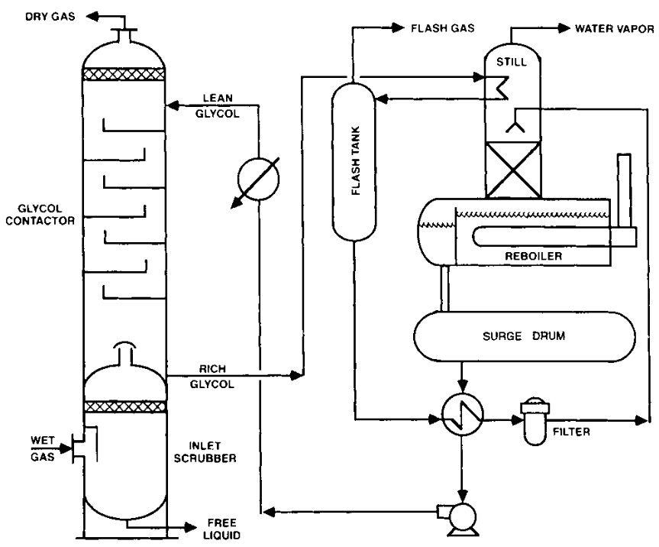

[6 marks]

- A process gas has to be cooled from 20 ºC to minus 35 ºC using a refrigeration plant. The refrigerant is Propane. Use the attached Mollier chart to calculate the compressor power requirements and condenser duty of a one stage refrigeration system. The refrigeration duty for the process is 450000 kJ/hr and the available condensing medium is air at 25 ºC. The polytropic efficiency of propane compressor is 80%. State any assumptions. Enclose your Mollier chart with your student number with the returned exam answers.

Key assumption is the temperature approach between propane and the process gas and propane and the air for the condensation duty – assume 5 DegC. Hence Propane condensing temperature is 25 + 5 = 30DegC and required Propane for rerfrig duty is -35-5 = -40 DegC. The cycle can now displayed on Mollier chart. Student show know four stages – compress, condense, expand, remove heat from process.

A to B is the duty of the refrigeration heat exchanger; 820 – 600 = 220kJ/kg
Exchanger duty is 450000 kJ/hr so mass rate of Propane refrigerant = 450000/220 = 2045kg/hr.
The isentropic enthalpy change for the propane compressor is C – B = 950- 820 = 130kJ/kg, The polytropic enthalpy change will be 130/effy = 130/0.8 = 162.5 kJ/kg. Point D
Therefore compressor power = 162.5 x 2045 = 332312 kJ/hr = 92.3 kW
Enthalpy change over condenser is D – A = 982.5 – 600 = 382.5 kJ/kg
Duty of condenser = 382.5 x 2045 kJ/hr = 217 kW

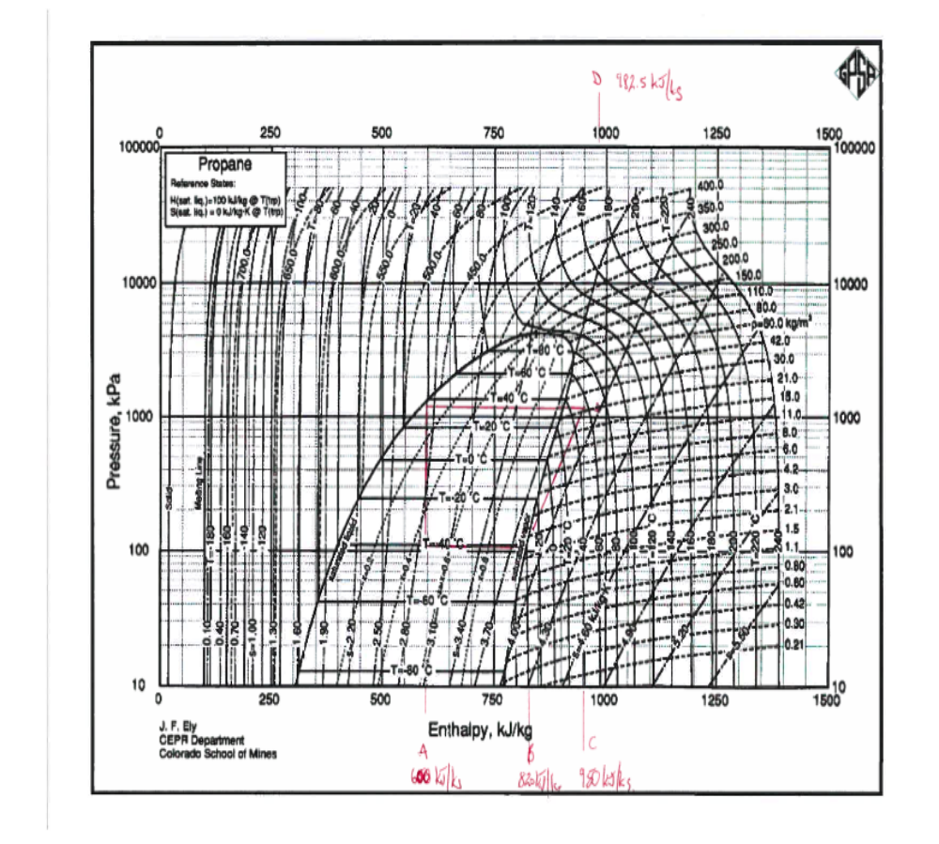
[8 marks]

Question 4 – Process Safety

- Identify and describe by example the four key principles of Inherent Safety Design.

Key principles are;

Eliminate – design to remove the need for a hazardous material. For an oilfield, partial process, reduce number of vessels and pump fluid to shore.

Prevent – measures to reduce hazard being realised. Design to contain maximum pressure, simpler plant, fewer leak points.

Control – measures to control the hazard and prevent it being realised. Emergency shutdown system.

Mitigate – design to reduce magnitude of hazard. Blast walls, plant layout, firewater.

[8 marks]

- A relief valve duty can be critical or sub-critical. Describe these conditions with particular reference to the upstream and downstream pressure across the relief valve.

For critical flow the velocity through a restriction – relief valve – has reached the speed of sound. The flow is only dependent upon the upstream pressure.
Sub-critical flow the velocity through restrictions is below speed of sound and flow is dependent up both up and downstream pressure.

[2 marks]

- A relief valve has a set pressure of 300 kPa. The backpressure on the relief valve is 200 kPa. Use the following information to establish whether the flow through the valve is critical (choked) or subcritical.
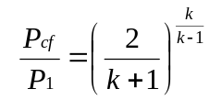

P_{cf} is the critical flow nozzle pressure;
P₁ is the upstream relieving pressure;
k is the ratio of specific heats (C_{p}/C_{v}) = 1.1

Calculate P_{cf}

P_{cf} = P₁ x (2/(k+1))^(k/(k-1))
= 300 x (2/2.1)^(1.1/0.1)
= 300 x (2/2.1)^(11)
= 175kPa

Backpressure is higher than P_{cf} hence flow is subcritical.
[2 marks]

- Explain what is meant by gas blowby from a high pressure to low pressure system. Why is it important to recognise gas blowby.

A high pressure vessel is connected to a low pressure vessel. Liquid from the HP vessel is transferred to the LP vessel via a level control valve. If the liquid level fails and the vessel empties HP gas can ‘blowby’ into the LP system. It is important to recognise this possible instance. The gas blowby rate could be the maximum demand case for the LP system relief design.
[4 marks]

- A single offshore platform is to contain the following systems – Wells, Oil Processing, Gas Processing, Water Injection, Utilities, Power Generation and Living Quarters (including control room and temporary refuge). The wells have to be accessed by a drilling jack-up. The platform also requires a flare tower. Describe how you would wish to layout the systems recognising safety principles. A sketch may assist and indicate the prevailing wind direction. Discuss the significance of wind direction.

Student should recognise the main aim is to separate hazards from personnel. The wells should located at one end the living quarters at the other. Next most hazardous is gas compression followed by Separation, Power generation follows then water injection and utilities. Student may argue that power gen is a relatively low hazard and swap with Water Injection. Also may place compression at a higher level.
Hence – Wells/gas/separation/power/water inj/utilities and LQ – hazardous to non-hazardous. The prevailing wind should take any releases away from the living quarters, this will minimise the probability of the living quarters being affected by fire and toxic/dangerous gases.

[4 marks]

Question 5 – Flow Assurance

- Describe the main conditions necessary for hydrate formation. Why is hydrate formation a concern for transportation and process systems.

Hydrates are formed by a combination of small hydrocarbon molecules – methane to butane, H2S and CO2 – and water. The solid crystals can formed can lead to flow restrictions and blockages. This could result in an unsafe situation and/or a loss of production. Their formation is favoured by high pressure and low temperature.
[4 marks]

- Hydrate formation can be calculated using K charts, an example of which is attached. Explain how these charts could be used to calculate the hydrate formation pressure at a given temperature for a known mixture of methane, ethane, propane and nitrogen. No chart is available for Nitrogen.

The use of the charts is analogous to the calculation of a dewpoint for a hydrocarbon mixture. At the dewpoint the following criteria is fulfilled,
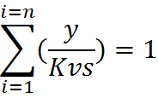
yi is the mole fraction of species i and Kvs is the equilibrium ratio between the gaseous/vapour fraction and the solid hydrate for each component.
Procedure
- make an initial guess at the hydrate formation pressure.
- For methane, ethane and propane estimate the Kvs from the respective charts
- The Ksv for Nitrogen is infinity as it is not a hydrate former
- Calculate y/Kvs for each component with y/Kvs for Nitrogen equal to zero
- Complete the summation, if not equal 1 re-guess formation pressure and repeat.

[6 marks]

- A downward sloping, 1000m long pipeline with an internal diameter of 0.292m joins a 100m long vertical pipe (riser) of the same diameter. The pipeline contains oil, gas and water flowing at an average pressure of 20 bara. The flow rates are:

Oil = 0.009 m³/s
Water = 0.009 m³/s
Gas = to be determined

The oil and water densities are 800 and 1000 kg/m³ respectively.
Determine the gas rate at which the system will start the cycle of severe slugging.
State any assumptions used.

At the onset of severe slugging the rate of pressure rise due to vertical pipe filling with liquid will be equal to rate of pressure rise of the gas bubble.

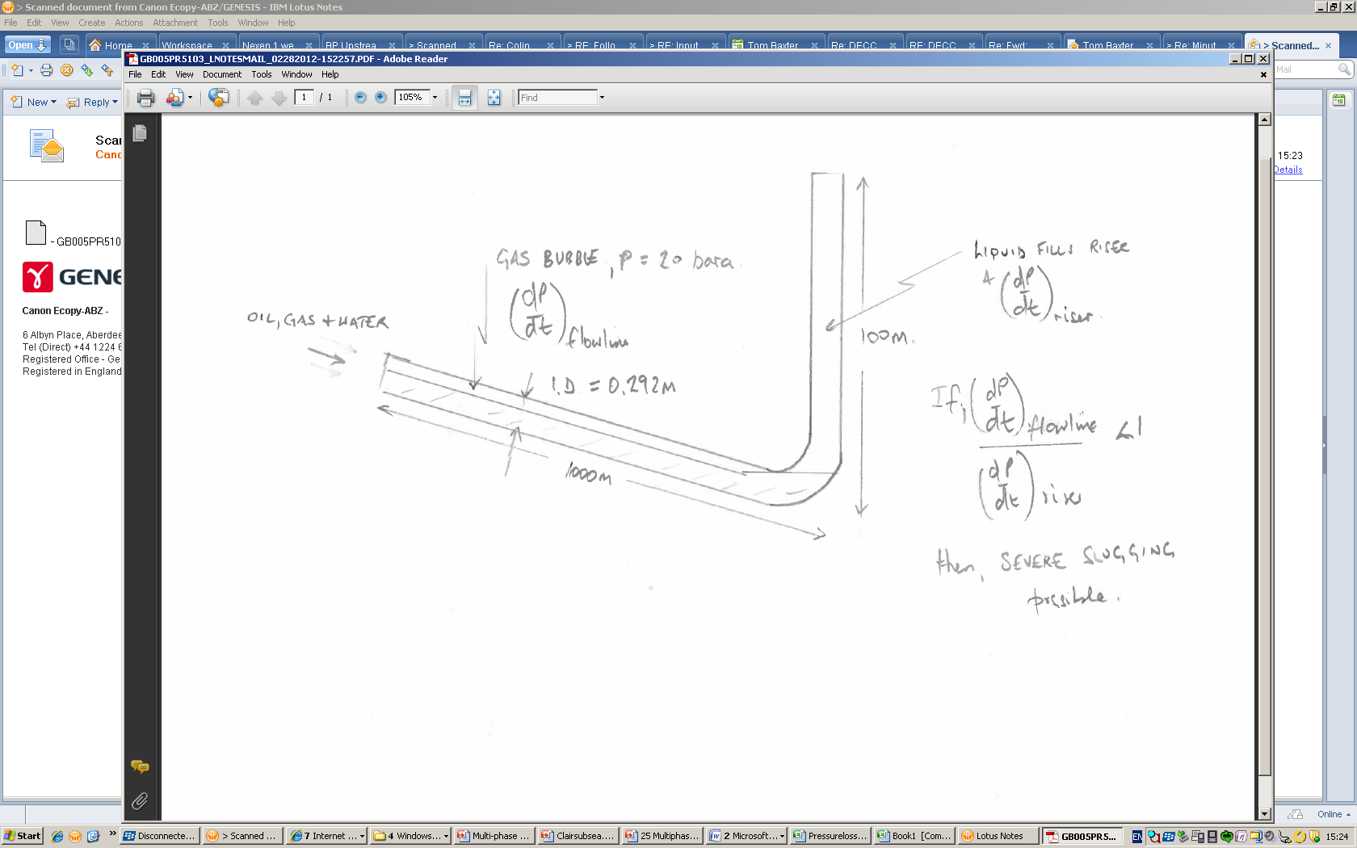
Calculate the rate of pressure rise in the vertical riser.
Mean liquid density 0.5x1000 + 0.5 x800 = 900 kg/m3.
The volume rate of liquid is 0.009 + 0.009 = 0.018 m3/s
CSA of riser is 3.14 x 0.292^2/4 = 0.067 m2
Liquid velocity in riser = 0.18/0.067 = 0.27 m/s
Hence dP/dt in riser = 900 x 9.81 x 0.27 = 2384 Pa/s
At severe slugging dP/dt in riser equals dP/dt of the flowline gas bubble
Gas rate = X m3/s
Fraction of gas in flowline = X/(X+0.009+0.009)
Volume of gas in downward sloping flowline = X/(X+0.018) x 0.067 x 1000 = 67X/(X+0.018) v/v
Assume ideal gas law. Increase in gas bubble pressure will be proportional to volume percent of gas added (X m3/s)
dP/dT gas bubble =X/(67X/(X+0.018)) x 20 = (X+0.018)x20/67 bar/s
At the onset of severe slugging the rate of pressure rise due to vertical pipe filling with liquid will be equal to rate of pressure rise of the gas bubble
Hence (X+0.018)x 20/67 x 100000 = 2384
X = 0.062 m3/s – Gas rate at which severe slugging may occur.

[10 marks]

END OF PAPER

Figures and charts

Question 3 c – Mollier chart for Propane

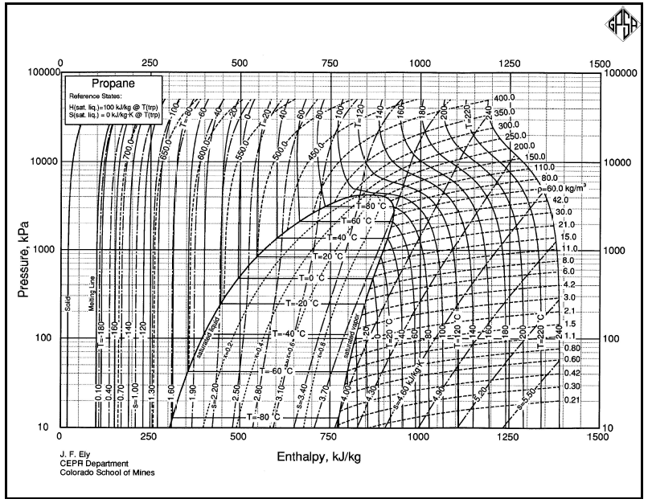

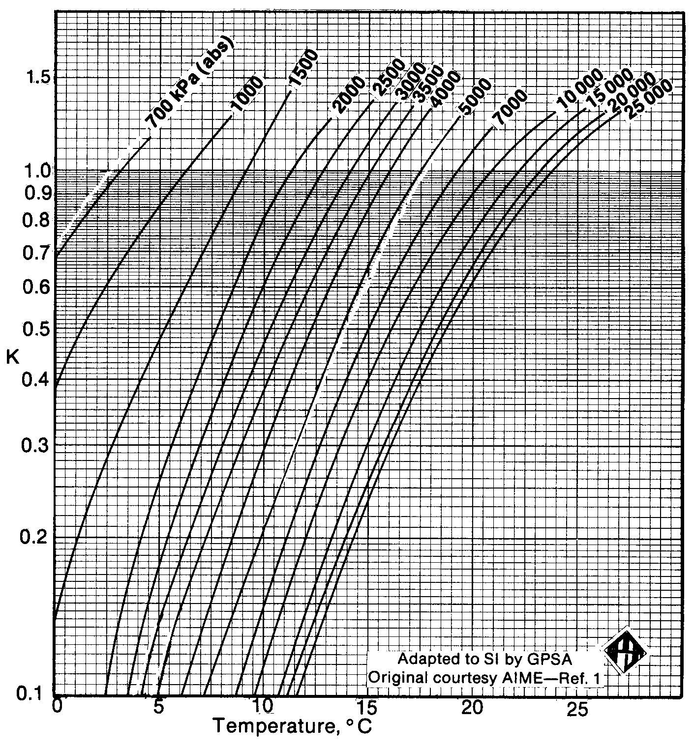
Question 5b Hydrate K chart for Ethane
ETHANE

