UNIVERSITY OF ABERDEEN SESSION 2015/16

Degree Examination

EG5099 Upstream Oil and Gas Processing

December 2015

**PLEASE NOTE THE FOLLOWING**

1. You **must not** have in your possession any material other than that expressly permitted in the rules appropriate to this examination. Where this is permitted, such material **must not** be amended, annotated or modified in any way.
2. You **must not** have in your possession any material that could be determined as giving you an advantage in the examination.
3. You **must not** attempt to communicate with any candidate during the exam, either orally or by passing written material, or by showing material to another candidate, nor must you attempt to view another candidate’s work.

**Failure to comply with the above will be regarded as cheating and may lead to disciplinary action as indicated in the Academic Quality Handbook (**[**www.abdn.ac.uk/registry/quality/appendix7x1.pdf**](http://www.abdn.ac.uk/registry/quality/appendix7x1.pdf)**) Section 4.14 and 5.**

# CANDIDATE INSTRUCTIONS

## Attempt all 5 questions. Each question is worth 20 marks.

## 

### Question 1

1. The following temperature–pressure plot is the phase envelope for a multi-component hydrocarbon fluid. Describe the phase transitions and liquid to gas ratio moving from point A to B.

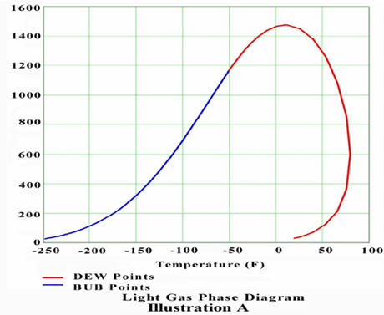

P

T

A

B

Critical Point

[4 marks]

The path is reducing pressure at constant temperature. At point A the fluid is in the vapour (dense phase) region. As the pressure drops the path from A reaches the dew point locus where the first droplets of liquid appear as the pressure is further reduced more liquid forms. The amount of liquid formed will reach a maximum then start to reduce as approaches the dewpoint from within the phase boundary. The fluid will again cross the dewpoint locus before point B where all the fluid will have revapourised.

1. The heavier components in a hydrocarbon system are often simulated using Psuedo-components. Describe a Pseudo-Component. What properties define a Pseudo-component for modelling purposes?

[4 marks]

For the heavier components in a reservoir fluid one or more pseudo-components (or hypothetical components) can be used.

Pseudo-components are a mixture of many components with different properties but modelled as one component with generalised/average physical properties.

Pseudo-Components are defined either by the critical properties or by average molecular weight, specific gravity and normal boiling point. Acentric factors and binary interaction parameters can also be entered.

1. An oil, water separator is to be simulated. Of particular interest is the partitioning of aromatic components in the oil into the water phase. It is proposed that the Peng-Robinson equation of state is used to describe the system. Comment on the suitability of Peng-Robinson in this application.

[4 marks]

Here we are dealing with two immiscible liquids. In the instance the commonly used P-R equation is not suitable. An activity coefficient based model particularly NRTL or UNIQUAC would be much more appropriate.

1. Export oil is controlled to a true vapour pressure (TVP). Why is TVP an important specification?

[2 marks]

TVP is important as it limits vapourisation in storage and transport which could be a safety concern and also result in loss of product.

1. An export oil with a true vapour pressure (TVP) of 0.9 bara is produced from an oil-gas separator operating at 1.9 bara and 70 DegC. The reference temperature for TVP is 15 DegC. Explain how a separator operating at 1.9 bara can produce a TVP of 0.9 bara? Use a PT phase envelope plot to support your explanation.

[4 marks]

This can be explained by reference to the oil phase envelope. The vapour pressure is the point that the fluid will release gas – the bubble point. TVP is measured at 15 DegC and the separator is at 70 DegC.



P

T

Critical Point

15 C

75 C

0.9 bara

1.9 bara

1. In the above example it is desired to increase the TVP to 0.95 bara. The pressure of the vessel remains fixed. How could you achieve an increased TVP by manipulating temperature? Explain your reasoning.

[2 marks]

To increase the TVP we require to hold more light ends (methane, ethane, propane) in the liquid phase – this can be achieved by reducing the temperature.

### Question 2

1. Methane is vented from a pressurised vessel as indicated in the following figure.



Using the following information calculate the flow rate of methane Qs in Sm3/s (S is flow at standard conditions.)

Assume - vessel pressure P1 remains constant, system behaves isothermally and flow at the vent outlet is sonic.

T = 60 DegC

Standard T = 15 DegC

P1 = 10 bara

P3 = 1 bara

Standard P = 1 bara

Vent pipe inside diameter = 0.08m

Compressibility, z = 0.95

The flow relationship in the vent pipe as a function of pressure drop is;

(P1 – P2) = Qs2 . 0.088

Qs flow rate in Sm3/s

Sonic velocity at vent tip can be calculated from;

c = √(k.R.T/Mw)

where;

c = sonic velocity, m/s

k = ratio of specific heats, Cp /Cv = 1.31

R = universal gas constant, (8314 J/kgmol DegK)

T = absolute temperature, DegK

Mw = molecular weight

The solution for quadratic is as flows;

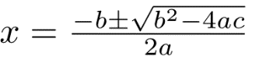

[8 marks]

Calculate c the velocity at the vent pipe at pressure P2

c = (1.31 x 8314 x 333/16)^0.5 = 476 m/s (1 mark)

Vent pipe CSA = 3.14 x 0.08^2/4 = 0.005m2

Hence volume flow Q2 at pressure P2 = 476 x 0.005 = 2.38 m3/s at P2 (1 marks)

Assuming PV = zRT, Q2 at standard conditions is,

Qs = 2.38 x P2/1 x 288/333 x 1/0.95 = 2.17 x P2 Sm3/s (2 marks)

Substitute Qs into (P1 – P2) = Qs2 . 0.088 with P1 = 10 bara

(10 – P2) = (2.17 x P2)^2 x 0.088

10 – P2 = 0.414 x P2^2

0.414 x P2^2 + P2-10 = 0 ( 2marks)

Solve the quadratic for positive root



P2 = -1 + (1^2 - 4 x 0.414 x (-10))^0.5/(2 x 0.414) = 3.85 bara (1mark)

Hence

Qs = 2.17 x P2= 8.35 Sm3/s (1 mark)

1. Describe an emulsion and the conditions which promote emulsion formation.

[4 marks]

In Physical Chemistry an emulsion is a mixture of two or more liquids (with no or very limited mutual solubility) in which one is present as droplets, of microscopic or ultramicroscopic size, distributed throughout the other. Emulsions are formed from the component liquids most often by mechanical means, such as agitation and shearing. Emulsions are stabilized by agents that form films at the surface of the droplets (e.g. surfactants) or that impart to them a mechanical stability (e.g. fine solids). Cold temperatures can stabilise emulsions – the lower viscosity results in less droplet collisions and coalescence. Low temperature also results in a higher surface tension making coalescence less likely.

1. A gravity separator has four main functions, name and describe the four functions. Illustrate your answer with a diagram of a typical separator.

[8 marks]

Separation vessels usually contain four major sections, plus the necessary controls. The primary

separation section, A, is used to separate the main portion of free liquid in the inlet stream. It usually contains an inlet nozzle which may be tangential, or a diverter baffle to take advantage of the inertial effects of centrifugal force or an abrupt change of direction to separate the major portion of the liquid from the gas stream.

The secondary or gravity section, B, is designed to utilize the force of gravity to enhance separation of entrained droplets. It consists of a portion of the vessel through which the gas moves at a relatively low velocity with little turbulence.

The coalescing section, C, utilizes a coalescer or mist extractor which can consist of a series of vanes, a knitted wire mesh pad, or cyclonic passages. This section removes entrained droplets of liquid from the gas by impingement on a surface where they coalesce. For a three phase separator oil and water droplet coalescence can be achieved using tilted plate type devices.

The liquid collection section, D, acts as receiver for all liquid removed from the gas in the primary, secondary, and coalescing sections. Depending on requirements, the liquid section should have a certain amount of surge volume, for degassing or slug catching.

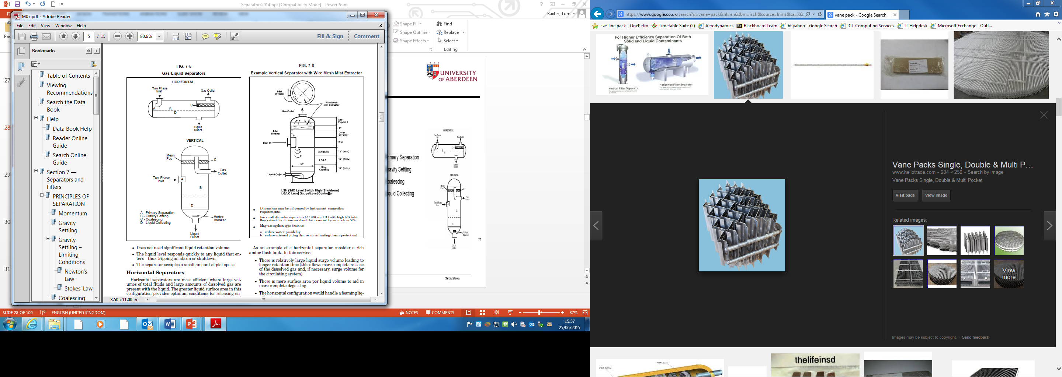

### Question 3

1. Seawater is often injected into an oilfield for voidage replacement. Prior to injection the oxygen is removed from the seawater. Why is oxygen removed?

[2 marks]

The removal of oxygen form seawater is an established means of corrosion control and allows the use of carbon steel material for flowlines and downhole tubulars in place of corrosion resistant alloys.

1. A gas pipeline is to be operated at 150 bara. The gas enters the pipeline at 30 DegC and drops to 4 DegC as it cools flowing within the pipeline. In order to prevent hydrate formation the gas is to be dried. The pipeline operator requires to set a water content of the gas which would give a 10 DegC margin below the minimum water dewpoint in the pipeline. Given the attached water saturation chart, estimate the water outlet specification required from the gas drier.

[4 marks]

Use chart to determine the water dewpoint at 4 – 10 DegC = - 6 DegC and 150 bara – 15MPa.

Answer – 40 kg/106 Sm3

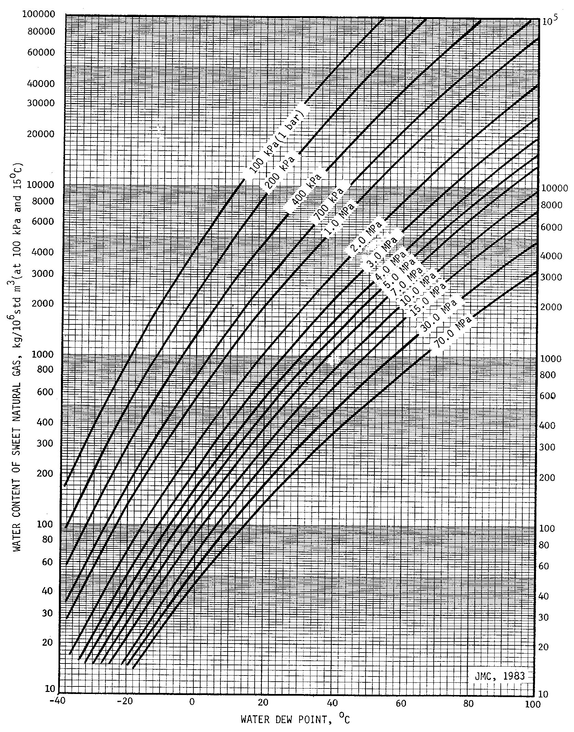

1. Describe how an operating line and equilibrium line would be constructed for a dehydration operation using a glycol absorber. The gas entering the glycol unit is water saturated at the absorber operating pressure and temperature. The gas rate is known and the gas outlet water specification is given. The glycol circulation rate, absorber pressure and temperature are fixed.

[8 marks]

The operating line can be constructed by calculating the water saturation level of gas at the contactor inlet P and T. The outlet conditions are the water specification to be achieved. (2 marks)

Taking the gas outlet specification in mg/m3 or similar, the dewpoint temperature of the gas can be determined. Assume the glycol at the top of the column in contact with the gas requires to be 10 DegC below the equilibrium dewpoint of the gas to achieve the required specification. The required glycol concentration can thus be established from equilibrium values. (2 marks)

By conducting a water mass balance the amount of water removed from the inlet saturation level to the outlet spec can be calculated. The water removed is absorbed by the glycol and knowing the glycol circulation rate and inlet concentration the outlet glycol concentration be calculated. (2 marks)

The water equilibrium concentration in the gas in contact with the outlet glycol can be determined from equilibrium values. Inlet and outlet operating and equilibrium values are hence known and the absorber lines can be constructed. (2 marks)



1. A hydrocyclone unit, removing oil from produced water, is successfully operating on an oilfield. The hydrocyclone unit contains multiple individual cyclones. A large proportion of the production is subsequently shutdown thus significantly lowering the flow to the hydrocyclone. At these low flow conditions the hydrocyclone performance drops and the oil content in the product water from the cyclone increases to a level above that required for disposal. Explain why the performance deteriorates at low flowrates. Also, what might you suggest could be done to improve performance at low flowrates?

[6 marks]

A hydrocyclone utilises centrifugal force to separate fluids of different density (oil and water). The centrifugal force is provided by introducing water with dispersed oil into the hydrocyclone through a tangential port. The tangential port sets up a spinning motion hence centrifugal separation. At low flow the tangential velocity will be reduced hence the centrifugal separating force is reduced thereby producing poorer separation. (3 marks)

To improve the performance the tangential velocity at low flows has to be increased. This could be accomplished by blanking off a number of hydrocyclones thus increasing the flow/velocity to the hydrocyclones remaining in service. (3 marks)

### Question 4

1. Pumps are the single largest user of electricity within the European Union. Identify and describe 5 different areas whereby centrifugal pump efficiency will be affected. Categorise the identified aspects as mechanical or hydraulic.

[10 marks]

2 marks each for any five of the following;

Mechanical

**Bearing –** friction losses through bearings

**Seals -** friction losses through seals

Hydraulic

**Flow friction** - Flow friction occurs where the fluid is in contact with the rotating impeller surfaces and the interior surfaces in the pump casing. The flow friction causes a pressure loss which reduces the head. The magnitude of the friction loss depends on the roughness of the surface and the fluid velocity relative to the surface.

**Disk Friction -** Disk friction is the increased power consumption which occurs on the shroud and hub of the impeller because it rotates in a fluid-filled pump casing. The fluid in the cavity between impeller and pump casing starts to rotate and creates a primary vortex resulting in drag.

**Leakage Loss** - Leakage loss occurs because of smaller circulation through gaps between the rotating and fixed parts of the pump. Leakage loss results in a loss in efficiency because the flow in the impeller is increased compared to the flow through the entire pump.

**Mixing Loss** – Pressure loss occurs at cross-section expansions in the pump.

**Incidence Loss** - Incidence loss occurs when there is a difference between the flow angle and blade angle at the impeller or guide vane leading edges. A recirculation zone occurs on one side of the blade when there is difference between the flow angle and the blade angle. The recirculation zone causes a flow contraction after the blade leading edge. The flow must once again decelerate after the contraction to fill the entire blade channel and mixing loss occurs.

1. A centrifugal compressor, driven by a fixed speed electric motor, has an anti-surge control system. Describe the condition known as surge. Surge can be avoided by utilising a recycle loop – describe the fundamentals of recycle control and comment on the energy efficiency aspects of using recycle control. From an energy usage viewpoint what configuration of compressor and driver would be an improvement over the recycle loop?

[6 marks]

Surge

At some point on the compressor’s operating curve there exists a condition of minimum flow/maximum head where the developed head is insufficient to overcome the system resistance. An aerodynamic instability is brought about by flow reduction, which causes stalling. Stalling can occur at the inlet to the impeller, the radial portion of the impeller and in the discharge volute. This is the surge point. Without discharge flow, discharge pressure drops until it is within the compressor’s capability, only to repeat the cycle. The repeated pressure oscillations at the surge point should be avoided since it can be detrimental to the compressor, causing damage to the rotating element, casing and bearings. (2 marks)

Recycle Loop

By recycling gas, minimum flow is avoided. From an energy standpoint, recycle is wasteful as the recycle introduces additional gas into the compressor suction which has to be re-compressed. (2 marks)

Configuration

Changing from fixed speed to variable speed will allow for low flow operation by reducing speed and avoiding the need for recycle gas. Student might also mention inlet guide vanes and suction throttling. (2 marks)

1. A gas containing a mixture of methane, ethane, propane and butane is to be chilled to recover the propane and butane. The process group are considering the use of a Joule Thomson valve or a Turbo-expander. Describe the thermodynamics involved in the two processes. Also, describe the issues the process group would wish to address to identify the preferred the solution.

[4 marks]

The Joule Thomson valve creates a low temperature by reducing pressure across a valve. This process is isenthalpic.

The turbo expander produces a low temperature through some J-T expansion but this is coupled with an isentropic process through the expander. As the expander rotates energy is removed from the system hence much lower temperatures can be achieved and hence more recovery of propane and butane. (2 marks)

In selecting the preferred option the Process group should consider cost and complexity, a J-T valve is much cheaper than a turbo expander, has no moving parts, requires less maintenance and is simpler to control. However, the drop in pressure across the J-T valve may require a new recompressor to recover the lost pressure, hence negating many of the simplification benefits. Whereas the turbo expander could be coupled to a recompressor making it a much more energy efficient system. Finally a cost benefit analysis comparing the two options incorporating the differing revenue from propane and butane recovery optons should also be considered. (2 marks)

### Question 5

1. In two-phase flow explain the difference between no slip hold up and hold up. Why is hold up prediction important?

[4 marks]

If a an equal volume rate of gas and liquid are introduced into a horizontal pipeline it might be expected that the liquid hold-up i.e. the fraction of liquid volume to the total volume, would be 50%. This is unlikely to be the case as the gas is much more mobile than the liquid and will ‘slip’ through the pipeline at a higher velocity than the liquid, resulting in a higher than 50% liquid hold up. ( 1 mark)

In no slip conditions, which is seldom the case, the liquid and gas are assumed to be travelling at the same velocity, hence the hold up would be 50%. No slip hold up is often used in design calculations as it simplifies calculations. (1 mark)

Liquid hold-up is the ratio of the volume of liquid in the system to the total volume. It is an important feature of multi-phase flow lines as it will affect pressure drop, slug generation, rate of pipeline cooldown and other design and operational features. (2 marks)

1. A subsea oil and gas pipeline flows horizontally along the sea-bed then vertically upwards onto a host platform. Pressure drop readings are taken over a range of pipeline flowrates and the trend shown in the figure below is displayed. Explain why the pressure drop reduces with increasing flow then increases with increasing flow?

Pipeline

Pressure Drop

Pipeline

Flow Rate

[8 marks]

There will be two major components to pressure drop – friction and elevation. Elevation losses

will only occur in the riser. Friction losses will occur in both the horizontal pipeline and the riser.

Acceleration losses will be negligible.

Friction losses will follow: , thus as the flowrate increase the frictional pressure

drop increases. Friction losses will display the following trend:

flow

Pipe

ΔP

ΔPf

(4 marks if student recognizes friction and elevation effects)

Elevation losses will follow  where  is the two-phase density in the riser. At low flowrates there will be a high hold-up of liquid in the riser hence  will be high. When the flowrate is increased, there will be less liquid hold-up in the riser as the higher velocity will “sweep” the liquid along with the gas. Elevation losses will display the following trend:

ΔPel

Pipe

ΔP

Settle at no slip in riser

flow

Combining friction and elevation losses results in:

Combined

Pipe

ΔP

flow

friction

elevation

(4 marks if hold up effect is understood)

1. A two phase oil, gas pipeline pipe is flowing in stratified flow. In order to increase the production rate the pipeline is sphered. In this operation, the liquid in the pipeline is displaced by introducing a sphere which is propelled at the pipeline mixture velocity. At the end of the pipeline, the displaced liquid is routed to a slug catcher. The slug catcher requires to have sufficient liquid volume to handle the liquid displaced by the sphering operation. Given the following information estimate the liquid volume required of the slug catcher.

Pipeline length = 50 km

Pipeline inside diameter = 0.4m

Pipeline gas superficial velocity = 2.57 m/s

Pipeline liquid superficial velocity = 0.14 m/s

Pipeline liquid hold up = 3.Ns

Where Ns is the no slip holdup

The slug catcher is designed with a liquid export pump operating continuously at 0.018 m3/s

[8 marks]

Pipeline CSA = 3.14 x 0.4^2/4 = 0.126 m2

Pipeline volume = 0.126 x 50000 = 6300 m3 (1 mark)

No slip hold up, Ns = 0.14/(2.57+0.14) = 0.052

Therefore pipeline liquid hold up = 3 x 0.052 = 0.156 (1 mark)

Hence, liquid volume in pipeline = 6300 x 0.156 = 983 m3

The length of the liquid slug will be = 983/0.125 = 7801m (2 marks)

The liquid slug will be travelling at the pipeline mixture velocity = 2.57 + 0.14 = 2.71 m/s

Hence time taken to flow the liquid slug into slug catcher = 7801/2.71 = 2879 s (2 marks)

During that time the liquid removed by the pump = 2879 x 0.018 = 51.8 m3

Therefore liquid volume requirements of slug catcher = 983 – 51.8 = 931 m3 (2 marks)

## END OF PAPER

## Figures and charts

Question 3 – Gas Water Saturation chart.

