**UNIVERSITY OF ABERDEEN SESSION 2016-17**

**EG5099**

**Degree Examination in EG5099 Upstream Oil and Gas Processing**

**Day Date December Time**

**PLEASE NOTE THE FOLLOWING**

1. You **must not** have in your possession any material other than that expressly permitted in the rules appropriate to this examination. Where this is permitted, such material **must not** be amended, annotated or modified in any way.
2. You **must not** have in your possession any material that could be determined as giving you an advantage in the examination.
3. You **must not** attempt to communicate with any candidate during the exam, either orally or by passing written material, or by showing material to another candidate, nor must you attempt to view another candidate’s work.
4. You **must not** take to your examination desk any electronic devices such as mobile phones or other “smart” devices. The only exception to this rule is an approved calculator.

**Failure to comply with the above will be regarded as cheating and may lead to disciplinary action as indicated in the Academic Quality Handbook.**

# Notes: (i) Candidates *ARE/~~ARE NOT~~ permitted to use an approved calculator

***(ii) Candidates *~~ARE~~/ARE NOT permitted to use Engineering Mathematics Handbook***

1. ***Candidates ARE NOT permitted to use GREEN or RED pen in their exam booklet.***

***Attempts ALL questions***

***Each question is worth 20 marks.***

### Question 1

1. Sketch a typical mixed hydrocarbon gas phase envelope. Indicate the cricondenbar. What is the significance of the Cricondenbar for the operation of gas pipeline systems?

[4 marks]

Cricondenbar is the horizontal tangent at top of phase envelope. (2marks)

If a gas pipeline is operated above the cricondenbar conditions promoting two-phase flow are prevented. Irrespective of pipeline temperature, the gas can not enter the two-phase region. If liquid were to be produced, this would reduce the flow area, impacting production and could also cause troublesome slug flow. (2 marks)

1. For a two-phase separator operating at temperature T and pressure P indicate on a typical multicomponent hydrocarbon phase envelope the location of temperature T and pressure P for the gas and liquid streams.

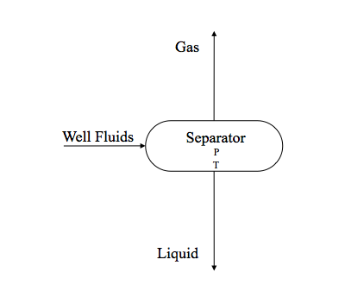

[4 marks]

Gas will be on the dewpoint locus at T & P ( 2marks).

Liquid on the bubble point locus at T & P. Example shown is 50 oC and 1000kPa. ( 2marks)

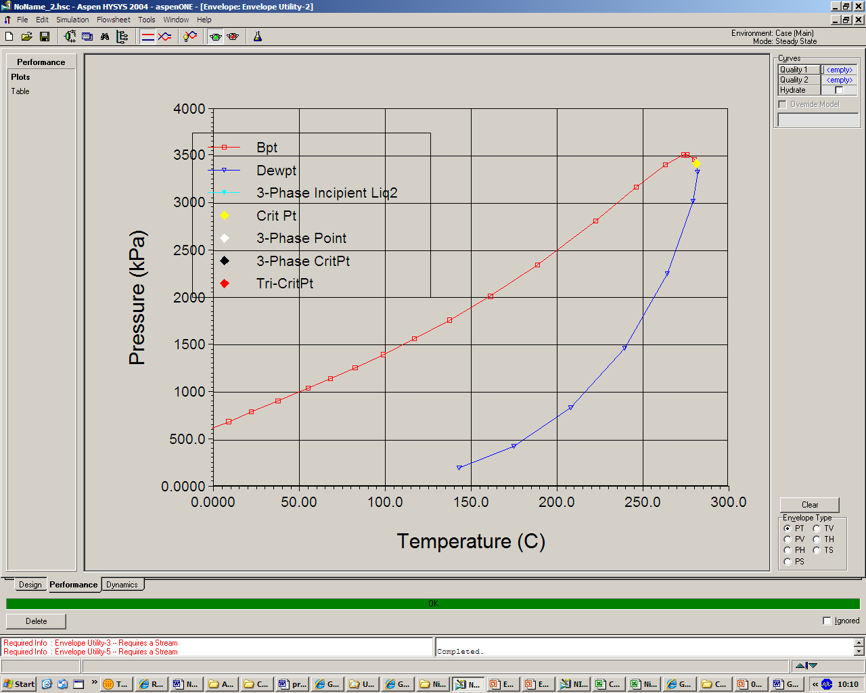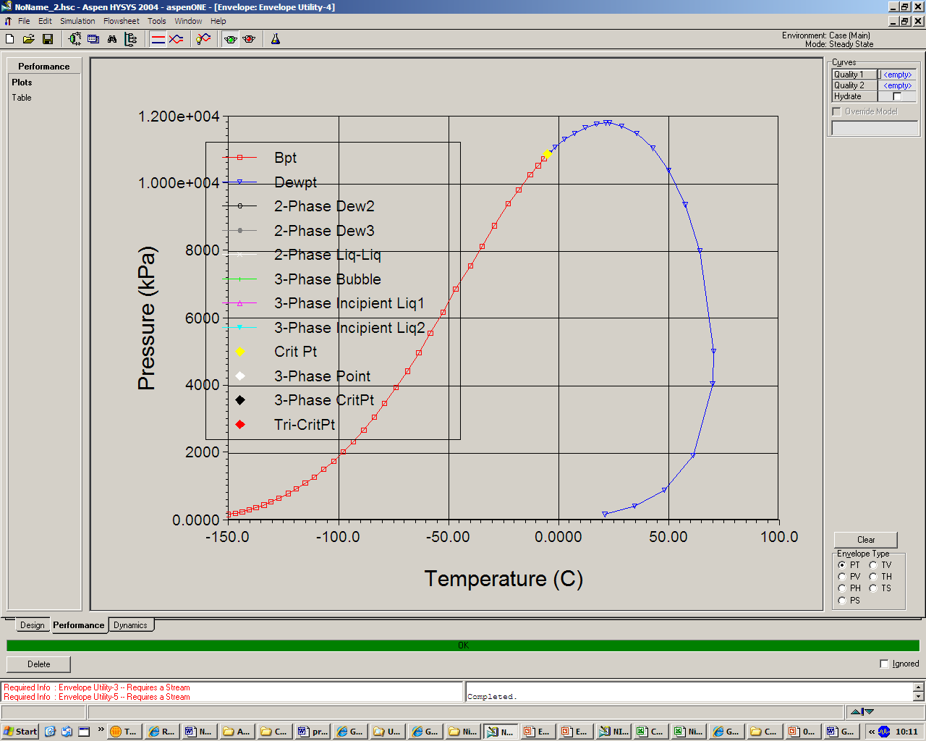

1. A final stage oil and gas separator is operating at 85 oC and 1.6 bara producing a crude oil product with a true vapour pressure (TVP) of 0.85 bara at 37.8 oC. Explain what will happen to the TVP of the crude oil if;

i) the Separator temperature reduces and the pressure is held constant

ii) the Separator pressure reduces and the temperature is held constant

[4 marks]

If the temperature reduces there will be less vapourisation of the light components hence the TVP of the crude oil will increase. (2 marks)

If the pressure reduces there will be increased vapourisation of the light components hence the TVP of the crude oil will decrease. (2 marks)

1. The standard and cubic form of the SRK equation of state and the associated fugacity coefficient expression are as follows. Describe the steps required to use these expressions to calculate the saturation temperature (boiling point) at a given pressure for a single component.



z3 - z2 + (A - B- B2) z - AB = 0

Where;

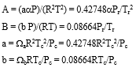



ω is the acentric factor, usual notation applies for other variables.

Fugacity Coefficient Φ is expressed as;

ln Φ = z - 1 - ln (z - B) - A/B ln (1 + B/z)

[8 marks]

The process is trial and error. Firstly the critical properties and the acentric factor have to be sourced from literature for the component.

The reduced pressure, m and α can be calculated. Reduced temperature can be expressed as T/ Tc.

Guess T (the saturation temperature) and solve the cubic for Z. The highest root being the gas the lower the liquid.

Substitute Z, A and B into the fugacity expression and calculate the liquid and gas phase fugacities.

At the saturation temperature the liquid and gas phase fugacities will be equal.

If not reinitialise T and repeat until equal fugacities are found.

### Question 2

1. Describe the concept of equivalent length as used in piping system pressure drop calculations.

[2 marks]

A component in a piping such as a bend or a valve is attributed a length of straight pipe which would give the same pressure drop as the component. Usually expressed as L/D.

1. An oil (density, ρ = 800 kg/m3, viscosity, μ = 0.003 Pa.s ) flows from A to C in a pipe with an inside diameter of 0.1 m. The pressure loss from A to C is 200100 Pa. Given the following information calculate the volume flowrate of oil in m3/s.

System sketch with distances in metres. H is a horizontal section, V is a vertical upward section.



Darcy’s equation applies (usual notation)

For turbulent flow the Blasius expression for friction factor applies, f = 0.316/Re0.25

|  |  |  |  |
| --- | --- | --- | --- |
| Pipe Fitting | | | Equivalent Length in Pipe Diameters (L/D) |
| Fittings | 90o Standard Elbow  45o Standard Elbow  90o Long Radius Elbow |  | 30  16  20 |
| 90o Street Elbow  45o Street Elbow  Square Corner Elbow |  | 50  26  57 |
| Standard Tee | Flow through run  Flow through branch | 20  60 |
| Close Pattern Return Bend |  | 50 |

[8 marks]

Pipe velocity v is unknown

Reynolds Number = ρ.v.d/μ = 800 x v x 0.1/0.003 = 26700.v

From Blasius, friction factor f = 0.316 / (26700.v)0.25

Calculate equivalent length

Straight pipe = 15 + 5 +22 + 13 = 55m

Fittings

1 90 degree standard elbow L/D = 30, EL = 30 x 0.1 = 3m

1 90 long radius elbow L/D = 20, EL = 20 x 0.1 = 2m

1 flow through branch tee L/D = 60, EL = 60 x 0.1 = 6m

Total equivalent length L = 55 +3+2+6 = 66m

Pressure loss due to friction;

ΔP = ρ.f.L.v2/(2D) = 800 x (0.316 / (26700.v)0.25) x 66 x v2/ (2 x 0.1)

Pressure loss due to elevation;

ρ.g.h

h = 5+13 = 18m

ΔP = 800 x 9.81 x 18 = 141200 Pa (1 mark)

Total pressure drop = 200100 Pa

Thus, pressure drop due to friction = 201000 – 141200 = 58900

Hence,

800 x (0.316 / (26700.v)0.25) x 66 x v2/ (2 x 0.1) = 58900

Solving for v

6525 v1.75 = 58900

v = 3.52 m/s

Volume flow, Q = v.A

Pipe CSA, A = 3.14 x 0.1^2/4 = 0.00785 m2

Q = 3.52 x 0.0785 = 0.28m3/s

Check flow is turbulent – NRe = 26700 x 3.52 = 93984, OK fully turbulent.

1. The work done in compressing a gas can be expressed as;



For an isentropic compression process the following expression holds;



Using these relations and the gas law expression to show that the isentropic enthalpy change can be expressed as;



Usual notation applies.

[6 marks]

Answer

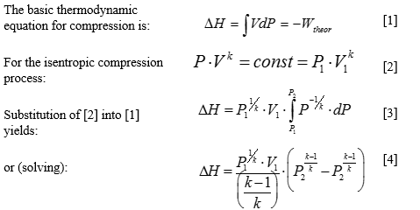

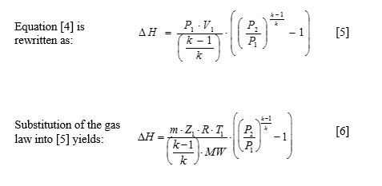

1. For a centrifugal compressor describe the condition known as surge.

[4 marks]

At some point on the compressor’s operating curve there exists a condition of minimum flow/maximum head where the developed head is insufficient to overcome the system resistance. An aerodynamic instability is brought about by flow reduction, which causes stalling. Stalling can occur at the inlet to the impeller, the radial portion of the impeller and in the discharge volute. This is the surge point. Without discharge flow, discharge pressure drops until it is within the compressor’s capability, only to repeat the cycle. The repeated pressure oscillations at the surge point should be avoided since it can be detrimental to the compressor, causing damage to the rotating element, casing and bearings.

### Question 3

1. A glycol dehydration system is used to remove water from a gas stream. Describe the operating principles and main components of a glycol system including the regeneration system. A sketch may help.

[6 marks]

Glycol absorbs water as it flows down through a contactor countercurrent to the gas flow. Mass transferred is enhanced by either a trayed or packed column configuration. Water-rich glycol is removed from the bottom of the contactor, passes through the reflux condenser coil, flashes off most of the soluble gas in a flash tank, and flows through the rich-lean heat exchanger to the regenerator. In the regenerator, absorbed water is distilled from the glycol at near atmospheric pressure by application of heat. The regenerated lean glycol flows through the rich-lean and glycol cooler exchanger for cooling before being recirculated to the contactor by the glycol pump. Heat integration to reduce energy consumption in the reboiler is affected by hot to cold glycol exchange.



1. Sketch a typical refrigeration cycle on a pressure enthalpy Mollier chart. Indicate the four key components of a refrigeration cycle. Show both isotherms and isentropic lines.

[6 marks]

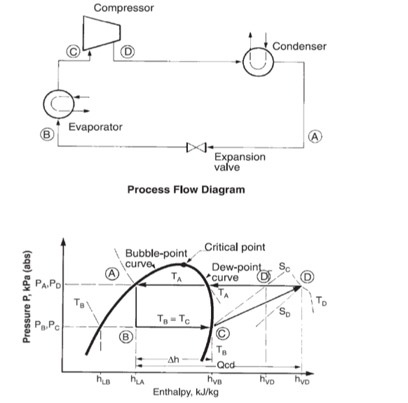

1. Water saturated methane gas enters a tri-ethylene glycol (TEG), counter flow, gas dehydrator absorber operating at 30 oC and 70 bara. It is required to produce a product gas with a water content of 35 mg/Sm3 from the absorber. Using the attached water saturation and equilibrium charts calculate the TEG concentration required to achieve this water content.

[4 marks]

From glycol water saturation chart, at 35 mg/Sm3 and 70 bara (7 MPa) the equilibrium water dewpoint of the gas is minus 18 oC. (1mark)

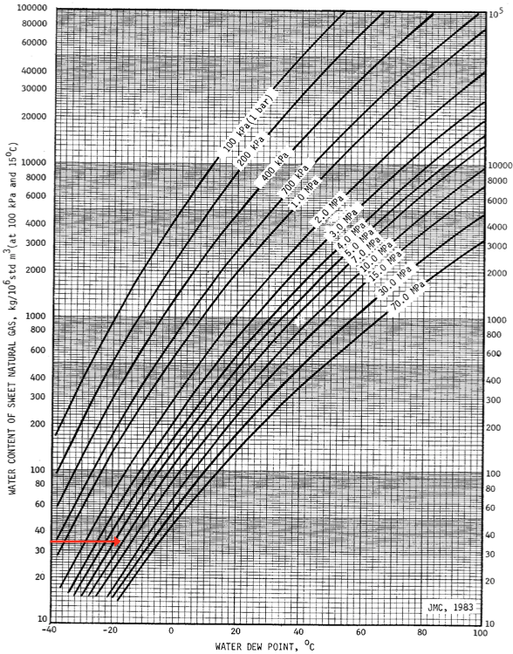

A margin of 10 oC over equilibrium should be provided to give a mass transfer driving force at the top of the contactor. (1 mark)

The required water dewpoint is minus 28 oC. (1 mark)

From the TEG equilibrium chart this corresponds to a required TEG concentration of approx. 99.5wt%. (1 mark)

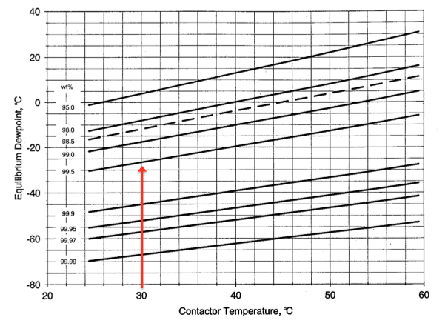

1. A seawater deaeration column utilising nitrogen gas in a single stage, packed stripping column is in operation. You are asked to determine the height of a transfer unit. Describe how you would undertake this task.

[4 marks]

A number of field measurements have to be taken; the concentration of oxygen in the nitrogen at column inlet and outlet and the concentration of oxygen in the seawater at inlet and outlet.

From the seawater inlet and outlet oxygen concentrations Henry’s law would be used to evaluate the equilibrium oxygen concentration at the nitrogen water interface. Sufficient information is now available to determine the number of transfer units (NTU).

The height of the packing, Z, would be established from the column data sheets.

Knowing Z = NTU x HTU the HTU can be determined.

### Question 4

The following oil, gas, water separation and associated compression arrangement has been proposed for an offshore development. It is a single process train comprising two stages of three phase separation with interstage heating.

An export pump and cooler deliver the oil to an export pipeline. The export pump is driven by a fixed speed electric motor in a 2 x 100% parallel configuration. The pump efficiency at design conditions is 70%

Large quantities of hot water are produced from each separator.

The interstage heater is an electric unit. Electrical supply to the heater, pump and compressor is from a simple cycle, gas turbine coupled to an alternator – the gas turbine is fueled by process gas.

The system is designed for a 100% throughput but as the development ages, flowrates will drop progressively to 10% of design. The initial discharge requirement from the pump is 100 bara, but as the throughput reduces, the back pressure from the pipeline reduces requiring less pump discharge pressure.

Gas from the LP separator is cooled and passed to a knock out drum. The liquids from the drum are recycled to the inlet of the LP Separator. The gas is compressed in a 1x100% LP centrifugal compressor to a pressure equal to the HP Gas. The compressor is driven by a fixed speed electric motor and controlled by an anti-surge recycle system. The compressor polytropic efficiency is 70%.



Review this arrangement from an energy efficiency standpoint, identifying 10 topics which you would recommend require investigation before the design is finalised. For each topic identified give a short description of why you think it is worthy of consideration.

[20 marks]

2 mark for each for any 10 identified.

Export pump arrangement. Existing design will be inefficient at turndown conditions as the pumps will be far from their design duty. Consider other arrangements such as 4 x 33%, 5 x 25%.

As above for compressors.

Variable speed drives for export pumps. Variable speed drives will minimise the requirement for recycle control which is inefficient. It will also allow the pumps to operate closer to their best efficiency point.

As above for compressor.

Pump efficiency appears low. Improved efficiency will reduce fuel gas usage.

As above for compressors.

Impeller change out for pumps to match turndown conditions. This would improve efficiency at turndown conditions.

As above for compressors.

Combined cycle rather than simple cycle gas turbine. This would result in a significant improvement in generation efficiency and reduction in the requirement for fuel gas requirement.

Combined heat and power. Use the heat from the gas turbine exhaust gas as process heating thus reducing electrical load.

Use the hot oil from the LP Separator to preheat the oil from the first stage separator. This would reduce the overall heat and electrical load.

Use the discharged hot water in a Rankine cycle to produce electricity. This would reduce the load on power generation reducing fuel gas usage.

Use the some of the pressure drop across LCV 01 to drive a turbine to produce electricity. This would reduce the load on power generation reducing fuel gas usage.

### Question 5

1. Describe a hydrate and the conditions necessary for their formation.

[2 marks]

A hydrate is an ice like substance where water forms a clathrate with small hydrocarbon molecules, H2S and CO2.

Conditions for formation are free water, high pressure and low temperature.

1. In a non flowing pipeline it is important to be able to predict the rate of temperature loss with time. By conducting a heat balance over a pipeline segment show that the rate of temperature decay is given by the following expression.

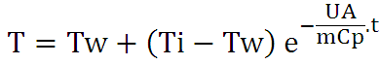

Where

m = mass of fluid within segment (kg)

Cp = specific heat capacity of fluid (J/kg o C)

U = overall heat transfer coefficient (W/m2 o C)

A = area of pipe (m2)

Tw = temperature of surroundings (o C)

Ti = initial temperature at time zero (o C)

T = average bulk fluid temperature at time t (o C)

t = time (s)

[8 marks]

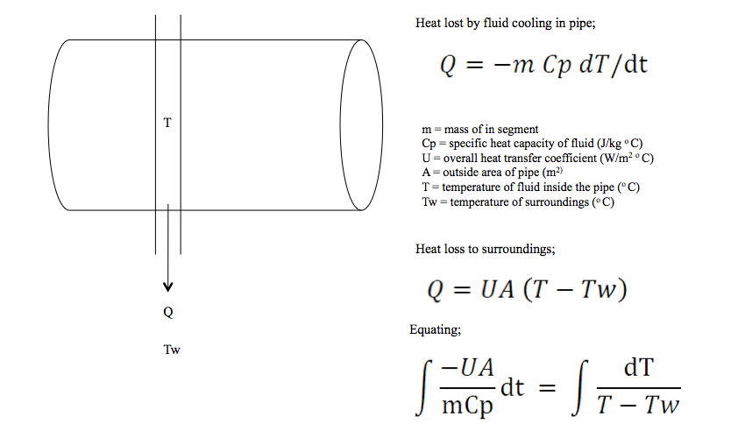

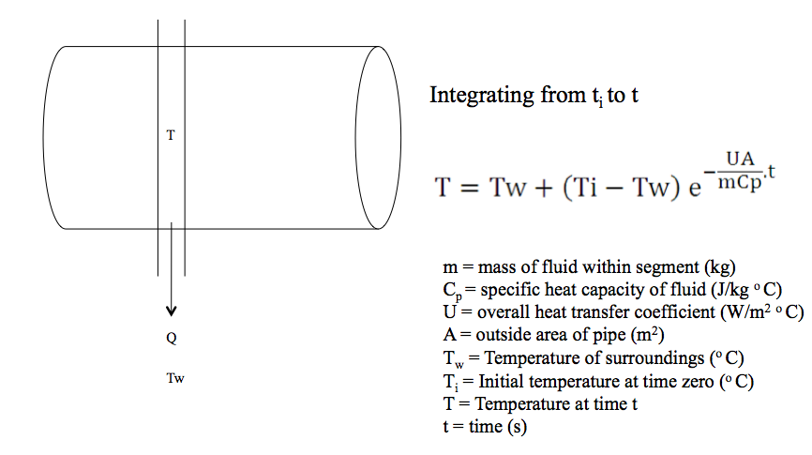

1. A wax is characterised by cloud point and pour point. Describe the meaning of both terms.

[4 marks]

Cloud point is where the temperature is cooled to the point here the first crystals of wax appear. (2 marks)

Pour point is the temperature at which the system gels or solidifies. (2 marks)

1. Describe the phenomenon, and the conditions which promote, severe slugging in a pipeline, vertical riser system.

[6 marks]

Pipeline of downward gradient meets riser base.

Liquid blocks the base of the riser.

Riser fills with liquid if accompanying gas bubble has insufficient pressure to overcome liquid head.

Riser continues to fill.

Once riser is full the backpressure stabilises however the accompanying gas bubble pressure continues to rise

Once the gas bubble pressure is greater than the riser back pressure the riser starts to unpack.

Slowly at first then accelerating as the head in the riser reduces.

Severe slugging produces gas and liquid flow and pressure transients which are very difficult to manage.

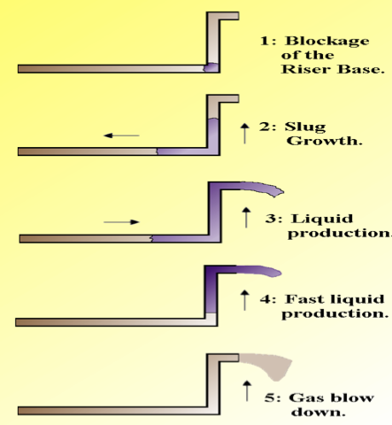

## END OF PAPER Figures and charts

**Question 3c Water Saturation Chart**

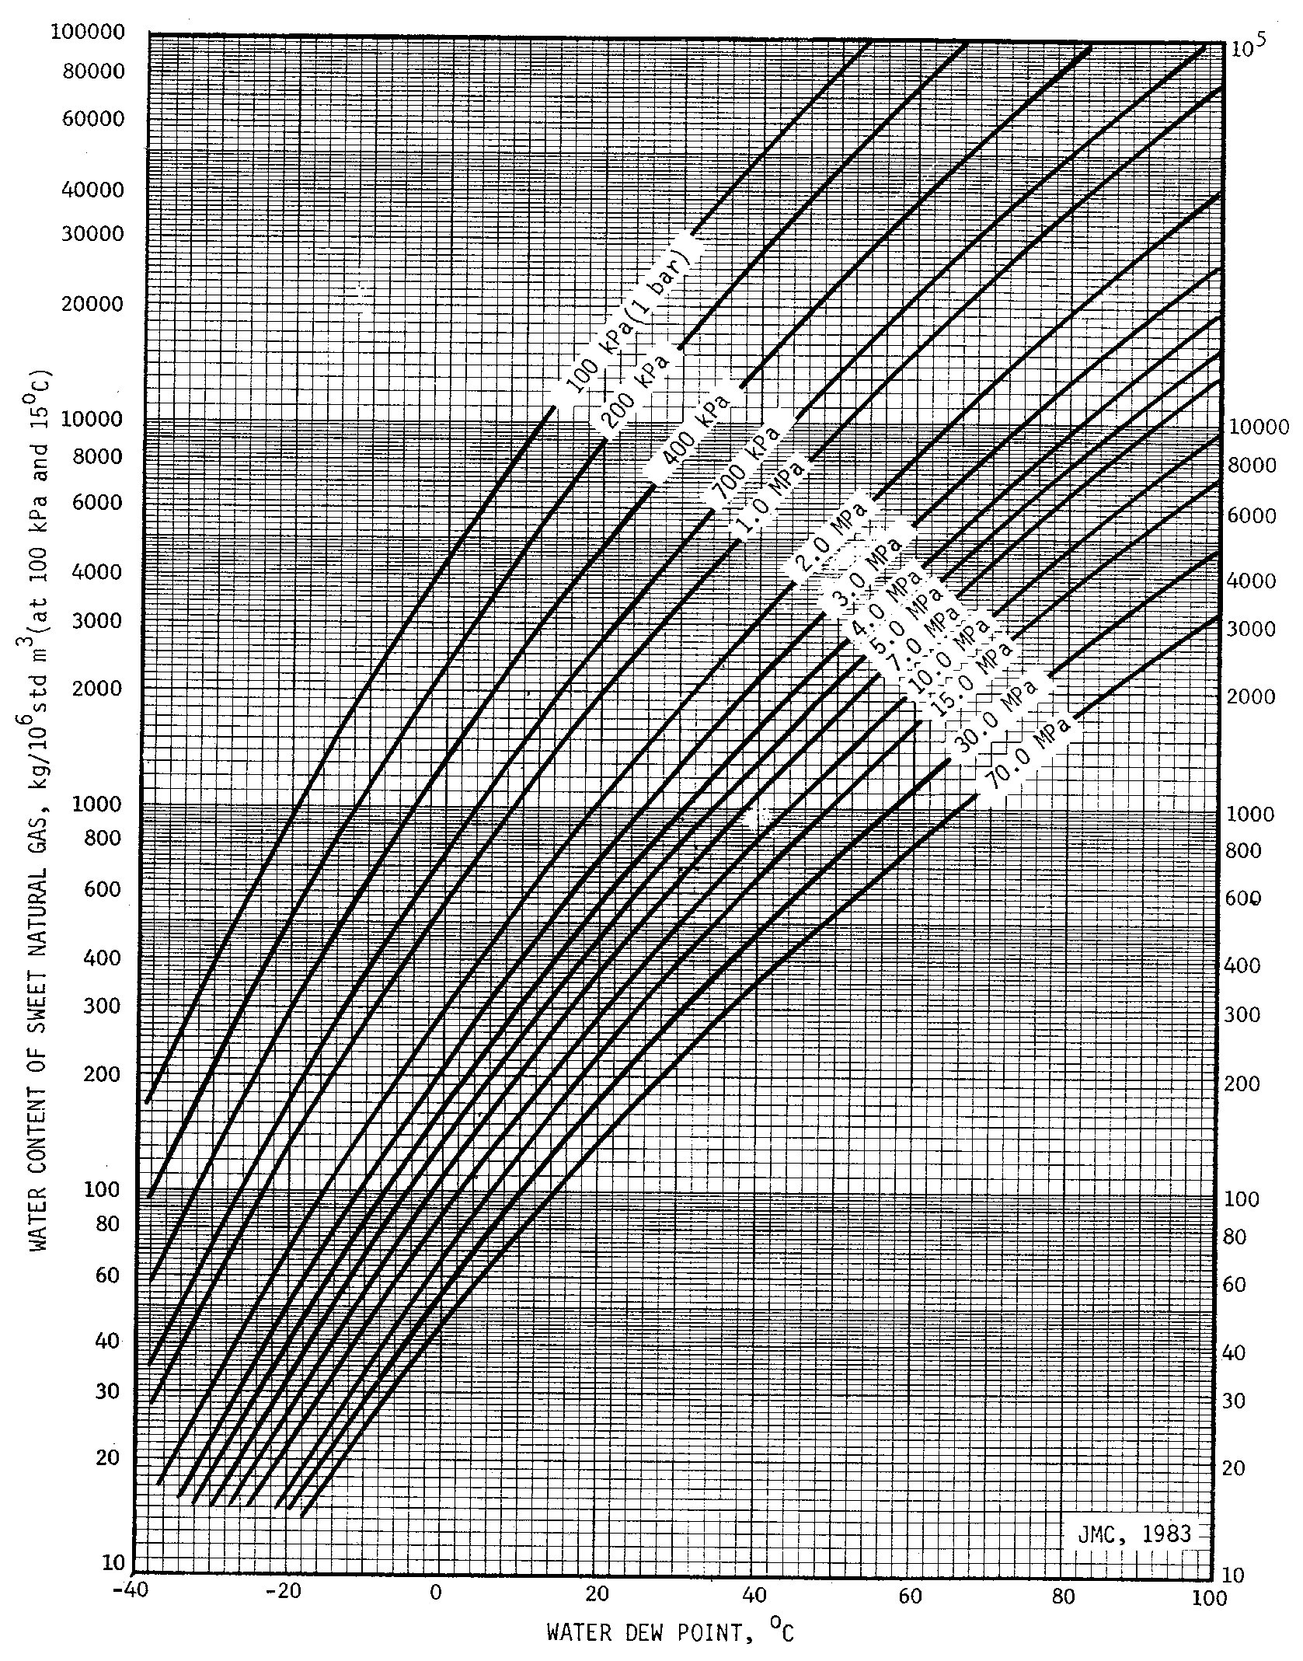

**Question 3c TEG Equilibrium Chart**

