Configure a Zmala terminal
This part is for the helper setting up the TV terminal. Install the software first using ZmalaTerminal-Installation.pdf. Have the Presenter remote, TV remote and server QR document ready. For Wi-Fi, use an Android phone already connected to the network: open Settings > Wi-Fi (or Internet), select the connected network and choose Share or QR code. Unlock if asked and show it to the terminal camera at Scan the Wi-Fi QR code. Menu names vary. A printed Wi-Fi QR from the server is another option; Ethernet skips Wi-Fi setup.

Prepare the account and QR documents

1 Open the server
From a PC or phone on the same network, open the server address, normally http://zmalaserver.local:8080/, and sign in. Use its IP address if the name does not resolve. If no server exists yet, follow ZmalaServer-Installation.pdf first.

2 Create or select the account
In Accounts, create an account of type Terminal, or select the existing account this Pi is replacing. Set its display name and portrait. In Groups, place this account and the people it may call in at least one shared group.

3 Choose the terminal settings
Open Terminals and find the device. Set the language and review automatic answer, video, sound and display options, then save. Automatic answer lets a permitted caller connect without a green press after the selected delay; choose Never locally, or disable it on the server, if this is not wanted.

4 Prepare the setup QR codes
On that terminal card, open Setup. Use Download Wi-Fi QR PDF and enter the intended network details. Then use Download server QR PDF for this terminal. Print both codes clearly or display them on another screen.
Keep both QR documents private: they grant access to the Wi-Fi and this terminal account. Use the server code made for this terminal. The Pi hostname does not select the account.

When replacing a terminal
Stop the old terminal before enrolling its replacement. Reuse the existing server QR only while its server address, device ID and token are still valid. If any of these changed, download a current QR. The new Pi needs its own remote pairing and TV permission.

Pair the remote and connect Wi-Fi
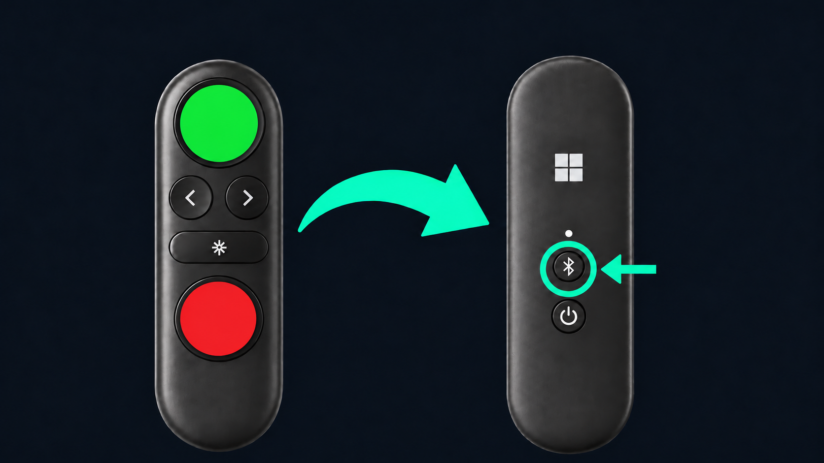
Front on the left, back on the right. The highlighted rear button starts Bluetooth pairing.

1 Connect the camera and charge the remote
If the USB instruction screen appears, connect the C10/C20 to a blue USB 3 port and the charging cradle beside it. The screen advances when the C10/C20 is detected; the cradle itself does not report a USB device.

2 Pair the remote
Switch the remote on using its rear on/off switch. Hold the small rear Bluetooth button for about three seconds until the white light flashes. Keep it near the Pi and wait for the button test. If flashing stops before pairing succeeds, start pairing again.

3 Complete the button test
Press and release left, right, green, red and middle in the order shown. Only the next button is highlighted. All five must pass. A keyboard cannot complete this test; if the remote disconnects, the unfinished test starts again.

4 Scan the Wi-Fi code and then the server code
Hold the Wi-Fi QR steadily in front of the C10/C20, with the whole code inside the four corner guides shown on the TV. Move the code closer or farther away until it fits clearly. Wait for success and the ten-second confirmation. When the server QR screen appears, show the server QR inside the same guides. An incorrect or unreachable server leaves an error and lets you try again.
Setup starts in English and uses the chosen terminal language after the server code is accepted. Language choices are shown in their own language, in alphabetical order. Left and right wrap through the list. Some detailed help is in English.

Check the TV controls and make a call
Keep the TV remote in your hand. These checks start after the server QR, so instructions can use the terminal language. A failed test can be retried; continuing without a feature leaves that part of automatic TV control disabled.

1 Power test
When ready, press green. Zmala asks the TV to switch off, waits a few seconds and wakes it. Press green if you saw both actions, or red if you did not. Use the retry option if needed.

2 Input test
When instructed, use the TV remote to select broadcast TV or another input. Zmala waits to detect the change, returns to its screen, goes back to the other source, then returns to Zmala again. There is a short pause between switches. If the screen does not return within 30 seconds, select the Zmala HDMI input manually.

3 Confirm what you saw
Press green only if the automatic switching happened. Press red otherwise. Follow the help or repeat the test. The terminal records the result; a command being sent is not enough to confirm a pass.

If the TV needs extra setup
For Samsung, follow the on-screen Anynet+ and Network Control instructions. Select the correct TV if several are found, and approve its ZmalaCall permission prompt using the TV remote. For Sony BRAVIA, check BRAVIA Sync and TV auto power on. Menu wording varies; physical Sony operation has not yet been verified by this project.
If Samsung shows “Check Device Power”, first confirm the HDMI port and cable. Check Connected Devices or Source: the Pi must not be configured as an old cable or satellite box, such as Sky. In Universal remote setup, remove only the obsolete box profile assigned to the Pi’s HDMI port. Leave other devices alone. Repeat the TV setup checks and a call from both standby and live TV.

Finish with a real call
- Point the C10/C20 at the seating area. Call a permitted green Available or blue Try calling contact.
- Check that the picture moves in both directions and each person can hear the other. Check the small local-camera view too.
- End the call with red. Then wait without pressing a button: the blue countdown bar should appear after ten seconds. After the Return to TV delay, check that the TV returns to standby if it was off, or the previous input if it was on. Repeat with an unanswered call. Automatic return is disabled when the delay is set to Never.
- Restart once with help from the installer or administrator to check saved setup and remote reconnection. Verify Wi-Fi before removing the installation Ethernet cable.

Change settings after setup
From the contact carousel, hold red for seven seconds. A progress bar appears after two seconds. Keep holding until Settings opens. Releasing early cancels the gesture.
Use left/right to choose a setting; green opens it. Inside, left/right changes the draft, green saves and red discards it. Red on the list asks to exit: green confirms; red stays. Saved changes go to the server. If saving fails, retry after restoring the connection.
Setting | Available choices
Language | The languages offered by the server
Automatic answer | Never; 10 or 30 seconds; 1, 2, 5 or 10 minutes
Automatic framing | On or off; the C10/C20 view follows detected people, up to 2 times zoom
Ringtone volume | 0-100%, in 5% steps; separate from call volume
Button sounds volume | 0-100%, in 5% steps; quiet during calls and ringing
Ringtone | Nokia (default) and the sounds added on your server
Portraits | 3 or 5; short contact lists keep the smaller layout
Return to TV | 30 seconds; 1, 2, 5, 10 or 20 minutes; Never

The terminal ID appears at the bottom of Settings; give it to your helper if they need to find this device on the server. The C10/C20 provides the camera, microphone and speaker automatically.
If the C10/C20 is waking, wait a few seconds. Zmala retries without switching sound to the TV. Press red if you want to cancel the call. Your administrator can adjust video quality and the starting call volume on the server.
Open Ringtone with green. Press left or right to browse and hear each choice after a short pause. The list wraps at both ends. Press green to save or red to keep the previous tone.
Ringtone volume controls incoming ringing, previews and the tone while waiting for someone to answer; 0% is silent. Button sounds volume is separate. Use middle and left/right to change the sound heard during calls. A call stops any ringtone preview.

Reset and enroll again
In Settings, select Reset and press green to open its confirmation. Press green again to reset, or red to cancel. Reset removes this terminal profile's enrollment, saved configuration, notification counts and setup checks. It repeats setup without deleting server accounts. Existing Bluetooth pairing remains, but the button test runs again.
Have both QR documents ready before resetting. Reset is for deliberate reconfiguration, not the first response to a temporary call or network problem.

Using a secure server connection
If the terminal will be used on a network that blocks UDP, ask the server administrator for an HTTPS server QR code. The administrator must first configure the secure call service and media relay.
Install the current terminal software, then use Settings and Reset to enroll with the new QR code. An old HTTP QR code cannot activate secure relay mode. Do not turn off certificate checks to work around an enrollment error.
Call and answer controls stay the same. The terminal receives temporary relay credentials from the server. It updates them while idle, so an active call is not interrupted. If the terminal has been offline for a long time, restore its server connection before making a call.
Before use, make a call in both directions and check sound and video. If registration or media fails, ask the administrator to check the endpoint addresses, certificates, clock and network access. No automatic switch to an unencrypted connection is made.

Setting up ZmalaPhone
Create an App account for each phone and add it to the family’s shared group. Keep Terminal accounts for TV terminals. In Accounts, select the chain-link Connection details button beside the person, then Download server QR PDF. The App sheet has two QR codes: download the app first, then scan the account code in ZmalaPhone. Give this private sheet to that phone user; they do not need the administration password.
Send the signed ZmalaPhone.apk download link with ZmalaPhone-Installation.pdf and ZmalaPhone-Guide.pdf. The installation guide covers a printed QR or a QR picture saved on the same phone, permissions and the first test call.
For incoming alerts while the app is closed, configure the server’s private Firebase sender and ask the phone user to allow notifications. Test a call with their app open and again with the phone asleep. For calls from other networks, configure secure relay mode first and supply HTTPS setup codes.

