Prepare a new Zmala terminal
For the person installing a new Raspberry Pi 4 terminal. This guide takes you from a blank microSD card to the first setup screen. Continue with ZmalaTerminal-Guide.pdf to connect the remote, scan the QR codes and test the TV.

Before you start
- Raspberry Pi 4 Model B in the Argon ONE Pi 4 V2 case, a 32GB or larger microSD card and a card reader.
- Windows PC, Internet access and an Ethernet cable to the same router or local network.
- TV and HDMI cable, Nuroum C10/C20 camera, Microsoft Presenter+ remote and its charging cradle.
- Suitable Pi 4 USB-C power supply rated at least 5 V 3 A. Keep the TV remote nearby.
The current installer accepts Raspberry Pi OS Lite 64-bit based on Debian 13 Trixie. A desktop image, 32-bit image or a different Debian version will fail its checks.

Prepare the microSD card
Download Raspberry Pi Imager

1 Choose the image and card
In Raspberry Pi Imager, select Raspberry Pi 4, Raspberry Pi OS Lite (64-bit) based on Debian Trixie, and the intended microSD card. Writing erases the selected card; check the device carefully.

2 Customize the image
Set hostname, username and initial password to zmala. Enable SSH with password authentication in Imager. Set your locale and Wi-Fi country, but leave Wi-Fi network credentials unset; Zmala will obtain them from a QR code.

3 Write and verify
Let Imager finish writing and verification. Eject the card and insert it into the Pi while its power is disconnected.
Raspberry Pi image preparation help

Connect the terminal
Use the case ports shown below. Connect the cables before connecting power.
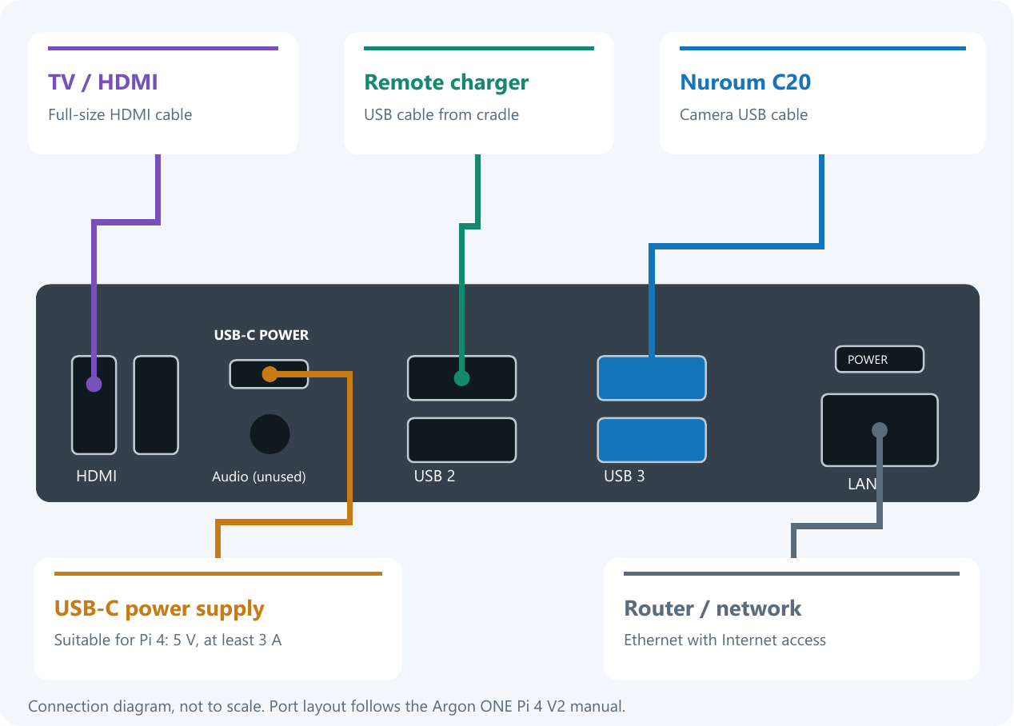
Argon ONE Pi 4 V2 connections. Use one HDMI output and leave the other unused.

1 Camera and charger
Plug the C10/C20 camera cable into a blue USB 3 port. Plug the remote charging cradle into the adjacent black USB 2 port. Place the remote on its cradle to charge.

2 TV and network
Connect one full-size HDMI socket on the Argon case to the TV. Select that HDMI input on the TV. Connect Ethernet to the router and keep it connected through installation.

3 Power
Connect USB-C power last. If needed, press the case power button once. Allow the first boot to finish before running the installer.
On a bare Pi 4, use a micro-HDMI cable instead of the full-size HDMI cable used with the Argon case. The port layout will differ.

Install the terminal software
Published ZmalaCall releases

1 Download the installer
Open the release link supplied by your administrator. Download ZmalaTerminal-Pi4-setup.exe and the two ZmalaTerminal PDF guides. Run the executable on your Windows PC; it installs the software on the Pi over Ethernet.

2 Check the Pi
Leave Network address as zmala.local and click Check Pi. The hostname entered in Imager was zmala; the .local suffix is used to find it on the network. If this fails, use the Pi Ethernet IP shown by the router.

3 Confirm installation
When checks pass, click Install and confirm the displayed Pi. Keep the PC, Pi power and Ethernet connected. The installer installs dependencies and services, configures the Argon fan, then reboots and checks startup automatically.

4 Continue on the TV
Wait for the installer to report success. The TV should show the USB, remote or QR setup screen. Continue with the helper setup part of ZmalaTerminal-Guide.pdf. If the TV is blank, check its selected HDMI input and cable before repeating installation.

If installation stops
Open View details, then Open saved log. A wrong OS, failed login or missing wired connection must be corrected before trying again. After a connection loss, the installation may still be running on the Pi; check its reported status before starting another install.
SSH is already enabled by the flashing steps and is restricted to Ethernet by installation. Do not remove Ethernet until setup is complete and Wi-Fi has been verified. No separate Python or SSH installation on the PC is needed.

