A few verses to help correct the errors that I noticed in your post (in order, from top to bottom):
Acts 7:23,30
23 And when he was full forty years old, it came into his heart to visit his brethren the children of Israel.
30 And when forty years were expired, there appeared to him in the wilderness of mount Sina an angel of the Lord in a flame of fire in a bush.
Moses was 80 years young when God called him from the burning bush.
Exodus 4:24-26
24 And it came to pass by the way in the inn, that the LORD met him, and sought to kill him.
25 Then Zipporah took a sharp stone, and cut off the foreskin of her son, and cast it at his feet, and said, Surely a bloody husband art thou to me.
26 So he let him go: then she said, A bloody husband thou art, because of the circumcision.
In v25 "son" is singular. Moses's life was not in danger and neither was the son that was already circumcised. Look very carefully at God's command in Genesis 17:9-14. The life in danger was the uncircumcised child. So, why did God not kill that son? Let's look at what we're given. What I see is that Zipporah needed to learn how serious the covenant of circumcision was. Think about her culture and background. It's probably safe to assume that the first son was circumcised at Moses' command (why else would one of them be circumcised? It's possible Jethro commanded it but we don't see him worshiping the LORD until after the exodus - Exodus 18:7-26). So, what about the second son? It appears from what we are given that Zipporah rebelled against her husband (and thus God) and she needed a little help (mercy) to do the right thing. God chose to provide that mercy (Psalm 118:1) instead of slaying the child which He also could have done because the child was to be circumcised on the eighth day and anything else was sin (Romans 6:23). Remember how meek Moses was? Numbers 12:3 tells us: "above all the men which were upon the face of the earth". Part of being meek is being gentle. Just like God does not force himself on us (Matthew 23:37, Luke 13:34) so too Moses (a figure of Christ [Romans 5:14]) would not force his wife. Instead, he would just pray God to help his wife and it looks like that's what happened. This also goes without saying that God knew that Zipporah would relent her rebellion and obey, otherwise the child might have been slain without warning (which, after the eighth day God was well within His right to do). Moses likely interceded on her behalf, just as Jesus intercedes on our behalf (Romans 8:34), and that was the difference between life and death: just like Jesus (John 5:24).
The following is a simplified family tree for Moses with scripture references (backup link:https://drive.google.com/file/d/1ZEL9T0_N__pi5SoCFEfUDx7ymv4D5lou/view?usp=sharing)
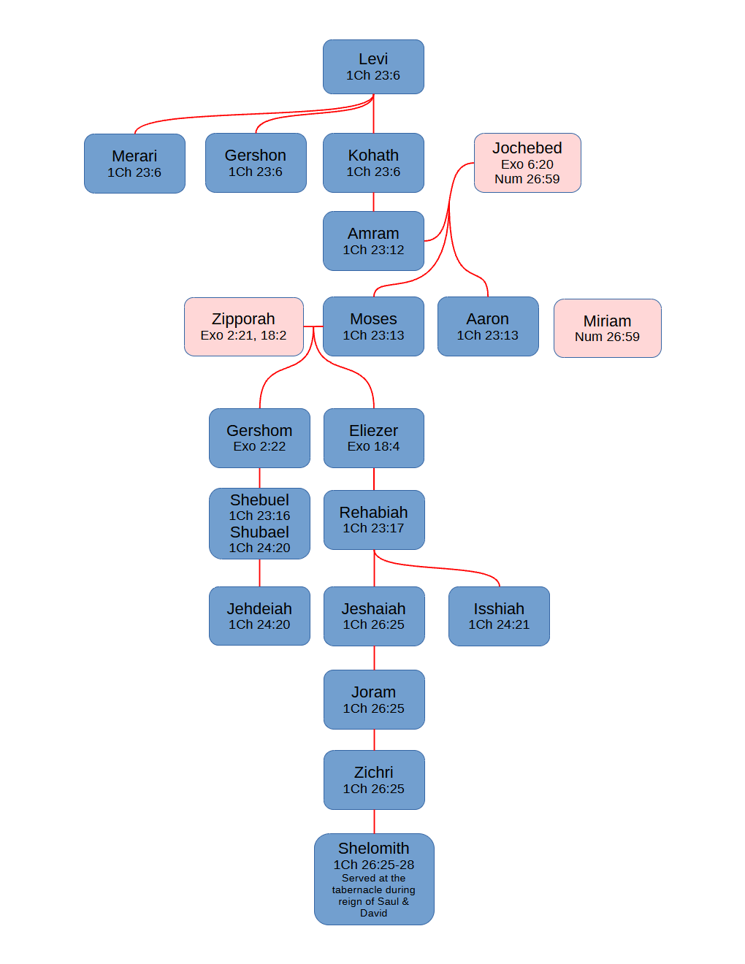
The Gershom in Judges 18:30 does not appear to be the same Gershom son of Moses. My search of the KJV was not exhaustive so if you find proof of a connection in the KJV I would appreciate learning it.
Some tips to help rightly divide the word of truth (John 17:17):
- Get yourself a firm foundation and cleave to the Authorized King James version which is how God chose to preserve His word in English (Psalm 12:6,7, Proverbs 30:5,6 Matthew 5:18, 24:35, Mark 13:31, Luke 21:33). If anything disagrees with it, casts doubt at it, adds to it, or takes away from it, it is evil (1 John 4:6, Proverbs 8:13).
- God promised to preserve his word for ever. Do you believe it?
Psalms 12:6-7
6 The words of the LORD are pure words: as silver tried in a furnace of earth, purified seven times.
7 Thou shalt keep them, O LORD, thou shalt preserve them from this generation for ever.
- Ever notice how the KJV just won't go away but the translations of men have to be changed (revised) and none of them have ever or will ever produce the spiritual fruit that the KJV has?
Acts 5:38-39
38 And now I say unto you, Refrain from these men, and let them alone: for if this counsel or this work be of men, it will come to nought:
39 But if it be of God, ye cannot overthrow it; lest haply ye be found even to fight against God.
- Changing God's word in any way comes with dire consequences (Deuteronomy 4:2, 12:32, Revelation 22:18,19). If it isn't obvious: that includes every new translation that is not of God.
Deuteronomy 4:2
Ye shall not add unto the word which I command you, neither shall ye diminish ought from it, that ye may keep the commandments of the LORD your God which I command you.
Deuteronomy 12:32
What thing soever I command you, observe to do it: thou shalt not add thereto, nor diminish from it.
Revelation 22:18-19
18 For I testify unto every man that heareth the words of the prophecy of this book, If any man shall add unto these things, God shall add unto him the plagues that are written in this book:
19 And if any man shall take away from the words of the book of this prophecy, God shall take away his part out of the book of life, and out of the holy city, and from the things which are written in this book.
Jeremiah 23:1
Woe be unto the pastors that destroy and scatter the sheep of my pasture! saith the LORD.
- The Bible warns us many different ways from front to back to stay away from "popular thought and media" (AKA mainstream culture) which is also known as "the world [system]" which is one of the three primary enemies of God (Matthew 7:13, James 4:4, 2 Corinthians 6:17, Romans 16:17). The other two are our flesh and Satan.
- Mixing worldliness and Godliness is the error of Balaam. It's the result of lust and compromising with evil and God's people should never do that. God made a difference between Egypt and His people during the plagues and He expects no different from His people today (Malachi 3:6, Matthew 10:34).
- Beware the oldest trick in the book: Genesis 3:6. Shun anything and anyone that manipulates, provokes, or entices you using emotions, physical attractiveness, or anything that only God can give (for example wisdom and understanding) (1 John 2:16, 1 Peter 1:15,16, Leviticus 11:44, 19:2, 20:7).
- Learn to recognize one of your enemies: his goal is to look like your best friend:
Isaiah 14:14
I will ascend above the heights of the clouds; I will be like the most High.
- Compare everything you see with scripture and test everything against the word of God (John 7:24, 1 Thessalonians 5:21, Luke 6:44, Ephesians 5:15, Acts 17:11).
- Do not rely on what the world has taught you (Proverbs 3:5, 1 Corinthians 2:14). Rely only on the Spirit of God and the word of God to guide you.
Psalms 119:105 (NUN.)
Thy word is a lamp unto my feet, and a light unto my path.
- Do not compromise with evil and make the same error that Balaam did which is trying to mix Godliness with the world (Jude 1:11, Matthew 7:15). This warning appears on this list twice intentionally.
- Always keep an eye out for Satan subtily creeping into your life. He will not always be in-your-face obvious. More often than not he will be hidden amongst your best friends (Judas Iscariot), the "church" (2 Corinthians 11:14), and even pretending to be spiritual leaders (John 8:44, Matthew 7:15). Satan knows that fear and intimidation doesn't work well on God's people (think the early church which was heavily persecuted and flourished as a result) and so his main tactic is infiltration (and that's what the Bible teaches us as well).
- There is only one truth and there is only one Spirit to guide you into it.
John 16:13
Howbeit when he, the Spirit of truth, is come, he will guide you into all truth: for he shall not speak of himself; but whatsoever he shall hear, that shall he speak: and he will shew you things to come.
- Feed on the bread of life (God's word) daily (1 Peter 2:2). Head knowledge won't get you anywhere with God.
James 2:19
Thou believest that there is one God; thou doest well: the devils also believe, and tremble.
Psalms 51:6
Behold, thou desirest truth in the inward parts: and in the hidden part thou shalt make me to know wisdom.
Do you desire truth in the inward parts?
Matthew 5:6
Blessed are they which do hunger and thirst after righteousness: for they shall be filled.

