==============

TECHNICAL GUIDE

==============

.. centered:: 

|  |  |
| --- | --- |
| Date: 25/09/2019 | Responsible area: Olga Diaz |

1. System architecture 2

1.1. Module diagram 2

1.2. Individual modules description 2

1.2.1. BillingCloud Mvc 2

1.2.2. BillingCloud API 3

1.3. External dependencies 3

2. Data design 3

2.1. BillingCloud Data Model 3

2.2. BillingCloud Api 4

2.2.1 Path 4

**2.2.2** Definitions 25

3. SW Components 28

3.1. Basic components 28

3.2. SW Structure 29

3.2.1. BillingCloud Mvc 29

3.2.2. BillingCloud 30

3.3. Algorithms and basic libraries: 30

3.3.1. BillingCloud Mvc 30

3.3.2. BillingCloud 31

# System architecture

BillingCloud is a tool that allows cost management, both the costs of having applications in the cloud, as well as other costs of different origins, such as royalties, marketing, etc. This application will allow the visualization and analysis of the costs and impact to the franchisees of them following certain business rules.

All software development will be done with .NET Core (cross-platform) technology and deployed in the Amazon cloud.

## Module diagram

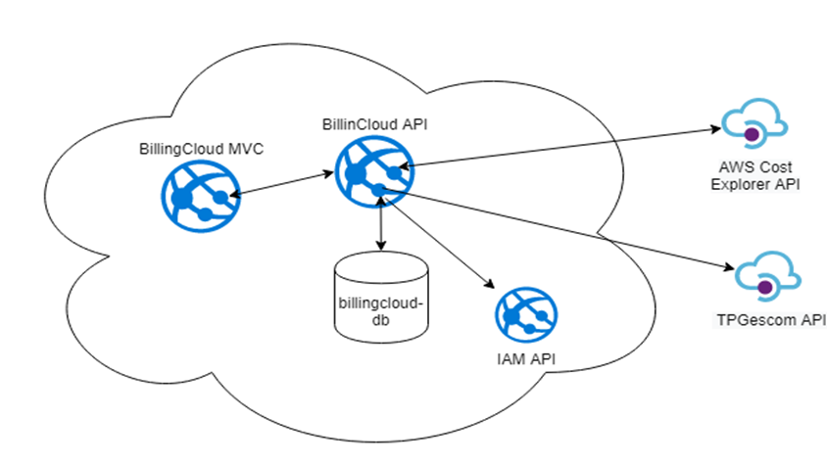

## Individual modules description

The application consists of a Web module and an API module:

### BillingCloud Mvc

* Overview and purpose

Front web that allows the user to perform the following operations:

* + Costs: Consultation of the costs of general and store suppliers.
  + Delivery rules: Allows you to set the rules for the distribution of the costs of services between the stores.
  + Reports: Display reports in the form of graphs of monthly costs by family and by service.
  + Billing: Permute set rules, billing models and assignment of models to stores.
* Dependencies
  + IAM Api: Uses the IAM API so that the user can log against Azure AD.
  + BillingCloud Api: BillingCloud API module that will contain business logic.

### BillingCloud API

* Overview and purpose

Rest API of services required to maintain BillingCloud costs and rules.

* Dependencies
  + TPGESCOM Api: Use the TPGescom API to get information from the stores of the DATA_STORE bbdd

## External dependencies

* Flexmonster: Reporting tool used to generate the graphs.

# Data design

## BillingCloud Data Model

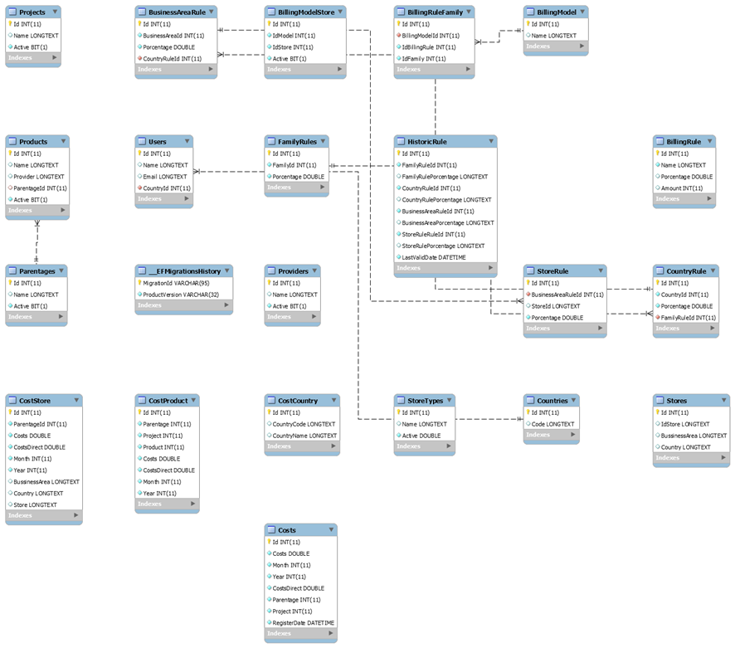

## BillingCloud Api

* Version: 1.0.0
* URI scheme
  + Host : api.dev.aws.telepizza.com
  + BasePath : /billingcloud/v1.0
  + Schemes : HTTPS, HTTP
* Security:
  + Type : oauth2
  + Flow : implicit
  + Token URL : <https://api.dev.aws.telepizza.com/authorize>

### Path

POST /api/billingmodel/add

This service is used to create a billing model

**Parameters**

|  |  |  |
| --- | --- | --- |
| Type | Name | Schema |
| Body | billingModelDto | BillingModelDto |
| *optional* |

**Responses**

|  |  |  |
| --- | --- | --- |
| HTTP | Description | Schema |
| 200 | Success | No Content |

**Consumes**

* application/json-patch+json
* application/json
* text/json
* application/json

**Tags**

• BillingModel

GET /api/billingmodel/all

This service is used to get all billing models

**Responses**

|  |  |  |
| --- | --- | --- |
| HTTP | Description | Schema |
| 200 | Success | No Content |

**Tags**

• BillingModel

GET /api/billingmodel/allrulefamily

This service is used to get all family rules

**Responses**

|  |  |  |
| --- | --- | --- |
| HTTP | Description | Schema |
| 200 | Success | No Content |

**Tags**

• BillingModel

DELETE /api/billingmodel/delete/{id}

This service is used to delete a billing model

**Parameters**

|  |  |  |
| --- | --- | --- |
| Type | Name | Schema |
| Path | id | string |
| *optional* |

**Responses**

|  |  |  |
| --- | --- | --- |
| HTTP | Description | Schema |
| 200 | Success | No Content |

**Tags**

• BillingModel

DELETE /api/billingmodel/deleterulefamily/{idModel}/{id}

This service is used to delete a family rule

**Parameters**

|  |  |  |
| --- | --- | --- |
| Type | Name | Schema |
| Path | id | string |
| *required* |

**Responses**

|  |  |  |
| --- | --- | --- |
| HTTP | Description | Schema |
| 200 | Success | No Content |

**Tags**

• BillingModel

GET /api/billingmodel/getmodel/{id}

This service is used to obtain a billing model by id

**Parameters**

|  |  |  |
| --- | --- | --- |
| Type | Name | Schema |
| Path | id | integer (int32) |
| *required* |

**Responses**

|  |  |  |
| --- | --- | --- |
| HTTP | Description | Schema |
| 200 | Success | No Content |

**Tags**

• BillingModel

POST /api/billingmodel/update

This service is used to modify an existing billing model

**Parameters**

|  |  |  |
| --- | --- | --- |
| Type | Name | Schema |
| Body | billingModelDataDto | BillingModelDto |
| *optional* |

**Responses**

|  |  |  |
| --- | --- | --- |
| HTTP | Description | Schema |
| 200 | Success | No Content |

**Consumes**

* application/json-patch+json
* application/json
* text/json
* application/*+json

**Tags**

• BillingModel

POST /api/billingmodelstore/add

This service is used to assign a billing model to a store

**Parameters**

|  |  |  |
| --- | --- | --- |
| Type | Name | Schema |
| Body | billingModelStoreDto | BillingModelStoreDto |
| *optional* |

**Responses**

|  |  |  |
| --- | --- | --- |
| HTTP | Description | Schema |
| 200 | Success | No Content |

**Consumes**

* application/json-patch+json
* application/json
* text/json
* application/*+json

**Tags**

• BillingModelStore

GET /api/billingmodelstore/all

This service is used to obtain all billing models associated with stores

**Responses**

|  |  |  |
| --- | --- | --- |
| HTTP | Description | Schema |
| 200 | Success | No Content |

**Tags**

• BillingModelStore

DELETE /api/billingmodelstore/delete/{id}

This service is used to remove the billing model associated with a store

**Parameters**

|  |  |  |
| --- | --- | --- |
| Type | Name | Schema |
| Path | id | string |
| *required* |

**Responses**

|  |  |  |
| --- | --- | --- |
| HTTP | Description | Schema |
| 200 | Success | No Content |

Tags

• BillingModelStore

GET /api/billingmodelstore/getmodelstore/{id}

This service is used to get the billing model associated with a store by id

**Parameters**

|  |  |  |
| --- | --- | --- |
| Type | Name | Schema |
| Path | id | integer (int32) |
| *required* |

**Responses**

|  |  |  |
| --- | --- | --- |
| HTTP | Description | Schema |
| 200 | Success | No Content |

**Tags**

• BillingModelStore

POST /api/billingmodelstore/update

This service is used to modify the billing model associated with a store

**Parameters**

|  |  |  |
| --- | --- | --- |
| Type | Name | Schema |
| Body | billingRelation | BillingModelStoreDto |
| *optional* |

Responses

|  |  |  |
| --- | --- | --- |
| HTTP | Description | Schema |
| 200 | Success | No Content |

**Consumes**

* application/json-patch+json
* application/json
* text/json
* application/*+json

**Tags**

• BillingModelStore

POST /api/billingrule/add

This service is used to create a billing rule

**Parameters**

|  |  |  |
| --- | --- | --- |
| Type | Name | Schema |
| Body | billingRuleDto | BillingRuleDto |
| *optional* |

**Responses**

|  |  |  |
| --- | --- | --- |
| HTTP | Description | Schema |
| 200 | Success | No Content |

**Consumes**

* application/json-patch+json
* application/json
* text/json
* application/*+json

**Tags**

• BillingRule

GET /api/billingrule/all

This service is used to obtain billing rules

**Responses**

|  |  |  |
| --- | --- | --- |
| HTTP | Description | Schema |
| 200 | Success | No Content |

**Tags**

• BillingRule

DELETE /api/billingrule/delete/{id}

This service is used to delete a billing rule

**Parameters**

|  |  |  |
| --- | --- | --- |
| Type | Name | Schema |
| Path | id | string |
| *required* |

**Responses**

|  |  |  |
| --- | --- | --- |
| HTTP | Description | Schema |
| 200 | Success | No Content |

**Tags**

• BillingRule

GET /api/billingrule/getrule/{id}

This service is used to get a billing rule by id

**Parameters**

|  |  |  |
| --- | --- | --- |
| Type | Name | Schema |
| Path | id | integer (int32) |
| *required* |

**Responses**

|  |  |  |
| --- | --- | --- |
| HTTP | Description | Schema |
| 200 | Success | No Content |

**Tags**

• BillingRule

POST /api/billingrule/update

This service is used to modify a billing rule

**Parameters**

|  |  |  |
| --- | --- | --- |
| Type | Name | Schema |
| Body | billingData | BillingRuleDto |
| *optional* |

**Responses**

|  |  |  |
| --- | --- | --- |
| HTTP | Description | Schema |
| 200 | Success | No Content |

**Consumes**

* application/json-patch+json
* application/json
* text/json
* application/*+json

**Tags**

• BillingRule

POST /api/costmgmt/add

This service is used to add costs for AWS services

**Parameters**

|  |  |  |
| --- | --- | --- |
| Type | Name | Schema |
| Body | costes | CostDto |
| *optional* |

**Responses**

|  |  |  |
| --- | --- | --- |
| HTTP | Description | Schema |
| 200 | Success | No Content |

**Consumes**

* application/json-patch+json
* application/json
* text/json
* application/*+json

**Tags**

• CostMgmt

DELETE /api/costmgmt/deletecost

This service is used to delete costs for AWS services

**Parameters**

|  |  |  |
| --- | --- | --- |
| Type | Name | Schema |
| Query | month | integer (int32) |
| *optional* |
| Query | year | integer (int32) |
| *optional* |

**Responses**

|  |  |  |
| --- | --- | --- |
| HTTP | Description | Schema |
| 200 | Success | No Content |

**Tags**

• CostMgmt

GET /api/costmgmt/filter/{costFilterDto}

This service is used to get costs from AWS services

**Parameters**

|  |  |  |
| --- | --- | --- |
| Type | Name | Schema |
| Path | costFilterDto | string |
| *required* |

**Responses**

|  |  |  |
| --- | --- | --- |
| HTTP | Description | Schema |
| 200 | Success | No Content |

**Tags**

• CostMgmt

GET /api/costmgmt/{id}

This service is used to obtain costs for AWS services by id

**Parameters**

|  |  |  |
| --- | --- | --- |
| Type | Name | Schema |
| Path | id | integer (int32) |
| *required* |

**Responses**

|  |  |  |
| --- | --- | --- |
| HTTP | Description | Schema |
| 200 | Success | No Content |

**Tags**

• CostMgmt

POST /api/costproduct/add

This service is used to group AWS costs into a family or product

**Parameters**

|  |  |  |
| --- | --- | --- |
| Type | Name | Schema |
| Body | costesProducto | CostProductDto |
| *optional* |

**Responses**

|  |  |  |
| --- | --- | --- |
| HTTP | Description | Schema |
| 200 | Success | No Content |

**Consumes**

* application/json-patch+json
* application/json
* text/json
* application/*+json

**Tags**

• CostProduct

DELETE /api/costproduct/deletecostproduct

This service is used to eliminate a grouping of AWS costs in a family or product

**Parameters**

|  |  |  |
| --- | --- | --- |
| Type | Name | Schema |
| Query | month | integer (int32) |
| *optional* |
| Query | year | integer (int32) |
| *optional* |

**Responses**

|  |  |  |
| --- | --- | --- |
| HTTP | Description | Schema |
| 200 | Success | No Content |

**Tags**

• CostProduct

GET /api/costproduct/filter/{costProductFilterDto}

This service is used to get AWS costs grouped by families based on a filter

**Parameters**

|  |  |  |
| --- | --- | --- |
| Type | Name | Schema |
| Path | costProductFilterDto | String |
| *required* |

**Responses**

|  |  |  |
| --- | --- | --- |
| HTTP | Description | Schema |
| 200 | Success | No Content |

**Tags**

• CostProduct

GET /api/costproduct/{id}

This service is used to get AWS costs grouped by families by Id.

**Parameters**

|  |  |  |
| --- | --- | --- |
| Type | Name | Schema |
| Path | id | integer (int32) |
| *required* |

**Responses**

|  |  |  |
| --- | --- | --- |
| HTTP | Description | Schema |
| 200 | Success | No Content |

**Tags**

• CostProduct

POST /api/coststore/add

This service is used to add the AWS costs associated with the stores.

**Parameters**

|  |  |  |
| --- | --- | --- |
| Type | Name | Schema |
| Body | costes | CostStoreDto |
| *optional* |

**Responses**

|  |  |  |
| --- | --- | --- |
| HTTP | Description | Schema |
| 200 | Success | No Content |

**Consumes**

* application/json-patch+json
* application/json
* text/json
* application/*+json

**Tags**

• CostStore

DELETE /api/coststore/deletecoststore

This service is used to eliminate the AWS costs associated with stores

**Parameters**

|  |  |  |
| --- | --- | --- |
| Type | Name | Schema |
| Query | month | integer (int32) |
| *optional* |
| Query | year | integer (int32) |
| *optional* |

**Responses**

|  |  |  |
| --- | --- | --- |
| HTTP | Description | Schema |
| 200 | Success | No Content |

**Tags**

• CostStore

GET /api/coststore/filter

This service is used to get the AWS costs associated with stores

**Parameters**

|  |  |  |
| --- | --- | --- |
| Type | Name | Schema |
| Query | bussinessArea | string |
| *optional* |
| Query | country | string |
| *optional* |
| Query | date | string |
| *optional* |
| Query | idStore | string |
| *optional* |

**Responses**

|  |  |  |
| --- | --- | --- |
| HTTP | Description | Schema |
| 200 | Success | No Content |

**Tags**

• CostStore

GET /api/coststore/{id}

This service is used to get the AWS costs associated with stores by Id.

**Parameters**

|  |  |  |
| --- | --- | --- |
| Type | Name | Schema |
| Path | id | integer (int32) |
| *required* |

**Responses**

|  |  |  |
| --- | --- | --- |
| HTTP | Description | Schema |
| 200 | Success | No Content |

**Tags**

• CostStore

POST /api/familyrule

This service is used to create a family rule

**Parameters**

|  |  |  |
| --- | --- | --- |
| Type | Name | Schema |
| Body | id | FamilyRuleDto |
| *optional* |

**Responses**

|  |  |  |
| --- | --- | --- |
| HTTP | Description | Schema |
| 200 | Success | No Content |

**Consumes**

* application/json-patch+json
* application/json
* text/json
* application/*+json

**Tags**

• FamilyRule

GET /api/familyrule

This service is used to get a family rule.

**Responses**

|  |  |  |
| --- | --- | --- |
| HTTP | Description | Schema |
| 200 | Success | No Content |

**Tags**

• FamilyRule

GET /api/familyrule/costdistributionprocess

This service is used to distribute AWS costs across stores according to family rules.

**Parameters**

|  |  |  |
| --- | --- | --- |
| Type | Name | Schema |
| Query | country | string |
| *optional* |
| Query | family | string |
| *optional* |
| Query | month | integer (int32) |
| *optional* |
| Query | month | integer (int32) |
| year |

**Responses**

|  |  |  |
| --- | --- | --- |
| HTTP | Description | Schema |
| 200 | Success | No Content |

**Tags**

• FamilyRule

POST /api/familyrule/costsimulatedistributionprocess

This service is used to simulate the process of distributing AWS costs between stores according to family rules.

**Parameters**

|  |  |  |
| --- | --- | --- |
| Type | Name | Schema |
| Body | familyRule | FamilyRuleDto |
| *optional* |

**Responses**

|  |  |  |
| --- | --- | --- |
| HTTP | Description | Schema |
| 200 | Success | No Content |

**Consumes**

* application/json-patch+json
* application/json
* text/json
* application/*+json

**Tags**

• FamilyRule

DELETE /api/familyrule/delete/{id}

This service is used to remove a family rule

**Parameters**

|  |  |  |
| --- | --- | --- |
| Type | Name | Schema |
| Path | id | integer (int32) |
| *required* |

**Responses**

|  |  |  |
| --- | --- | --- |
| HTTP | Description | Schema |
| 200 | Success | No Content |

**Tags**

• FamilyRule

GET /api/familyrule/getrule/{id}

This service is used to get a family rule by Id.

**Parameters**

|  |  |  |
| --- | --- | --- |
| Type | Name | Schema |
| Path | id | integer (int32) |
| *required* |

**Responses**

|  |  |  |
| --- | --- | --- |
| HTTP | Description | Schema |
| 200 | Success | No Content |

**Tags**

• FamilyRule

GET /api/familyrule/listado/{id}

This service is used to get list of family rules.

**Parameters**

|  |  |  |
| --- | --- | --- |
| Type | Name | Schema |
| Path | id | integer (int32) |
| *required* |

**Responses**

|  |  |  |
| --- | --- | --- |
| HTTP | Description | Schema |
| 200 | Success | No Content |

**Tags**

• FamilyRule

POST /api/familyrule/update

This service is used to modify a family rule.

**Parameters**

|  |  |  |
| --- | --- | --- |
| Type | Name | Schema |
| Body | familyData | FamilyRuleDto |
| *optional* |

**Responses**

|  |  |  |
| --- | --- | --- |
| HTTP | Description | Schema |
| 200 | Success | No Content |

**Consumes**

* application/json-patch+json
* application/json
* text/json
* application/*+json

**Tags**

• FamilyRule

POST /api/historicrule/add

This service is used to add a rule to the rule history

**Parameters**

|  |  |  |
| --- | --- | --- |
| Type | Name | Schema |
| Body | historicRuleDto | HistoricRuleDto |
| *optional* |

**Responses**

|  |  |  |
| --- | --- | --- |
| HTTP | Description | Schema |
| 200 | Success | No Content |

**Consumes**

* application/json-patch+json
* application/json
* text/json
* application/*+json

**Tags**

• HistoricRule

GET /api/historicrule/all

This service is used to obtain the history of rules

**Responses**

|  |  |  |
| --- | --- | --- |
| HTTP | Description | Schema |
| 200 | Success | No Content |

**Tags**

• HistoricRule

GET /api/historicrule/filterhistoricrules

This service is used to get the rule history by a filter

**Parameters**

|  |  |  |
| --- | --- | --- |
| Type | Name | Schema |
| Query | idCountry | string |
| *optional* |
| Query | idProduct | string |
| *optional* |

**Responses**

|  |  |  |
| --- | --- | --- |
| HTTP | Description | Schema |
| 200 | Success | No Content |

**Tags**

• HistoricRule

GET /api/historicrule/{id}

This service is used to get the rule history of a rule by id

**Parameters**

|  |  |  |
| --- | --- | --- |
| Type | Name | Schema |
| Path | id | integer (int32) |
| *required* |

**Responses**

|  |  |  |
| --- | --- | --- |
| HTTP | Description | Schema |
| 200 | Success | No Content |

**Tags**

• HistoricRule

GET /api/parentagemgmt

This service is used to get the families in which AWS services are grouped

**Responses**

|  |  |  |
| --- | --- | --- |
| HTTP | Description | Schema |
| 200 | Success | No Content |

**Tags**

• ParentageMgmt

GET /api/productmgmt/all

This service is used to obtain all AWS products or services

**Responses**

|  |  |  |
| --- | --- | --- |
| HTTP | Description | Schema |
| 200 | Success | No Content |

**Tags**

• ProductMgmt

GET /api/productmgmt/{id}

This service is used to obtain AWS products or services by ID

**Parameters**

|  |  |  |
| --- | --- | --- |
| Type | Name | Schema |
| Path | id | integer (int32) |
| *required* |

**Responses**

|  |  |  |
| --- | --- | --- |
| HTTP | Description | Schema |
| 200 | Success | No Content |

**Tags**

• ProductMgmt

GET /api/Project

This service is used to obtain the projects

**Responses**

|  |  |  |
| --- | --- | --- |
| HTTP | Description | Schema |
| 200 | Success | No Content |

**Tags**

• Project

GET /api/shop/getcountries

This service is used to obtain the countries in which the costs will be distributed

**Responses**

|  |  |  |
| --- | --- | --- |
| HTTP | Description | Schema |
| 200 | Success | No Content |

**Tags**

• Shop

GET /api/shop/getshops

This service is used to obtain the stores on which the costs will be distributed

**Parameters**

|  |  |  |
| --- | --- | --- |
| Type | Name | Schema |
| Query | countryCode | string |
| *optional* |

**Responses**

|  |  |  |
| --- | --- | --- |
| HTTP | Description | Schema |
| 200 | Success | No Content |

**Tags**

• Shop

GET /api/versión

This service is used to get the deployed version

**Responses**

|  |  |  |
| --- | --- | --- |
| HTTP | Description | Schema |
| 200 | Success | No Content |

**Produces**

* application/json

### Definitions

BillingModelDto:

|  |  |
| --- | --- |
| Name | Schema |
| billingRuleFamilyList | < BillingRuleFamily > array |
| id | integer (int32) |
| name | string |

BillingModelStoreDto:

|  |  |
| --- | --- |
| Name | Schema |
| billingRuleFamilyList | < BillingRuleFamily > array |
| active | boolean |
| id | integer (int32) |
| idModel | integer (int32) |
| idStore | integer (int32) |

BillingRuleDto:

|  |  |
| --- | --- |
| Name | Schema |
| amount | integer (int32) |
| id | integer (int32) |
| name | string |
| porcentage | number (double) |

BillingRuleDto:

|  |  |
| --- | --- |
| Name | Schema |
| billingModelId | integer (int32) |
| id | integer (int32) |
| idBillingRule | integer (int32) |
| idFamily | integer (int32) |

BusinessAreaDto:

|  |  |
| --- | --- |
| Name | Schema |
| businessAreaId | string |
| id | string |
| name | string |
| porcentage | string |
| stores | < StoreDto > array |

BusinessAreaRuleDto:

|  |  |
| --- | --- |
| Name | Schema |
| businessAreaId | string |
| id | string |
| name | string |
| porcentage | string |
| stores | < StoreDto > array |

CostDto:

|  |  |
| --- | --- |
| Name | Schema |
| costs | number (double) |
| costsDirect | number (double) |
| month | integer (int32) |
| parentage | integer (int32) |
| project | integer (int32) |
| registerDate | string (date-time) |
| year | integer (int32) |

CostProductDto:

|  |  |
| --- | --- |
| Name | Schema |
| costs | number (double) |
| costsDirect | number (double) |
| month | integer (int32) |
| parentage | integer (int32) |
| product | integer (int32) |
| project | integer (int32) |
| year | integer (int32) |

CostStoreDto:

|  |  |
| --- | --- |
| Name | Schema |
| bussinessArea | string |
| costs | number (double) |
| costsDirect | number (double) |
| country | string |
| month | integer (int32) |
| parentageId | integer (int32) |
| store | string |
| year | integer (int32) |

CountryRuleDto:

|  |  |
| --- | --- |
| Name | Schema |
| costs | number (double) |
| businessAreaRulesDto | < BusinessAreaRuleDto > array |
| countryId | integer (int32) |
| porcentage | number (double) |

FamilyRuleDto:

|  |  |
| --- | --- |
| Name | Schema |
| businessArea | < BusinessAreaDto > array |
| businessAreaNumElem | integer (int32) |
| countryRules | < CountryRuleDto > array |
| countrySelectedValue | string |
| countryTextValue | string |
| familyId | string |
| idCountryRule | string |
| idFamilyRule | string |
| idRule | integer (int32) |
| month | integer (int32) |
| porcenCountryValue | string |
| porcenParentageValue | string |
| productValue | string |
| providerValue | string |
| year | integer (int32) |

HistoricRuleDto:

|  |  |
| --- | --- |
| Name | Schema |
| businessAreaPorcentage | string |
| familyRuleId | integer (int32) |
| storeRuleRuleId | integer (int32) |

StoreDto:

|  |  |
| --- | --- |
| Name | Schema |
| id | integer (int32) |

# SW Components

## Basic components

* + Visual Studio 2017
  + .NET Core 2.2 SDK (v2.2.402)

## SW Structure

### BillingCloud Mvc

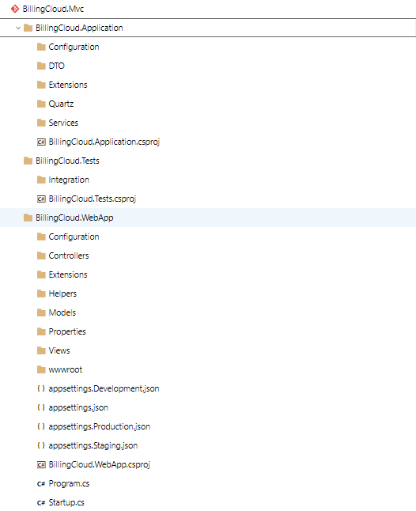

### BillingCloud

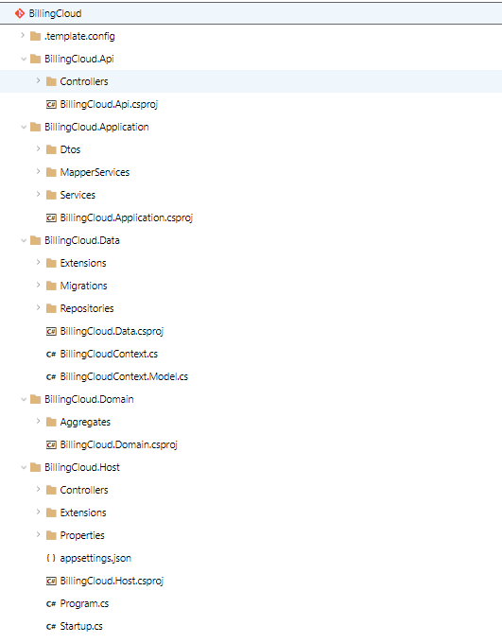

## Algorithms and basic libraries:

Manage NuGet Packages:

* + TelepizzaSeedwork: <https://pkgs.dev.azure.com/TelepizzaIT/_packaging/Sales.Seedwork/nuget/v3/index.json>
  + nuget.org: <https://api.nuget.org/v3/index.json>

### BillingCloud Mvc

|  |  |
| --- | --- |
| Name | Version |
| AWSSDK.CostExplorer | 3.3.100.10 |
| Irensaltali.Currency 1.0.2 |  |
| Kafka.Producer.Sdk | 1.0.3 |
| Microsoft.AspNetCore.App | 2.2.0 |
| Microsoft.AspNetCore.Authentication.AzureAD.UI | 2.2.0 |
| Microsoft.AspNetCore.DataProtection.StackExchangeRedis | 2.2.5 |
| Microsoft.AspNetCore.Hosting.Abstractions | 2.2.0 |
| Microsoft.AspNetCore.Http.Abstractions | 2.2.0 |
| Microsoft.AspNetCore.Mvc | 2.2.0 |
| Microsoft.AspNetCore.Razor.Design | 2.2.0 |
| Microsoft.Extensions.Caching.Abstractions | 2.2.0 |
| Microsoft.Extensions.Caching.StackExchangeRedis | 2.2.5 |
| Microsoft.Extensions.DependencyInjection | 2.2.0 |
| Microsoft.Extensions.Hosting.Abstractions | 2.2.0 |
| Microsoft.Extensions.Options.ConfigurationExtensions | 2.2.0 |
| Microsoft.VisualStudio.Web.BrowserLink | 2.2.0 |
| Microsoft.VisualStudio.Web.CodeGeneration.Design | 2.2.3 |
| Newtonsoft.Json | 12.0.2 |
| Npoi.Mapper | 3.3.0 |
| Seedwork.CrossCutting.Configuration | 1.0.3 |
| Seedwork.CrossCutting.HttpClientInvoker | 1.0.38 |
| Seedwork.IAM.Services | 1.0.9 |
| Seedwork.Kafka | 1.0.29 |
| Seedwork.Version | 1.0.7 |
| Serilog | 2.8.0 |
| Serilog.Exceptions | 5.3.1 |
| Serilog.Extensions.Logging | 2.0.4 |
| Serilog.Sinks.Elasticsearch | 8.0.0 |

### BillingCloud

|  |  |
| --- | --- |
| Name | Version |
| AutoMapper.Extensions.Microsoft.DependencyInjection | 6.1.0 |
| Kralizek.Extensions.Configuration.AWSSecretsManager | 1.1.0 |
| Microsoft.AspNetCore.App | 2.2.0 |
| Microsoft.EntityFrameworkCore.Design | 2.2.4 |
| Microsoft.Extensions.Caching.Redis | 2.2.0 |
| Pomelo.EntityFrameworkCore.MySql | 2.2.0 |
| Scrutor | 3.0.2 |
| Seedwork.CrossCutting.Configuration | 1.0.3 |
| Seedwork.CrossCutting.HttpClientInvoker | 1.0.33 |
| Seedwork.CrossCutting.Injecter | 1.0.11 |
| Seedwork.CrossCutting.MVC | 1.0.18 |
| Seedwork.CrossCutting.SwaggerExtensions | 1.0.8 |
| Seedwork.Data | 1.0.11 |
| Seedwork.Domain | 1.0.12 |
| Seedwork.Version | 1.0.6 |
| Serilog | 2.8.0 |
| Serilog.Exceptions | 5.0.0 |
| Serilog.Extensions.Logging | 2.0.4 |
| Serilog.Sinks.Elasticsearch | 7.1.0 |
| Swashbuckle.AspNetCore | 4.0.1 |