Project Proposal of Distributed Systems WS22/23
Group 8
Qixiang Shao, Qianrong Yi, Ziming Fang
- Introduction
This project is to design a distributed chatting system. This system will allow fundamental functions of private and group chats. All servers and clients will passively or actively communicate with each other including Dynamic discovery, fault detection and solution, voting mechanism, and multicasting functions. The detailed requirements are illustrated as follows.
- Project Requirement Analysis
The project is to realize message-sending and receiving functions. The following functions, therefore, are required for the project:
  - Client perspective
- Account registration: Each client can create an account before being accessible to the messaging service, which consists of the following processes:
- Register Process:
User -> (Request) -> Leader(elected from Leader election; if the Leader died, it will request the next server according to the election result until success.)
- Login Process:
Step 1: User -> (ID : Login message) -> Leader
Step 2: Leader -> (Sub server IP) -> User
Step 3: Leader -> (User ID and User IP) -> Serve and update the group view
Step 4: If there are messages in the user's mailbox, the messages will be transmitted; the sent message will be hung at the "sub server" side when there are still untransferred messages in the FIFO queue. (in order to guarantee ordering)
- User Online Process:
User -> (Heartbeat message) -> Sub server
Sub server -> (Heartbeat message) -> User
- Friend request: Each client can send a request to any other client, in order to be authorized to chat with him/her. (optional)
- Private messaging: Each client can message any online client, which consists of the following steps:
Step 1: User -> (target User ID) -> Sub Server
Step 2: Sub Server searches the responsible Sub server for the target ID, then forwards the message to the responsible Sub server.
If it is itself, then do step 3.
Step 3: all incoming messages will be stored in a time-logical FIFO. Once the target ID(user) is online, the sub-server will then transmit the message to the corresponding user. Hanging the message transfer from target to source, until a confirmation is received(to causal ordering guaranteed)
- Group chatting: Each client can create a chatting group in which all members can join after being login:
- Similar to private messaging; causal total ordering is guaranteed by the following strategy:
only start transferring the next message when the last message is confirmed delivered to all the online users. time out user will be considered offline.
- Fault Tolerance during messaging: The leader decides on the failing node exiting the ring. Apply a Practical Byzantine Fault Tolerance algorithm to achieve a consensus mechanism and reduce the malicious influence of untrustable nodes. The algorithm consists of four procedures: Request, Pre-Prepare, Prepare, Commit, and Reply.
  - Server perspective
- Account message storage: A server database stores the ID, address, and group information of each client. The client can directly chat with another online client by sending his/her unique ID to the server.
- Leading server: The leader detects the state of each server to detect offline servers by Server online process and redistributes the clients connected to the offline servers to other live servers then updates the group view.
a. Server Liveness Process:
Leader -> (Heartbeat message) -> Sub server
Sub server -> (Heartbeat message) -> Leader
- Normal server(Sub server): Receive, transmit and forward messages; Detect the liveness between itself and leader. If the connection fails, trigger the election process.
- Election mechanism: Elect and vote for a leader by the LaLann-Chang-Roberts algorithm if the current leader fails.
- Fault Tolerance during leader election: Restart the election algorithm if the leader node fails. In some cases, the heartbeat liveness detection from a node to the leader fails due to connection or network error and falsely triggers the node to another leader election. In that case, the node must confirm to the other one or two nodes if the leader really fails before triggering a new election.
  - Message perspectives
- Message type: The system massaging application support image and text form.
- Online messaging: the client can instantly receive the message if the client is online.
- Offline messaging: The message will be stored temporarily in the FIFO queue of the server and will be transmitted once the client is online again.
- Time stamps in transmission: The message includes transmit time and receive time to clarify the chronological order.
- Lamport timestamp with vector clock
- Delivery state of messages: Message senders can see whether the messages are already transmitted to the receiver or not.
- Architecture diagram
Our architectural model is in the Client-Server manner, shown in Fig.1. One private/group chat consists of several clients who have their local storage. Between the client group and server group, a load-balancing mediator is used for the dynamic (de)provision of the resource. Servers will store the registration information in an external database. Servers have three main functions, namely Server State Detection, Leader Election, and Reliable Ordered Multicast.
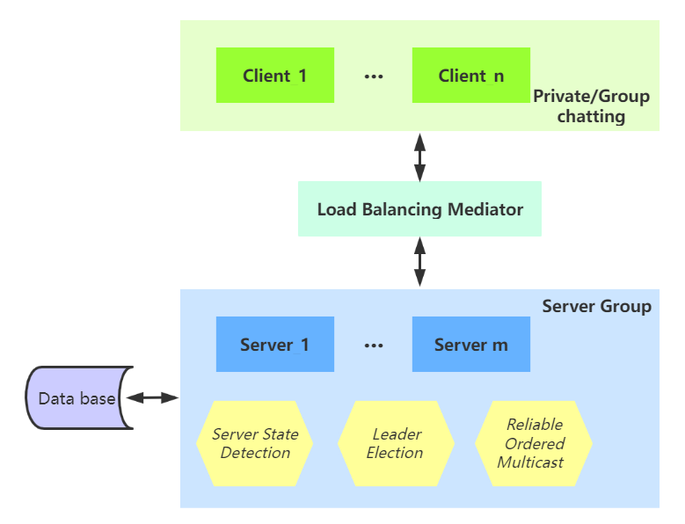
Fig. 1. Architecture diagram

First Pro
1 ELECTION
2 FAULT TOLERRENCE
3 FIFO(LOGICAL ) & LAMPORT VECTOR（if not for “all i” vector?）
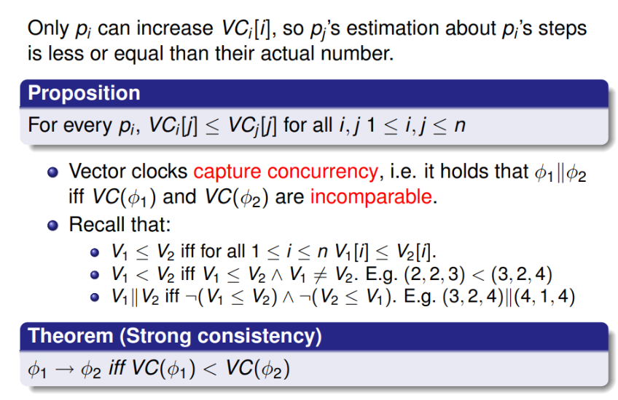
4 Dynamic Discovery

1 message

2 server
- message storing
- registerlist update
- #liveness detection(state vector update)

3 client:
- read from CMD
- print
- #liveness detection(server...)

4 r/w register file

Second Prority
1 LOGIN/FRIEND REQUEST
2
3 LOAD BALENCING

