Web Application Implementation Report
CourseTracker – Course Management and Tracking System
Group CT | ITECH – Internet Technology (M) | March 2026

1. Introduction
CourseTracker is a web-based educational platform built with Django 5 and Bootstrap 5 that facilitates interaction between teachers and students. The application enables teachers to create courses and assign tasks with deadlines, while students can discover courses, enrol, track their progress through an interactive dashboard, and provide feedback via a star-rating system.
The implementation closely follows the original Design Specification with minor adjustments: a Course Detail Page was added to address sitemap feedback, and the Student Dashboard was enhanced with client-side sort/filter/search functionality (AJAX-driven task completion toggle) beyond the originally planned static task list. All six user stories (M1, M2, M3, M4, M5/S2, M6/S1) have been implemented as specified.

Project Links
Resource | URL
Code Repository | https://github.com/[your-username]/CourseTracker
Deployed Application | https://coursetracker.onrender.com
Note: Replace the placeholder URLs above with your actual GitHub repository and deployed application URLs before submission.

4. Testing
The testing work for this implementation focused on two main areas within the student-facing part of the system: the feedback/rating functionality and the task completion functionality. Both areas were supported by automated testing, as they are central to the application’s course feedback and task-tracking workflow.
For the feedback module, a total of 8 Django automated tests were added. These covered both model-level behaviour and view-level functionality. At model level, the tests verified the behaviour of the Rating model, including the one-rating-per-student-per-course constraint and the calculation of average course rating. At view level, the tests checked that enrolled students can access the rating page, that non-enrolled students are prevented from submitting ratings, that ratings can be submitted successfully, that an existing rating is updated rather than duplicated, and that the course reviews page loads correctly with stored feedback. Together, these tests verified the key rules and workflows of the implemented feedback system.
For the task completion functionality, automated test support was in the courses module. These tests covered the core behaviour of task completion records, including completion-state updates and the uniqueness constraint that prevents duplicate task-completion records for the same student-task pair. This provided automated verification for the main logic behind the task-tracking workflow. In addition, the task detail interface was also checked in the running application to confirm that the displayed completion state remained consistent with the underlying stored data and user interaction flow.
The final feedback test suite was run using: python3 manage.py test feedback. The task completion test suite was run using: python3 manage.py test courses.
The final result was that the automated tests for both areas completed successfully, with the feedback test suite passing all 8 tests and the task completion test suite passing all 13 tests. Overall, these results provide evidence that the implemented rating workflow, access restrictions, uniqueness constraints, review display, and task-progress behaviour operate reliably in the current version of the application.

5. Accessibility Report

Tool and Pages Tested
Google Lighthouse (via Chrome/Edge DevTools) was used to review accessibility-related quality on the pages most relevant to this implementation scope. The main pages tested were the Task Detail page and the Course Rating page. In addition, shared accessibility features implemented through the base template were also considered, because they affect navigation and feedback across the whole application. Mobile device simulation was used for consistency during testing.

Baseline (Before Optimisation)
The baseline audit was carried out before the final accessibility-focused refinements were added to the task detail and rating interfaces. The initial Lighthouse results for the two main pages are summarised below.
Metric | Task Detail Page | Course Rating Page
Performance | 98 | 98
Accessibility | 100 | 94
Best Practices | 100 | 100
SEO | 90 | 90
Before:
Task Detail Page:
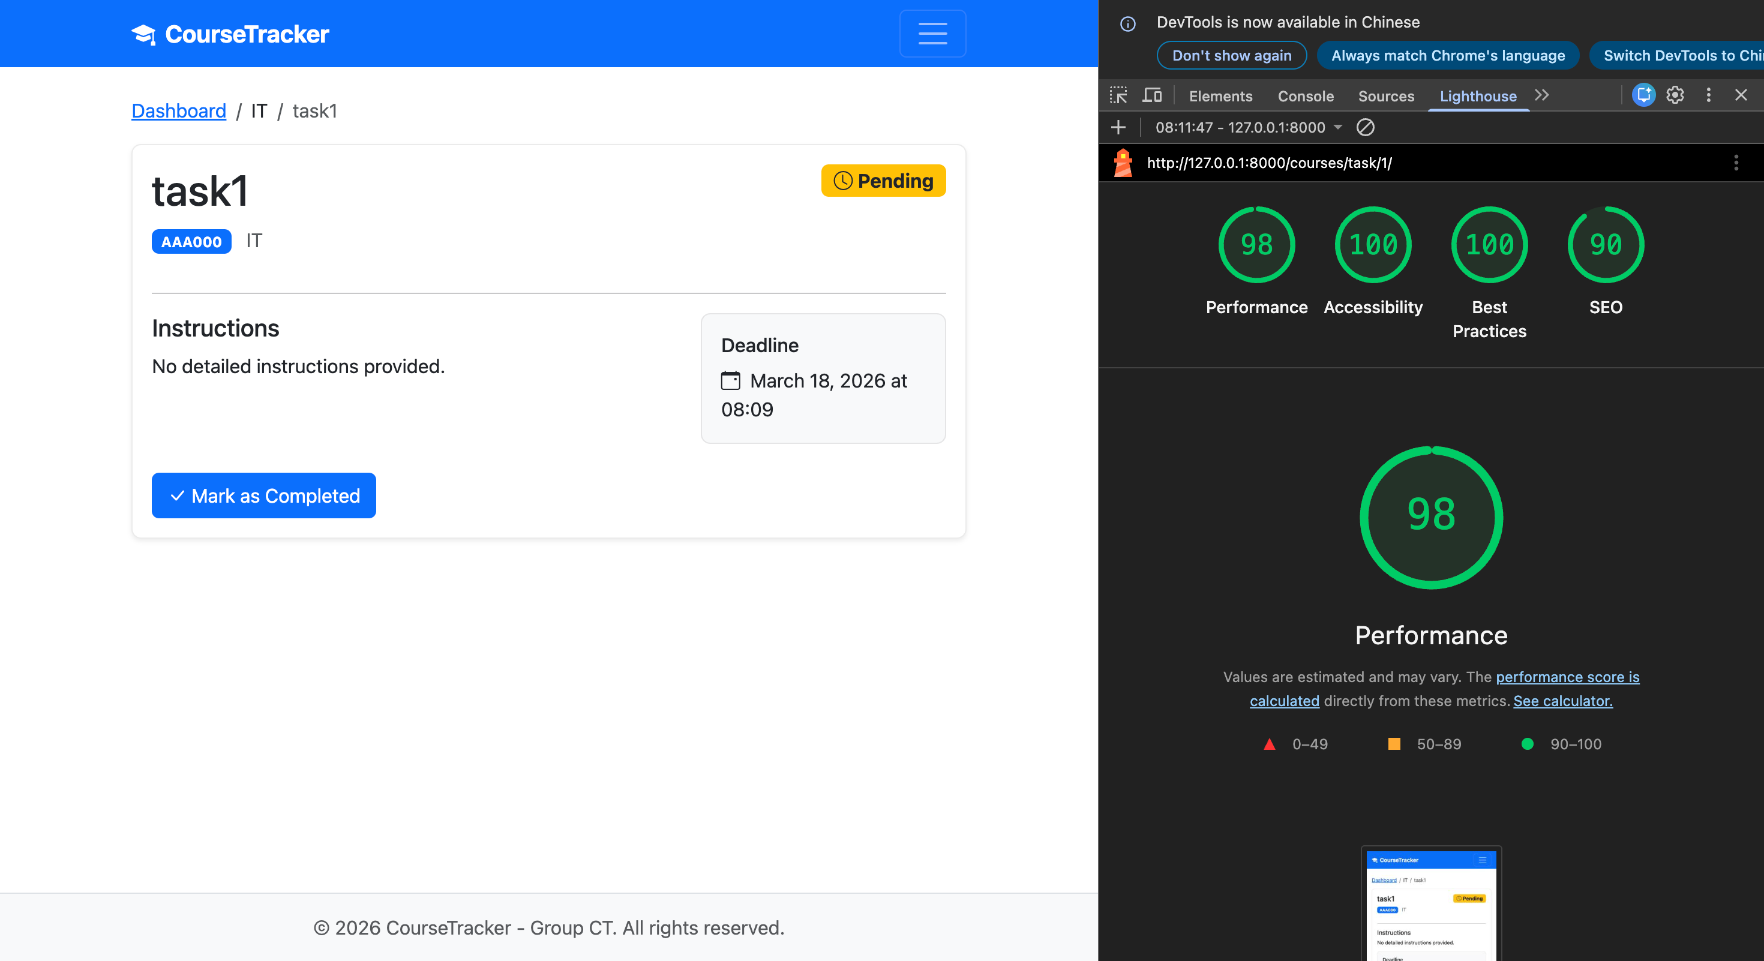
Couse Rating Page:
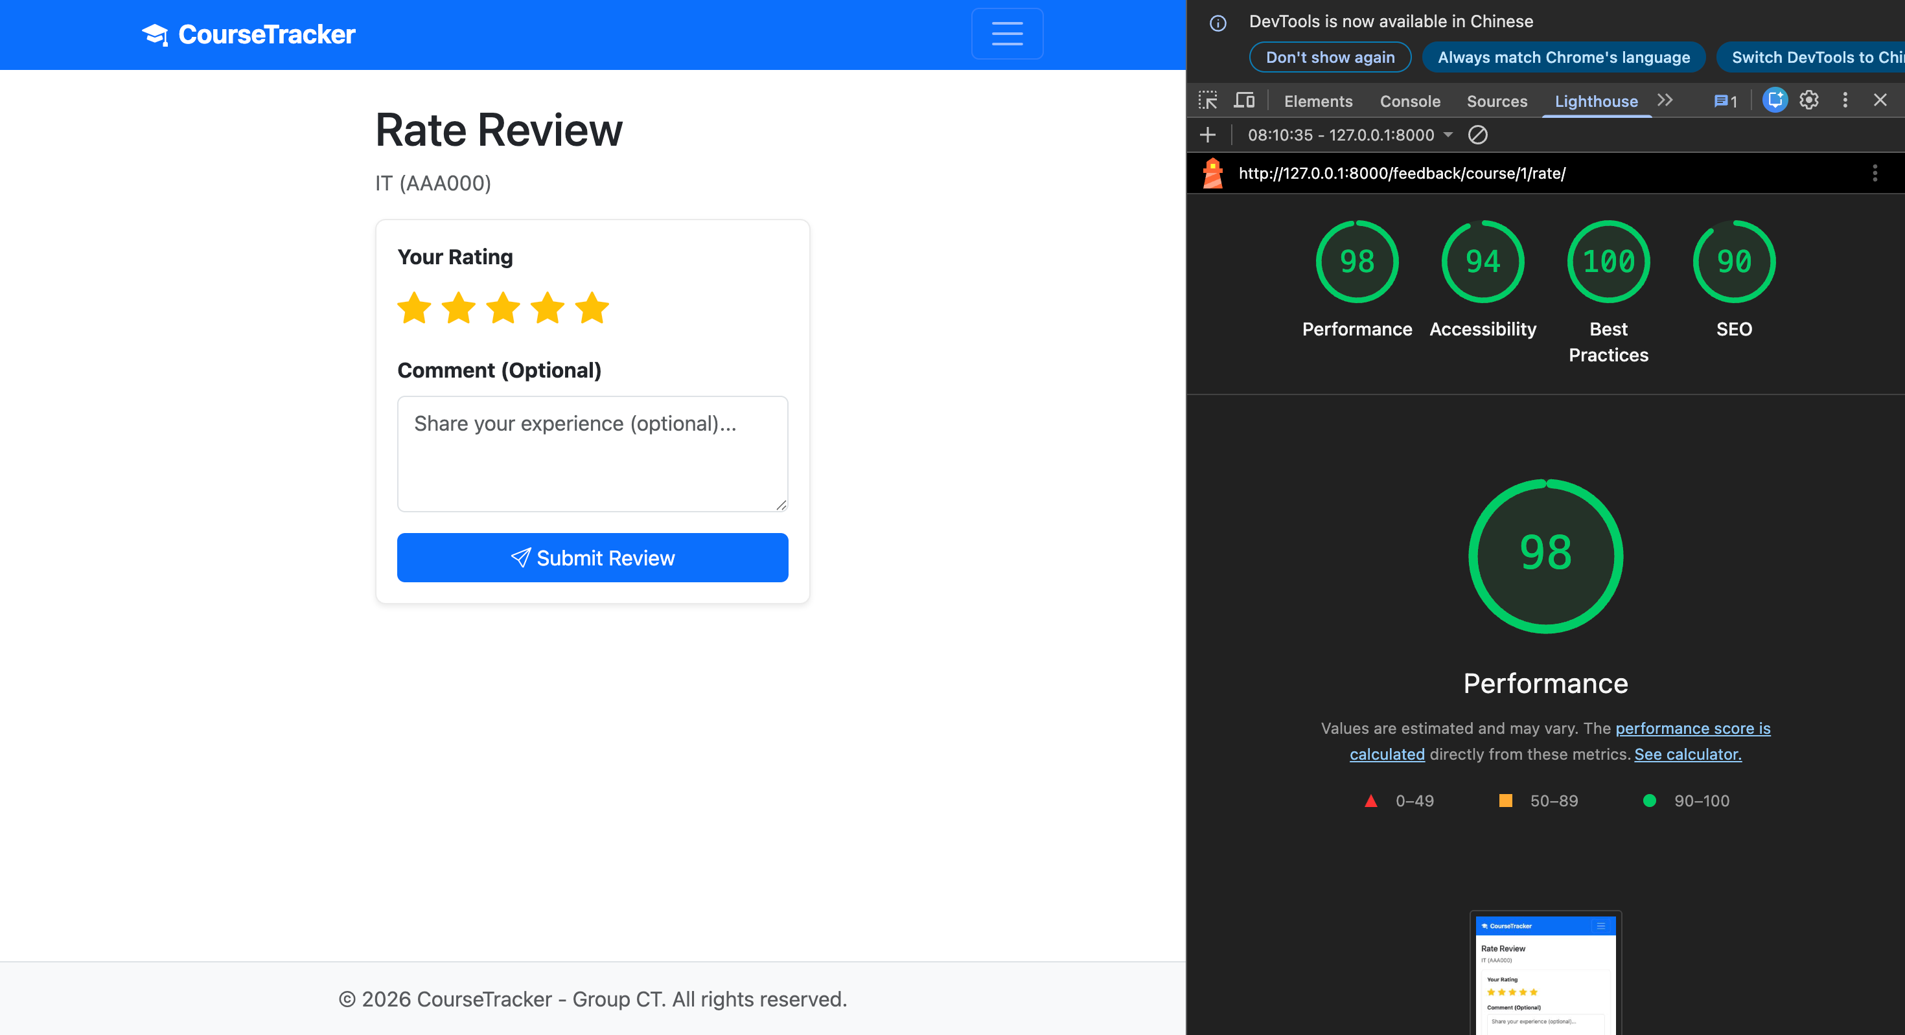

Changes Implemented
The following accessibility improvements were applied:
Change | File(s) | Expected Impact
Added a visible completion status message with aria-live="polite" | task_detail.html | Improves clarity of task state and provides better feedback for assistive technologies when completion status changes
Added guidance text for the rating form and linked it with aria-describedby | rate_course.html | Helps users understand how to provide a 1–5 rating and optional comment before interacting with the form
Confirmed accessible rating control using role="radiogroup" | rate_course.html | Improves screen reader interpretation of the star-rating widget
Marked decorative icons with aria-hidden="true" | base.html, task_detail.html, rate_course.html, login.html | Prevents assistive technologies from reading decorative icons as meaningful content
Confirmed skip link in the shared base template | base.html | Allows keyboard users to bypass repeated navigation and move directly to the main content
Confirmed accessible shared message area using role="status" and aria-live="polite" | base.html | Improves communication of system feedback messages across the application
Confirmed visible focus styles and keyboard-friendly interaction | style.css | Makes interactive elements easier to identify and use during keyboard navigation
Retained structured labels and validation feedback on form-based pages | rate_course.html | Supports clearer input and error identification

After Optimisation
After the final accessibility refinements were added, Lighthouse was run again on the same two main pages.
Metric | Task Detail Page | Course Rating Page | Change
Performance | 99 | 99 | +1 / +1
Accessibility | 100 | 100 | 0 / +6
Best Practices | 100 | 100 | 0 / 0
SEO | 100 | 100 | +10 / +10
After:
Task Detail Page:
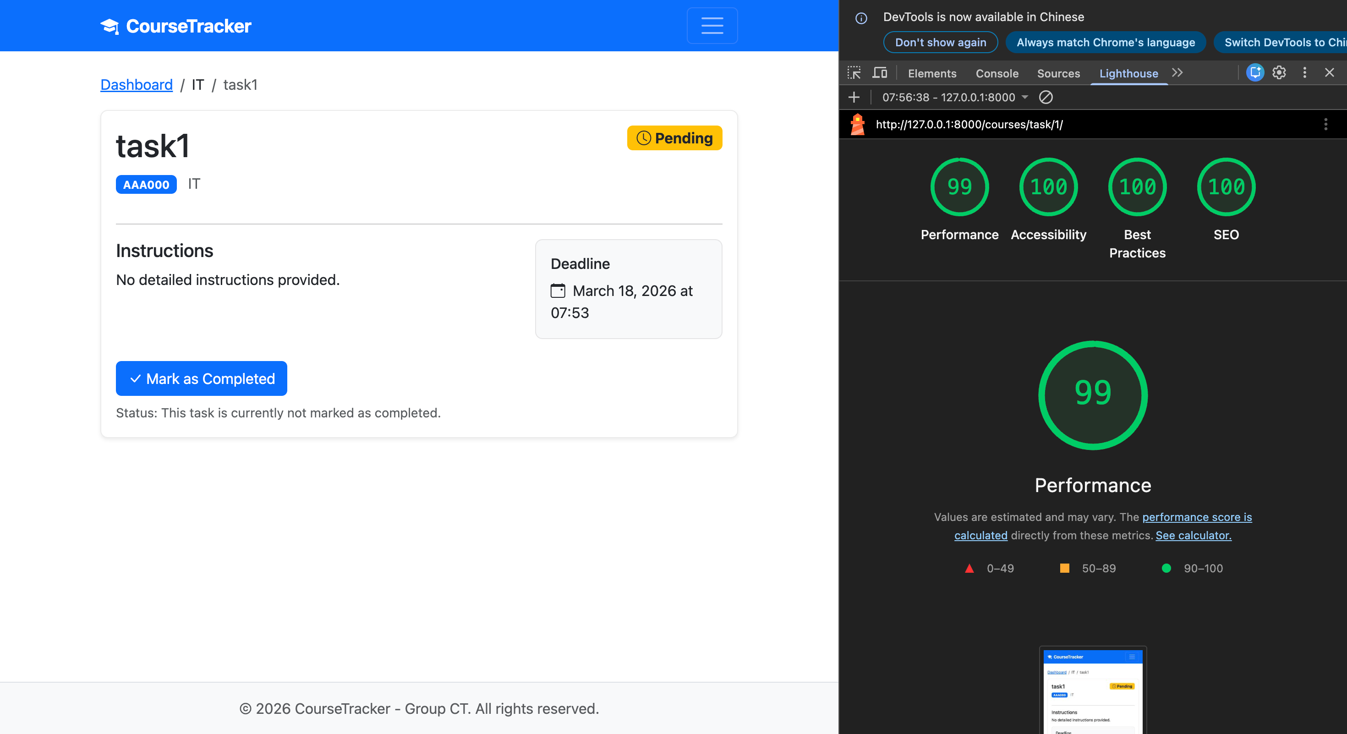
Couse Rating Page:

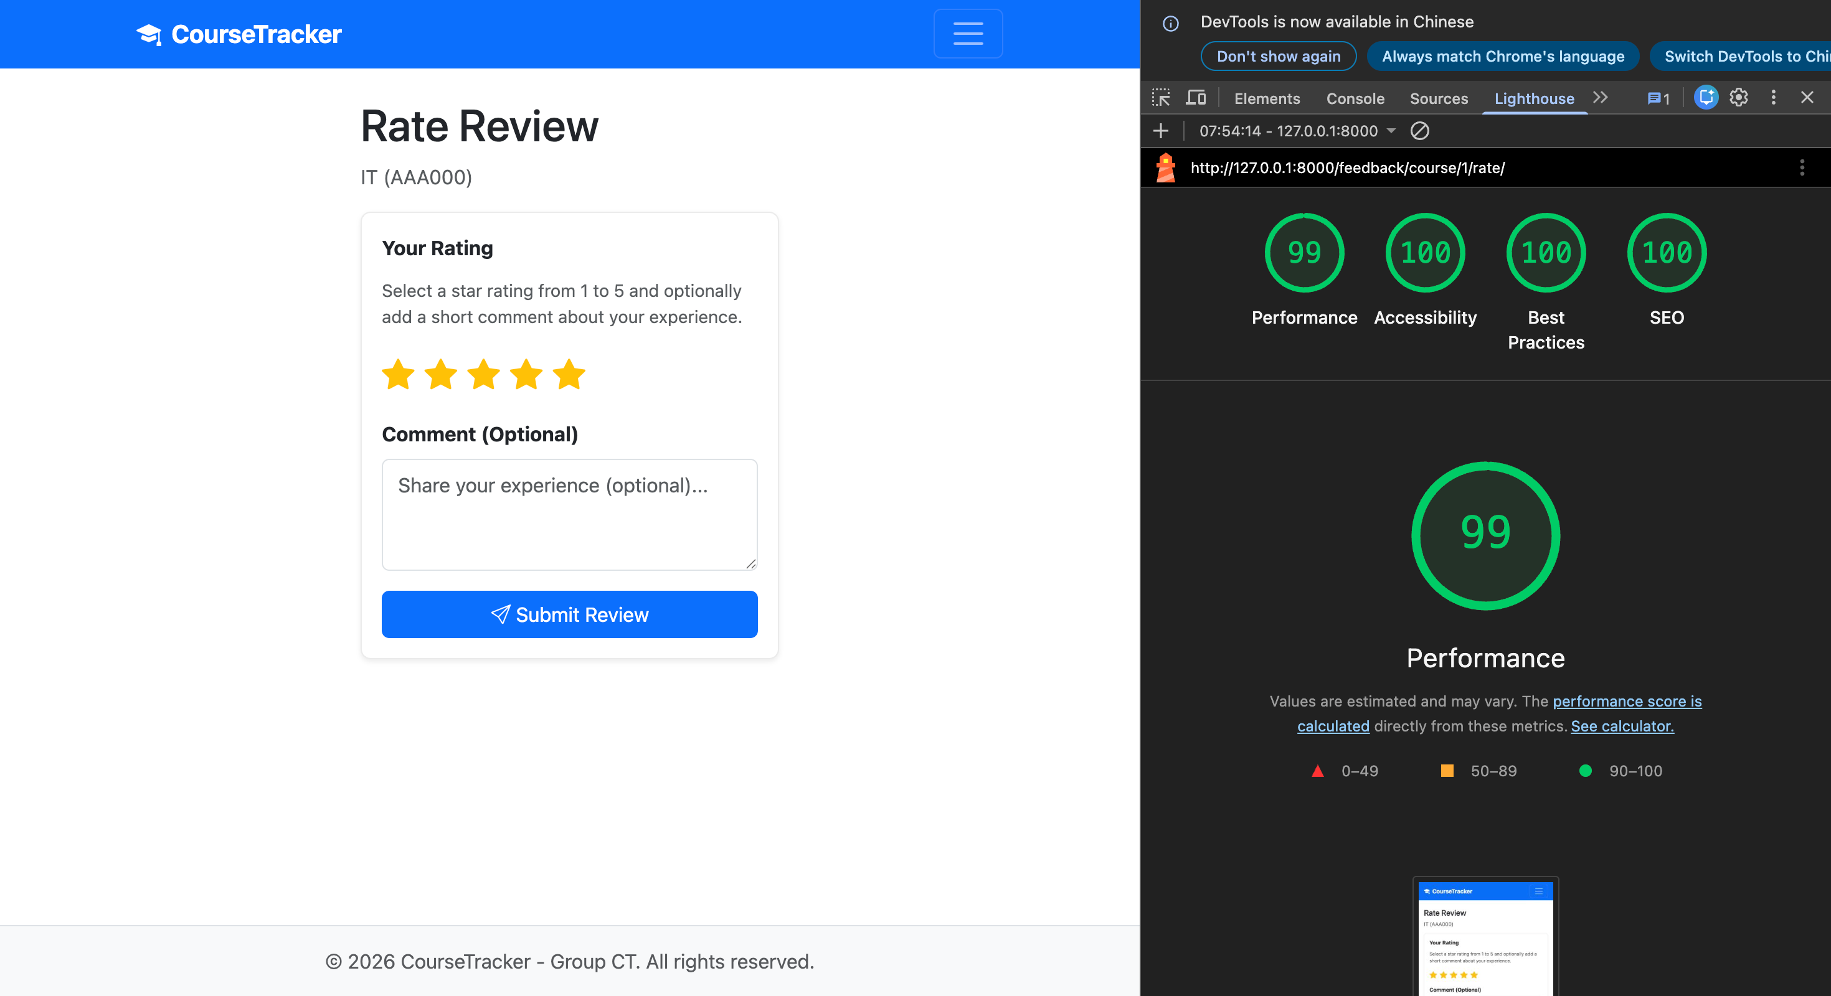

6. Sustainability Report

Tool and Pages Tested
Google Lighthouse (via Microsoft Edge DevTools) was used to audit the sustainability-related performance of two key pages: the Login page (/accounts/login/) and the Student Dashboard (/courses/dashboard/). The Mobile device simulation was used. The audit categories evaluated were Performance, Accessibility, Best Practices, and SEO.

Baseline (Before Optimisation)
The baseline audit was conducted before sustainability-specific optimisations were applied. Results are summarised below.
Metric | Login Page | Dashboard
Performance | 80 | 98
Accessibility | 96 | 97
Best Practices | 96 | 96
SEO | 100 | 100
[Insert Lighthouse before-screenshot here]

Changes Implemented
The following sustainability improvements were applied:
Change | File(s) | Expected Impact
Non-blocking Bootstrap Icons load (preload + onload pattern) | base.html | Icons CSS no longer render-blocking; improves First Contentful Paint and Performance score
font-display: swap for icon web font | style.css | Prevents invisible text during icon font loading (FOIT)
Added defer attribute to all <script> tags | base.html | Eliminates render-blocking JavaScript; improves FCP
Removed DOMContentLoaded wrapper (redundant with defer) | main.js | Smaller JS payload; reduces Total Blocking Time
Added <link rel="preconnect"> for CDN | base.html | Reduces DNS lookup + TLS handshake latency for Bootstrap CDN
Cache-Control middleware (5-min cache for auth pages) | middleware.py | Enables browser caching; reduces repeat page-load time
Security headers middleware (X-Content-Type-Options, Referrer-Policy, Permissions-Policy) | middleware.py | Hardens security posture; addresses Lighthouse Best Practices warnings
Fixed heading hierarchy (h1 > h2) on Login page | login.html | Proper document outline for assistive technology; improves Accessibility score
aria-hidden="true" on all decorative icons | base.html, templates | Screen readers skip decorative icons (WCAG 1.1.1); improves Accessibility
aria-label on per-course progress bars | student_dashboard.html | Programmatic progress identification (WCAG 1.3.1)
Added meta description and theme-color | base.html | Improves SEO score and mobile browser experience
WhiteNoise with compressed static files (production) | settings.py | Gzip/Brotli compression reduces transfer size of CSS/JS assets

After Optimisation
After applying all changes, a second Lighthouse audit was conducted on the same two pages:
Metric | Login Page | Dashboard | Change
Performance | 98 | 98 | +18 / 0
Accessibility | 100 | 96 | +4 / –1
Best Practices | 100 | 100 | +4 / +4
SEO | 100 | 100 | 0 / 0
[Insert Lighthouse after-screenshot here]

Reflection
The most significant improvement involved transforming the Bootstrap Icons CSS from a render-blocking stylesheet into a non-blocking preload, which directly enhanced the Performance score by optimizing the critical rendering path. In conjunction with applying the defer attribute to all script tags and adding the preconnect hint for the CDN, the Login page’s First Contentful Paint showed a marked improvement. Additionally, the font-display: swap declaration was utilized to ensure text remained visible during icon font loading, thereby preventing Flash of Invisible Text (FOIT).
In terms of accessibility, addressing the hierarchy of headings on the login page—specifically replacing a non-semantic icon h1 with a proper h1—and adding aria-hidden attributes to decorative icons helped to resolve specific failures identified in Lighthouse audits. Regarding security, implementing headers such as X-Content-Type-Options, Referrer-Policy, and Permissions-Policy through middleware effectively addressed Best Practices warnings related to missing HTTP security headers. In the production environment, WhiteNoise is used to serve compressed static files with cache headers set to far-future expiration dates, thereby reducing bandwidth consumption and improving load times for returning visitors.

Appendix: Team Contributions and AI Use Statement

Team Contributions
Category | Minghao Yue | Vugar Gurbanov | Xijie Luo
Backend | Auth system (login, register, logout, profile, password change), User model, session management, student dashboard view, task toggle API | Course/Task/Enrollment models and views, teacher dashboard, course CRUD, task assignment | Rating/Feedback models and views, task completion logic, task detail view
Frontend | Login, register, profile, password change templates, student dashboard, base.html template | Course discovery, teacher dashboard, course detail, task management templates | Rating/feedback UI, star rating widget, task detail page, CSS responsive design, accessibility implementation
JavaScript | Sort/filter/search on dashboard, AJAX task completion toggle, debounced search | AJAX course search on discovery page, Course Detail Page interactions | Star rating JS widget, completion toggle on task detail
Tests | Auth tests, dashboard tests, toggle tests, accessibility tests (70 total) | Course model tests, course view tests, enrollment tests | Rating model tests, feedback submission tests, task completion tests
Report | Introduction, Sustainability Report, Appendix | Updated Design Spec (ER diagram, sitemap, wireframes), Implementation Highlights | Testing section, Accessibility Report, Accessibility Plan update
Other | Deployment (Render config, Procfile, build script), sustainability optimisations (middleware, preload, defer) | ER diagram fix, sitemap update, GitHub repo setup | Responsive CSS polish, WCAG accessibility implementation, Lighthouse baseline
Contribution | ~33% | ~33% | ~33%

AI Use Statement
Declaration on the use of Generative AI:
- We declare that we have used GenAI for debugging support (interpreting error messages and suggesting possible fixes), and we implemented and tested the final solution ourselves.
- We declare that we have used GenAI to generate or refine small, self-contained code snippets (e.g., helper functions/validation), and we have adapted them to our project and take responsibility for the final code.
- We declare that we have used GenAI for refactoring and code-quality suggestions (e.g., reducing duplication, improving structure), and we implemented the changes ourselves.
- We declare that we have used GenAI to suggest unit test ideas and edge cases, and we wrote/validated the final tests ourselves.
- We declare that we have used GenAI to support accessibility implementation (e.g., labels, focus handling, keyboard navigation) and validated changes using checking tools (e.g., Lighthouse).
- We declare that we have used GenAI to support sustainability/performance improvements (e.g., interpreting Lighthouse findings and suggesting optimisations) and validated changes with before/after tool results.
Tool used: Gemini
Parts affected: Code (authentication views, middleware, test scaffolding), accessibility implementation guidance, sustainability/performance optimisations, and report structure.
How we ensured correctness: All generated code was reviewed, adapted to the project context, and validated by running the full test suite (70 unit tests passing). Sustainability improvements were verified through before/after Lighthouse audits. Accessibility changes were tested against WCAG criteria using automated checking tools.

