TODO: Update Unity, Create simulation of solar system in unity

Timeline
Departure: Sunday, 2351/09/23 → Mars on the way out, Moon on the other side of earth
Passing by Mars:
Passing by Saturn?:
Passing by Uranus?:
Passing by Neptune

Human Spaceship: Agnus
Supposed to travel out into the Oort Cloud to collect samples. Autonomous probes have been disappearing in the OC: They stopped sending signals and hence couldn’t be detected anymore. Therefore it is assumed, that the OC contains more asteroids than expected.

Crew
Captain: Arthur Threadbare (m, 46) Rich kid. Would have loved to buy a military ship, but there are laws against it, so he bought a cargo freighter and souped it up as a hobby
Executive Officer (XO): Gregory Cambrian (nb, 44)
Pilot: Sergej Hudson (m, 34), knows Knudtsen basically all his life and vice versa. Likes to say daft.
IT-Specialist: Sergej Knudtsen (m, 34), knows Hudson basically all his life and vice versa. Likes to say daft.
Handyman/Mechanic: Stella Odradek (f, 37), has a device called cloak that can conceal the identity of people for several digital devices
Doctor: Musashi Miyako (f, 19), likes plants (especially Gilbert the cactus) and has brought several seeds aboard
Cook/Physicist: Mullu Dawson (f, 59)
Ship engineer: Manolo Alvarez (m, 87): Will probably soon die from high trust
Chris Hank (m, 11): Grandson of Manolo
Cat: Spot, tabby-cat

Specifications
Max. Acceleration: 20 g (new drive), 5 g (old drive)
Dimensions: 25 m long, 10 m high, 10 m wide
Floors: Height 2.5 m, floors 0.3 m → 7 floors. 4 & 5 have an open ground between them.
- Cockpit: 3 seats for pilot, weaponry and infrastructure
- Galley & med bay
- Dorms
- Cargo
- Cargo
- Machinery, life systems etc.
- Reactor
Artificial Gravity Module: Can simulate gravity of about 0.1 g. Only there to give them a sense of up and down when not accelerating/decelerating
Built in: 2306 (bought by Arthur in 2336)

Background
The year is 2351. Some people already live on moon and mars permanently. The asteroid belt is being mined by autonomous machines, which break from time to time, so it’s not that profitable.

Setup of the solar system
Mercury, Venus, Earth, Mars, Asteroid Belt (Ceres), Jupiter, Saturn, Uranus, Neptune, Orcus with Moon Vanth, Pluto, Kuiper Belt (Makemake, Quaoar), Scattered Disc (Eris, Gonggong), Sedna, Oort
Located in the Local Interstellar Cloud, Local Bubble, Orion-Cygnus Arm, Milky Way.
Closest planetary system: Proxima Centauri (4.2465 ly)
Solar system constellation in 2351:
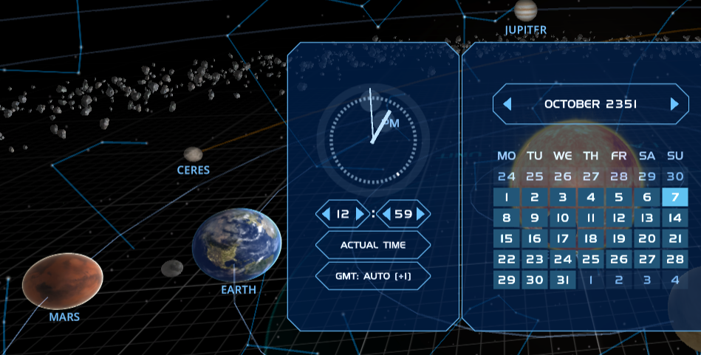
And
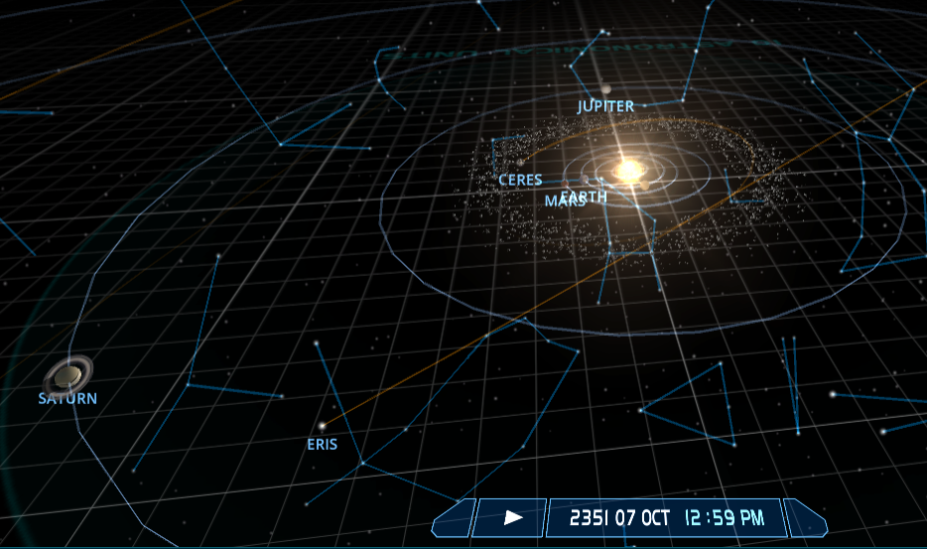
And
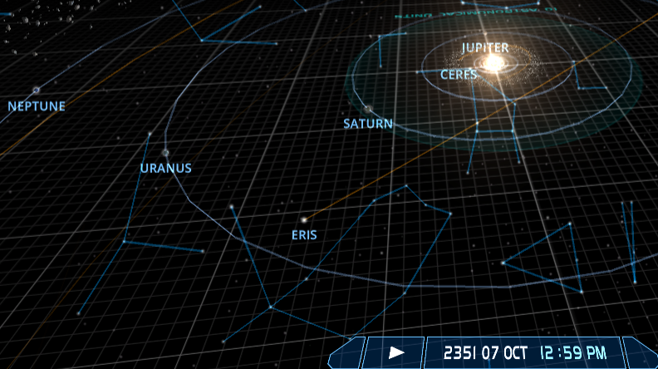

Earth
Ruled by the Round Table (RT; humans who are between 120 and 170 years old), which control all of earth except for the British Islands, which are controlled by separists who call themselves The Identity (but who are just sock puppets of RT. Later we might find out that RT aren’t humans after all, but creatures from the Oort cloud who hide themselves between digital avatars. We don’t yet know what their objectives are.
Several crises have been happening recently and over fifty billion people live there.
Atmosphere: Troposphere (12 km), Stratosphere (50 km), Mesosphere (80 km), Thermosphere (700 km), Exosphere (10 000 km).

Important Chars
Kendra “Ken” Carapace (f, 46): Police officer in the city were the Agnus crew lived. Old school buddyy of Arthur Threadbare. Gave Art the tip that the govt is after them and tries to find out how the govt found out.

Moon
Sparse settlements all over the moon, all under huge domes or under the surface. They are connected via tubes. There are several harbors.
Distance from earth: 384 000 km.

Mars
Same as moon, but only on a small portion of the surface. Two networks exist which are not connected to each other via tubes. When they grow, there might come a civil war some time in the future.

Space terminology
Asteroid: Arbitrary shape, no atmosphere
Comet: Small icy bodies that warm up in the sun and release gases
Meteoroid: Interplanetary body bigger than atom and smaller than asteroids
Meteor: Shooting star, can be asteroid, comet or meteroid

Technology

Space Ships
Fusion drives are a thing. They can provide trust up to 30 g. To survive that acceleration, humans need to take special drugs and undergo training.
Small gravity generators do exist, but they are a rather new (and expensive) technology that works kind of flaky. It can generate gravity of about 0.1 g in a limited area of roundabout 100 m².
Usual weapons are different kinds of torpedoes and rail guns. Since the latter have an immense rebound, they can only be mounted on very sturdy ships.

Weapons
Handguns and rifles of course. Maybe some “blasters”.

Ideas
- Playing around with languages. Lyrics from the human perspective are english, lyrics from the view of different alien species are in different languages (German, French, Spanish, Japanese, Chinese)
- The object the Agnus’ crew accidentally got is actually part of a drive that can bend spacetime and enable longer travels like for example to Proxima Centauri
- Some other bodies of the solar system are also inhabited, but below the surface and we don’t know about it yet. E.g. Ganymede and some other moons. Or even the gas giants, with creatures we can’t yet imagine
- It’s no accident that Jupiter catches all those asteroids that might otherwise hit the earth. They are being collected by the species that lives there
- Turns out Spot is actually female. The find out when they discover she’s pregnant

