

ASSESSMENT ITEM COVER SHEET
Colson
Student Name: Tobias
Last name (USE BLOCK LETTERS) First Name
3
1
8
4
0
5
6
Student Number: Email: c3184056@uon.edu.au
(Your NUmail account)

Course:
S
E
N
G
1
1
2
0
Software Eng 2
ode
Course Code Course Title

Campus of Study: Callaghan
Assessment Item Title: Engineering Report

10/10/2016
Tutorial Group: Word Count (If applicable): Due Date/Time:

Lecturer/Tutor Name:
X

Extension Granted: Yes No Granted Until:
Please attach the approved copy of your extension approval.

(Please tick box if applicable)
Students within the Faculty of Business and Law, Faculty of Science and Information Technology, Faculty of Engineering and Built Environment and the School of Nursing and Midwifery:
I verify that I have completed the online Academic Honesty Module and adhered to its principles

Students within the School of Education:
I understand that correct referencing and academic literacy are essential criteria on all written assignments in the School of Education; and I have read and understood the School of Education Course Outline Policy Supplement, which includes important information related to assessment policies and procedures.

NB: STUDENTS MAY EXPECT THAT THIS ASSIGNMENT WILL BE RETURNED WITHIN 3 WEEKS OF THE DUE DATE OF SUBMISSION

X

I declare that this assessment item is my own work unless otherwise acknowledged and is in accordance with the University’s academic integrity policy available from the Policy Library on the web at http://www.newcastle.edu.au/policylibrary/000608.html

DATE STAMP HERE
I certify that this assessment item has not been submitted previously for academic credit in this or any other course. I certify that I have not given a copy or have shown a copy of this assessment item to another student enrolled in the course.
I acknowledge that the assessor of this assignment may, for the purpose of assessing this assignment:
- Reproduce this assessment item and provide a copy to another member of the Faculty; and/or
- Communicate a copy of this assessment item to a plagiarism checking service (which may then retain a copy of the item on its database for the purpose of future plagiarism checking).
- Submit the assessment item to other forms of plagiarism checking.

I certify that any electronic version of this assignment item that I have submitted or will submit is identical to this paper version.

Turnitin ID:

(if applicable)

Signature: 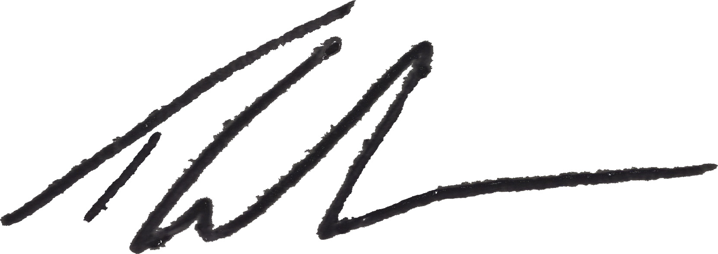 Date:13/10/2016

