UILayout plug-in for APEX
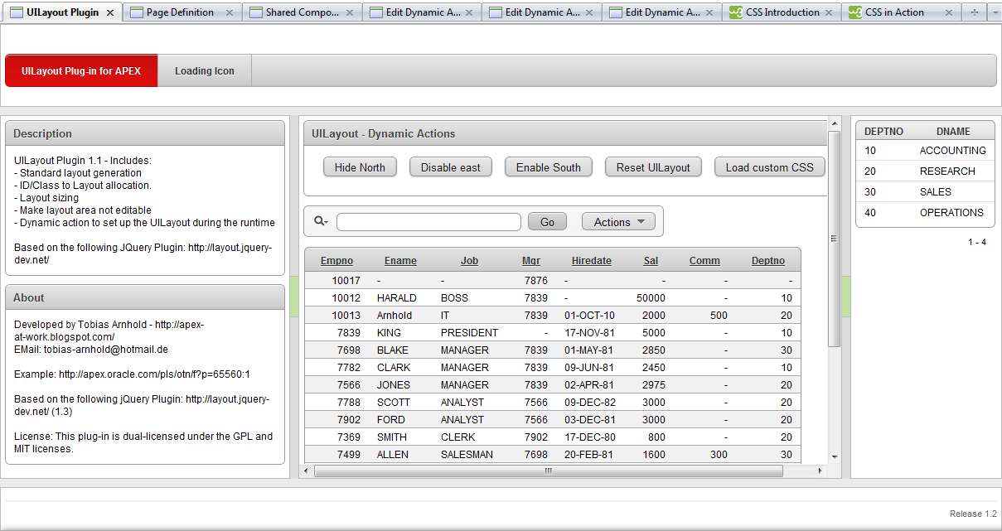
Index
1. Installation 2
2. Plug-ins 2
3. UILayout – Initialize [Plug-in] 3
4. UILayout – Styling [Plug-in] 5
5. UILayout – Dynamic Action [Plug-in] 6
6. About 7

Installation

Download the current version from: http://www.apex-plugin.com/

Import the following files into your APEX application under “Home > Application Builder > Application xxx >Shared Components > Plug-ins”

dynamic_action_plugin_com_aaw_uilayout_initialize.sql
dynamic_action_plugin_com_aaw_uilayout_styling.sql
dynamic_action_plugin_com_aaw_uilayout_da.sql

After you successfully imported all plug-ins your screen should look like that:

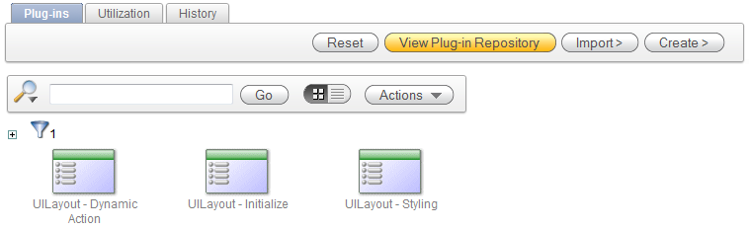

Plug-ins

UILayout – Initialize [Plug-in]
To execute the UILayout you only need the “UILayout – Initialize” plug-in. All major settings are made in this plug-in. All details are described in point 3.

UILayout – Styling [Plug-in]
The “UILayout – Styling” plug-in creates individual styles for your layout. The original jQuery plug-in is based on the CSS class settings. These settings are loaded before the layout becomes dynamically created. This Styling plug-in makes those changes afterwards. Right now it doesn’t include all settings like you can use in the standard CSS classes. That is the reason why you can choose if you want to load the CSS file in the Initialize plug-in. If you want to have the full controls over all CSS settings then don’t use this plug-in and build your own CSS which you can load inside the page header. The example application shows how it works. All details are described in point 4.

UILayout – Dynamic Action [Plug-in]
The “UILayout – Dynamic Action” plug-in let you interact with the layout during the runtime of your application. All details are described in point 5.

UILayout – Initialize [Plug-in]

Create a dynamic action called “UILayout” which fires after “Page Load”.

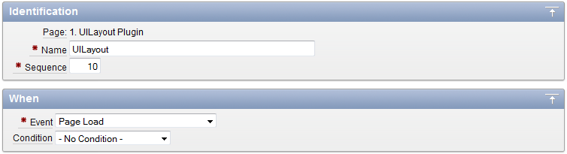

Add the following action: UILayout – Initialize [Plug-in]
You now have to configure the basic setup of the UILayout:

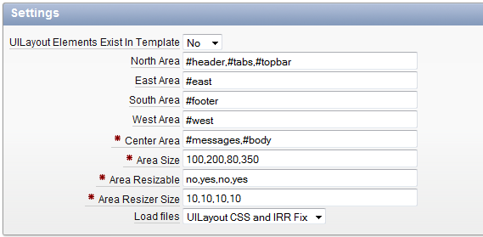
UILayout Elements Exist In Template:
If is set to “No” then you need to setup each area of the UI.Layout. You do that by adding IDs and classes to the right areas:
North Area
East Area
South Area
West Area
Center Area

If set to “Yes” then your page template needs to be fully supported by the UI.Layout plug-in. For more information please follow the documentation:
http://layout.jquery-dev.net/documentation.cfm#Example

Area’s:
Add IDs or classes to each area by comma separated lists. Use the jQuery syntax (ID = #west or Class = .west).

Area Size:
Set the size of each area in pixel with the following logic:
North, East, South, West.
Example:
100,0,100,400

If you want to hide one area then set it to 0.

Area Resizable:
Set if the layout areas are resizable with yes or no.
Use the following logic:
North,East,South,West
Example
no,no,no,yes

Area Resizer Size:
Set the size of each area resizer in pixel with the following logic:
North, East, South, West.
Example
10,10,10,10
What is the “Area Resizer”?
It is the line which separates the areas from each other.

Load files:
Select between the following options:
UILayout CSS and IRR Fix
Only UILayout CSS file
Only IRR Fix file
No files

UILayout CSS:
Don't select UILayout CSS file in case you use your own CSS files for the UILayout plug-in. For more information please follow the documentation:
http://layout.jquery-dev.net/documentation.cfm
If you want to use the "UILayout - Styling" plug-in then you need to select the UILayout CSS file.
IRR Fix:
There is a common problem with IRR and the UILayout. Until it is fixed in APEX set it to Yes. For more information watch this forum post: http://forums.oracle.com/forums/message.jspa?messageID=9298288

UILayout – Styling [Plug-in]

Add the following action: UILayout – Initialize [Plug-in] to you dynamic action. When you set the colors for initialization then use our dynamic action from point 3: “UILayout”
You now have to configure the plug-in:
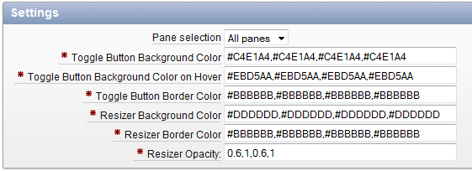

Pane selection:
Select which panes should be affected (All,North,East,South,West).
If you select all then you need to put your values in this order: North,East,South,West

Toggle Button Background Color, Toggle Button Background Color on Hover, Toggle Button Border Color, Resizer Background Color, Resizer Border Color:
All settings use the same input validation. Add the color you want to use. If you selected "All panes" then please enter values comma separated:
North,East,South,West = #5CABE8,#5CABE8,#5CABE8,#5CABE8
else then only the value for the selected pane.

Resizer – Is the separator of the areas. In the middle of it is the ToggleButton (only when the resizer is changeable).

ToggleButton – This button let your area hide and changes the color when your mouse moves over it.

Resizer Opacity:
Opacity of 0.1 is almost invisible and opacity of 1 is fully visible.<br>
Add the opacity you want to use. If you selected "All panes" then please enter values with comma separated:<br> North,East,South,West = 0.8,1,0.2,1<br>else then only the value for the selected pane.

UILayout – Dynamic Action [Plug-in]

Create a dynamic action which fires for example after a click event.

Add the following action: UILayout – Dynamic Action [Plug-in] to your dynamic action.
You now have to configure the plug-in:
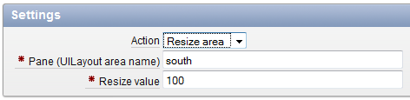
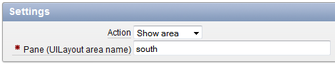
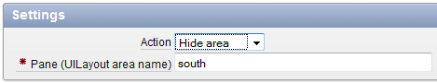
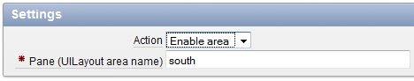
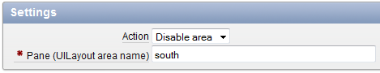

Action:
Set the action which you want to be executed. You can choose between these actions:
Resize area
Show area
Hide area
Enable area
Disable area

Pane:
Enter the name of the UILayout area. For example: west
Other possible values: north, east, south

Resize:
Set new new value of the area width. Only to set if you choose: Resize area

About

Developed by:
Tobias Arnhold - http://apex-at-work.blogspot.com/

Example:
http://apex.oracle.com/pls/otn/f?p=65560:1

Original jQuery Plugin:
http://layout.jquery-dev.net/

Info:
This version includes a bugfix using the plugin with APEX 5.

License: This plug-in is dual-licensed under the GPL and MIT licenses.

