**“UILayout – UT” plug-in for APEX**

**Index**

1. Information 2

2. Feature list 2

3. Installation 2

4. Implement the plugin 3

5. Configure the Universal Theme (UT) 4

6. Configure the plugin 5

7. About 7

# Information

This plugin is created to extend the usability inside the „Universal Theme“ (UT). It gives you control about different areas of the UT. It uses the jQuery plugin „UI Layout“ as base and is designed to only work with the UT.

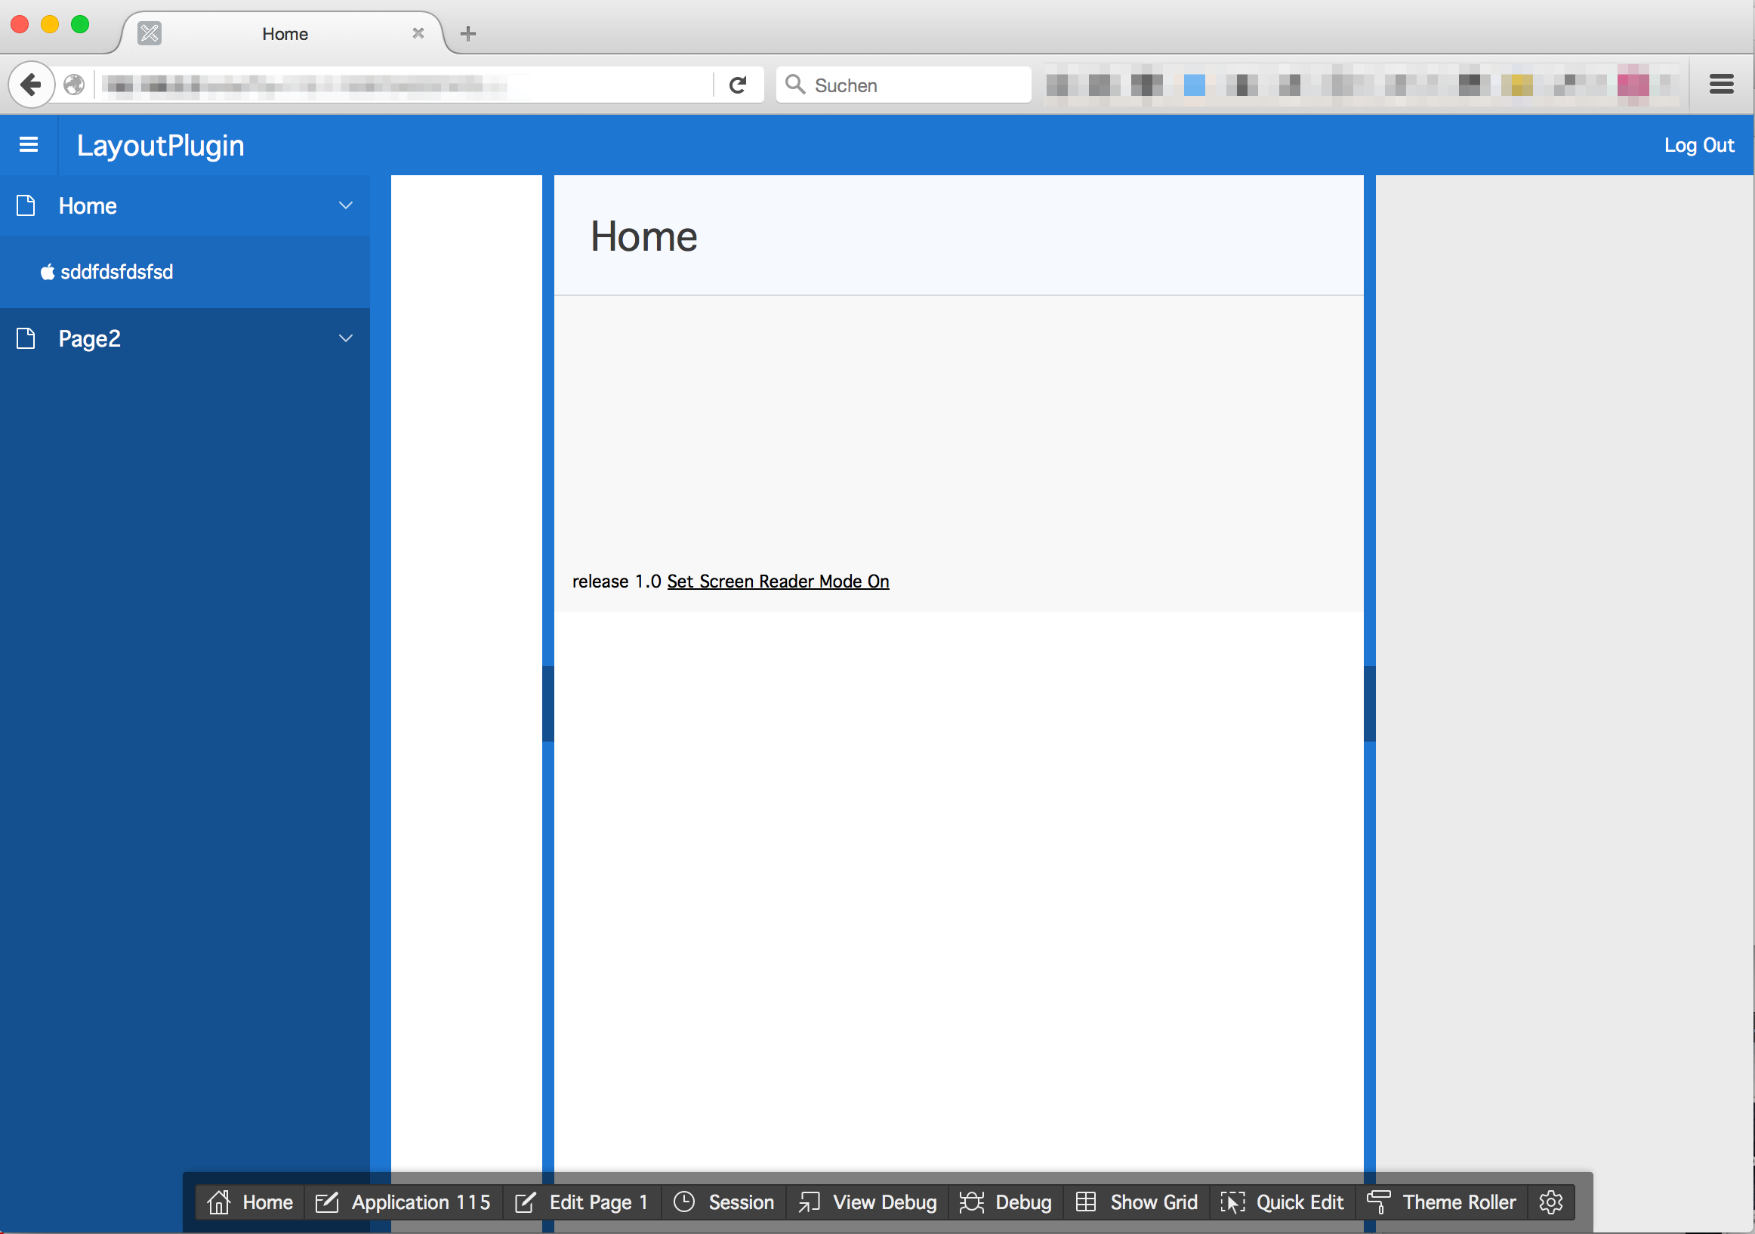

# Feature list

- Control up to 3 panels: navigation, left and right panel  
- Same responsive behavior as you are used to with the standard UT  
- Resizer colors: Grey, UT colors or custom colors  
- Default width and max width can be set up for each panel  
- Resizer bar width can be set up for each panel  
- The navigation area is controlled by the default UT button

- Move and hover effects for the resizer bars

- Easy to set up - Dynamic Action: "Page Load"

# Installation

Download the current version from: <https://github.com/tobiasarnhold/uilayout-ut>

Import the following file into your APEX application under “Home > Application Builder > Application xxx >Shared Components > Plug-ins”

dynamic_action_plugin_com_aaw_uilayout_ut.sql

After you successfully imported the plug-ins your screen should look like that:

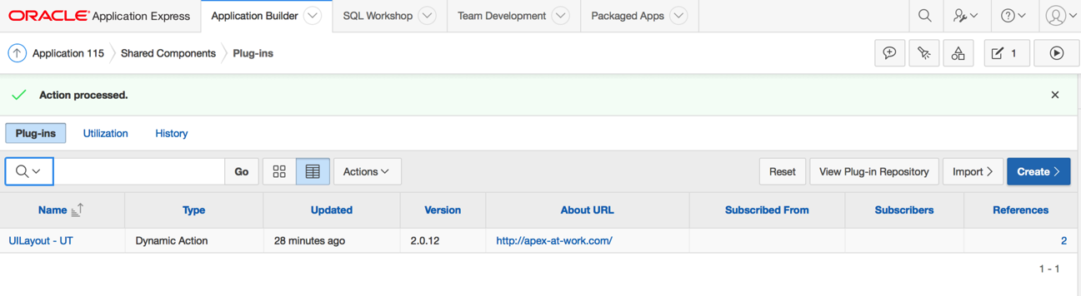

# Implement the plugin

Create a dynamic action called “UILayout - UT” which fires after “Page Load”.

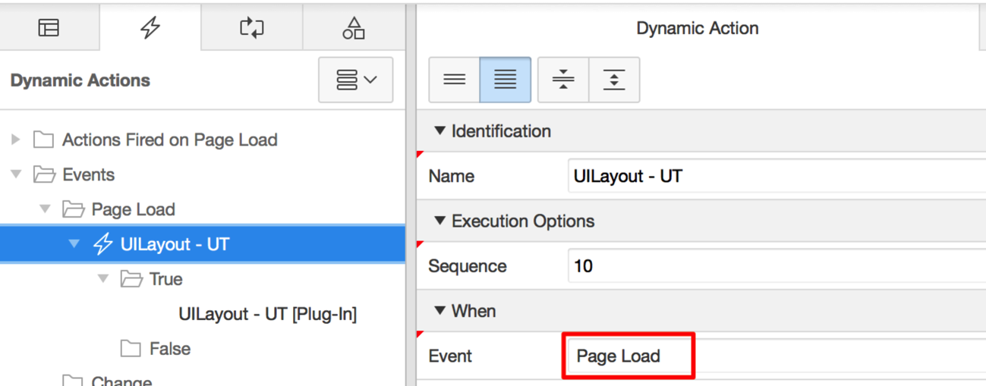

Add the following TRUE action: UILayout – UT [Plug-In]

# Configure the Universal Theme (UT)

Define which UT areas should be displayed. The plugin can only run if the UT itself is configured correctly.

You can choose between:

„Theme Default“

„Left and Right Side Columns“

„Left Side Column“

„Right Side Column“

„Standard“

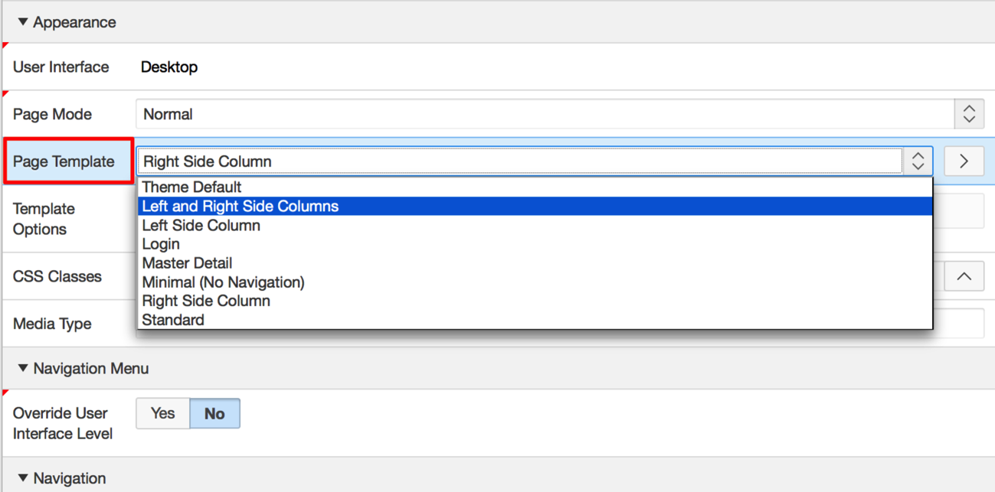

# Configure the plugin

Next step is to configure the plugin:

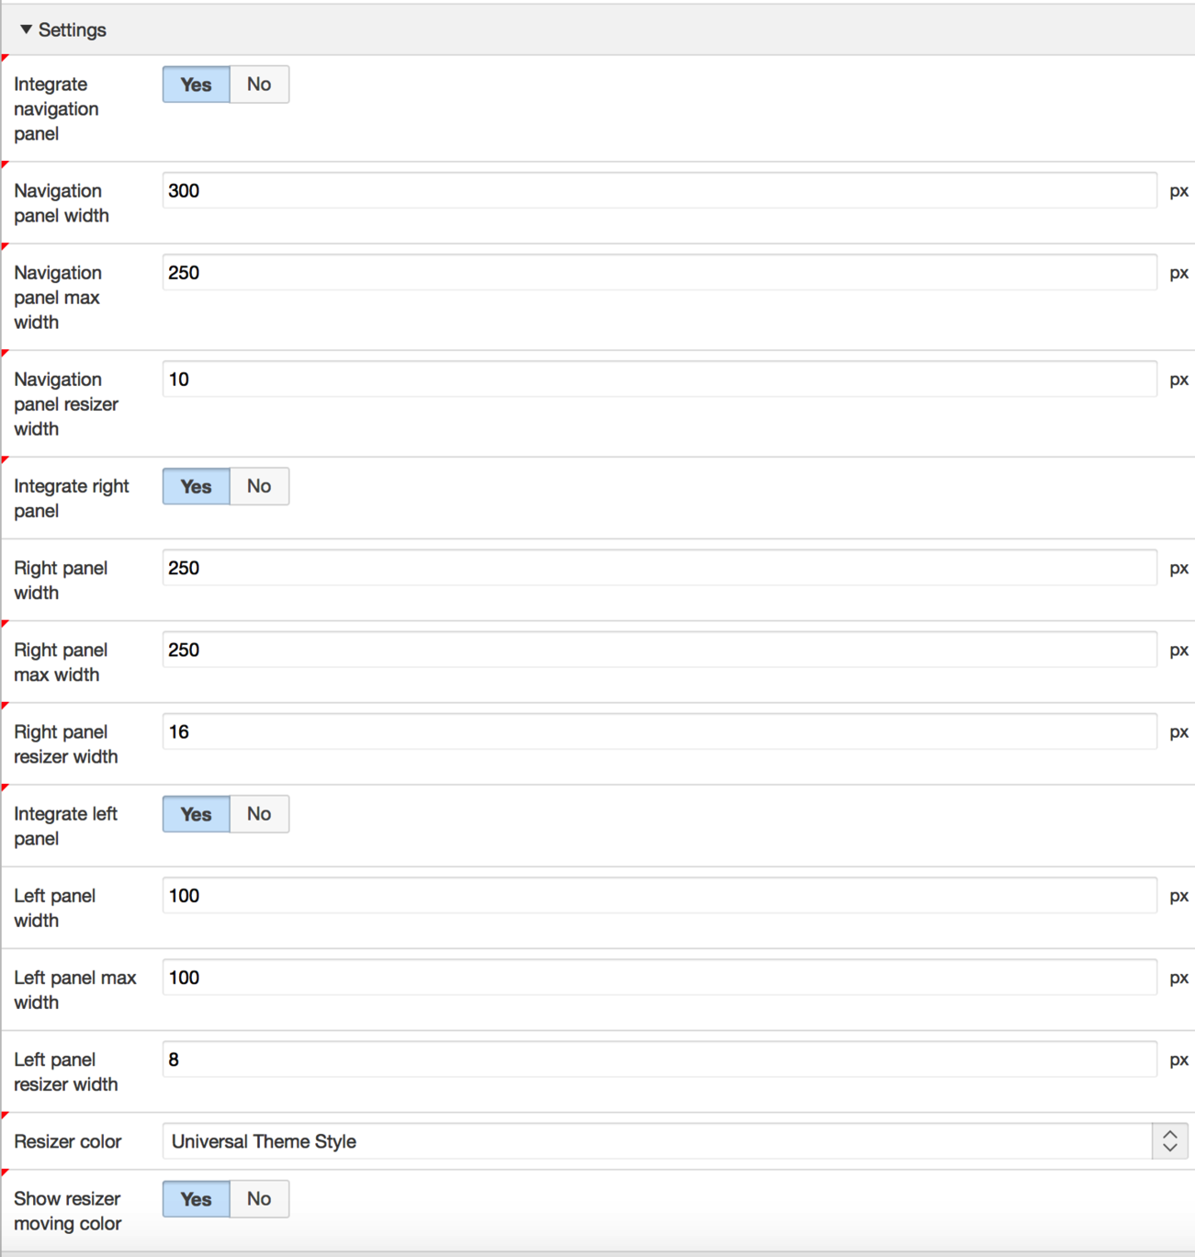

**Description**

Integrate navigation panel

Defines if the navigation panel can be moved around or not.

Navigation panel width

Defines the with of the panel in px. Only a number value is allowed.

Navigation panel max width

Defines the maximum with of the panel in px. Only a number value is allowed.

Navigation panel resizer width

Defines the width of the resizer bar in px. Only a number value is allowed.

Integrate right panel

Defines if the right panel can be moved around or not.

Be aware that if you have an active right panel but you disable it inside the plugin then you will experience some ugly CSS bugs. In that case active the “Integrate right panel” option and set the “Right panel resizer width” to 0.

Right panel width

Defines the with of the panel in px. Only a number value is allowed.

Right panel max width

Defines the maximum with of the panel in px. Only a number value is allowed.

Right panel resizer width

Defines the width of the resizer bar in px. Only a number value is allowed.

Integrate left panel

Defines if the left panel can be moved around or not.

Be aware that if you have an active left panel but you disable it inside the plugin then you will experience some ugly CSS bugs. In that case active the “Integrate left panel” option and set the “Left panel resizer width” to 0.

Left panel width

Defines the with of the panel in px. Only a number value is allowed.

Left panel max width

Defines the maximum with of the panel in px. Only a number value is allowed.

Left panel resizer width

Defines the width of the resizer bar in px. Only a number value is allowed.

Resizer color

Defines which color template should be used.

1. Default: Grey

2. Universal Theme (UT): Colors of the UT configuration

3. Custom: Define your own colors.

Custom resizer color and toggler color

Set up to two comma separated custom colors for the resizer bar and the toggler button. Color must include the #.

Example: #2578CF,#19528E

Show resizer moving color

Defines if some highlighted colors should be displayed when you move or hover the resizer bar or button.

# About

Developed by:

Tobias Arnhold - <http://apex-at-work.com/>

Original jQuery plugin:

<http://layout.jquery-dev.net/>

License: This plug-in is dual-licensed under the GPL and MIT licenses.