**Title: Nectar compounds impact bacterial and fungal growth and shift community dynamics in a nectar analog**

**Running head: NECTAR COMPOUNDS IMPACT GROWTH AND SHIFT COMMUNITY**

**Authors**: Tobias G. Mueller[1][2]*, Jacob S. Francis[1], Rachel L. Vannette[1]

[1] Department of Entomology and Nematology, University of California, Davis, Davis, CA, USA

[2] Department of Entomology, Cornell University, Ithaca, NY, USA

* Corresponding author; email: tm524@cornell.edu, (+1) 512-992-7688, 4124 Comstock Hall, Cornell University, Ithaca, NY, 14850

Yeast Media (YM)

To make 1000ml of YM, dissolve the following in deionized H2O

* 3g Malt Extract
* 5g Peptone
* 10g Glucose (Dextrose)
* 20g Agar
* 3g Yeast Extract

after autoclaving add

* 1mL Chloramphenicol (100 mg/mL)

Tryptone Soy Agar Media (TSA)

To make 1000ml of TSA, dissolve the following in deionized H2O

* 15g Tryptone
* 15g Agar
* 5g Soytone
* 5g NaCl
* 50g Fructose

after autoclaving add

* 1mL Cycloheximide (100mg/mL)

**Supplemental method 1.** The media recipes for the yeast media (YM) and tryptone soy agar (TSA) that fungi and bacteria were cultured on respectively

| **Treatment** | **Levels Found in Nectar** | **Citations** |
| --- | --- | --- |
| **4 mM H2O2** | H2O2 levels up to 4mM have been found in ornamental tobacco (*Nicotiana langsdorffii × Nicotiana sanderae*) nectar | Carter, C. et al. Tobacco Nectaries Express a Novel NADPH Oxidase Implicated in the Defense of Floral Reproductive Tissues against Microorganisms. Plant Physiol 143, 389–399 (2007); Carter, C. & Thornburg, R. W. Is the nectar redox cycle a floral defense against microbial attack? Trends in Plant Science 9, 320–324 (2004) |
| **2 mM H2O2** |
| **30% Sugar** | Sugar levels in nectar can range from 8% to over 80% | Baker, H. G. Sugar Concentrations in Nectars from Hummingbird Flowers. Biotropica 7, 37–41 (1975); Herrera, C. M., Canto, A., Pozo, M. I. & Bazaga, P. Inhospitable sweetness: nectar filtering of pollinator-borne inocula leads to impoverished, phylogenetically clustered yeast communities. Proceedings of the Royal Society B: Biological Sciences 277, 747–754 (2010) |
| **100 ng/ml Linalool** | Linalool levels can range from 5ng to over 100ng/ml in *Penstemon digitalis* nectar | Burdon, R. C. F., Junker, R. R., Scofield, D. G. & Parachnowitsch, A. L. Bacteria colonising Penstemon digitalis show volatile and tissue-specific responses to a natural concentration range of the floral volatile linalool. Chemoecology 28, 11–19 (2018) |
| **150 μg/ml BrLTP2.1 (LTP)** | Exact concentrations are unknown, however, fluorescence of BrLTP2.1 shows high levels in *brassica rapa* nectar. Previous experiments tested up to 300μg/ml | Schmitt, A. J. et al. The major nectar protein of Brassica rapa is a non-specific lipid transfer protein, BrLTP2.1, with strong antifungal activity. J Exp Bot 69, 5587–5597 (2018) |
| **22 μg/ml Deltaline** | Deltaline levels can be up to .63μg/100mg in *Delphinium* nectar, however, concentrations of the norditerpene alkaloid class as a whole can reach up to 22μg/ml in *Delphinium* nectar | Cook, D., Manson, J. S., Gardner, D. R., Welch, K. D. & Irwin, R. E. Norditerpene alkaloid concentrations in tissues and floral rewards of larkspurs and impacts on pollinators. Biochemical Systematics and Ecology 48, 123–131 (2013) |
| **1% Ethanol** | The highest reported level of ethanol in nectar is 3.8%, however, no formal survey of ethanol in floral nectar has been performed | Wiens, F. et al. Chronic intake of fermented floral nectar by wild treeshrews. PNAS 105, 10426–10431 (2008) |

**Supplemental Table 1** The concentrations of nectar compounds used as treatments along with their reported natural concentrations in floral nectar

| **Treatment** | Base nectar | 30% sugar | 2mM H2O2 | 4mM H2O2 | 100 ng/mL Linalool | 150 μg/mL LTP | .22 μg/mL Delaline | 1% Ethanol |
| --- | --- | --- | --- | --- | --- | --- | --- | --- |
| **Total made** | **25 mLs** | **25 mLs** | **25 mLs** | **25 mLs** | **25 mLs** | **15mL** | **25 mLs** | **25 mLs** |
| **g Sucrose** | 1.875 | 3.75 | 1.875 | 1.875 | 1.875 | 1.125 | 1.875 | 1.875 |
| **g Glucose** | 0.9375 | 1.875 | 0.9375 | 0.9375 | 0.9375 | 0.5625 | 0.9375 | 0.9375 |
| **g Fructose** | 0.9375 | 1.875 | 0.9375 | 0.9375 | 0.9375 | 0.5625 | 0.9375 | 0.9375 |
| **g Peptone** | 0.25 | 0.25 | 0.25 | 0.25 | 0.25 | 0.15 | 0.25 | 0.25 |
| **g Yeast Extract** | 0.75 | 0.75 | 0.75 | 0.75 | 0.75 | 0.45 | 0.75 | 0.75 |
| **mL 100x non-essential amino acids** | 12.5 | 12.5 | 12.5 | 12.5 | 12.5 | 7.5 | 12.5 | 12.5 |
| **μL 30% H2O2** | - | - | 5.67 | 11.33 | - | - | - | - |
| **μL linalool** | - | - | - | - | 2.87 | - | - | - |
| **μg LTP** | - | - | - | - | - | 2250 | - | - |
| **mg Deltaline** | - | - | - | - | - | - | 0.55 | - |
| **μL 100% Ethanol** | - | - | - | - | - | - | - | 250 |

**Supplemental Table 2** Recipes for synthetic nectar treatment solutions. All treatments were fully dissolved in deionized water before being syringe filtered through a .2μm filter to ensure sterility

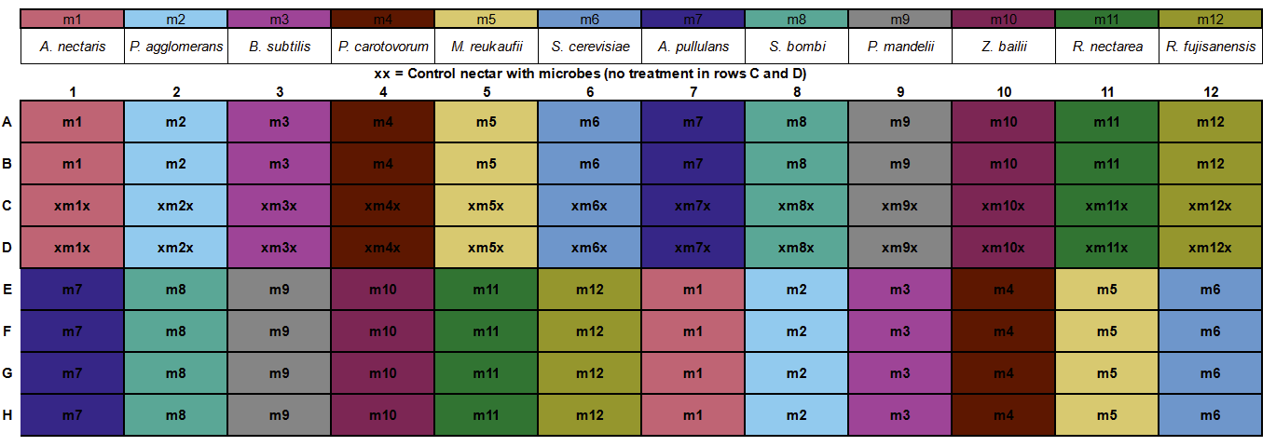

**Supplemental Figure 1** The layout of microbes on the 96 well plate. Each microbe (m1-m12, listed above) had 6 replicates in each treatment nectar (rows A:B, and E:H) and 2 replicates in control nectar (rows C:D) marked above with an X. The placement of each microbe on the plate was determined with a random number generator and kept consistent across all assays

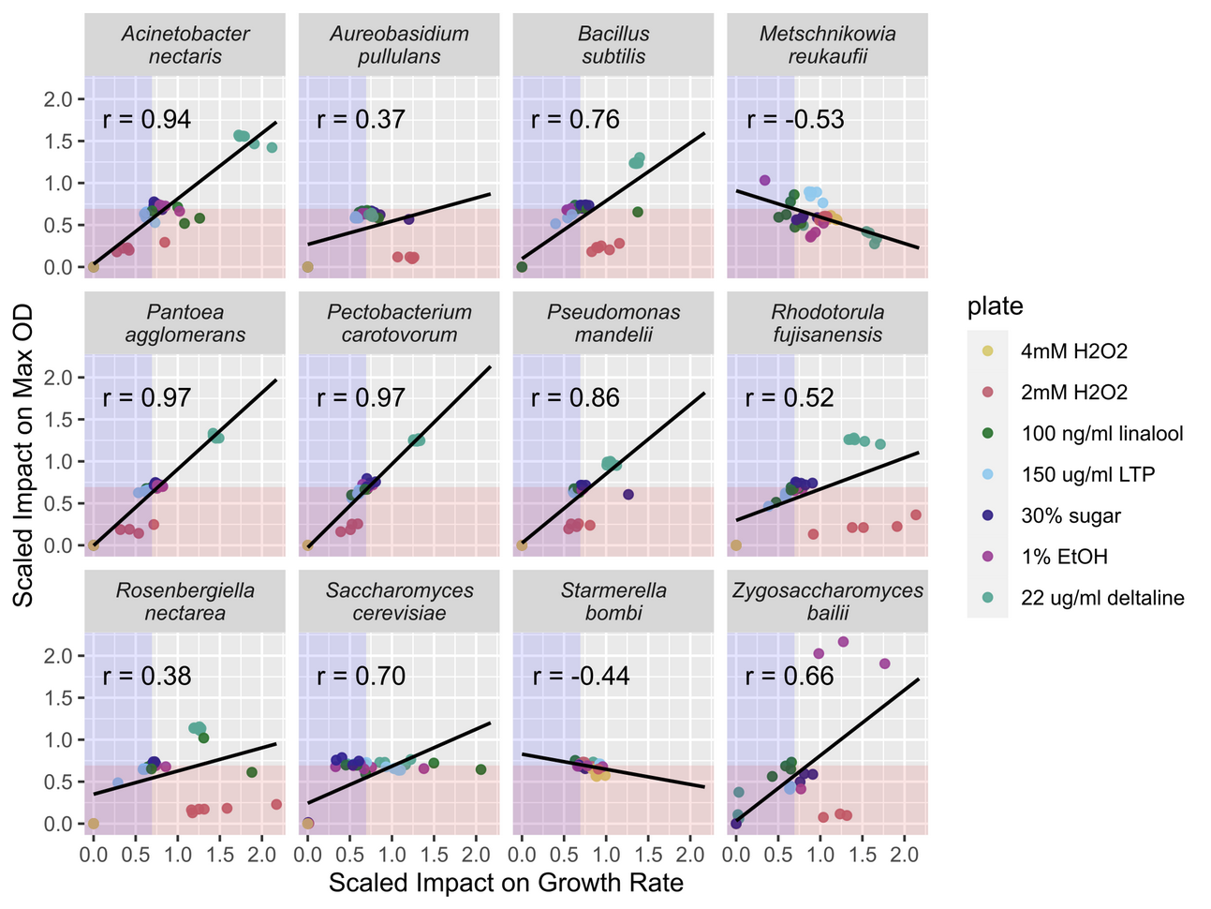

**Supplemental Figure 2** The treatment impacts on maximum OD and growth rate were correlated across many but not all species. The axes indicate the scaled effect of treatment compared to control nectar. Points inside the red/blue shaded area had a lower OD/growth rate, in treatment than control solutions. Points in both the blue and red shaded area had both a lower OD *and* growth rate in treatment than control solutions. The Pearson's correlation coefficient (r) is given for each microbse

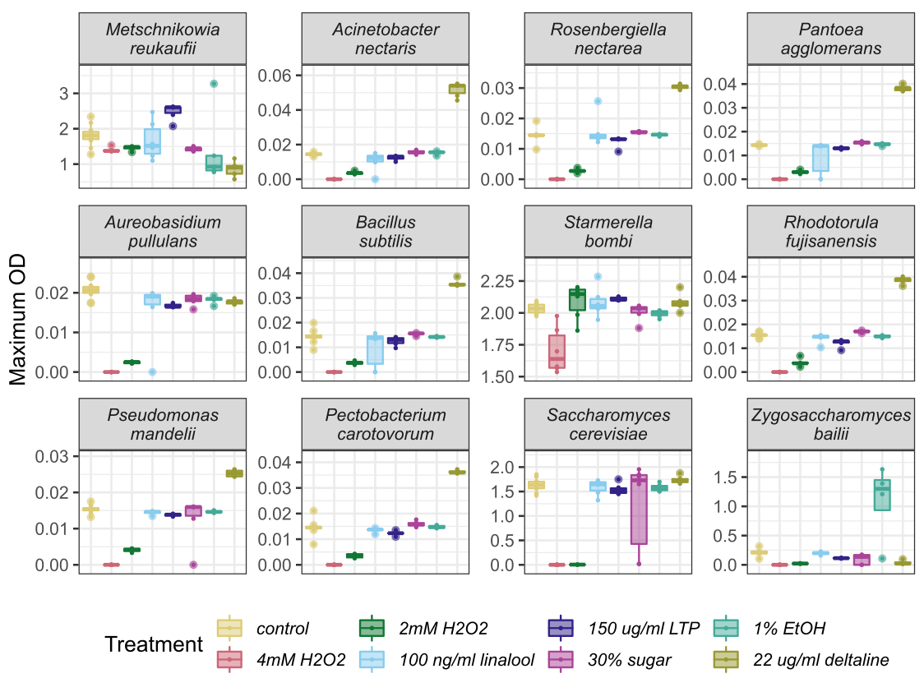

**Supplemental Figure 3.** Microbes differed in their maximum OD across different treatment nectars. Microbes are ordered from most frequently (top left) to least frequently isolated from nectar (bottom right)

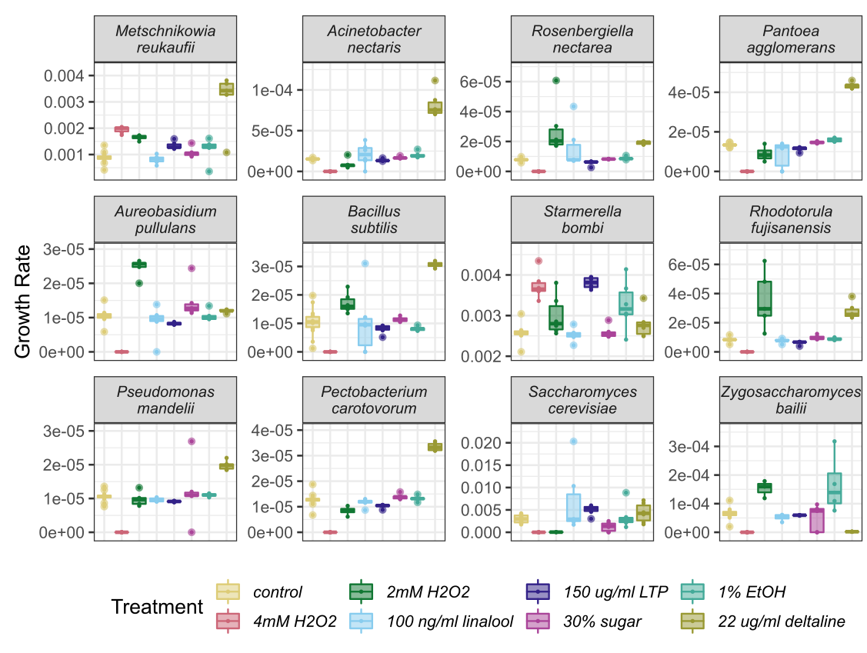

**Supplemental Figure 4.**  Microbes differed in their growth rate across different treatment nectars. Microbes are ordered from most frequently (top left) to least frequently isolated from nectar (bottom right)

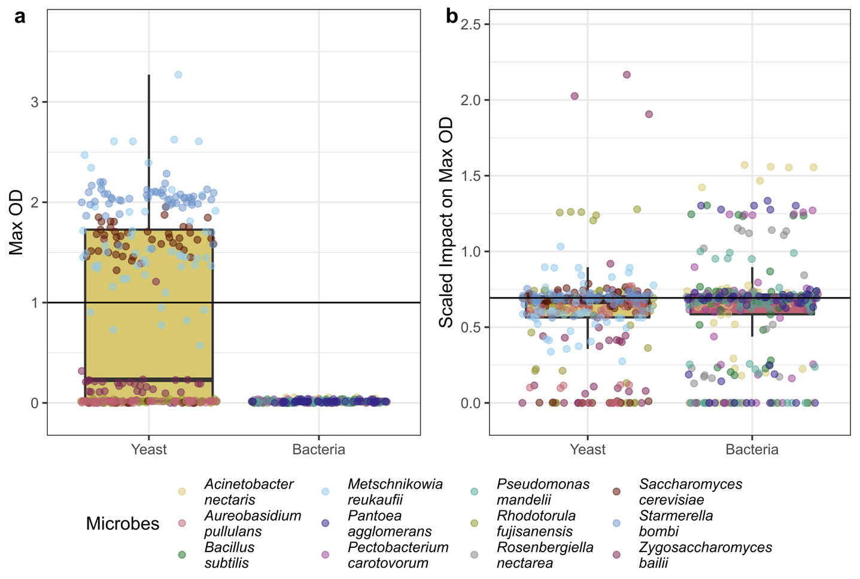

**Supplemental Figure 5.** Bacteria and Yeast differed overall in their maximum OD and in their susceptibility to treatments. The Y axis is the scaled impact of a treatment on maximum OD compared to controls.