IBM Data Science Capstone Project
Final Report

1. Introduction

1.1 Problem Description
For this project I have chosen to investigate the districts in Stuttgart to find out where there are good places to place an open air restaurant.

1.2 Background
A good place to place a open air restaurant (german Biergarten) might be a location with high throughput of people locals as well as tourists and might be marked as a place with several parks in urban area and som other outdoor takeaway stuff like cafes or icecream shops etc. An other option could be also that there are several metro stations nearby.

2. Data
1. Wikipedia for getting the Districts of Stuttgart
https://de.wikipedia.org/wiki/Liste_der_Stadtbezirke_und_Stadtteile_von_Stuttgart

2. Geocoder to get Locationdata of Districts

3. Foursquare API to get venues in that area
https://api.foursquare.com/v2/venues/explore

3. Methodology

3.1 Short description
Fetching the top venues per district and then clustering the distrincts by applying K-Means algorithm. Then interpret the clusters and draw a conclusion which cluster might fit best.

3.2 Analyis

Fetching Districts from Wikipedia
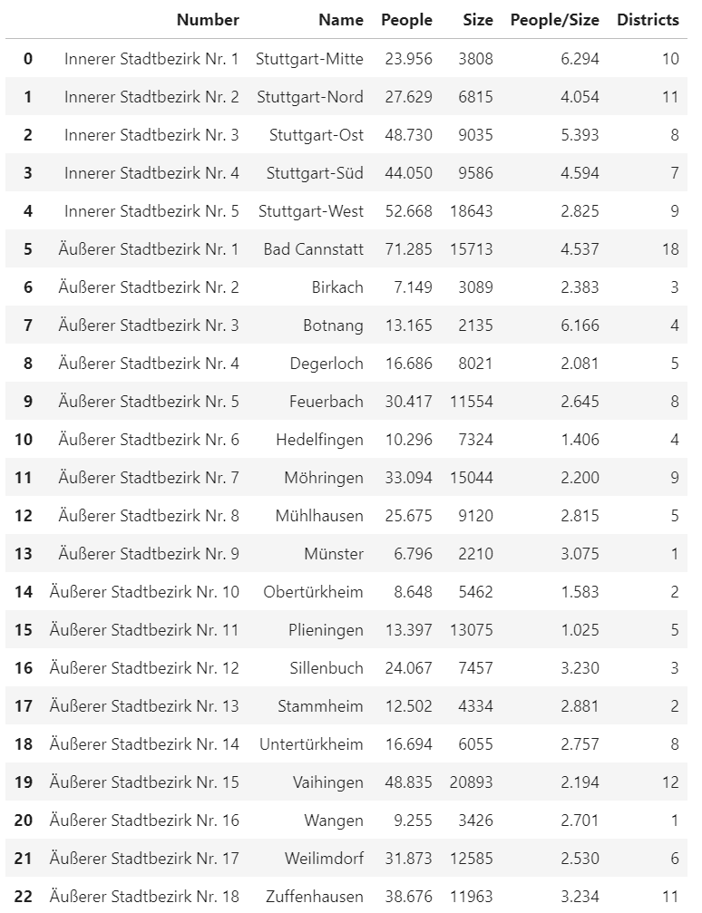
There are 5 inner districts and 18 outer districts next step is to enrich those data with the coordinates with Geocoder. At first try there have been some district mislocated because of name duplicates in Germany. Solution was to prepend the outer areas with „Stuttgart“ which led to the following Dataframe.
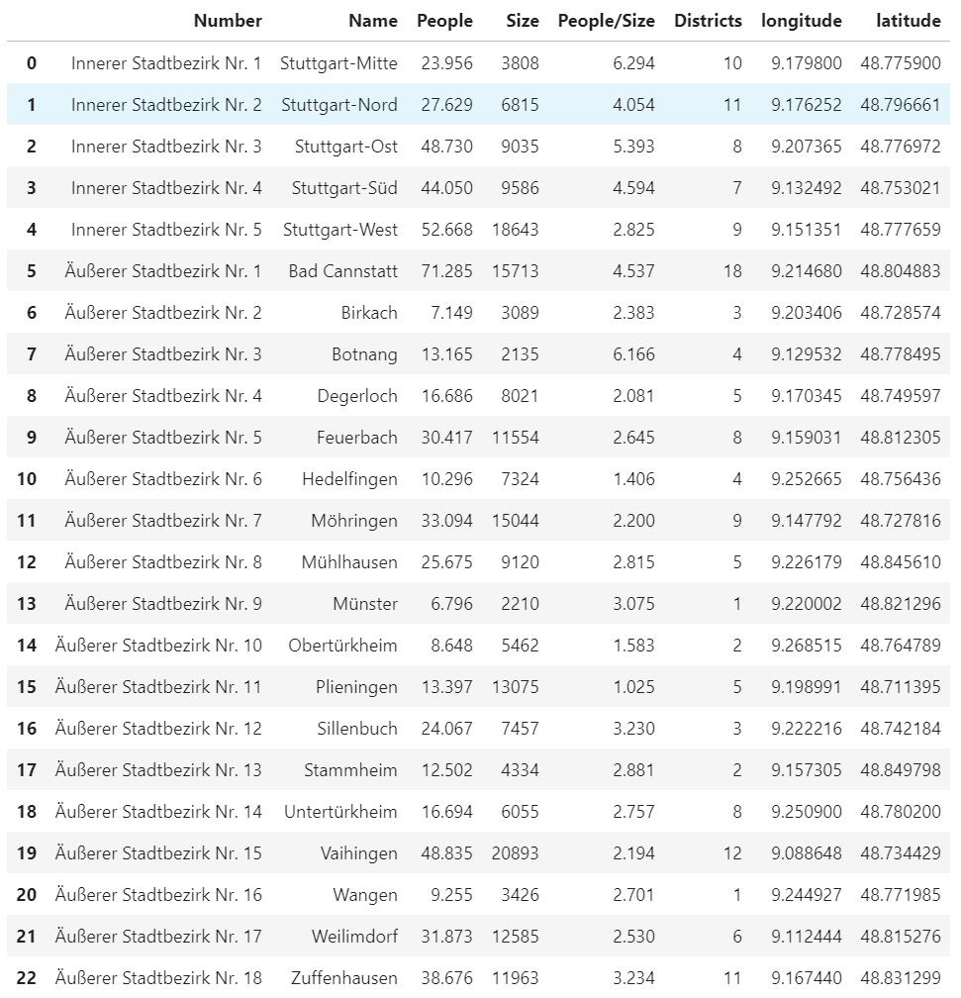
A first check on the map now shows the all districts in the Stuttgart area.

Visual Representation
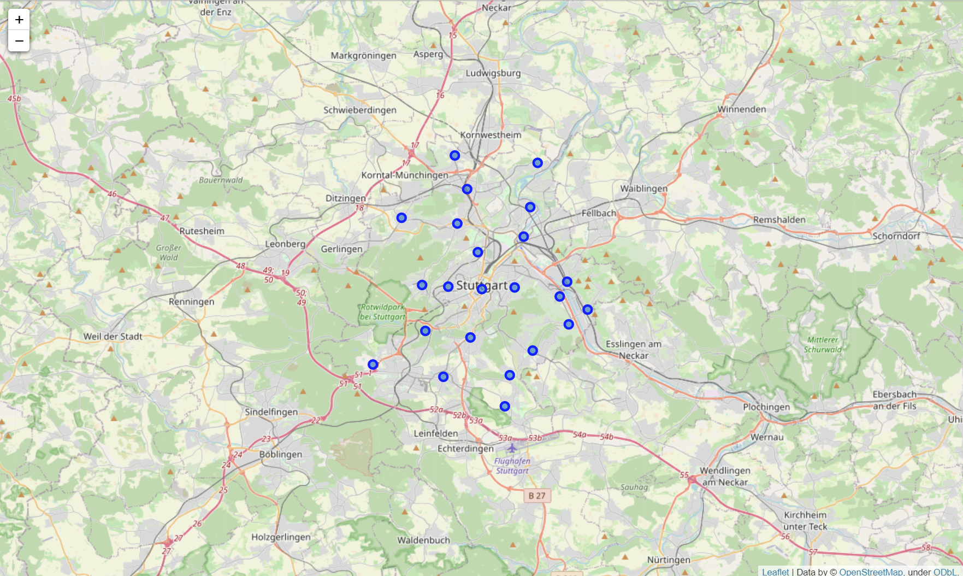

Fetching Venues
After that fetching of the venues with a radius of 3km is done from Foursquare API with a maximum of 100 Venues per district which results in the following number of venues
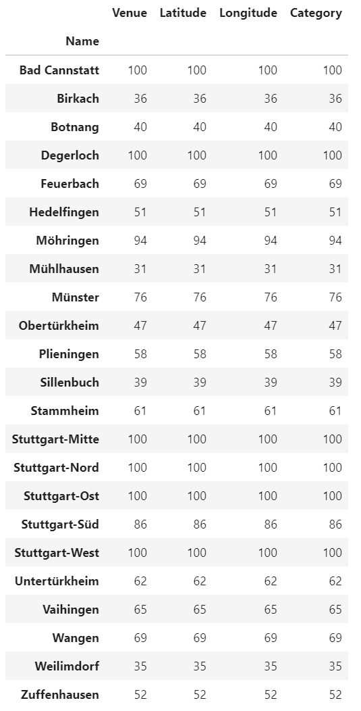

Calculating Most common Venues
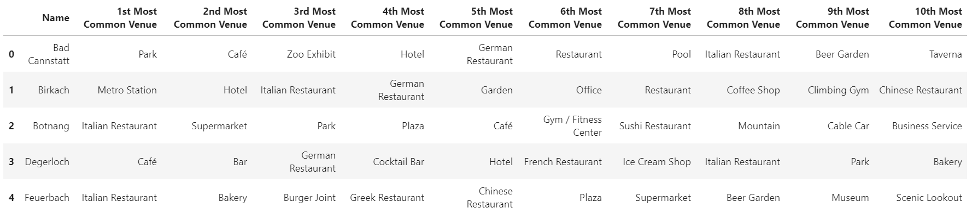

Calculating ideal number of Clusters
To Calculate the ideal number of clusters I use silhouette_score which results in ideal number of clusters as 7.

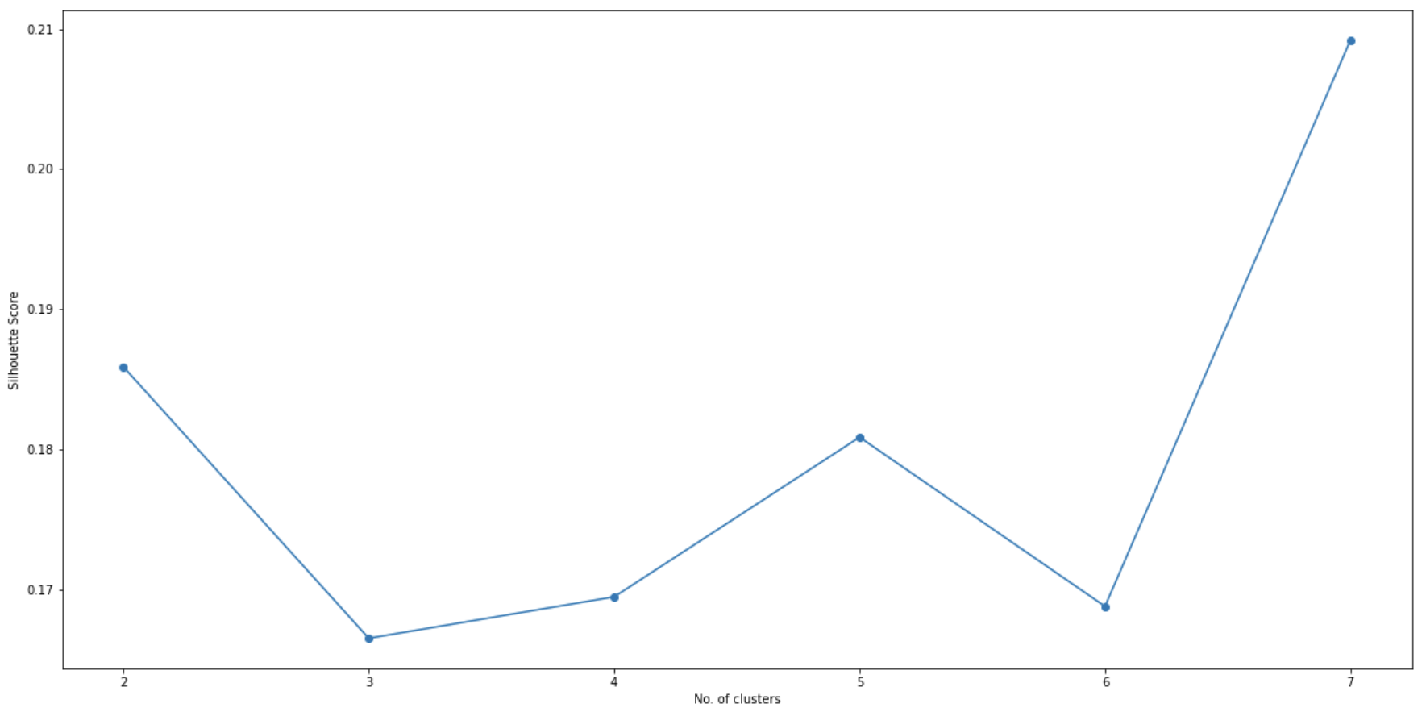
Applying K-Means
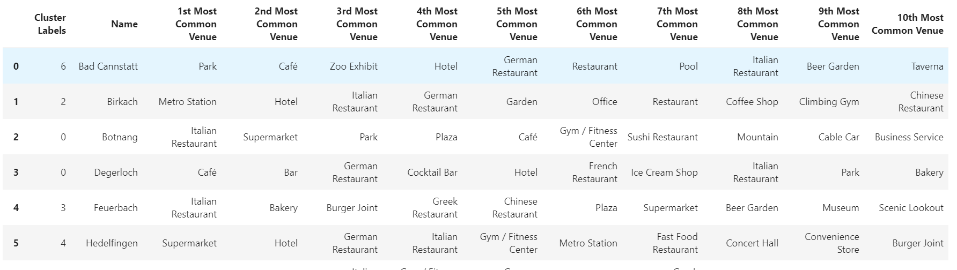

Visual Representation of Clusters

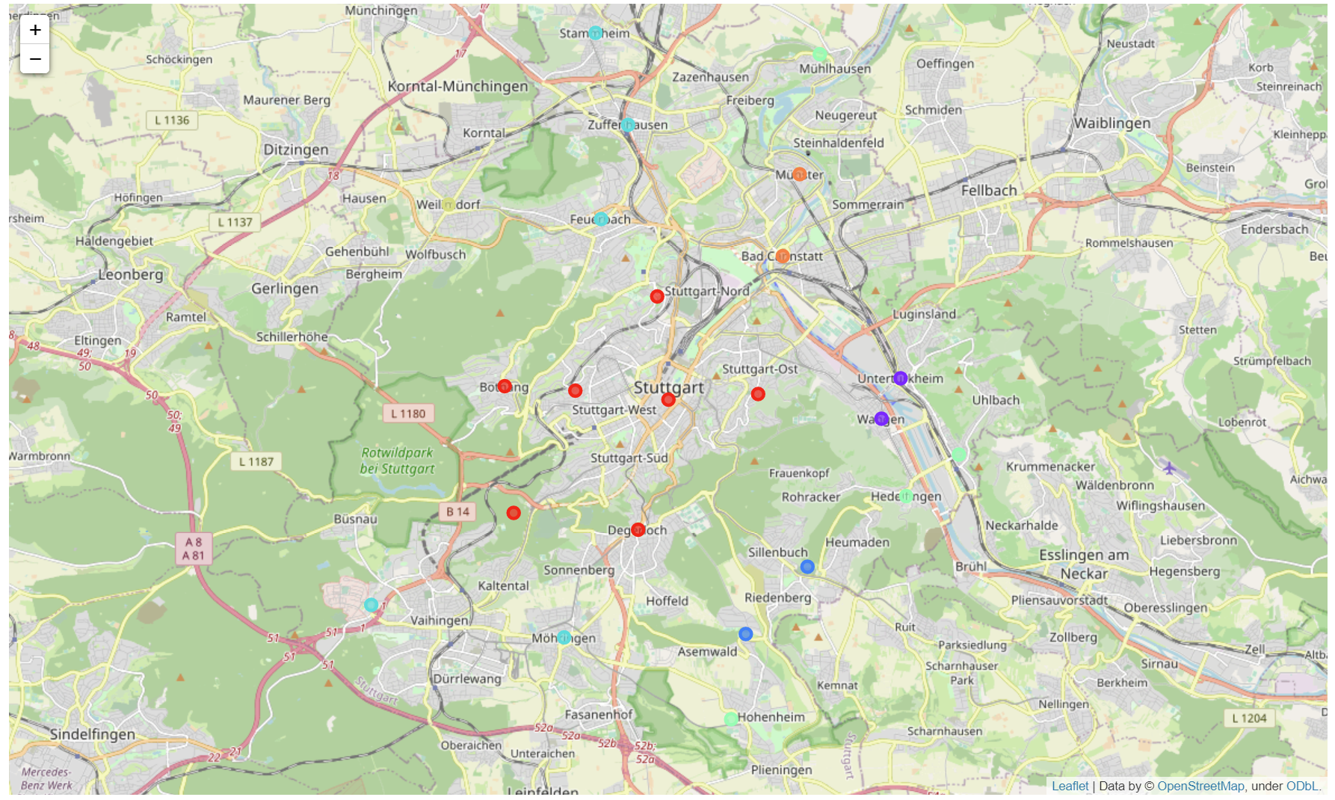
4. Results
Cluster 1
Cluster 1 represents mostly parks, cafes and other leisure time activities like ice-cream shops and bars this is typical urban area and an ideal location for a biergarten.
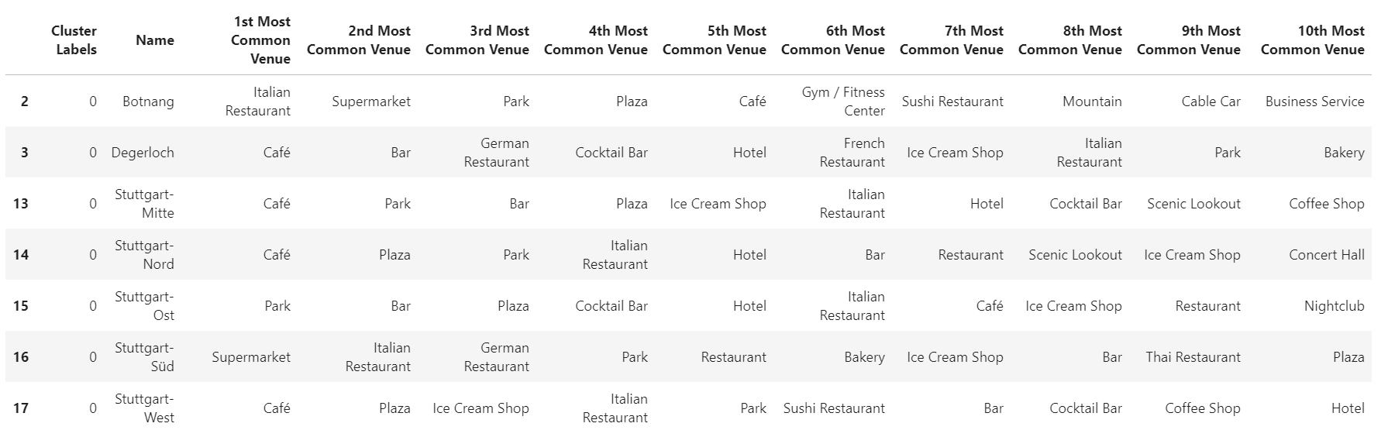
Cluster 2
Cluster 2 is some kind of suburban area with Hotels and Restaurants as well as Sports locations.
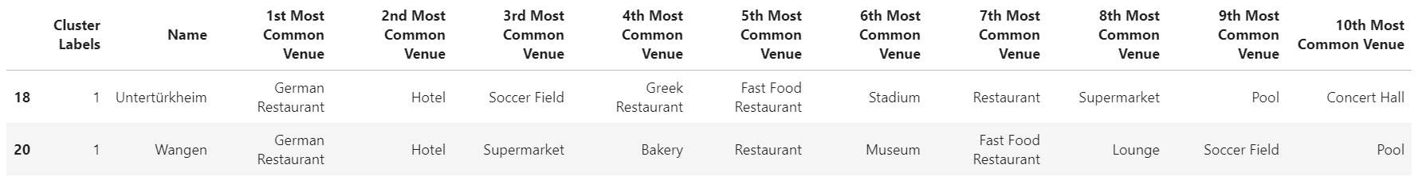
Cluster 3
Cluster 3 is also outside of the city with metro stations and hotels but with the offices etc more likely an area with many business people.

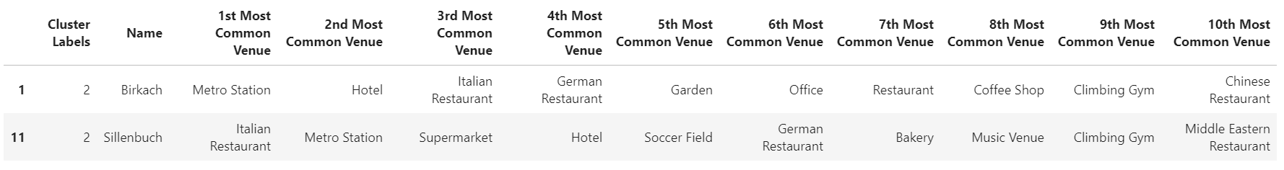
Cluster 4
Cluster 4 is also suburban area in which many people live indicated by supermarkets.
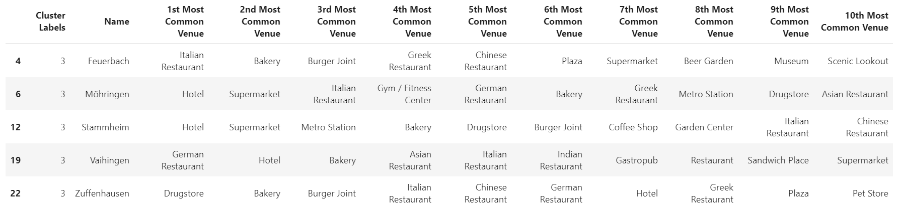
Cluster 5
Cluster 5 is also an area in which the people live but less tourists travel to thats an area mainly for locals also indicated by relativ common supermarkets
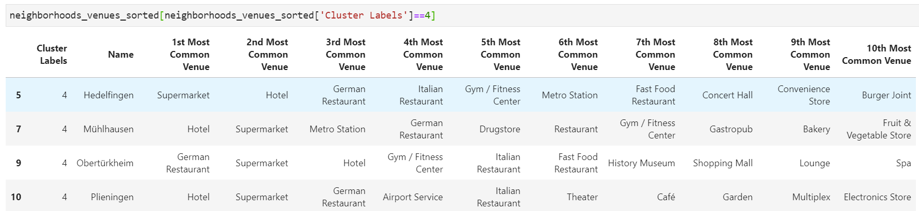
Cluster 6
Also a cluster for locals who travel to their workplaces with metro and shop in the supermarkets.
Cluster 7
This cluster is also for leisure time activities with Zoos, Parks etc.
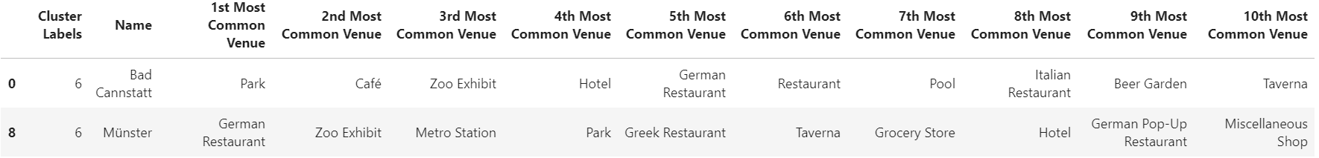

Discussion and Recommendation
Based on the clusters I would have two recommendations if it is mainly a beergarden for locals and families I would place it in cluster 7. If it is mainly a beergarden with focus on business people and tourists I would place it in cluster 1 because of the high throughput in city center and the parks. The zoos etc attract more the families with children.

References:
The Jupyter Notebook of the analysis can be found on Github.
https://github.com/tobiasgrott/Coursera_Applied_Data_Science_Capstone/blob/master/final_project/FinalProject.ipynb

