**“GetOutOfYourBubble.com” / “WhatDoOthersRead.Com”**

Problem: Increasingly sophisticated algorithms pre-select content online, making people more likely to encounter content that is similar to what they like and/or agree with (“filter bubbles”). Similarly, many people reading the news online follow only a small number of outlets often aligned with their political views, as following multiple publications can be time-consuming and inconvenient.

**Solution: I am developing a website that allows users conveniently compare coverage of major news outlets (for US, UK, Germany), classifying them on a political spectrum. Main functions:**

1. 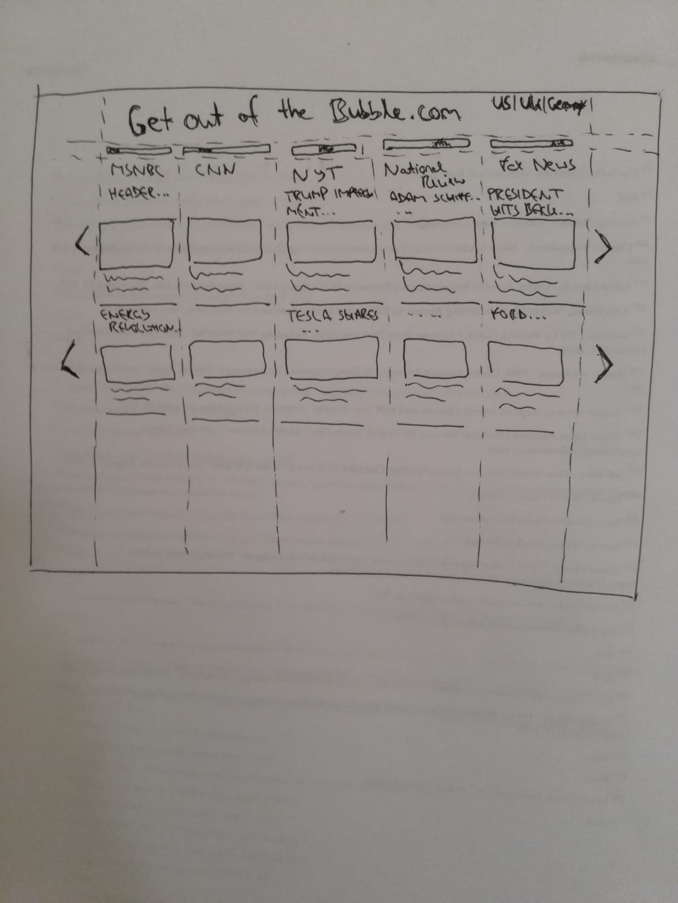Show snippet of headline article (or grouped by subject) of New York Times, FOX News, MSNBC, CNN, Politico, Washington Post, horizontally to next to each other, on a pre-defined scale from politically left to right leaning, allowing users to explore coverage of news media in a non-personalised way.
2. 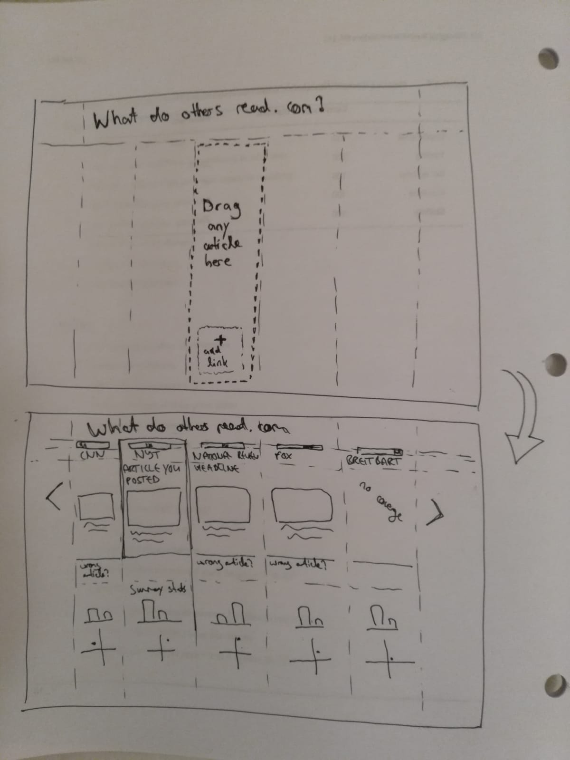Users can drop a link to any article and receive “matching” articles from outlets on a (pre-classified) political spectrum. A more advanced version could also provide simple text analysis in real-time (e.g. sentiment analysis, word counts etc.). This allows users to conventiently explore other views based on articles they enjoy.

Where I am at and what I need: I have developed a very simple prototype that displays headlines from publications in real-time (function 1 above), together with a simple machine learning algorithm that classifies articles to find the “matching” ones. I would love to get support from some students interested in CS (frontend) or NLP (backend) to help with implementation, as well as AWS + Heroku credits to test a live prototype with real users over the winter break.

Contact: [toh833@harvard.edu](mailto:toh833@harvard.edu)