Oxygen uptake rates in a typical gill-breather

2025-02-23

## Practical 1: Assessment

## BSX-2030 Integrated Zoology

## Student number: 500690571

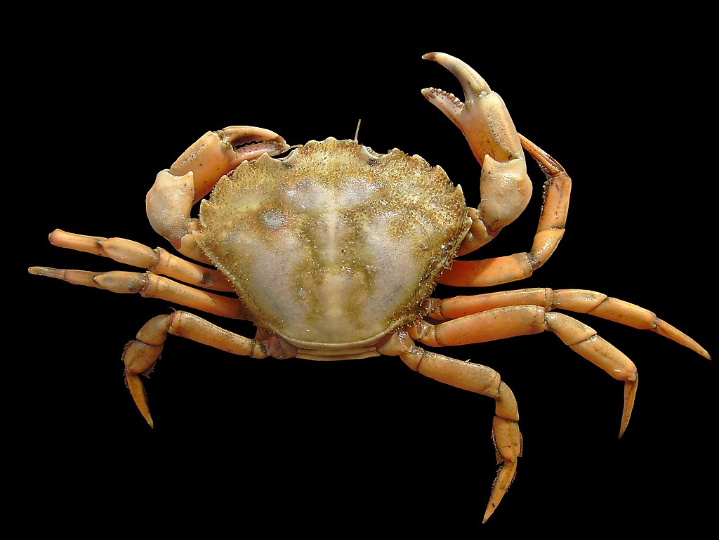

© Hans Hillewaert [CC BY-SA 4.0](https://creativecommons.org/licenses/by-sa/4.0/)

# Results

## Task 1

Task 1: Present the data in 4 tables i.e. Tables 6, 7, 8 and 9 from the practical handout. Each table needs a caption. Table titles go above the table

### Table 6 - calculation of Oxygen uptake for crabs in two aqueous conditions

|  | | **A** | **B** | **C** | **D** | **E** |
| --- | --- | --- | --- | --- | --- | --- |
| **Crab Name** | **Treatment** | **Difference in pO2 (mmHg)** | **Time between readings (min)** | **Difference in pO2 in water (mmHg)\*** | **Difference in pO2 accounting for volume (ml)†** | **Oxygen Uptake (ml-1 O2 h-1)‡** |
| A1 | Submerged | 13.3 | 19 | 5.15e-04 | 0.41 | 1.29 |
| A2 | Submerged | 14.3 | 19 | 5.53e-04 | 0.44 | 1.40 |
| A1 | Resubmerged | 15.2 | 15 | 5.88e-04 | 0.47 | 1.87 |
| A2 | Resubmerged | 7.8 | 15 | 3.02e-04 | 0.24 | 0.97 |
| Data collected on 2025-01-30 at Deiniol Road, Brambell Building, 1st Floor Lab B1 | | | | | | |
| *value from column A $×$ solubility coefficient (3.87 10-5) | | | | | | |
| †value from column C $×$ vol of water (ml) | | | | | | |
| ‡value from column D () (ml-1 O2 h-1) | | | | | | |

### Table 7 - Oxygen uptake rate accounting for weight and converting to mmol for shore crabs in two aqueous conditions

|  | | **A** | **B** | **C** |
| --- | --- | --- | --- | --- |
| **Crab Name** | **Treatment** | **Oxygen uptake rate (ml-1 O2 h-1)** | **Oxygen uptake rate per unit mass (ml O2 kg-1 h-1)\*** | **Standardised Oxygen uptake rate (mmol O2 kg-1 h-1)†** |
| A1 | Submerged | 1.29 | 48.02 | 2.14 |
| A2 | Submerged | 1.40 | 50.42 | 2.25 |
| A1 | Resubmerged | 1.87 | 69.51 | 3.10 |
| A2 | Resubmerged | 0.97 | 34.83 | 1.55 |
| Data collected on 2025-01-30 at Deiniol Road, Brambell Building, 1st Floor Lab B1 | | | | |
| *value from column A divided by body mass in kg | | | | |
| †value from column B divided by 22.414 (the conversion ratio between moles and litres). Conversion to mmol is in aid of comparing these values with those calculated in air (Table 8) | | | | |

### Table 8 - Calculating Oxygen uptake for shore crabs exposed to air

|  | | **A** | **B** | **C** | **D** | **E** |
| --- | --- | --- | --- | --- | --- | --- |
| **Crab Name** | **Treatment** | **Universal gas constant $×$ assumed temperature ($RT$)\*** | **Difference in pO2 (mmHg)** | **Difference in pO2 (mmol O2)‡** | **Difference per unit mass (mmol O2 kg-1)§** | **Oxygen uptake rate (mmol O2 kg-1 h-1)¶** |
| A1 | Aerial Exposure | 17,969 | -0.9† | -3.98e-05 | -1.48e-03 | -1.46e-03 |
| A2 | Aerial Exposure | 17,969 | 1.0 | 4.45e-05 | 1.61e-03 | 1.58e-03 |
| Data collected on 2025-01-30 at Deiniol Road, Brambell Building, 1st Floor Lab B1 | | | | | | |
| *The universal gas constant is 62.36, the experiment assumes a temperature of 15°C (which is 288.15°K) | | | | | | |
| †The container of crab A1 was found to have increased in partial pressure of Oxygen between readings, which would theoretically mean the crab lost oxygen, it is more likely this is an anomaly. | | | | | | |
| ‡ $\frac{B}{A}×$ volume of air in litres (mmol O2). This reflects the equation for the ideal gas law, rearranged to find $n$ (to find the quantity of moles of oxygen), $\frac{P}{RT}×V=n$ | | | | | | |
| §The oxygen difference in millimoles divided by the mass, in kg, for each crab (0.795 for A1 and 0.800 for A2). It should be noted that this step is not in the handout, but I felt it pertinent to include as the values of Oxygen uptake rate for the aqueous samples are in (mmol O2 kg-1 h-1) | | | | | | |
| ¶The value in column D (mmol O2 kg-1 h-1). Time interval recorded for both as 61 minutes | | | | | | |

### Table 9 - Rates of oxygen uptake expressed as mmol O2 kg-1 h-1 in crabs submerged in seawater, exposed to roughly one hour aerial exposure and then resubmerged

|  | **Change in Oxygen uptake rate (Δ mmol O2 kg-1 h-1)** | | |
| --- | --- | --- | --- |
| **Crab Name** | **Submerged** | **Aerial Exposure** | **Resubmerged** |
| A1 | 2.14 | -1.46e-03 | 3.10 |
| A2 | 2.25 | 1.58e-03 | 1.55 |
| Data collected on 2025-01-30 at Deiniol Road, Brambell Building, 1st Floor Lab B1 | | | |

## Task 2

### Table 10 - rates of Oxygen uptake (mmolO2 kg-1 h-1) with percentage changes compared to initial “submerged” reading.

|  | Submerged | Aerial Exposure | | Resubmerged | |
| --- | --- | --- | --- | --- | --- |
| Crab Name | Oxygen Uptake | Oxygen Uptake | % change | Oxygen Uptake | % change |
| A1 | 2.14 | -1.46e-03 | -100.1% ▼ | 3.10 | +44.9% ▲ |
| A2 | 2.25 | 1.58e-03 | -99.9% ▼ | 1.55 | -31.1% ▼ |
| Data collected on 2025-01-30 at Deiniol Road, Brambell Building, 1st Floor Lab B1. Change in Oxygen uptake rate is shown as Δ mmol O2 kg-1 h-1 | | | | | |

Upon initial submersion of the crabs in seawater for 19 minutes, crab A1 experienced an Oxygen uptake of 2.14 mmol O2 kg-1 h-1 and crab A2 experienced an Oxygen uptake of 2.25 mmol O2 kg-1 h-1, these values are considered baselines to compare the other readings with. A2 was heavier, with a weight of 0.0277 kg compared with crab A1’s weight of 0.0269 kg, it should also be noted the volume of the tank for A1 was smaller by 5 ml at 795ml compared with 800ml for A2. Upon aerial exposure, crab A1 was found to have an Oxygen uptake rate of -1.46e-03 mmol O2 kg-1 h-1, this is because an increase of PO2 was measured in the tank for A1, the PO2 for the tank of A2 was found to decrease, leading to an oxygen uptake rate being measured as 1.58e-03 mmol O2 kg-1 h-1, both recordings were calculated over 61 minutes, as shown in Table 8. As shown in Table 10, these values are 100.1% and 99.9% decreases respectively. Compared with initial submersion, crab A1 was found to have in increased rate at 3.10 mmol O2 kg-1 h-1, a 44.9% increase, however, A2 was found to have a rate of 1.55 mmol O2 kg-1 h-1, a 31.1% decrease.

## Task 3

# Discussion

A previous study found a decrease from control to aerial emersion of 50% in the Oxygen uptake rate(Simonik and Henry, 2014). This contrasts to the current study, where a decrease of over 99% was found. Both prove that the Shore Crab (*Carcinus maenas*) is capable of oxygen uptake in an aerated environment, however the capacity to do so were distinct between the studies. The methods followed were similar but distinct, *Carcinus maenas* was used for both, however the previous study used much larger timescales for study, keeping the crabs in air for 6 hours, opposed to just over 1 in this experiment, it is possible it takes time for the crabs to truly adjust to an aerated environment(Simonik and Henry, 2014). Fewer metrics were measured in the current experiment. Another study found that shore crabs can respire anaerobically in hypoxic conditions, it is possible this could account for the distinct drop (Hill et al., 1991). Finally, it is possible these values are anomalous, as it should not be possible for one value to increase. Shore crabs have been found to be very plastic, able to withstand changing environmental conditions. For example, pollution, fluctuations in temperature and aerial exposure, and this has helped it find success in it’s environment (McGaw and Whiteley, 2024). In light of this, it is improbable that the results seen in this study differ from the past evidence because the crabs selected were not able to adjust to the adverse conditions.

Another possible explanation is that the crabs experienced stress from the experiment. Allowing for settling time between tests was not conducted in this study, a limitation due to time. A recent study on *Carcinus maenas* found that stress due to handling can cause Oxygen uptake to stay elevated for over 10 hours, especially so with physical touch. This explains why the Oxygen uptake rate for crab A1 was found to be 45% elevated from control after the emersion (Wilson et al., 2021). The gills of *Carcinus maenas* are not typical of water-breathing animals, they were found to have a layer of chitin surrounding their gill filaments. This was believed to help with support in the air, at the cost of less efficient oxygen exchange with water. However, in spite of the gills not collapsing in air their ability to diffuse oxygen is not efficient, a decrease of 75% PaO2 was measured during emersion, with a value of 19 mmHg (Taylor and Butler, n.d.).

In conclusion, *Carcinus maenas* have a strong ability to respire in air, albeit worse than in water, and can survive anoxic aqueous environments this way. This is important to understand because of the species status as invasive in the southern hemisphere, namely Argentina. They might be able to out-compete native species, especially considering climate change (Vera-Escalona et al., 2023). An understanding of the processes of respiration can help with conservation efforts and understanding how the species will react to changing oceanic conditions. The ability this species has to adapt to different environments, outcompeting native species, makes the mechanisms of the way in which it does this interesting for study. It is known that as the temperature of water increases, the Oxygen content decreases, this species has an advantage that other more typical gill breathers will not have to these changing conditions, by having the ability to spend prolonged periods of time in possibly anoxic environments. The gills of other species rely on the density and viscosity of water to exchange Oxygen (O’mahoney and Full, 1984).

(word count: 584)

## Task 4

# Bibliography

Hill, A.D., Taylor, A.C. and Strang, R.H.C. 1991. [Physiological and metabolic responses of the shore crab *Carcinus maenas* (l.) during environmental anoxia and subsequent recovery](https://doi.org/10.1016/0022-0981(91)90104-5). *Journal of Experimental Marine Biology and Ecology*. **150**(1), pp.31–50.

McGaw, I.J. and Whiteley, N.M. 2024. Chapter 2 - respiratory and cardiovascular system *In*: D. Weihrauch and I. J. McGaw, eds. Academic Press, pp.21–45. Available from: <https://www.sciencedirect.com/science/article/pii/B9780323996945000131>.

O’mahoney, P.M. and Full, R.J. 1984. [Respiration of crabs in air and water](https://doi.org/10.1016/0300-9629(84)90429-8). *Comparative Biochemistry and Physiology Part A: Physiology*. **79**(2), pp.275–282.

Simonik, E. and Henry, R.P. 2014. [Physiological responses to emersion in the intertidal green crab, carcinus maenas (l.)](https://doi.org/10.1080/10236244.2014.905001). *Marine and Freshwater Behaviour and Physiology*. **47**(2), pp.101–115.

Taylor, E.W. and Butler, P.J. n.d. Aquatic and Aerial Respiration in the Shore Crab, Carcinus maenas (L.), Acclimated to 15  .

Vera-Escalona, I., Gimenez, L.H. and Brante, A. 2023. [Short-Term and Long-Term Predictions: Is the Green Crab Carcinus maenas a Threat to Antarctica and Southern South America under a Climate-Change Scenario?](https://doi.org/10.3390/d15050632) *Diversity*. **15**(5), p.632.

Wilson, C.H., Nancollas, S.J., Rivers, M.L., Spicer, J.I. and McGaw, I.J. 2021. [Effects of handling during experimental procedures on stress indices in the green shore crab, carcinus maenas (l)](https://doi.org/10.1080/10236244.2021.1923369). *Marine and Freshwater Behaviour and Physiology*. **54**(2), pp.65–86.