Oxygen uptake rates in a typical gill-breather

2025-02-14

## Practical 1: Assessment

## BSX-2030 Integrated Zoology

## Student number: 500690571

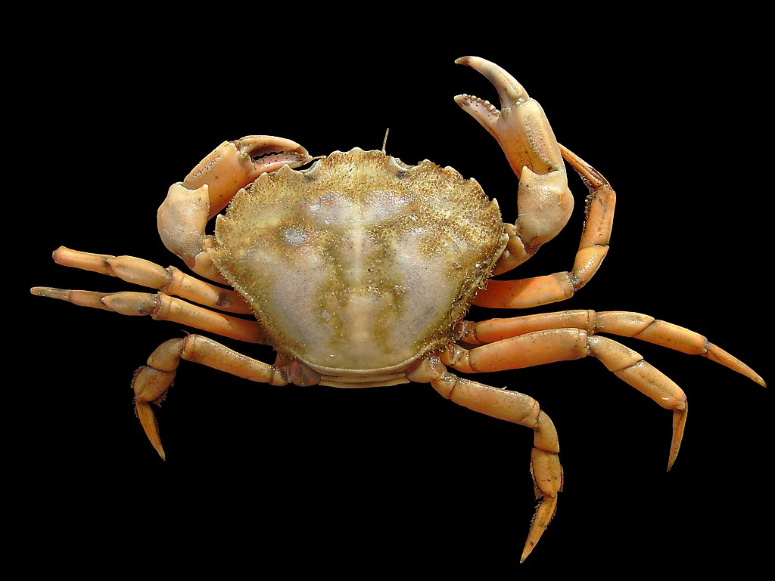

© Hans Hillewaert [CC BY-SA 4.0](https://creativecommons.org/licenses/by-sa/4.0/)

## Task 1

Task 1: Present the data in 4 tables i.e. Tables 6, 7, 8 and 9 from the practical handout. Each table needs a caption. Table titles go above the table

### Table 6 - calculation of Oxygen uptake for crabs in two aqueous conditions

|  | | **A** | **B** | **C** | **D** | **E** |
| --- | --- | --- | --- | --- | --- | --- |
| **Crab Name** | **Treatment** | **Difference in pO2 (mmHg)** | **Time between readings (min)** | **Difference in pO2 in water (mmHg)\*** | **Difference in pO2 accounting for volume (ml)†** | **Oxygen Uptake (ml-1 O2 h-1)‡** |
| A1 | Submerged | 13.3 | 19 | 5.15e-04 | 0.41 | 1.29 |
| A2 | Submerged | 14.3 | 19 | 5.53e-04 | 0.44 | 1.40 |
| A1 | Resubmerged | 15.2 | 15 | 5.88e-04 | 0.47 | 1.87 |
| A2 | Resubmerged | 7.8 | 15 | 3.02e-04 | 0.24 | 0.97 |
| Data collected on 2025-01-30 at Deiniol Road, Brambell Building, 1st Floor Lab B1 | | | | | | |
| *value from column A solubility coefficient (3.87 10-5) | | | | | | |
| †value from column C vol of water (ml) | | | | | | |
| ‡value from column D () (ml-1 O2 h-1) | | | | | | |

### Table 7 - Oxygen uptake rate accounting for weight and converting to mmol for shore crabs in two aqueous conditions

|  | | **A** | **B** | **C** |
| --- | --- | --- | --- | --- |
| **Crab Name** | **Treatment** | **Oxygen uptake rate (ml-1 O2 h-1)** | **Oxygen uptake rate per unit mass (ml O2 kg-1 h-1)\*** | **Standardised Oxygen uptake rate (mmol O2 kg-1 h-1)†** |
| A1 | Submerged | 1.29 | 48.02 | 2.14 |
| A2 | Submerged | 1.40 | 50.42 | 2.25 |
| A1 | Resubmerged | 1.87 | 69.51 | 3.10 |
| A2 | Resubmerged | 0.97 | 34.83 | 1.55 |
| Data collected on 2025-01-30 at Deiniol Road, Brambell Building, 1st Floor Lab B1 | | | | |
| *value from column A divided by body mass in kg | | | | |
| †value from column B divided by 22.414 (the conversion ratio between moles and litres). Conversion to mmol is in aid of comparing these values with those calculated in air (Table 8) | | | | |

### Table 8 - Calculating Oxygen uptake for shore crabs exposed to air

|  | | **A** | **B** | **C** | **D** |
| --- | --- | --- | --- | --- | --- |
| **Crab Name** | **Treatment** | **Universal gas constantassumed temperature ()\*** | **Difference in pO2 (mmHg)** | **Volume of oxygen in moles‡** | **C x (*mmol O*2 h-1)** |
| A1 | Aerial Exposure | 17,969 | -0.9† | -5.01e-05 | -4.93e-05 |
| A2 | Aerial Exposure | 17,969 | 1.0 | 5.57e-05 | 5.47e-05 |
| Crabs in air | | | | | |
| *The universal gas constant is 62.36, the experiment assumes a temperature of 15°C (which is 288.15°K) | | | | | |
| †The container of crab A1 was found to have increased in partial pressure of Oxygen between readings, which would theoretically mean the crab lost oxygen, it is more likely this is an anomaly. | | | | | |
| ‡ volume of air in litres (mmol O2). This reflects the equation for the ideal gas law, rearranged to find (to find the quantity of moles of oxygen), | | | | | |