BSX-2030 Endocrine Crab Practical TN

Tobias Nunn

2025-04-03

# Introduction

bazinga

banana

coconut

# Methods

blabablalbalbla

mike nuts

ligma

# Results

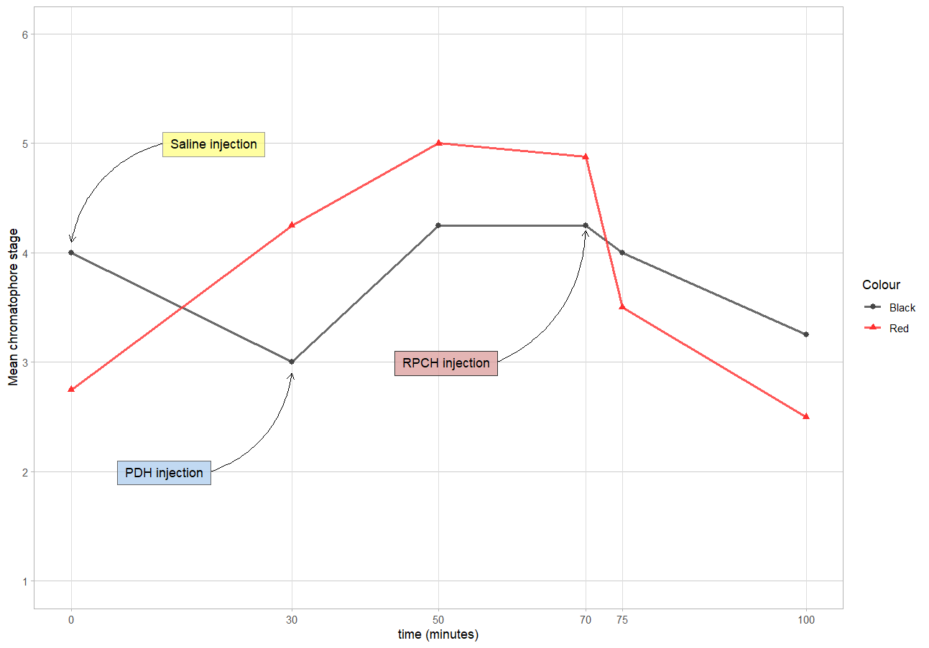

figure 1 - graph of mean … no significant changes… group sizes 4…

|  | **P values for start time - end time (mins from primary injection)\*** | | | | |
| --- | --- | --- | --- | --- | --- |
| **Pigment** | **0 - 30** | **30 - 50** | **50 - 70** | **70 - 75** | **75 - 100** |
| Red | 0.109 | 0.317 | 0.317 | 0.285 | 0.180 |
| Black | 0.102 | 0.059 | 1.000 | 0.317 | 0.317 |
| Data collected on 2025-03-10 at Deiniol Road, Brambell Building, 1st Floor Lab B1 | | | | | |
| *P values taken between pairs of times when measurements were taken for a Wilcoxon Paired Rank Test | | | | | |

New names:  
New names:  
• `` -> `...8`

`summarise()` has grouped output by 'cycle'. You can override using the  
`.groups` argument.

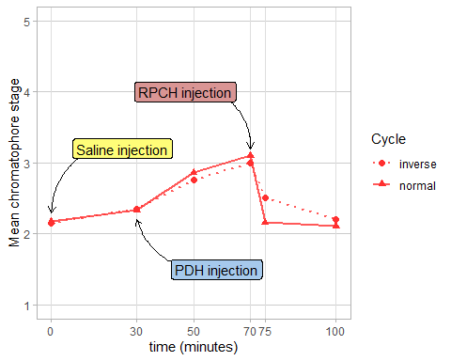

`summarise()` has grouped output by 'pigment'. You can override using the  
`.groups` argument.

