ENS-2002 Research Experience Portfolio
Tobias Nunn
2025-04-22
Table of contents

1. Introduction
look for £bookmark for places to revisit
The field of microbial genomics has seen much study over the last decade, with hundreds of papers being made on a wide range of methods and hypotheses. However, there is always more that can be inferred due to the seemingly limitless quantities of bacteria and the environments they inhabit, and thus the relationships that form over time. It is a field with a lot of potential for practical applications. For example, an understanding of gut microbiomes could have implications for Crohn’s disease (vandeputte2017?).
This project is a research study into the bacteria comprising host-associated microbiomes, using genetics as the tool of study. Specifically, bottom-up estimates of function based on gene content. This is a resource efficient way to study these environments through the link between gene coding and protein function. The main source of analysis was the NCBI genomic database. however,
There are similarities between closely related taxa of bacteria, and as such many of the protein groups coded for are similar between them. These form the bases for the relationships with hosts, as a microbiome could be mutualistic, providing a benefit, as seen by …
A future avenue of research will be to make comparisons based on host taxa.
Many secondary analyses were performed with the purpose of training to understand and handle different computational tools and programs. These largely involved data exploration and gaining an understanding of output files. The majority of the research concerned the use of publicly available data from the NCBI website, which could be downloaded and aid analysis. Exploration of data was a large part of this project. There is a massive wealth of information on databases such as the NCBI, which holds 2.61 million bacterial genomes that can be annotated.
There are many functions genes can express, and it is of particular interest how evolutionary history can shape gene expression, as well as how host organism may shape communities, as co-evolution has occured between bacteria and host. £bookmark find a reference
Microbiomes and their hosts are closely linked and an understanding of their relationships can have implications for alleviating the effects of climate change (petrushin2024?).
Whilst not the focus of work, this project relates closely to work done on poison dart frogs, with a specific focus on how bacterial skin microbiomes can interact with DB, the chytridiomycosis causing fungus. This builds on several previous studies, such as (jiménez2017?), which found differences in Microbiome can change susceptibility to infection. This involved the use of many online tools, such as EggNOG-mapper, (huerta-cepas2017?). An emphasis is put on how host can shape these microbiomes, building on research by (lunjani2021?).
These samples acted as the basis of study, with many tools being used to explore qualities of the samples. This is ideal as these samples are of a known source. This study will aim to investigate some of these relationships through bottom-up estimates of function based on gene content, using publically available data, and present these in the context of how they might have a beneficial impact on potential host organisms. This work may be cause for future research to be done in the area.
£bookmark this is heavy self-plagarism, change things around, but i like the message
(500 words, 5-10 refs)
This is a flow chart showing the different processes I used.

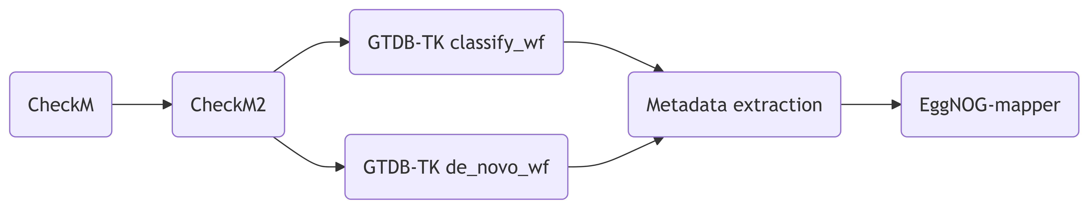

2. Overview
This work started in the summer, when I had done nothing of the type before, so I had basically no idea what I was doing or what I was messing with. So I made mistakes, many mistakes. Then, I kept going, building on those mistakes until around christmas I realised I was completely out of my depth and I needed to reivaluate. My notetaking especially was crude by modern comparison. So I decided to do a reset, I believed this was important as it allowed me to start again from a more informed point, and “do things right this time”. However, I did conduct analysis in the first half of the year that could be relevent, error prone as it may be. And I do not want my mistakes to be buried, they must be remembered so I do not repeat them, or so anyone else reading this does not repeat them. So I would like to dedicate section 2.0. to the mistakes I made and how I learned from them to gain skills and become a better data scientist, as I believe this step was the catalyst for all hereafter steps to be as good as they were, without these errors, I doubt I would have worked as hard to make the work I did after as good, and thats alright.
here::here for good pathing
proper integration of images into the notebooks
(i understand if you need to dock points for this, but I think it is too important to not write down)

3. Summer Work

3.1 Introduction
This project technically started in the summer of 2024, between July and August. I was tasked with basically making basic explorations of 10 bacterial genome samples made by Bangor Researchers in labs at ECW, as I was still in my first year and did not have much experience, I made mistakes. I also did not recognise the importance of notekeeping at that point, so a record of that work does not exist.

3.2 Methods
The summer work was more of a learning exercise than anything, just for me to familiarise myself with R scripting and bash and hawk so I would have a basis when properly beginning the project

4. CheckM

4.1 Introduction
£bookmark add citation: https://pmc.ncbi.nlm.nih.gov/articles/PMC4484387/
After my reset at christmas, I wanted to fully explore and understand what this tool does and outputs. I looked at files and documentation so that I could better understand what the results meant for the samples. This lead to many, smaller analyses conducted. All of these processes are noted throughout Notebook 1. These included comparisons between CheckM and CheckM2, these are not included here, this is just a list of the CheckM processes run.

4.2 Check M lineage_wf

4.2.1 Introduction
A smaller analysis done towards the beginning of the project. CheckM analyses were done on the local Bangor samples largely for the purposes of data exploration and practice, with a side aim of comparing and contrasting with CheckM2, as from what I had read CheckM2 was not a direct predecessor to Check M. This was used to describe the samples in terms of metrics of quality.

4.2.2 Methods
Using this script I ran a slurm job on hawk under the lineage_wf (workflow) of CheckM for all 10 Bangor-made samples. I also worked on exporting the data I want to tabulate off of hawk. This was done by identifying different documents in the flye directories on hawk, specifically files called “assembly_info.txt” which contain the same information, but are vastly more exportable. To access them one should enter this on the command line:
cd /scratch/scw2160/02_outputs/flye_asm/flye_asm_[accession]/
Using this script I exported them off of hawk, to my local machine.
Using the CheckM documentation. I found the output that i needed was bin_stats_ext.tsv. This is where the contamination and other assorted fields are presented. Thus, i can import this file to R to visualise. I then developed and improved the script CheckMtablegenerator.R. Which creates Table 4.1. This used a few packages, including one for tabulation, gt. This is a very useful package for table generation, here is some info.

4.2.3 Results
The CheckM analysis produced this output directory. My export script exported all 10 “assembly_info.txt” files to a directory in my home directory, as well as adding their accession ID to the name, this is important as otherwise I would not know which file belonged to each accession. I then brought them down and stored them here.
Table 4.1: Subset of data obtained from CheckM analysis of samples taken from the skin microbiome of Dendrobates tinctorius, including metrics of quality.
Accession | Marker lineage | Completeness | Contamination | GC | GC std | Genome size | contigs | Longest contig | Coding density | Predicted genes
1Dt1h | o__Actinomycetales | 100.00 | 0.00 | 65.519% | 4.284% | 4,336,578 | 4 | 2,051,556 | 90.334% | 3,818
1Dt2d | f__Enterobacteriaceae | 100.00 | 0.90 | 53.889% | 1.270% | 5,345,294 | 6 | 2,288,975 | 87.931% | 4,937
1Dt100h | o__Actinomycetales | 98.84 | 0.19 | 52.446% | 0.564% | 2,379,473 | 2 | 2,349,045 | 89.586% | 2,071
2Dt1l | o__Actinomycetales | 98.82 | 2.32 | 67.742% | 0.844% | 3,996,506 | 16 | 1,089,026 | 93.707% | 3,915
3Dt1c | o__Sphingomonadales | 97.23 | 1.19 | 66.487% | 1.385% | 3,636,266 | 86 | 275,317 | 90.660% | 3,433
3Dt2j | o__Sphingomonadales | 96.19 | 1.21 | 65.644% | 1.752% | 2,813,977 | 75 | 195,248 | 92.779% | 2,786
3Dt2c | o__Sphingomonadales | 95.75 | 0.85 | 66.093% | 1.604% | 3,819,610 | 84 | 247,364 | 89.769% | 3,516
3Dt2h | o__Actinomycetales | 87.98 | 0.51 | 70.327% | 1.317% | 3,006,227 | 166 | 125,244 | 90.324% | 2,978
1Dt100g | o__Sphingomonadales | 76.77 | 0.00 | 68.105% | 1.332% | 2,104,071 | 153 | 74,994 | 92.645% | 2,179
2Dt1e | o__Actinomycetales | 44.74 | 0.00 | 71.162% | 1.565% | 2,332,403 | 149 | 70,689 | 89.402% | 2,215
Source: CheckM lineage_wf performed on 2024-12-25
Table 4.1 shows that CheckM could not identify lineage to genus for any sample, and only found the family in one case. 7 of the 10 samples scored above 95% for completeness, with the lowest, 2Dt1e, being under 45%, I did not know what counted as “significantly complete”, so arbitrarily placed the value at 90%. There does not appear to be a correlation between completeness and contamination. Contamination is fairly low in all, none above 3% and 3 samples on 0.00%. There is a general inverse relationship between completeness and number of contigs.
As mentioned, Table 4.1 is a subset of the data, there was more outputted by CheckM, some of which overlaps with other analyses, but i did not know if it was relevent to include, so left it out, however, creating a new one with the omitted fields in would not be hard. This table will pair with one produced from CheckM2, because from what i’ve seen one is kind of an improvement on the other, but they kind of do different things, its confusing and thus why i want to do the comparison for future reference.

4.2.4 Conclusion
The main purpose of doing this is to compare with Checkm2, so im not sure what conclusions i can get from just this, other than many of the samples look sufficiently complete and i learned a fair amount from this experience. I think this will act as a good first step to compare future analysis against, for confirmation, as many upcoming analyses will give repeat data in some areas. Some of the field, for example “GC” are odd and i dont quite understand their significance, perhaps Aaron can give more info when he gets to this part of the notebook.

4.2.5 Scripts
- checkmtest.sh
- assemblytabledatagetter.sh
- CheckMtablegenerator.R

4.3 CheckM tree_qa

4.3.1 Introduction
In the CheckM documentation for lineage_wf, there are 6 functions, 5 are categorised as M (Mandetory), however a 6th “checkm tree_qa” is marked as “R” and is stated to be optional, looking closer at this function, it has 5 different potential outputs that look interesting, so I figured I would give it a go and see what I could get out of it, sort of exploratory.

4.3.2 Methods
The vast majority of the code required was already used for the original checkm bash script, so I copied it and made the modifications, producing this script. I could not figure out a way to run all 5 functions at once, so I had to go into the file and change the name (because these were all outputting to one place so naming the function was required to distinguish)and -o function(how to select the desired output) for each iteration. This was not an issue however as when run as a slurm job on hawk, none of the options took longer than 10 seconds to complete. In order to turn the output from option 2 into a table, i created this R script, which outputs this file. I am not sure if i mentioned it above, but i found a way to do the formatting for my tables in this document, which frees up memory and reduces load times, by loading in a .csv of the cleaned data, instead of cleaning the data and doing the whole script in R, which also creates multiple instances. Basically, it was a whole thing, but now it is not a problem because of some clever coding.
viewClade function

4.3.3 Results
I created an output directory to store all the outputs. As mentioned, there were five; 2 are metadata tables which contain taxonomy data, one basic and one with more data. The next two are .tree files which place the samples in a tree with online references from the IMG database, one had the ID on that system, in the other the tip labels contained the full taxonomy of each sample. It is possible i can use these for a comparative analysis of CheckM and gtdbtk or ncbi and img. The fifth and final output is: “multiple sequence alignment of reference genomes and bins which can be used to infer a de novo genome tree”. It looks to be a fasta file for proteins in each sequence, as of now i am unsure what to do with it, I recognize de novo from gtdbtk, is there a link? I will have to consult Aaron for this one.
Table 4.2: Subset of data obtained from secondary CheckM analysis of samples taken from the skin microbiome of Dendrobates tinctorius, including taxonomy at various levels
Accession | Unique Markers (of 43) | Taxonomy (Contained) | Taxonomy (Sister Lineage)
1Dt100g | 41 | k__Bacteria→p__Proteobacteria→c__Alphaproteobacteria→o__Sphingomonadales | f__Sphingomonadaceae→g__Sphingomonas
1Dt100h | 42 | k__Bacteria→p__Actinobacteria→c__Actinobacteria→o__Actinomycetales | f__Dermabacteraceae
1Dt1h | 42 | k__Bacteria→p__Actinobacteria→c__Actinobacteria→o__Actinomycetales→f__Brevibacteriaceae→g__Brevibacterium | s__Brevibacterium_linens
1Dt2d | 43 | k__Bacteria→p__Proteobacteria→c__Gammaproteobacteria→o__Enterobacteriales→f__Enterobacteriaceae→g__Pantoea | s__
2Dt1e | 32 | k__Bacteria→p__Actinobacteria→c__Actinobacteria→o__Actinomycetales→f__Dermabacteraceae | g__Brachybacterium→s__Brachybacterium_faecium
2Dt1l | 42 | k__Bacteria→p__Actinobacteria→c__Actinobacteria→o__Actinomycetales→f__Microbacteriaceae→g__Microbacterium | unresolved
3Dt1c | 43 | k__Bacteria→p__Proteobacteria→c__Alphaproteobacteria→o__Sphingomonadales | f__Sphingomonadaceae→g__Sphingomonas
3Dt2c | 43 | k__Bacteria→p__Proteobacteria→c__Alphaproteobacteria→o__Sphingomonadales | f__Sphingomonadaceae→g__Sphingomonas
3Dt2h | 42 | k__Bacteria→p__Actinobacteria→c__Actinobacteria→o__Actinomycetales→f__Microbacteriaceae→g__Microbacterium | s__Microbacterium_testaceum
3Dt2j | 43 | k__Bacteria→p__Proteobacteria→c__Alphaproteobacteria→o__Sphingomonadales | f__Sphingomonadaceae→g__Sphingomonas
Source: CheckM tree_qa performed on 2024-12-30
Table 4.2 is a subset of output 2 showing some taxonomic assignments for the samples, as well as “unique markers”. 9 are above 40, with only 2Dt1e falling below at 32. Output 1 is a simplified version of output 2, with the same main fields but missing some found in 2. As mentioned, this is a subset, due to space, and some difficulties in coding, I only took the unique fields. The output table also contained data on number of genes and fragment count, GC etc that is already shown in Table 4.1. As well as this, there were some extra fields focusing on the mean values of each field for the groupings each sample were in, I believe this is the final value in “Taxonomy (Contained)”, again because of space and relevance i cut them from the final product.

4.3.4 Tree_qa Phylograms

Sphingomonas samples
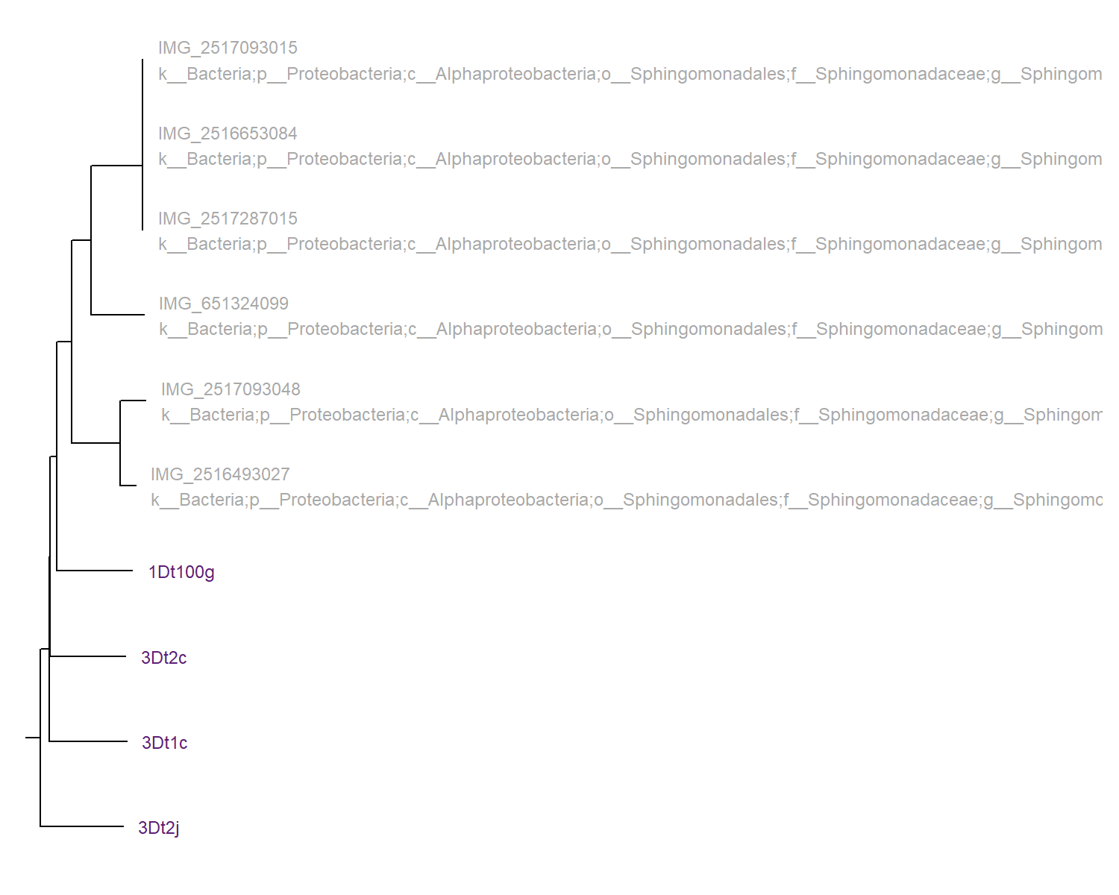
Figure 4.1: Phylogram for 4 samples known to be of the genus Sphingomonas. Generated by checkm tree_qa on the 30th of December 2024.

Microbacterium samples
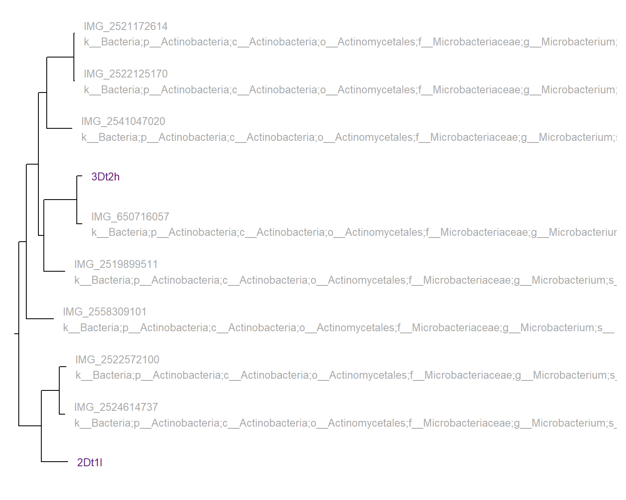
Figure 4.2: Phylogram for 2 samples known to be of the genus Microbacterium. Generated by checkm tree_qa on the 30th of December 2024.

Brachybacterium / Dermabacter sample
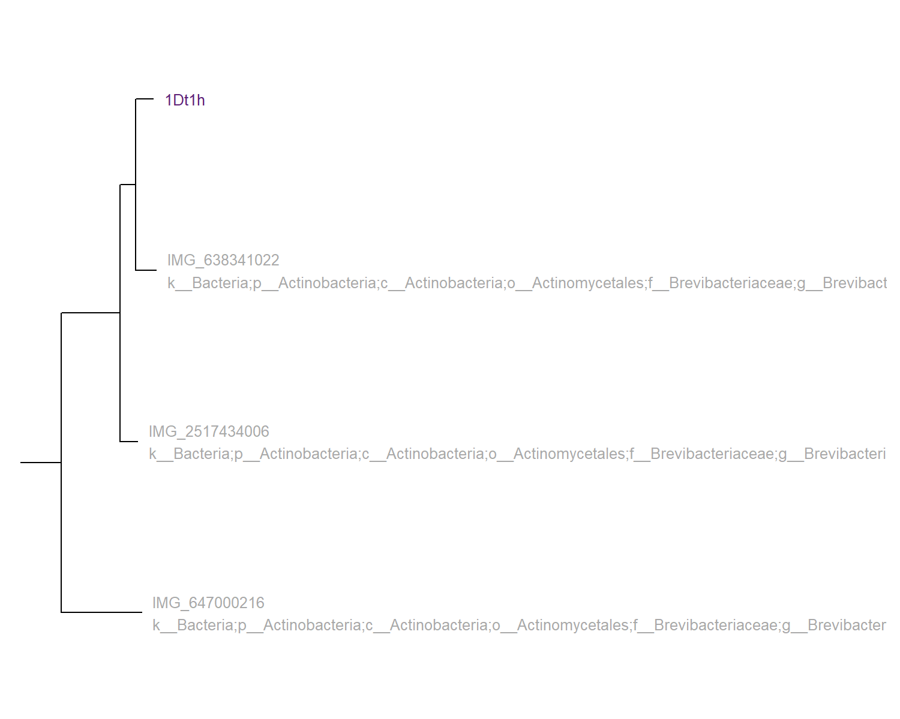
Figure 4.3: Phylogram for 1 sample known to be of the genus Brachybacterium. Generated by checkm tree_qa on the 30th of December 2024.

Brevibacterium sample
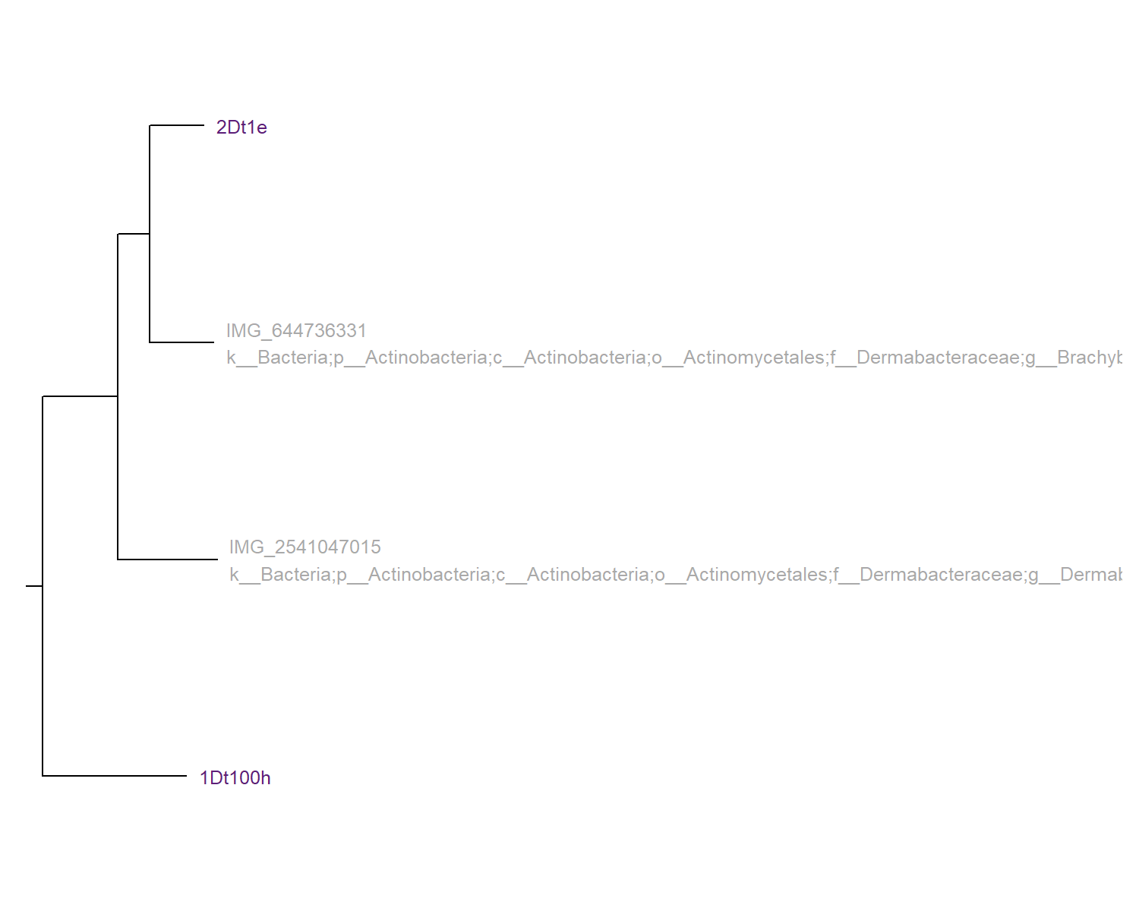
Figure 4.4: Phylogram for 1 sample known to be of the genus Brevibacterium. Generated by checkm tree_qa on the 30th of December 2024.

Pantoea sample
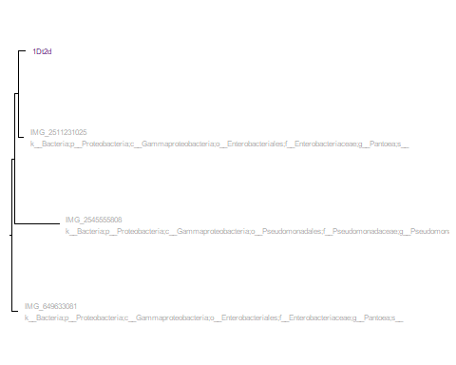
Figure 4.5: Phylogram for 1 sample of disputed genus. Generated by checkm tree_qa on the 30th of December 2024.
Outputs 3 and 4 produce the same tree files, with some minor differences in labeling, so i have only outputted the results from the one that returns the full taxonomic ID of each sample in the tip label. The trees look to be trustworthy, confirming previous taxonomic assignments i have run. It should be noted these use the IMG database, not the NCBI database, this looks to be a smaller database as many of our samples are outgroups on the trees with no direct sister samples, this can be seen most for Figure 2, with all 4 samples in the outgroup. This analysis does confirm again that sample 1Dt2d identified first as “Enterobacter cancerogenus” is in fact a species of the genus “Pantoea”. As mentioned above i am yet to figure out if i can do anything with the output from option 5, so i will discuss with Aaron when term time begins again. Many of the samples cannot be given a species name by this analysis, for example, all of the samples in the genus Sphingomonas are closest to each other, so it is hard to discern if they are of different species.

4.4 Conclusion
Output 2, and to a lesser extent 1, present interesting data, it is not as useful as the data produced by the main analysis, but i think it was worth doing. It is possible i am not fully apreciating all of the outputs of this. Only very few of the samples get a taxonomy to the species level, however, it does confirm that sample 1Dt2d, marked “Enterobacter cancerogenus” by early taxonomic analysis actually belongs to the genus Pantoea. Confirming the analysis done all the way back in the technical spike for gtdbtk de novo Conclusion. This is mirrored in the outputs of the phylogenetic trees, which are good, but i doubt are a suitable replacement for the ones output by gtdbtk, which i will get onto at some point in the future. I have mentioned 5 several times, so i will just say that i might come back to look at it later. I learned some new things vis a vis new functions to tabulate like changing text size and pruning/collapsing trees in R, so i am less reliant on dendroscope, and have less tree files floating around. Overall, i think this has been a useful thing to do, even if the outputs are not as important or useful as what i have done or am about to do, even just for the experience alone, but who knows, maybe there is something in this data that will be useful to someone reading this.

4.4.1 Scripts
- checkMtreeqa.sh
- CheckMtreeqa.R

5. CheckM2

5.1 Introduction
CheckM2 is a basic secondary analysis to test the quality of the samples provided with a score for completeness and contamination (Chklovski et al. 2023).

5.2 Methods

5.2.1 CheckM2: slurm job
I used the script run_checkm2TN.sh to run CheckM2 on all 10 fasta files at once.

5.2.2 CheckM2: R table generation
The CheckM2 job produced a set of files:
Table 5.1: CheckM2 output files
Filename
checkM2comparison.xlsx
cumcomb.csv
diamond_output/DIAMOND_RESULTS.tsv
diamondko.csv
eggnogko.csv
protein_files/flye_asm_1Dt100g_part2.faa
protein_files/flye_asm_1Dt100h_part2.faa
protein_files/flye_asm_1Dt1h_part2.faa
protein_files/flye_asm_1Dt2d_part2.faa
protein_files/flye_asm_2Dt1e_part2.faa
protein_files/flye_asm_2Dt1l_part2.faa
protein_files/flye_asm_3Dt1c_part2.faa
protein_files/flye_asm_3Dt2c_part2.faa
protein_files/flye_asm_3Dt2h_part2.faa
protein_files/flye_asm_3Dt2j_part2.faa
quality_report.tsv
uniquecomp.csv

The file I needed was quality_report.tsv, which gives info on each sample:
- Completeness
- Contamination
- Completeness Model Used
- Translation Table Used
I created an R script CheckM2tablegenerator.R. This produced Table 5.3
Table 5.2: First five rows of DIAMOND_RESULTS.tsv file
V1 | V2 | V3 | V4 | V5 | V6 | V7 | V8 | V9 | V10 | V11 | V12
flye_asm_1Dt1h_part2Ωcontig_2_1 | UniRef100_E8NCL3~K07154 | 49.7 | 396 | 196 | 2 | 18 | 411 | 17 | 411 | 0 | 354
flye_asm_1Dt1h_part2Ωcontig_3_3 | UniRef100_A0A142NN80~K01866 | 91.8 | 428 | 35 | 0 | 1 | 428 | 1 | 428 | 0 | 767
flye_asm_1Dt1h_part2Ωcontig_3_7 | UniRef100_A0A0M4DMT0~K03088 | 44.0 | 407 | 224 | 2 | 2 | 404 | 8 | 414 | 0 | 313
flye_asm_1Dt1h_part2Ωcontig_3_9 | UniRef100_A0A142NQF8~K01755 | 93.0 | 473 | 33 | 0 | 1 | 473 | 1 | 473 | 0 | 857
flye_asm_1Dt1h_part2Ωcontig_3_10 | UniRef100_A0A142NNT5~K03402 | 93.5 | 168 | 11 | 0 | 8 | 175 | 6 | 173 | 0 | 282

5.2.3 Results
Table 5.3: Quality analysis from CheckM2 based on samples taken from the skin microbiome of Dendrobates tinctorius
Accession | Completeness | Contamination | Completeness model used | Translation table used | Additional notes
1Dt1h | 100.00 | 0.31 | Neural Network (Specific Model) | 11 | None
1Dt2d | 100.00 | 0.87 | Neural Network (Specific Model) | 11 | None
2Dt1l | 100.00 | 0.27 | Neural Network (Specific Model) | 11 | None
3Dt2c | 99.94 | 0.39 | Neural Network (Specific Model) | 11 | None
3Dt2j | 99.80 | 0.00 | Neural Network (Specific Model) | 11 | None
1Dt100h | 99.12 | 0.00 | Gradient Boost (General Model) | 11 | None
3Dt1c | 98.34 | 0.86 | Neural Network (Specific Model) | 11 | None
3Dt2h | 86.04 | 0.10 | Neural Network (Specific Model) | 11 | None
1Dt100g | 78.42 | 0.33 | Neural Network (Specific Model) | 11 | None
2Dt1e | 48.29 | 0.08 | Neural Network (Specific Model) | 11 | None
Source: CheckM2 predict performed on 2024-12-28
This is the table of CheckM2 analysis, there are many differences in which fields are produced, also, there appears to be differences in the values themselves for Completeness and Contamination, perhaps part of the comparitive analysis, done in the conclusion should be the date at which both were at, as older versions will probably have less accurate values, and this may cause the difference as genomics is a fast evolving field. A noteable difference is that CheckM used an internal diamond database, whereas CheckM2 required me to download my own.

5.2.4 Scripts
- run_checkm2TN.sh
- CheckM2tablegenerator.R.

5.2.5 Comparison of CheckM and CheckM2
Table 5.4: Comparison of quality metrics for the same fasta files between CheckM/1.1.3 and CheckM2/0.1.3
 | CheckM/1.1.3 |  | CheckM2/0.1.3
Accession | Completeness | Contamination | Completeness | Contamination
1Dt100g | 76.77 | 0.00 | 78.42 | 0.33
1Dt100h | 98.84 | 0.19 | 99.12 | 0.00
1Dt1h | 100.00 | 0.00 | 100.00 | 0.31
1Dt2d | 100.00 | 0.90 | 100.00 | 0.87
2Dt1e | 44.74 | 0.00 | 48.29 | 0.08
2Dt1l | 98.82 | 2.32 | 100.00 | 0.27
3Dt1c | 97.23 | 1.19 | 98.34 | 0.86
3Dt2c | 95.75 | 0.85 | 99.94 | 0.39
3Dt2h | 87.98 | 0.51 | 86.04 | 0.10
3Dt2j | 96.19 | 1.21 | 99.80 | 0.00
Source: CheckM lineage_wf performed on 2024-12-25 CheckM2 predict performed on 2024-12-28

5.3 CheckM2 DIAMOND_RESULTS.tsv

5.3.1 Introduction
I decided to take a look at the full outputs of CheckM2 to see if there was anything interesting to analyse other than the Completeness and Contamination, I found this file called DIAMOND_RESULTS.tsv. It has a bunch of weird stuff in it, I did however recognise the existence of KO pathways in the second column, along with links to a website that displays 3D images of proteins, so I decided to take a closer look at this file.

5.3.2 Methods
The file did not output with column headers, I believe the ones found here match up well, but the descriptions of some are vague, so I am not sure what the significance of a few of the columns is. Due to the size of DIAMOND_RESULTS.tsv, I decided not to include it as a table or image in this document. I created this R script to import the data to a table and do an analysis of the important looking fields. This was quite a difficult task that made this little project stretch over 2 days. The main output I wanted from this was a comparison between the KO pathways outputted from this and those outputted by Eggnog-mapper. Eggnog-mapper still is not working on Hawk so maybe we could get the KO pathways for the heatmaps through CheckM2 instead. I did this analysis at two levels, a comparison of which unique KOs each system recognised, and the “cumulative” or total differences.
I figured if I am going to make decisions based on if two methods are different, I should compare them statistically instead of eyeballing it. It is simple enough, tests, graphs, that sort of stuff. This lead me to do many things in R, but only some of the analyses I did were valid. I started off testing which KO values against which accessions in each file, excluding repetitions. However, I then realised that this methodology did not give a full picture of the results, so I decided to work on trying to identify when duplicates occured and add them to the dataset. After much trial and error to get right, I created this file. I included all the dead-ends as comments at the end for posterity. I finally decided to use the shared KO values divided by the total for each accession and method to create my values showing the differences between DIAMOND and eggNog-mapper. I then decided to run a statistical analysis to see if the differences observed between groups was significant.

5.3.3 Results
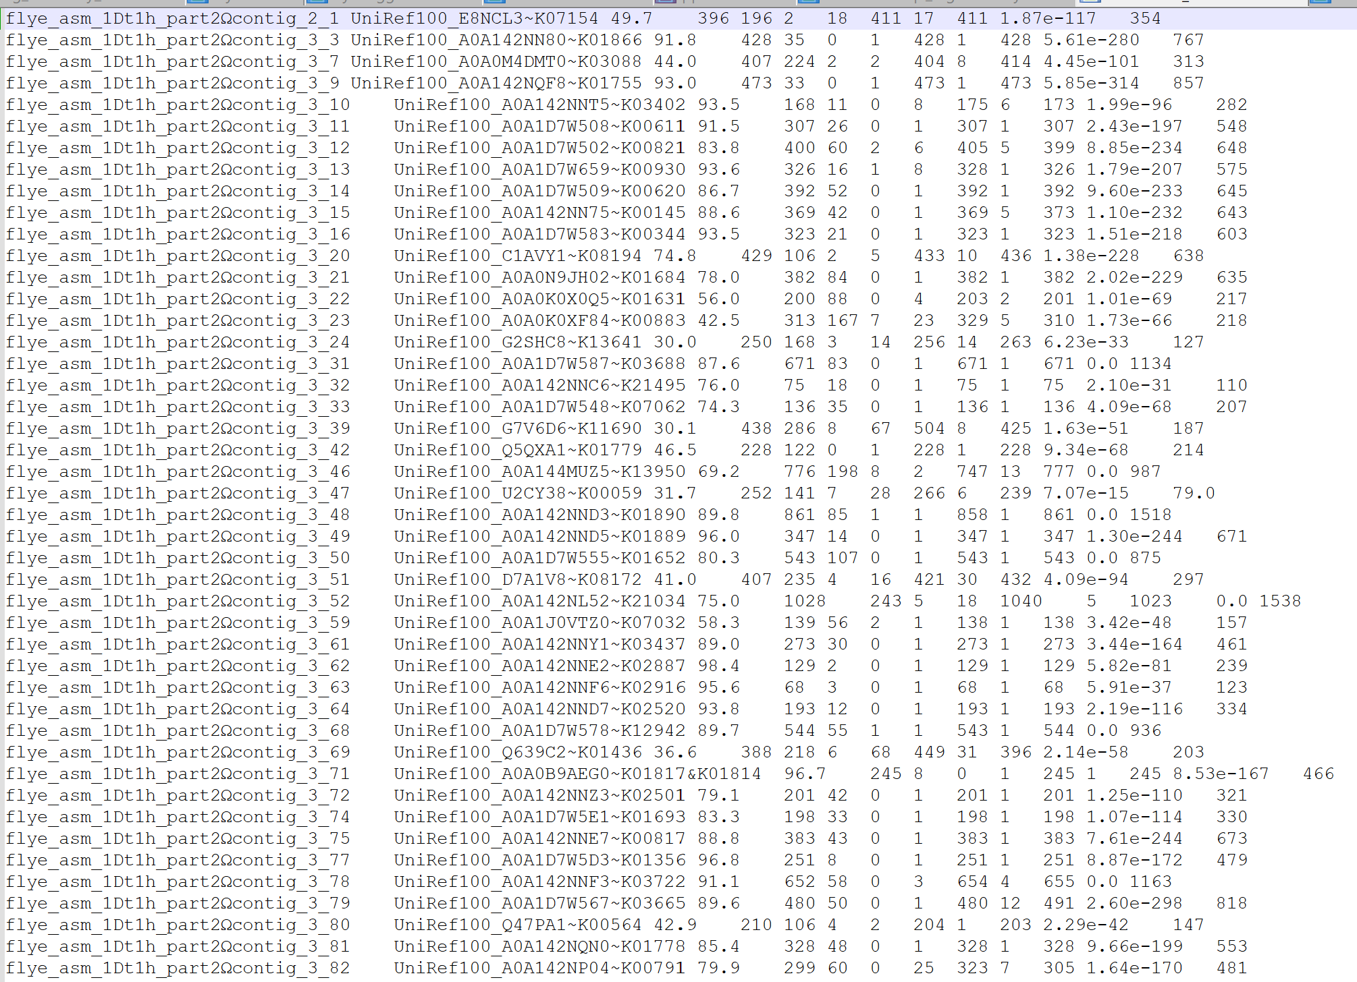
Figure 5.1: The original file is very large, so I cannot include it in the document, there is a line for each gene in all 10 samples. Here is a screenshot of it in Notepad ++
Table 5.5: Unique KO pathway analysis from CheckM2 based on samples taken from the skin microbiome of Dendrobates tinctorius
Accession | Total unique KOs | KO # in DIAMOND file | KO # from eggNog-mapper files | % diff DIAMOND - eggNog | % diff eggNog - DIAMOND
1Dt100g | 1160 | 1096 | 1034 | 0.9448276 | 0.8913793
1Dt100h | 1179 | 1055 | 1107 | 0.8948261 | 0.9389313
1Dt1h | 1627 | 1505 | 1466 | 0.9250154 | 0.9010449
1Dt2d | 2856 | 2631 | 2702 | 0.9212185 | 0.9460784
2Dt1e | 966 | 828 | 854 | 0.8571429 | 0.8840580
2Dt1l | 1641 | 1471 | 1467 | 0.8964046 | 0.8939671
3Dt1c | 1641 | 1572 | 1438 | 0.9579525 | 0.8762949
3Dt2c | 1654 | 1582 | 1447 | 0.9564692 | 0.8748489
3Dt2h | 1411 | 1254 | 1280 | 0.8887314 | 0.9071580
3Dt2j | 1475 | 1428 | 1302 | 0.9681356 | 0.8827119
Source: DIAMOND_RESULTS.tsv produced by CheckM2 predict performed on 2024-12-28
Table 5.6: KO pathway Total Frequency analysis from CheckM2 based on samples taken from the skin microbiome of Dendrobates tinctorius
Accession | EggNog-mapper most-frequent KO pathways | Ocurrance number in genome | accession.d | DIAMOND most-frequent KO pathways | Ocurrance number in genome
1Dt100g | K00799 | 8 | 1Dt100g | K00249 | 11
1Dt100g | K02014 | 6 | 1Dt100g | K00059 | 8
1Dt100g | K00626 | 4 | 1Dt100g | K02014 | 8
1Dt100g | K00666 | 4 | 1Dt100g | K00799 | 7
1Dt100g | K11177 | 4 | 1Dt100g | K01069 | 4
1Dt100h | K02015 | 8 | 1Dt100h | K02015 | 8
1Dt100h | K01990 | 7 | 1Dt100h | K01990 | 6
1Dt100h | K02013 | 6 | 1Dt100h | K02013 | 6
1Dt100h | K02016 | 6 | 1Dt100h | K02016 | 6
1Dt100h | K02031 | 6 | 1Dt100h | K02031 | 5
1Dt1h | K02016 | 18 | 1Dt1h | K00059 | 21
1Dt1h | K00059 | 13 | 1Dt1h | K02016 | 18
1Dt1h | K01990 | 12 | 1Dt1h | K02031 | 11
1Dt1h | K01992 | 11 | 1Dt1h | K02032 | 11
1Dt1h | K02031 | 11 | 1Dt1h | K07749 | 11
1Dt2d | K02029 | 28 | 1Dt2d | K18900 | 21
1Dt2d | K03406 | 21 | 1Dt2d | K07495 | 16
1Dt2d | K02031 | 17 | 1Dt2d | K00059 | 15
1Dt2d | K02028 | 14 | 1Dt2d | K02029 | 15
1Dt2d | K02032 | 14 | 1Dt2d | K02529 | 15
2Dt1e | K02026 | 20 | 2Dt1e | K02026 | 19
2Dt1e | K02027 | 18 | 2Dt1e | K02025 | 18
2Dt1e | K02025 | 15 | 2Dt1e | K02027 | 17
2Dt1e | K06147 | 9 | 2Dt1e | K02529 | 12
2Dt1e | K02529 | 8 | 2Dt1e | K06147 | 9
2Dt1l | K02034 | 30 | 2Dt1l | K02529 | 30
2Dt1l | K02035 | 28 | 2Dt1l | K02031 | 27
2Dt1l | K02031 | 26 | 2Dt1l | K02035 | 25
2Dt1l | K02033 | 26 | 2Dt1l | K02032 | 24
2Dt1l | K02025 | 22 | 2Dt1l | K02033 | 24
3Dt1c | K02014 | 24 | 3Dt1c | K02014 | 40
3Dt1c | K03406 | 14 | 3Dt1c | K03406 | 16
3Dt1c | K14266 | 11 | 3Dt1c | K14266 | 14
3Dt1c | K02529 | 7 | 3Dt1c | K02529 | 8
3Dt1c | K03088 | 7 | 3Dt1c | K05349 | 8
3Dt2c | K02014 | 23 | 3Dt2c | K02014 | 35
3Dt2c | K03406 | 17 | 3Dt2c | K07497 | 18
3Dt2c | K14266 | 12 | 3Dt2c | K03406 | 17
3Dt2c | K02483 | 7 | 3Dt2c | K14266 | 17
3Dt2c | K03496 | 7 | 3Dt2c | K00059 | 8
3Dt2h | K02529 | 14 | 3Dt2h | K02529 | 18
3Dt2h | K02025 | 13 | 3Dt2h | K02025 | 11
3Dt2h | K02026 | 13 | 3Dt2h | K02026 | 11
3Dt2h | K02027 | 12 | 3Dt2h | K02027 | 11
3Dt2h | K03088 | 9 | 3Dt2h | K03088 | 10
3Dt2j | K02014 | 12 | 3Dt2j | K02014 | 21
3Dt2j | K00626 | 6 | 3Dt2j | K00249 | 9
3Dt2j | K00799 | 6 | 3Dt2j | K00059 | 8
3Dt2j | K07107 | 5 | 3Dt2j | K00799 | 8
3Dt2j | K03088 | 4 | 3Dt2j | K01897 | 7
Source: DIAMOND_RESULTS.tsv produced by CheckM2 predict performed on 2024-12-28
Table 5.5 and Table 5.6 represent my analysis of the DIAMOND_RESULTS.tsv file. I decided to do this by comparing it to the outputs I got from eggNog-mapper when I ran it earlier in the year. Table 5.5 represents a comparison of unique KO pathways. Often, the same KO pathway is found multiple times in the same genome, this makes evolutionary sense but if CheckM2 is a good alternative to eggNog-mapper, which does not work on hawk yet then it must find similar KO pathways. Table 5.5 would confirm this as similarities between output files consistently stay above 85%. Table 8 represents a comparison of highest frequency, taken as the top 5 most frequent for each genome. Basically, what are each system finding most often. Often, there will be similarities, with values only off by 2 or 3, however, occasionally the most common in DIAMOND will be absent from the list for eggNog-mapper and vice-versa.

5.3.4 Statistical analysis results
Table 5.7: Shared KO values between two systems represented as proportions of their totals based on samples taken from the skin microbiome of Dendrobates tinctorius
Accession | % of shared KO values present in DIAMOND_RESULTS.tsv | % of shared KO values present in eggNog-mapper outputs
1Dt100g | 84.9% | 92.0%
1Dt100h | 91.5% | 84.9%
1Dt1h | 84.7% | 87.3%
1Dt2d | 88.4% | 82.8%
2Dt1e | 82.6% | 82.1%
2Dt1l | 83.4% | 85.4%
3Dt1c | 82.1% | 94.1%
3Dt2c | 80.7% | 93.7%
3Dt2h | 86.7% | 83.4%
3Dt2j | 84.1% | 94.9%
Source: DIAMOND_RESULTS.tsv produced by CheckM2 predict performed on 2024-12-28 and the series of eggNog-mapper outputs I generated using eggNog-mapper v2 for the web 2024-08-28
shapiro.test(groupby$DIAMOND_per)
Shapiro-Wilk normality test
data: groupby$DIAMOND_per
W = 0.94467, p-value = 0.6061
shapiro.test(groupby$eggNog_per)
Shapiro-Wilk normality test
data: groupby$eggNog_per
W = 0.8645, p-value = 0.08619
compttest <- t.test(groupby$DIAMOND_per, groupby$eggNog_per)
compttest
Welch Two Sample t-test
data: groupby$DIAMOND_per and groupby$eggNog_per
t = -1.6563, df = 15.199, p-value = 0.1182
alternative hypothesis: true difference in means is not equal to 0
95 percent confidence interval:
-0.07200294 0.00899259
sample estimates:
mean of x mean of y
0.8490075 0.8805126
Table 5.7 shows that the common KO values represent a very large proportion of the total KO values for both methods and all accessions, never dipping below 80%. Shapiro testing showed that a parametric test could be used for this. I decided on a Student’s t-test(t(15.199) = -1.6563, p = 0.1182). As the p value is larger than 0.05, we accept the null hypothesis that the groups are not significantly different.

6. GTDB-TK Classify

6.1 Introduction
In september, when I was still inexperienced, I ran GTDB-Tk on the 10 samples using the classify_wf. At the time, that is the only way I thought it could be used. I got a few trees output from this, but because the trees were not monophyletic, so I discarded them as not possible to be correct. However, there was another output that I did not see or disregarded.

6.2 Methods
The script used was the same as in the de_novo process.

6.3 Results

6.3.1 Table
The table was too large to include here, so here is a link to it in the repo: gtdbtk.bac120.summary.tsv

6.3.2 tree example
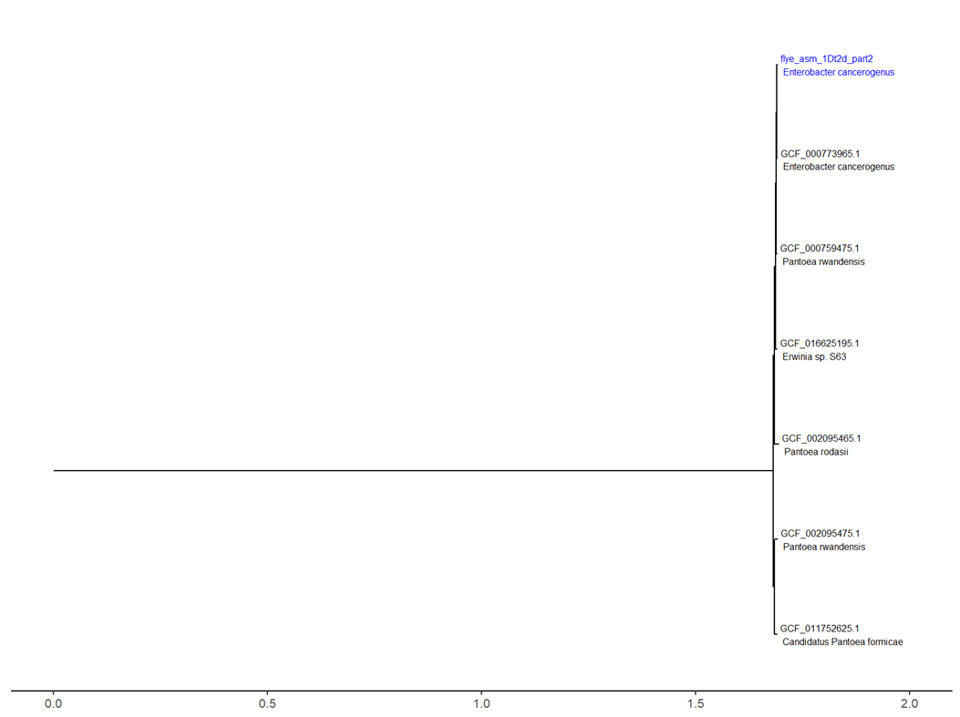
Figure 6.1: Early phylogenetic tree made using the GTDB-Tk classify workflow
Figure 6.1 shows that the clade is not monophyletic, with representatives from 3 genera (Enterobacter, Erwinia and Pantoea).

6.4 Manual trees
At some point I made a set of trees that cannot be sourced to any other analysis I performed at the time.
These were made using This script, which does not exist in the current version of the repo. I cannot find what process made the basis of these trees. I remember, as well as the small trees it output a big tree of everything that did have them in the right place

7. GTDB-TK de novo

7.1 Introduction
£bookmark citation: https://academic.oup.com/bioinformatics/article/36/6/1925/5626182
Earlier in the year I had used GTDB-TK to identify Genera for the 10 samples and create phylogenetic trees, this is described in Chapter 6. However, upon review of these trees I found oddities, errors that did not quite make sense.
I decided to take a closer look at the documentation for GTDB-TK to see what I had done exactly. I had initially used the classify_wf, it was here I discovered the de_novo_wf. It states:
“The de novo workflow infers new bacterial and archaeal trees containing all user supplied and GTDB-Tk reference genomes. The classify workflow is recommended for obtaining taxonomic classifications, and this workflow only recommended if a de novo domain-specific trees are desired. One should take the taxonomic assignments as a guide, but not as final classifications. In particular, no effort is made to resolve the taxonomic assignment of lineages composed exclusively of user submitted genomes.”
I took this to mean that the de_novo_workflow would be a more accurate way of estimating the taxonomic assignment of the samples. Though now I re-read it I am not so sure. I found a paper that discusses this, (chaumeil2022?). I then read this page, on a discussion board. From what I understand from all of this, Classify_wf gives good taxonomic assignments, but its trees are not perfect, and de_novo_wf is the opposite, it is weaker at assigning (explaining why that one sample without a major group was such an error for it) but spends more run-time making accurate trees. I shall have to dig up my work on classify, as from what I gather, it was not an error to run it.

7.2 Methods
The de_novo workflow takes the .fasta files for the 10 local samples and runs a few opperations, detailed in the documentation above, to place them in existing trees, these are output as newick .Nexml format. This project uses a few slurm scripts, as it is run on hawk. I produced this script to run it on hawk.

7.3 Results

7.4 Phylogenetic trees

7.4.1 Introduction
After de_novo_wf analysis is done, the trees can be crafted in R. However, it should be noted this process does not assign taxonomy to the samples one uploads, merely places them in a tree

7.4.2 Methods
the outputs from the GTDB-tk de_novo_wf, namely the .nexml tree file, can be read into R and modified to make more visually appealing, they can then be combined with metadata to find the names, though now I see these names may not be wholly accurate. I also toyed with the idea of one large, interactive tree, though the capability to do that well is beyond my current skill level. There was one sample for which a taxonomy could not be assigned, meaning I could not isolate it to include in the trees, thus I excluded it from further study, this perhaps was another error on my part I now see. This is done across several scripts £bookmark

7.4.3 Results
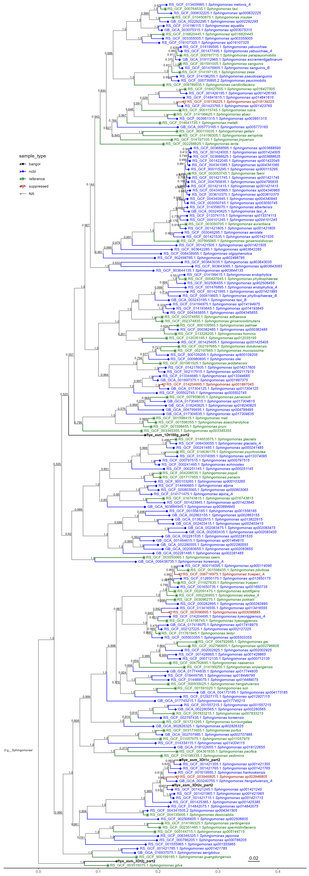
Figure 7.1: GTDB-tk de_novo_wf phylogenetic tree for 4 Bangor-made genomic sequences in the genus Sphingomonas (seen in the colour black)
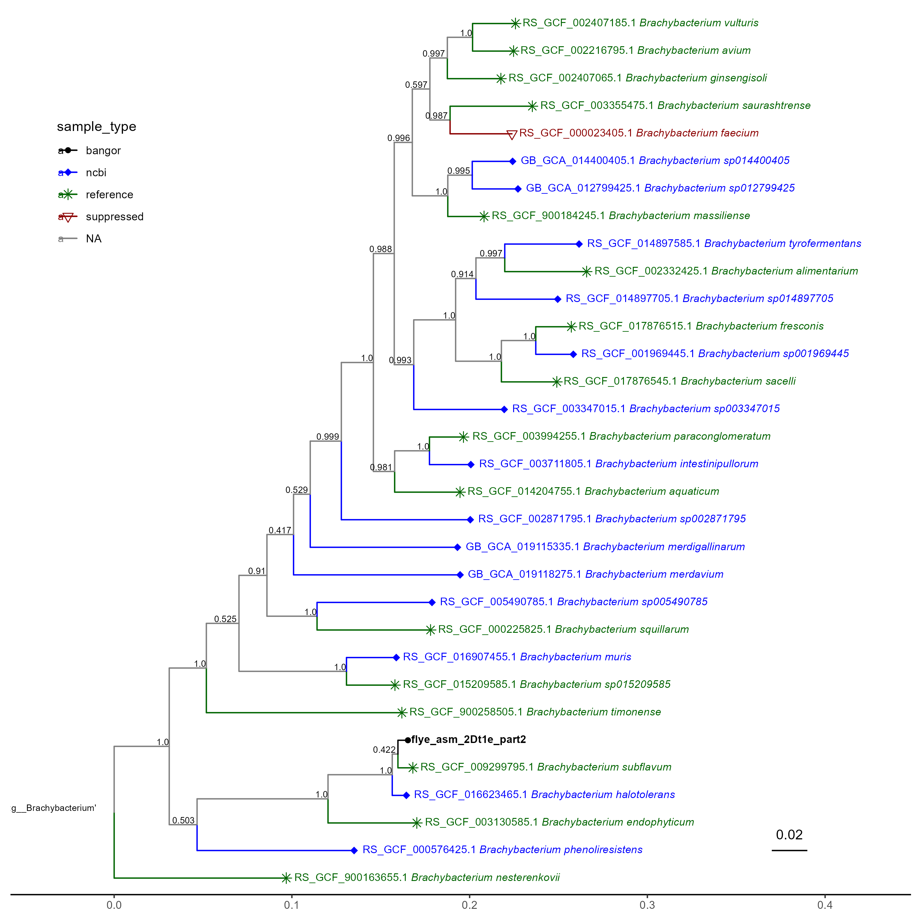
Figure 7.2: GTDB-tk de_novo_wf phylogenetic tree for 1 Bangor-made genomic sequence in the genus Brachybacterium (seen in the colour black)
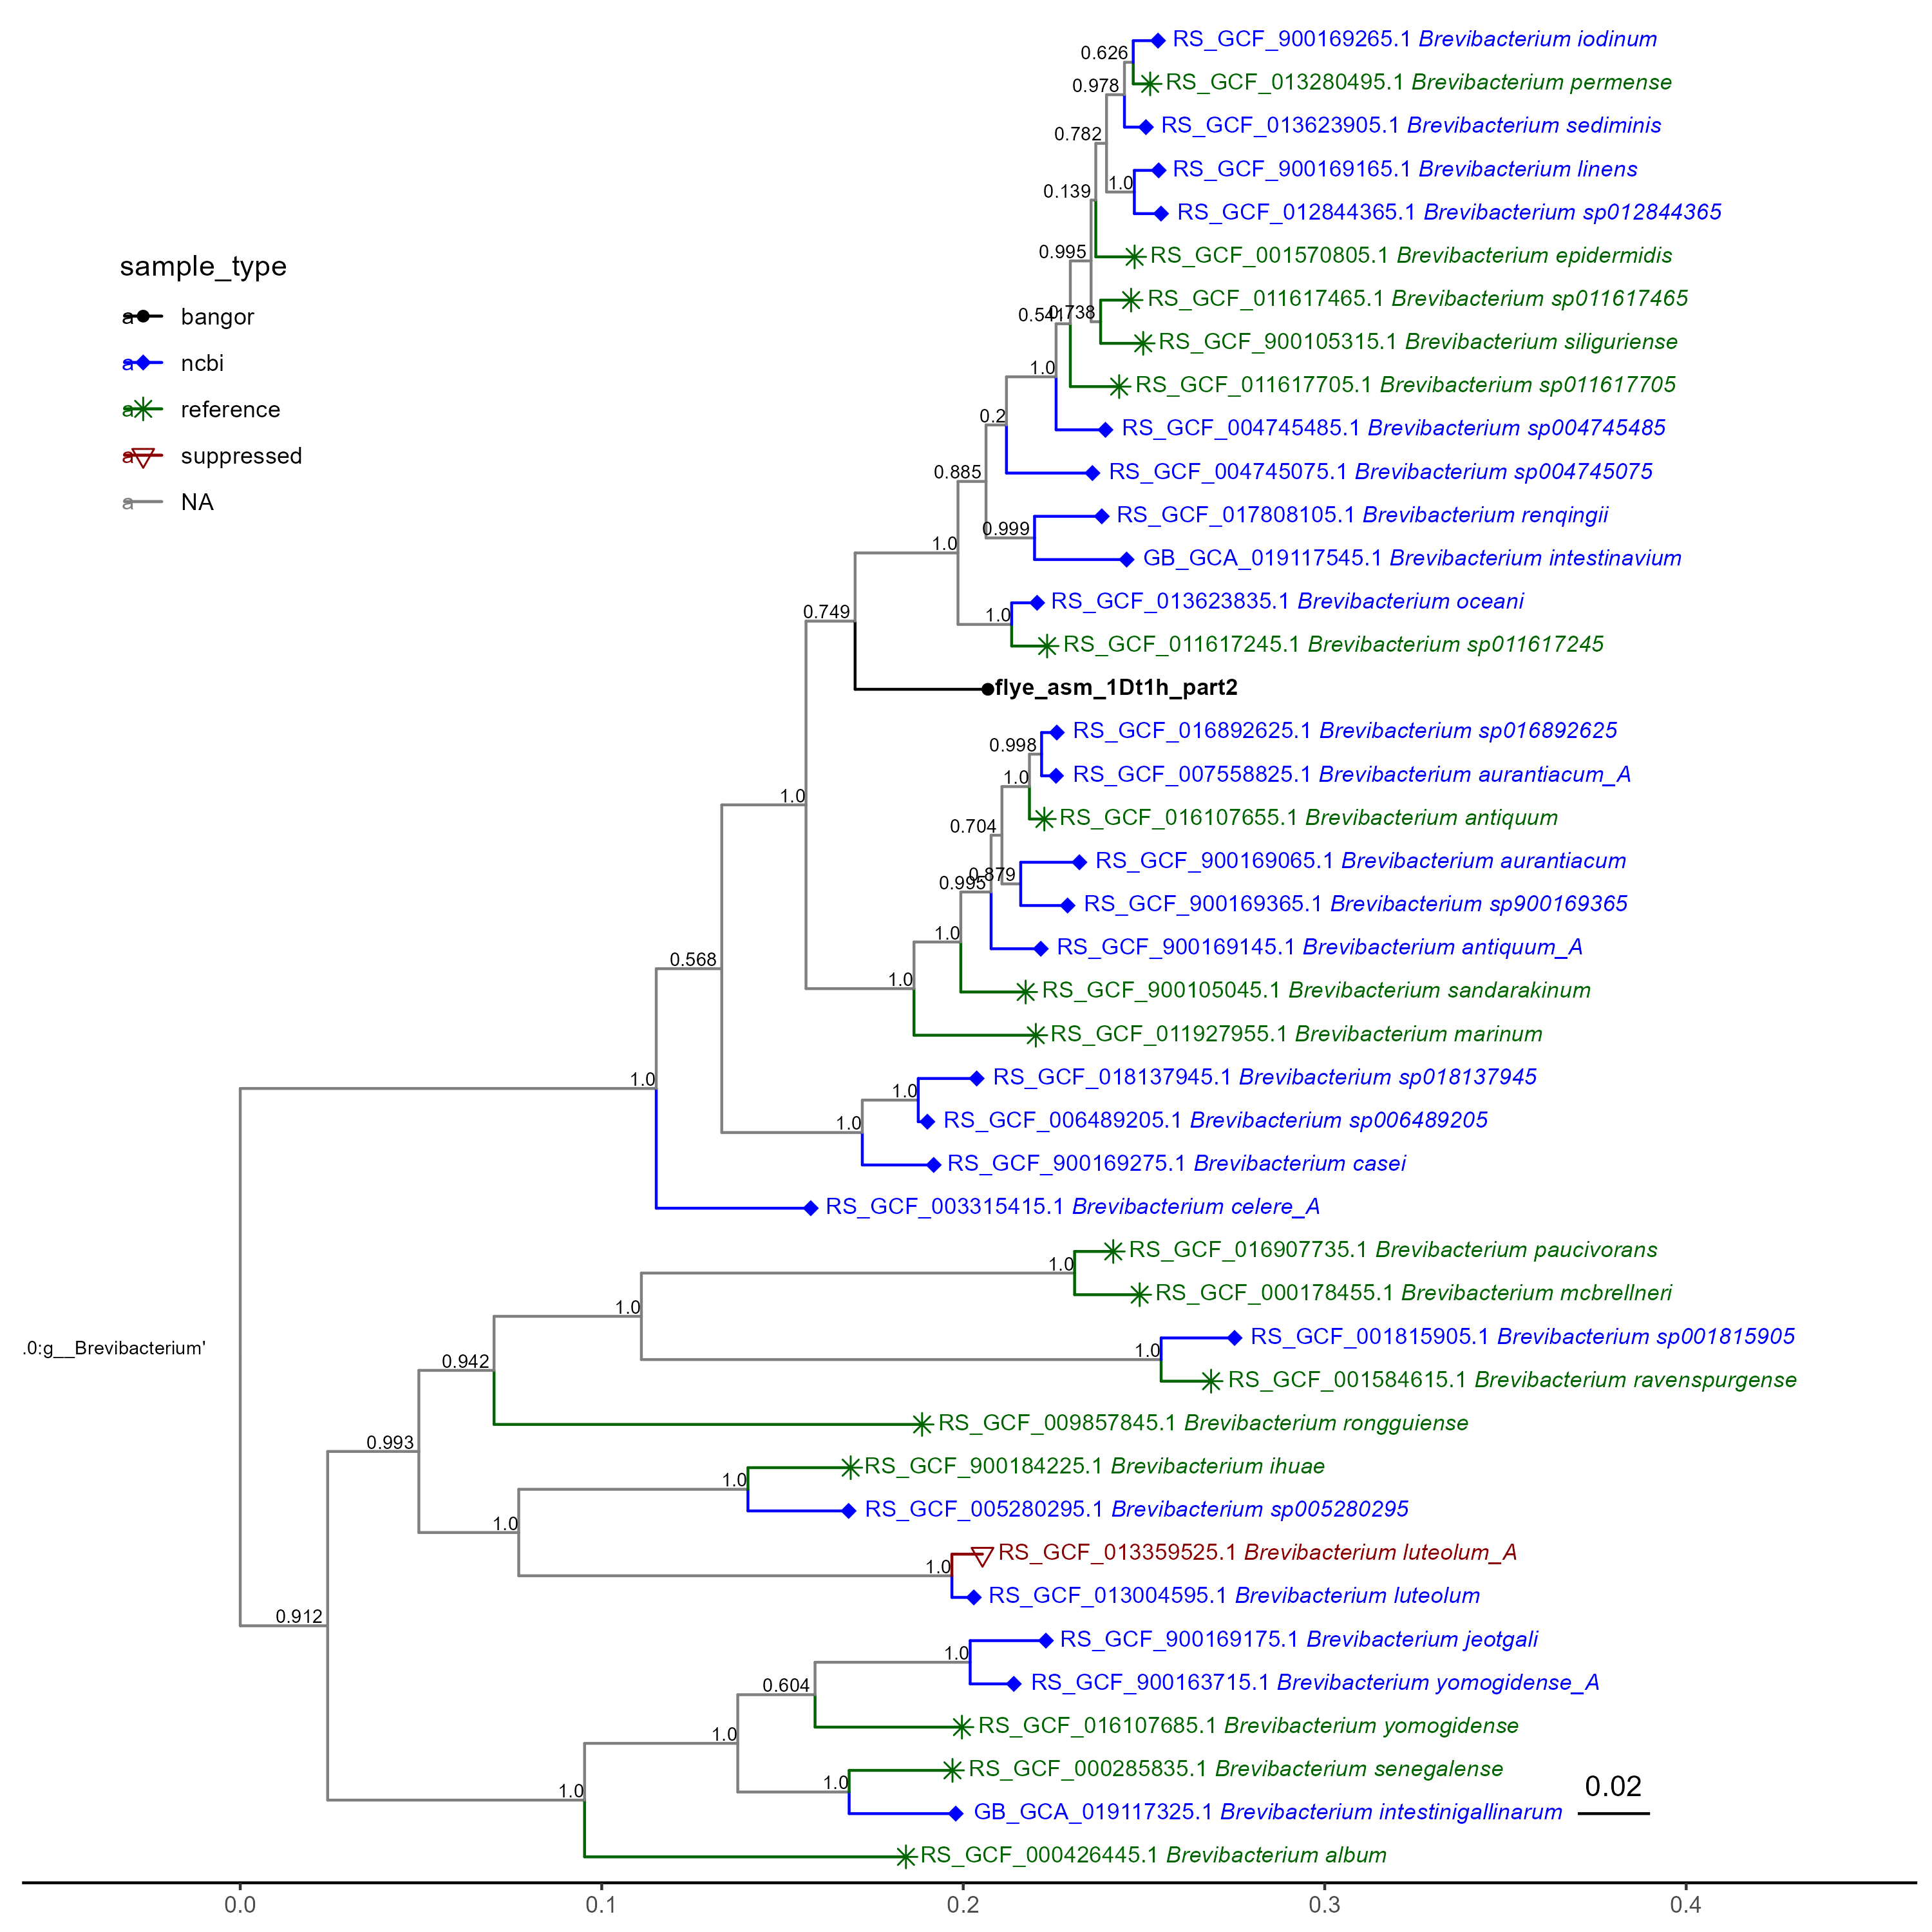
Figure 7.3: GTDB-tk de_novo_wf phylogenetic tree for 1 Bangor-made genomic sequence in the genus Brevibacterium (seen in the colour black)
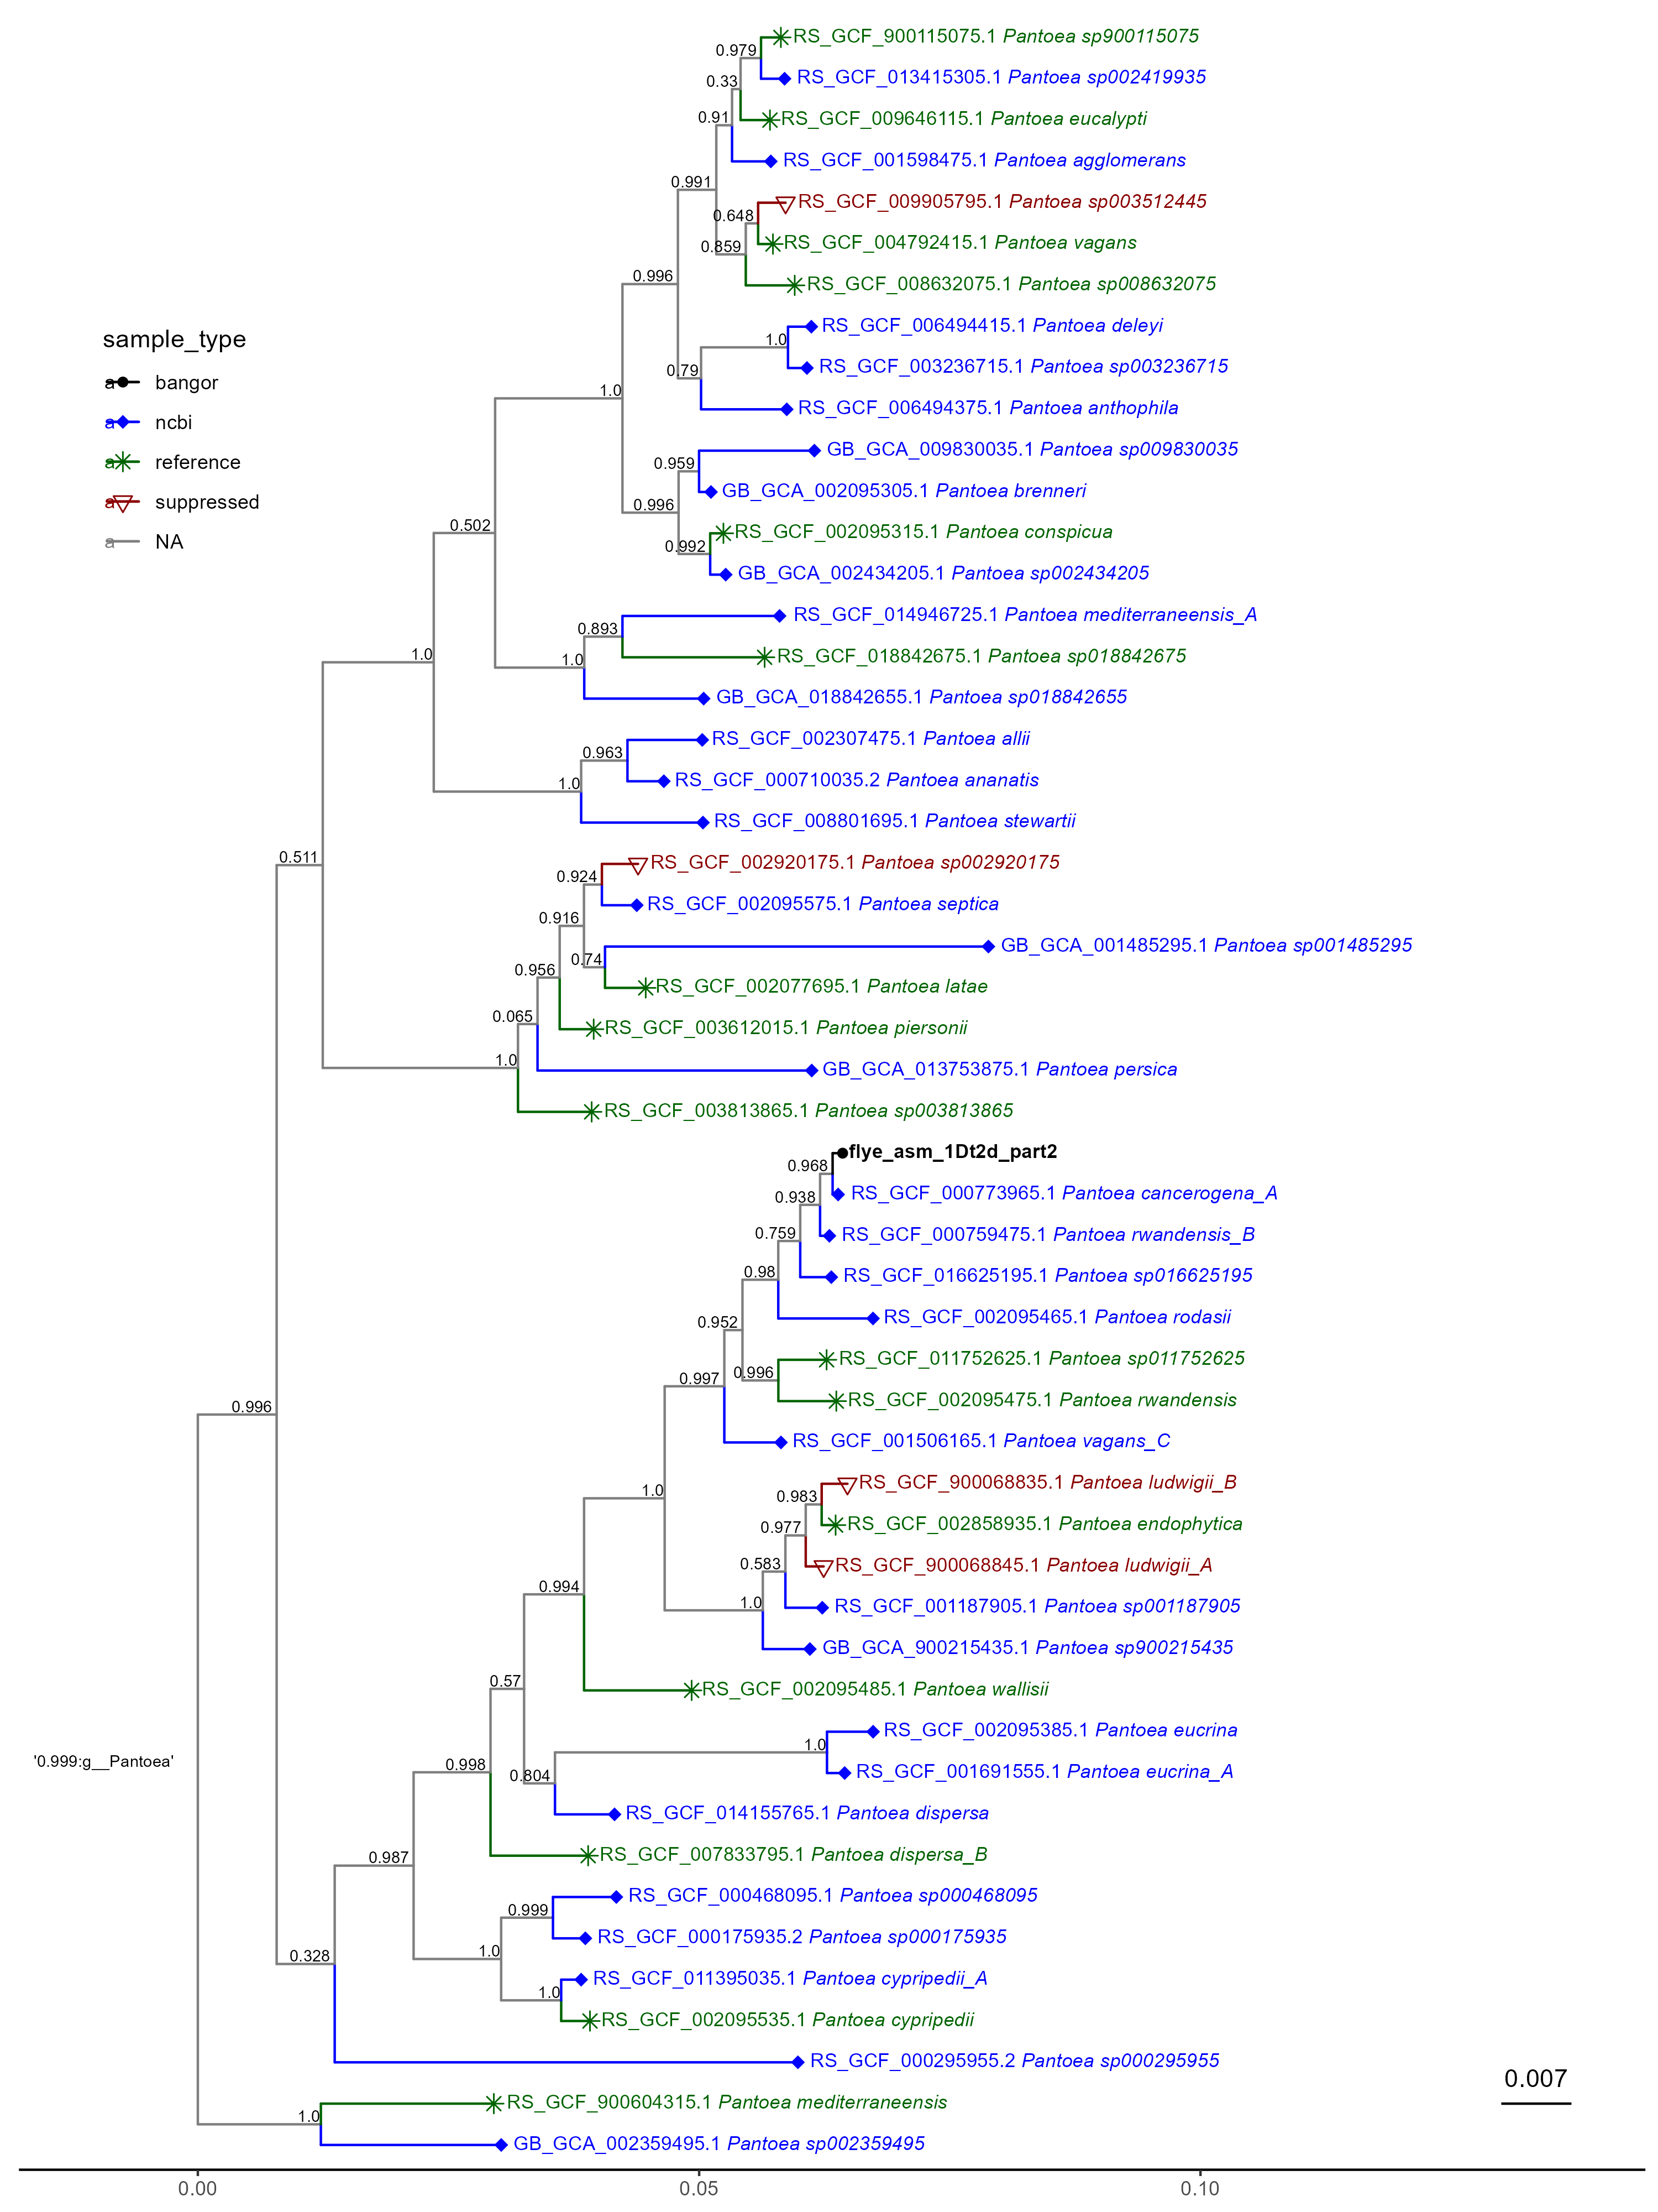
Figure 7.4: GTDB-tk de_novo_wf phylogenetic tree for 1 Bangor-made genomic sequence of disputed genus (seen in the colour black)
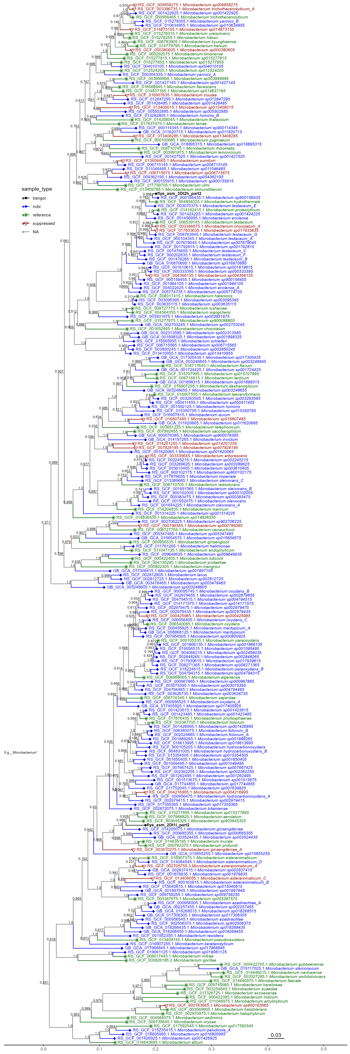
Figure 7.5: GTDB-tk de_novo_wf phylogenetic tree for 1 Bangor-made genomic sequence of the genus Microbacterium (seen in the colour black)

7.5 Scripts

8. Obtaining metadata

8.1 Introduction
Throughout the project, an understanding of the information behind the genetic samples was important. This information was held on the same repositories as the samples. This includes information on host, environment, dating, sequencing method and CheckM scores for the NCBI database, and grouping information for the KEGG database. The KEGG metadata was especially helpful as it allows grouping boxes to be added to the heatmaps for more transparent bioinformatics and simpler interpretation.

8.2 Methods
API calls were used to download the metadata, they are a simple, if technical way of transferring large quantities of data. Both the NCBI and KEGG databases have REST APIs. These allow communication between R and these websites by using a special package called httr2, into which a URL and other items are passed, including a list of accessions for which data is wanted. An example of the code is used in NCBImetadatacollector.R. The code block with an indepth explanation exists in that code. In short, one creates a list or dataframe of accessions that should be passed to the website, so the metadata can be transferred, then several parameters are passed in to specify what is desired, the call will then be run and output will be several files in the .JSON format. One of the fields that needs to be passed is an output directory.

8.3 Results
Figure 8.1: req_perform method of httr
As can be seen in Figure 8.1, An example of having to pass in an empty, existing directory to the call so that it can place the data somewhere
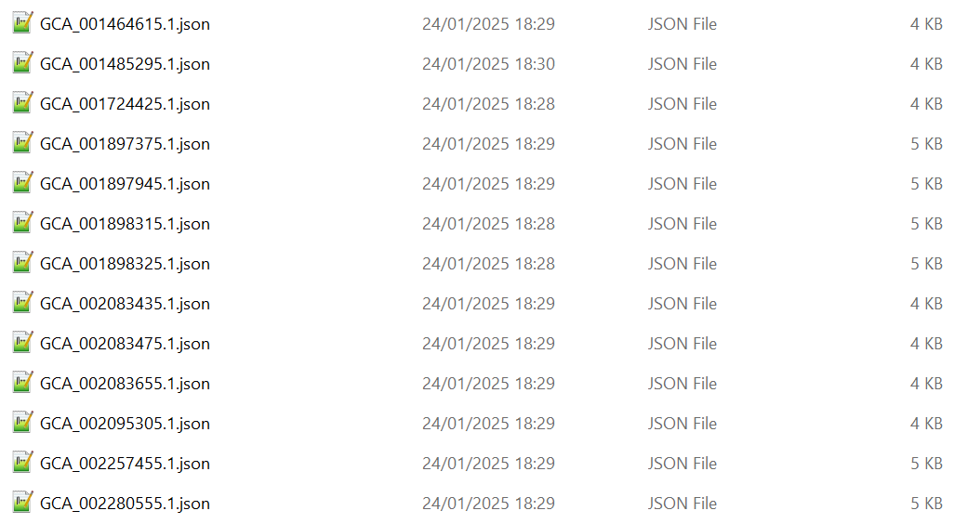
Figure 8.2: JSON output from NCBI stored directly as files
As can be seen in Figure 8.2, A subset of the files output by my API call to illustrate what the directory would look like on an average Windows file explorer

8.4 Scripts
- NCBI_metadata_collector.R
- NCBI_fasta_collector.R

9. EggNOG-mapper process - prototype

9.1 Introduction
Given how long it takes to run some of the jobs, I didn’t want to do all of the eggNOG-mapper jobs before knowing if the results would be useful and create valid heat maps at the end. So I decided to do the following:
- Download the metadata for the chosen genera, this used the dataset_report API for the NCBI website. This served multiple purposes, for example they told me which samples have a high quality metric, they could also help with the generation of trees from gtdb-tk de_novo_wf
- Choose 10 accessions per genus to use in my prototype pipeline. All groups totalled 10 samples, our own Bangor-made accession will be included in this number, excluding 1Dt100h, as gtdb-tk could not classify it into a family.
- Download the genomic .fasta files for all of these. This will use the Download API to pull them from the NCBI website.
- Annotate all those fastas using eggNog-mapper on hawk.
- create the file(s) that turn the annotation file into a heatmap
I chose accessions at random, ensuring there were 10 total per genus including the Bangor samples.
All of these steps are described in more detail in Chapter 8 and Chapter 10, so instead here I will write about the ways in which I optimised and improved the processes before tackling the full set of 587 samples.

9.2 Process Optimisation
- eggNOG-mapper requires a lot of resources and can take several hours to complete a single job. I wanted to use the same parameters that the online version of eggNOG-mapper uses, i.e. --evalue 0.001 --score 60 --pident 40 --query_cover 20 --subject_cover 20 so I didn’t change them. I did change slurm parameters such as:
- ntasks=2
- cpus-per-task=25
- time=01:00:00
- mem=45g
After a lot of experimentation, the values above seemed to give me the best result. I used seff to check I was not requesting more resources on hawk than I needed.
- As the eggNOG-mapper jobs can take a long time to run, I needed a way to be notified when they had finished without just logging back into hawk. I discovered you can set mail parameters in the slurm script:
- mail-user=0rtpjri2@anonaddy.me
- mail-type=ALL
- Batching with control files You can only have 20 jobs in the queue on hawk at any one time, so I used a script to create ‘control files’. These contained two items per line:
- the accession number
- the fasta file name
I created a bash script called slurmsquared.sh, this script loops over the control files line by line and then executes the slurm script eggnogslurmrunner.sh, passing in the accession and file name as parameters. This script creates the slurm job to actually run eggNOG-mapper.
This way, all I had to do to process each batch of 20 was upload a new control file and then execute slurmsquared, telling it which control file to look at.
- Extract annotation Excel files eggNOG-mapper produces a lot of files but for the heatmaps I needed the Excel file which had the accession at the beginning and then emapper.annotations.xlsx. I created a script called eggnog_annotation_getter.sh to copy all the Excel files out of their main results directory into a separate folder, where I could download them in batches.
- Separate the post-eggNOG process into different R scripts Once the KO values are extracted from each eggNOG-mapper annotation file, they go through a process in the Microbiome R package called enrichKO. This takes some time to run. Separating out the steps into different scripts meant I didn’t have to re-run the enrichment process but instead it could write out tsv files that I then used in the later steps to create the heatmap.
The new part1_enrich focuses purely on enriching the output files and sending those outputs into .tsv files that part2_aggregate can now read in and aggregate, producing the output table needed in the unmodified (but renamed) part3_heatmap.

9.3 Results
The prototype phase produced the following heatmaps.
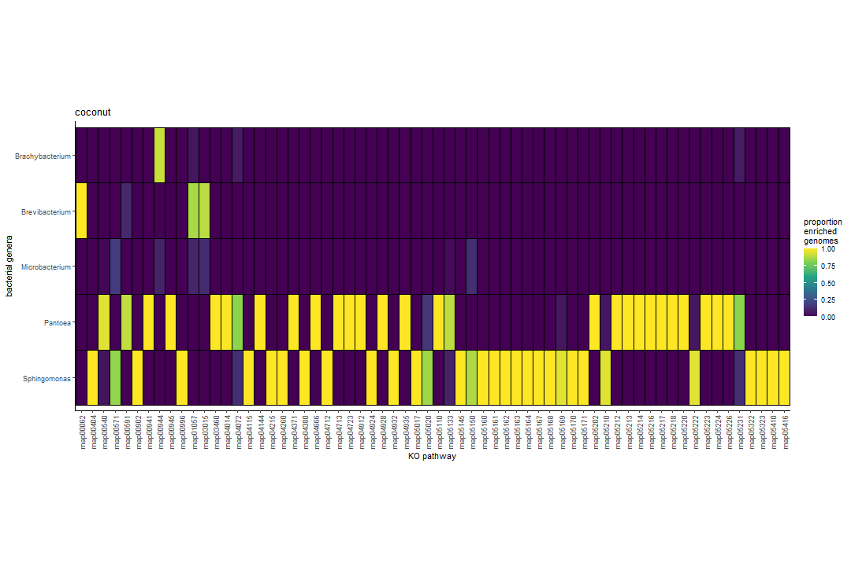  (a) Aesthetic 1 | 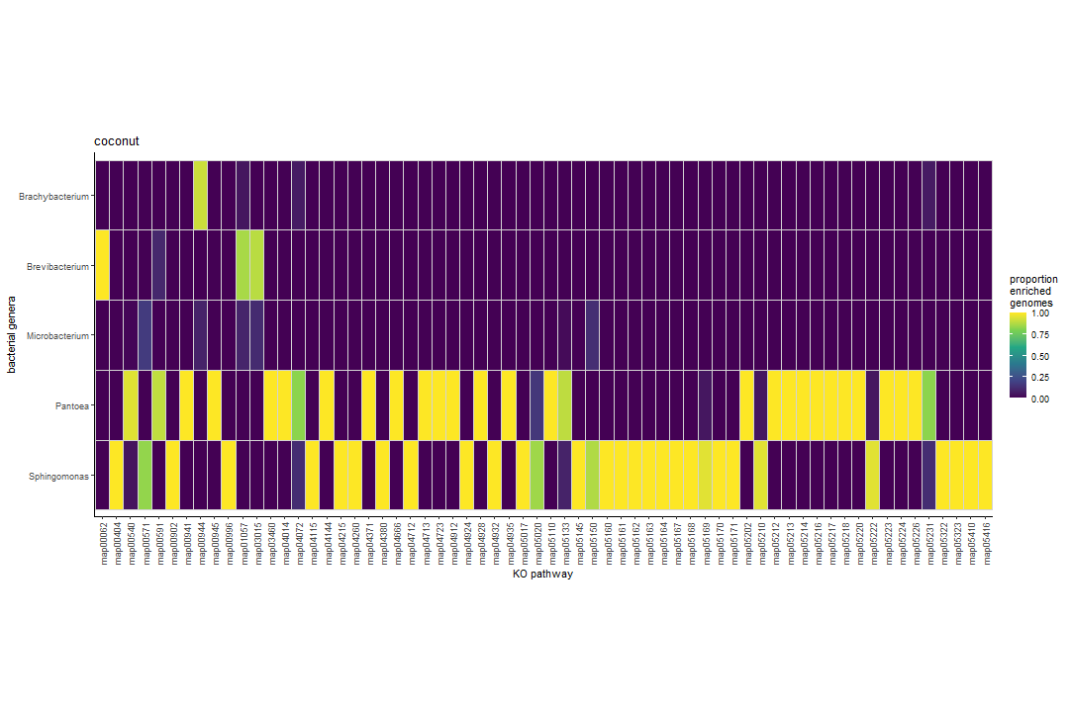  (b) Aesthetic 2

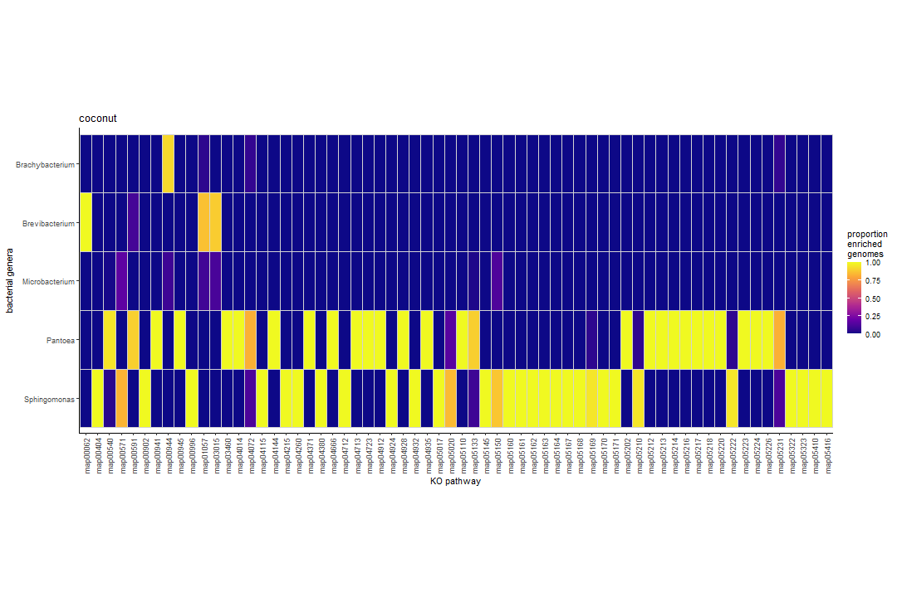
(c) Aesthetic 3

Figure 9.1: Examples of heatmaps created during prototype phase

10. eggNOG-mapper full process

10.1 Introduction
Doing some stuff with eggnog
In order to create the heatmaps comparing enriched pathways, the genome .fasta files need to be annotated. To do this, I used a program called EggNOG-mapper. I had many itterations of this process as I optimised the process through trial and error. However, the final scripts used are: £bookmark . These scripts are fed the .fasta files and run in slurm, outputting annotated .xlsx format files.

11. Final Heatmap and analysis

11.1 Introduction
The main purpose of the project, this took much time to get right. The first part of the process is discussed above. This section concerns the output of EggNOG-mapper, which become the inputs here, with the end goal of creating a heatmap where 1 Genus has over 80% of accessions enriched for a pathway and each of the others have less than 20%. This task created a pipeline that evolved over time, but the current scripts that are used are:
- KEGG_pathway_pipeline_p1_enrich.R
- KEGG_pathway_pipeline_p2_aggregate.R
- KEGG_pathway_pipeline_p3_proportion.R
These are in specifically that order, as one file feeds the next.

11.2 Methods
Once the output of EggNOG-mapper is downloaded (?@sec-eggnogmapper), they must first be enriched. This is p1 of the pipeline KEGG_pathway_pipeline_p1_enrich.R. The R package Mircrobiomeprofiler is used, specifically the EnrichKO() function to itterate over all the annotated accessions.
However, having a couple thousand individual enriched files cannot make a heatmap, thus they must be aggregated into one file, KEGG_pathway_pipeline_p2_aggregate.R.
Finally, the proportions must be applied to this so that only the rows meeting the criteria (>80% in any one and <20% in the rest), KEGG_pathway_pipeline_p3_proportion.R. I merged a 4th script with this, so this one also contains all of the formatting for the heatmap.

11.3 Results
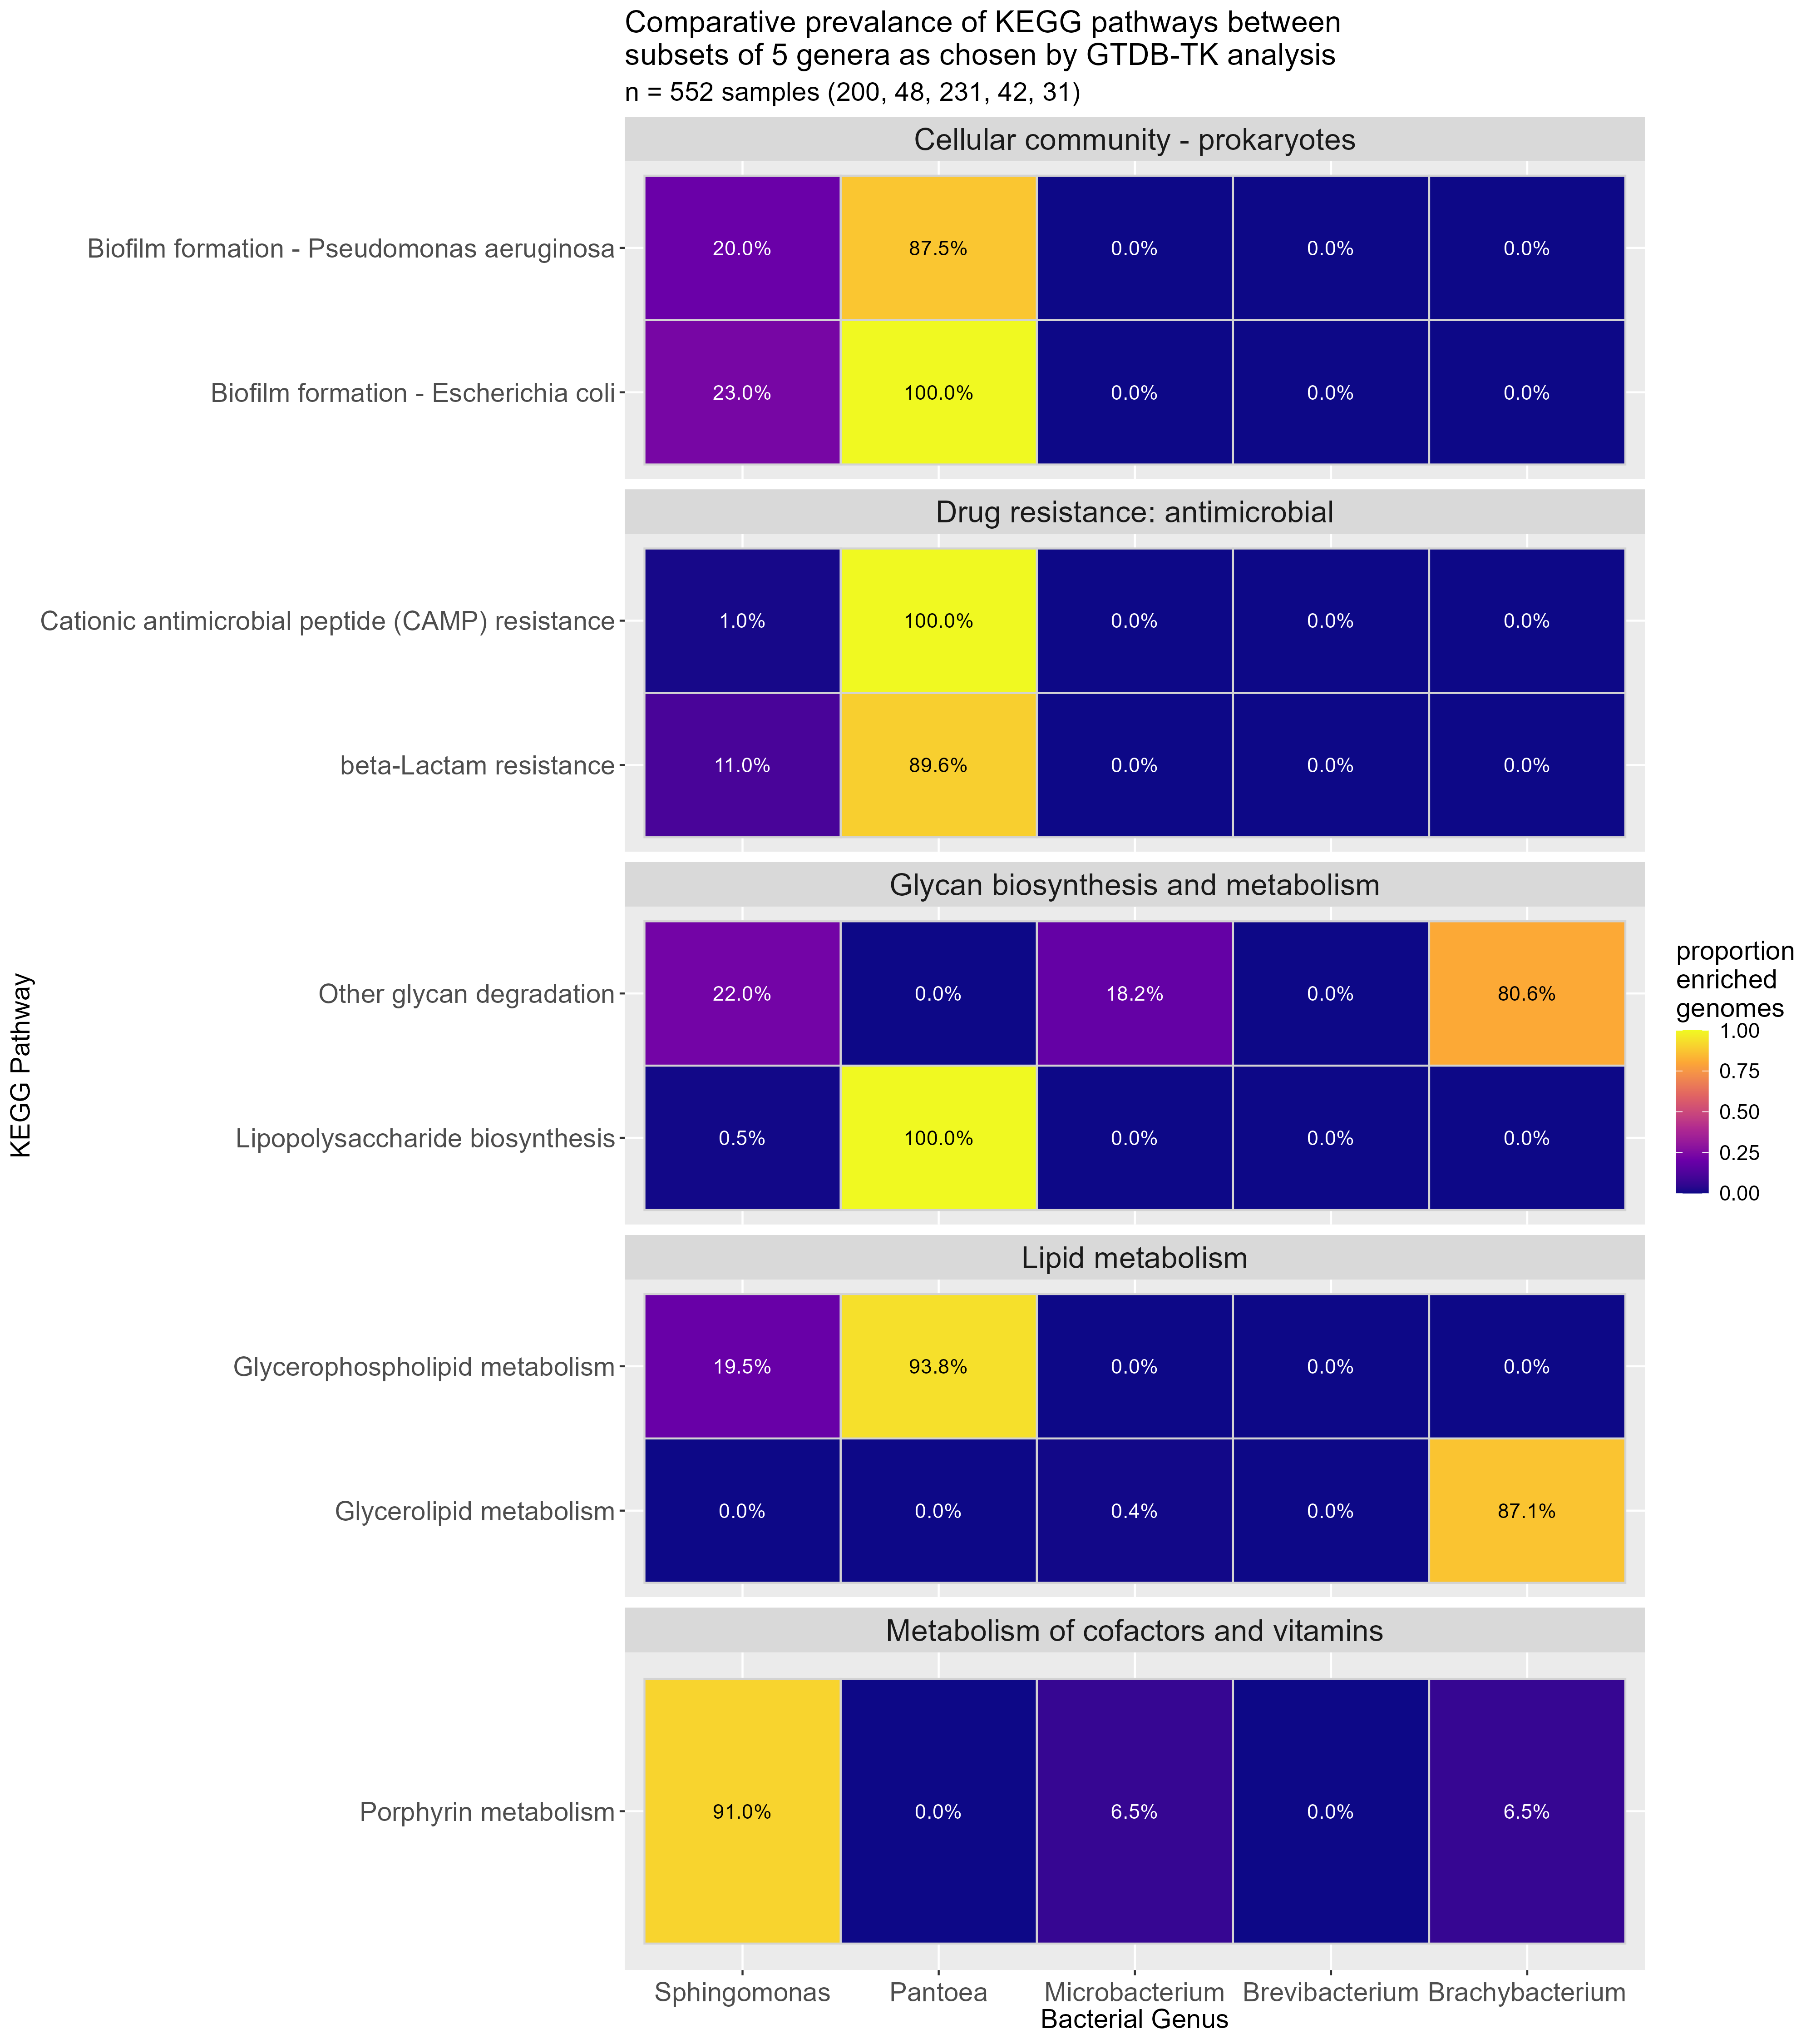
Figure 11.1: Heatmap comparing significant map pathways in 552 samples of both laboratory and public origin
As can be seen in Figure 11.1, metabolism makes up three of the five KEGG groupings. Seen to be more enriched in one Genus than the others. With the other two being Drug resistence and biofilm formation. The Genus Pantoea makes up 6 of the 9 pathways found, with Microbacterium and Brevibacterium having none.

11.4 Next steps
other heatmaps like the common one, the cutdown one
link to the prototype page where i did those

12. Wolbachia side-project

12.1 Introduction
In mid-August 2024 I helped with my supervisor Aaron Comeault’s paper (“Phylogenetic and functional diversity among Drosophila-associated metagenome-assembled genomes”) as a learning exercise for EggNOG-mapper and heatmapping. After receiving notes from the reviewers, Aaron asked me to process two samples of note from the study, that were Wolbachia species through Eggnog mapper and GTDB-TK so as to identify specific “Cif” and “WOPhage” genes. Specifically, I was tasked with answering the questions:
- Do they harbor the characterized Cif genes? or WOPhage?
- What other Wolbachia are they closely affiliated with?

12.2 Methods
Both of these processes were run using modified bash scripts I had already made for my own project on Hawk. Specifically; metagenomerunner.sh, metagenomequared.sh and wolbachia_gtdbtk.sh.

12.2.1 EggNOG-mapper
The first two scripts work in tandem, as their names suggest. The specifications for the eggnog analysis are set in metagenomerunner.sh, including the amount of memory to use, the input file location and where the output files should be located. metagenomequared.sh is passed a file containing a list of the file names and paths, I called this genera_control_file_batch_aa.tsv. metagenomesquared.sh uses this file to set parameters for the accession and filename based on the items in the list, then calls slurm to run metagenomerunner.sh, passing in the parameters. A while loop is used so that the rows can be itterated over, meaning I only need to run metagenomesquared.sh once to get both jobs loaded to hawk. Once the samples are annotated, a copy statement using command-line code at the end of metagenomerunner.sh copies the outputs to my home directory, where they are more easily transferred to my machine. Then, in R, i use a script called gene_analysis.R to load the outputs and attempt to find any reference to these “Cif” or “Wophage” genes. Unlike for the usual analysis, I do not run Microbiomeprofiler::enrichKO(), I am unsure whether enrichment would have been relevent for this analysis. Ultimately, none of these genes were found from this analysis.

12.2.2 blastn
In order to confirm or disprove the result above. Aaron told me to use a program called blastn. I ran this locally on the command line, my commands are stored in the script blaster.txt. These outputted the files; ztaro_tblastn_results.txt and ztsac_tblastn_results.txt

12.2.3 GTDB-TK
This process also began on hawk, using wolbachia_gtdbtk.sh. This process is simpler, as it takes a directory of .fasta files, for the un-annotated genomes. Then outputs a directory of files which I downloaded to my local machine. Then, using R, I read in the gtdbtk.bac120.decorated.tree output to the treemaker.R script, where I use the package ggtree to make the tree. However, Styling needed to be done for a more interpretable output, to aid this, I used the NCBI REST API to download metadata about the samples mentioned in the tree file, then used that to modify the tip labels and add identifiers of which samples were the local ones.

12.2.4 Results
Do they harbor the characterized Cif genes? or WOPhage?
After sending the outputs of the blastn analysis (ztaro_tblastn_results.txt and ztsac_tblastn_results.txt) to Aaron. He determined that they do confirm the existence of these genes. As it was not directly for my project, I did not question how he confirmed this. That may have been a mistake on my part.
What other Wolbachia are they closely affiliated with?
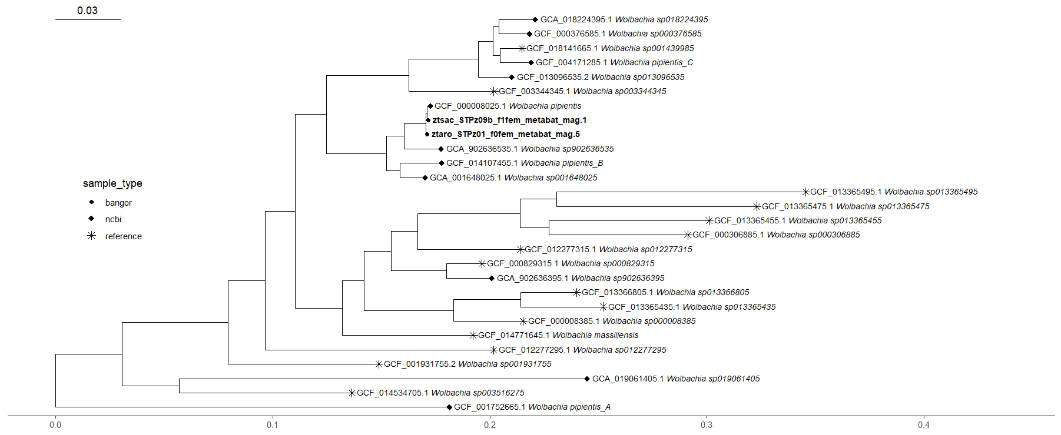
Figure 12.1: Phylogenetic tree showing which strains of Wolbachia are closest related to those isolated from Drosophila flies by Comeault et al.
The tree presents that the closest strain to both of the bangor samples are Wolbachia pipentis.

12.2.5 Scripts
this bit is by no means done, and i need to decide on how i want to do this bit, do i give a long list of individual files, directories? the other bits need refinement too, but that can wait until later. £bookmark

13. Flye outputs

13.1 Introduction
There were some files outputted from the initial Flye_asm work done by Aaron that I thought warranted a look at to sharpen my teeth on.

13.2 Methods

13.2.1 Flye analysis 1: assembly_info.txt
I created an R script, rawflyeanalysis.R. Basic stuff, imports the text files I chose to download (I wonder if I could download the flye.log files and use a sub() to cut out the non-useful stuff). This then sorts and processes the data into the table seen below using a few packages.

13.2.2 Flye analysis 2: flye.log
I then went back to the flye.log analysis I wanted to do largely for posterity. This was horrifyingly complex due to the “complex” nature of the flye.log files. I did this by creating a modified copy of my assembly_info.txt file grabber shell script, called flye.loggetter.sh, using ctrl + h to find and replace instead of manually changing things. I added this to an existing output directory in my home section of hawk, which I exported using MobaXterm. This is the folder called flyestuff, which contains both the flye.log and the assembly_info.txt files for each accession, I grouped them as it seemed relevent for organisation and didnt hinder the coding process at all. The R file I used to tabulate this is flyeloganalysis.R.

13.2.3 Results
Accession | Number of contigs | Total length | Largest fragment | Mean fragment length
3Dt2h | 166 | 3,006,227 | 125,244 | 18,109.80
1Dt100g | 153 | 2,104,071 | 74,994 | 13,752.10
2Dt1e | 149 | 2,332,403 | 70,689 | 15,653.71
3Dt1c | 86 | 3,636,266 | 275,317 | 42,282.16
3Dt2c | 84 | 3,819,610 | 247,364 | 45,471.55
3Dt2j | 75 | 2,813,977 | 195,248 | 37,519.69
2Dt1l | 16 | 3,996,506 | 1,089,026 | 249,781.62
1Dt2d | 6 | 5,345,294 | 2,288,975 | 890,882.33
1Dt1h | 4 | 4,336,578 | 2,051,556 | 1,084,144.50
1Dt100h | 2 | 2,379,473 | 2,349,045 | 1,189,736.50
coverage could not be calculated from this method as no result matched what was found in the *flye.log* files
Source: assembly_info.txt files produced in flye_asm analysis, August 27th 2024
Figure 13.1: Data obtained from flye outputs of samples taken from the skin microbiome of Dendrobates tinctorius
The basic flye output analysis produced this table, as mentioned, I couldn’t get coverage to match what was on the flye.log file that I got the original of this table from, it is possible that file is the one that is wrong, but genome coverage is kind of all over the place, so I just omitted it as I don’t think it’s one of the mandatory fields. I chose to sort the table by “Number of contigs” rather arbitrarily, but it does show something interesting in that why is there such a large range in fragment number?
Accession | Fragments | Total length | Fragments N50 | Largest fragment | Scaffolds | Mean coverage
3Dt2h | 166 | 3,006,227 | 26,385 | 125,244 | 0 | 390
1Dt100g | 153 | 2,104,071 | 18,022 | 74,994 | 0 | 318
2Dt1e | 149 | 2,332,403 | 22,011 | 70,689 | 0 | 344
3Dt1c | 86 | 3,636,266 | 63,365 | 275,317 | 0 | 320
3Dt2c | 84 | 3,819,610 | 69,733 | 247,364 | 0 | 190
3Dt2j | 75 | 2,813,977 | 71,970 | 195,248 | 0 | 350
2Dt1l | 16 | 3,996,506 | 345,773 | 1,089,026 | 0 | 289
1Dt2d | 6 | 5,345,294 | 1,019,507 | 2,288,975 | 0 | 225
1Dt1h | 4 | 4,336,578 | 1,857,409 | 2,051,556 | 0 | 404
1Dt100h | 2 | 2,379,473 | 2,349,045 | 2,349,045 | 0 | 224
Source: flye.log files produced in flye_asm analysis, August 27th 2024
Figure 13.2: Data obtained from flye.log outputs of samples taken from the skin microbiome of Dendrobates tinctorius
This is a table of the type of stuff I first collated in the Summer, it shares many similarities and cross overs with Table 2, neither have quality statistics, but both are metadata largely concerning the length and fragment, a marked difference is this one comes with a concrete value of coverage. Comparative analysis of them feels like a thing that would happen in the conclusion to this document.

13.2.4 Scripts
- flye.loggetter.sh
- flyeloganalysis.R

14. Learning, General Progress and Important Mistakes

14.1 Evolution of skills

14.1.1 Notebooking with R studio
I have made much progress with my record-making ability over the course of the project. When I started, in the summer, I was hardly recording my actions at all, as I prioritised results over that, assuming it would not be important later. Then, when the year began I started recording basic notes in a word document, they were basic and sloppy, but was better than what came before. Then, at Christmas when I decided to get my act together and fix errors I had made, I decided I wanted my notes to be more detailed and meaningful, so I started recording all details that I felt could be important, dates, exact descriptions, links to files created and details of what they did and why. These, I did in an R markdown format, a new concept to me at the time it is essentially an R document that has more bells and whistles than a traditional R script, allowing for cross-referencing and text modifications like allowing for bold and italic text, and the ability to Output to either html or word depending on what is required.
This was good, but I then discovered that Quarto Markdown existed, from what I found online it is a direct predecessor to Rmd, so I decided to make the switch from Notebook 3 onward, this was relatively similar to Rmd, but it did bring the benefit of a link to zotero for automatic bibliography (which doesnt work great but its fun it exists, it allows me to not have to manually make in-line references). And was overall cleaner with a more updated UI. Then, I discovered R projects. Basically a way of being able to connect all the scripts to one place for better linking.
This then developed even further as just recently I discovered R books existed. They are, as I understand it, a derived kind of R project that opperates like a book, with the ability to output to html multiple pages that are all linked together. I decided to make the portfolio an R book because it’s size was monstrous and all of it on 1 long page was ugly. I still do not understand the full breadth of what this resource can do, but I have come a long way.

14.1.2 Informatic Evolution
The Heatmaps are the main point of the project, and as such I have spent a lot of time on them. The first version of them was made in the summer on bacterial samples taken from insect species, including Drosophila. This was made using scripts that were given to me by Aaron that I adapted largely through a process of trial and error until I got a good-looking output. When I next attempted it on my own data, during the prototype, I wanted to do it myself, maybe take aspects of his code but largely start from scratch, so that is what I did.
The heatmaps went through many different evolutions over time, so many so that there are details of that process in Notebooks 2, 3 and 4 devoted just to that. I found ways of making better colour schemes, using API-downloaded metadata to add groupings based on what functions the pathways had and I added the percentages to the boxes, then fixed the problem with the axis.

14.1.3 Resources
My library of packages has increased as well. Even before the project I was confident using ggplot. However, over the course of the project I have found many packages I have found incredibly useful:
- ggplot - Great for making more detailed / visually appealing visuals than base R can accomodate
- Tidyverse (specifically tidyr and deplyr) - these have been very useful for data handling and transformation, in too many ways to really discuss here, but they allow for greater potential when handling data
- gt and flextable - Good for adding style to tables when presenting them. They each have benefits and weaknesses, so I cannot recommend one over the other
- httr2 - This is the package that allowed me to make API calls to the NCBI and KEGG websites, which is the reason I was able to transfer large amounts of data as quickly as I did

14.2 Learning programs

14.2.1 R
My ability to both read and utilize R has increased dramatically from where I started.

14.2.2 bash / slurm
I now have a cursery knowledge of how to use these systems on Hawk. I am not perfect, but I am proficient enough to navigate without issue and run jobs correctly.

14.3 Mistakes

14.3.1 Innitial delete
All the way back at the beginning of the project, in the summer, something I did on hawk deleted all of the genomic .fasta files that had been created by Aaron through Flye-asm. To this day, noone knows exactly why that happened. However, this did teach me the importance of understanding something before messing with it and not just racing to get a result out to be shown. I then took the time to get to grips with bash and command-line coding by testing on sample documents before applying commands that ran the risk of modifying the important folders.
(I also then either made copies of all important files from then on or downloaded them and stored them in OneDrive or Github so they could be recovered, just in case.)

14.4 Next steps

14.4.1 further analysis
There are several analyses I did in prototyping that I did not have the time to do on the final results that I would like to begin the dissertation with, these include:
- Analysing the significance of the pathways found in the heatmaps
- Analyse the other output files from CheckM2
- making the other heatmap versions (like the cutdown heatmap, the “core” heatmap, etc)
- figuring out the interactive tree
- get concrete taxonomic assignments somehow, specifically ANI

14.4.2 Coding languages
There are a few more languages I would like to learn. Specifically Python and SQL. I have been thinking about what I would like to do for my Masters and there are select places that offer Bioinformatics, in the course of this I learnt about how many tools (including some I have used, like GTDB-Tk) are created using python and some of the courses even have researchers make their own tools. This makes me want to have at least a basic understanding of the language as I now see how it might be important in conjunction with R (also many internships ask for it as what i guess is a matter of preference), instead of one or the other. As I am going to be handling large amounts of data, I believe a smart way to store and handle it is a SQL server, so that I can make a relational database and largely do more with the data with less effort. I toyed with the idea this year, but ultimately decided I did not want to do too much at one time, and the analyses I was running were too simple to require it.

15. Conclusion
The pathways found in the Chapter 11 analysis could be analysed and lead to a greater understanding of potential functions the bacteria have in relation to their host, the dyeing poison dart frog. A potential next step is to test samples from the same taxa of host over large geographic ranges to see what variation exists between populations, akin to work done by (marzinelli2015?) , using public data of known host and sampling site. It has been found that microbiomes are made of almost universally found or “core” symbionts and more variable microbiota (parfrey2018?). Using public host data to find these for different taxa could be an interesting avenue of study. Understanding phylogeny and taxonomy is important for knowing the variation between samples (washburne2018?). For example, in this dataset, Brachybacterium and Brevibacterium are very closely related, meanng there are fewer differences between them than the other groups, this means next steps could be to remove the more distinct samples to bring out those differences. It is important to inspect the quality of samples before real analysis can be performed, this is what i used CheckM and CheckM2 for (Chklovski et al. 2023).
I have learnt many skills from this project. My skills using R have especially grown exponentially from where I started. I have also gained crucial skills in notebook keeping and organisation that are necessities for any serious scientist. Secondarily, I have gained skills in command-line scripting and bash as well as data visualisation. I now also understand how to use genomic tools such as GTDB-Tk (chaumeil2022?).
(250 words 5-10 refs, this is split between analysis and skills)

References
Chklovski, Alex, Donovan H. Parks, Ben J. Woodcroft, and Gene W. Tyson. 2023. “CheckM2: A Rapid, Scalable and Accurate Tool for Assessing Microbial Genome Quality Using Machine Learning.” Nature Methods 20 (8): 1203–12. https://doi.org/10.1038/s41592-023-01940-w.

REST APIs Here are links to both in case you want to understand them in more detail: - NCBI - https://www.ncbi.nlm.nih.gov/datasets/docs/v2/api/rest-api/ - KEGG - https://www.kegg.jp/kegg/rest/keggapi.html
JSON This is a file type that works well with API calls, it needs special code to unravel it and pull out the useful information into a data frame, but that is a topic for another section. All that is needed to be known here is that it is a useful filetype for online data transfer.
annotation Here meaning the process by which genes are identified from chunks of genome
version Specifically, the version on Hawk was version 2.1.12

