Host-associated functional adaptations of Pseudomonas species in vertebrate microbiomes


Tobias Nunn
A dissertation submitted in partial fulfilment of the requirements for the degree of BSc/MZool in Zoology
School of Natural Sciences, Bangor University
Academic year 2025-26

Supervised by Dr Aaron Comeault

Declaration
By submitting this dissertation, I confirm that I am familiar with Bangor University’s rules about unfair academic practice, including plagiarism, self-plagiarism, and collusion, and have had a chance to discuss any concerns with my supervisor. I confirm that this assignment is all my own work and that I did not use AI to produce any of the text. I also confirm that no part of this text has been submitted for academic credit before (including for BSX-2021).

Student name: Tobias Nunn Date: 2025/03/23
Signature:


Gen-AI in assessment declaration
Student 500 number: 500690571
Module Code: BSX-3070
Assessment: Dissertation write-up
Assessment’s Gen-AI Category (see the Assessment Brief): 2

The following statement reflects my use of Gen-AI within this assessment (select all that apply):
Description of use | Select (X)
Gen-AI has not been used at all in producing this assessment.
Gen-AI was used in an assistive role to research topics and provide explanations. | X
Gen-AI was used in an assistive role to suggest sources of information, e.g. publications to read.
Gen-AI was used in an assistive role to summarize the content of publications or other sources.
Gen-AI was used in an assistive role to produce an outline or draft structure of my assessment.
Note: for Category 2 assessments, the fundamental content of the submission (e.g., the arguments, interpretations, conclusions etc) must be your own.
Gen-AI was used in an assistive role to improve spelling, grammar, sentence structure and/or clarity of expression of my assessment.  Note: for Category 2 assessments, the basic written expression must be your own. Therefore, whilst Gen-AI may correct mistakes it must not produce the actual content. | X
Gen-AI was used in an assistive role to translate text during the production of the work.
Gen-AI was used in an assistive role to analyse data and/or produce visualizations of data.
Gen-AI was used in an assistive role to help produce creative outputs e.g. art, imagery, movie, music, creative writing.
Gen-AI was used in an assistive role to refine computer code and/or other output. | X
Gen-AI was used in another assistive role (please describe):  Gen-AI was used to speed up work-flows by aggregating data, as shown in the supplementary tables. This was done under researcher supervision and based on specifications the researcher passed to it | X
Gen-AI was fully used to complete a Category 3 assessment and use complied with the assessment instructions provided.

By using this cover sheet and entering my student ID above, I declare that I have provided honest and accurate details regarding my use of Gen-AI within this assessment.

Host-associated functional adaptations of Pseudomonas species in vertebrate microbiomes

Abstract
The characterisation of functional differences between bacteria, brought about by the coevolutionary forces seen in host-associated microbiomes, is an expanding field. Public genomic databases could allow for efficient and cost-effective analyses of these differences. The genus Pseudomonas represents a generalist bacterium that has been studied in many vertebrate Classes. This allows for a comparative assessment of these differences across functionally distinct host ecosystems. This study utilises the NCBI genomic database to identify signs of adaptation in Pseudomonas associated with 4 vertebrate host Classes. This involves filtering, annotation and enrichment of this data. The Kyoto Encyclopaedia of Genes and Genomes (KEGG), through the eggNOG-mapper tool, was used for this enrichment step. This assigned proteins to Orthologous Groups of shared function. EnrichKO was used to place these into pathways and identify over-representation. These were functionally compared between groups. This identified 6 pathways as over-represented in 1 or more of the host groups, split between 2 pathways found specifically inside 1 host group, and 4 shared between multiple. This analysis was checked and built on through further abundance analysis, to identify the proportion of the group found significantly over-represented. A phylogenetic analysis identified potential biases in the data, through taxonomy and geography. This study successfully made novel discoveries surrounding functional adaptation in host-associated microbiomes. However, the adaptations seen are often too broad-reaching to properly ascertain the cause of the adaptation. This method is ideal for speed and efficiency, however, there are factors that are difficult to control, resulting in potential limitations or biases in the data. Overall, this represents a useful tool for study design, identifying functional mechanisms for further research. As the wealth of genomic data grows, this technique will only increase in utility and scope, as it can be used to study the functional differences underlying a range of microbial systems.

Keywords
Microbiome; Ecology; Adaptation; Functional Genetics; Genomics; Bioinformatics

Introduction
There is a wealth of literature surrounding the importance of host-associated microbiomes to vertebrate lineages. The majority of research focuses on specific relationships between hosts and their microbiomes derived from shared evolutionary history. For example, an understanding of how skin microbiomes can interact with and bolster host immunity to pathogens (Ross et al., 2019), the interactions between the digestive microhabitat of the vertebrate gut and its associated microbiome, and how this aids in digestion for the host (Youngblut et al., 2019) and the links between microbiome health and stress response, specifically concerning climate change, in vertebrates (Greenspan et al., 2022). There are even some papers specifically looking into the interplay between these microbiomes and host behaviour (Cryan and Dinan, 2012). Comparatively few papers discuss the microbiota as a community inside an ecosystem, which is shaped by competition between microbiota and control from the host (Foster et al., 2017). This means functionally distinct hosts are potential drivers of functional changes and adaptation in the bacterial lineages found closely associated with them (Comeault et al., 2025). Over evolutionary timescales, this could lead to eco-evolutionary interplay shaping both host and microbiome (Limborg and Heeb, 2018). However, the specific path evolution takes will differ for each species, as well as each population of bacteria.
A comparative approach can be used to identify signals of differential functional adaptation to hosts of different clades. Certain groups of genes are often found to express more or less when grouped in specific ways, being considered “enriched” in these groups (Neave et al., 2017, Props et al., 2019, Ghaly et al., 2023). This comparative approach to functional differences in gene expression forms the basis of many methodologies in the field. These include Over-Representation Analysis (ORA) (Wieder et al., 2021), Pathway Analysis (PA) (García-Campos et al. 2015) and Gene-Set Enrichment Analysis (GSEA) (Shi and Walker, 2007). All of these facilitate the discovery of differences in enrichment between groups of bacteria.
It can be assumed that taxonomically homologous bacteria will share functional characteristics based on the host environments from which they were sequenced. For example, in the case of host-associated microbiomes, evolutionary relationships inside of the host taxa can drive similar selection pressures to form on the bacteria, and thus convergent adaptation, effectively grouping the bacteria of the microbiomes by function and allowing for comparative approached across a range of host taxa at many scales. Assuming that populations of generalist bacteria are somewhat reproductively isolated, specific differences in functional potential should be found, driven by the selective pressures the host environment puts on the bacteria that inhabit it. These pressures should be different between multiple host groups of functional similarity.
To facilitate this analysis across multiple host taxa, a highly generalist clade of bacteria is required, found across a vast range of environments, and ideally with a large wealth of previous research to provide enough samples for meaningful statistical analysis. An ideal bacterial taxa is the Genus Pseudomonas. It can be found ubiquitously across a wide variety of environments and ecosystems, spanning both terrestrial and aquatic environments (Spiers et al., 2000). At the time the genome of P. aeruginosa was first sequenced, it was the largest bacterial genome ever seen, presenting the wide variety of conserved genes held within (Stover et al., 2000). As such, previous study has focused on the functional divergence of Pseudomonas between different environments, finding variation in the enrichment of genes concerning the specific metabolites the bacteria utilize (Saati-Santamaría et al., 2022). This presents an interesting model to use to understand and characterise the coevolutionary processes between hosts and their associated microbiomes. For example, the Classes of the Order Vertebrata are found widespread across Earth, accounting for much of the biodiversity on the planet. The importance of the microbiome to these groups cannot be understated, with a vast array of literature covering all taxa, however, there are still many unknowns in the field. The adoption of Next Generation Sequencing (NGS) techniques has allowed much more widescale and rapid sequencing of microbiome data (Colston and Jackson, 2016). However, de novo sequencing with NGS remains computationally costly when working at the large scales required to accurately capture the functional and taxonomic breadth of a microbiome, or the full host range a generalist bacteria may associate with (Vincent et al., 2017).
This can be addressed using publicly available online genomic data repositories. These are databases of genomic sequences, and their associated metadata, storing vast quantities of data that researchers have already generated. As the sequences already exist, this allows for more rapid library preparation and analysis, and costs a fraction of the capital required for de novo sequencing. This is especially important for microbial genomics, as many sequences are Metagenomic Assembled Genomes (MAGs). Creating these requires a complicated process of library preparation, deep shotgun sequencing and computational algorithms. However, there are only a few years of data for high-quality shotgun sequenced bacterial genomes from environmental and host conditions, and this remains costly (Chivian et al., 2022). This makes public genomic repositories ideal, in theory, for microbial analysis. Data from these sites can supplement analyses, helping strengthen the statistics involved, and keep costs down to allow a wider range of analysis. As an important data source, it is vital to characterise its abilities, and limitations, for novel analysis in its own right, without being supported by new, lab-made data.
This study aims to use publicly available genomic data to make novel and cost-free inferences into the functional adaptation experienced by the generalist bacterial genus Pseudomonas to multiple different groups of vertebrate hosts, assumed to act as functionally similar or identical ecosystems. Achieving this aim will involve the objectives of:
- Downloading and processing publicly available genomes through a bioinformatics pipeline to translate and annotate them
- Run them through software designed to conduct functional enrichment analysis
- Use a comparative approach to identify functional differences in gene content between host groups

Method
Data collection and filtering steps
The National Centre for Biotechnology Information (NCBI) Genome dataset, operated by the US National Institute of Health (NIH) was chosen as the source of data for the study, as it contains a wide variety of bacterial sequences. Firstly, metadata for all samples with the genus Pseudomonas were downloaded, then, the same was done for the files containing the genomic content, identified using an Accession number. The genus level was chosen as it was the lowest taxonomic level having a meaningful amount of data. This was done on the 8th of December 2025 and resulted in roughly 59,000 samples being downloaded. Using this metadata, samples could be filtered out of the study. The characteristics of relevant samples for this study are those with:
- hosts from vertebrate taxa
- putative wild hosts; and
- high genome assembly quality.
Only potentially wild hosts were taken as it can be assumed domesticated and human hosts have non-natural or disrupted microbiomes, such as through antibiotic exposure (Fishbein et al., 2023). An AI model was used to assign the hosts of samples to potential domestication status, this is presented in supplementary table S1. The accessions were then filtered again to remove any low quality samples. This was done using the CheckM scores within the metadata. Specifically, a completeness of 80% or above and a contamination below 15%. These metrics were chosen to admit a group of Amphibian-hosted accessions. An AI tool was then used to place these accessions into groups based upon the host taxonomic Class. This was chosen in the interest of speed and consistency, being potentially less prone to error than human assignment, this filtering step is presented in supplementary table S2. Only those groups which retained 28 or more accessions were kept to allow for statistically significant analysis. The distribution of samples between the remaining groups is seen in Table 1. An understanding of the taxonomic breadth of samples in the dataset was also deemed necessary, to comprehend the potential variability between samples. This is visualised by Table 2.
Descriptive analysis
A phylogenetic analysis was conducted upon the genomic data to identify the evolutionary relationships between the samples of the dataset. This analysis utilised the de_novo_wf workflow of the software GTDB-Tk, version 2.3.2 (Chaumeil et al., 2022). Accession metadata was added to the tree, including the host information seen in Table 1, the taxonomic information seen in Table 2, and information on country / region of origin. Samples originated from a diverse array of countries, therefore, it was decided to group samples at the continent or sub-continent level, to allow a more comprehensive number of groups. However, countries which produced over 100 samples were retained at this level, this was conducted with an AI tool, decisions in Supplementary Table S3. This was used to produce Figure 1.

Data processing pipeline
Annotation
Firstly, the genomic sequences needed to be translated into protein sequences. This was done using Prodigal version 2.6.3 (Hyatt et al., 2010). These protein sequences were then annotated using EggNOG-mapper version 2.1.12 (Cantalapiedra et al., 2021). The pipeline for this tool was split into its 2 constituent functions, and each was run separately, to greatly increase the speed of the annotation. The files containing the protein sequences were combined into 1 input file, to improve throughput. The EggNOG-mapper search and annotate phases were run separately, to optimise the use of computational resources. This required High Performance Computing (HPC) resources in the form of the high-memory node of the Hawk supercomputer, operated by Super Computing Wales (SCW). It was here that the memory intensive annotate phase was run. This annotated the data with KEGG Orthology (KO). These are groupings of genes of shared or similar function that KEGG (Kanehisa and Goto, 2000) have curated for purposes such as this study.

Enrichment
The tool enrichKO (Xu et al., 2024) was used to perform enrichment analysis, to find the KEGG pathways over-represented in specific groups. These pathways are networks connecting the KOs found in the samples into biological systems (Aoki-Kinoshita and Kanehisa, 2007). The tool takes a unique list of the KOs passed into it, then assigns the KOs to their known pathways. Also input into the tool is the “universe”, being the total list of KOs that is statistically compared against to find significant over-representation. The total unique list of KOs found across the groups of the study was used for this. This is useful as the background is representative of the data within it, potentially making the pathways found over-represented more meaningful. This finds over-representation for pathways across groups. However, as the list of KOs is uncoupled from the individuals they originate from in this method, it is unknown from where in said group they originate. This analysis is supported by another use of this tool, however, in this case it is run on a list of KOs from each individual in turn, the results are then combined based on the host group. It is then possible to find the proportion of those individuals over-represented for the pathways identified in the former method, compared with those in each group that are not over-represented for those pathways. This forms a measure of abundance that can illuminate the true correlation of an over-represented pathway with a host group.
Code is available in the GitHub repo associated with this study:
https://github.com/tobiasnunn/undergrad_dissertation

Data analysis
For the KO content of each group, enrichKO identified significant pathways, and used statistical methods to assign significance, thus producing a p-value. However, this value is then adjusted with the Benjamini-Hochberg Correction, ideal for multiple testing. This reduces the number of false positives by controlling the false discovery rate (Benjamini and Hochberg, 1995). Thus, this value was taken to infer that a pathway significantly correlates with a host group, specifically where the adjusted p-value was below 0.05. These could then be compared between the 4 groups for the each pathway found. Figure 2 represents the pathways which were found significantly over-represented in only 1 group (adjusted p < 0.05) and not in the other 3 (adjusted p > 0.05). Similarly, Figure 3 represents the pathways which could be found significantly over-represented in multiple of the study groups. This will show pathways that may correlate to certain lifestyles or traits that could be shared amongst the vertebrate clades, and are still different from the background, so there is confidence they did not arise by chance. As mentioned, this analysis was then cross-referenced, wherein, enrichment was run individual-wise to confirm the pathways found in Figures 2 and 3 were in fact present in some individuals of the study for the host groups they were found enriched in, this produced Figure 4.
Ethics Statement
This research was screened under Bangor University’s Research Ethics Framework and no issues were identified

Results
Descriptive tables
After the data were filtered, as discussed Methods, the remaining dataset comprised 337 genomes, split between 4 groups of unequal size (Table 1). The aim was for all vertebrate lineages to be represented, however, there were not enough samples hosted by individuals in Classes Reptilia (n=16), Agnatha (n=0) and Chondrichthyes (n=0). The group for Class Insecta-hosted Pseudomonas contained roughly 60 genomes. However, invertebrates were excluded from the study as too dissimilar to vertebrate taxa. As represented in Table 1, Mammal-hosted and Bony Fish-hosted Pseudomonas numbered much higher, at 140 and 113 respectively. Whereas, for Bird-hosted and Amphibian-hosted Pseudomonas, the groups were smaller, numbering 54 and 28 individuals. The amphibian-hosted results should be treated with caution, as the effects of biases in the data will be most prevalent in this group. It should also be noted that inside the Osteichthyes group, there were no fish representing the sub-class of lobe-finned fish Sarcopterygii, meaning this group also represents the sub-class of ray-finned fish Actinopterygii.

Table 1 - Count of Pseudomonas bacterial samples grouped by host's taxonomy at level of Class for 4 vertebrate Classes
Host group | Count
Mammal (Mammalia) | 140
Fish (Osteichthyes) | 113
Bird (Aves) | 54
Amphibian (Amphibia) | 28

Similarly, the 337 samples were broken down by Pseudomonas species. However, many individuals did not uniformly map to a species, being represented in the metadata by abstract strain IDs, for which there was only a single individual. Instead of all samples, Table 2 displays the 10 largest species of Pseudomonas present in the study, totalling 196 / 337 samples. Most obviously, it shows that the species P. aeruginosa dominates the dataset, representing 151 of 337 samples (≈45%). Comparatively, the next groups are much smaller. The second largest group, “Pseudomonas sp.”, representing individuals for which a species could not be assigned. The next-leading species, P plecoglossida, comprises 14 individuals. The groups get smaller from here, ultimately, the remaining 45 individuals are split between these 8 species, reiterating the dominance of P. aeruginosa.

Table 2 - Count of Pseudomonas genomes, grouped by species of Pseudomonas for 10 highest-represented species
Pseudomonas species | Count
P. aeruginosa | 151
Pseudomonas sp. | 18
P. plecoglossicida | 14
P. putida | 7
P. chlororaphis | 6
P. fluorescens | 5
P. guariconensis | 5
P. asiatica | 4
P. protegens | 4
P. imrae | 3

Phylogenetic analysis
Figure 1 displays the phylogenetic tree constructed from the data. It presents there are three groups in the tree, which form clades. Through adding the taxonomic information to the figure (middle ring), one can see the upper, tightly-knit clade corresponds specifically to the species P. aeruginosa. The other two clades, the left-lower and right-lower, are not obviously dominated by any singular species. Firstly, the inner-most ring displays vast majority of mammalian-hosted samples form a single cluster which matches closely with the clade of P. aeruginosa. Similarly, bony fish-hosted samples form a cluster in the lower-right clade, however, are seen much more dispersed throughout the lower-left clade. Amphibian and bird-hosted samples are seen more widely distributed across the dataset. The middle ring confirms P. aeruginosa is by far the biggest single Pseudomonas species present in the study, with the majority of samples being of unknown species. The outermost ring of Figure 1 presents that the largest Country of origin for the samples is China, with the clusters of fish-hosted samples seen in the lower-right clade mapping very closely to a Chinese origin. Outside of this, there is a wide diversity of geographic origin for the samples, with samples across all host groups originating in multiple continents. The majority of mammal-hosted samples are found in the upper clade of the tree, matching to P. aeruginosa. The other groups of the dataset are more evenly distributed across the taxonomic range in the data. However, fish-hosted samples also form a cluster, with the majority of samples found in a few taxonomic clades.
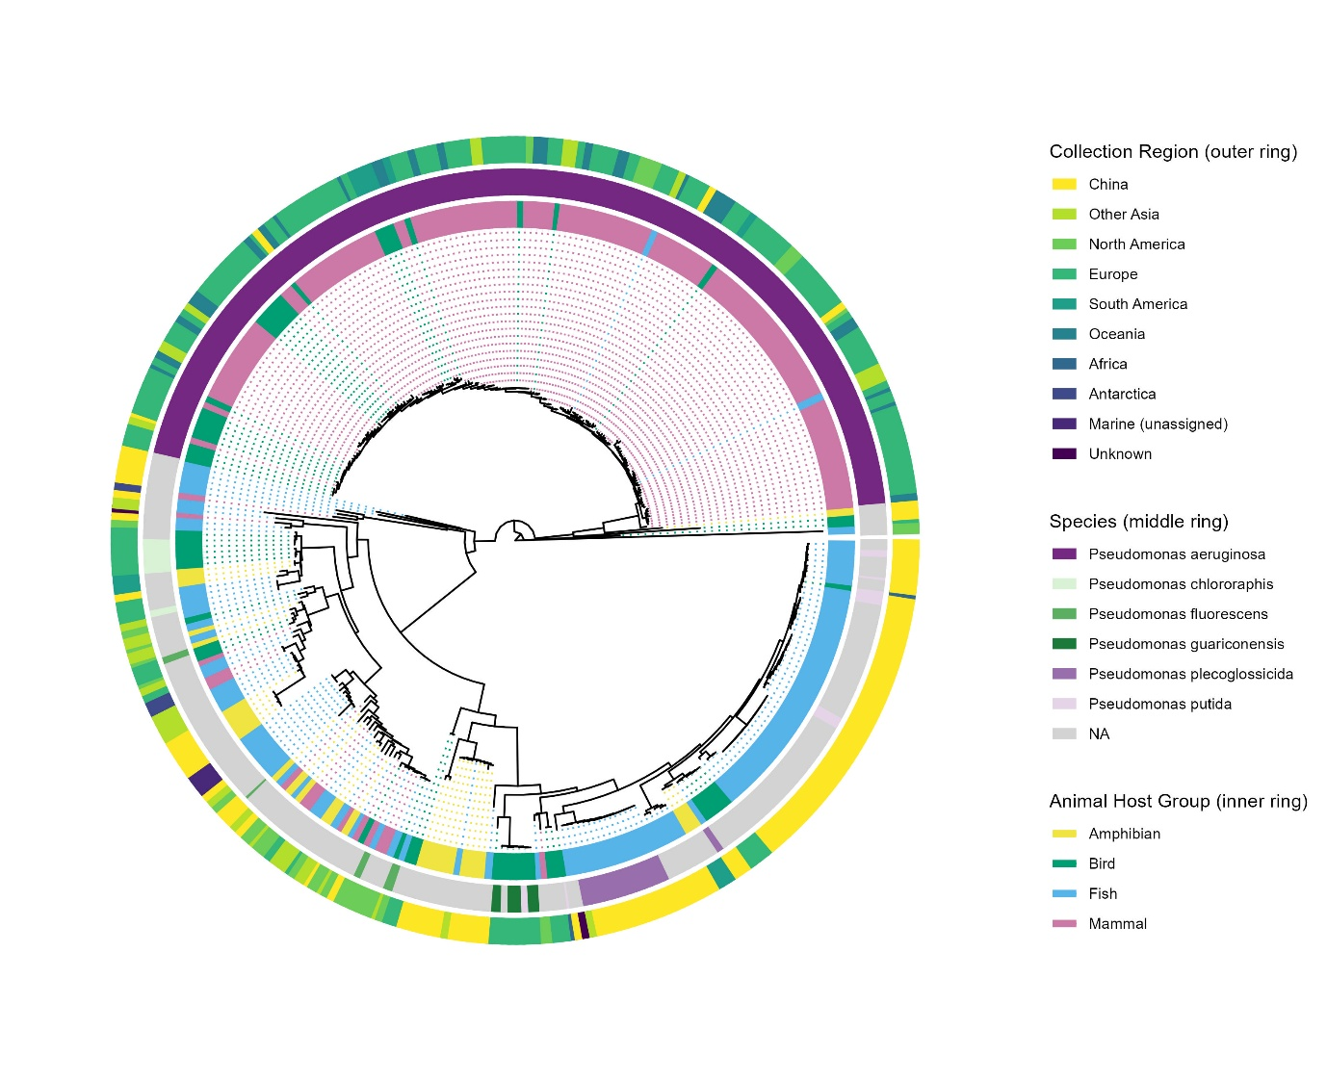

Figure 1 - Phylogenetic tree showing relationship between wild vertebrate hosted Pseudomonas bacteria (n=336). Added data includes: host Class group (Inner ring), bacterial taxonomic info for the largest species (Middle ring) and region of collection (Outer ring). In the case of the middle ring, NA is taken to mean any sample not in the groups listed in the key, an alternative is “Pseudomonas spp.”

Pathway analysis
Enrichment analysis concluded that there were 2 pathways that were over represented (adjusted p < 0.05) in 1 group, and were not significantly different from the background, through what could be expected by chance, in 3 groups. This is visualised in Figure 2. It should be noted that this does not imply the absence of these pathways in the other groups. This results states these pathways are over-represented in these groups compared to the background, moreso than would be expected by chance. The two pathways found are map00270 (Cysteine and methionine metabolism) and map01240 (Biosynthesis of cofactors), they were found to be over-represented in the amphibian host group and the Osteichthyes host group respectively. However, in the case of the latter, it was found to have an adjusted p value of 0.066 for the Amphibian host group, barely outside the range of significance.
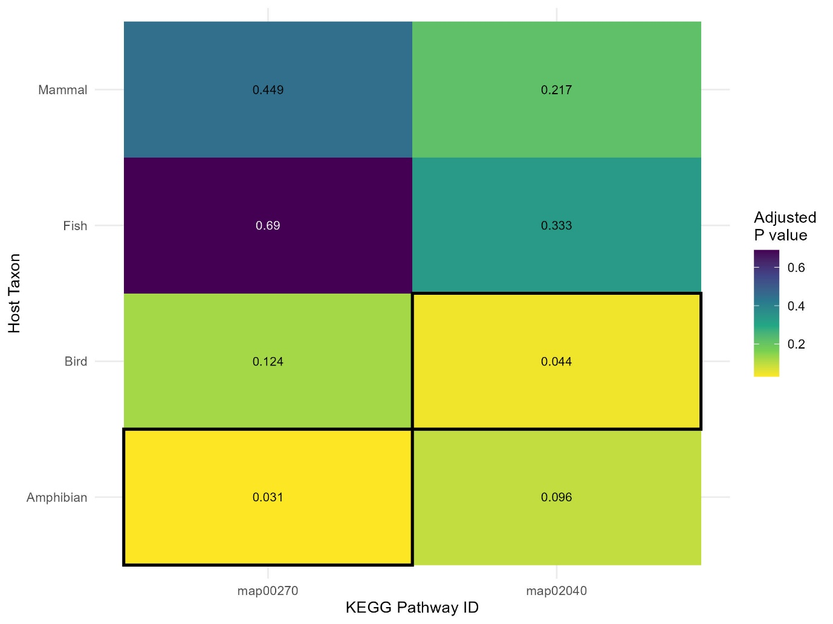
Figure 2 - Heatmap showing significantly enriched pathways between 4 groups of Pseudomonas bacteria, based on host Class. Lighter colour signifies lower p value, in addition, the exact p value is present in each cell. The dark border around some cells indicates a significant correlation between a pathway and a group (adjusted p value < 0.05).

Pathways found to be over-represented in multiple groups, presented in Figure 3, show great variation. It should be noted that an adjusted p value of 0 corresponds to a number with 4 decimal places or lower (i.e. <0.001), and are thus very significant results. Firstly, map02025 (Biofilm formation - Pseudomonas aeruginosa) is significantly over-represented with all groups excluding Amphibian hosts. However, with a p value of 0.096, this barely misses the significance threshold. Map02040 (Flagellar assembly) is found significantly over-represented in Amphibian and Bird hosted Pseudomonas. Map03010 (Ribosome) is found significantly over-represented in all but Fish-hosted samples. Finally, map03070 (Bacterial secretion system) is found significantly over-represented in Mammalian and Avian host groups.

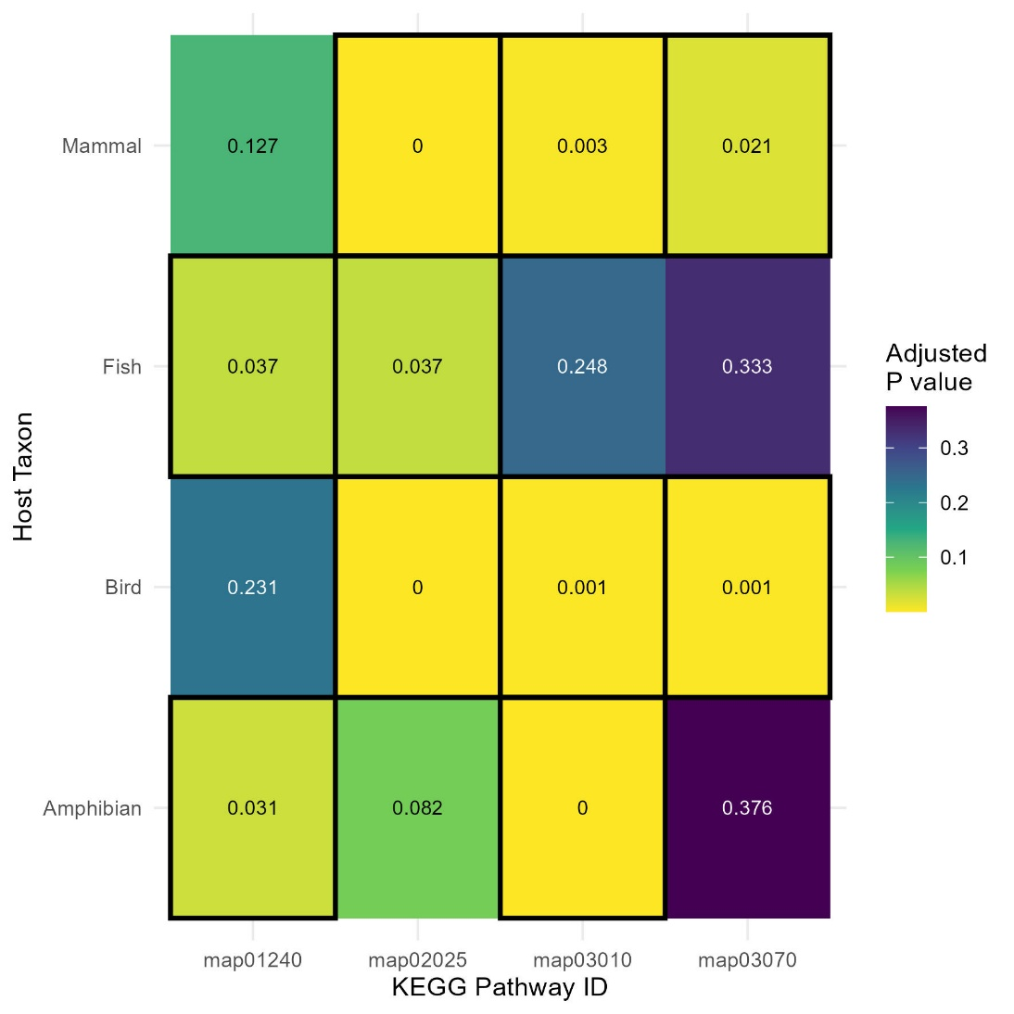
Figure 3 - Heatmap showing shared pathways of significant over-representation between 4 groups of Pseudomonas bacteria, based on host Class. Lighter colour signifies lower p value, in addition, the exact p value is present in each cell. The dark border around some cells indicates a significant correlation between a pathway and a group. An adjusted p value of 0 signifies a value of 0.0009 or lower.

Figure 4 displays a check on the abundance of the significant pathways identified in the individuals of the dataset. Meaning, the proportion of individuals found in each group that were significantly enriched (adjusted p value < 0.05). As this is not dependent on the group-wise enrichment, this does not clearly map to Figures 2 and 3, however it is worth having. For example, if a pathway is found enriched in one group, but the abundance of that pathway in the group is low, this could represent the pathway belongs to a sub-group, such as specifically Anurans inside Amphibia. They are not dependent on each other as first step the enrichKO tool conducts is to de-duplicate the list of KOs passed to it, which gives equal weighting to all KOs in the list, thus removing the impact of abundance.
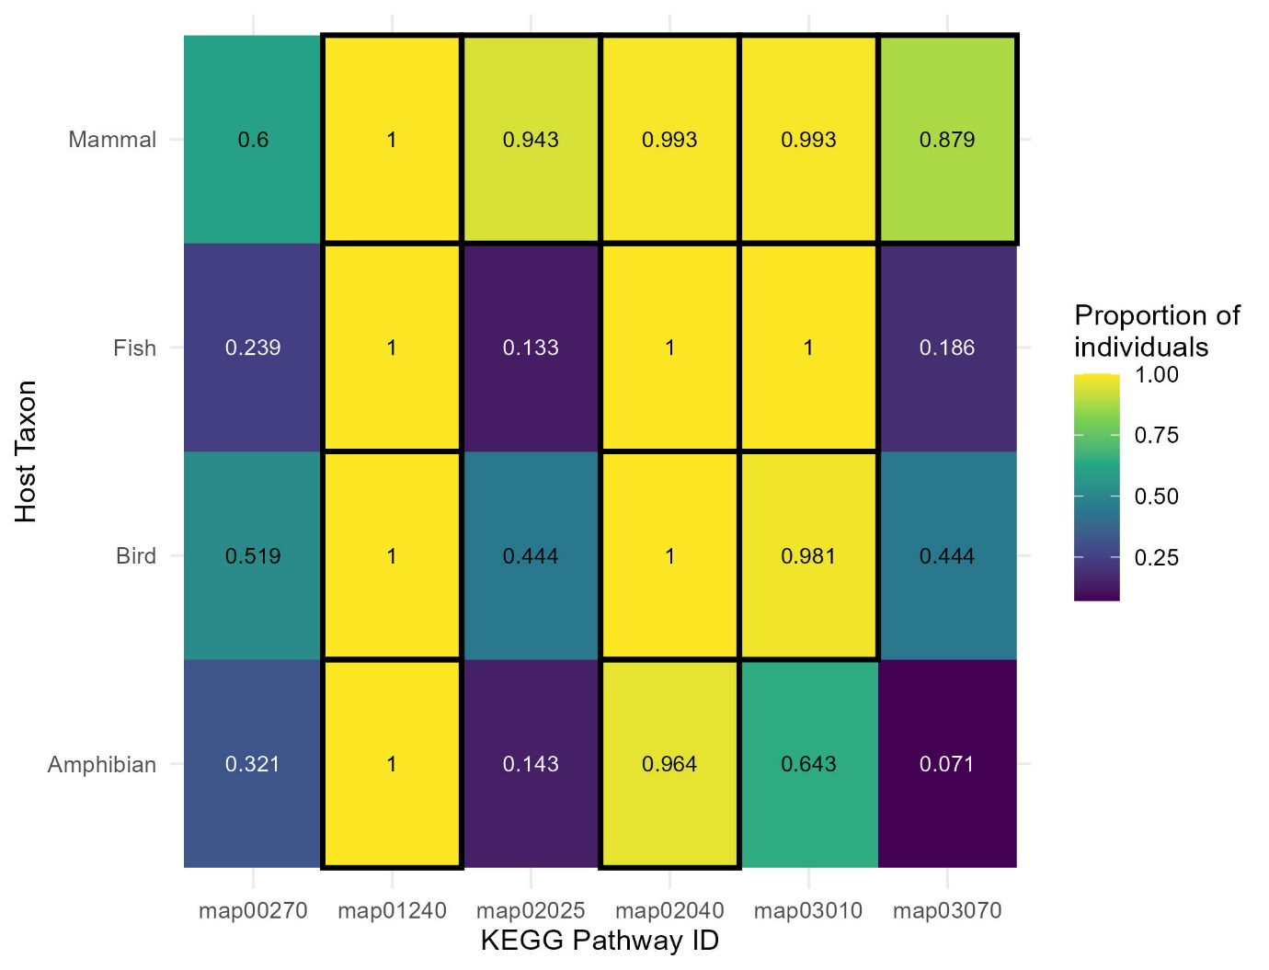
Figure 4 - Check of methodology. EnrichKO was ran on the individual genomes, instead of on the collective KO reserviour of host-groups. Numbers differ from Figures 2 and 3 in that they represent the proportion of individuals found enriched (adjusted p < 0.05) for the pathway of interest. The black border around some boxes represents where a pathway is over-represented for 80% of individuals in that group, this is taken as being a significant majority of samples.

Discussion
Limitations
Figure 1 shows clustering in the Mammalian and Fish host groups. This un-even distribution of host groups across taxonomic clades could represent taxonomic bias in the data. As shown in Table 2, P. aeruginosa alone represents nearly half of the samples in the dataset; it is possible the full breadth of diversity in Pseudomonas is not being represented in this dataset. Finally, the correlation between fish-hosted samples and Chinese origin presents possible geographic bias in the data for fish-hosted samples, especially considering over half (54) of the samples originate specifically in Whenzhou (Supplementary Table 3). Overall, it is evident that for the larger groups, there are some potential biases, this presents a limitation with this study type, the research is dependent on there being an even distribution of researchers across the world studying the full range of bacterial species in the taxa of interest across the full range of host microbiomes it can be found in. This is impossible to avoid in this analysis type, as some vertebrate lineages are naturally more studied than others, this reflects a bias toward mammalian species in the field as a whole (dos Santos et al., 2020). This can be easily seen by the distribution of samples in Table 1. Comparatively, bacteria from herpetological and non-ray-finned fish contexts are lacking in this data source. In addition, a lack of consistency in recording metadata hinders the ability of this method. For example, the inconsistency in host name necessitating the use of either an AI tool (Supplementary Table S1) or hours of time spent meticulously categorising for a researcher. Contributing to this is the many samples in the database with missing host information, leading to their exclusion from this study. This massively reduces the number of high-quality samples available to study.
Pathway discussion
A total of 6 pathways were found to be significantly over-represented in one or more groups. Two pathways were found over-represented in only 1 host group (Figure 2), implying that this is an adaptation to the microbiomes of that host clade. There were 4 pathways found over-represented in multiple groups (Figure 3). This over-representation suggests that these are significant adaptations in these bacteria to some shared characteristic seen between these Classes of vertebrate. Abundance of these pathways in the groups of the study (Figure 4) does not show a clear and consistent relationship with group-wise over-representation. However, this does not disprove the analysis, only adding new context to it, as will be discussed on a case-by-case basis.
Firstly, map00270 (Cysteine and methionine metabolism), found over-represented in amphibian hosts, is a pathway involved in the biosynthesis and degradation of the aforementioned amino acids. These molecules are known to be semi-essential to the diets of mammals, having many important roles, ranging from metabolism to immunity and oxidation (Bin et al., 2017). Specifically, Methionine has similarly been recognised as important to the diets of fish. This molecule is seen as indispensable in vertebrate taxa, meaning that vertebrates cannot synthesise it de novo (Gao et al., 2019). Previous study has shown that complex molecules, such as xenobiotics are capable of passing through the skin surface membranes of Amphibians directly (Kaufmann and Dohmen, 2016). Microbiome research also focusses largely in the gut, where research in humans finds the microbiome is capable of producing beneficial molecules the host cannot make itself. Such as, through the production of vitamins and the digestion of complex carbohydrates (Schluter and Foster, 2012). This could suggest it is useful in the uptake of these molecules for the host. This pathway is not heavily abundant (>80%) in any group with the Amphibian host group having one of the lower abundances at 32%. This could represent that this pathway is over-represented in a sub-group. This could be for many reasons, including; isolation source, taxonomic bias in the group and a specific clade inside the Class. Future study could focus on uncovering the true group for this pathway, by further sequencing amphibian microbiome data.
The pathway Map02040 (Flagellar assembly) is found over-represented in Avian hosted samples. This is a highly conserved pathway for Gram-negative bacteria, with Pseudomonas bacteria expressing polar flagella. It is used in propulsion and motility (Bouteiller et al., 2021). Previous research has found that it is useful for P. flourescens in the colonisation of wheat roots and survival in the environment (Turnbull et al., 2001). Other research has found that flagella help to make biofilms significantly stronger compared to modified bacteria without the ability to form flagella (Ozer et al., 2021). This suggests a link with another over-represented pathway, map02025. Finally, there is also research finding that flagella are potentially important for infection, as Pseudomonas is an opportunistic pathogen (Lorenz et al., 2018). This could suggest a proportion of samples in these groups coming from clinical isolates on captive wild species, as there is no way to account for that in the data. This pathway is found with near universal abundance in all groups (Figure 4), confirming its high conservation. As a pathway with many uses, it is unclear for what purpose the samples with Avian hosts may be over-represented for it. The pathway is almost significantly over-represented in Amphibians host, with an adjusted p-value of 0.096, with no other group reaching a value above 0.4 (Figure 2). This could suggest the pathway is broadly over-represented, perhaps the patterns seen are an artifact of bias in the data. More research into this system will be required to fully contextualize the pathway.
The pathway map01240 (Biosynthesis of cofactors) is found significantly over-represented in Fish and Amphibian hosted Pseudomonas. This could represent that this pathway represents adaptation more broadly to an aquatic / semi-aquatic lifestyle. This pathway is relatively large, accounting for the biosynthesis of around 57 separate molecules. An understanding of which of these molecules more specifically are expressed in the bacteria of these groups will be vital in fully illuminating the over-representation of this pathway, and what that means for the host-microbe relationship. This could be done by researching this system at the module level, to uncover what precisely is changing between groups. Without the context this analysis would provide, it is hard to place this result in the wider scientific landscape. This does present a limitation of this type of analysis, pathways may be too broad or vague to make meaningful analyses. The universal abundance of this pathway in all samples of the dataset further confuses this (Figure 4).
The pathway map02025 (Biofilm formation - Pseudomonas aeruginosa) is found significantly over-represented in all groups excluding amphibians However, the adjusted p value for this group is barely insignificant, at 0.082. This very likely could suggest the pathway is over-represented in all groups of the dataset, and is highly conserved. This lack of significance in amphibian hosts could very likely be an artifact of lack of diversity in that group, caused by the small size. Interestingly, abundance metrics do not reflect this (Figure 4). Mammal hosted Pseudomonas have an abundance of over 90%, however, the other groups do not have over 50%, with Fish and Amphibian host groups below 15%. This implies that, for those individuals which are likely to have the pathway, it is important for their lifestyle. However, this lifestyle is not shared across the whole group in any case excluding Mammals. The name of the pathway could help give insights into this, with the pattern in Figure 4 loosely matching the relationships seen in Figure 1, with Mammal hosted samples making up the majority of P. aeruginosa. However, there are no Amphibian-hosted samples marked P. aeruginosa, perhaps this pathway also represents closely-related species, or the lower average quality of the samples in the group means they are being mis-placed in the tree. This pathway has a much more extensive history of study (Drenkard and Anusubel, 2002; Laverty et al., 2014; Vetrivel et al., 2021). These biofilms are used to adhere to surfaces, many bacteria use this to craft a more ideal habitat, and this could act as evidence that these bacteria are closely associated with the surfaces they are found on. This result from Figure 3 is unsurprising in the light of previous research, though, does not reveal anything new about the system. However, future research could look into the reason why it is only seen over-represented in sub-groups for all groups excluding mammals (Figure 4), as this would appear non-parsimonious with the consensus it is a highly conserved pathway. Perhaps it is truly a matter of taxonomy and only P. aeruginosa samples are over-represented for this pathway, however, there are other factors in the data that could prove to be the source, such as taxonomic sub-groups of the hosts
The pathway Map03010 (Ribosome) is found to be over-represented in 3 of the 4 groups, excluding fish-hosted samples. Comparison with Figure 4 shows that, in spite of this lack of over-representation, the pathway is over-represented almost universally in all groups excluding the Amphibian host group, for which it only appears over-represented in 64% of samples. In spite of all Fish-hosted samples having this pathway, they have significantly less of the pathway than the other groups. More research will be required to uncover the meaning of this, it could be an effect of bias, a lack of diversity in the group originating from roughly half of samples being very phylogenetically close, and originating in China. However, this could present an adaptation to terrestrial / semi-terrestrial hosts. This is another pathway hard to fit into the scientific landscape, as the majority of literature focuses on methods to use the ribosome in the context of antibiotics to combat Pseudomonas infections (Sanz-García et al., 2018; Halfon et al., 2019; Goltermann et al., 2024). The pathway encompasses the creation of multiple sub-units that create the ribosome. This implies that samples without Fish hosts have more of these sub-units, for the pathway to be over-represented. It is possible that knowledge of which specific sub-units are present in each group, but not in the Fish-hosted group will help place this in the scientific landscape. It may be that, with a pathway this broad with many sub-groups, different ribosomal sub-units are being over-represented in each group, and there are more divergent signals than this analysis would at first suggest.
Finally, map03070 (Bacterial secretion system) is found significantly over-represented in Mammalian and Avian host groups. This refers to structures Gram-negative bacteria use to secrete proteins with various functions. This is another broadly researched pathway in the study taxa. Previous analysis has placed the capabilities of P. aeruginosa in the context of pathogenesis. Finding that secretion systems are broadly conserved, and used for the secretion of virulence factors (Bleves et al., 2010). This is a complex pathway, involving systems that secrete across both membranes of the Gram-negative envelope, and those that only secrete across the inner and outer membrane. However, the numbers of these systems were found to differ between the environment the samples were sequenced from, and the species of Pseudomonas as well (Ma et al., 2003). This is the only pathway for which the pattern seen in Figure 3 matches to that of Figure 4. This is to say, it appears in proportionally larger abundances (88% and 45% in mammalian host group and bird host group) for the groups it is also found to be significantly more over-represented in. This is likely due to chance, as the two methods are not dependent on each other and this is the only pathway with that pattern. However, the high abundance seen in Mammal-hosted samples is curious, considering the lack of abundance in the other 3 groups, suggesting secretion systems are more broadly important and conserved, as well as more diverse in this taxa. As it is only found in a medium abundance in Avian hosts, it could be an adaptation to a sub-group of birds. Future research could look into which sub-group of avian diversity is causing this over-representation in this data.

Conclusion
In conclusion, this methodology is able to identify signs of adaptive evolution in a generalist clade of bacteria to the host-associated microbiomes of multiple vertebrate taxa. However, this identification may not always lead to meaningful understanding about the true characteristics of an adaptation found, due to the unequal depth of literature surrounding the many pathways. As noted above, the nature of the data source may introduce biases or otherwise hinder analysis through a lack of control on key variables. However, as larger aggregations of high-quality data become available, the power of this methodology will increase. As sequencing microbiome data de novo still remains expensive, this presents a useful paradigm for saving cost through the re-contextualisation of older data.
Overall, this study concludes that this methodology acts as a semi-effective, cost free and, once set up, rather rapid way to identify systems in bacterial ecology that warrant further study. This method could identify pathways that might not often be considered for study in complex systems like the host-associated microbiome, which requires a great expenditure of resources to fully contextualise. Once identified, targeted analysis can then be conducted to characterise the functional variation underlying the biodiversity of these microbial ecosystems. This will allow the saving of resources by identifying the systems of study prior to the undertaking of research. This can also be more broadly applied to any instance of functional difference between groups of bacteria. On the other hand, currently this would not be possible for many bacterial taxa, due to bias in the clades which are chosen to be sequenced, leading to many samples originating from well-studied groups like Pseudomonas and Escherichia, and less from other species of bacteria that may be important to microbiome study. This largely stems from which bacteria are seen important in a clinical setting, such as P. aeruginosa and E. coli infections. This is one of the reasons, along with inconsistent and low-quality metadata, that despite there being over 50 thousand Pseudomonas samples on the NCBI database, only 337 samples were able to be used within this study.
There are many more systems this method can be used for and directions this work can be built on. For example, with more data on Pseudomonas associated with hosts in class Reptilia, which can then be added to this analysis. Similarly, data from a wider range of hosts across vertebrate taxa will contribute to less bias and add confidence in the pathways found. Analysis at different levels is also possible, with interesting potential in comparing bacteria from hosted and environmental contexts, as well as those sequenced from invertebrate and vertebrate hosts. It is possible that more significant differences in functional content will be seen through comparing bacteria hosted inside sub-clades of the vertebrate classes. For example, the large number of mammalian hosts could permit this, though, there would be heavy bias for P. aeruginosa (Figure 1). As described above, information at the level of pathway is not always sufficient. An understanding of the list of KOs that appear associated with a group would give an exact understanding of what functional differences are occurring at the sub-pathway level.
This tool has great potential for investigating the functional coevolution between a host and its associated microbiota. This could help contribute to this burgeoning area of study, with the ability to illuminate the functional and adaptive interplay found within this system (Limborg and Heeb, 2018). The use of functional genetic methods could have broad reaching applications across the scientific landscape, from better understanding the mechanisms of disease, to understanding the effects of climate change on threatened species. Underlying these key advances could be the information that effectively and rapidly characterising host-associated microbiomes can bring.

Author Contributions
I performed the roles of coming up with the original idea, developing the project design, collecting the data from public repositories, constructing the bioinformatics pipeline to process and eventually visualise said data, analysed and interpreted these results and wrote this dissertation.
Aaron Comeault provided supervision of the work, including the provision of advice for potential directions the project should take, and suggesting analyses that could be run. Similarly, he provided some of the methodological steps. Such as the use specifically of the NCBI genomic database and the tools eggnog-mapper and enrichKO. Prior to the start of the dissertation, he also provided me the opportunity to train the techniques used in this study and develop skills necessary for its undertaking. This was done through an internship in the summer of 2024, and the module ENS-2002, conducted school year 2024-2025.
As data used was publicly available, the original researchers who sequenced the samples should be credited with this role in the project. There are too many to name them individually, so credit could go to the microbial research community at large.

Acknowledgements
I would like to acknowledge Nancy Pickering for her help in proof-reading the dissertation.

References
Aoki-Kinoshita, K.F. & Kanehisa, M. 2007. Gene Annotation and Pathway Mapping in KEGG In: N.H. Bergman (ed.) Comparative Genomics [Online]. Totowa, NJ: Humana Press. pp.71–91 Available at: https://doi.org/10.1007/978-1-59745-515-2_6. Accessed 22nd March 2026.
Benjamini, Y. & Hochberg, Y. 1995. Controlling the False Discovery Rate: A Practical and Powerful Approach to Multiple Testing Journal of the Royal Statistical Society: Series B (Methodological), [E-journal], 57 (1), pp.289–300. Available at: https://doi.org/10.1111/j.2517-6161.1995.tb02031.x. Accessed 8th March 2026.
Bin, P., Huang, R. & Zhou, X. 2017. Oxidation Resistance of the Sulfur Amino Acids: Methionine and Cysteine BioMed Research International, [E-journal], 2017 (1), p.9584932. Available at: https://doi.org/10.1155/2017/9584932. Accessed 9th March 2026.
Bleves, S., Viarre, V., Salacha, R., Michel, G.P.F., Filloux, A. & Voulhoux, R. 2010. Protein secretion systems in Pseudomonas aeruginosa: A wealth of pathogenic weapons International Journal of Medical Microbiology, [E-journal], 300 (8), pp.534–543. Available at: https://doi.org/10.1016/j.ijmm.2010.08.005. Accessed 13th March 2026.
Bouteiller, M., Dupont, C., Bourigault, Y., Latour, X., Barbey, C., Konto-Ghiorghi, Y. & Merieau, A. 2021. Pseudomonas Flagella: Generalities and Specificities International Journal of Molecular Sciences, [E-journal], 22 (7). Available at: https://doi.org/10.3390/ijms22073337. Accessed 13th March 2026.
Cantalapiedra, C.P., Hernández-Plaza, A., Letunic, I., Bork, P. & Huerta-Cepas, J. 2021. eggNOG-mapper v2: Functional Annotation, Orthology Assignments, and Domain Prediction at the Metagenomic Scale Molecular Biology and Evolution, [E-journal], 38 (12), pp.5825–5829. Available at: https://doi.org/10.1093/molbev/msab293. Accessed 8th March 2026.
Chaumeil, P.-A., Mussig, A.J., Hugenholtz, P. & Parks, D.H. 2022. GTDB-Tk v2: memory friendly classification with the genome taxonomy database Bioinformatics, [E-journal], 38 (23), pp.5315–5316. Available at: https://doi.org/10.1093/bioinformatics/btac672. Accessed 21st March 2026.
Chivian, D., Jungbluth, S.P., Dehal, P.S., Wood-Charlson, E.M., Canon, R.S., Allen, B.H., Clark, M.M., Gu, T., Land, M.L., Price, G.A., Riehl, W.J., Sneddon, M.W., Sutormin, R., Zhang, Q., Cottingham, R.W., Henry, C.S. & Arkin, A.P. 2023. Metagenome-assembled genome extraction and analysis from microbiomes using KBase Nature Protocols, [E-journal], 18 (1), pp.208–238. Available at: https://doi.org/10.1038/s41596-022-00747-x. Accessed 18th February 2026.
Colston, T.J. & Jackson, C.R. 2016. Microbiome evolution along divergent branches of the vertebrate tree of life: what is known and unknown Molecular Ecology, [E-journal], 25 (16), pp.3776–3800. Available at: https://doi.org/10.1111/mec.13730. Accessed 21st December 2025.
Comeault, A.A., Orta, A.H., Fidler, D.B., Nunn, T., Ellison, A.R., Anspach, T.A. & Matute, D.R. 2025. Phylogenetic and functional diversity among Drosophila-associated metagenome-assembled genomes mSystems, [E-journal], 10 (7), pp.e00027-25. Available at: https://doi.org/10.1128/msystems.00027-25. Accessed 23rd March 2026.
Cryan, J.F. & Dinan, T.G. 2012. Mind-altering microorganisms: the impact of the gut microbiota on brain and behaviour Nature Reviews Neuroscience, [E-journal], 13 (10), pp.701–712. Available at: https://doi.org/10.1038/nrn3346. Accessed 27th February 2026.
Drenkard, E. & Ausubel, F.M. 2002. Pseudomonas biofilm formation and antibiotic resistance are linked to phenotypic variation Nature, [E-journal], 416 (6882), pp.740–743. Available at: https://doi.org/10.1038/416740a. Accessed 13th March 2026.
Fishbein, S.R.S., Mahmud, B. & Dantas, G. 2023. Antibiotic perturbations to the gut microbiome Nature Reviews Microbiology, [E-journal], 21 (12), pp.772–788. Available at: https://doi.org/10.1038/s41579-023-00933-y. Accessed 18th March 2026.
Foster, K.R., Schluter, J., Coyte, K.Z. & Rakoff-Nahoum, S. 2017. The evolution of the host microbiome as an ecosystem on a leash Nature, [E-journal], 548 (7665), pp.43–51. Available at: https://doi.org/10.1038/nature23292. Accessed 27th February 2026.
Gao, Z., Wang, X., Tan, C., Zhou, H., Mai, K. & He, G. 2019. Effect of dietary methionine levels on growth performance, amino acid metabolism and intestinal homeostasis in turbot (Scophthalmus maximus L.) Aquaculture, [E-journal], 498, pp.335–342. Available at: https://doi.org/10.1016/j.aquaculture.2018.08.053. Accessed 9th March 2026.
García-Campos, M.A., Espinal-Enríquez, J. & Hernández-Lemus, E. 2015. Pathway Analysis: State of the Art Frontiers in Physiology, [E-journal], 6. Available at: https://doi.org/10.3389/fphys.2015.00383. Accessed 26th January 2026.
Ghaly, T.M., Rajabal, V., Penesyan, A., Coleman, N.V., Paulsen, I.T., Gillings, M.R. & Tetu, S.G. 2023. Functional enrichment of integrons: Facilitators of antimicrobial resistance and niche adaptation iScience, [E-journal], 26 (11). Available at: https://doi.org/10.1016/j.isci.2023.108301. Accessed 3rd March 2026.
Goltermann, L., Laborda, P., Irazoqui, O., Pogrebnyakov, I., Bendixen, M.P., Molin, S., Johansen, H.K. & La Rosa, R. 2024. Macrolide resistance through uL4 and uL22 ribosomal mutations in Pseudomonas aeruginosa Nature Communications, [E-journal], 15 (1), p.8906. Available at: https://doi.org/10.1038/s41467-024-53329-8. Accessed 21st March 2026.
Greenspan, S.E., Peloso, P., Fuentes-González, J.A., Bletz, M., Lyra, M.L., Machado, I.F., Martins, R.A., Medina, D., Moura-Campos, D., Neely, W.J., Preuss, J., Sturaro, M.J., Vaz, R.I., Navas, C.A., Toledo, L.F., Tozetti, A.M., Vences, M., Woodhams, D.C., Haddad, C.F.B., Pienaar, J. & Becker, C.G. 2022. Low microbiome diversity in threatened amphibians from two biodiversity hotspots Animal Microbiome, [E-journal], 4 (1), p.69. Available at: https://doi.org/10.1186/s42523-022-00220-w. Accessed 27th February 2026.
Halfon, Y., Jimenez-Fernandez, A., La Rosa, R., Espinosa Portero, R., Krogh Johansen, H., Matzov, D., Eyal, Z., Bashan, A., Zimmerman, E., Belousoff, M., Molin, S. & Yonath, A. 2019. Structure of Pseudomonas aeruginosa ribosomes from an aminoglycoside-resistant clinical isolate Proceedings of the National Academy of Sciences, [E-journal], 116 (44), pp.22275–22281. Available at: https://doi.org/10.1073/pnas.1909831116. Accessed 21st March 2026.
Hyatt, D., Chen, G.-L., LoCascio, P.F., Land, M.L., Larimer, F.W. & Hauser, L.J. 2010. Prodigal: prokaryotic gene recognition and translation initiation site identification BMC Bioinformatics, [E-journal], 11 (1), p.119. Available at: https://doi.org/10.1186/1471-2105-11-119. Accessed 8th March 2026.
Kanehisa, M. & Goto, S. 2000. KEGG: Kyoto Encyclopedia of Genes and Genomes Nucleic Acids Research, [E-journal], 28 (1), pp.27–30. Available at: https://doi.org/10.1093/nar/28.1.27. Accessed 8th March 2026.
Kaufmann, K. & Dohmen, P. 2016. Adaption of a dermal in vitro method to investigate the uptake of chemicals across amphibian skin Environmental Sciences Europe, [E-journal], 28 (1), p.10. Available at: https://doi.org/10.1186/s12302-016-0080-y. Accessed 9th March 2026.
Laverty, G., Gorman, S.P. & Gilmore, B.F. 2014. Biomolecular Mechanisms of Pseudomonas aeruginosa and Escherichia coli Biofilm Formation Pathogens, [E-journal], 3 (3), pp.596–632. Available at: https://doi.org/10.3390/pathogens3030596. Accessed 13th March 2026.
Limborg, M.T. & Heeb, P. 2018. Special Issue: Coevolution of Hosts and Their Microbiome Genes, [E-journal], 9 (11). Available at: https://doi.org/10.3390/genes9110549. Accessed 18th March 2026.
Lorenz, A., Preuße, M., Bruchmann, S., Pawar, V., Grahl, N., Pils, M.C., Nolan, L.M., Filloux, A., Weiss, S. & Häussler, S. 2019. Importance of flagella in acute and chronic Pseudomonas aeruginosa infections Environmental Microbiology, [E-journal], 21 (3), pp.883–897. Available at: https://doi.org/10.1111/1462-2920.14468. Accessed 13th March 2026.
Ma, Q., Zhai, Y., Schneider, J.C., Ramseier, T.M. & Saier, M.H. 2003. Protein secretion systems of Pseudomonas aeruginosa and P. fluorescens Biochimica et Biophysica Acta (BBA) - Biomembranes, [E-journal], 1611 (1), pp.223–233. Available at: https://doi.org/10.1016/S0005-2736(03)00059-2. Accessed 13th March 2026.
Neave, M.J., Michell, C.T., Apprill, A. & Voolstra, C.R. 2017. Endozoicomonas genomes reveal functional adaptation and plasticity in bacterial strains symbiotically associated with diverse marine hosts Scientific Reports, [E-journal], 7 (1), p.40579. Available at: https://doi.org/10.1038/srep40579. Accessed 3rd March 2026.
Ozer, E., Yaniv, K., Chetrit, E., Boyarski, A., Meijler, M.M., Berkovich, R., Kushmaro, A. & Alfonta, L. 2021. An inside look at a biofilm: Pseudomonas aeruginosa flagella biotracking Science Advances, [E-journal], 7 (24), p.eabg8581. Available at: https://doi.org/10.1126/sciadv.abg8581. Accessed 13th March 2026.
Props, R., Monsieurs, P., Vandamme, P., Leys, N., Denef, V.J. & Boon, N. 2019. Gene Expansion and Positive Selection as Bacterial Adaptations to Oligotrophic Conditions mSphere, [E-journal], 4 (1), p.10.1128/mspheredirect.00011-19. Available at: https://doi.org/10.1128/mspheredirect.00011-19. Accessed 3rd March 2026.
Ross, A.A., Rodrigues Hoffmann, A. & Neufeld, J.D. 2019. The skin microbiome of vertebrates Microbiome, [E-journal], 7 (1), p.79. Available at: https://doi.org/10.1186/s40168-019-0694-6. Accessed 27th February 2026.
dos Santos, J.W., Correia, R.A., Malhado, A.C.M., Campos-Silva, J.V., Teles, D., Jepson, P. & Ladle, R.J. 2020. Drivers of taxonomic bias in conservation research: a global analysis of terrestrial mammals Animal Conservation, [E-journal], 23 (6), pp.679–688. Available at: https://doi.org/10.1111/acv.12586. Accessed 6th March 2026.
Sanz-García, F., Hernando-Amado, S. & Martínez, J.L. 2018. Mutational Evolution of Pseudomonas aeruginosa Resistance to Ribosome-Targeting Antibiotics Frontiers in Genetics, [E-journal], 9. Available at: https://doi.org/10.3389/fgene.2018.00451. Accessed 21st March 2026.
Schluter, J. & Foster, K.R. 2012. The Evolution of Mutualism in Gut Microbiota Via Host Epithelial Selection PLoS Biology, [E-journal], 10 (11), p.e1001424. Available at: https://doi.org/10.1371/journal.pbio.1001424. Accessed 9th March 2026.
Shi, J. & Walker, M.G. 2007. Gene Set Enrichment Analysis (GSEA) for Interpreting Gene Expression Profiles Current Bioinformatics, [E-journal], 2 (2), pp.133–137.
Turnbull, G.A., Morgan, J.A.W., Whipps, J.M. & Saunders, J.R. 2001. The role of bacterial motility in the survival and spread of Pseudomonas fluorescens in soil and in the attachment and colonisation of wheat roots FEMS Microbiology Ecology, [E-journal], 36 (1), pp.21–31. Available at: https://doi.org/10.1111/j.1574-6941.2001.tb00822.x. Accessed 20th March 2026.
Vetrivel, A., Ramasamy, M., Vetrivel, P., Natchimuthu, S., Arunachalam, S., Kim, G.-S. & Murugesan, R. 2021. Pseudomonas aeruginosa Biofilm Formation and Its Control Biologics, [E-journal], 1 (3), pp.312–336. Available at: https://doi.org/10.3390/biologics1030019. Accessed 13th March 2026.
Vincent, A.T., Derome, N., Boyle, B., Culley, A.I. & Charette, S.J. 2017. Next-generation sequencing (NGS) in the microbiological world: How to make the most of your money Journal of Microbiological Methods, [E-journal], 138, pp.60–71. Available at: https://doi.org/10.1016/j.mimet.2016.02.016. Accessed 18th March 2026.
Wieder, C., Frainay, C., Poupin, N., Rodríguez-Mier, P., Vinson, F., Cooke, J., Lai, R.P., Bundy, J.G., Jourdan, F. & Ebbels, T. 2021. Pathway analysis in metabolomics: Recommendations for the use of over-representation analysis PLOS Computational Biology, [E-journal], 17 (9), p.e1009105. Available at: https://doi.org/10.1371/journal.pcbi.1009105. Accessed 3rd March 2026.
Xu, S., Hu, E., Cai, Y., Xie, Z., Luo, X., Zhan, L., Tang, W., Wang, Q., Liu, B., Wang, R., Xie, W., Wu, T., Xie, L. & Yu, G. 2024. Using clusterProfiler to characterize multiomics data Nature Protocols, [E-journal], 19 (11), pp.3292–3320. Available at: https://doi.org/10.1038/s41596-024-01020-z. Accessed 8th March 2026.
Youngblut, N.D., Reischer, G.H., Walters, W., Schuster, N., Walzer, C., Stalder, G., Ley, R.E. & Farnleitner, A.H. 2019. Host diet and evolutionary history explain different aspects of gut microbiome diversity among vertebrate clades Nature Communications, [E-journal], 10 (1), p.2200. Available at: https://doi.org/10.1038/s41467-019-10191-3. Accessed 27th February 2026.

Appendices
Supplementary Tables in a Data Archive, stored at: https://github.com/tobiasnunn/undergrad_dissertation/blob/353ed5f1beead97bc4f2dfe1d9d77e76b3a87033/05_dissertation/AI_Supplementary_Tables.xlsx

