Tobias Salem  Celsiusgatan 7  11230 Stockholm, SE | Phone: 08-559 22 535  Cellphone: 0735-93 13 75  Skype: tobias.salem  E-mail: tobias.salem@gmail.com | 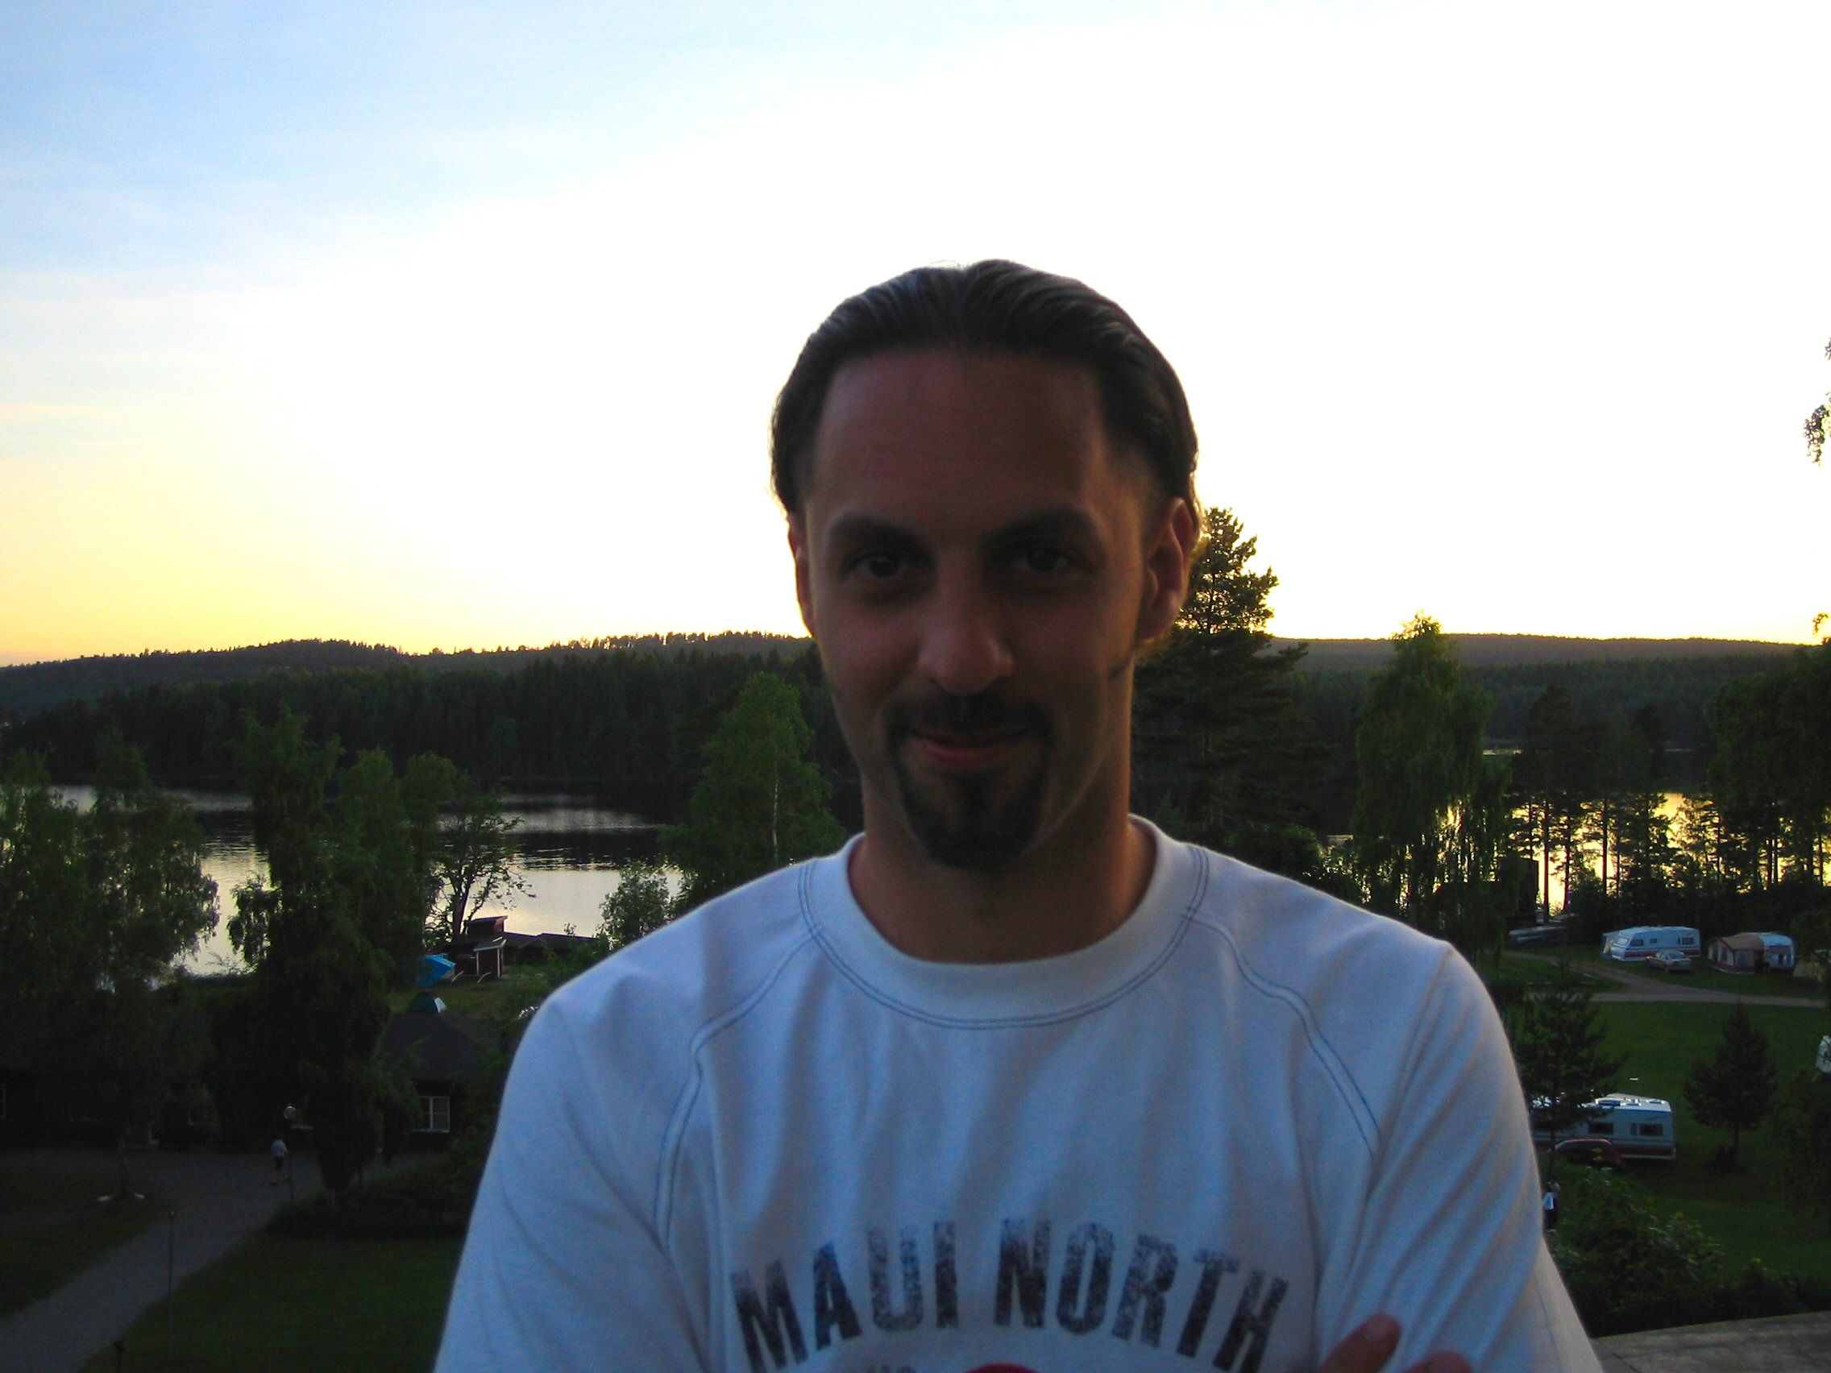

Interdisciplinary System Architect and Developer | Last updated:  2009-04-22

Goals | - Seeks challenging architect & developer assignments, the dream would be AI and machine learning applied to biotechnology, robotics, space science or the games & entertainment industry. I am however open to other industries.  - Wants to evolve as a system architect and developer, but am also open to research assignments or similar.

Future | Wanted role: | System architect/developer
 | Alternative role: | Project leader
 | Form of employment: | Contract or permanent
 | Work form: | Full time or part time
 | Placement: | Primary the Stockholm area
 | Level of experience: | Experienced (more than 4 years)
 | Available: | Within a month

Future employer | Company size: | Less important. Would however prefer a smaller firm because of the more familiar atmosphere and less bureaucracy.
 | Category: | IT, telecommunications, biotechnology, games and entertainment industry.

Region | Willing to move: | Yes, for the right assignment
 | Canada | Germany | Sweden
 | United Kingdom | USA

Work permit | Germany | I have permission to work for all employers in this country.
 | Sweden | I have permission to work for all employers in this country.
 | United Kingdom | I have permission to work for all employers in this country.
 | Canada | I need sponsorship/support of my employer to get a work permit in this country.
 | USA | I need sponsorship/support of my employer to get a work permit in this country.

Experience | 08/2006- 11/2008 | Lightlabs AB | Stockholm
 | Senior System Developer & consultant
The assignments has included all aspects of system architecture and development, from business analysis and design, to implementation, testing and deployment. Example of assignments have been Saab Avitronics and TK SE (Swedish Defence Department).
Role: project leader, product designer, system architect, system developer, database designer, database developer
Keywords: Java Standard & Enterprise Edition, Unix, Linux, Windows, Oracle, DB2, aeronautics support systems, test driven development, Agile, Scrum

 | 02/2005 - 08/2006 | Mblox Northern Europe | Stockholm
 | Senior System Developer & product manager
The work tasks has included all aspects of the system development cycle – analysis, architectural design, implementation, testing and deployment. This has been applied to business critical systems for billing, customer management, telecommunications traffic statistics and similar solutions which support the mobile platform of mBlox for SMS, MMS and related applications.
Roles: project leader, product manager, system architect and developer, database designer and developer
Keywords: Java Standard & Enterprise Edition, Unix, Linux, Windows, Oracle, PostgreSQL, telecommunications, business operations and support, financial systems, statistical systems

 | 05/2004 - 02/2005 | Awardit AB | Stockholm
 | Technical Director
Have improved and developed Awardit's customer loyalty system (Java based running on Dynamo Application Server and Oracle), which for example consist of transaction handling, SMS-communication, card terminals and CRM system. The position has also involved server support and network administration on Red Hat Linux and Sun Solaris 9.
Roles: technical director, system architect and developer, web developer, network manager
Keywords: Java Standard & Enterprise Edition, C, Unix, Linux, Oracle, customer loyalty systems, CRM systems, campaign management, transaction management

 | 03/2003 - 01/2004 | Bioseeker Group | Stockholm
 | Technical Director
System developer/project leader with overall technical responsibility. Focus on Java Enterprise, the MVC framework Struts and Oracle databases. During this position I have improved and developed Bioseeker's system where they present their strategy for business intelligence and market and sell their analytical reports in the biotechnology domain. Furthermore I have developed their e-business platform Biomarket Group which works as a marketplace for both Bioseeker and their partners worldwide.
Roles: technical director, system architect and developer, web developer, database designer and developer, network manager
Keywords: Java Standard & Enterprise Edition, Oracle, e-commerce, campaign management

 | 08/1999 - 02/2003 | SysTeam Infogrator AB | Stockholm
 | Technical consultant
I have here participated in a number of projects with 2-3 consultants where I informally have had the role as both system developer and project leader with frequent customer contact. The work have consisted of the complete process from conceptual modelling, database modelling, to implementation, tuning and support. The biggest project (roughly two years) was for the client Lessmore where we both adapted the product Dynamic Trade for dynamic markets and also built a tailor-made front office and back office system according to their specific requirements.
Roles: project leader, system architect and developer, database designer and developer, web developer, transaction management
Keywords: Java Standard & Enterprise Edition, Oracle, Windows, e-commerce, CRM systems, campaign management, transaction management

 | 01/1999 - 09/1999 | SICS | Kista
 | Researcher & student
Master’s degree project at SICS (Swedish Institute of Computer Science, www.sics.se) Intelligent Systems Laboratory about agent-based systems.
Roles: researcher, student
Keywords: Java Standard Edition, Windows, artificial intelligence, agent based systems, machine learning

 | 6/1992 - 8/1998 | PSab | Stockholm
 | Computer administration and support
 | Summer job as network technician, computer support, product evaluator, and software developer.

Education | 5/2007 | Crisp | Stockholm
 | Certified
 | Certified Scrum master. Agile project management

 | 9/2006 | IBM | Stockholm
 | Certified
 | IBM Certified Rational Application Developer

 | 3/2002 | Sun Microsystems | Stockholm
 | Certified
 | Sun Certified Developer for the Java 2 Platform

 | 9/2001 | Sun Microsystems | Stockholm
 | Certified
 | Sun Certified Programmer for the Java 2 Platform

 | 10/1999 | Oracle Education | Kista
 | Course
 | Development of Java based applications on the Oracle Application Server.

 | 10/1999 | Oracle Education | Kista
 | Course
 | Programming in SQL and PL/SQL (stored procedures and related technologies).

 | 9/1999 | Oracle Education | Kista
 | Course
 | Database development and administration for system developers.

 | 8/1999 | Institute of Computer Science at Stockholm university and KTH | Stockholm
 | Masters degree
 | Masters degree in computer science with major in interactive systems, artificial intelligence and agent based systems.

 | 6/1995 | Stockholm university | Stockholm
 | Course
 | Linear algebra, mathematical analysis

 | 6/1994 | Jakobsbergs gymnasium | Järfälla
 | High school
 | Technical/natural sciences program

Memberships | 1/2001 - current | Stockholm Wushu Academy | Martial arts organisation for classical Wushu

 | 8/1995 - 9/1999 | Cultural section at DSV (Stockholm university and KTH) | Special interest organisation for cultural events and debates.

 | 8/1995 - 9/1999 | Business section at DSV (Stockholm university and KTH) | Special interest organisation for an active interaction between the academic and business world. We for example organized venues where companies could visit the school to present their business and interact with the students.

 | 1/1992 - 1/1999 | Järfälla Taekwondo | Martial arts organisation for Taekwondo, a korean development of japanese karate.

Knowledge (in selection) | Area | Level of knowledge | Last used | Experience
 | Ajax (jQuery) | Average | Currently used | 1 year
 | Ant (build tool) | Average | Currently used | 4 years
 | Apache, Tomcat | Advanced | Currently used | 6 years
 | C/C++ | Advanced | 2005 | 7 years
 | CGI, Perl | Average | 2005 | 6 years
 | Delphi | Average | 1999 | 2 years
 | Eclipse | Advanced | Currently used | 1 years
 | HTML, CSS, DHTML, Javascript | Advanced | Currently used | 10 years
 | Java Enterprise Edition (EJB, Servlets, JSP etc.) | Advanced | Currently used | 6 years
 | Java Standard Edition | Advanced | Currently used | 10 years
 | JBoss | Advanced | Currently used | 4 years
 | LISP, Scheme | Advanced | 1999 | 4 years
 | Microsoft .Net | Average | 2003 | 1 years
 | Microsoft Office (Word, Excel, PowerPoint) | Average | Currently used | 10 years
 | Microsoft Windows NT/2000, XP. Client och Server Edition. | Advanced | Currently used | 5 years
 | Novell Netware | Average | 2000 | 2 years
 | Oracle | Advanced | Currently used | 6 years
 | Pascal | Advanced | 1999 | 8 years
 | PostgreSQL | Average | Currently used | 2 years
 | Prolog | Advanced | 1999 | 4 years
 | Rational Rose | Average | 2000 | 2 years
 | Smalltalk | Advanced | 1999 | 2 years
 | Spring (MVC framework) | Average | Currently used | 1 years
 | SQL Server | Average | 2003 | 4 years
 | SQL, PL/SQL | Advanced | Currently used | 8 years
 | Struts (MVC framework) | Average | Currently used | 4 years
 | TCP/IP | Average | Currently used | 8 years
 | Toad | Advanced | Currently used | 6 years
 | Unix, Linux, Solaris | Advanced | Currently used | 8 years
 | Weblogic | Average | 2003 | 4 years
 | Visual Studio .Net | Average | 2003 | 1 years
 | XML, Web Services | Average | Currently used | 4 years

References | Pierre Wijkman | DSV | Professor
 | Phone: | 08-16 16 30
 | E-mail: | pierre@dsv.su.se
 | Reference type: | Academic. Supervisor for my masters assignment at SICS.

 | Fredrik Espinoza | SICS | Ph. Lic.
 | Phone: | 08-633 15 15
 | E-mail: | espinoza@sics.se
 | Reference type: | Academic. Reviewer for my masters assignment at SICS

 | Henrik Boström | DSV, Compumine AB | Associate Professor
 | Phone: | 08-16 16 16
 | E-mail: | henke@dsv.su.se
 | Reference type: | Academic. Teacher of the AI oriented courses at DSV.

 | Nils Keife | E-work | Consultant
 | Phone: | 08-50 60 55 24
 | E-mail: | nils.keife@ework.se
 | Reference type: | Job related. Former colleague at SysTeam Infogrator.

 | Lars Bergström | SysTeam Infogrator | Consultant
 | Phone: | 0736-501073
 | E-mail: | lasse.e.bergstrom@gmail.com
 | Reference type: | Job related. Former colleague at SysTeam Infogrator.

 | John Henningsson | SysTeam Infogrator | Consultant manager
 | Phone: | 0709-25 47 11
 | E-mail: | john.henningsson@systeam.se
 | Reference type: | Job related. Closest boss at SysTeam Infogrator.

 | Ronnie Andersson | Bioseeker Group | Co-founder
 | Phone: | 08-673 17 00
 | E-mail: | ronnie.andersson@bioseeker.com
 | Reference type: | Job related. Closest boss at Bioseeker.

 | Anders Lanzén | Bioseeker Group | Analyst
 | Phone: | 076-256 50 09
 | E-mail: | lanzen@yahoo.com
 | Reference type: | Job related. Former colleague at Bioseeker.

 | Mathias af Jochnick | mBlox Northern Europe & Lightlabs | Team leader
 | Phone: | 0703-414084
 | E-mail: | mathias@lightlabs.se
 | Reference type: | Job related. Closest boss at both mBlox and Lightlabs.

 | Pushparaj Silva | Saab Avitronics | System developer
 | Phone: | 0734-374253
 | E-mail: | pushpa@kth.se
 | Reference type: | Job related. Colleague at Saab Avitronics (assignment through Lightlabs).

Personal Information | Apart from science and technology in general, and artificial intelligence, biotechnology and astrophysics in particular, I am interested in martial arts, music, movies and literature. I like working with other motivated people, am highly ambitious, a quick learner, like challenges and very seldom gives up!

