

RAIL / ROAD SYSTEMS ENGINEERING GROUP PROCEDURE

FARE GATES PROVISIONING PROCEDURE

RSE/SP/FS/02/660/0

CONTROLLED DOCUMENT

0 | 16/01/2017 | Initial issue.
Rev | Date | Description of Revision

Total number of pages (including cover sheet) is 6

Table of Contents

1. PURPOSE 3
2. APPLICATION 3
3. REFERENCES 3
4. RESPONSIBILITIES 3
4.1 RAIL TRANSIT SYSTEM PLANNING DIVISION 3
4.2 FARE SYSTEM SUB-GROUP 3
4.3 ARCHITECTURE SUB-GROUP 3
4.4 rAIL dESIGN dEVELOPMENT SUB-GROUP 3
5. PROCEDURE 3
APPENDIX A: AFC GATE PROVISION IN MRT STATION FLOW CHART 6

PURPOSE
The aim of this document is to establish the procedure for providing fare gates.

APPLICATION
This document shall apply during station design of a new rail line.

REFERENCES
- 886th PSC Paper On Review Of Fare Gates For Downtown Line 3 (DTL3) And Tuas West Extension (TWE)
- 903th PSC Paper On Process Flow For The Provision Of Fare Gates In New MRT Stations

RESPONSIBILITIES

RAIL TRANSIT SYSTEM PLANNING DIVISION
Rail Transit System Planning (RPL) Division will derive the one hour projected ridership data for morning and evening peak periods using data provided by Urban Redevelopment Authority (URA) as well as banding for the station to determine its potential ultimate loading.

FARE SYSTEM SUB-GROUP
Fare System (FS) Sub-Group will derive the 15 minutes peak period from projected ridership data provided by RPL and calculate gate quantity.

ARCHITECTURE SUB-GROUP
Architecture (AR) Sub-Group will review the layout of fare line in the station architectural drawings.

rAIL dESIGN dEVELOPMENT SUB-GROUP
Rail Design Development (RDD) Sub-Group will oversee Architectural and Engineering Consultant / Advance Engineering Consultant to develop the design of the station.

PROCEDURE
  - INPUTS FROM VARIOUS LTA WORK GROUPS
  - Passenger throughput requirements for new stations are established with inputs from RDD, RPL, AR and FS.
  - Prior to preparing the tender specification for Automatic Fare Collection (AFC) equipment for the new rail line, FS will review the AFC equipment provision in the whole rail network to assess whether there is any need for additional equipment. FS will seek the necessary approval before incorporating the equipment quantities into the tender specification.
  - GUIDELINES FOR MINIMUM FARE GATES QUANTITY
  - The guidelines for minimum fare gates quantity to be provisioned for new MRT stations are as follows:

- There will be minimum 3 exit gates per escalator (40 passengers per minute per gate versus 120 passengers per minute per escalator) and another exit gate for maintenance purpose. A total of 4 exit gates to be provided in every station.
- There will be minimum 2 entry gates with one additional for maintenance purpose. A total of 3 entry gates to be provided in every station.
- There will be minimum 2 wide gates per station.
- To allow installation of additional gates for future expansion, the underfloor ducting will be extended to cover the full fare line subject to physical constraint on-sites.

Station Layout With |  | Minimum Fare Gates For Future Rail Lines
1. | Single fare line | 7 normal gates (4 exit & 3 entry gates) | + 2 wide gates
2. | Multiple fare lines
a) | Single fare line | 7 normal gates (4 exit & 3 entry gates) | + 2 wide gates
b) | Remote fare line | 4 normal gates (2 exit & 2 entry gates) | + 1 wide gate
  - ONE HOUR RIDERSHIP PROJECTION
  - RPL will derive the one hour projected ridership data for morning and evening peak periods using data provided by URA as well as banding for the station to determine its potential ultimate loading.
  - RPL will update projected ridership data in banding for ultimate loading during preliminary design submission.
  - RPL will update projected ridership data in banding for ultimate loading 18 months before station opens for revenue.
  - DERIVATION OF GATE QUANTITIES AND FARE LINES
    - FS will
- derive the number of AFC gate aisles for the 15 minutes peak period from the projected ridership data provided by RPL for station opening and ultimate year;
- add 20% provision to be included for maintenance; and
- adjust the number of AFC gate aisles according to the guidelines for fare gate provision.
    - FS will subsequently review the layout of fare line in the station architectural drawings with AR taking into consideration the recommendations in the Passenger Flow Analysis Report.
    - If there are any new developments in the station throughput / layout after the design stage, AR will advise FS to assess any impact on the fare line layout and the number of AFC gate aisles.
  - PEDESTRIAN FLOW ANALYSIS
    - RDD will work with the Architectural and Engineering Consultant / Advance Engineering Consultant to develop the design of the station. The Consultant will produce a Pedestrian Flow Analysis Report incorporating the projected ridership data and the number and distribution of immediate and future fare gate aisles to be submitted during the different design stages of the engineering study. For interchange stations, the Pedestrian Flow Analysis Report should also address the impact on the affected station in existing rail line.
    - The Pedestrian Flow Analysis Report will be forwarded to AR, FS and RPL for review. RDD will collate all comments and co-ordinate with the Consultant to address the inputs.
    - The Pedestrian Flow Analysis Report will be reviewed by AR to ensure the parameters and layout used are in compliance to the Architectural Design Criteria. AR will capture any changes in the projected distribution of passengers within the station and developments to the station layout. The fare line layout, numbers and distribution of both initial and future AFC gate aisles shall be considered in the report.
    - A full simulation of the passenger flows in the station, submitted as part of the Pre-final Pedestrian Flow Analysis Report, shall be reviewed to ensure it validates the station design, layout and numbers of facilities such as the number and distribution of fare gate aisles.
  - POST REVENUE SERVICE
    - After commencement of revenue service, FS will review the adequacy of AFC equipment (both fare gates and ticketing machines) with the Rail Operator during the Reliability, Availability and Maintainability (RAM) review on AFC equipment performance. The RAM review will be conducted within 6 months of revenue service.
    - Should there be any proposed revision to the AFC equipment quantity, FS will initiate discussion with Asset Management for Operating Asset (AMO) Team and AR before submitting the recommendation to the Project Supervisory Committee (PSC) for consideration.
    - The recommendation shall first explore the feasibility of redistribution of AFC equipment instead of making additional procurement.
    - 2 years after commencement of revenue service where the new rail line will reach its steady state operations, FS will conduct the second round of review to assess the adequacy of AFC equipment in the whole rail network. Similar to the above, FS will discuss recommendation for any revision to equipment quantity with AMO and AR before submission to PSC for consideration.

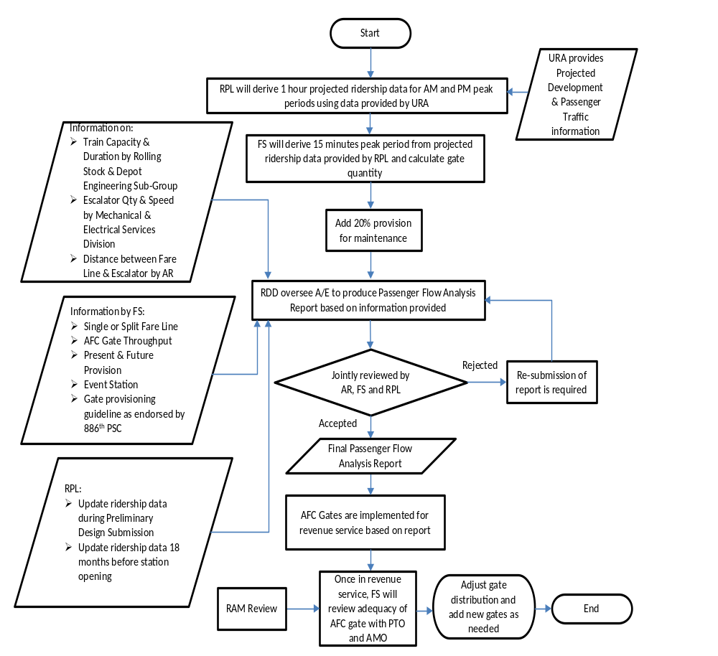APPENDIX A: AFC GATE PROVISION IN MRT STATION FLOW CHART

