To get this working, you need to get 2 important libraries (look at the INSTALLED wording, that’s the libraries you will need):

Go to **Sketch** > **Include Library** > **Manage Libraries** > Search the 2 libraries

**Adafruit_GFX**

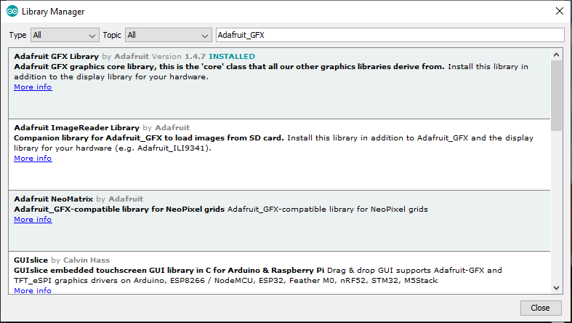

**SSD1306**

