Unhoused Funding Data Report

Tobin Haefele

Table of Contents

## Introduction

In this report we partnered with the city of Missoula’s “Community Planning, Development, and Innovation” (CPDI) department, specifically with the Community Development Division. In an effort to understand and monitor Missoula’s unhoused population the CPDI department joined the Homeless Management Information System (HMIS) data collection effort by establishing a coordinated entry system. This allowed them to build datasets that can tell us much about the unhoused population. Along with this they have also executed a survey of the unhoused population to provide further data for us. Thanks to their hard work we have data to analyze and report on.

## Executive summary

The purpose of this report is to analyze the data provided by the CPDI department and provide a report on the findings. The report concluded with the following findings:

* Total amount spent, prevention vs currently homeless
* Funding sources and distribution of funding
* Demographics

### Analyzing the utilization of the housing solutions fund by prevention or currently homeless

Our first analysis is how the housing solutions fund is being utilized to help the unhoused population. We will look at the total amounnt of money spent on prevention and the total amount spent on those who are currently homeless. Along with this we also want to look at what the funding is being used for and how much is being used in each category.

Initial analysis of the housing solutions fund found that a total of $193,628 was put towards either prevention or assistance to those currently unhoused. Of this total around 77% of the funding is being used for prevention of homelessness compared to 23% being allocated for those who are currently homeless. This disparity could be explained by the fact that it is much cheaper to prevent homelessness than it is to assist those who are currently homeless. This also aligns with the CPDI’s goal of preventing homelessness before it happens.

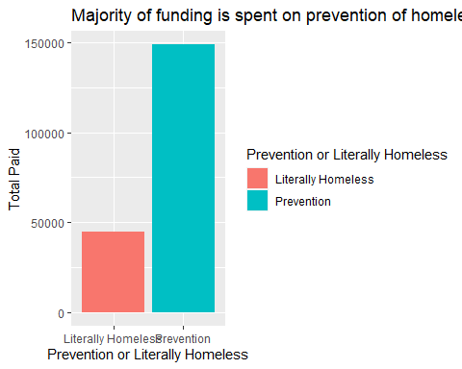

In this section I will analyze the categories of funding and how much is being spent on each category. This will allow us to view what the funding is being used for and how much is being spent on each category, allowing us to see if the funding is being used in the most optimal way.

Within the Prevention group we can see that the over 70% of funding is going towards rent while deposits make up around 14%. The makeup of these categories make sense as preventing eviction or helping with deposits to secure a place to live is a great way to prevent homelessness.

Among those currently homeless the majority of funding is going toward deposits (28%) and transportation (23%), both of these categories support the idea of helping those who are homeless either get into a home or get somewhere they have family/friends or a better opportunity.

| Prevention.or.Literally.Homeless | Category | TotalSpent | percent_total |
| --- | --- | --- | --- |
| Prevention | Rent | $105,461 | 70.857% |
| Prevention | Deposits | $21,335 | 14.335% |
| Prevention | Other | $16,103 | 10.819% |
| Prevention | Utilities | $5,266 | 3.538% |
| Prevention | Applications | $372 | 0.250% |
| Prevention | Transportation | $300 | 0.202% |

| Prevention.or.Literally.Homeless | Category | TotalSpent | percent_total |
| --- | --- | --- | --- |
| Literally Homeless | Deposits | $12,931.58 | 28.87% |
| Literally Homeless | Transportation | $10,322.75 | 23.05% |
| Literally Homeless | Other | $7,815.72 | 17.45% |
| Literally Homeless | Utilities | $6,185.57 | 13.81% |
| Literally Homeless | Rent | $5,938.60 | 13.26% |
| Literally Homeless | Applications | $1,597.39 | 3.57% |

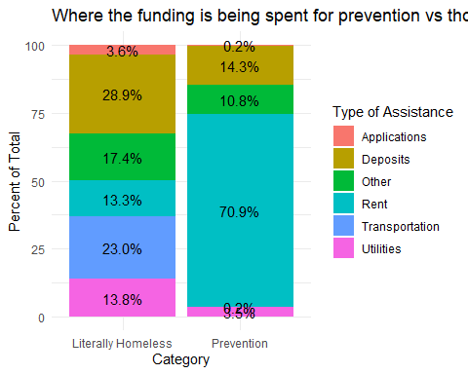

### Evaluating the sources of funding and their impact on services provided

In this next section we will take a look at where this funding is coming in from and how much is coming from each source. Using this data we can identify which sources are being utilized the most and which are being utilized the least.

Looking at the intial table we can see that just over half of the funding is coming from AHTF

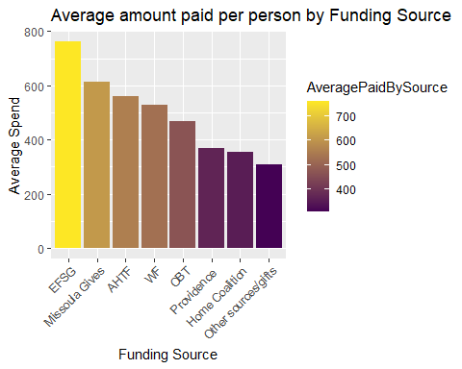

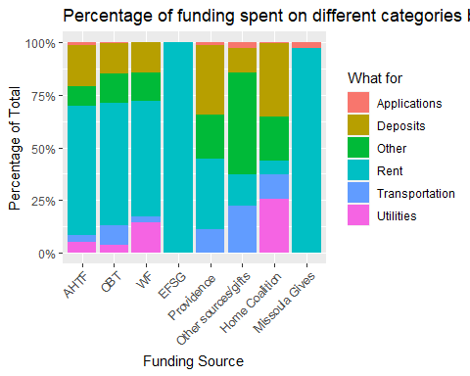

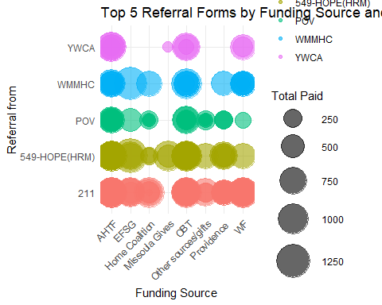

### Comparing demographics of those who are receiving funding to the overall population of those who are unhoused

| Race_Consolidated | Frequency | TotalPaid | AveragePaid | PercentTotal |
| --- | --- | --- | --- | --- |
| White | 139 | $85,836.62 | $617.53 | 84.3% |
| American Indian, Alaska Native, or Indigenous | 17 | $10,743.93 | $632.00 | 10.5% |
| Black, African American, or African | 5 | $3,507.45 | $701.49 | 3.4% |
| Asian American/Pacific Islander | 2 | $1,772.00 | $886.00 | 1.7% |

Demographics of the people receiving funding compared to the overall MCES population

| Race_Consolidated | Frequency | PercentTotal |
| --- | --- | --- |
| White | 3257 | 67.5585978 |
| American Indian, Alaska Native, or Indigenous | 639 | 13.2545115 |
| Multiple | 551 | 11.4291641 |
| Black, African American, or African | 241 | 4.9989629 |
| Asian American/Pacific Islander | 93 | 1.9290604 |
| Hispanic/Latina/e/o | 40 | 0.8297034 |

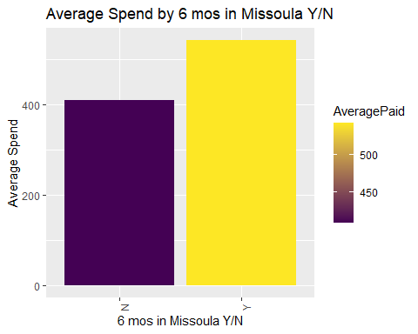

### Conclusion

insert conclusion