**Add Product**

**Tobin Saji Antony**

**CODE:**

**EProductServlet.java**

**package com.Servlets;**

**import java.io.IOException;**

**import java.util.Date;**

**import java.util.List;**

**import javax.servlet.ServletException;**

**import javax.servlet.http.HttpServlet;**

**import javax.servlet.http.HttpServletRequest;**

**import javax.servlet.http.HttpServletResponse;**

**import org.hibernate.Session;**

**import org.hibernate.SessionFactory;**

**import com.Entity.EProduct;**

**import com.Entity.EUser;**

**import com.Entity.HibernateUtil;**

**/\*\***

**\* Servlet implementation class EProductServlet**

**\*/**

**public class EProductServlet extends HttpServlet {**

**private static final long serialVersionUID = 1L;**

**/\*\***

**\* @see HttpServlet#HttpServlet()**

**\*/**

**public EProductServlet() {**

**super();**

**// TODO Auto-generated constructor stub**

**}**

**/\*\***

**\* @see HttpServlet#doGet(HttpServletRequest request, HttpServletResponse response)**

**\*/**

**protected void doGet(HttpServletRequest request, HttpServletResponse response) throws ServletException, IOException {**

**// TODO Auto-generated method stub**

**response.getWriter().append("Served at: ").append(request.getContextPath());**

**}**

**/\*\***

**\* @see HttpServlet#doPost(HttpServletRequest request, HttpServletResponse response)**

**\*/**

**protected void doPost(HttpServletRequest request, HttpServletResponse response) throws ServletException, IOException {**

**// TODO Auto-generated method stub**

**try {**

**if(request.getParameter("pname")!="" && request.getParameter("pprice")!="") {**

**String ProductName = request.getParameter("pname");**

**int ProductPrice = Integer.parseInt(request.getParameter("pprice"));**

**EProduct eProduct = new EProduct(ProductName, ProductPrice, new Date());**

**SessionFactory factory = HibernateUtil.getSessionFactory();**

**Session session = factory.openSession();**

**// using HQL**

**session.save(eProduct);**

**response.getWriter().append("Product Entered Successfully");**

**session.close();**

**}**

**else if(request.getParameter("pname")=="" && request.getParameter("pprice")!="") {**

**response.getWriter().append("Please Enter Product Name");**

**}**

**else if(request.getParameter("pname")!="" && request.getParameter("pprice")=="") {**

**response.getWriter().append("Please Enter Product Price");**

**}**

**else**

**{**

**response.getWriter().append("Please Enter Product Name and Product Price");**

**}**

**} catch(NumberFormatException nfe)**

**{**

**response.getWriter().append("Enter Valid Input");**

**}**

**catch(Exception ex) {**

**response.getWriter().append(ex.getLocalizedMessage());**

**}**

**}**

**}**

**SCREENSHOTS**

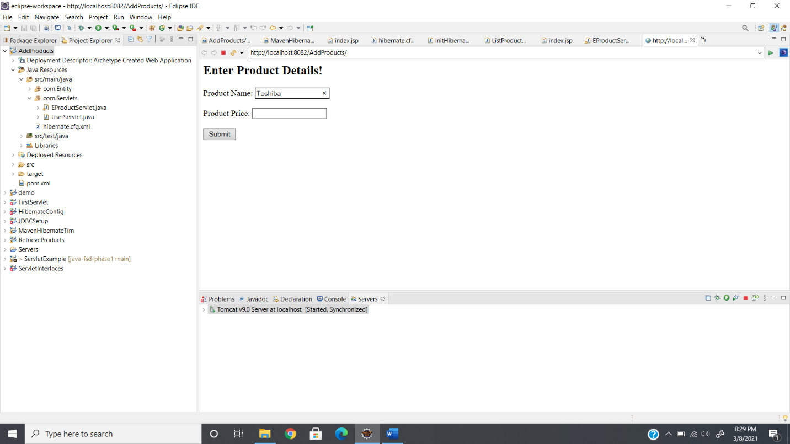

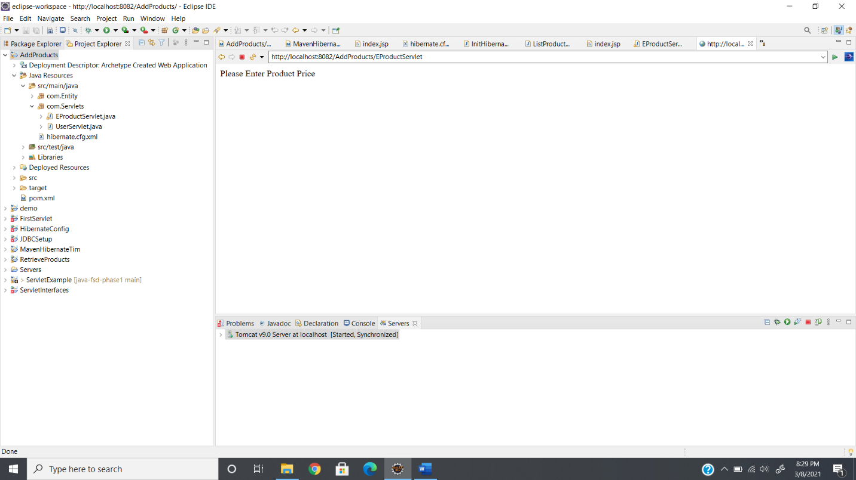

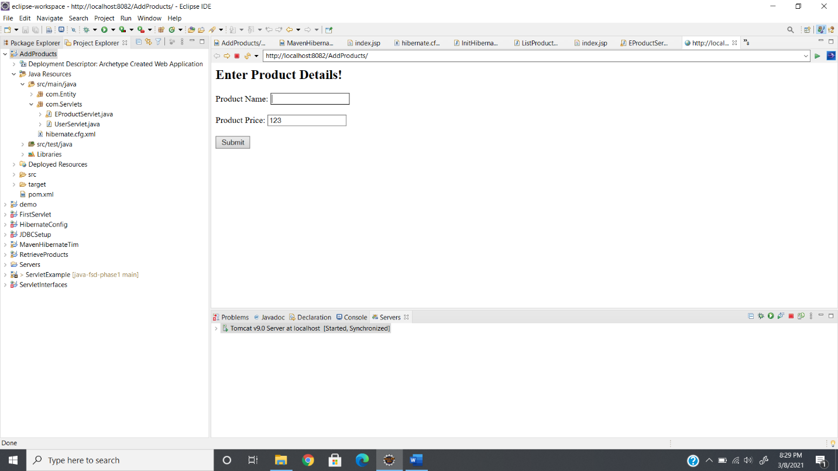

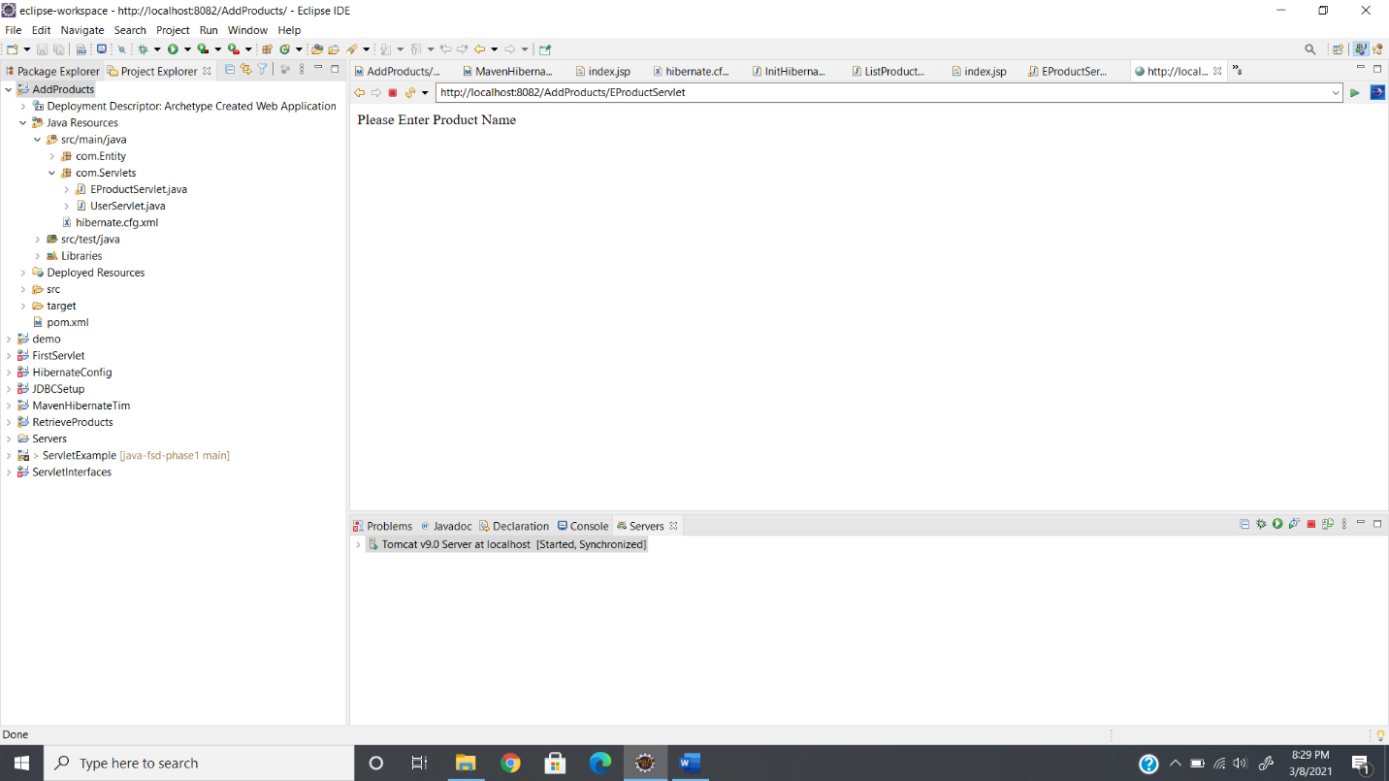

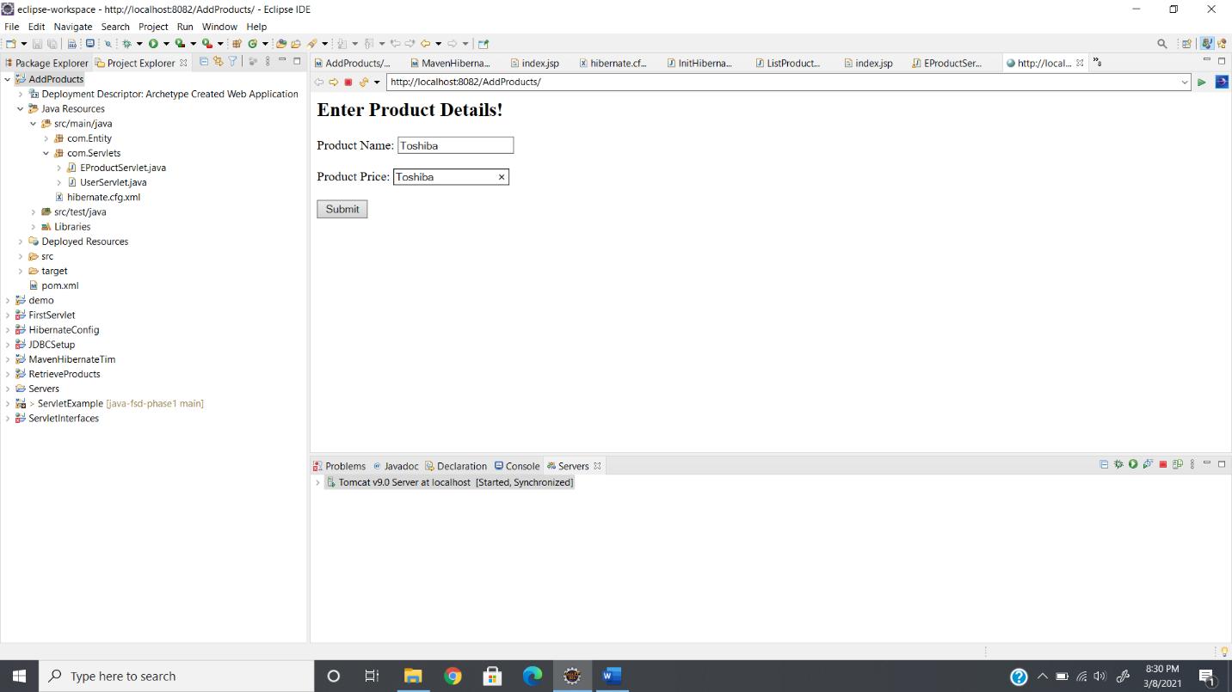

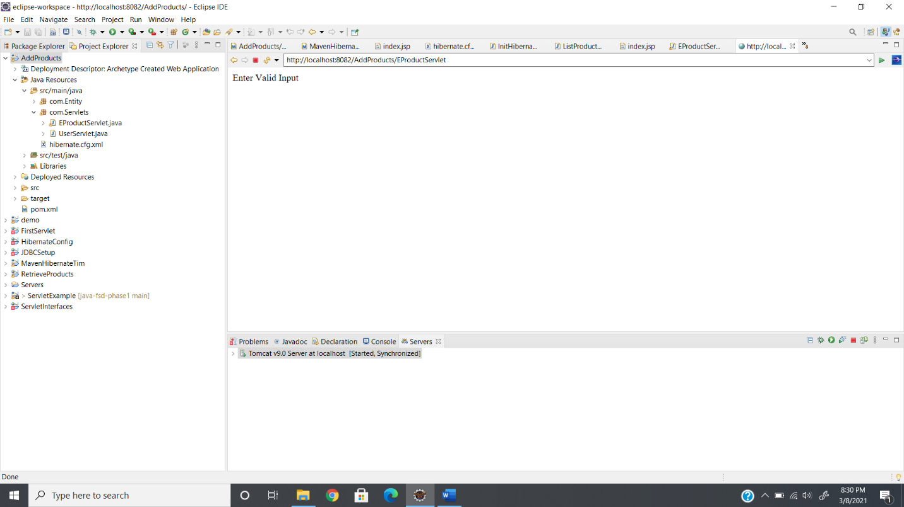

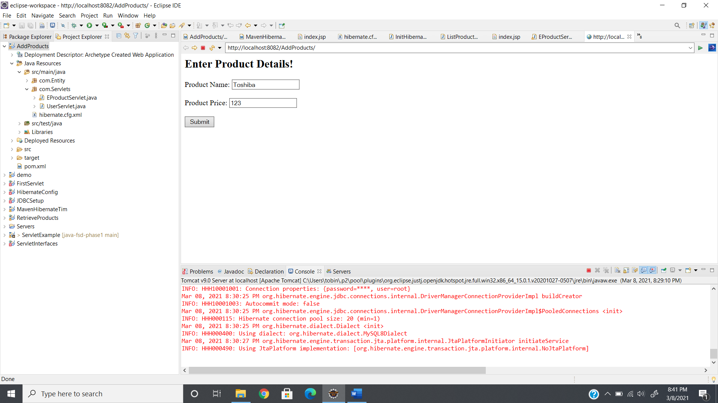

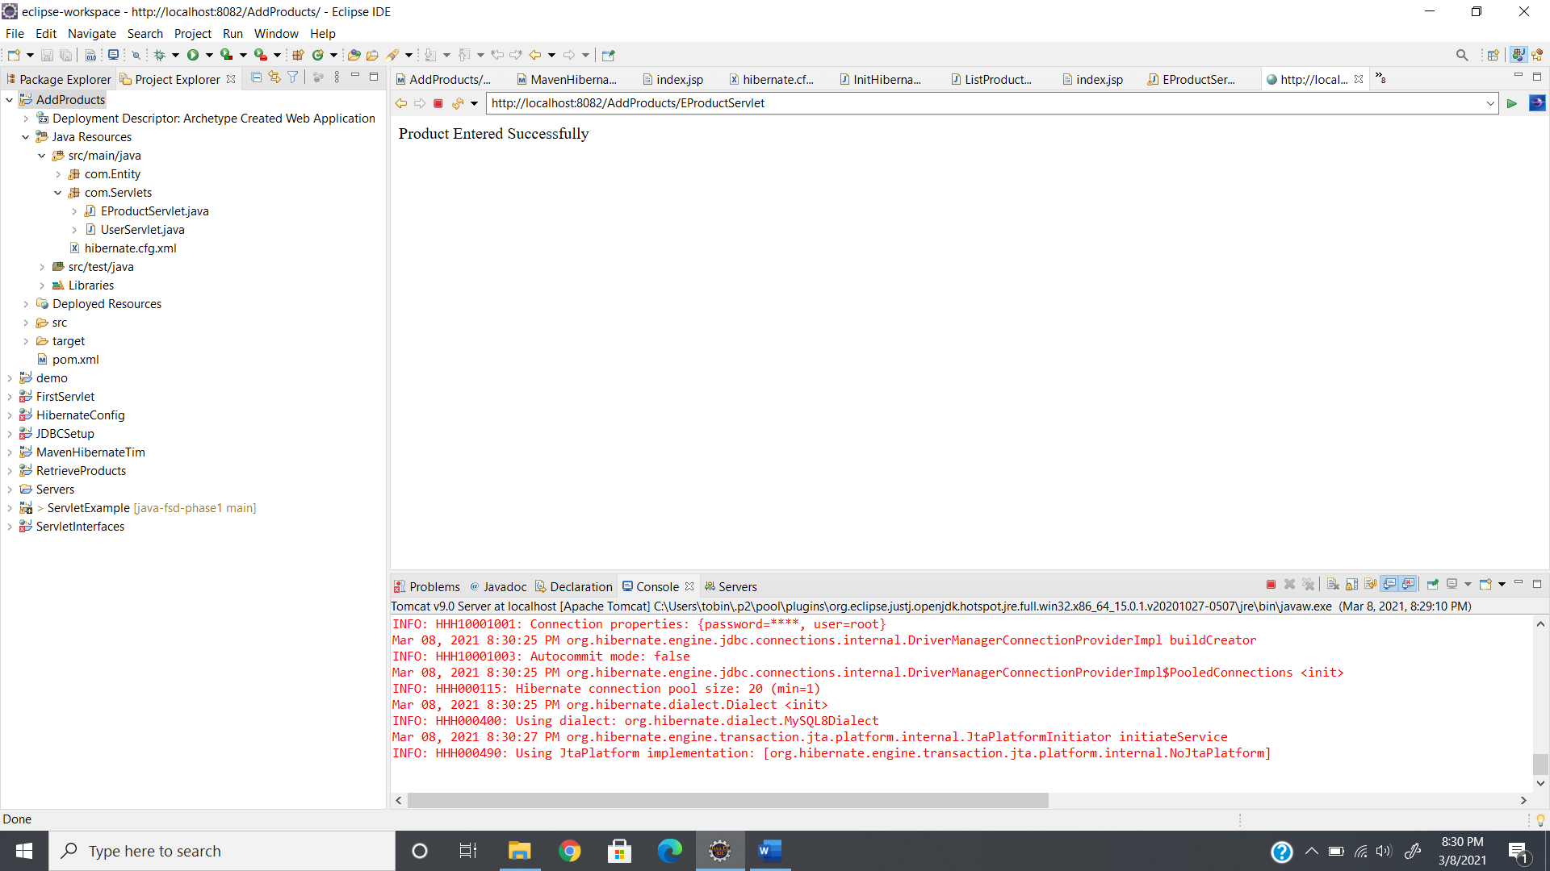

**GITHUB LINK:**

https://github.com/tobinsajiantony/Java_fsd_Phase_2_AddProducts