**Junit Authentication**

**Tobin Saji Antony**

**CODE:**

**AuthenticationApplicationTests.java**

package com.example.Authentication;

import static org.junit.jupiter.api.Assertions.assertEquals;

import static org.junit.jupiter.api.Assertions.assertFalse;

import static org.junit.jupiter.api.Assertions.assertTrue;

import org.junit.jupiter.api.Test;

import org.springframework.beans.factory.annotation.Autowired;

import org.springframework.boot.test.autoconfigure.orm.jpa.TestEntityManager;

import org.springframework.boot.test.context.SpringBootTest;

import com.example.Authentication.entities.User;

import com.example.Authentication.repositories.UserRepository;

import com.example.Authentication.services.UserService;

@SpringBootTest

class AuthenticationApplicationTests {

@Autowired

UserService userService;

@Autowired

UserRepository userRepository;

@Test

void contextLoads() {

}

@Test

public void AuthenticateUser() {

User dummyUser = new User();

dummyUser.setName("Dummy");

dummyUser.setEmail("test@test.com");

dummyUser.setPassword("password");

userRepository.save(dummyUser);

assertTrue(userService.authenticateUser(dummyUser.getName(), dummyUser.getPassword()).isValid());

User deleteUser = userRepository.findByName("Dummy");

userRepository.delete(deleteUser);

}

@Test

public void CreateUser() {

User dummyUser = new User();

dummyUser.setName("Dummy");

dummyUser.setEmail("test@test.com");

dummyUser.setPassword("password");

assertTrue(userService.createUser(dummyUser.getName(), dummyUser.getPassword(), dummyUser.getPassword(), dummyUser.getEmail()).isValid());

User deleteUser = userRepository.findByName("Dummy");

userRepository.delete(deleteUser);

}

@Test

public void GetUserByName() {

User dummyUser = new User();

dummyUser.setName("Dummy");

dummyUser.setEmail("test@test.com");

dummyUser.setPassword("password");

userService.createUser(dummyUser.getName(), dummyUser.getPassword(), dummyUser.getPassword(), dummyUser.getEmail());

assertEquals(dummyUser.getName(), userService.GetUserByName("Dummy").getName());

User deleteUser = userRepository.findByName("Dummy");

userRepository.delete(deleteUser);

}

}

**AuthenticationTests.Java**

package com.example.Authentication;

import com.example.Authentication.entities.User;

import com.example.Authentication.repositories.UserRepository;

import com.example.Authentication.services.UserService;

import org.junit.jupiter.api.Test;

import org.springframework.beans.factory.annotation.Autowired;

import org.springframework.boot.test.autoconfigure.orm.jpa.DataJpaTest;

import org.springframework.boot.test.autoconfigure.orm.jpa.TestEntityManager;

import org.springframework.boot.test.autoconfigure.web.servlet.AutoConfigureMockMvc;

import org.springframework.boot.test.context.SpringBootTest;

import org.junit.jupiter.api.Assertions.*;

import static org.junit.jupiter.api.Assertions.assertEquals;

import static org.junit.jupiter.api.Assertions.assertNotEquals;

import static org.junit.jupiter.api.Assertions.assertTrue;

@DataJpaTest

public class AuthenticationTests {

@Autowired

private TestEntityManager entityManager;

@Autowired

private UserRepository userRepository;

@Test

public void whenFindByName_thenReturnUser() {

// given

User dummyUser = new User();

dummyUser.setName("Dummy");

dummyUser.setEmail("test@test.com");

dummyUser.setPassword("password");

entityManager.persist(dummyUser);

entityManager.flush();

// when

User found = userRepository.findByName(dummyUser.getName());

// then

assertEquals(found.getName(), dummyUser.getName());

}

}

**SCREENSHOTS**

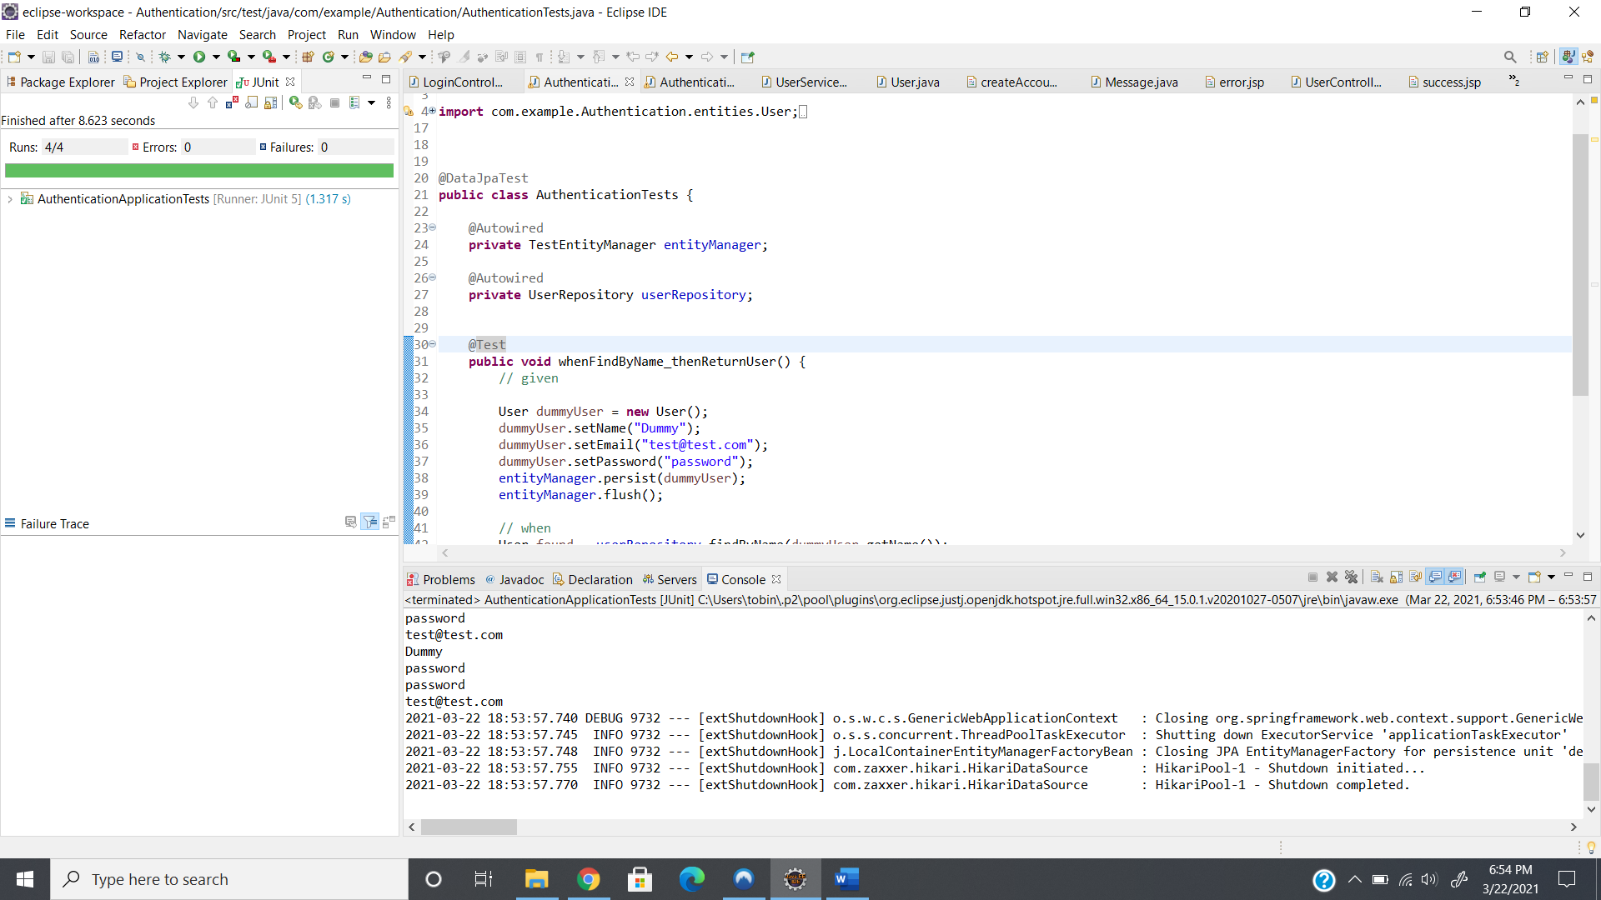

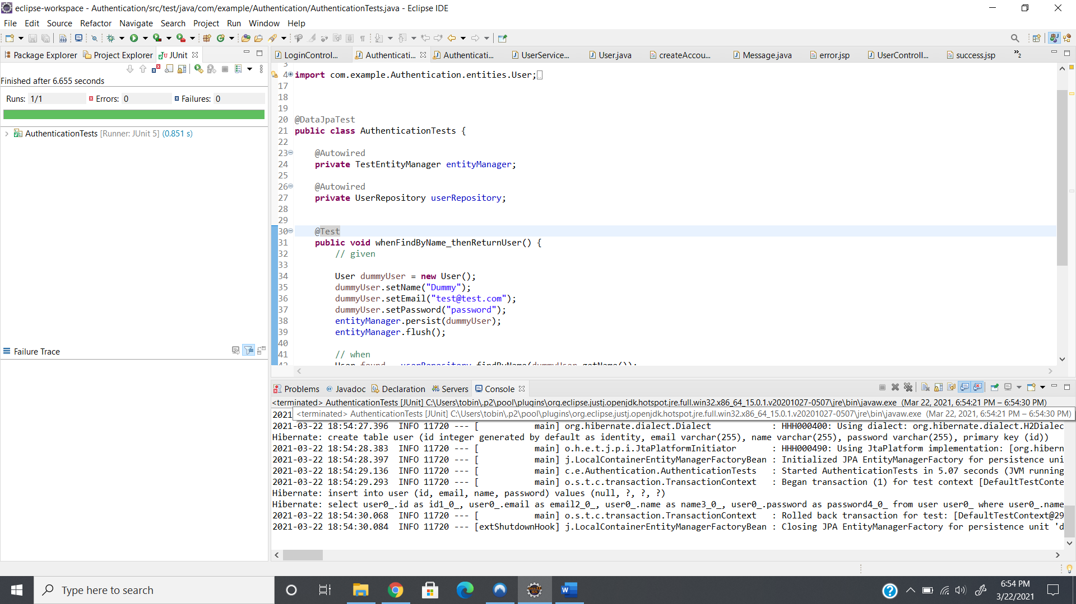

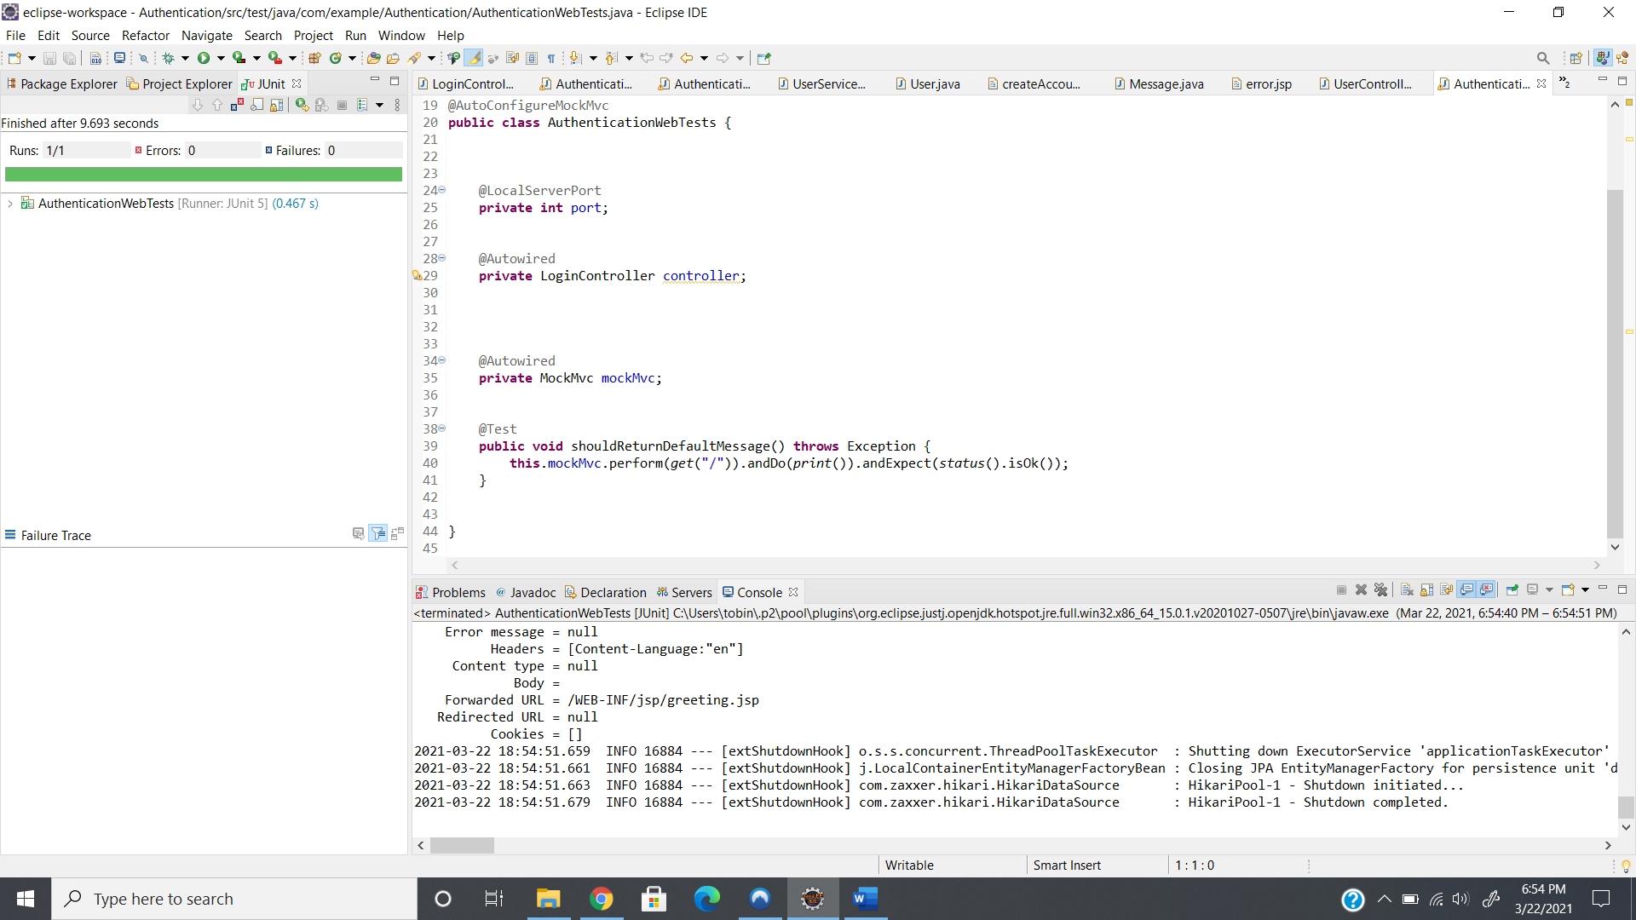

**GITHUB LINK:**

https://github.com/tobinsajiantony/Java_fsd_Phase_3_JUnitAuthentication