**User Manager**

**Tobin Saji Antony**

**CODE:**

**UserController.java**

package com.example.UserManager.controllers;

import org.slf4j.Logger;

import org.slf4j.LoggerFactory;

import org.springframework.beans.factory.annotation.Autowired;

import org.springframework.stereotype.Controller;

import org.springframework.ui.ModelMap;

import org.springframework.web.bind.annotation.GetMapping;

import org.springframework.web.bind.annotation.PostMapping;

import org.springframework.web.bind.annotation.RequestBody;

import org.springframework.web.bind.annotation.RequestMapping;

import org.springframework.web.bind.annotation.RequestParam;

import org.springframework.web.bind.annotation.ResponseBody;

import com.example.UserManager.entities.User;

import com.example.UserManager.services.UserService;

import org.slf4j.Logger;

import org.slf4j.LoggerFactory;

@Controller

public class UserController {

@Autowired

private UserService userService;

Logger logger = LoggerFactory.getLogger(UserController.class);

@GetMapping("/users")

public String showUsers(ModelMap model) {

logger.info("Getting all Users");

Iterable<User> users = userService.GetAllUsers();

logger.info("Passing users to view");

model.addAttribute("users", users);

return "users";

}

@GetMapping("/EditUser")

public String getUserById(ModelMap model,@RequestParam("userId") int Id) {

System.out.println("Controller hit");

System.out.println(Id);

User user = userService.GetUserById(Id);

if(user!=null) {

model.addAttribute("user", user);

return "EditUser";

}

else {

model.addAttribute("message", "No User with the ID found");

return "Error";

}

}

@RequestMapping(value = "/updateUser")

public String UpdateUser(ModelMap model, @RequestParam("id") int Id, @RequestParam("name") String name, @RequestParam("email") String email, @RequestParam("password") String password) {

System.out.println("update hit");

System.out.println(Id);

if(name!="" && email!="" && password!="") {

User user = new User(Id, name, email, password);

userService.UpdateUser(user);

model.addAttribute("message", "User Updated Succesfully");

return "success";

}

else if(name == "") {

model.addAttribute("message", "Please Enter Name");

return "Error";

}

else if(email == "") {

model.addAttribute("message", "Please Enter Email");

return "Error";

}

else {

model.addAttribute("message", "Please Enter Password");

return "Error";

}

}

}

**SCREENSHOTS**

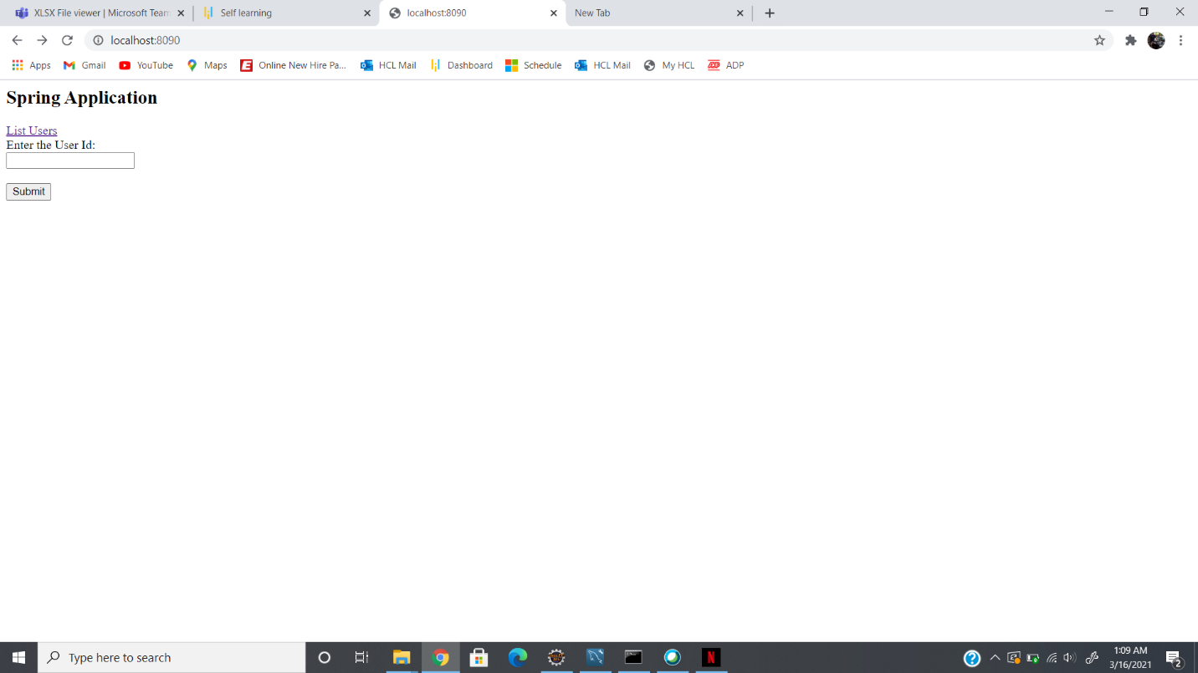

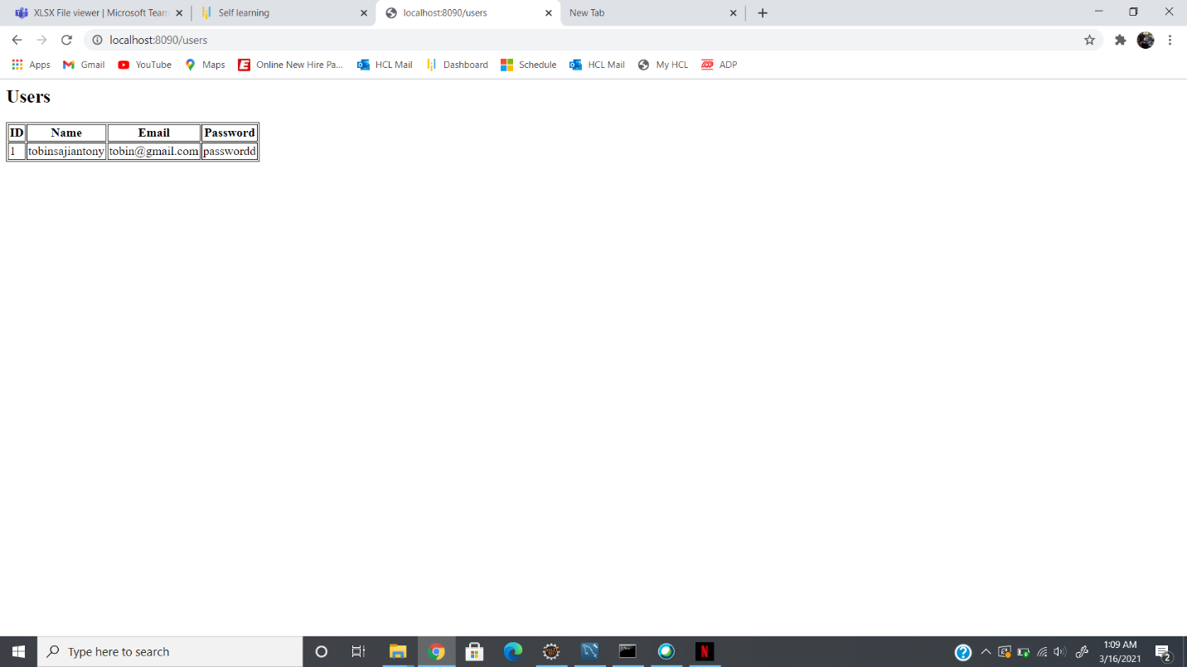

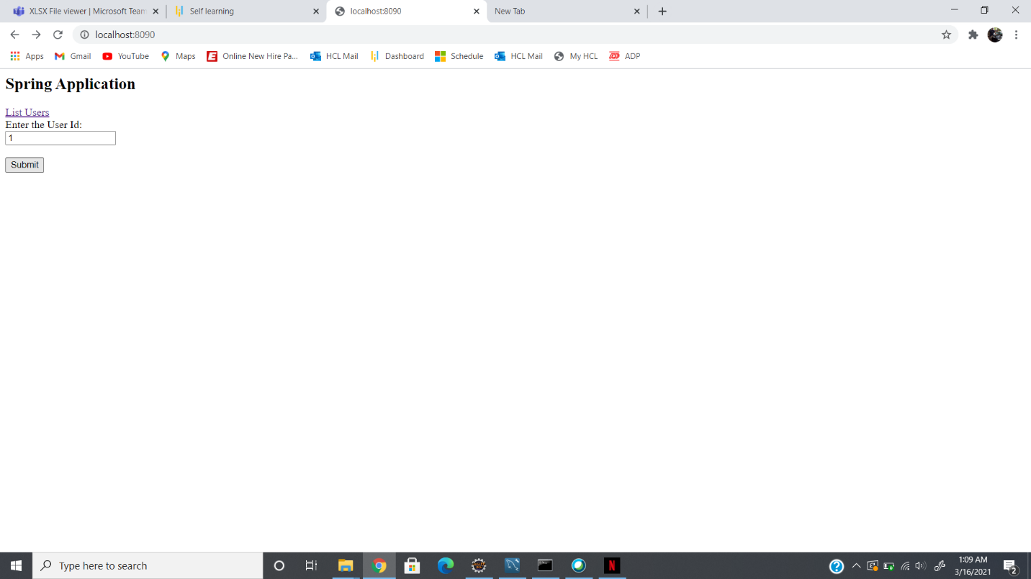

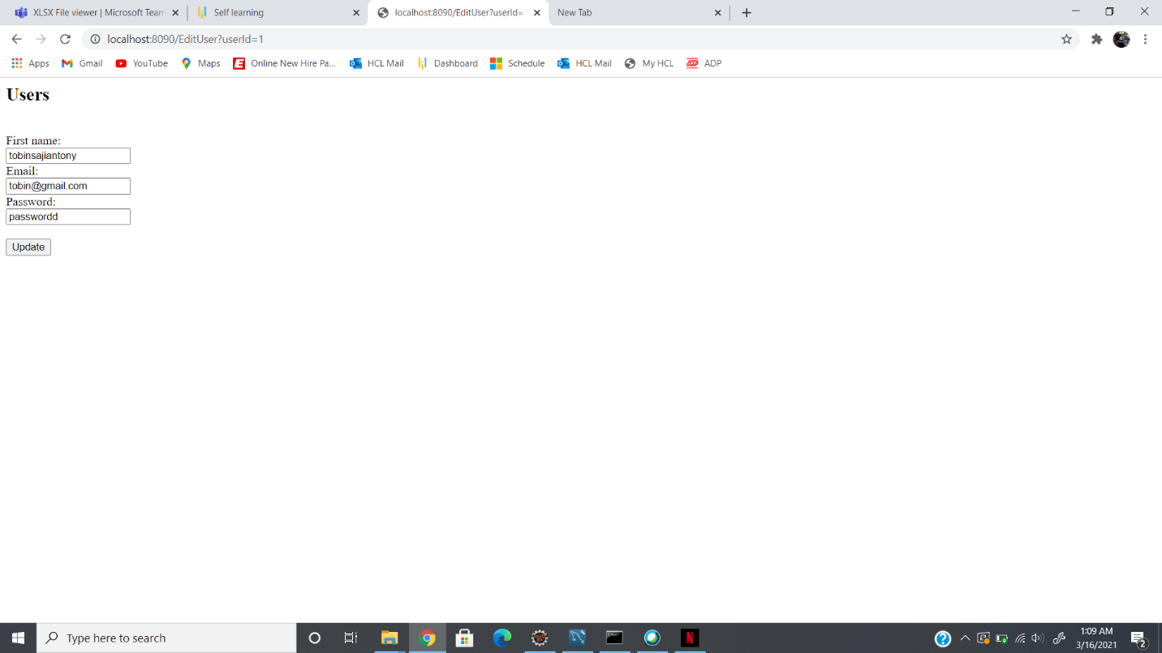

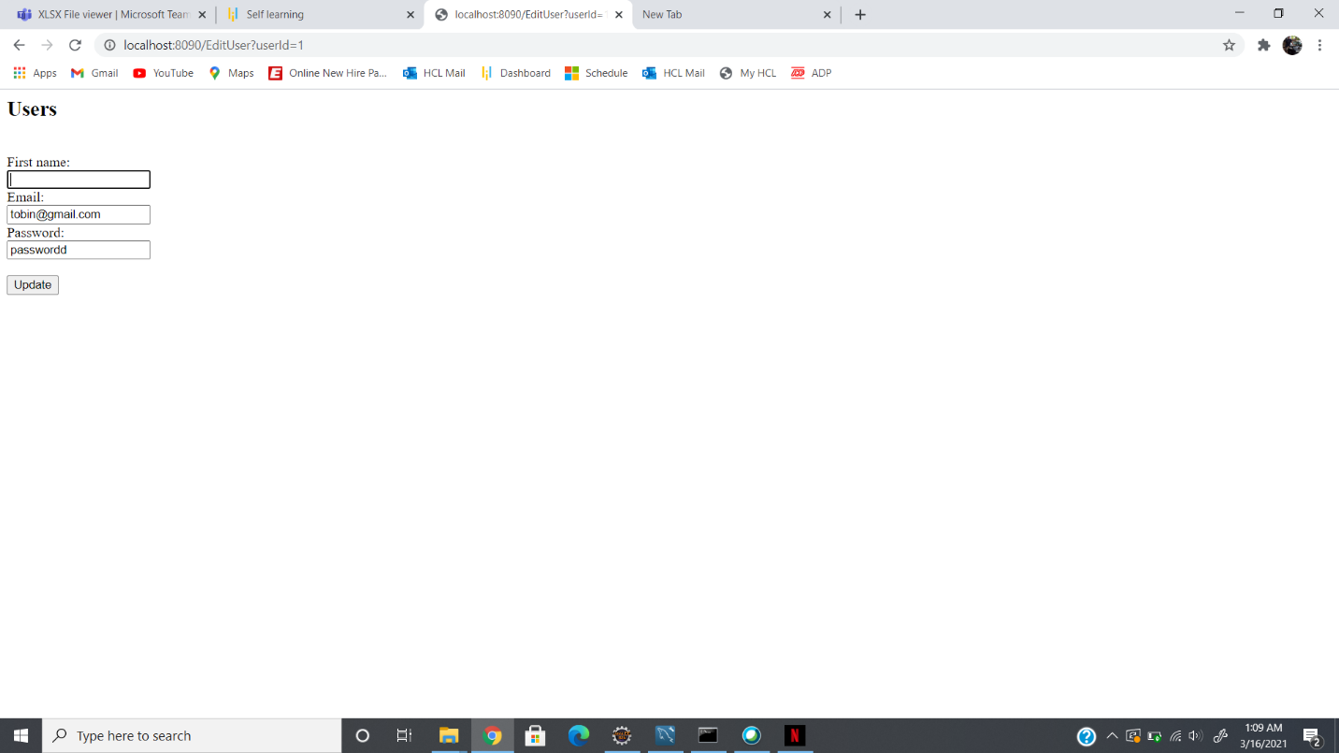

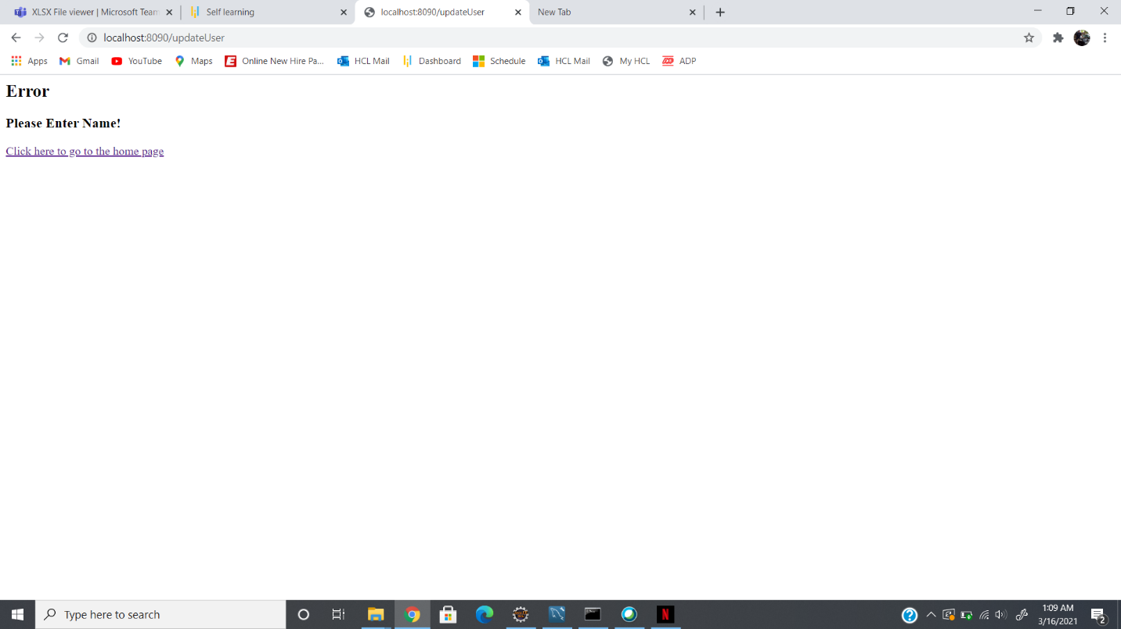

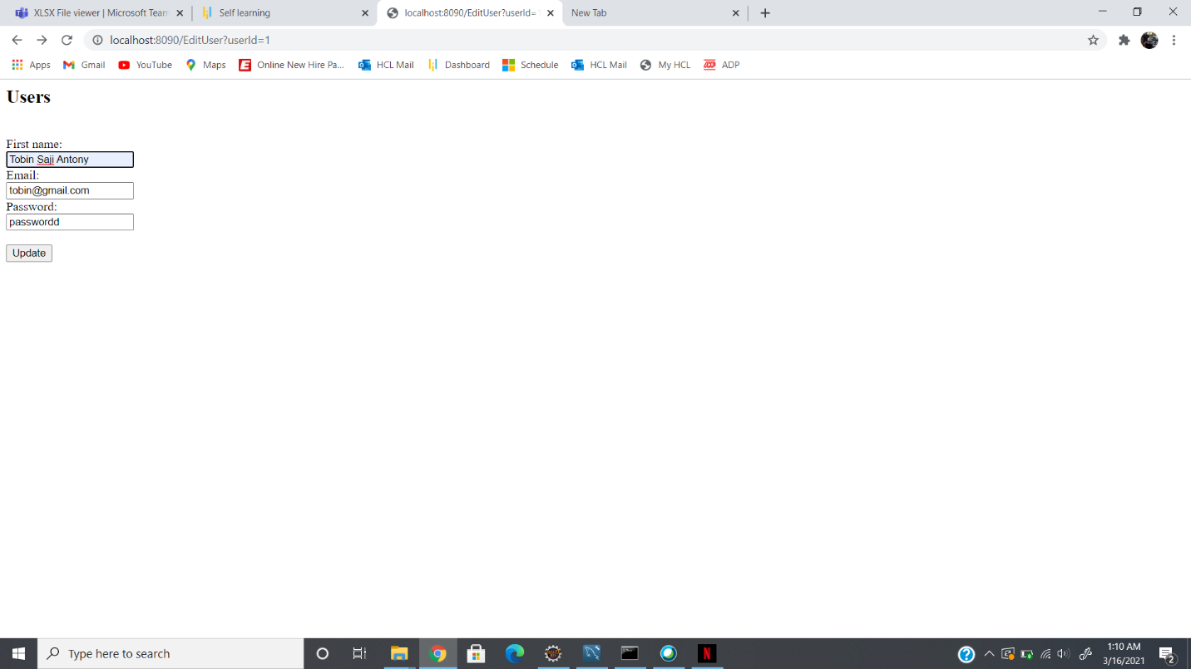

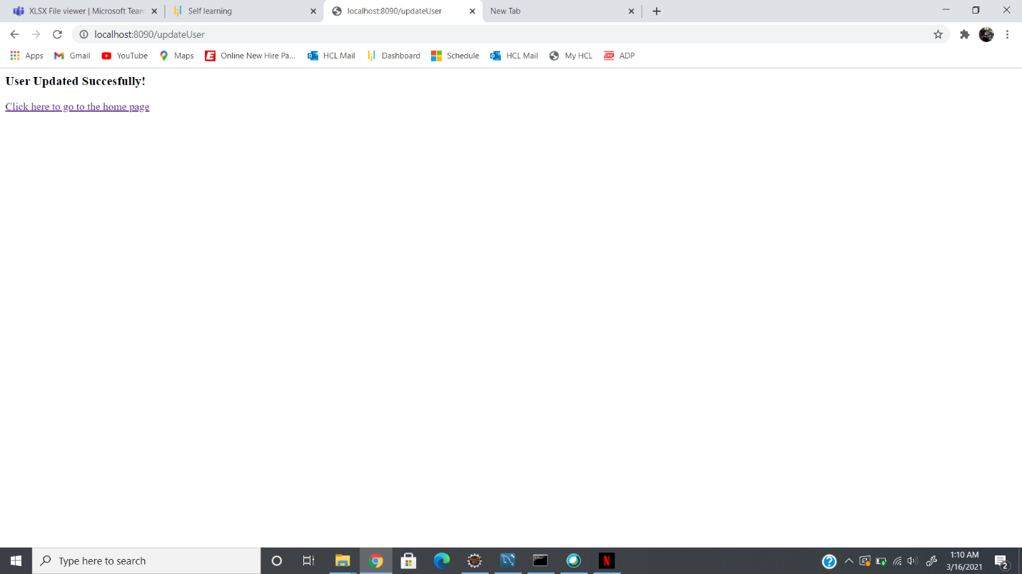

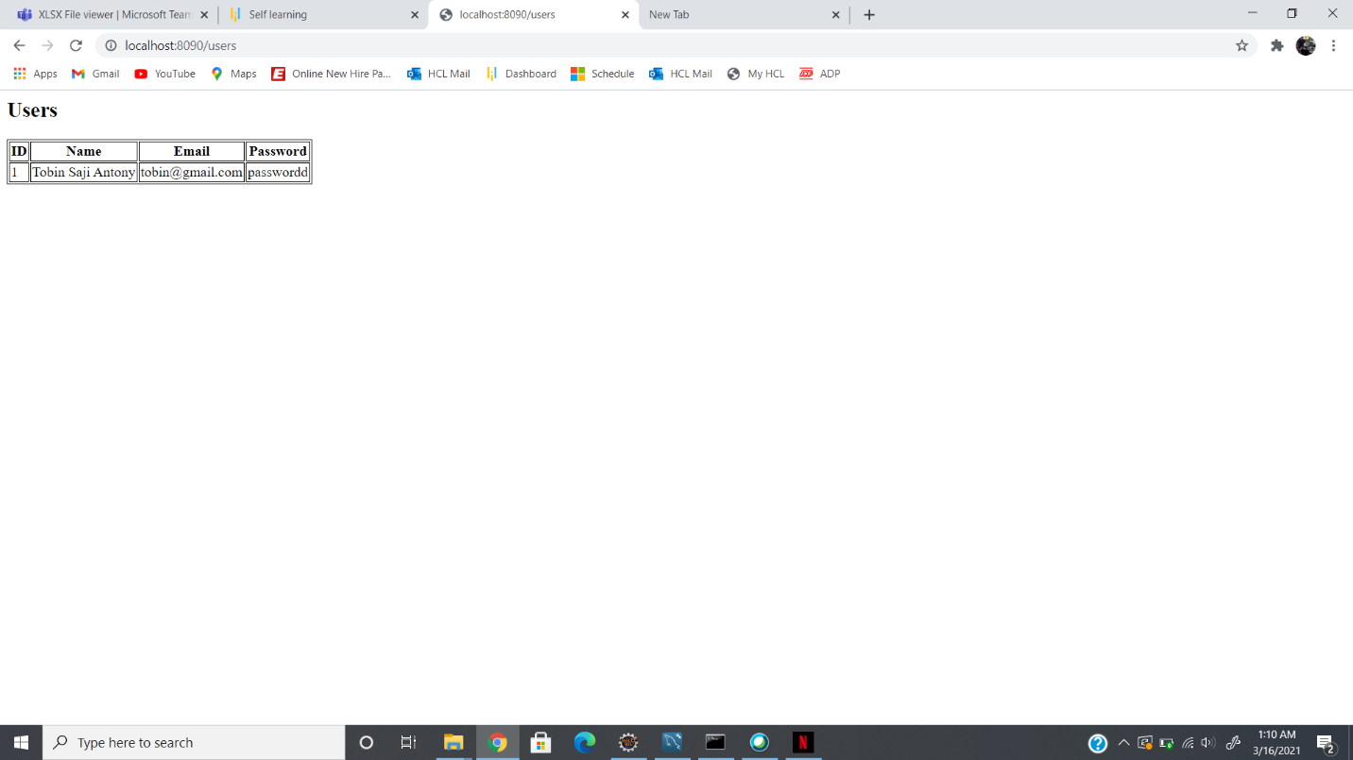

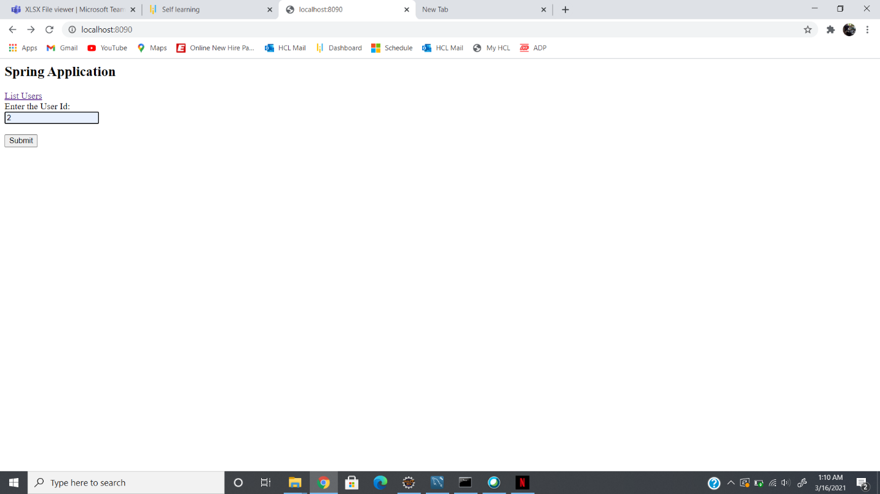

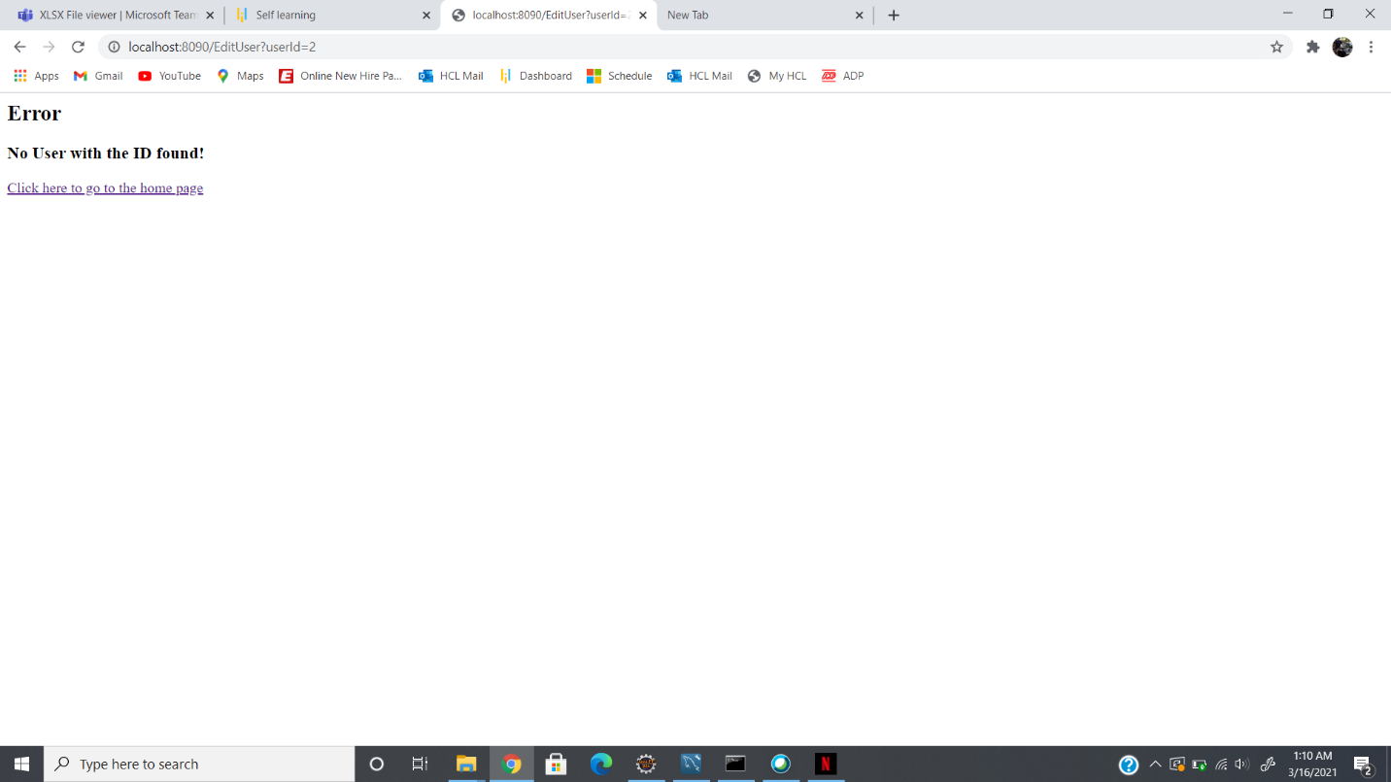

**GITHUB LINK:**

https://github.com/tobinsajiantony/Java_fsd_Phase_3_SearchAndUpdateUser