**SPRING SECURITY**

**Tobin Saji Antony**

**CODE:**

**Usage:**

**Please run the application and navigate to localhost:8090/. Enter ‘user’ and ‘password’ as the username and password**

**WebSecurityConfig.java**

package com.example.SpringSecurity;

import org.springframework.context.annotation.Bean;

import org.springframework.context.annotation.Configuration;

import org.springframework.security.config.annotation.web.builders.HttpSecurity;

import org.springframework.security.config.annotation.web.configuration.EnableWebSecurity;

import org.springframework.security.config.annotation.web.configuration.WebSecurityConfigurerAdapter;

import org.springframework.security.core.userdetails.User;

import org.springframework.security.core.userdetails.UserDetails;

import org.springframework.security.core.userdetails.UserDetailsService;

import org.springframework.security.provisioning.InMemoryUserDetailsManager;

@Configuration

@EnableWebSecurity

public class WebSecurityConfig extends WebSecurityConfigurerAdapter {

@Override

protected void configure(HttpSecurity http) throws Exception {

http

.authorizeRequests()

.antMatchers("/", "/index").permitAll()

.anyRequest().authenticated()

.and()

.formLogin()

//.loginPage("/login")

.permitAll()

.and()

.logout()

.permitAll();

}

@Bean

@Override

public UserDetailsService userDetailsService() {

UserDetails user =

User.withDefaultPasswordEncoder()

.username("user")

.password("password")

.roles("USER")

.build();

return new InMemoryUserDetailsManager(user);

}

}

**MvcConfig.java**

package com.example.SpringSecurity;

import org.springframework.context.annotation.Configuration;

import org.springframework.web.servlet.config.annotation.ViewControllerRegistry;

import org.springframework.web.servlet.config.annotation.WebMvcConfigurer;

@Configuration

public class MvcConfig implements WebMvcConfigurer {

public void addViewControllers(ViewControllerRegistry registry) {

registry.addViewController("/home").setViewName("home");

registry.addViewController("/").setViewName("home");

registry.addViewController("/hello").setViewName("hello");

registry.addViewController("/login").setViewName("login");

}

}

**UserController.java**

package com.example.SpringSecurity.controllers;

import org.slf4j.Logger;

import org.slf4j.LoggerFactory;

import org.springframework.beans.factory.annotation.Autowired;

import org.springframework.stereotype.Controller;

import org.springframework.ui.ModelMap;

import org.springframework.web.bind.annotation.GetMapping;

import org.springframework.web.bind.annotation.PostMapping;

import org.springframework.web.bind.annotation.RequestBody;

import org.springframework.web.bind.annotation.RequestMapping;

import org.springframework.web.bind.annotation.RequestParam;

import org.springframework.web.bind.annotation.ResponseBody;

import com.example.SpringSecurity.entities.User;

import com.example.SpringSecurity.services.UserService;

import org.slf4j.Logger;

import org.slf4j.LoggerFactory;

@Controller

public class UserController {

@Autowired

private UserService userService;

Logger logger = LoggerFactory.getLogger(UserController.class);

@GetMapping("/users")

public String showUsers(ModelMap model) {

logger.info("Getting all Users");

Iterable<com.example.SpringSecurity.entities.User> users = userService.GetAllUsers();

logger.info("Passing users to view");

model.addAttribute("users", users);

return "users";

}

}

**SCREENSHOTS**

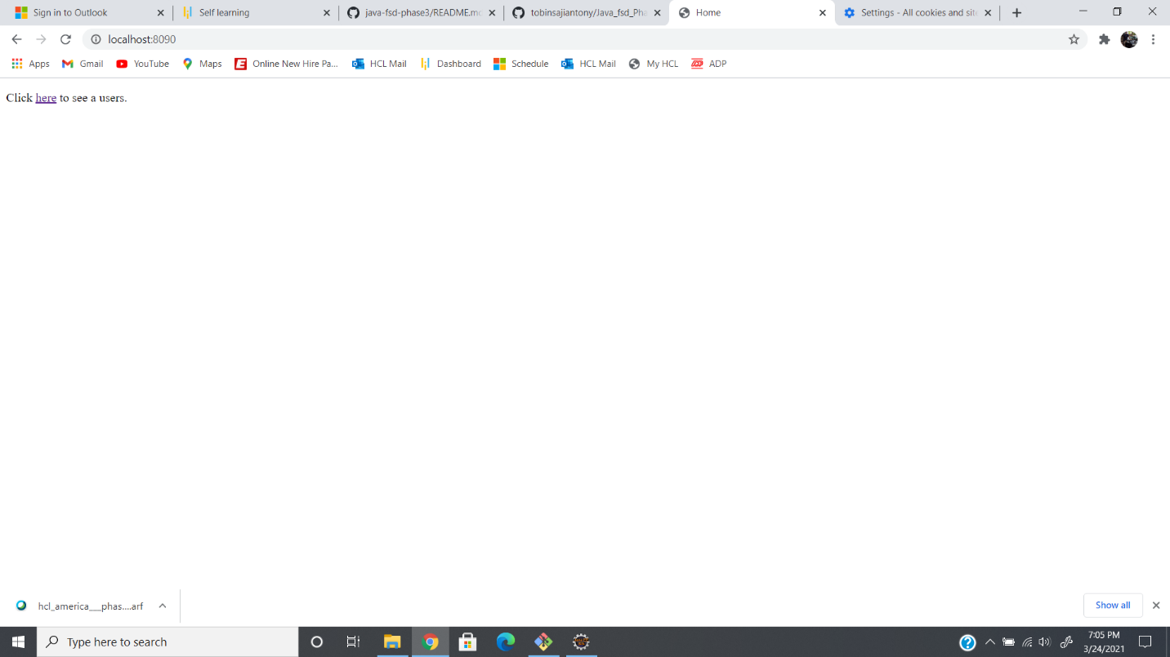

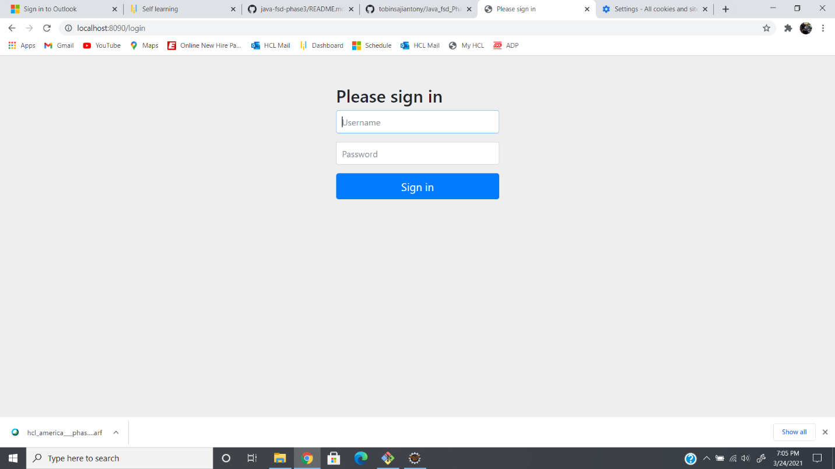

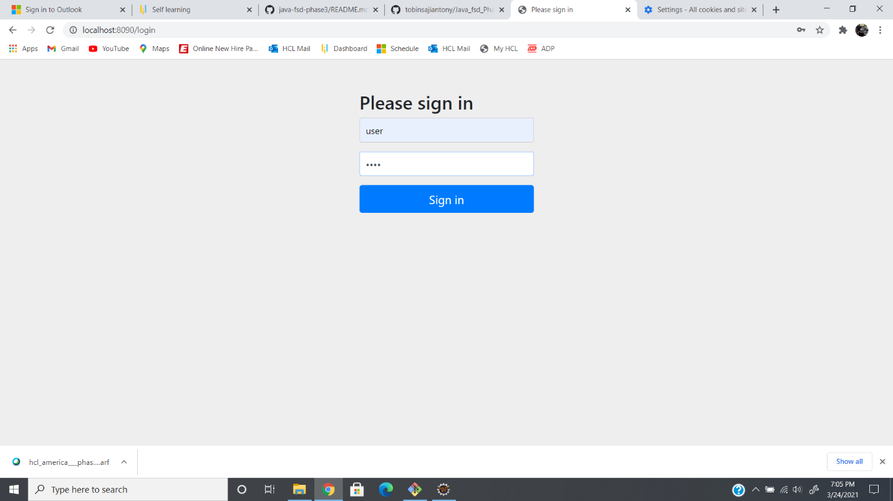

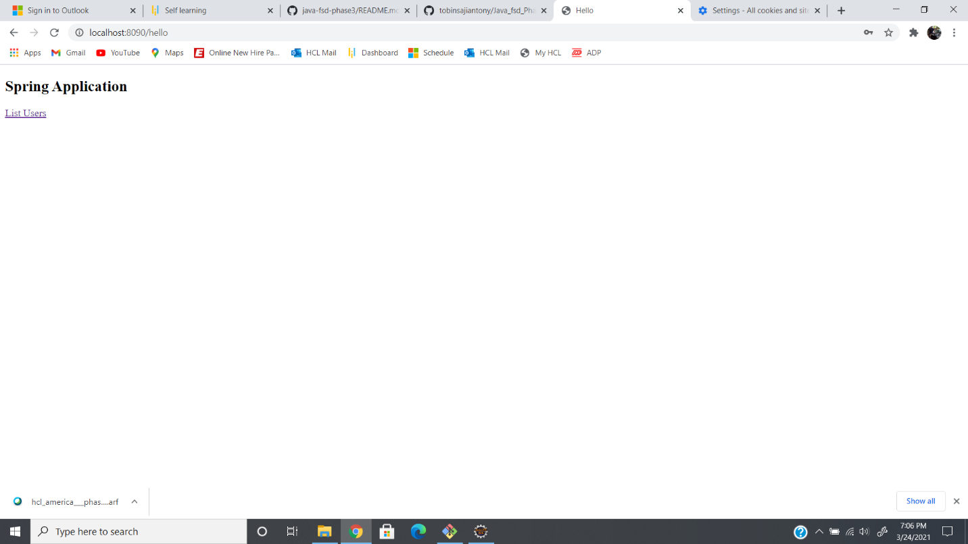

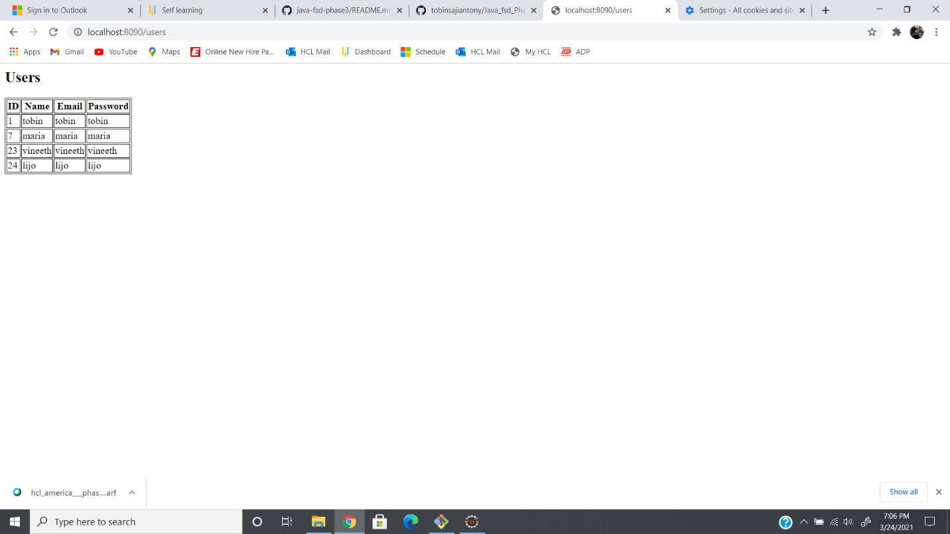

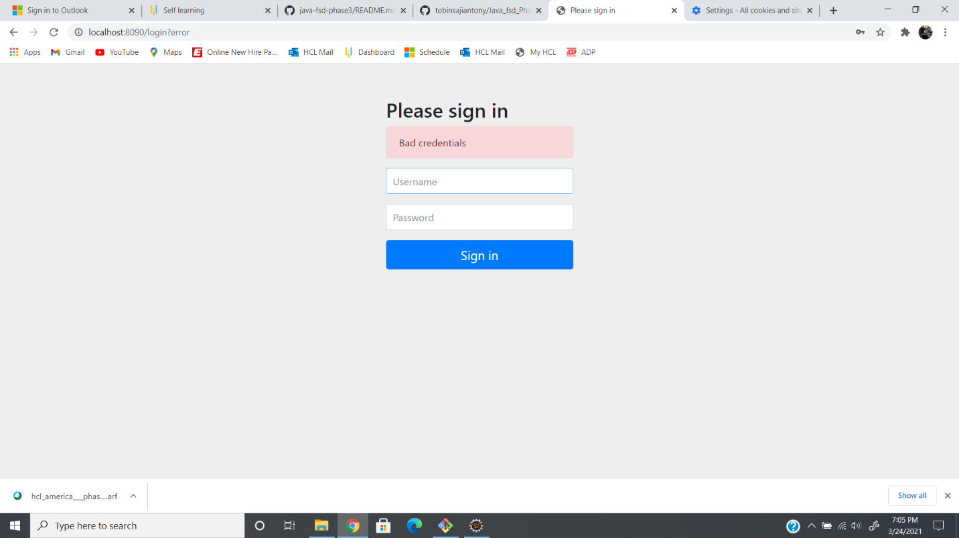

**GITHUB LINK:**

https://github.com/tobinsajiantony/Java_fsd_Phase_3_UserFeedback