**Task Manager**

This is an application that lets users authenticate into a web site and lets users perform crud operations on Tasks. It mainly consists of the following

**OVERALL DESCRIPTION**

Login Page: It is the initial page loaded of the website and prompts the user to enter the username and password. The entered inputs are sent to the servlet for verification and upon verification the user is logged in to the application. If the username or password is incorrect the user would not be allowed to log-in and appropriate error messages will be shown to the user. There is also a link in the login page to redirect the user to create an account if the user has none.

Create Account Page: This page can be accessed from the login page via a link. This page consists of fields for the user to enter the username, password and type in the password again for verification. If both the entered passwords match and there is a valid username then the account is created for the user. Appropriate error messages are shown if there is an issue in validating the data entered by the user.

User Landing Page: This page is the landing page on successful authentication of the user. This page also has a link called logout, that redirects the user to Login Page. This page lists all the tasks created by the logged in user. The user can update or delete the tasks from this page. The user can also add new tasks from this page.

Add Tasks Page: The user can add new tasks from this page.

Update Tasks Page: The user can update a particular task, from this page.

**Flow Chart**

1.Authentication

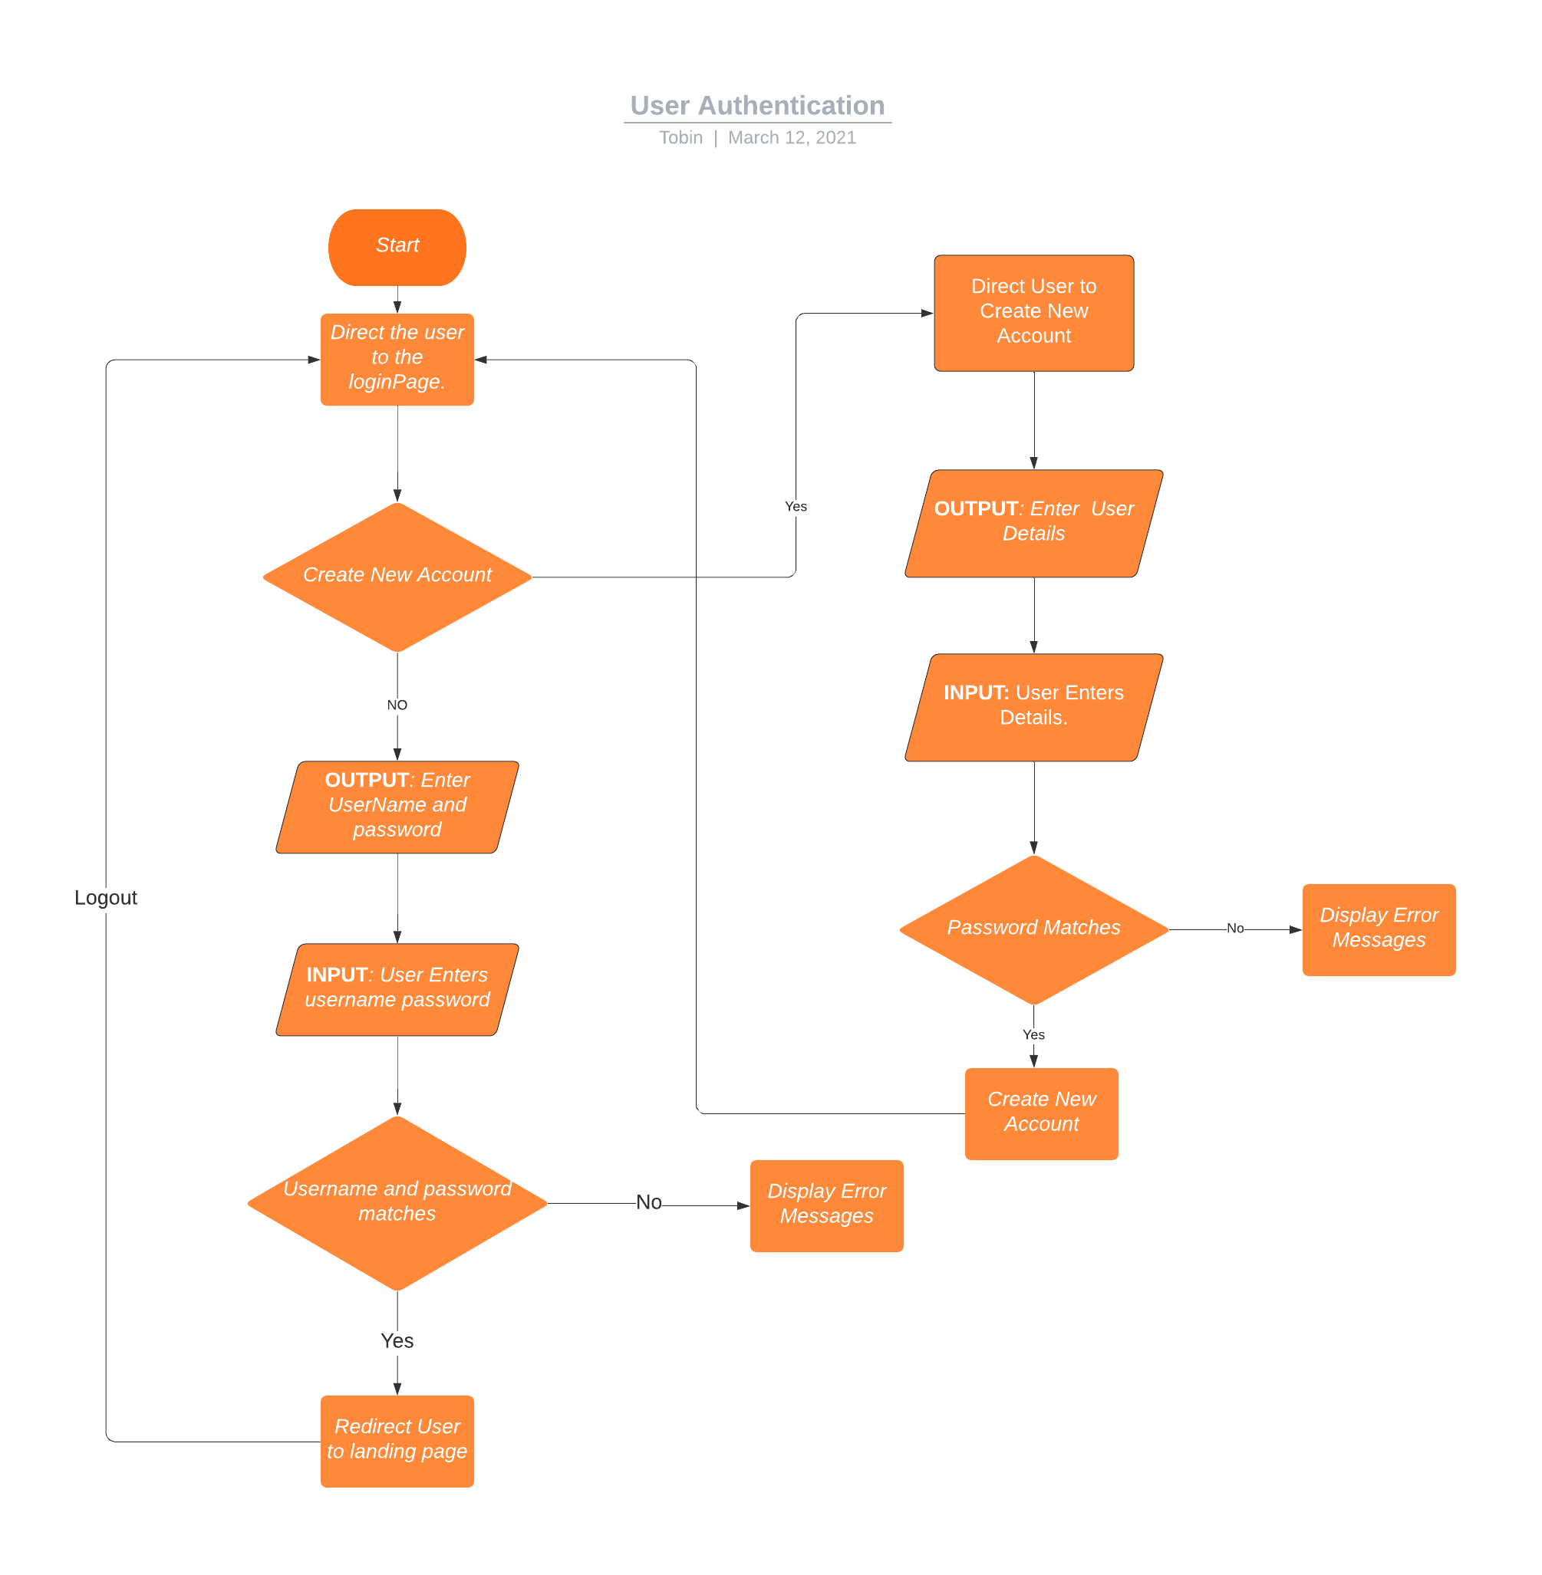

2. Task Manager

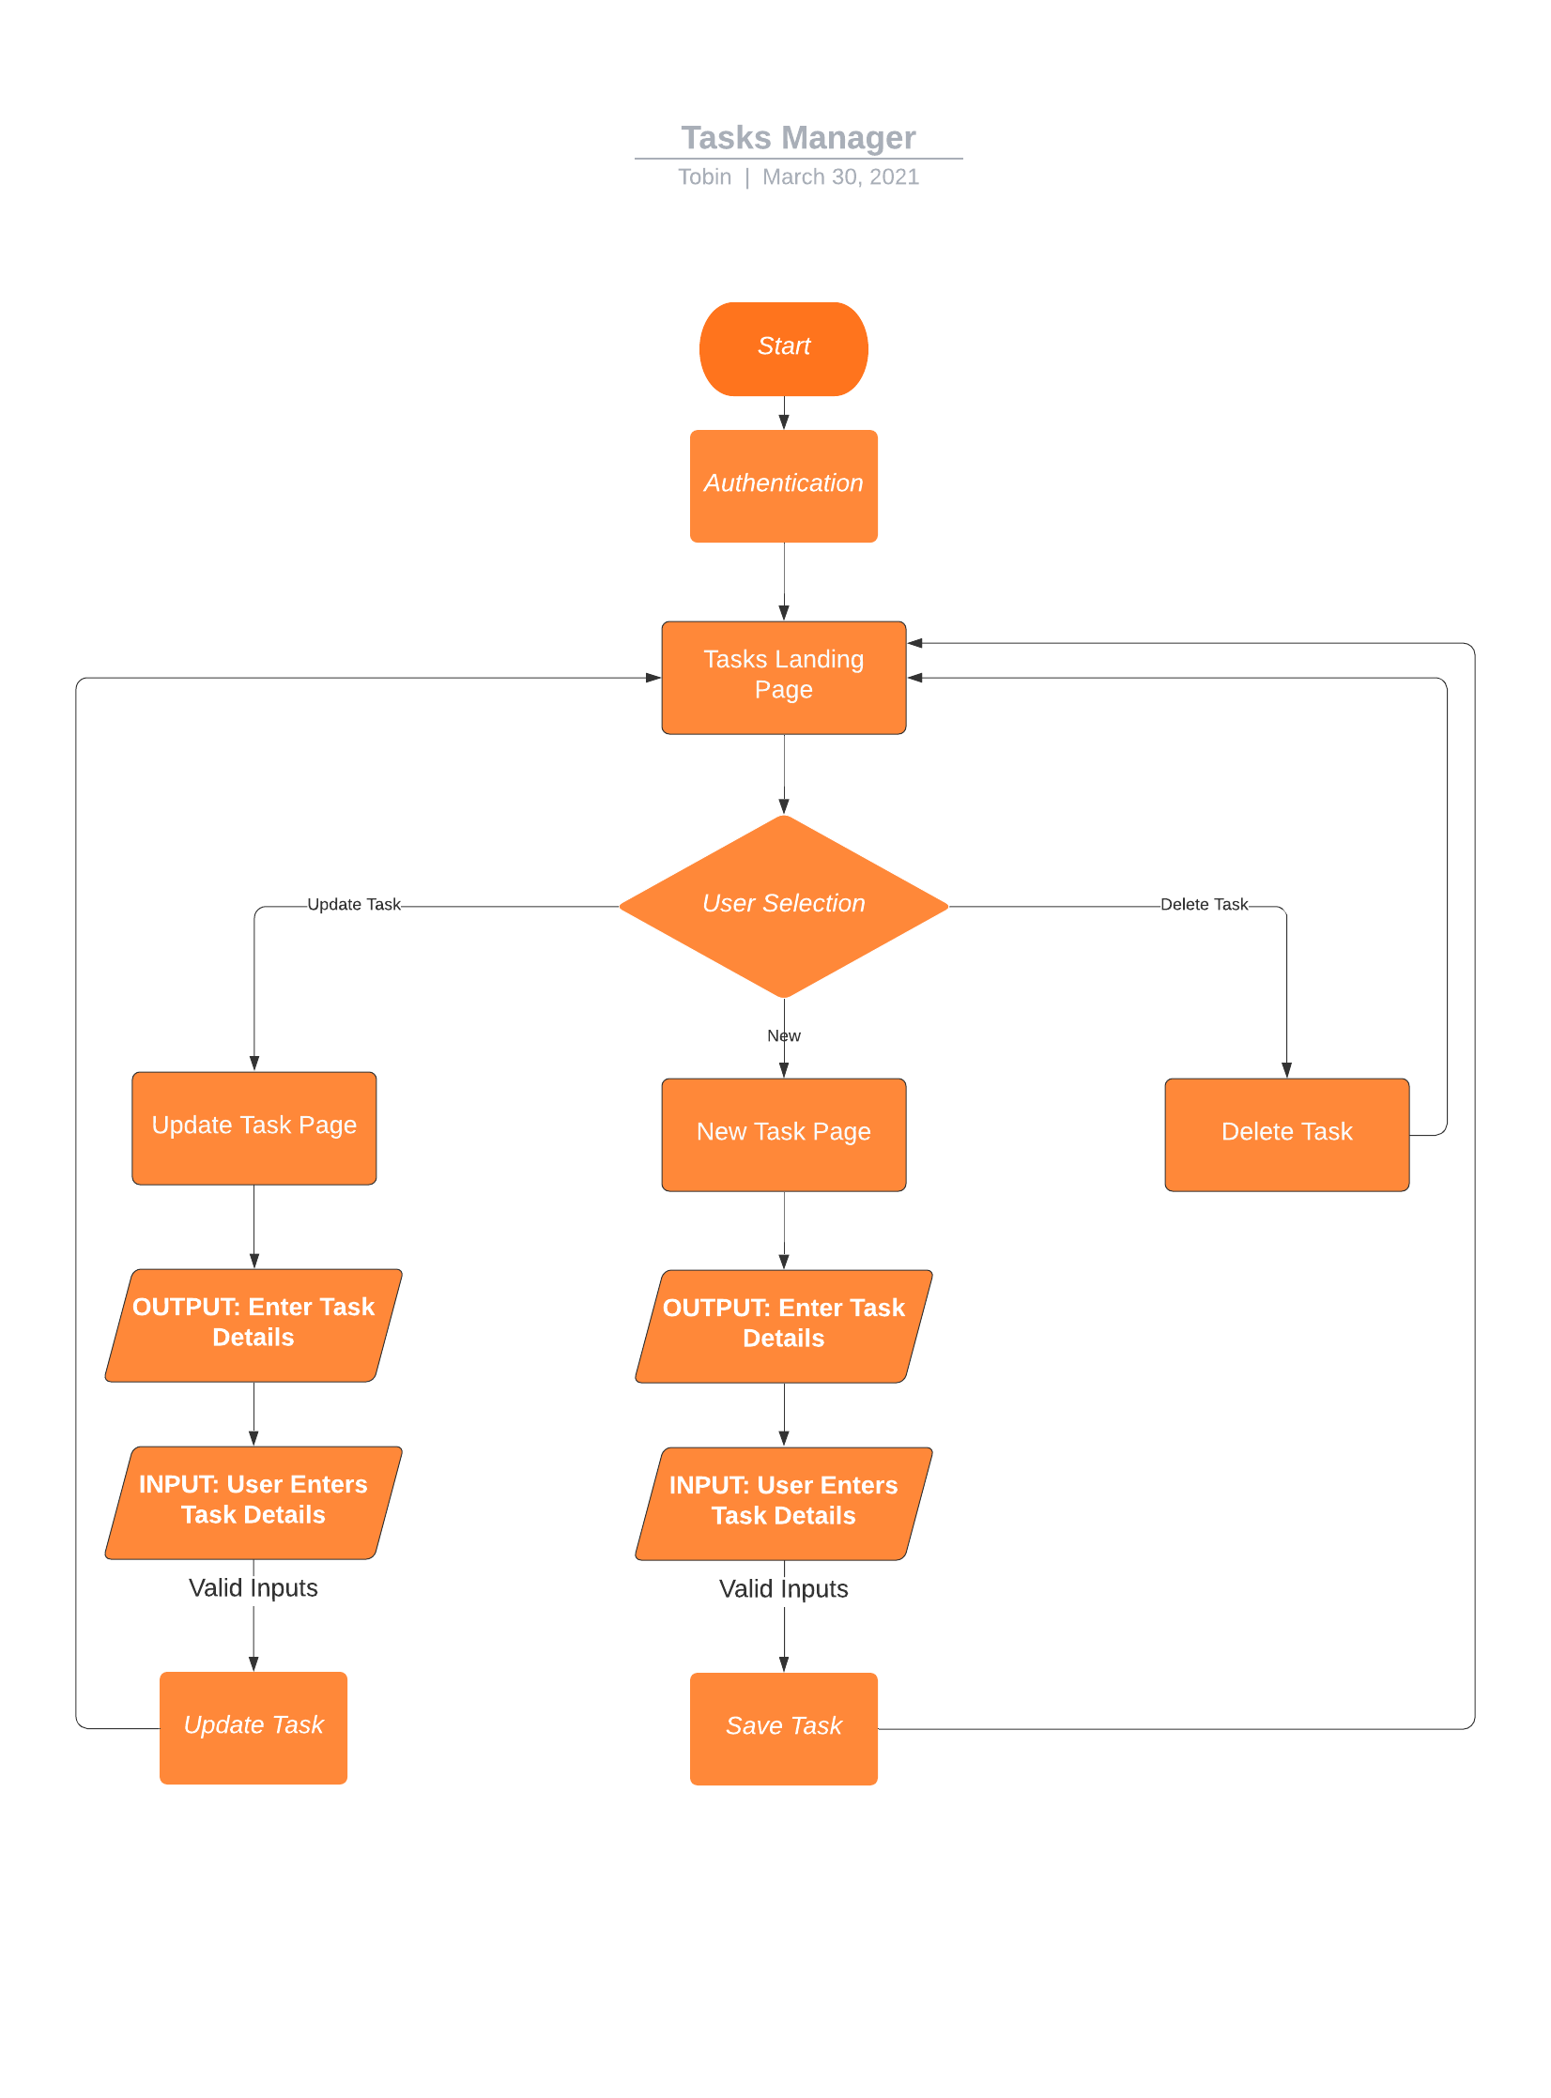

**SPRINTS**

SPRINT BACKLOG

|  |  |  |
| --- | --- | --- |
| Day | Tasks | Assignee |
| Not Assigned | Designing Of User Registration HTML page | Sprint Backlog |
| Not Assigned | Coding and testing of Registration page | Sprint Backlog |
| Not Assigned | Designing of User Login Page HTML | Sprint Backlog |
| Not Assigned | Coding and Testing of the Login Page | Sprint Backlog |
| Not Assigned | Design of Landing Tasks Page HTML | Sprint Backlog |
| Not Assigned | Coding and Designing Of The Landing Tasks Page | Sprint Backlog |
| Not Assigned | Design of Add/Update Tasks page. | Sprint Backlog |
| Not Assigned | Coding of Add/Update Tasks page. | Sprint Backlog |
| Not Assigned | Design and Coding of Delete Tasks page. | Sprint Backlog |
| Not Assigned | Integration Of the various Modules and Testing | Sprint Backlog |

**WEEK 1**

After discussing with the Business Analysts and Team leads, we have decided to take the following tasks in week 1 sprint.

|  |  |  |
| --- | --- | --- |
| Day | Tasks | Assignee |
| Day 1-2 | Designing Of User Registration HTML page,  Coding and testing of Registration page | Tobin |
| Day 3-4 | Designing of User Login Page HTML , Coding and testing of Login page | Tobin |
| Day 5-6 | Design of Landing Tasks Page HTML | Tobin |
| Day 7-8 | Coding and Designing Of The Landing Tasks Page | Tobin |

**After week 1 Status**

|  |  |  |  |
| --- | --- | --- | --- |
| Day | Tasks | Assignee | Status |
| Day 1-2 | Designing Of User Registration HTML page,  Coding and testing of Registration page | Tobin | Completed |
| Day 3-4 | Designing of User Login Page HTML , Coding and testing of Login page | Tobin | Completed |
| Day 5-6 | Design of Landing Tasks Page HTML | Tobin | Completed |
| Day 7-8 | Coding and Designing Of The Landing Tasks Page | Tobin | Not Completed |

On day 9 and 10 in Sprint 1 the user task were reviewed and checked if they met Acceptance Criteria. The last user story did not meet the requirements hence was moved to next sprint.

On day 10 the retrospective of the sprint was held and various issues and concerns were discussed. It was found that the last task couldn’t be completed to an issue in the UI design provided.

**SPRINT 2**

The following task were decided to be taken in sprint 2.

|  |  |  |
| --- | --- | --- |
| Day | Tasks | Assignee |
| Day 11 - 12 | Coding and Designing Of The Landing Tasks Page (Moved from sprint 1) | Tobin |
| Day 13 – 14 | Design of Add/Update Tasks page.  Coding of Add/Update Tasks page. | Tobin |
| Day 15 – 16 | Design and Coding of Delete Tasks page. | Tobin |
| Day 17 - 18 | Integration Of the various Modules and Testing | Tobin |

After Sprint 2 development, The status is as follows:

|  |  |  |  |
| --- | --- | --- | --- |
| Day | Tasks | Assignee | Status |
| Day 11 - 12 | Coding and Designing Of The Landing Tasks Page (Moved from sprint 1) | Tobin | Completed |
| Day 13 – 14 | Design of Add/Update Tasks page.  Coding of Add/Update Tasks page. | Tobin | Completed |
| Day 15 – 16 | Design and Coding of Delete Tasks page. | Tobin | Completed |
| Day 17 - 18 | Integration Of the various Modules and Testing | Tobin | Completed |

Thus after 2 intense sprints of agile methodology the application was developed successfully.

**Conclusion**

The Task Manager website is an application that let users create accounts and add new tasks and lets them perform crud operations on the same.

* It is implemented using Java, Hibernate, MySql.
* The Database credentials need to be specified in the configuration file hibernate.cfg.xml.
* The application can be viewed by running maven build.

**Screenshots**

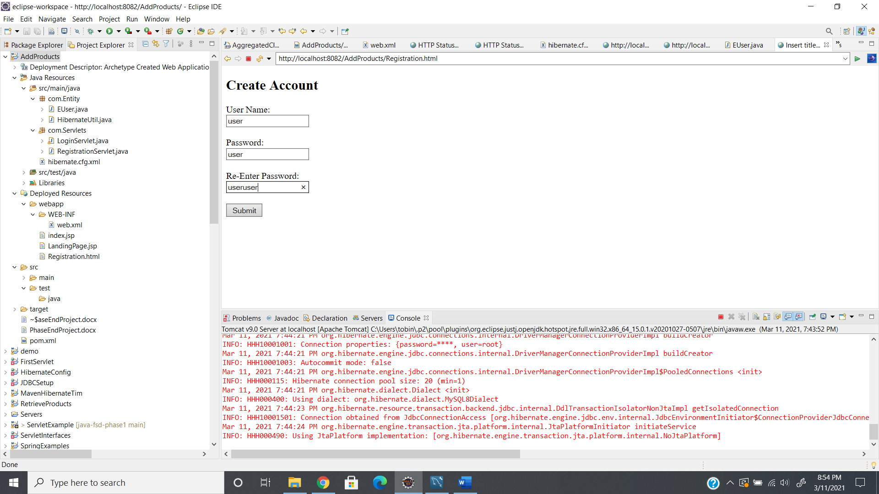

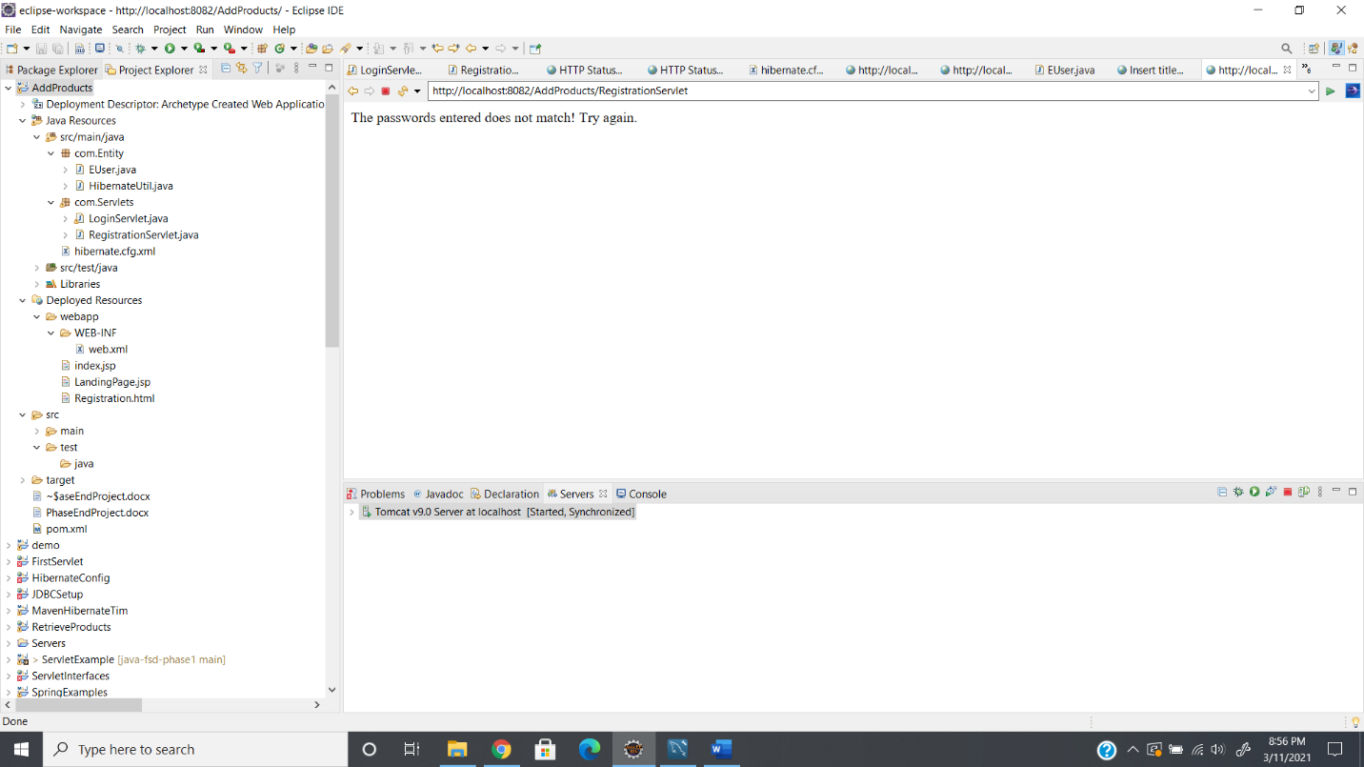

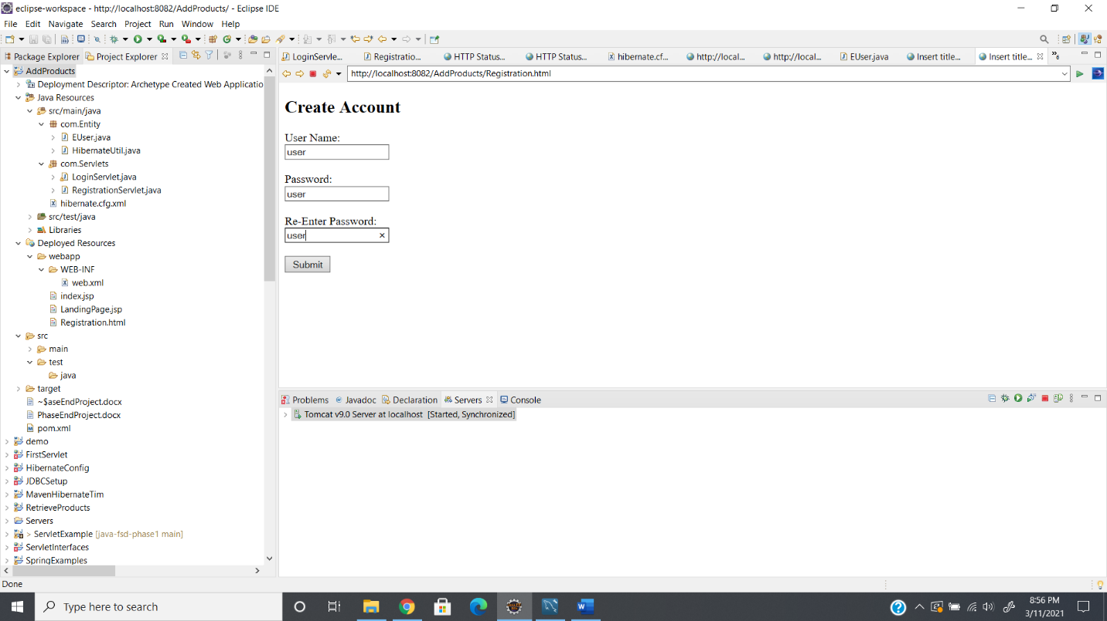

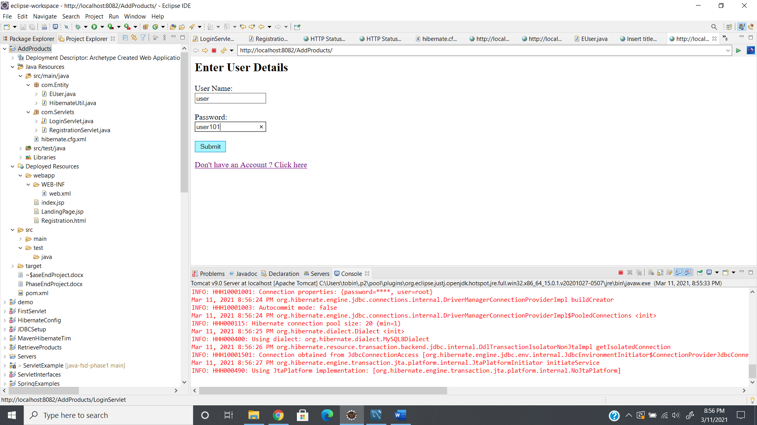

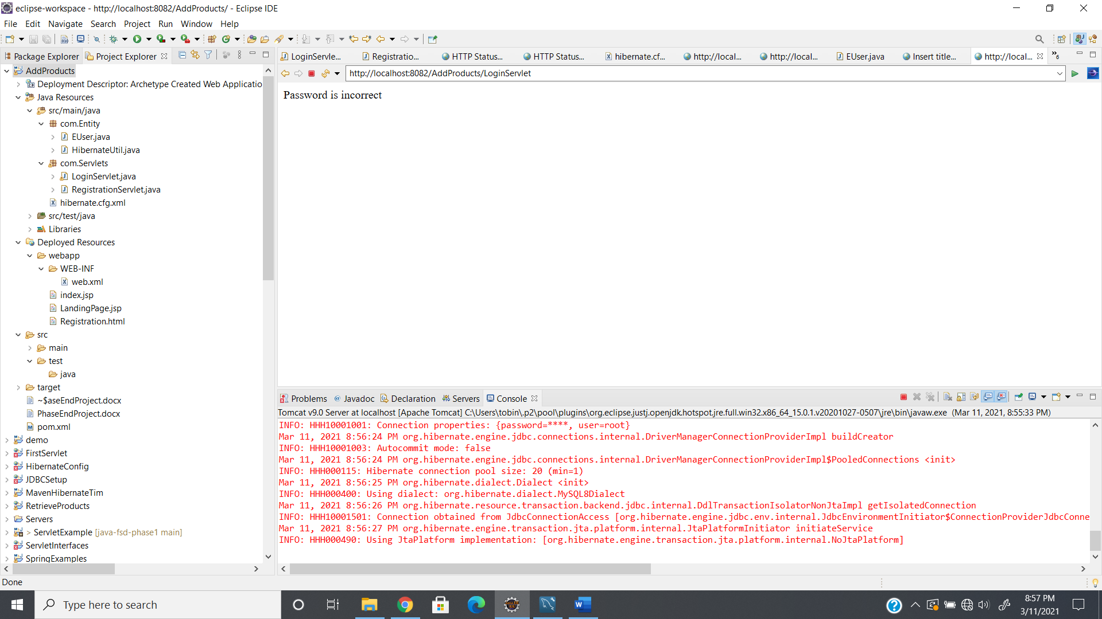

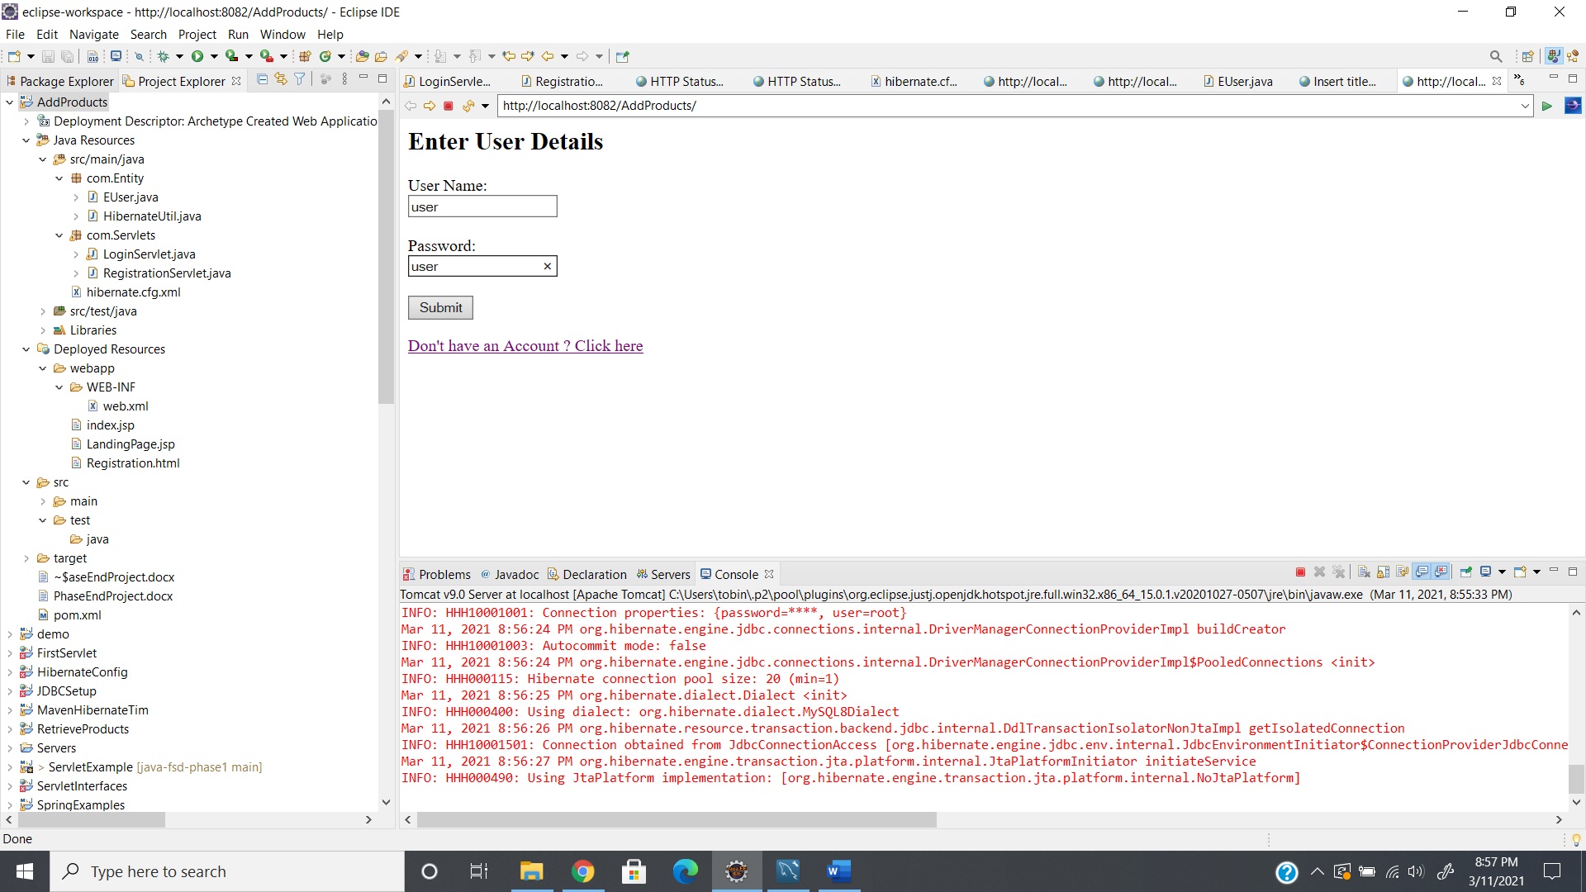

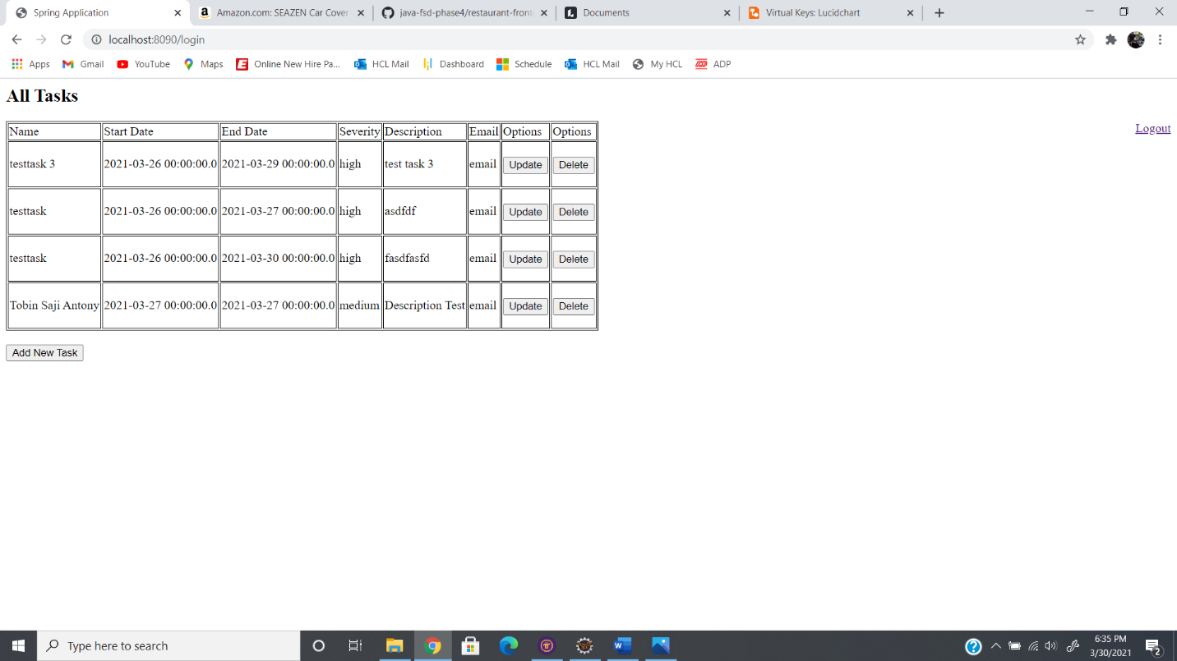

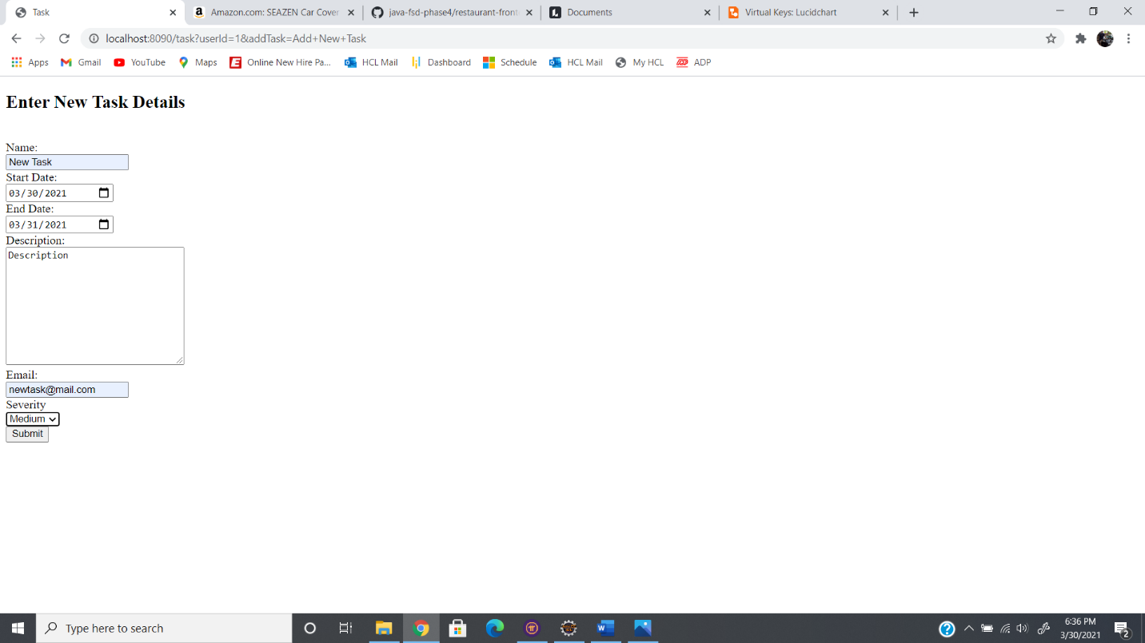

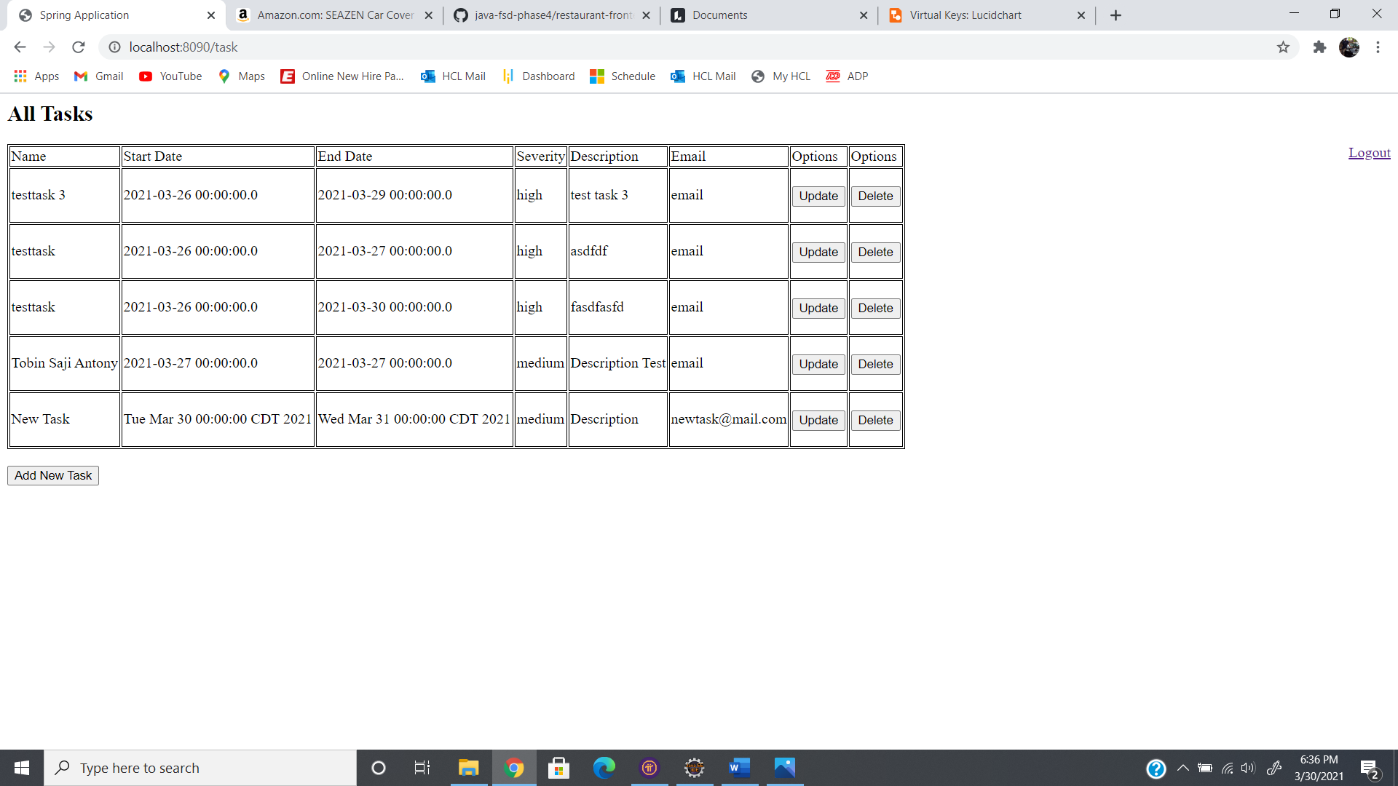

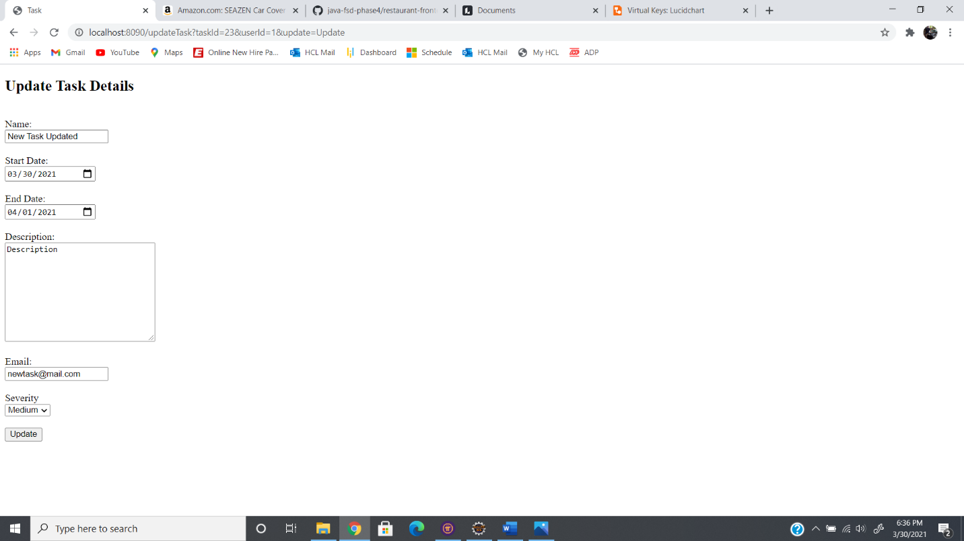

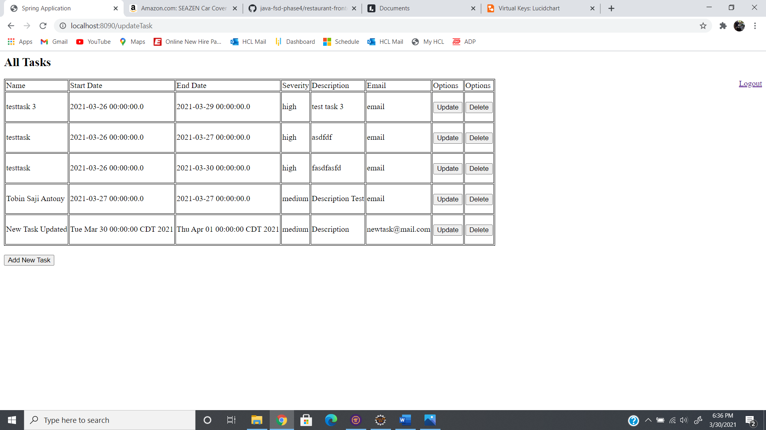

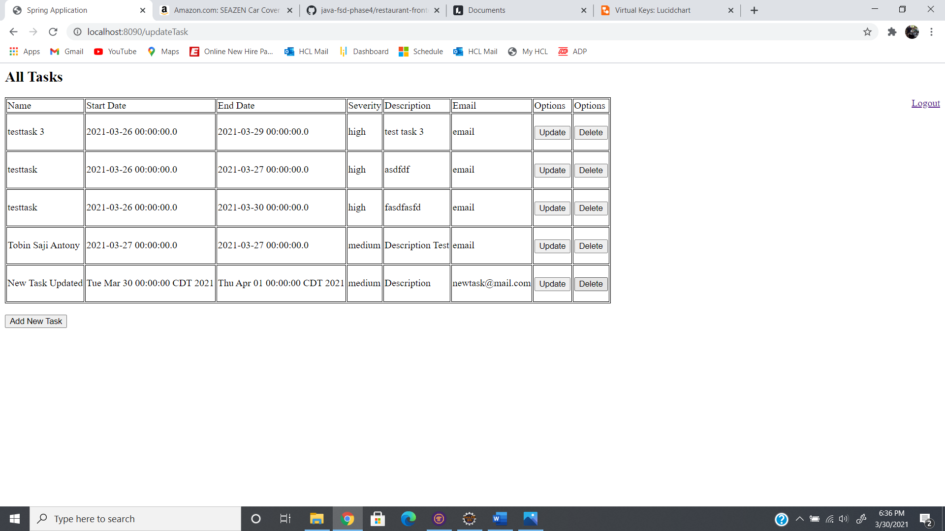

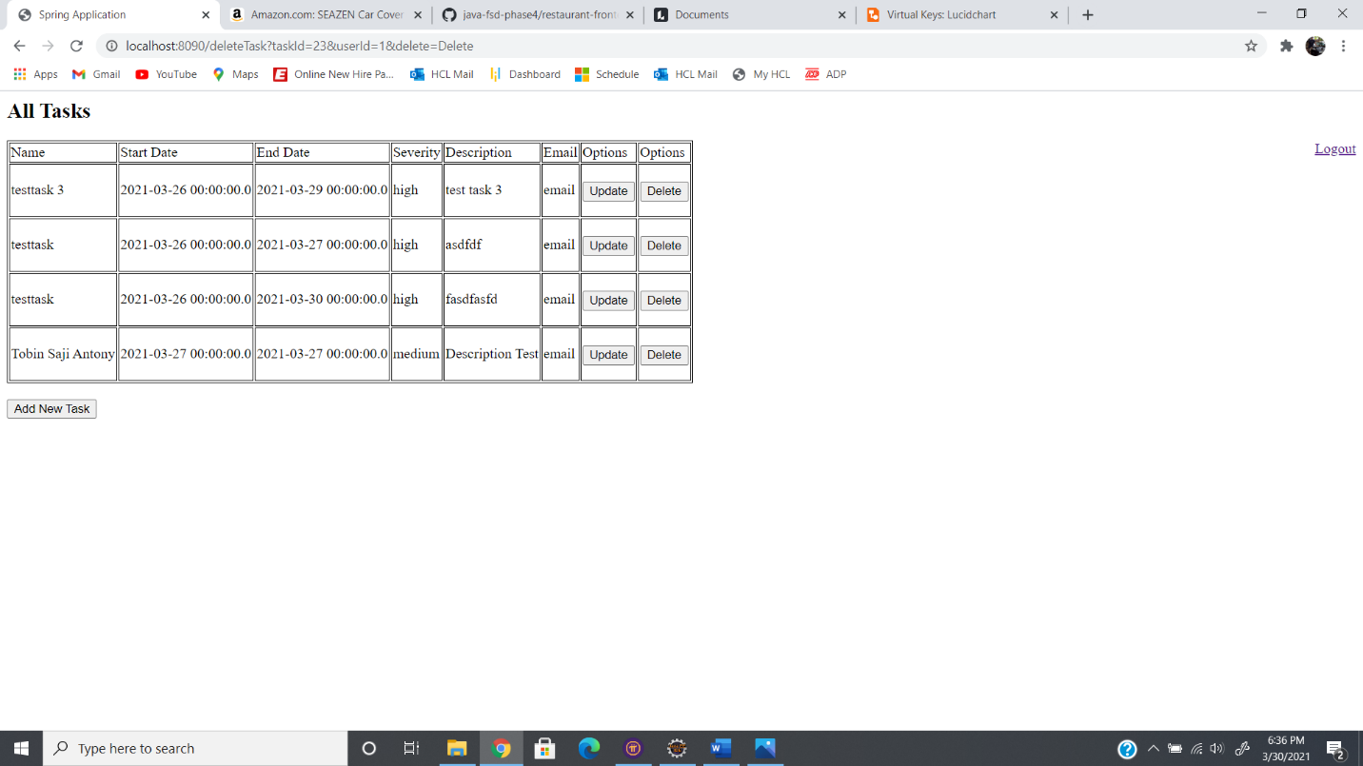

**GitHub Link:**

https://github.com/tobinsajiantony/Java_fsd_Phase_3_TaskManager