**User Feedback**

**Tobin Saji Antony**

**CODE:**

**Usage:**

**Please run the application and open the html file form.html**

**FeedbackController.java**

package com.example.UserFeedback.controllers;

import org.springframework.beans.factory.annotation.Autowired;

import org.springframework.web.bind.annotation.CrossOrigin;

import org.springframework.web.bind.annotation.GetMapping;

import org.springframework.web.bind.annotation.PathVariable;

import org.springframework.web.bind.annotation.PostMapping;

import org.springframework.web.bind.annotation.RequestBody;

import org.springframework.web.bind.annotation.ResponseBody;

import org.springframework.web.bind.annotation.RestController;

import com.example.UserFeedback.entities.Feedback;

import com.example.UserFeedback.services.FeedbackService;

@RestController

public class FeedbackController {

@Autowired

FeedbackService feedbackService;

@GetMapping("/feedback")

public @ResponseBody Iterable<Feedback> getAllFeedbacks() {

// This returns a JSON or XML with the Feedbacks

return feedbackService.GetAllFeedback();

}

@PostMapping("/feedback")

@CrossOrigin

public Feedback addNewFeedback(@RequestBody Feedback newFeedback) {

System.out.println("Post hit");

return feedbackService.SaveFeedback(newFeedback);

}

}

**Form.html**

<html>

<head>

  <script>

    function submitData() {

      comment = document.getElementById('comments').value;

      rating = document.getElementById('rating').value;

      user = document.getElementById('user').value;

      if (comment != '' && rating != '' && user != '') {

        let data = { 'comments': comment, 'rating': rating, 'user': user }

        fetch("http://localhost:8090/feedback", {

          method: "POST",

          headers: new Headers({ 'content-type': 'application/json' }),

          body: JSON.stringify(data)

        }).then(res => {

          alert("Request complete!");

        });

      }

      else if (comment == '') {

        alert('Please Enter Comment');

      }

      else if (rating == '') {

        alert('Please Enter Rating');

      }

      else {

        alert('Please Enter User');

      }

    }

  </script>

</head>

<body>

  <form>

    <label for="comments">Comments:</label><br>

    <input type="text" id="comments" name="comments"><br><br>

    <label for="rating">Rating:</label><br>

    <input type="text" id="rating" name="rating"><br><br>

    <label for="user">User:</label><br>

    <input type="text" id="user" name="user"><br><br>

    <input type="button" onclick="submitData()" value="Submit">

  </form>

</body>

</html>

**SCREENSHOTS**

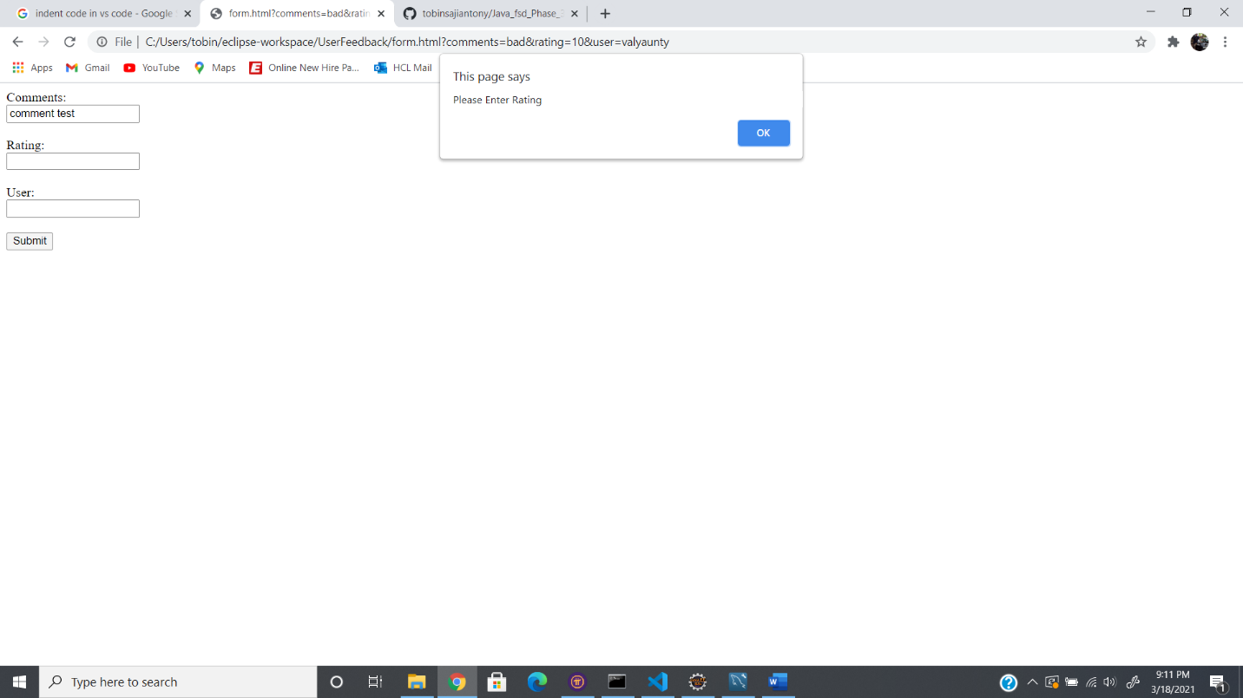

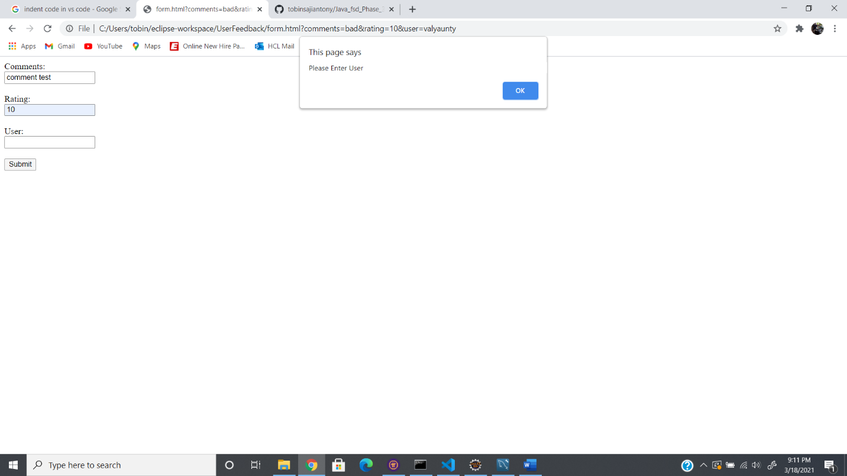

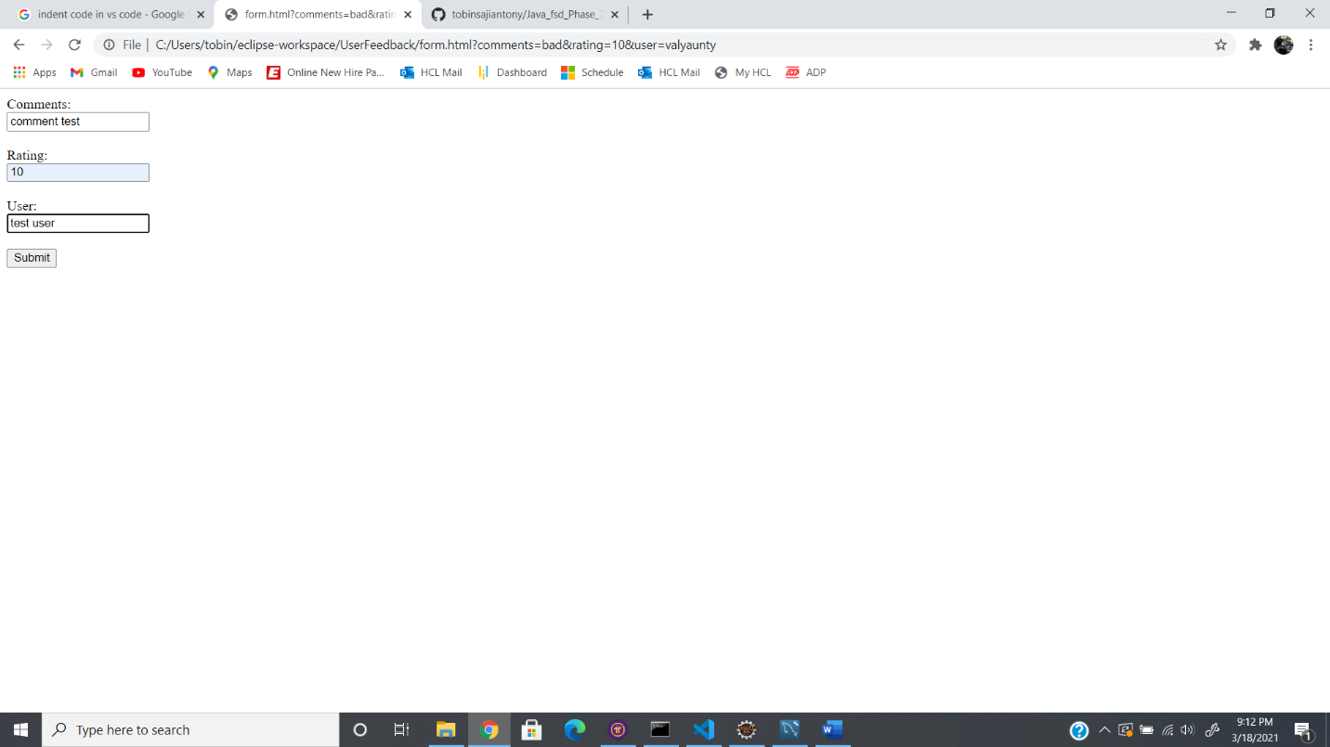

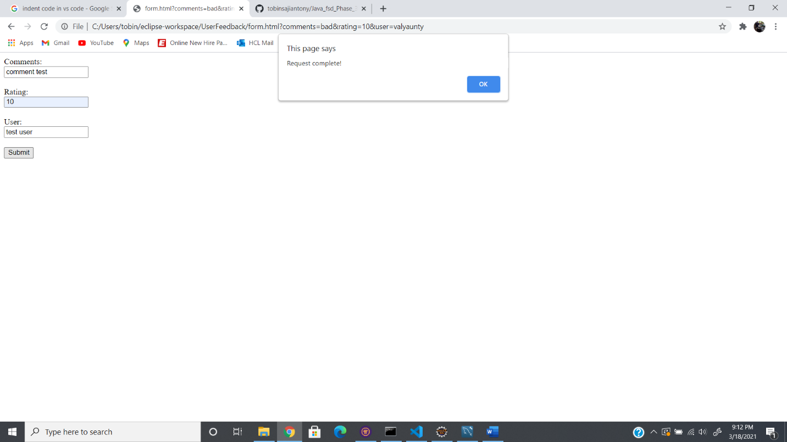

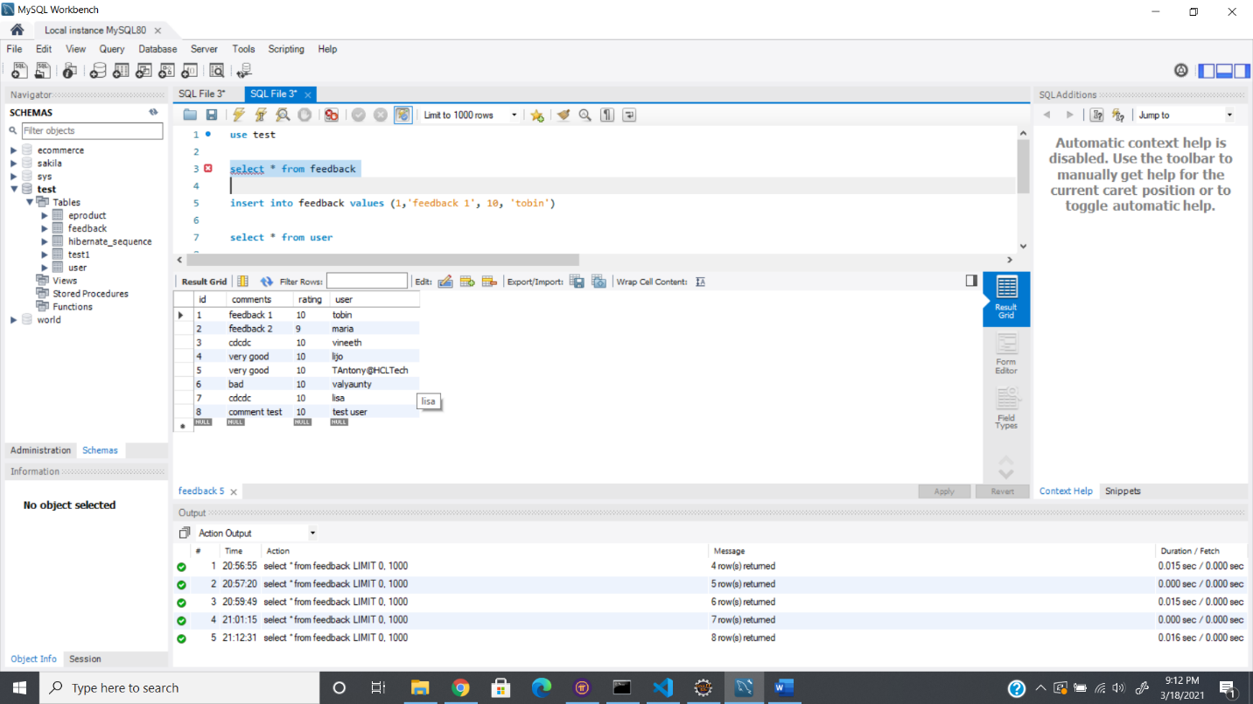

**GITHUB LINK:**

https://github.com/tobinsajiantony/Java_fsd_Phase_3_UserFeedback