**Budget Planner**

**Tobin Saji Antony**

**Usage:**

Open file login.html. and use

1)

Username: productmanager

Password: productmanager

2)

Username: finance

Password: finance

As credentials for the two different users.

**SAMPLE CODE:**

**Table_example.html**

<!DOCTYPE html>

<html>

<head>

    <title>Ming's Diner</title>

    <meta charset="utf-8">

    <meta name="viewport" content="width=device-width, initial-scale=1">

    <link rel="stylesheet" href="https://stackpath.bootstrapcdn.com/bootstrap/4.3.1/css/bootstrap.min.css" integrity="sha384-ggOyR0iXCbMQv3Xipma34MD+dH/1fQ784/j6cY/iJTQUOhcWr7x9JvoRxT2MZw1T" crossorigin="anonymous">

      <!-- Optional JavaScript -->

      <!-- jQuery first, then Popper.js, then Bootstrap JS -->

      <script src="https://code.jquery.com/jquery-3.3.1.slim.min.js" integrity="sha384-q8i/X+965DzO0rT7abK41JStQIAqVgRVzpbzo5smXKp4YfRvH+8abtTE1Pi6jizo" crossorigin="anonymous"></script>

      <script src="https://cdnjs.cloudflare.com/ajax/libs/popper.js/1.14.7/umd/popper.min.js" integrity="sha384-UO2eT0CpHqdSJQ6hJty5KVphtPhzWj9WO1clHTMGa3JDZwrnQq4sF86dIHNDz0W1" crossorigin="anonymous"></script>

      <script src="https://stackpath.bootstrapcdn.com/bootstrap/4.3.1/js/bootstrap.min.js" integrity="sha384-JjSmVgyd0p3pXB1rRibZUAYoIIy6OrQ6VrjIEaFf/nJGzIxFDsf4x0xIM+B07jRM" crossorigin="anonymous"></script>

    <style>

        th, td, p, input {

            font:14px Verdana;

        }

        table, th, td

        {

            border: solid 1px #DDD;

            border-collapse: collapse;

            padding: 2px 3px;

            text-align: center;

        }

        th {

            font-weight:bold;

        }

    </style>

    <script src="create_table.js"></script>

</head>

<body onload="CreateTableFromJSON()">

  <!-- Navbar -->

<nav class="navbar navbar-expand-lg navbar-light bg-light">

  <a class="navbar-brand" href="table_example.html">Project Manager Dashboard</a>

  <button class="navbar-toggler" type="button" data-toggle="collapse" data-target="#navbarNav" aria-controls="navbarNav" aria-expanded="false" aria-label="Toggle navigation">

    <span class="navbar-toggler-icon"></span>

  </button>

  <div class="collapse navbar-collapse" id="navbarNav">

    <ul class="navbar-nav">

      <li class="nav-item active">

        <a class="nav-link" href="table_example.html">Project</a>

      </li>

      <li class="nav-item">

        <a class="nav-link" href="vendor.html">Vendors</a>

      </li>

    </ul>

  </div>

  <div class="navbar-collapse collapse w-100 order-3 dual-collapse2">

    <ul class="navbar-nav ml-auto">

        <li class="nav-item">

            <a class="nav-link" href="login.html">Logout</a>

        </li>

    </ul>

</div>

</nav>

<!--navbar end  -->

    <div class="contain-fluid">

        <div class="row" style="margin-top: 20px; margin-left: 20px;">

            <div class="column">

                <p id="showData"></p>

                <button type="button" class="btn btn-primary" data-toggle="modal" data-target="#exampleModal">

                  Add New Project

                </button>

            </div>

        </div>

    </div>

    <!-- <p id="newData">

        <label>Client Name</label><input type="text" id="clientNameInput" /><br />

        <label>Project Name</label><input type="text" id="projectNameInput" /><br />

        <label>Project Manager</label><input type="text" id="projectManagerInput" /><br />

        <label>Project Cost</label><input type="number" id="projectCostInput" /><br />

    </p>

    <input type="button" onclick="AddNewDeal()" value="Save" /> -->

    <!-- Modal begin -->

    <!-- Button trigger modal -->

  <!-- Modal -->

  <div class="modal fade" id="exampleModal" tabindex="-1" role="dialog" aria-labelledby="exampleModalLabel" aria-hidden="true">

    <div class="modal-dialog" role="document">

      <div class="modal-content">

        <div class="modal-header">

          <h5 class="modal-title" id="exampleModalLabel">Modal title</h5>

          <button type="button" class="close" data-dismiss="modal" aria-label="Close">

            <span aria-hidden="true">&times;</span>

          </button>

        </div>

        <div class="modal-body">

            <div class="form-group">

            <input type="hidden" class="form-control" id="dealId" /><br />

            <label>Client Name</label>

            <input type="text" class="form-control" id="clientNameInput" /><br />

            <label>Project Name</label>

            <input type="text" class="form-control" id="projectNameInput" /><br />

            <label>Project Manager</label>

            <input type="text" class="form-control" id="projectManagerInput" /><br />

            <label>Project Cost</label>

            <input type="number" class="form-control" id="projectCostInput" /><br />

        </div>

        </div>

        <div class="modal-footer">

          <button type="button" class="btn btn-secondary" data-dismiss="modal">Close</button>

          <button type="button" class="btn btn-primary" onclick="AddNewDeal()">Save changes</button>

        </div>

      </div>

    </div>

  </div>

    <!-- Modal End -->

</body>

**Create_table.js**

<!DOCTYPE html>

<html>

<head>

    <title>Ming's Diner</title>

    <meta charset="utf-8">

    <meta name="viewport" content="width=device-width, initial-scale=1">

    <link rel="stylesheet" href="https://stackpath.bootstrapcdn.com/bootstrap/4.3.1/css/bootstrap.min.css" integrity="sha384-ggOyR0iXCbMQv3Xipma34MD+dH/1fQ784/j6cY/iJTQUOhcWr7x9JvoRxT2MZw1T" crossorigin="anonymous">

      <!-- Optional JavaScript -->

      <!-- jQuery first, then Popper.js, then Bootstrap JS -->

      <script src="https://code.jquery.com/jquery-3.3.1.slim.min.js" integrity="sha384-q8i/X+965DzO0rT7abK41JStQIAqVgRVzpbzo5smXKp4YfRvH+8abtTE1Pi6jizo" crossorigin="anonymous"></script>

      <script src="https://cdnjs.cloudflare.com/ajax/libs/popper.js/1.14.7/umd/popper.min.js" integrity="sha384-UO2eT0CpHqdSJQ6hJty5KVphtPhzWj9WO1clHTMGa3JDZwrnQq4sF86dIHNDz0W1" crossorigin="anonymous"></script>

      <script src="https://stackpath.bootstrapcdn.com/bootstrap/4.3.1/js/bootstrap.min.js" integrity="sha384-JjSmVgyd0p3pXB1rRibZUAYoIIy6OrQ6VrjIEaFf/nJGzIxFDsf4x0xIM+B07jRM" crossorigin="anonymous"></script>

    <style>

        th, td, p, input {

            font:14px Verdana;

        }

        table, th, td

        {

            border: solid 1px #DDD;

            border-collapse: collapse;

            padding: 2px 3px;

            text-align: center;

        }

        th {

            font-weight:bold;

        }

    </style>

    <script src="create_table.js"></script>

</head>

<body onload="CreateTableFromJSON()">

  <!-- Navbar -->

<nav class="navbar navbar-expand-lg navbar-light bg-light">

  <a class="navbar-brand" href="table_example.html">Project Manager Dashboard</a>

  <button class="navbar-toggler" type="button" data-toggle="collapse" data-target="#navbarNav" aria-controls="navbarNav" aria-expanded="false" aria-label="Toggle navigation">

    <span class="navbar-toggler-icon"></span>

  </button>

  <div class="collapse navbar-collapse" id="navbarNav">

    <ul class="navbar-nav">

      <li class="nav-item active">

        <a class="nav-link" href="table_example.html">Project</a>

      </li>

      <li class="nav-item">

        <a class="nav-link" href="vendor.html">Vendors</a>

      </li>

    </ul>

  </div>

  <div class="navbar-collapse collapse w-100 order-3 dual-collapse2">

    <ul class="navbar-nav ml-auto">

        <li class="nav-item">

            <a class="nav-link" href="login.html">Logout</a>

        </li>

    </ul>

</div>

</nav>

<!--navbar end  -->

    <div class="contain-fluid">

        <div class="row" style="margin-top: 20px; margin-left: 20px;">

            <div class="column">

                <p id="showData"></p>

                <button type="button" class="btn btn-primary" data-toggle="modal" data-target="#exampleModal">

                  Add New Project

                </button>

            </div>

        </div>

    </div>

    <!-- <p id="newData">

        <label>Client Name</label><input type="text" id="clientNameInput" /><br />

        <label>Project Name</label><input type="text" id="projectNameInput" /><br />

        <label>Project Manager</label><input type="text" id="projectManagerInput" /><br />

        <label>Project Cost</label><input type="number" id="projectCostInput" /><br />

    </p>

    <input type="button" onclick="AddNewDeal()" value="Save" /> -->

    <!-- Modal begin -->

    <!-- Button trigger modal -->

  <!-- Modal -->

  <div class="modal fade" id="exampleModal" tabindex="-1" role="dialog" aria-labelledby="exampleModalLabel" aria-hidden="true">

    <div class="modal-dialog" role="document">

      <div class="modal-content">

        <div class="modal-header">

          <h5 class="modal-title" id="exampleModalLabel">Modal title</h5>

          <button type="button" class="close" data-dismiss="modal" aria-label="Close">

            <span aria-hidden="true">&times;</span>

          </button>

        </div>

        <div class="modal-body">

            <div class="form-group">

            <input type="hidden" class="form-control" id="dealId" /><br />

            <label>Client Name</label>

            <input type="text" class="form-control" id="clientNameInput" /><br />

            <label>Project Name</label>

            <input type="text" class="form-control" id="projectNameInput" /><br />

            <label>Project Manager</label>

            <input type="text" class="form-control" id="projectManagerInput" /><br />

            <label>Project Cost</label>

            <input type="number" class="form-control" id="projectCostInput" /><br />

        </div>

        </div>

        <div class="modal-footer">

          <button type="button" class="btn btn-secondary" data-dismiss="modal">Close</button>

          <button type="button" class="btn btn-primary" onclick="AddNewDeal()">Save changes</button>

        </div>

      </div>

    </div>

  </div>

    <!-- Modal End -->

</body>

**SCREENSHOTS**

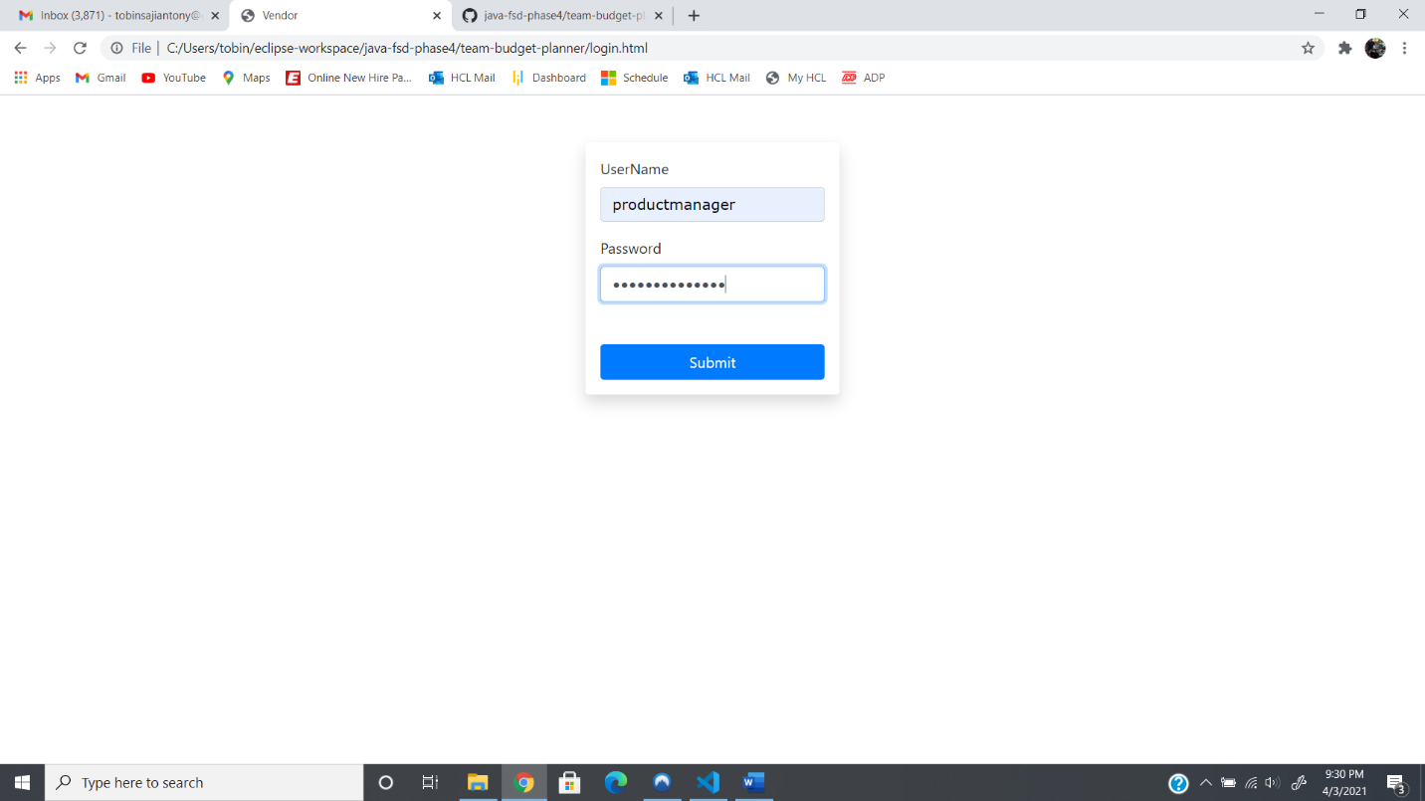

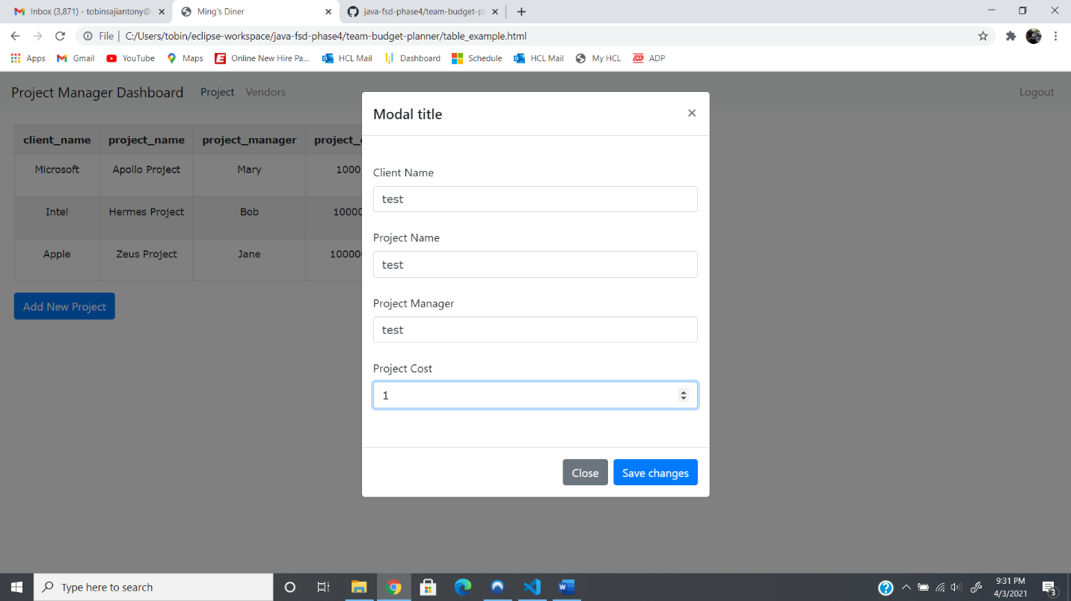

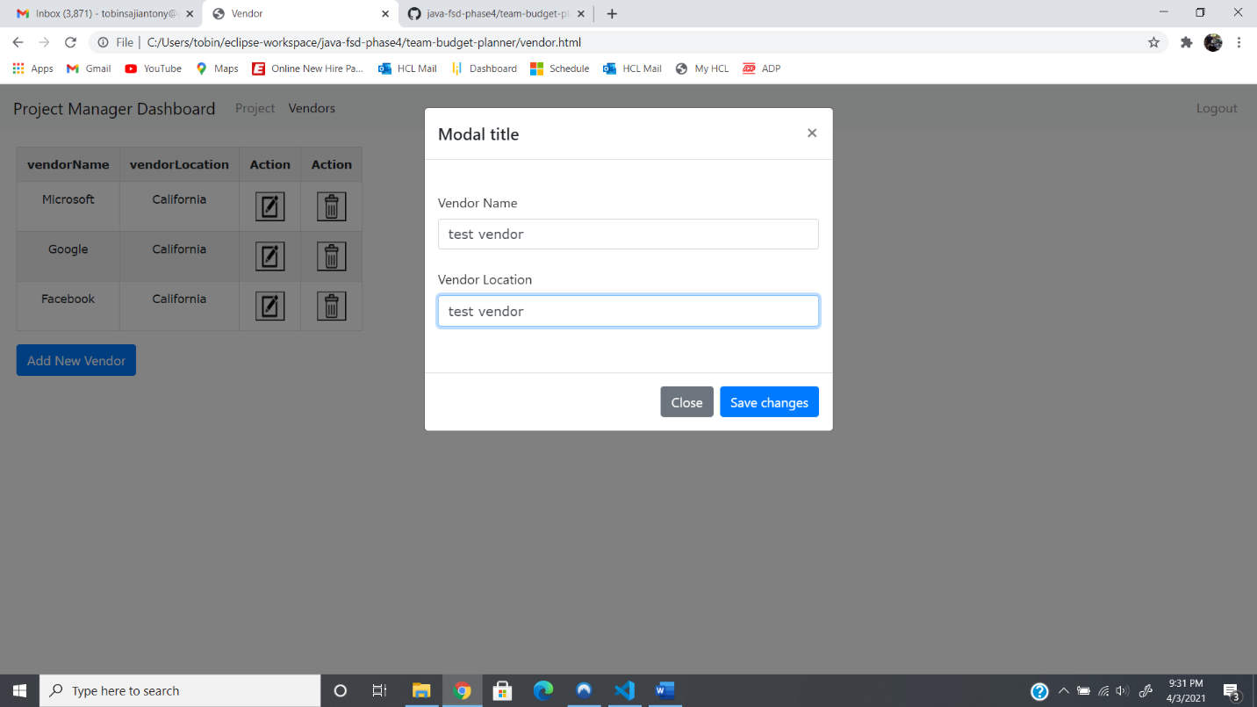

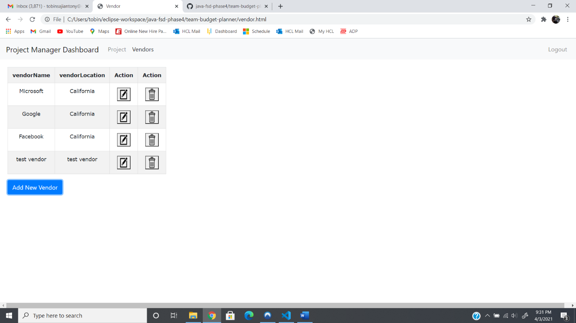

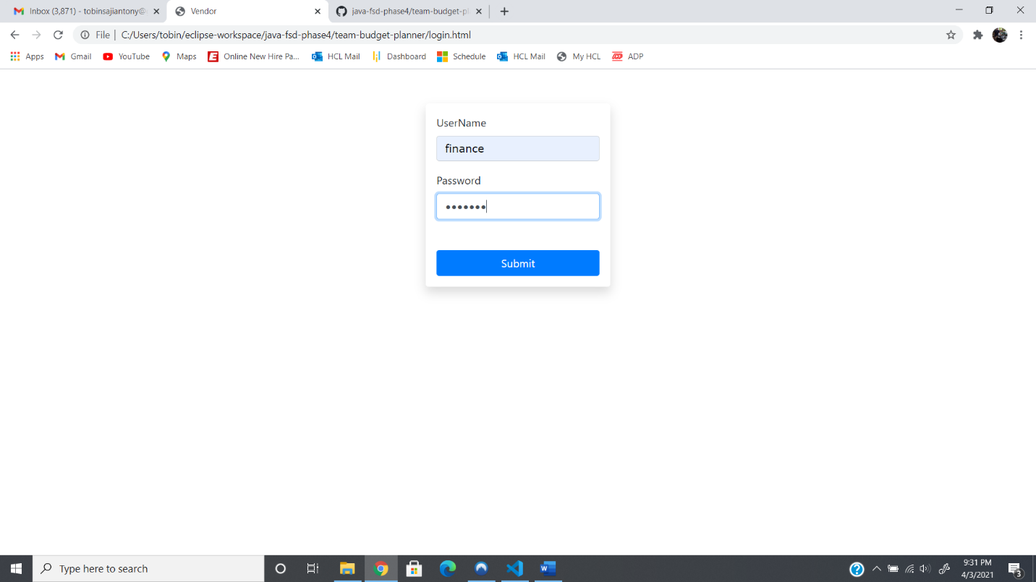

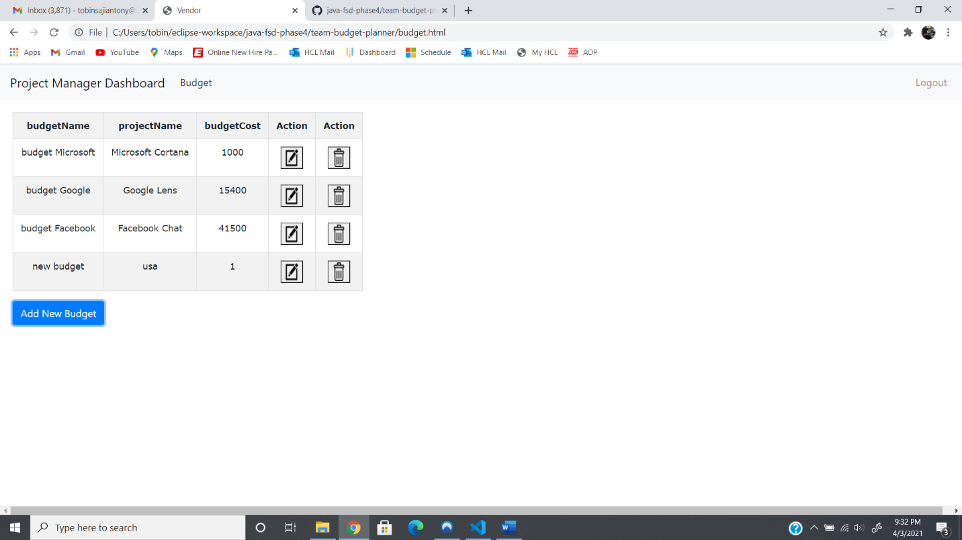

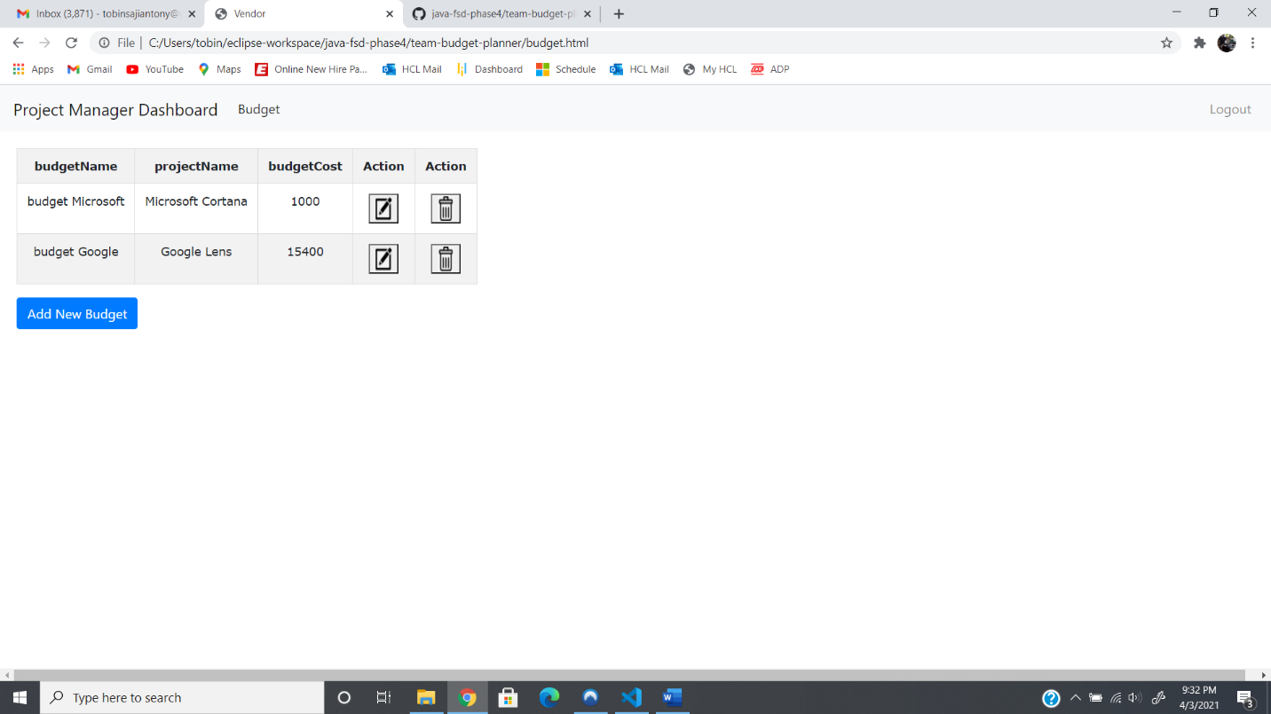

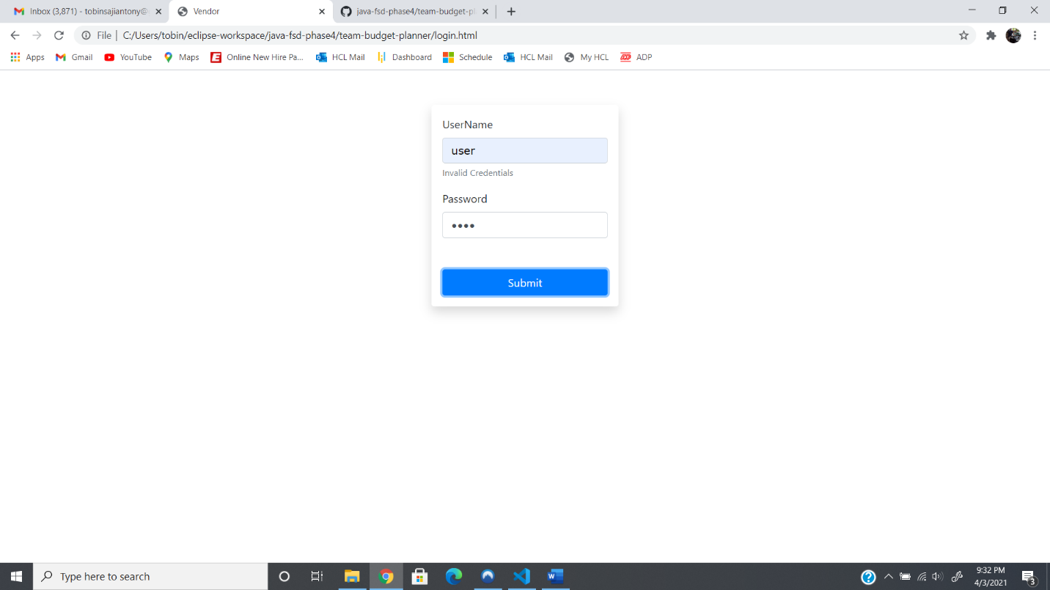

**GITHUB LINK:**

https://github.com/tobinsajiantony/Java_fsd_Phase_4_Restaurant